**PROJECT 3 PROPOSAL**

GROUP 1:Sarah Chauvin, Abrea Jyles, Elizabeth Viramontes, Gabriela Zarate

1. What is your dataset and why did you choose it:
2. Kaggle datasets: Different animal species in national parks in the US: [Biodiversity in National Parks (kaggle.com)](https://www.kaggle.com/datasets/nationalparkservice/park-biodiversity?select=species.csv)
3. Inspiration/reasoning: We chose this dataset because we want to know the diversity and distribution of animal species in our national parks, and we want to gain an understanding of how we, as a society, are protecting or affecting these species. This information is important because it is our responsibility to see and protect the beautiful world we have. We all want to continue enjoying nature.
4. Three research-guiding questions (each answered by dashboard and map)
   1. What is the distribution of species category across each state with national parks? Where do we find the most biodiversity (by species total in each category or just by species total)?
   2. Which states/parks have the most endangered species?
   3. How does the size of different parks compare with the conservation status of the animals in each park across the country?
   4. Where are the national parks in the US? What are the closest parks to the user’s location? (if we have time)
5. Inspiration - other code/articles similar to your dataset:
   1. [Best Months to Visit Each National Park (With Calendar) - The National Parks Experience (travel-experience-live.com)](https://www.travel-experience-live.com/best-months-to-visit-national-parks-calendar/)
   2. <https://www.proxi.co/blog/national-parks-map>
   3. <https://www.kaggle.com/code/gsdeepakkumar/biodiversity-an-eda>
   4. <https://lnt.org/>
6. Possible visualizations for the dashboard
   1. Bubble chart: Distribution of number of species by state and category (y: species category, x: state, bubble size: # of species). (Q1)
   2. Sunburst Chart: Top 5/10 states, by park, with the most endangered species and the names of the species. ([Large Number of Slices](https://plotly.com/javascript/sunburst-charts/#large-number-of-slices)). (Q2)
   3. Horizontal stacked bar charts: Compare the size of each park with the distribution of species in each conservation status level. Could do top 5/10 largest and top 5/10 smallest. (Q3)
   4. Table: Biodiversity breakdown by state.
   5. Map: On page load, show location of all parks with marker size indicating size of park. With filters by state or park, marker size could indicate number of total species with popup including species category breakdown. (Q4)
   6. Links for the conservation of the parks and how to participate in stewardship.
   7. Pictures of the most popular parks per states.
7. Color palette.

Bootstrap: Earth

Earth tones from coolors.co, similar to these

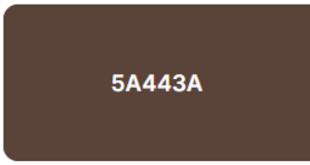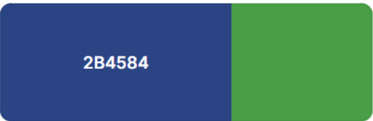

1. Roles & responsibilities
   1. All: data cleaning, create own slides and discuss putting them together as a group, about us page, write up
      1. Q1, bubble chart, dashboard: Gabriela
      2. Q2, sunburst chart, home page: Elizabeth
      3. Q3, bar charts, dashboard: Sarah
      4. Q4, map, map page: Abrea
   2. GitHub link: <https://github.com/gabrielaza22/project-3-group-01>