Chapter 15- Git GUI Tools
$ git gui ----opens the interface---can also be opened my right clicking in bottom of working directory
See videos in Building your Repository for walk through of the gui’s features
IDE tools
Github Desktop, GitKraken, Atom, VSCode- with lots of extensions like GitLens and GitGraph
Chapter 16 - Advanced Git
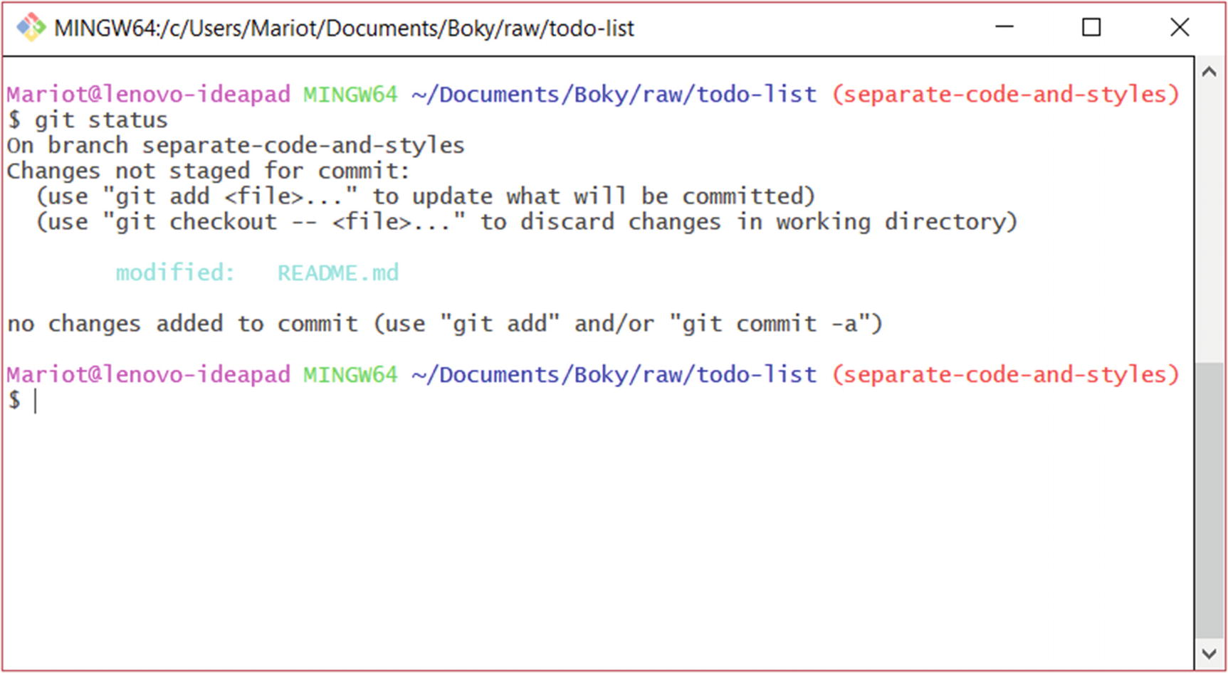
Notice
$git checkout -- <file> above--- As you can see, reverting a file to a previous state just means to check it out.
Stashing
$ git stash push
Note
Just using the command “git stash” is the same as using “git stash push.” It’s recommended to use the full command because it’s more intuitive and easier to understand.
This command will take your modified files, stage them, and create a temporary commit within the stash, leaving your working directory clean.
$ git stash list
$ git stash show
$ git stash pop
This command will take the latest changes in the stash and apply it to the current branch.
Git stash is last in- first out
Resetting
$ git reset --hard origin/separate-code-and-styles----book example of specific file
Your commits made after the target state, your current changes, and staged files will all be deleted as the “--hard” option overwrites everything on its path. It’s the most dangerous command in Git and you should think hard before using it.

