**Nome: Gabriel Lujan Bonassi**

**Nº USP: 11256816**

1. Fazer uma aquisição analógica;
2. Acender o LED azul quando o valor for próximo de 3.3 V e o LED verde quando o valor for próximo de 0 V.

Para estes dois itens, como é igual ao exercício 8, podemos reutilizar o código daquele exercício, fazendo as adaptações necessárias para utilizar as definições dos registradores dadas pelo codewarrior (através do #include “derivative.h”, que por sua vez da um #include <MKL25Z4.h>)

Código:

#include "derivative.h" /* include peripheral declarations */

void ADC0_init(void);

void LED_set(int s);

void LED_init(void);

int main(void)

{

     short int result;

     LED_init();

     ADC0_init();

     while (1)

     {

         ADC0_SC1A = 0x10; // inicia a conversao, single-ended, AD8 selecionado como input

         while (!(ADC0_SC1A & 0x80)){} //aguarda a conversao acabar (faco um AND entre a flag COCO e 1, quando os 2 forem 1, retorna 1 e para o while)

         result = ADC0_RA; // le o resultado da conversao na var result

         LED_set(result >> 7); // seta o led com base no bit 7 do result

     }

}

void ADC0_init(void) {

    SIM_SCGC5 |= (1<<10); // enable clock PORTB (pg. 206)

    SIM_SCGC6 |= 0x8000000; // enable clock ADC0 (pg. 207)

    PORTE_PCR0 = 0; // enable PTB0 pin out

    ADC0_SC2 &= ~0x40; // software trigger

    ADC0_CFG1 = 0x54;

}

void LED_init(void) {

    SIM_SCGC5 |= 0x1000; // enable clock PORTD

    SIM_SCGC5 |= 0x400; // enable clock PORTB

    // posso dar enable nos dois clocks ao mesmo tempo? sim!

    PORTD_PCR1 = 0x100; // enable PTD1 as GPIO (pg. 183) (Blue LED)

    PORTB_PCR19 = 0x100; // enable PTB19 as GPIO (Green LED)

    PORTB_PCR18 = 0x100; // enable PTB18 as GPIO (Red LED)

    GPIOB_PDDR |= 0x80000; // make PTB19 (Green LED) as output (pg. 778) (bit relativo ao numero da porta)

    GPIOB_PDDR |= 0x40000; // make PTB18 as output (Red LED)

    GPIOB_PDDR |= 0x02; // make PTD1 as output (Blue LED)

}

void LED_set(int s) {

    // Red LED

    if (s & 1) { // usa BIT 0 de s

        GPIOB_PCOR = 0x40000; // turn on

    } else {

        GPIOB_PSOR = 0x40000; // turn off

    }

    // Green LED

    if (s & 2) { //usa BIT 1 do s

        GPIOB_PCOR = 0x80000; // turn on

    } else {

        GPIOB_PSOR = 0x40000; // turn off

    }

    // Blue LED

    if (s & 4) { //usa bit 2 do s

        GPIOD_PCOR = 0x02; // turn on

    } else {

        GPIOD_PSOR = 0x02; // turn off

    }

}

1. Utilizar um timer periódico para, por interrupção, disparar a conversão AD. Usar a interrupção de fim de conversão para acender os LEDs. Permitido o uso do Processor Expert para este item.

Configurando o timer periódico usando o “Component” TimerInt_LDD:

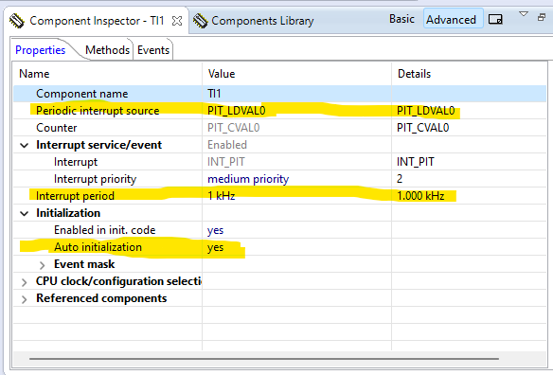Configurando o “Component” ADC:

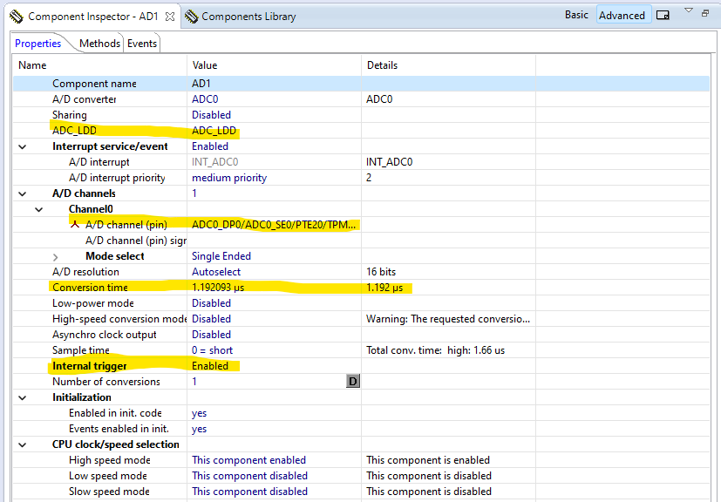

Repare que o “Internal trigger” está em “Enabled”. Vamos configurar o input do trigger do ADC utilizando o Timer que criamos:

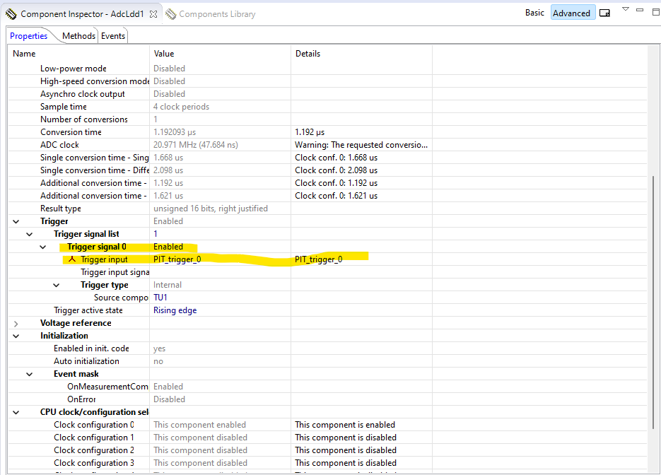

Agora, vamos configurar dois arquivos: events.c e main.c

Código do events.c:

/* ###################################################################

**     Filename    : Events.h

**     Project     : Ex5

**     Processor   : MKL25Z128VLK4

**     Component   : Events

**     Version     : Driver 01.00

**     Compiler    : GNU C Compiler

**     Date/Time   : 2023-07-07, 14:11, # CodeGen: 0

**     Abstract    :

**         This is user's event module.

**         Put your event handler code here.

**     Settings    :

**     Contents    :

**         Cpu_OnNMIINT - void Cpu_OnNMIINT(void);

**

** ###################################################################*/

/*!

** @file Events.h

** @version 01.00

** @brief

**         This is user's event module.

**         Put your event handler code here.

*/

/*!

**  @addtogroup Events_module Events module documentation

**  @{

*/

#ifndef __Events_H

#define __Events_H

/* MODULE Events */

#include "PE_Types.h"

#include "PE_Error.h"

#include "PE_Const.h"

#include "IO_Map.h"

#include "TI1.h"

#include "TU1.h"

#include "AD1.h"

#include "AdcLdd1.h"

#include "Bit1_Green_LED.h"

#include "BitIoLdd1.h"

#include "Bit2_Blue_LED.h"

#include "BitIoLdd2.h"

#ifdef __cplusplus

extern "C" {

#endif

/*

** ===================================================================

**     Event       :  Cpu_OnNMIINT (module Events)

**

**     Component   :  Cpu [MKL25Z128LK4]

*/

/*!

**     @brief

**         This event is called when the Non maskable interrupt had

**         occurred. This event is automatically enabled when the [NMI

**         interrupt] property is set to 'Enabled'.

*/

/* ===================================================================*/

void Cpu_OnNMIINT(void);

void AD1_OnEnd(void);

/*

** ===================================================================

**     Event       :  AD1_OnEnd (module Events)

**

**     Component   :  AD1 [ADC]

**     Description :

**         This event is called after the measurement (which consists

**         of <1 or more conversions>) is/are finished.

**         The event is available only when the <Interrupt

**         service/event> property is enabled.

**     Parameters  : None

**     Returns     : Nothing

** ===================================================================

*/

void AD1_OnCalibrationEnd(void);

/*

** ===================================================================

**     Event       :  AD1_OnCalibrationEnd (module Events)

**

**     Component   :  AD1 [ADC]

**     Description :

**         This event is called when the calibration has been finished.

**         User should check if the calibration pass or fail by

**         Calibration status method./nThis event is enabled only if

**         the <Interrupt service/event> property is enabled.

**     Parameters  : None

**     Returns     : Nothing

** ===================================================================

*/

/*

** ===================================================================

**     Event       :  TI1_OnInterrupt (module Events)

**

**     Component   :  TI1 [TimerInt_LDD]

*/

/*!

**     @brief

**         Called if periodic event occur. Component and OnInterrupt

**         event must be enabled. See [SetEventMask] and [GetEventMask]

**         methods. This event is available only if a [Interrupt

**         service/event] is enabled.

**     @param

**         UserDataPtr     - Pointer to the user or

**                           RTOS specific data. The pointer passed as

**                           the parameter of Init method.

*/

/* ===================================================================*/

void TI1_OnInterrupt(LDD_TUserData *UserDataPtr);

/* END Events */

#ifdef __cplusplus

}  /* extern "C" */

#endif

#endif

/* ifndef __Events_H*/

/*!

** @}

*/

/*

** ###################################################################

**

**     This file was created by Processor Expert 10.3 [05.09]

**     for the Freescale Kinetis series of microcontrollers.

**

** ###################################################################

*/

Código do main.c:

/* ###################################################################

**     Filename    : main.c

**     Project     : Ex5

**     Processor   : MKL25Z128VLK4

**     Version     : Driver 01.01

**     Compiler    : GNU C Compiler

**     Date/Time   : 2023-07-07, 14:11, # CodeGen: 0

**     Abstract    :

**         Main module.

**         This module contains user's application code.

**     Settings    :

**     Contents    :

**         No public methods

**

** ###################################################################*/

/*!

** @file main.c

** @version 01.01

** @brief

**         Main module.

**         This module contains user's application code.

*/

/*!

**  @addtogroup main_module main module documentation

**  @{

*/

/* MODULE main */

/* Including needed modules to compile this module/procedure */

#include "Cpu.h"

#include "Events.h"

#include "TI1.h"

#include "TU1.h"

#include "AD1.h"

#include "AdcLdd1.h"

#include "Bit1_Green_LED.h"

#include "BitIoLdd1.h"

#include "Bit2_Blue_LED.h"

#include "BitIoLdd2.h"

/* Including shared modules, which are used for whole project */

#include "PE_Types.h"

#include "PE_Error.h"

#include "PE_Const.h"

#include "IO_Map.h"

/* User includes (#include below this line is not maintained by Processor Expert) */

uint16_t adc_value;

/*lint -save  -e970 Disable MISRA rule (6.3) checking. */

int main(void)

/*lint -restore Enable MISRA rule (6.3) checking. */

{

  /* Write your local variable definition here */

  /*** Processor Expert internal initialization. DON'T REMOVE THIS CODE!!! ***/

  PE_low_level_init();

  /*** End of Processor Expert internal initialization.                    ***/

  /* Write your code here */

  /* For example: for(;;) { } */

  while(1) {

    if (adc_value > 200) {

      Bit1_Green_LED_SetVal(); // OFF

      Bit2_Blue_LED_ClrVal();  // ON

    } else if (adc_value > 50) {

      Bit1_Green_LED_ClrVal(); // ON

      Bit2_Blue_LED_SetVal();  // OFF

    } else {

      Bit1_Green_LED_SetVal(); // OFF

      Bit1_Green_LED_SetVal(); // OFF

    }

   }

  /*** Don't write any code pass this line, or it will be deleted during code generation. ***/

  /*** RTOS startup code. Macro PEX_RTOS_START is defined by the RTOS component. DON'T MODIFY THIS CODE!!! ***/

  #ifdef PEX_RTOS_START

    PEX_RTOS_START();                  /* Startup of the selected RTOS. Macro is defined by the RTOS component. */

  #endif

  /*** End of RTOS startup code.  ***/

  /*** Processor Expert end of main routine. DON'T MODIFY THIS CODE!!! ***/

  for(;;){}

  /*** Processor Expert end of main routine. DON'T WRITE CODE BELOW!!! ***/

} /*** End of main routine. DO NOT MODIFY THIS TEXT!!! ***/

/* END main */

/*!

** @}

*/

/*

** ###################################################################

**

**     This file was created by Processor Expert 10.3 [05.09]

**     for the Freescale Kinetis series of microcontrollers.

**

** ###################################################################

*/