**Nome: Gabriel Lujan Bonassi**

**Nº USP: 11256816**

1. Utilizar um timer periódico para, por interrupção, disparar a conversão AD por hardware. Usar a interrupção de fim de conversão para acender os LEDs como feito no exercício 7.

Da mesma maneira que realizado no exercício 5, vamos configurar os “Components” do Timer, ADC e os LEDs:

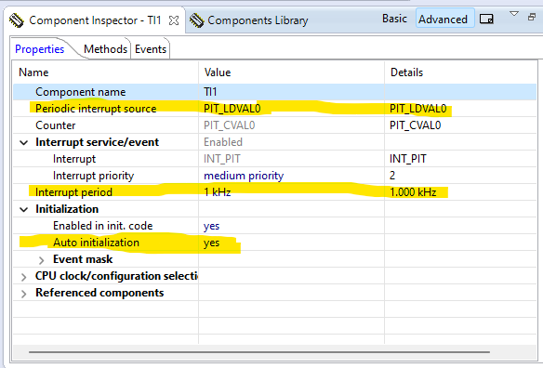

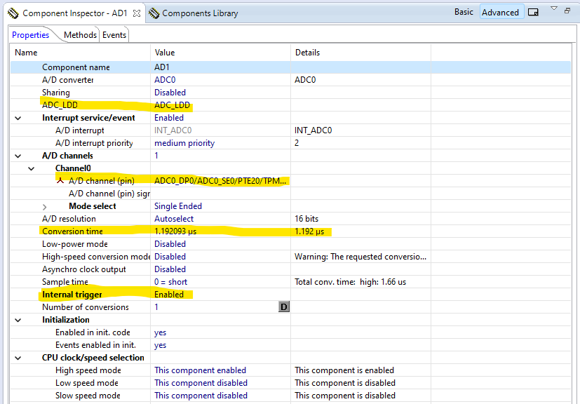

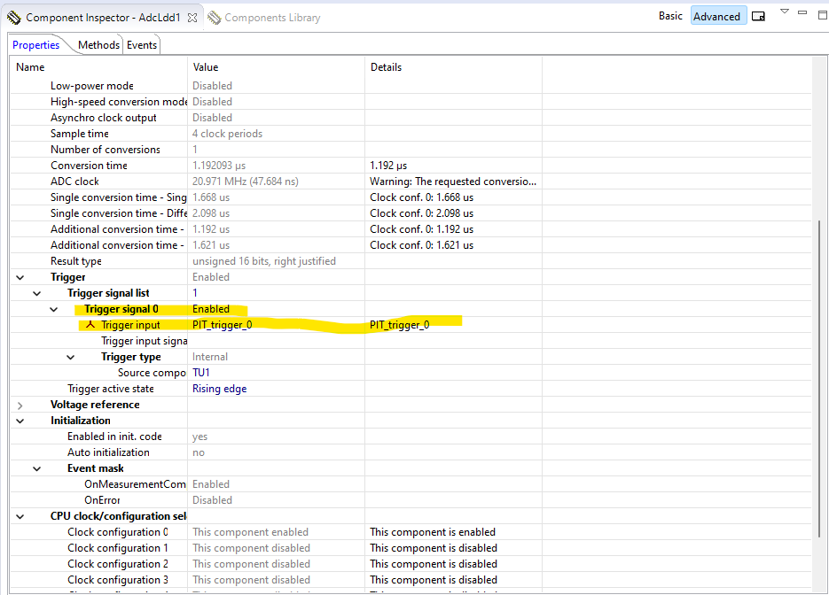

Código do events.h:

/* ###################################################################

**     Filename    : Events.h

**     Project     : Ex5

**     Processor   : MKL25Z128VLK4

**     Component   : Events

**     Version     : Driver 01.00

**     Compiler    : GNU C Compiler

**     Date/Time   : 2023-07-07, 14:11, # CodeGen: 0

**     Abstract    :

**         This is user's event module.

**         Put your event handler code here.

**     Settings    :

**     Contents    :

**         Cpu_OnNMIINT - void Cpu_OnNMIINT(void);

**

** ###################################################################*/

/*!

** @file Events.h

** @version 01.00

** @brief

**         This is user's event module.

**         Put your event handler code here.

*/

/*!

**  @addtogroup Events_module Events module documentation

**  @{

*/

#ifndef __Events_H

#define __Events_H

/* MODULE Events */

#include "PE_Types.h"

#include "PE_Error.h"

#include "PE_Const.h"

#include "IO_Map.h"

#include "TI1.h"

#include "TU1.h"

#include "AD1.h"

#include "AdcLdd1.h"

#include "Bit1_Green_LED.h"

#include "BitIoLdd1.h"

#include "Bit2_Blue_LED.h"

#include "BitIoLdd2.h"

#ifdef __cplusplus

extern "C" {

#endif

/*

** ===================================================================

**     Event       :  Cpu_OnNMIINT (module Events)

**

**     Component   :  Cpu [MKL25Z128LK4]

*/

/*!

**     @brief

**         This event is called when the Non maskable interrupt had

**         occurred. This event is automatically enabled when the [NMI

**         interrupt] property is set to 'Enabled'.

*/

/* ===================================================================*/

void Cpu_OnNMIINT(void);

void AD1_OnEnd(void);

/*

** ===================================================================

**     Event       :  AD1_OnEnd (module Events)

**

**     Component   :  AD1 [ADC]

**     Description :

**         This event is called after the measurement (which consists

**         of <1 or more conversions>) is/are finished.

**         The event is available only when the <Interrupt

**         service/event> property is enabled.

**     Parameters  : None

**     Returns     : Nothing

** ===================================================================

*/

void AD1_OnCalibrationEnd(void);

/*

** ===================================================================

**     Event       :  AD1_OnCalibrationEnd (module Events)

**

**     Component   :  AD1 [ADC]

**     Description :

**         This event is called when the calibration has been finished.

**         User should check if the calibration pass or fail by

**         Calibration status method./nThis event is enabled only if

**         the <Interrupt service/event> property is enabled.

**     Parameters  : None

**     Returns     : Nothing

** ===================================================================

*/

/*

** ===================================================================

**     Event       :  TI1_OnInterrupt (module Events)

**

**     Component   :  TI1 [TimerInt_LDD]

*/

/*!

**     @brief

**         Called if periodic event occur. Component and OnInterrupt

**         event must be enabled. See [SetEventMask] and [GetEventMask]

**         methods. This event is available only if a [Interrupt

**         service/event] is enabled.

**     @param

**         UserDataPtr     - Pointer to the user or

**                           RTOS specific data. The pointer passed as

**                           the parameter of Init method.

*/

/* ===================================================================*/

void TI1_OnInterrupt(LDD_TUserData *UserDataPtr);

/* END Events */

#ifdef __cplusplus

}  /* extern "C" */

#endif

#endif

/* ifndef __Events_H*/

/*!

** @}

*/

/*

** ###################################################################

**

**     This file was created by Processor Expert 10.3 [05.09]

**     for the Freescale Kinetis series of microcontrollers.

**

** ###################################################################

*/

Código do main.c:

/* ###################################################################

**     Filename    : main.c

**     Project     : Ex5

**     Processor   : MKL25Z128VLK4

**     Version     : Driver 01.01

**     Compiler    : GNU C Compiler

**     Date/Time   : 2023-07-07, 14:11, # CodeGen: 0

**     Abstract    :

**         Main module.

**         This module contains user's application code.

**     Settings    :

**     Contents    :

**         No public methods

**

** ###################################################################*/

/*!

** @file main.c

** @version 01.01

** @brief

**         Main module.

**         This module contains user's application code.

*/

/*!

**  @addtogroup main_module main module documentation

**  @{

*/

/* MODULE main */

/* Including needed modules to compile this module/procedure */

#include "Cpu.h"

#include "Events.h"

#include "TI1.h"

#include "TU1.h"

#include "AD1.h"

#include "AdcLdd1.h"

#include "Bit1_Green_LED.h"

#include "BitIoLdd1.h"

#include "Bit2_Blue_LED.h"

#include "BitIoLdd2.h"

/* Including shared modules, which are used for whole project */

#include "PE_Types.h"

#include "PE_Error.h"

#include "PE_Const.h"

#include "IO_Map.h"

/* User includes (#include below this line is not maintained by Processor Expert) */

uint16_t adc_value;

/*lint -save  -e970 Disable MISRA rule (6.3) checking. */

int main(void)

/*lint -restore Enable MISRA rule (6.3) checking. */

{

  /* Write your local variable definition here */

  /*** Processor Expert internal initialization. DON'T REMOVE THIS CODE!!! ***/

  PE_low_level_init();

  /*** End of Processor Expert internal initialization.                    ***/

  /* Write your code here */

  /* For example: for(;;) { } */

  while(1) {

    if (adc_value > 200) {

      Bit1_Green_LED_SetVal(); // OFF

      Bit2_Blue_LED_ClrVal();  // ON

    } else if (adc_value > 50) {

      Bit1_Green_LED_ClrVal(); // ON

      Bit2_Blue_LED_SetVal();  // OFF

    } else {

      Bit1_Green_LED_SetVal(); // OFF

      Bit1_Green_LED_SetVal(); // OFF

    }

   }

  /*** Don't write any code pass this line, or it will be deleted during code generation. ***/

  /*** RTOS startup code. Macro PEX_RTOS_START is defined by the RTOS component. DON'T MODIFY THIS CODE!!! ***/

  #ifdef PEX_RTOS_START

    PEX_RTOS_START();                  /* Startup of the selected RTOS. Macro is defined by the RTOS component. */

  #endif

  /*** End of RTOS startup code.  ***/

  /*** Processor Expert end of main routine. DON'T MODIFY THIS CODE!!! ***/

  for(;;){}

  /*** Processor Expert end of main routine. DON'T WRITE CODE BELOW!!! ***/

} /*** End of main routine. DO NOT MODIFY THIS TEXT!!! ***/

/* END main */

/*!

** @}

*/

/*

** ###################################################################

**

**     This file was created by Processor Expert 10.3 [05.09]

**     for the Freescale Kinetis series of microcontrollers.

**

** ###################################################################

*/

1. Utilize DMA para gravar os dados na memória.

Vamos utilizar um “Component” Init_DMA com as seguintes configurações: Inicializando o Channel 0, configurando o Data Source, o Data Destination, o Byte Count e o DMA

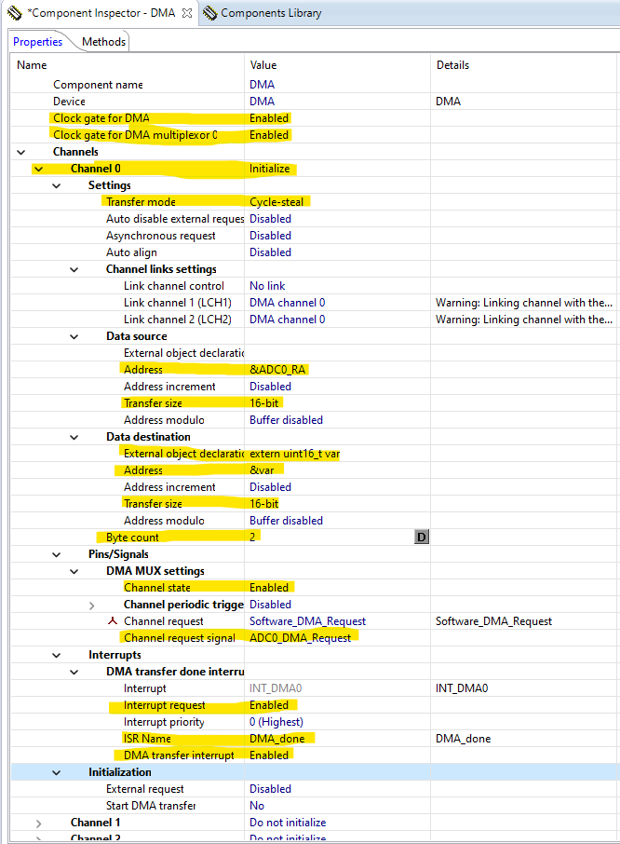

Por último, geramos os seguintes arquivos: events.h, main.c e DMA.c

Código do events.h:

/* ###################################################################

**     Filename    : Events.c

**     Project     : ex6

**     Processor   : MKL25Z128VLK4

**     Component   : Events

**     Version     : Driver 01.00

**     Compiler    : GNU C Compiler

**     Date/Time   : 2022-07-07, 01:35, # CodeGen: 0

**     Abstract    :

**         This is user's event module.

**         Put your event handler code here.

**     Settings    :

**     Contents    :

**         Cpu_OnNMIINT - void Cpu_OnNMIINT(void);

**

** ###################################################################*/

/*!

** @file Events.c

** @version 01.00

** @brief

**         This is user's event module.

**         Put your event handler code here.

*/

/*!

**  @addtogroup Events_module Events module documentation

**  @{

*/

/* MODULE Events */

#include "Cpu.h"

#include "Events.h"

#ifdef __cplusplus

extern "C" {

#endif

extern uint16_t adc_value;

/* User includes (#include below this line is not maintained by Processor Expert) */

/*

** ===================================================================

**     Event       :  Cpu_OnNMIINT (module Events)

**

**     Component   :  Cpu [MKL25Z128LK4]

*/

/*!

**     @brief

**         This event is called when the Non maskable interrupt had

**         occurred. This event is automatically enabled when the [NMI

**         interrupt] property is set to 'Enabled'.

*/

/* ===================================================================*/

void Cpu_OnNMIINT(void)

{

  /* Write your code here ... */

}

/*

** ===================================================================

**     Event       :  TI1_OnInterrupt (module Events)

**

**     Component   :  TI1 [TimerInt_LDD]

*/

/*!

**     @brief

**         Called if periodic event occur. Component and OnInterrupt

**         event must be enabled. See [SetEventMask] and [GetEventMask]

**         methods. This event is available only if a [Interrupt

**         service/event] is enabled.

**     @param

**         UserDataPtr     - Pointer to the user or

**                           RTOS specific data. The pointer passed as

**                           the parameter of Init method.

*/

/* ===================================================================*/

void TI1_OnInterrupt(LDD_TUserData *UserDataPtr)

{

  AD1_Measure(0);

}

/*

** ===================================================================

**     Event       :  AD1_OnEnd (module Events)

**

**     Component   :  AD1 [ADC]

**     Description :

**         This event is called after the measurement (which consists

**         of <1 or more conversions>) is/are finished.

**         The event is available only when the <Interrupt

**         service/event> property is enabled.

**     Parameters  : None

**     Returns     : Nothing

** ===================================================================

*/

void AD1_OnEnd(void)

{

}

/*

** ===================================================================

**     Event       :  AD1_OnCalibrationEnd (module Events)

**

**     Component   :  AD1 [ADC]

**     Description :

**         This event is called when the calibration has been finished.

**         User should check if the calibration pass or fail by

**         Calibration status method./nThis event is enabled only if

**         the <Interrupt service/event> property is enabled.

**     Parameters  : None

**     Returns     : Nothing

** ===================================================================

*/

void AD1_OnCalibrationEnd(void)

{

  /* Write your code here ... */

}

PE_ISR(DMA_done)

{

    DMA_DSR0 |= DMA_DSR_BCR_DONE_MASK; // Clear Done Flag

    DMA_DSR_BCR0 |= DMA_DSR_BCR_BCR(2); // Set byte count register

}

/* END Events */

#ifdef __cplusplus

}  /* extern "C" */

#endif

/*!

** @}

*/

/*

** ###################################################################

**

**     This file was created by Processor Expert 10.3 [05.09]

**     for the Freescale Kinetis series of microcontrollers.

**

** ###################################################################

*/

Código do main.c:

/* ###################################################################

**     Filename    : main.c

**     Project     : ex6

**     Processor   : MKL25Z128VLK4

**     Version     : Driver 01.01

**     Compiler    : GNU C Compiler

**     Date/Time   : 2022-07-07, 01:35, # CodeGen: 0

**     Abstract    :

**         Main module.

**         This module contains user's application code.

**     Settings    :

**     Contents    :

**         No public methods

**

** ###################################################################*/

/*!

** @file main.c

** @version 01.01

** @brief

**         Main module.

**         This module contains user's application code.

*/

/*!

**  @addtogroup main_module main module documentation

**  @{

*/

/* MODULE main */

/* Including needed modules to compile this module/procedure */

#include "Cpu.h"

#include "Events.h"

#include "TI1.h"

#include "TU1.h"

#include "Bit1_Green_LED.h"

#include "BitIoLdd1.h"

#include "Bit2_Blue_LED.h"

#include "BitIoLdd2.h"

#include "AD1.h"

#include "AdcLdd1.h"

#include "DMA.h"

/* Including shared modules, which are used for whole project */

#include "PE_Types.h"

#include "PE_Error.h"

#include "PE_Const.h"

#include "IO_Map.h"

uint16_t var;

/* User includes (#include below this line is not maintained by Processor Expert) */

/*lint -save  -e970 Disable MISRA rule (6.3) checking. */

int main(void)

/*lint -restore Enable MISRA rule (6.3) checking. */

{

  /* Write your local variable definition here */

  /*** Processor Expert internal initialization. DON'T REMOVE THIS CODE!!! ***/

  PE_low_level_init();

  /*** End of Processor Expert internal initialization.                    ***/

  /* Write your code here */

  ADC0_SC2 |= ADC_SC2_DMAEN_MASK; // DMA Enable

  while(1) {

    if (var > 32000) {

      Bit1_Green_LED_SetVal();

      Bit2_Blue_LED_ClrVal();

    } else {

      Bit1_Green_LED_ClrVal();

      Bit2_Blue_LED_SetVal();

    }

  }

  /*** Don't write any code pass this line, or it will be deleted during code generation. ***/

  /*** RTOS startup code. Macro PEX_RTOS_START is defined by the RTOS component. DON'T MODIFY THIS CODE!!! ***/

  #ifdef PEX_RTOS_START

    PEX_RTOS_START();                  /* Startup of the selected RTOS. Macro is defined by the RTOS component. */

  #endif

  /*** End of RTOS startup code.  ***/

  /*** Processor Expert end of main routine. DON'T MODIFY THIS CODE!!! ***/

  for(;;){}

  /*** Processor Expert end of main routine. DON'T WRITE CODE BELOW!!! ***/

} /*** End of main routine. DO NOT MODIFY THIS TEXT!!! ***/

/* END main */

/*!

** @}

*/

/*

** ###################################################################

**

**     This file was created by Processor Expert 10.3 [05.09]

**     for the Freescale Kinetis series of microcontrollers.

**

** ###################################################################

*/

Código do DMA.c:

/* ###################################################################

**     This component module is generated by Processor Expert. Do not modify it.

**     Filename    : DMA.c

**     Project     : ex6

**     Processor   : MKL25Z128VLK4

**     Component   : Init_DMA

**     Version     : Component 01.002, Driver 01.02, CPU db: 3.00.000

**     Compiler    : GNU C Compiler

**     Date/Time   : 2022-07-09, 19:54, # CodeGen: 9

**     Abstract    :

**          This file implements the DMA (DMA) module initialization

**          according to the Peripheral Initialization settings, and

**          defines interrupt service routines prototypes.

**     Settings    :

**          Component name                                 : DMA

**          Device                                         : DMA

**          Clock gate for DMA                             : Enabled

**          Clock gate for DMA multiplexor 0               : Enabled

**          Channels                                       :

**            Channel 0                                    : Initialize

**              Settings                                   :

**                Transfer mode                            : Cycle-steal

**                Auto disable external request            : Disabled

**                Asynchronous request                     : Disabled

**                Auto align                               : Disabled

**                Channel links settings                   :

**                  Link channel control                   : No link

**                  Link channel 1 (LCH1)                  : DMA channel 0

**                  Link channel 2 (LCH2)                  : DMA channel 0

**                Data source                              :

**                  External object declaration            :

**                  Address                                : &ADC0_RA

**                  Address increment                      : Disabled

**                  Transfer size                          : 16-bit

**                  Address modulo                         : Buffer disabled

**                Data destination                         :

**                  External object declaration            : extern uint16_t var

**                  Address                                : &var

**                  Address increment                      : Disabled

**                  Transfer size                          : 16-bit

**                  Address modulo                         : Buffer disabled

**                Byte count                               : 2

**              Pins/Signals                               :

**                DMA MUX settings                         :

**                  Channel state                          : Enabled

**                  Channel periodic trigger               : Disabled

**                  Channel request                        : Software_DMA_Request

**                  Channel request signal                 : ADC0_DMA_Request

**              Interrupts                                 :

**                DMA transfer done interrupt              :

**                  Interrupt                              : INT_DMA0

**                  Interrupt request                      : Enabled

**                  Interrupt priority                     : 0 (Highest)

**                  ISR Name                               : DMA_done

**                  DMA transfer interrupt                 : Enabled

**              Initialization                             :

**                External request                         : Disabled

**                Start DMA transfer                       : No

**            Channel 1                                    : Do not initialize

**            Channel 2                                    : Do not initialize

**            Channel 3                                    : Do not initialize

**          Initialization                                 :

**            Call Init method                             : yes

**     Contents    :

**         Init - void DMA_Init(void);

**

**     Copyright : 1997 - 2014 Freescale Semiconductor, Inc.

**     All Rights Reserved.

**

**     Redistribution and use in source and binary forms, with or without modification,

**     are permitted provided that the following conditions are met:

**

**     o Redistributions of source code must retain the above copyright notice, this list

**       of conditions and the following disclaimer.

**

**     o Redistributions in binary form must reproduce the above copyright notice, this

**       list of conditions and the following disclaimer in the documentation and/or

**       other materials provided with the distribution.

**

**     o Neither the name of Freescale Semiconductor, Inc. nor the names of its

**       contributors may be used to endorse or promote products derived from this

**       software without specific prior written permission.

**

**     THIS SOFTWARE IS PROVIDED BY THE COPYRIGHT HOLDERS AND CONTRIBUTORS "AS IS" AND

**     ANY EXPRESS OR IMPLIED WARRANTIES, INCLUDING, BUT NOT LIMITED TO, THE IMPLIED

**     WARRANTIES OF MERCHANTABILITY AND FITNESS FOR A PARTICULAR PURPOSE ARE

**     DISCLAIMED. IN NO EVENT SHALL THE COPYRIGHT HOLDER OR CONTRIBUTORS BE LIABLE FOR

**     ANY DIRECT, INDIRECT, INCIDENTAL, SPECIAL, EXEMPLARY, OR CONSEQUENTIAL DAMAGES

**     (INCLUDING, BUT NOT LIMITED TO, PROCUREMENT OF SUBSTITUTE GOODS OR SERVICES;

**     LOSS OF USE, DATA, OR PROFITS; OR BUSINESS INTERRUPTION) HOWEVER CAUSED AND ON

**     ANY THEORY OF LIABILITY, WHETHER IN CONTRACT, STRICT LIABILITY, OR TORT

**     (INCLUDING NEGLIGENCE OR OTHERWISE) ARISING IN ANY WAY OUT OF THE USE OF THIS

**     SOFTWARE, EVEN IF ADVISED OF THE POSSIBILITY OF SUCH DAMAGE.

**

**     http: www.freescale.com

**     mail: support@freescale.com

** ###################################################################*/

/*!

** @file DMA.c

** @version 01.02

** @brief

**          This file implements the DMA (DMA) module initialization

**          according to the Peripheral Initialization settings, and

**          defines interrupt service routines prototypes.

*/

/*!

**  @addtogroup DMA_module DMA module documentation

**  @{

*/

/* MODULE DMA. */

#include "DMA.h"

  /* Including shared modules, which are used in the whole project */

#include "PE_Types.h"

#include "PE_Error.h"

#include "PE_Const.h"

#include "IO_Map.h"

#include "Cpu.h"

/*

** ===================================================================

**     Method      :  DMA_Init (component Init_DMA)

**     Description :

**         This method initializes registers of the DMA module

**         according to the Peripheral Initialization settings.

**         Call this method in user code to initialize the module. By

**         default, the method is called by PE automatically; see "Call

**         Init method" property of the component for more details.

**     Parameters  : None

**     Returns     : Nothing

** ===================================================================

*/

/* Channel 0 data destination external object declaration */

extern uint16_t var;

void DMA_Init(void)

{

  /* SIM_SCGC7: DMA=1 */

  SIM_SCGC7 |= SIM_SCGC7_DMA_MASK;

  /* SIM_SCGC6: DMAMUX=1 */

  SIM_SCGC6 |= SIM_SCGC6_DMAMUX_MASK;

  /* DMAMUX0_CHCFG0: ENBL=0,TRIG=0,SOURCE=0 */

  DMAMUX0_CHCFG0 = DMAMUX_CHCFG_SOURCE(0x00);

  /* DMAMUX0_CHCFG1: ENBL=0,TRIG=0,SOURCE=0 */

  DMAMUX0_CHCFG1 = DMAMUX_CHCFG_SOURCE(0x00);

  /* DMAMUX0_CHCFG2: ENBL=0,TRIG=0,SOURCE=0 */

  DMAMUX0_CHCFG2 = DMAMUX_CHCFG_SOURCE(0x00);

  /* DMAMUX0_CHCFG3: ENBL=0,TRIG=0,SOURCE=0 */

  DMAMUX0_CHCFG3 = DMAMUX_CHCFG_SOURCE(0x00);

  /* DMA_DSR_BCR0: DONE=1 */

  DMA_DSR_BCR0 |= DMA_DSR_BCR_DONE_MASK;

  /* DMA_SAR0 = &ADC0_RA */

  DMA_SAR0 = (uint32_t)(&ADC0_RA);

  /* DMA_DAR0 = &var */

  DMA_DAR0 = (uint32_t)(&var);

  /* DMA_DSR_BCR0: ??=0,CE=0,BES=0,BED=0,??=0,REQ=0,BSY=0,DONE=0,BCR=2 */

  DMA_DSR_BCR0 = DMA_DSR_BCR_BCR(0x02);

  /* DMA_DCR0: EINT=1,ERQ=0,CS=1,AA=0,??=0,??=0,??=0,??=0,EADREQ=0,SINC=0,SSIZE=2,DINC=0,DSIZE=2,START=0,SMOD=0,DMOD=0,D_REQ=0,??=0,LINKCC=0,LCH1=0,LCH2=0 */

  DMA_DCR0 = DMA_DCR_EINT_MASK |

             DMA_DCR_CS_MASK |

             DMA_DCR_SSIZE(0x02) |

             DMA_DCR_DSIZE(0x02) |

             DMA_DCR_SMOD(0x00) |

             DMA_DCR_DMOD(0x00) |

             DMA_DCR_LINKCC(0x00) |

             DMA_DCR_LCH1(0x00) |

             DMA_DCR_LCH2(0x00);

  /* DMAMUX0_CHCFG0: ENBL=1,TRIG=0,SOURCE=0 */

  DMAMUX0_CHCFG0 = (DMAMUX_CHCFG_ENBL_MASK | DMAMUX_CHCFG_SOURCE(0x00));

}

/*

** ###################################################################

**

**  The interrupt service routine(s) must be implemented

**  by user in one of the following user modules.

**

**  If the "Generate ISR" option is enabled, Processor Expert generates

**  ISR templates in the CPU event module.

**

**  User modules:

**      main.c

**      Events.c

**

** ###################################################################

PE_ISR(DMA_done)

{

// NOTE: The routine should include actions to clear the appropriate

//       interrupt flags.

//

}

*/

/* END DMA. */

/*!

** @}

*/

/*

** ###################################################################

**

**     This file was created by Processor Expert 10.3 [05.09]

**     for the Freescale Kinetis series of microcontrollers.

**

** ###################################################################

*/