Heatmap_clustering

Gabriel Burcea

03/08/2020

library(tidyverse)

## ── Attaching packages ─────────────────────────────────────────────────────────────────────────────────────────────────────────────────────────────── tidyverse 1.3.0 ──

## ✓ ggplot2 3.3.1 ✓ purrr 0.3.4  
## ✓ tibble 3.0.3 ✓ dplyr 1.0.0  
## ✓ tidyr 1.1.0 ✓ stringr 1.4.0  
## ✓ readr 1.3.1 ✓ forcats 0.5.0

## ── Conflicts ────────────────────────────────────────────────────────────────────────────────────────────────────────────────────────────────── tidyverse_conflicts() ──  
## x dplyr::filter() masks stats::filter()  
## x dplyr::lag() masks stats::lag()

library(cluster)  
library(plotly)

##   
## Attaching package: 'plotly'

## The following object is masked from 'package:ggplot2':  
##   
## last_plot

## The following object is masked from 'package:stats':  
##   
## filter

## The following object is masked from 'package:graphics':  
##   
## layout

library(fpc)  
library(dendextend)

##   
## ---------------------  
## Welcome to dendextend version 1.13.4  
## Type citation('dendextend') for how to cite the package.  
##   
## Type browseVignettes(package = 'dendextend') for the package vignette.  
## The github page is: https://github.com/talgalili/dendextend/  
##   
## Suggestions and bug-reports can be submitted at: https://github.com/talgalili/dendextend/issues  
## Or contact: <tal.galili@gmail.com>  
##   
## To suppress this message use: suppressPackageStartupMessages(library(dendextend))  
## ---------------------

##   
## Attaching package: 'dendextend'

## The following object is masked from 'package:stats':  
##   
## cutree

library(factoextra)

## Welcome! Want to learn more? See two factoextra-related books at https://goo.gl/ve3WBa

library(FactoMineR)  
library(NbClust)  
library(caret)

## Loading required package: lattice

##   
## Attaching package: 'caret'

## The following object is masked from 'package:purrr':  
##   
## lift

library(DMwR)

## Loading required package: grid

## Registered S3 method overwritten by 'quantmod':  
## method from  
## as.zoo.data.frame zoo

data_cluster <- read_csv("/Users/gabrielburcea/rprojects/stats_data_whole/data_categ_no_sev.csv")

## Parsed with column specification:  
## cols(  
## .default = col_character(),  
## age = col_double(),  
## date_completed = col_date(format = ""),  
## how_unwell = col_double(),  
## number_days_symptoms = col_double(),  
## number_morbidities = col_double()  
## )

## See spec(...) for full column specifications.

## Warning: 9 parsing failures.  
## row col expected actual file  
## 2910 how_unwell a double How Unwell '/Users/gabrielburcea/rprojects/stats_data_whole/data_categ_no_sev.csv'  
## 10025 number_days_symptoms no trailing characters 0 '/Users/gabrielburcea/rprojects/stats_data_whole/data_categ_no_sev.csv'  
## 19970 number_days_symptoms no trailing characters 9 '/Users/gabrielburcea/rprojects/stats_data_whole/data_categ_no_sev.csv'  
## 22410 number_days_symptoms a double Plus de 21 '/Users/gabrielburcea/rprojects/stats_data_whole/data_categ_no_sev.csv'  
## 31280 number_days_symptoms no trailing characters ?? ???? ?? '/Users/gabrielburcea/rprojects/stats_data_whole/data_categ_no_sev.csv'  
## ..... .................... ...................... ........... .......................................................................  
## See problems(...) for more details.

level_key_temperature <- c("Yes" = "37.5-38",   
 "Yes" = "38.1-39",   
 "Yes" = "38.2-39",  
 "Yes" = "39.1-41")  
  
  
  
data_select <- data_cluster %>%  
 dplyr::select(ID, covid_tested, chills, cough, diarrhoea, fatigue, headache, loss_smell_taste, muscle_ache,   
 nasal_congestion, nausea_vomiting, shortness_breath, sore_throat, sputum, temperature, asthma, diabetes_type_one,  
 diabetes_type_two, obesity, hypertension, heart_disease, lung_condition, liver_disease, kidney_disease) %>%  
 dplyr::filter(covid_tested != "none")   
  
covid_tested_levels <- c("positive" = "showing symptoms")  
  
data_transf <- data_select %>%   
 dplyr::mutate(covid_tested = forcats::fct_recode(covid_tested, !!!covid_tested_levels),   
 temperature = forcats::fct_recode(temperature, !!!level_key_temperature)) %>%  
 dplyr::filter(covid_tested != "none")

## Warning: Unknown levels in `f`: 38.2-39

data_piv <- data_transf %>%  
 pivot_longer(cols = 16:24,   
 names_to = "Comorbidities",  
 values_to = "Bolean") %>%  
 dplyr::filter(Bolean == "Yes") %>%  
 pivot_longer(cols = 3:15,   
 names_to = "Symptoms",   
 values_to = "Yes_No") %>%  
 dplyr::group_by(Comorbidities, Symptoms, Yes_No) %>%  
 dplyr::summarise(Count = n()) %>%  
 dplyr::mutate(Freq = Count / sum(Count)*100) %>%   
 dplyr::filter(Yes_No == "Yes")

## `summarise()` regrouping output by 'Comorbidities', 'Symptoms' (override with `.groups` argument)

data_piv$Bolean <- NULL  
data_piv$Yes_No <- NULL  
data_piv$Count <- NULL  
  
data_piv <- data_piv %>%  
 pivot_wider(names_from = Symptoms, values_from = Freq)  
  
data_piv$Comorbidities <- as.character(data_piv$Comorbidities)  
  
# scale data

# Disimilarity matrix   
d <- dist(data_piv, method = "euclidean")

## Warning in dist(data_piv, method = "euclidean"): NAs introduced by coercion

#Hierarchicla clustering using Complete Linkage  
hc_complete <- hclust(d, method = "complete")  
  
#Plot the obtained dendogram   
plot(hc_complete, cex = 0.6, hang = -31)

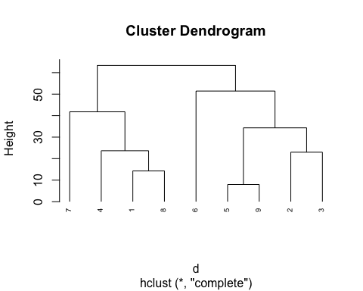

# Compute with agnes   
hc_agnes <- agnes(data_piv, method = "complete")  
  
# Agglomerative coeffiecient   
hc_agnes$ac

## [1] 0.626452

hc_agnes_2 <- agnes(data_piv, method = "ward")  
  
pltree(hc_agnes_2, cex = 0.6, hang = -1, main = "Dendrogram of agnes")

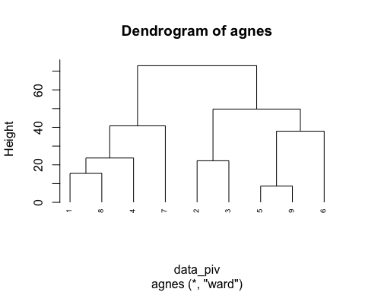 Divisive Hierarchicla Clustering

# compute divisive hierarchical clustering   
hc_diana<- diana(data_piv)  
  
# Divisive coefficient; amount of clustering structure found   
hc_diana$dc

## [1] 0.626452

#plot dendogram   
  
pltree(hc_diana, cex = 0.6, hang = -1, main = "Dendogram of diana")

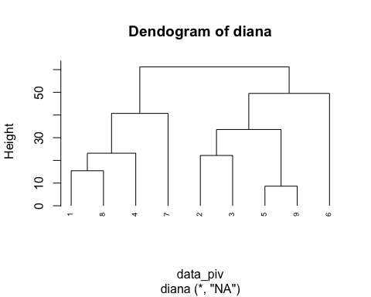

Working with Dendrograms

# Ward's method   
  
hc_ward_method <- hclust(d, method = "ward.D2")  
  
# Cut tree into 4 groups   
  
sub_grp <- cutree(hc_ward_method, k = 4)  
  
#Number of countries in each cluster  
table(sub_grp)

## sub_grp  
## 1 2 3 4   
## 3 2 3 1

plot(hc_ward_method, cex =0.6)  
  
rect.hclust(hc_ward_method , k = 3, border = 2:5)

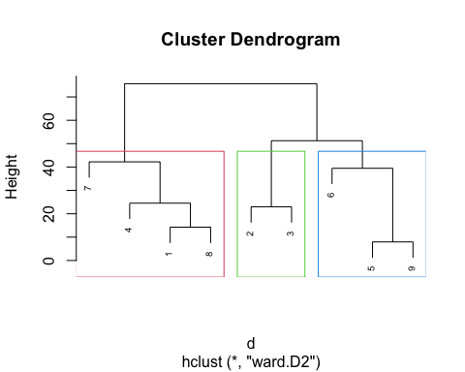

res_hc <- data_piv %>%  
 dist(method = "euclidean") %>%  
 hclust(method = "ward.D2")

## Warning in dist(., method = "euclidean"): NAs introduced by coercion

fviz_dend(res_hc, k = 4,   
 cex = 0.5,   
 k_colors = c("#2E9FDF", "#00AFBB", "#E7B800", "#FC4E07"),   
 color_labels_by_k = TRUE,   
 rect = TRUE)

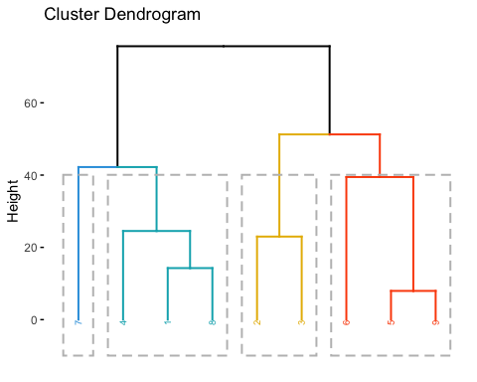

#data_piv$chills <- as.numeric(data_piv$chills )  
# data_piv$cough <- as.integer(data_piv$cough )  
# data_piv$diarrhoea <- as.integer(data_piv$diarrhoea)  
# data_piv$fatigue <- as.integer(data_piv$fatigue)  
# data_piv$headache <- as.integer(data_piv$headache)  
# data_piv$loss_smell_taste <- as.integer(data_piv$loss_smell_taste)  
# data_piv$muscle_ache <- as.integer(data_piv$muscle_ache)  
# data_piv$nasal_congestion <- as.integer(data_piv$nasal_congestion)  
# data_piv$nausea_vomiting <- as.integer(data_piv$nausea_vomiting)  
# data_piv$shortness_breath <- as.integer(data_piv$shortness_breath)  
# data_piv$sore_throat <- as.integer(data_piv$sore_throat)  
# data_piv$sputum <- as.integer(data_piv$sputum)  
# data_piv$temperature <- as.integer(data_piv$temperature)  
  
level_key_comorbidities <-  
 c("kidney disease" = "kidney_disease",  
 "lung condition" = "lung_condition",  
 "diabetes type one" = "diabetes_type_one",  
 "diabetes type two" = "diabetes_type_two",  
 "liver disease" = "liver_disease",  
 "heart disease" = "heart_disease")  
  
  
data_pi<- data_piv %>%  
 tidyr::replace_na(list(nausea_vomiting = 0)) %>%  
 dplyr::mutate(Comorbidities = forcats::fct_recode(Comorbidities, !!!level_key_comorbidities)) %>%  
 dplyr::rename('loss of smell and taste' = loss_smell_taste, 'muscle ache' = muscle_ache, 'nasal congestion'= nasal_congestion,  
 'nausea and vomiting' = nausea_vomiting, 'shortness of breath' = shortness_breath, 'sore throat' = sore_throat)

## Warning: Unknown levels in `f`: kidney_disease, lung_condition,  
## diabetes_type_one, diabetes_type_two, liver_disease, heart_disease

## Warning: Unknown levels in `f`: kidney_disease, lung_condition,  
## diabetes_type_two, liver_disease, heart_disease

## Warning: Unknown levels in `f`: kidney_disease, lung_condition,  
## diabetes_type_one, liver_disease, heart_disease

## Warning: Unknown levels in `f`: kidney_disease, lung_condition,  
## diabetes_type_one, diabetes_type_two, liver_disease

## Warning: Unknown levels in `f`: kidney_disease, lung_condition,  
## diabetes_type_one, diabetes_type_two, liver_disease, heart_disease

## Warning: Unknown levels in `f`: lung_condition, diabetes_type_one,  
## diabetes_type_two, liver_disease, heart_disease

## Warning: Unknown levels in `f`: kidney_disease, lung_condition,  
## diabetes_type_one, diabetes_type_two, heart_disease

## Warning: Unknown levels in `f`: kidney_disease, diabetes_type_one,  
## diabetes_type_two, liver_disease, heart_disease

## Warning: Unknown levels in `f`: kidney_disease, lung_condition,  
## diabetes_type_one, diabetes_type_two, liver_disease, heart_disease

data_pi <- as.data.frame(data_pi)  
data_pi$Comorbidities <- as.character(data_pi$Comorbidities)  
rownames(data_pi) <- data_pi$Comorbidities  
#data_scaled <- as.data.frame(scale(data_piv[2:14]))

km_res <- kmeans(data_pi[,2:14], centers = 3, nstart = 25)  
  
print(km_res)

## K-means clustering with 3 clusters of sizes 3, 4, 2  
##   
## Cluster means:  
## chills cough diarrhoea fatigue headache loss of smell and taste  
## 1 15.31119 57.93767 19.454553 49.45755 36.29471 18.81212  
## 2 31.02899 57.99607 22.495263 60.68110 43.61200 26.20437  
## 3 13.91683 59.47351 9.691482 50.21797 27.31388 14.88934  
## muscle ache nasal congestion nausea and vomiting shortness of breath  
## 1 42.30317 32.00114 4.633963 40.54518  
## 2 53.46396 35.38179 10.843595 51.05471  
## 3 42.82361 23.60832 7.444668 25.90543  
## sore throat sputum temperature  
## 1 51.88268 38.40512 21.93232  
## 2 51.52098 46.03112 26.12976  
## 3 34.62441 36.73709 35.89873  
##   
## Clustering vector:  
## asthma diabetes type one diabetes type two heart disease   
## 2 3 3 2   
## hypertension kidney disease liver disease lung condition   
## 1 1 2 2   
## obesity   
## 1   
##   
## Within cluster sum of squares by cluster:  
## [1] 729.2733 1201.6567 245.3031  
## (between_SS / total_SS = 63.9 %)  
##   
## Available components:  
##   
## [1] "cluster" "centers" "totss" "withinss" "tot.withinss"  
## [6] "betweenss" "size" "iter" "ifault"

fviz_cluster(km_res, data = data_pi[2:14])

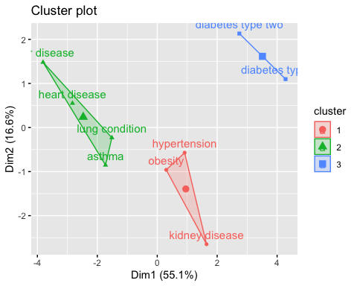

# Cut agnes() tree into 3 groups  
hc_a <- agnes(data_pi, method = "ward")  
cutree(as.hclust(hc_a), k = 3)

## asthma diabetes type one diabetes type two heart disease   
## 1 2 2 1   
## hypertension kidney disease liver disease lung condition   
## 3 3 1 1   
## obesity   
## 3

# Cut diana() tree into 3 groups  
hc_d <- diana(data_pi)  
cutree(as.hclust(hc_d), k = 3)

## asthma diabetes type one diabetes type two heart disease   
## 1 2 2 1   
## hypertension kidney disease liver disease lung condition   
## 2 3 1 1   
## obesity   
## 2

Comparing two deprograms. Comparing hierarchical clustering with complete linkage versus Ward’s method.

The output displays “unique” nodes, with a combination of labels/items not present in the other tree highlighted with dashed line. The quality of the alignment of the two trees can be measured using the function entanglement. Entanglement is a measure between 1 (full entanglement) 0 (no entanglement). A lower entanglement coefficient corresponds to a good alignment.

# Compute distance matrix  
res_dist <- dist(data_pi, method = "euclidean")

## Warning in dist(data_pi, method = "euclidean"): NAs introduced by coercion

# Compute 2 hierarchical clusterings  
hc_complete <- hclust(res_dist, method = "complete")  
hc_ward <- hclust(res_dist, method = "ward.D2")  
  
# Create two dendrograms  
dend_complete <- as.dendrogram (hc_complete)  
dend_ward <- as.dendrogram (hc_ward)  
  
tanglegram(dend_complete, dend_ward,   
 margin_inner = 10)

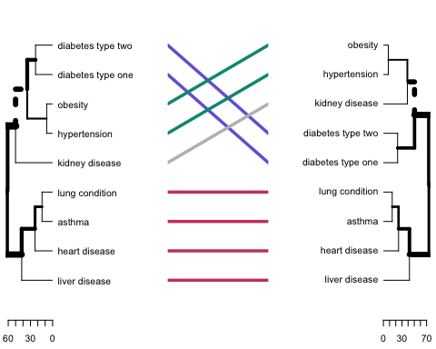

dend_list <- dendlist(dend_complete, dend_ward)  
  
tanglegram(dend_complete, dend_ward,   
 margin_inner = 10,  
 highlight_distinct_edges = FALSE, #Turn-off dashed line  
 common_subtrees_color_lines = FALSE, # Turn-off line colors  
 common_subtrees_color_branches = TRUE, # Color common branches  
 main = paste("entanglement =", round(entanglement(dend_list),2)))

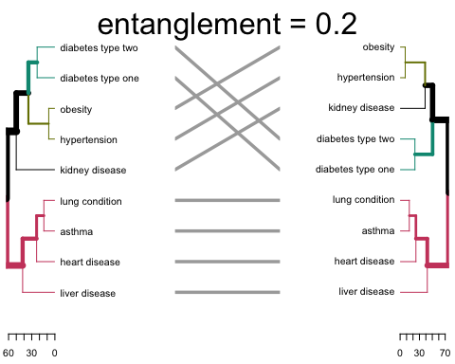

Partitioning clustering

I. K-means clustering: 1. each cluster represented by the center (mean of the data points) 2. sensitive to outliers

1. K-medoids clustering /PAM (Partitioning around Medoids)
2. each cluster represented by one of the objects in the cluster
3. less sensitive to outliers
4. CLARA algorithm (Clustering Large Applications) = PAM for large datasets ??

Optimal number of clusters

1. Elbow method: location of bend in WSS(within-cluster sum of square for eac K) plot - minimize intra-cluster variation
2. Average silhouette method: maximum of average silhouette curve (average silhouette of observations for each K)
3. Gap statistic method: compares the total within intra-cluster variation for different values of K with their expected values under null reference distribution of the data

fviz_nbclust(data_pi[2:14], kmeans, method = "wss",k.max = 8 )

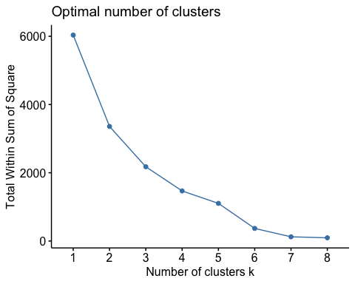

Average Silhouette Method - this method does suggest the same number of clusters just as elbow has indicated.

fviz_nbclust(data_pi[2:4], kmeans, method = "silhouette", k.max = 8)

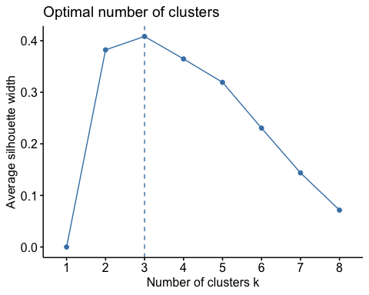

Gap Statistic Method - the same

gap_stat <- clusGap(data_pi[2:14], kmeans, nstart = 25, K.max = 8, B = 50)  
  
fviz_gap_stat(gap_stat)

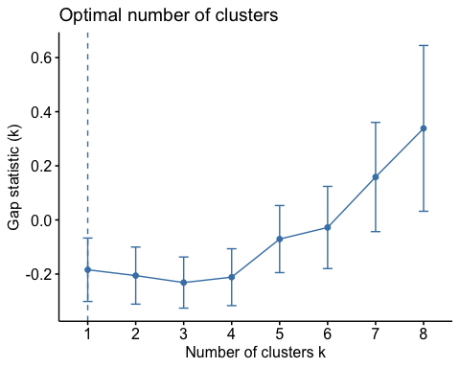

# data_piv %>%  
# mutate(Cluster = km_res$cluster) %>%  
# group_by(Cluster) %>%  
# summarise_all("mean")

library(pheatmap)  
pheatmap(t(data_pi[-1]), cutree_cols = 3)

