|  |  |
| --- | --- |
|  | Assignment 2 |
|  |  |
|  | GABRIEL CHARLES 20201126  INFO-0211  7/6/22 |

Contents

Wireframe for home page 3

Online Simulations Using developer Tool on Browser. 4

Gabriel Charles

Ms. Sherry Ann Mohammed

INFO-0211

June 8, 2022.

Assignment 2: Web Design for General Auto Ltd.

There were many challenges in the actual coding aspect of the entire project which showed there is plenty to learn. Although it was challenging, it was still a fun thing to do. These challenges were getting images to appear on the design and the positioning of texts, which hopefully will be cleared up by the end of this course. Others were easily corrected with the adjustments of values within the statements. The intended purpose was to create a website that will make potential customers become aware of the products and services the company provides. Users could expect to:

1. Zoom in or out.
2. Scroll up or down.
3. The web page rotates when changing the angle of mobile devices.
4. SBT Japan could be access using one of the links provided called Japan services.

In the end, this was a gross success.

# Wireframe for home page

General Auto Trinidad Limited

We specialize in the buying and selling of used vehicles. All types, all brands.

We offer 100% financing. Any licensed driver could own a vehicle.

Come one! Come all!

Vehicle Images

Navigation Menu

Common Vehicle Types for Sale Tables.

Footer

Fig 1. This is an illustration of the intended design of the main web page.

# Online Simulations Using developer Tool on Browser.

All the images on the pages below were screenshot simulations online using the developer tool in the Microsoft Edge browser.

Fig 2. The above image is a screenshot that shows how the website appears on an iPad Air screen.

Fig 3. The above image is a screenshot that shows how the website appears on an iPhone 12 Pro screen.

Fig 4. The above image is a screenshot that shows how the website appears on a Nest Hub screen.

Fig 5. The above image is a screenshot that shows how the website appears on a Pixel 5 screen.

Fig 6. The above image is a screenshot that shows how the website appears on a Samsung Galaxy S20 Ultra screen.

Fig 7. The above image is a screenshot that shows how the website appears on a laptop screen.

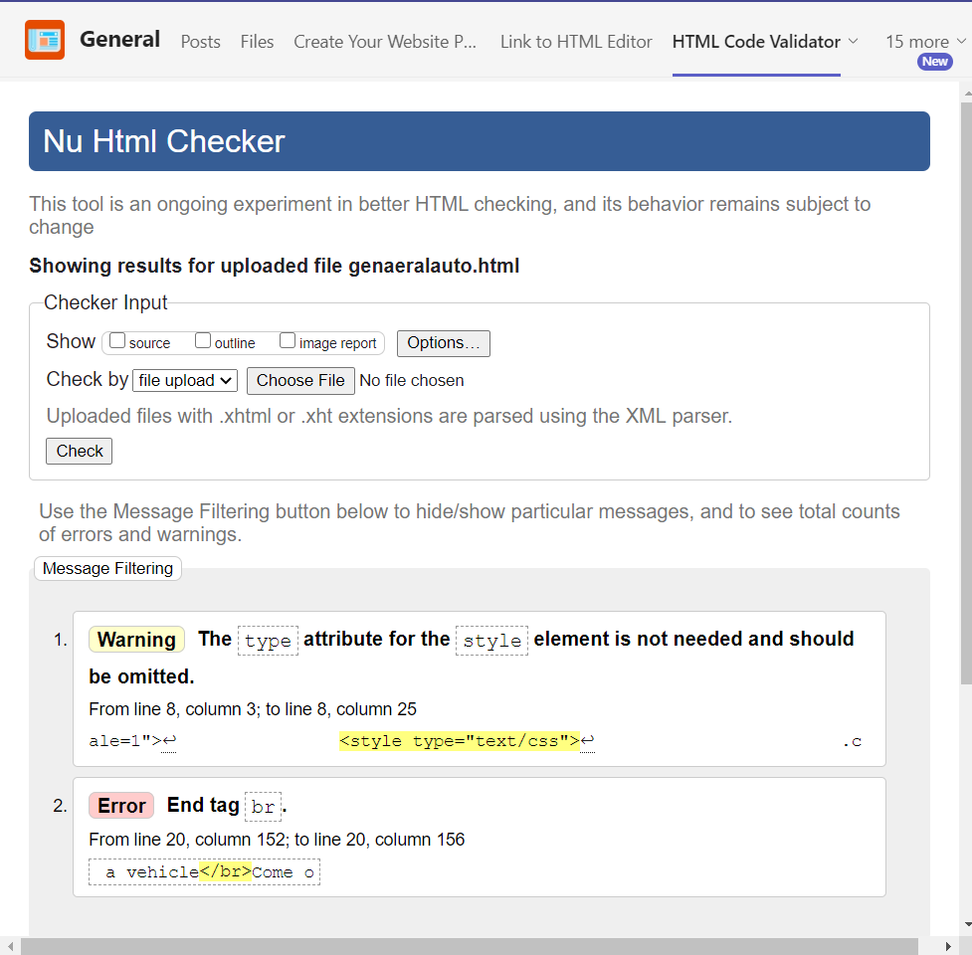

Fig 8. above is evidence of html code validation.

It shows two minor errors which could be a problem with the validator and not the code.

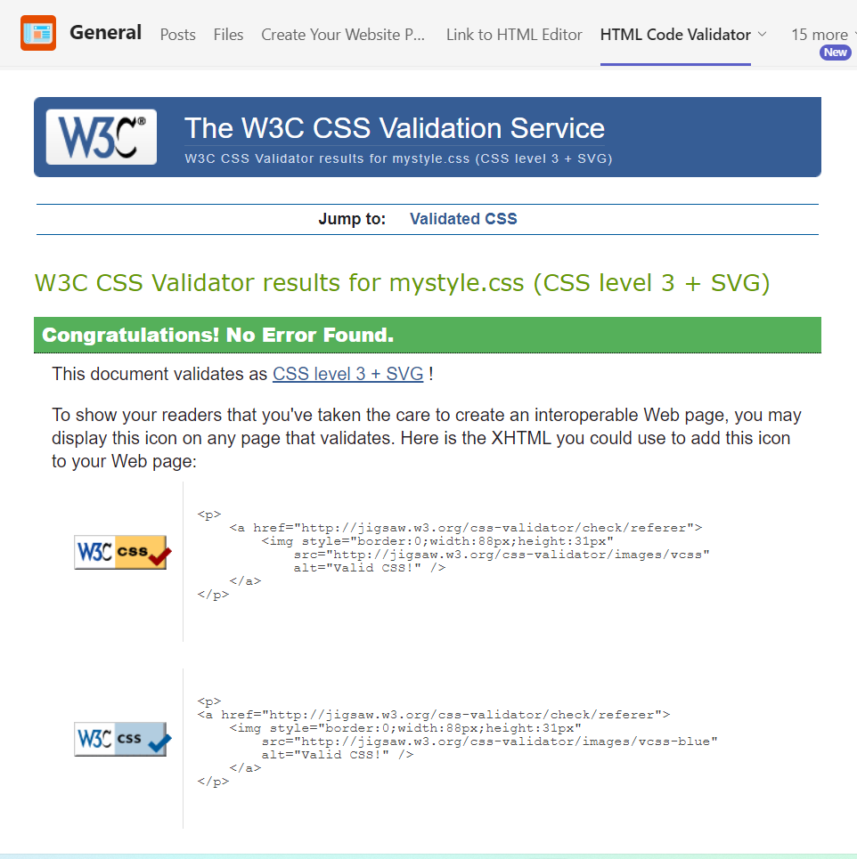

Fig 9. Is a presentation of successful CSS code validation.

Despite the difficulties faced in the coding side of this project, the intended design was accomplished. Users could expect a basic website with easy-to-use feature, with the purpose of inform users of the products and services the company offers. Even a person with limited understanding of the internet can use this website.