Smart Recipe Finder
Project Proposal
WDD 330 — BYU

1. Overview
Smart Recipe Finder is a web application that helps users discover recipes based on the ingredients they already have on hand. Users enter a list of available ingredients and receive curated recipe suggestions powered by the Spoonacular API. The app also integrates the Edamam API to display nutritional information such as calories, macronutrients, and dietary breakdowns.

The Problem
Many people struggle with meal planning, food waste, and knowing what to cook with limited ingredients. Grocery trips become repetitive, and unused ingredients go bad. There is no simple tool that combines ingredient-based recipe discovery with real nutritional data in one place.

Motivation
This app empowers users to make the most of what's in their kitchen, save money, reduce food waste, and make informed dietary choices — all from one simple interface. By bridging recipe search and nutrition tracking, Smart Recipe Finder addresses a gap in everyday meal planning tools.

Target Audience
The application serves home cooks looking for quick meal inspiration, budget-conscious individuals who want to minimize grocery spending, health-conscious users who track nutritional intake, students and young professionals learning to cook with limited pantry items, and busy families seeking fast meal planning solutions.

2. Target Audience
Smart Recipe Finder is designed for anyone who wants to simplify meal preparation and make smarter food choices. The primary audience includes:
- Home Cooks: Individuals who cook regularly and want inspiration from ingredients they already have, reducing the need for extra grocery trips.
- Budget-Conscious Shoppers: Users looking to minimize food waste and stretch their grocery budget by using what is already in their pantry.
- Health-Conscious Users: People who monitor calorie intake and macronutrient ratios and need nutritional data alongside recipe suggestions.
- Students & Young Professionals: New cooks with limited ingredients and cooking experience who need guidance on simple, achievable meals.
- Busy Families: Households that need quick, practical meal ideas without spending excessive time planning.
The app serves these users by providing an intuitive search interface, clear nutritional breakdowns, and the ability to save and revisit favorite recipes.

3. Major Functions
The following ten major functions define the core capabilities of Smart Recipe Finder:
# | Function | Description
1 | Ingredient-Based Recipe Search | Users type or select ingredients they have on hand. The app sends the ingredient list to the Spoonacular API and returns matching recipes ranked by how many of the user's ingredients each recipe uses. Supports multiple ingredient entry via a text input with autocomplete suggestions.
2 | Recipe Detail View | When a user selects a recipe from results, a detailed view opens showing the full ingredient list, step-by-step cooking instructions, preparation and cook times, serving size, and a recipe summary. The view also displays a high-quality recipe image.
3 | Nutritional Information Display | For each recipe, the Edamam API provides a nutritional breakdown including total calories, grams of protein, carbohydrates, and fat, plus additional data such as fiber, sugar, and sodium content. This information is displayed alongside the recipe details.
4 | User Authentication (Sign Up / Login) | Users can create an account with a username, email, and password, then log in to access personalized features. Authentication is managed via localStorage to simulate a backend experience for this project scope.
5 | User Profile & Dietary Settings | Authenticated users can set dietary preferences (e.g., vegan, vegetarian, gluten-free, keto) and specify allergen restrictions. These preferences are used to pre-filter search results automatically.
6 | Search Results Filtering & Sorting | After an initial search, users can refine results by cuisine type, meal type (breakfast, lunch, dinner), and diet. Results can be sorted by relevance, cook time, number of missing ingredients, or calorie count.
7 | Favorite / Save Recipes | Logged-in users can bookmark recipes to a personal favorites collection. Saved recipes persist in localStorage and can be accessed from the user profile at any time.
8 | Responsive Design (Mobile & Desktop) | The application adapts its layout for mobile phones and desktop browsers. Separate wireframes have been designed for each breakpoint to ensure a polished experience on all devices.
9 | Popular & Trending Recipes | The home screen displays a curated list of popular or trending recipes for users who want browsing inspiration without entering specific ingredients. This section pulls from Spoonacular's random or popular recipe endpoints.
10 | Error Handling & Input Validation | The app handles empty searches, API failures, network errors, and invalid user inputs with clear, user-friendly messages. Loading indicators display during API calls, and fallback content appears when data is unavailable.

4. Wireframes
Complete wireframes have been designed for both desktop and mobile breakpoints, covering all major screens of the application.

Desktop Wireframes
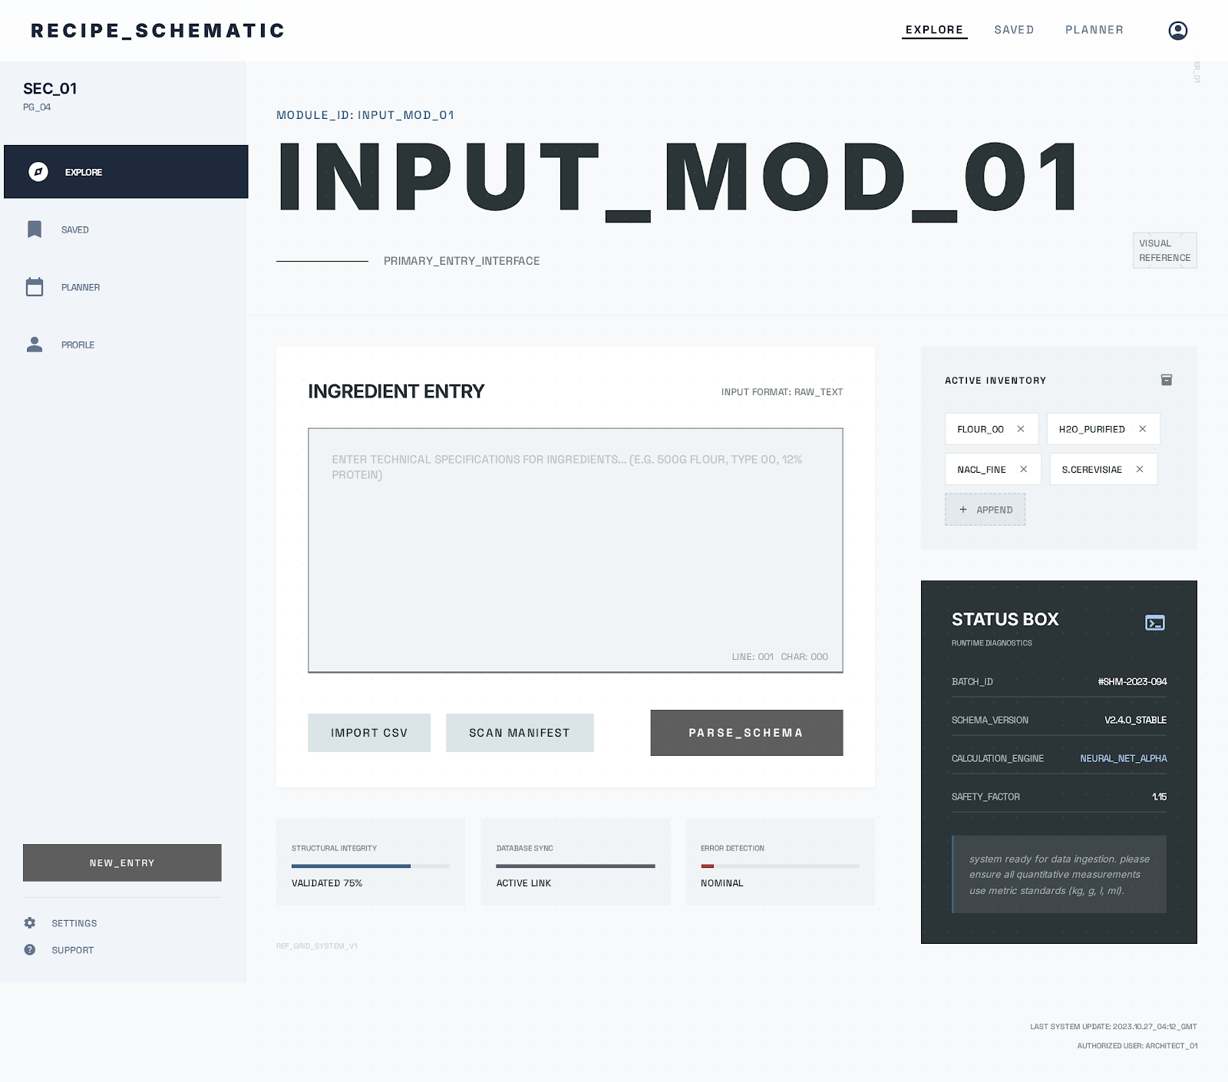
Home / Input Screen — Main landing page with ingredient input field and popular recipes
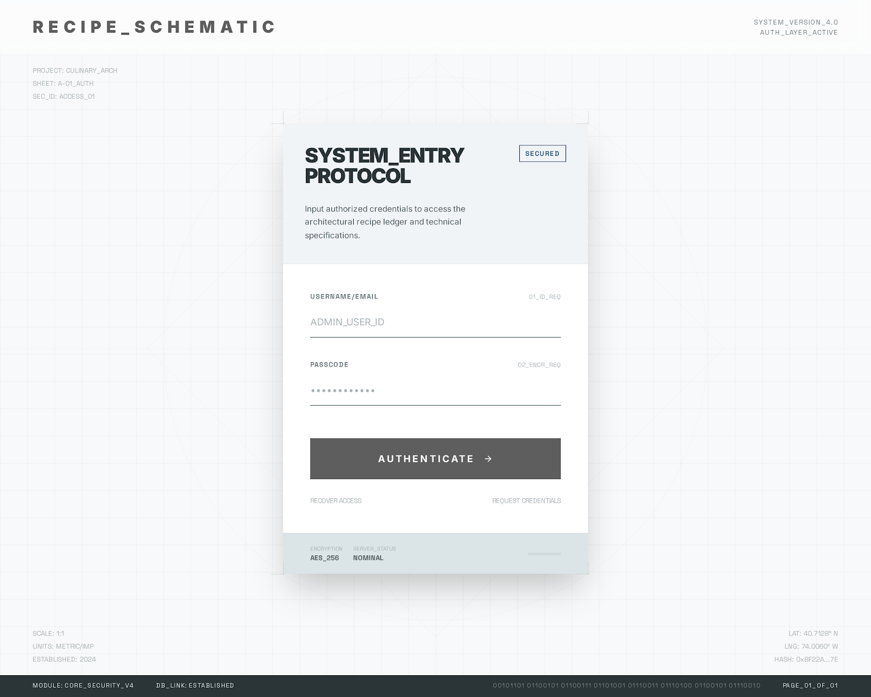
Login Screen — User authentication form
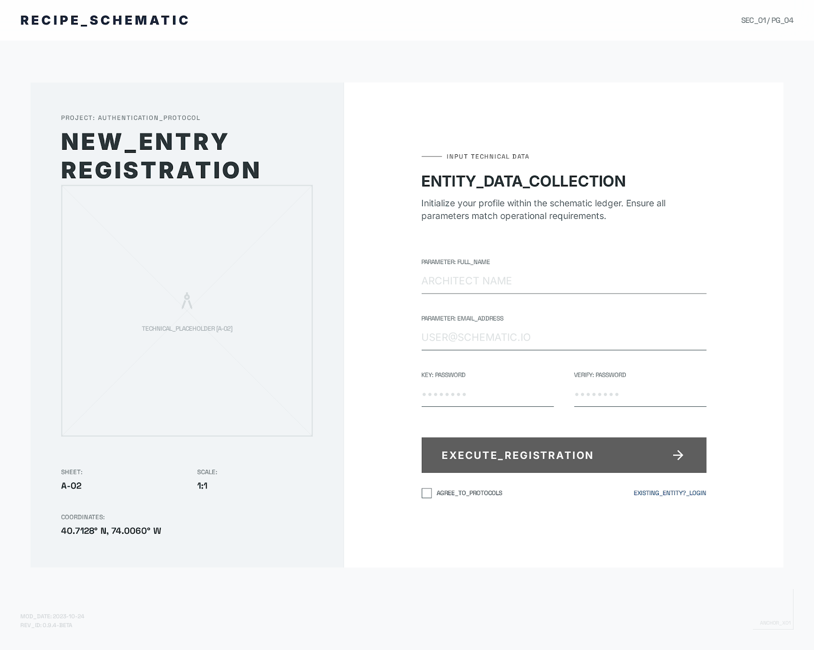
Sign Up Screen — New user registration form
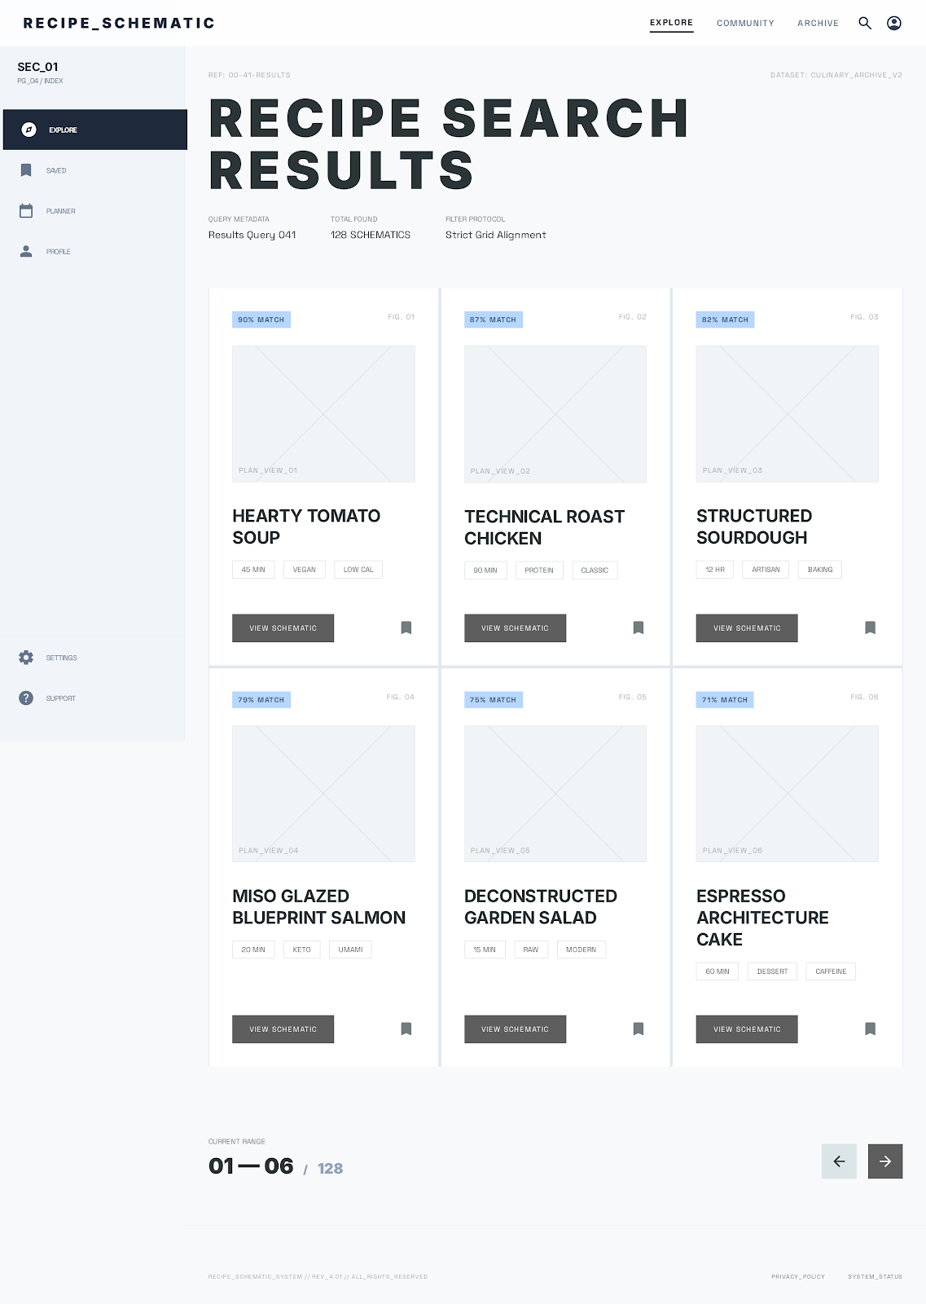
Search Results — Recipe list with filter/sort controls
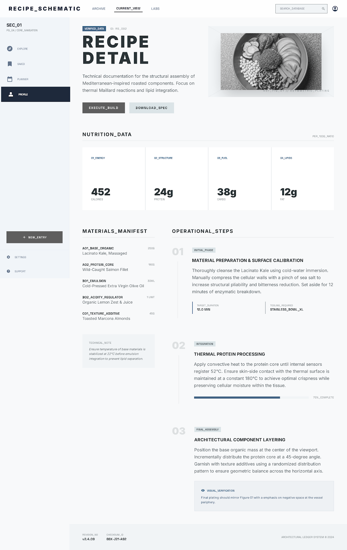
Recipe Detail — Full recipe view with instructions and nutrition data
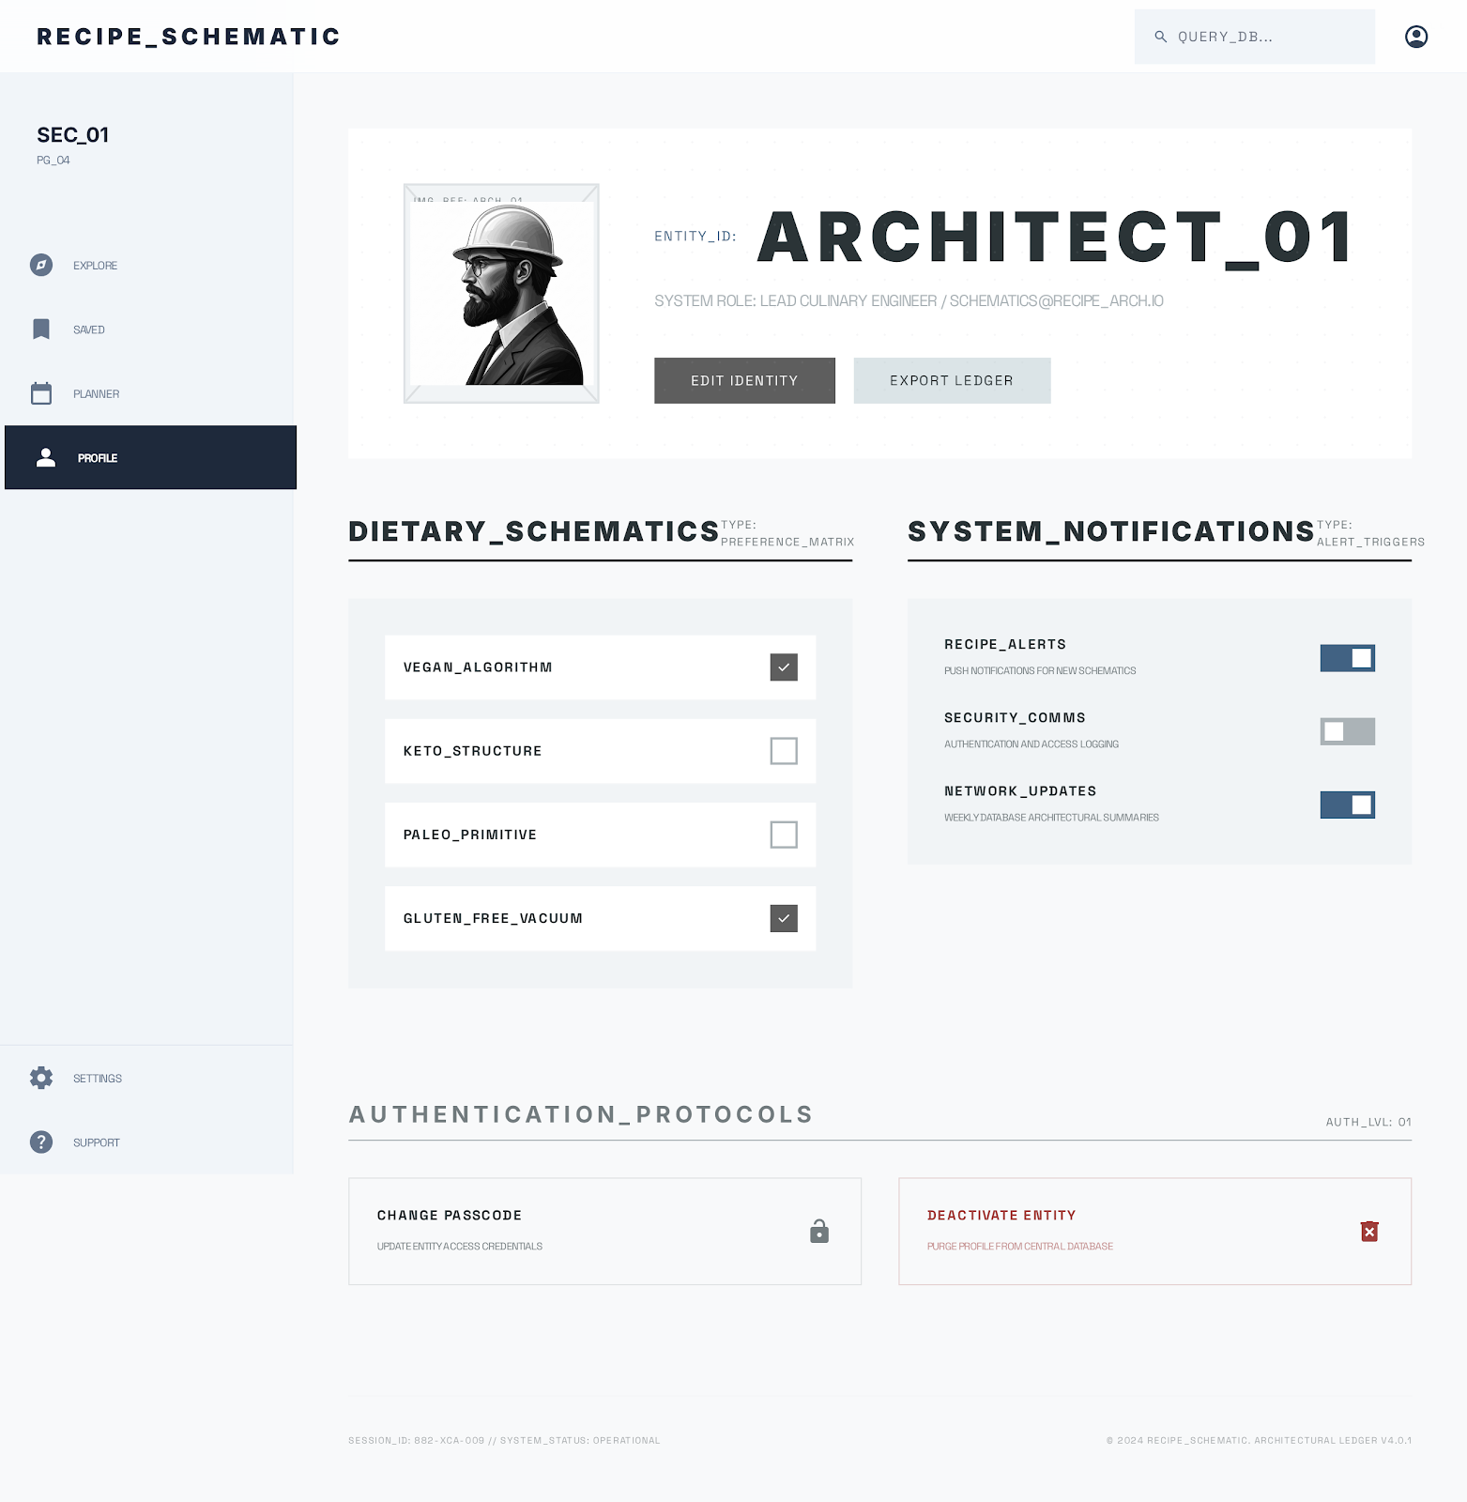
Profile / Settings — User preferences and saved recipes

Mobile Wireframes
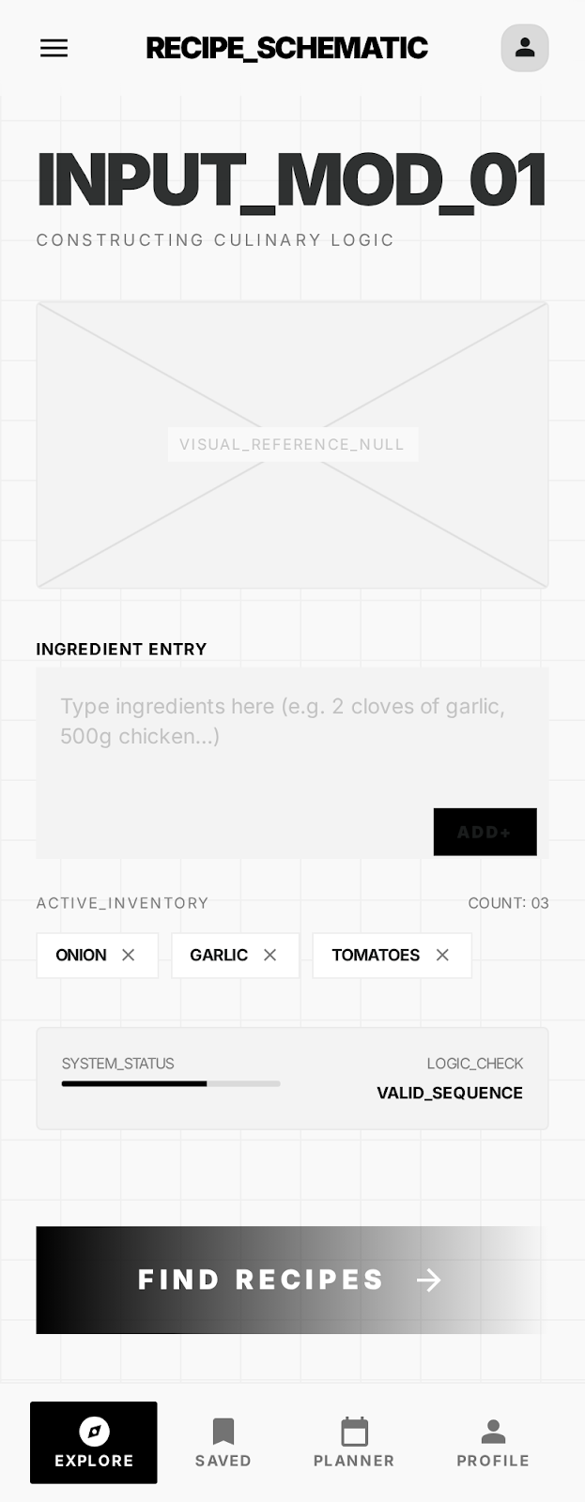
Home / Input Screen — Mobile landing with ingredient entry
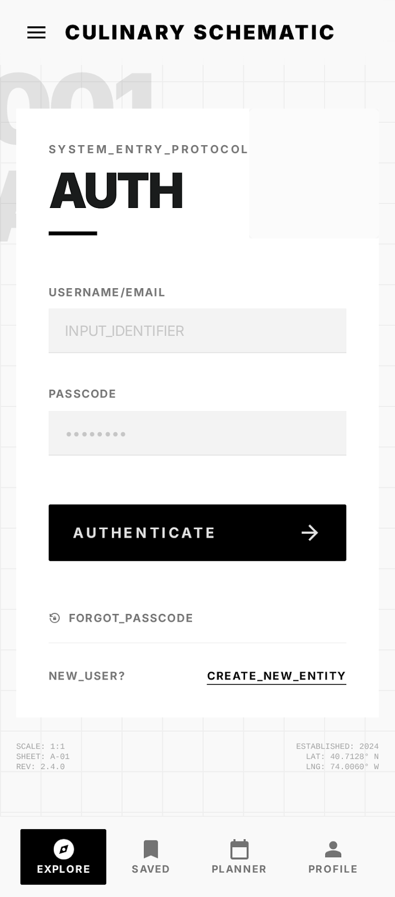
Login Screen — Mobile authentication
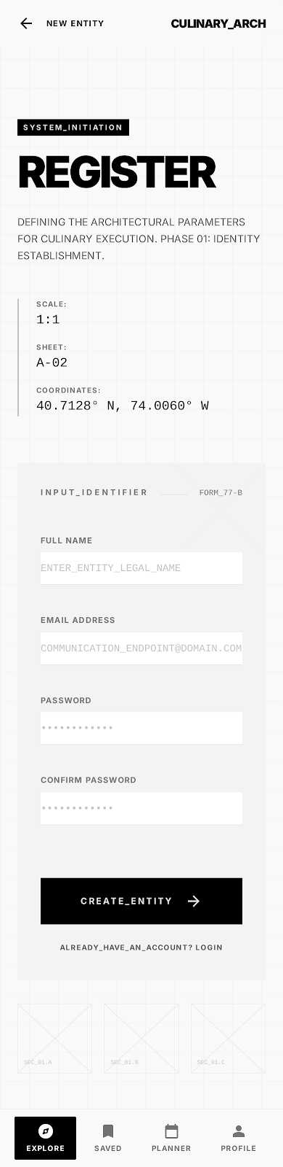
Sign Up Screen — Mobile registration
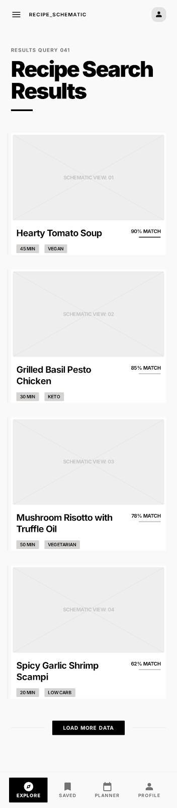
Recipe Results List — Mobile recipe browsing
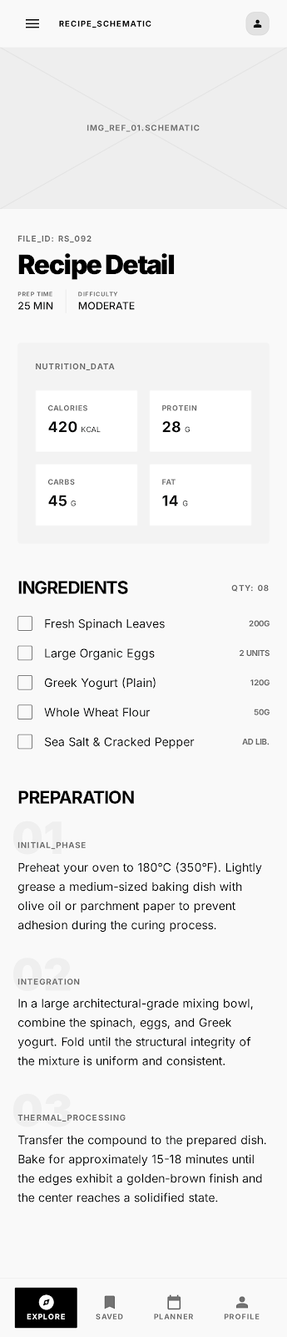
Recipe Detail View — Mobile recipe details with nutrition
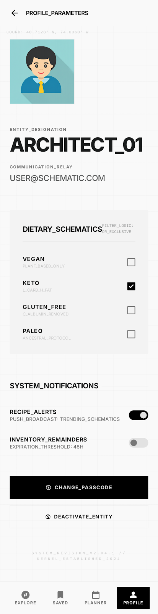
Profile / Settings — Mobile user preferences

5. External Data Sources

Spoonacular API
The Spoonacular API is the primary data source for recipe search and recipe details. Each recipe object returns a rich data set well exceeding ten attributes per element, including:
- id — unique recipe identifier
- title — recipe name
- image — URL to recipe photo
- imageType — format of the image (jpg, png)
- usedIngredientCount — number of user ingredients matched
- missedIngredientCount — number of ingredients the user is missing
- missedIngredients — array of missing ingredient objects with name, amount, unit, image
- usedIngredients — array of matched ingredient objects
- unusedIngredients — array of user ingredients not used in the recipe
- likes — popularity score
- summary — HTML description of the recipe
- instructions — step-by-step cooking directions
- readyInMinutes — total time to prepare
- servings — number of servings
- cuisine — cuisine type (e.g., Italian, Mexican)
- diets — array of compatible diets (e.g., vegan, gluten-free)

Edamam API
The Edamam API provides nutritional analysis for each recipe. The nutrition response includes the following data attributes per recipe:
- calories — total calorie count
- totalNutrients — object containing detailed nutrient values
- FAT — total fat in grams
- CHOCDF — total carbohydrates in grams
- PROCNT — total protein in grams
- FIBTG — dietary fiber in grams
- SUGAR — total sugars in grams
- NA — sodium in milligrams
- dietLabels — array of diet labels (e.g., LOW_CARB, HIGH_PROTEIN)
- healthLabels — array of health labels (e.g., VEGAN, GLUTEN_FREE)

Data Stored Locally
The following data is stored in localStorage to support user features without a backend:
- User account data: username, email, hashed password
- User dietary preferences and allergen restrictions
- Saved/favorite recipe IDs and basic recipe metadata
- Recent search history for quick re-searches (optional)

6. Initial Module List
The following files and modules are planned for the application:
Module / File | Type | Description
index.html | HTML | Main entry point with root div and script references
app.js | JS | Root module: routing setup, global state, app initialization
home.js | JS | Home screen component with ingredient input and trending recipes
search.js | JS | Handles Spoonacular API queries and renders recipe result cards
recipeDetail.js | JS | Fetches and renders full recipe details and Edamam nutrition data
auth.js | JS | Login and sign-up form logic, validation, and localStorage auth
profile.js | JS | User settings, dietary preferences, and saved recipes management
favorites.js | JS | Displays and manages the user's bookmarked recipe collection
filter.js | JS | Reusable filter and sort controls for search results
navigation.js | JS | Header/nav bar component with responsive mobile hamburger menu
apiService.js | JS | Centralized fetch wrapper for Spoonacular and Edamam API calls
storageService.js | JS | Abstraction layer for localStorage read/write operations
errorHandler.js | JS | Global error boundary and user-facing error/empty state messages
main.css | CSS | Global styles, color scheme, typography, layout grid
responsive.css | CSS | Media queries and responsive breakpoint overrides
utils.js | JS | Shared utility functions (debounce, format time, etc.)

7. Graphic Identity

Color Scheme
Role | Color Name | Hex Code
Primary | Warm Orange | #E8722A
Secondary | Deep Green | #2E7D32
Background | Off-White | #FAFAFA
Surface / Cards | White | #FFFFFF
Text Primary | Dark Charcoal | #212121
Text Secondary | Medium Gray | #757575
Accent / CTA | Vibrant Red-Orange | #D84315
Success | Green | #43A047
Error | Red | #E53935

Typography
Element | Font Family | Weight | Size
Page Headings | Poppins | Bold (700) | 24–32px
Section Headings | Poppins | Semi-Bold (600) | 18–22px
Body Text | Open Sans | Regular (400) | 16px
Buttons / CTAs | Poppins | Semi-Bold (600) | 14–16px
Captions / Labels | Open Sans | Regular (400) | 12–14px

Application Icon
The app icon combines a fork and a magnifying glass to represent food discovery. The magnifying glass circle is rendered in warm orange (#E8722A), while the fork forming the handle is in deep green (#2E7D32). The design is simple, flat, and uses rounded edges for a friendly, modern feel. The icon works at small sizes (favicon) and large sizes (splash screen).

Element Styling
- Border Radius: 8px on cards, buttons, and input fields
- Card Shadows: box-shadow 0 2px 8px rgba(0,0,0,0.1) for subtle depth
- Spacing: 16px base grid system consistent across all components
- Buttons: Rounded, filled primary color with 8px padding, hover state darkens by 10%
- Input Fields: 1px border (#E0E0E0), focus state highlights with primary color outline
- Recipe Images: 16:9 aspect ratio with 8px border-radius and cover fit
- Navigation: Fixed top bar with white background and subtle bottom shadow

8. Schedule (Weeks 5–7)

Week 5 — Foundation & Setup
Day | Deliverable
Monday | Set up project repository, initialize with Vite and React, configure ESLint and Prettier
Tuesday | Build routing structure and shared layout shell (header, nav, footer, responsive menu)
Wednesday | Implement Home/Input screen with ingredient entry field (static UI)
Thursday | Integrate Spoonacular API — ingredient search returns recipe result list
Friday | Build Search Results view displaying recipe cards with images and basic info

Week 6 — Core Features & Authentication
Day | Deliverable
Monday | Build Recipe Detail page with full instructions, ingredient list, and recipe image
Tuesday | Integrate Edamam API to display nutritional data on the recipe detail view
Wednesday | Implement Login and Sign Up forms with localStorage-based authentication
Thursday | Build Profile Settings page with dietary preference and allergen controls
Friday | Implement Favorites feature (save/unsave recipes) and responsive layout polish

Week 7 — Polish, Testing & Deployment
Day | Deliverable
Monday | Add filtering (cuisine, diet, meal type) and sorting (time, calories, relevance) controls
Tuesday | Implement error handling, loading spinners, empty states, and input validation
Wednesday | Cross-browser testing (Chrome, Firefox, Safari) and mobile responsiveness audit
Thursday | Performance optimization, code cleanup, accessibility review
Friday | Deploy to Netlify, Render or Vercel, finalize documentation, and submit project

9. Trello Board
A Trello board has been created to track all project tasks. The board is organized into columns that correspond to each week of development, plus a backlog and completion tracking system.
Trello Board Link: https://trello.com/invite/b/69c57f8a13e0cf97d9fd9c39/ATTIf758454511161f787cec70c3f52d0bf16E67373C/final-project

Board Columns
- Backlog — All identified tasks not yet scheduled
- Week 5 — Tasks planned for foundation and setup
- Week 6 — Tasks planned for core features and authentication
- Week 7 — Tasks planned for polish, testing, and deployment
- In Progress — Currently active work items
- Done — Completed and verified tasks

Task Cards
The board contains detailed task cards covering all phases of development:
List | Task Card
Backlog | Set up project scaffolding with Vite + React
Backlog | Research Spoonacular API endpoints and rate limits
Backlog | Research Edamam API nutrition endpoint
Backlog | Design application icon and favicon
Backlog | Define color palette and typography in CSS variables
Week 5 | Create routing and layout components
Week 5 | Build responsive navigation with mobile hamburger menu
Week 5 | Build Home/Input screen UI with ingredient entry
Week 5 | Integrate Spoonacular ingredient search API
Week 5 | Build Search Results component with recipe cards
Week 6 | Build Recipe Detail page with full instructions
Week 6 | Integrate Edamam nutrition data on detail view
Week 6 | Implement Login form with validation
Week 6 | Implement Sign Up form with validation
Week 6 | Build Profile Settings page
Week 6 | Implement Save/Favorite recipes feature
Week 7 | Add filter controls (cuisine, diet, meal type)
Week 7 | Add sort controls (time, calories, relevance)
Week 7 | Add error handling and loading states
Week 7 | Mobile responsiveness testing and fixes
Week 7 | Cross-browser compatibility testing
Week 7 | Performance optimization and code cleanup
Week 7 | Deploy to Netlify/Vercel/Render

10. Challenges
The following challenges are anticipated during the development of Smart Recipe Finder:

API Rate Limits
Both Spoonacular and Edamam impose request limits on their free tiers. We will need to implement result caching and minimize redundant API calls to stay within limits. Strategies include caching search results in sessionStorage and debouncing user input.

Nutritional Data Mapping
Matching recipe ingredients from Spoonacular to Edamam's nutrition analysis format may require data normalization. Ingredient names may not align perfectly between the two APIs, so fallback handling and manual mapping for common mismatches will be needed.

Responsive Wireframe Fidelity
Translating the distinct desktop and mobile wireframes into a single responsive codebase requires careful CSS architecture. Ensuring that the layout adapts gracefully at intermediate screen sizes (tablets) adds complexity.

Authentication Without a Backend
Implementing user authentication using only localStorage is inherently insecure and limited. Passwords stored locally can be accessed by any script on the page. We acknowledge this limitation and will simulate the experience for project purposes.

Cross-Browser Compatibility
Ensuring consistent behavior across Chrome, Firefox, Safari, and mobile browsers requires thorough testing. CSS features like flexbox and grid may render differently in older browsers, requiring fallbacks or prefixes.

API Error Handling
Network failures, empty search results, rate limit responses, and malformed API data must all be handled gracefully. The UI must display helpful messages rather than crashing or showing a blank screen.

