Snake Game with Processing

[Snake](https://en.wikipedia.org/wiki/Snake) is the common name for a video game concept where the player maneuvers a line which grows in length, with the line itself being a primary obstacle. The game grew in popularity in the 00’s, because we all played it on our old Nokia phones. In today’s project, I am implementing that same game, but with the difference that the game is played on the computer and the snake is controlled from the phone.

To achieve this project, the following resources were used:

* Arduino Mega 2560 development board
* HC-05 Bluetooth Module
* Processing Software
* 4 male-female wires

The connection diagram is the next one:

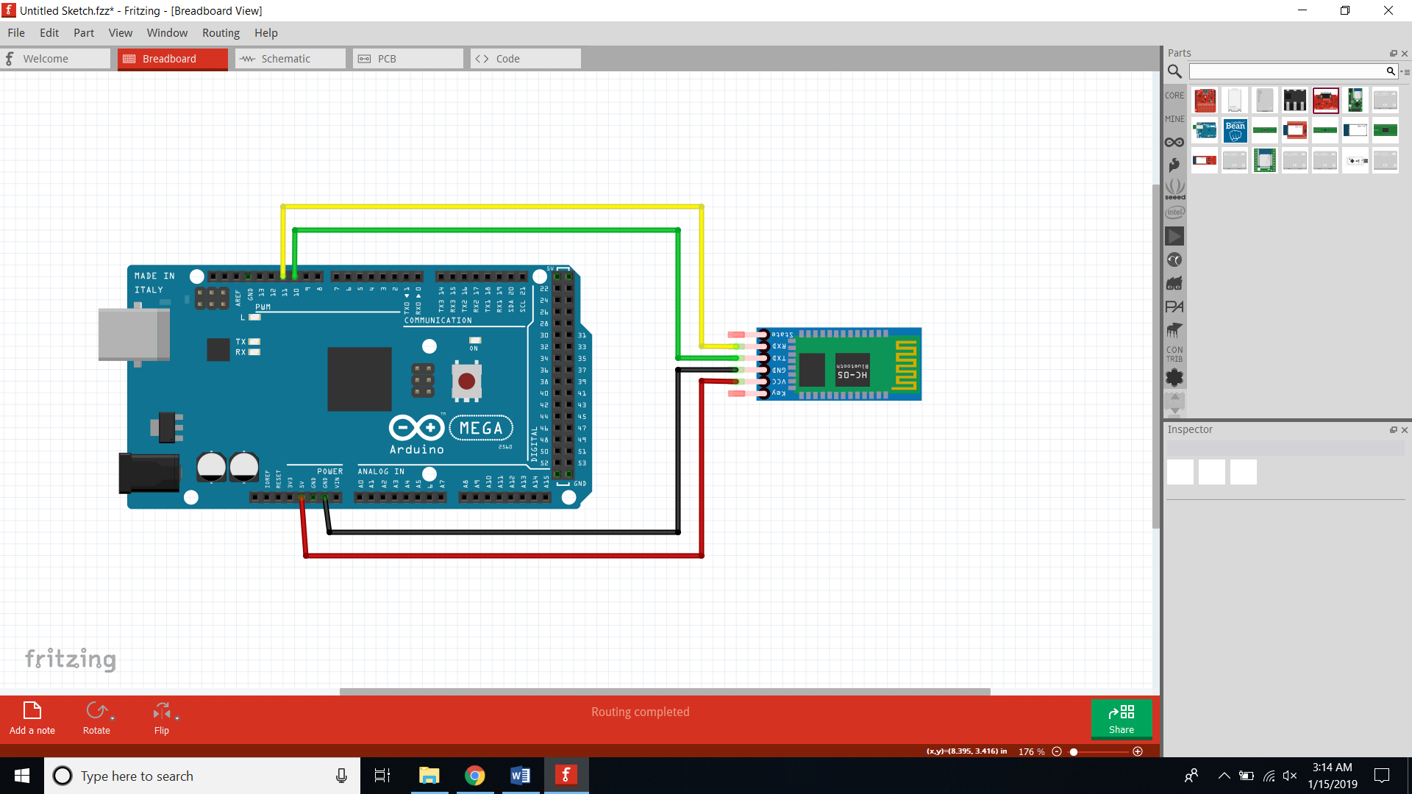

The board and the Bluetooth module are communicating using the Serial interface. In my example, I had to use Software Serial instead of the hardware capabilities of the Mega 2560 board, because otherwise I could not get them to communicate for some reason. Very important when making the connections is to connect the RX pin of HC-05 to the TX pin of the Software Serial port, and the TX pin of HC-05 to the RX pin of the Software Serial port, otherwise the communication will fail.

The communication between the game and the Processing framework is also done via Serial interface. The game reads the data sent by the Bluetooth module, and converts them to Strings, and depending on what Strings are read, the game decides what it should do.

The following diagram is a Flowchart diagram, that shows the states of the game and the decisions that happen. The user input is given in the “Read Moving Direction” state.

