STEP SCHOOL FEEDING PROJECT
LisheBora
End-to-end process guide: who does what, from set-up to payment
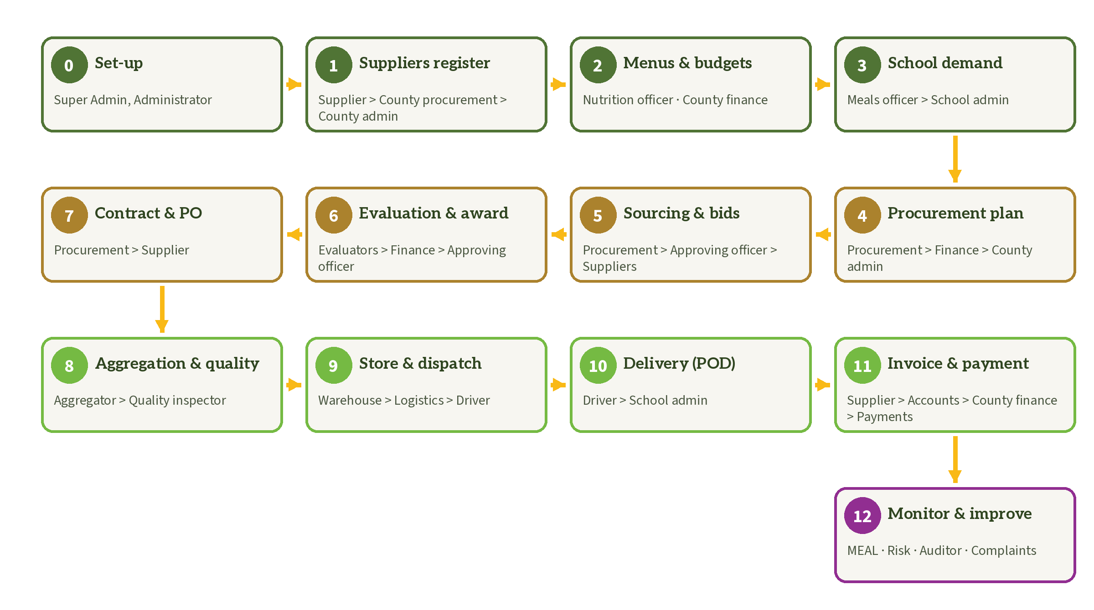
African Agricultural Technology Foundation (AATF)
Version 1.0 · September 2026 · For training and pilot preparation

Contents

Right-click the table above and choose Update Field to refresh the page numbers.

About this guide
This guide follows one school term through LisheBora, from setting up the platform to paying the supplier and reporting results. For each stage it shows who starts, who checks or approves, who receives the work next, and what the screens look like.
Screenshots were taken from the pilot demonstration environment. Names of schools, counties and food categories come from the programme sampling files; suppliers, orders, prices and users are illustrative demonstration data only.

How to read each stage
- Who does it: the roles involved, in the order they act (A → B means A hands over to B).
- Before you start: what must already exist.
- Steps: what each person does, and where in the menu.
- Hands over to: who receives the result.
- Controls and tips: approval rules and safeguards built into the platform.

Where to sign in
Page | Who uses it
/admin/sign-in | Super Administrators and Administrators only. Two-step code every time.
/sign-in | Everyone else: schools, county staff, suppliers, field staff. Password or a one-time SMS code; approval, procurement and finance roles also get a two-step code.
/register | New suppliers (self-registration).

The journey at a glance
The 13 stages of a term, with the roles that hand work to each other.
Stage | What happens | Who (in order)
0 | Set up the platform | Super Administrator, Administrator
1 | Suppliers register and are prequalified | Supplier > County Procurement Officer > County Administrator
2 | Menus, terms and budgets | Nutrition Officer (two people) · County Finance Officer
3 | School demand plan | School Meals Officer > School Administrator
4 | Procurement plan | County Procurement Officer > County Finance Officer > County Administrator
5 | Sourcing event and sealed bids | County Procurement Officer > Approving Officer > Suppliers
6 | Evaluation and award | Evaluators > County Procurement Officer > County Finance Officer > Approving Officer
7 | Contract and purchase orders | County Procurement Officer > Supplier
8 | Aggregation and quality | Aggregator > Quality Inspector
9 | Store and dispatch | Warehouse Officer > supervisor > Logistics Officer > Driver
10 | Delivery and proof of delivery | Driver > School Administrator
11 | Invoice and payment | Supplier > Finance Officer (accounts) > County Finance Officer > Finance Officer (payments)
12 | Monitor, learn and improve | MEAL, Risk & Compliance, Auditor, everyone for complaints

Roles at a glance
Each person is given one or more roles by the Administrator. A role decides what the person can see and do, and where (a school, a county or the whole programme).
Role | Typically | Main tasks | Signs in at
Super Administrator | Programme ICT lead | Creates administrators; everything an Administrator can do | /admin/sign-in
Administrator | Programme ICT or communications staff | Website content, master data, users (except administrators), onboarding | /admin/sign-in
School Meals Officer | Teacher or cook in charge of feeding | Prepares the term demand plan; records stock and meals | /sign-in
School Administrator | Head teacher or deputy | Validates and approves demand; confirms deliveries; raises complaints | /sign-in
Nutrition Officer | County nutritionist | Creates and validates menus | /sign-in
County Procurement Officer | County supply chain officer | Supplier review, procurement plans, sourcing events, contracts | /sign-in
County Finance Officer | County accountant | Budget lines, budget checks, payment approval | /sign-in
County Administrator | County director or coordinator | Approves plans and suppliers; oversees exceptions | /sign-in
Approving Officer | Accounting officer or delegate | Approves sourcing events and awards (by threshold) | /sign-in
Evaluation Committee Member | Appointed evaluators | Declares conflicts of interest; scores bids | /sign-in
Supplier / Farmer group | Farmers, cooperatives, traders | Registers, bids, acknowledges orders, invoices | /sign-in
Aggregator | Hub or collection-centre operator | Records produce intake; prepares batches | /sign-in
Quality Inspector | County or programme inspector | Inspects batches | /sign-in
Warehouse Officer | Store keeper | Stock, counts and adjustments | /sign-in
Logistics Officer | Transport coordinator | Dispatch planning, drivers and routes | /sign-in
Driver | Transporter | Trip milestones | /sign-in
Finance Officer | Accounts or payments staff | Verifies invoices; records payments | /sign-in
Programme MEAL Officer | Programme M&E staff | Dashboards, map, reports | /sign-in
Risk & Compliance Officer | Programme compliance | Risk flags and exception cases | /sign-in
Auditor | Internal or external auditor | Read-only access and the audit trail | /sign-in
Content Editor | Communications staff | Drafts website content for review | /sign-in

Stage 0: Set up the platform
Item | Details
Who does it | Super Administrator, then Administrators (sign in at /admin/sign-in).
Before you start | The platform is installed and the Super Administrator account exists (see the deployment runbook).
Hands over to | County teams and schools (they can now sign in); suppliers (they can now register on the website).

Steps
- Super Administrator: sign in at /admin/sign-in with the two-step code, change the password, then invite the Administrators under Users & roles → Invite (role: Administrator).
- Administrator: check Master data → Counties & schools. The three pilot counties and 32 sampled schools are already loaded; add NEMIS codes, GPS and further schools here or with the CSV import.
- Administrator: check Master data → Commodities & food categories. Add reference prices once the county has agreed them.
- Administrator: import staff accounts (System & onboarding → Import staff accounts): school admins, meals officers, county procurement, finance, nutrition, approvers, inspectors, warehouse and logistics officers. Each person gets a temporary password by SMS or email.
- Administrator: prepare the public website (Website content): homepage text and styles, pages, FAQs, news, images and videos. Publish when ready.
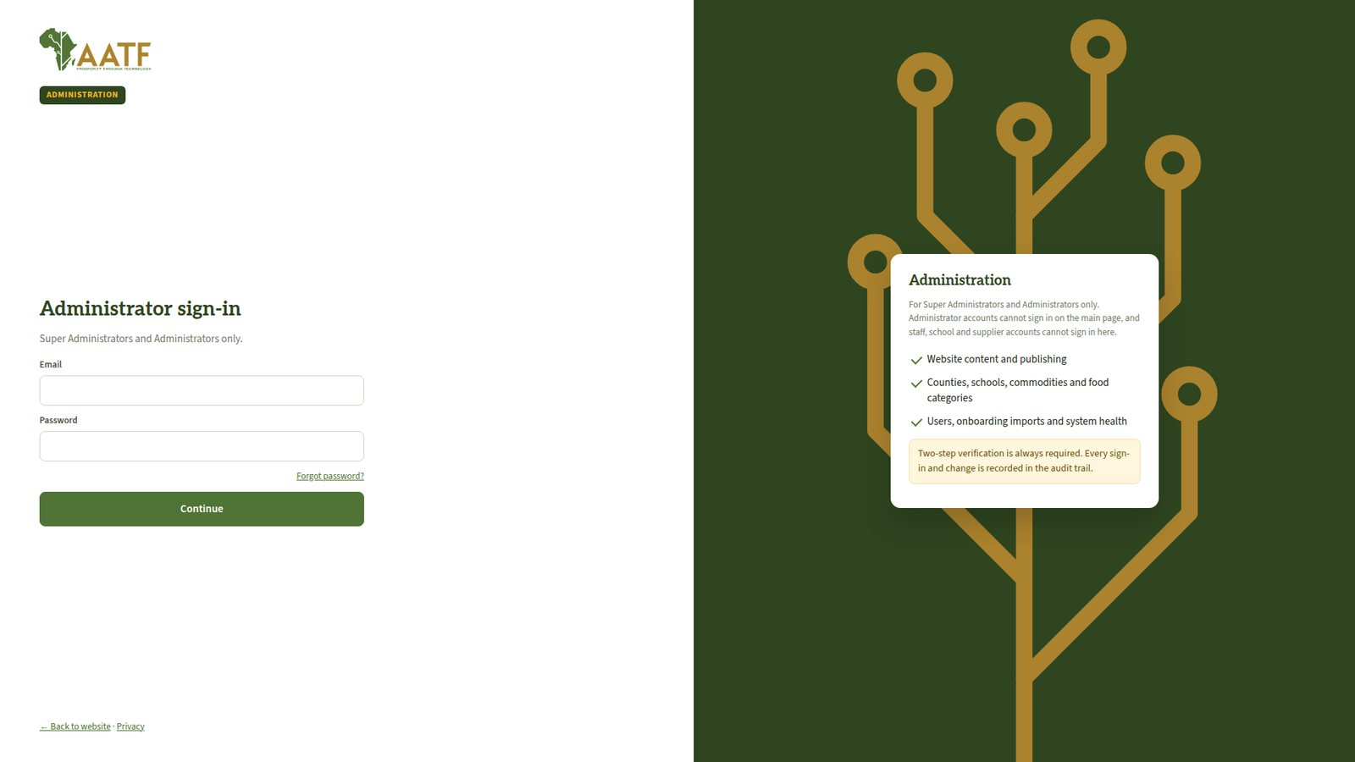
Administrator sign-in: separate from all other users.
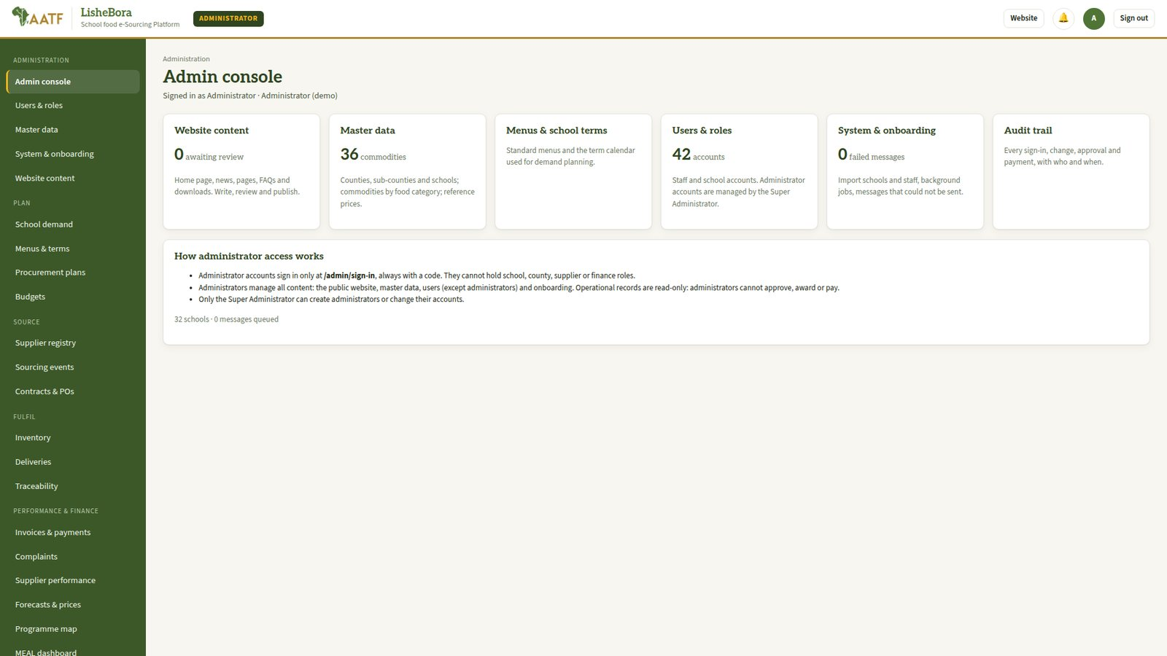
Admin console.
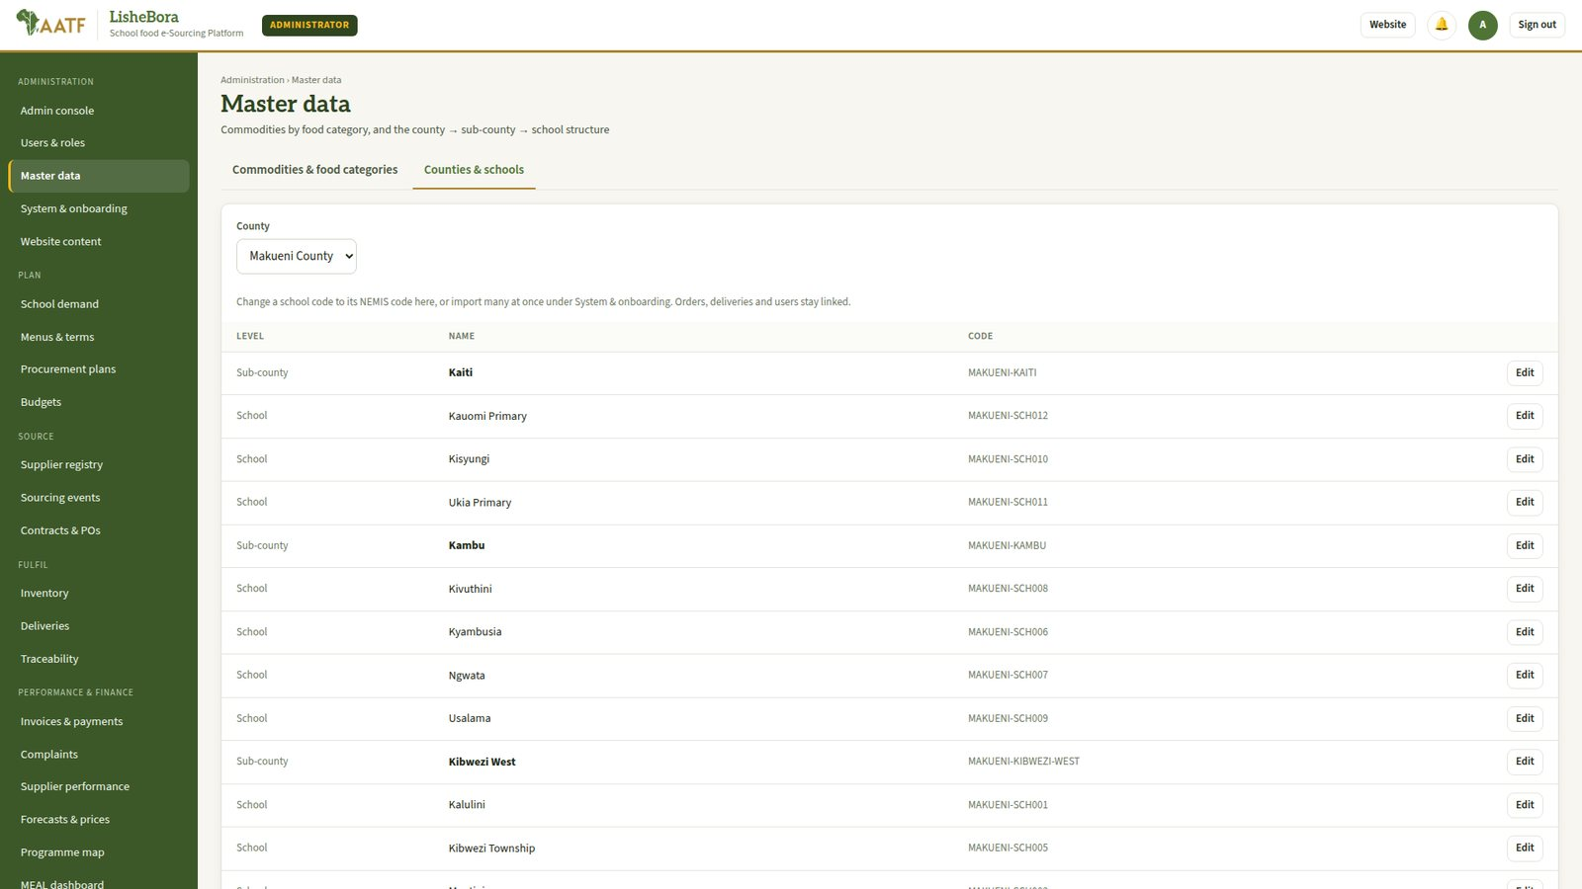
Master data: counties, sub-counties and schools.
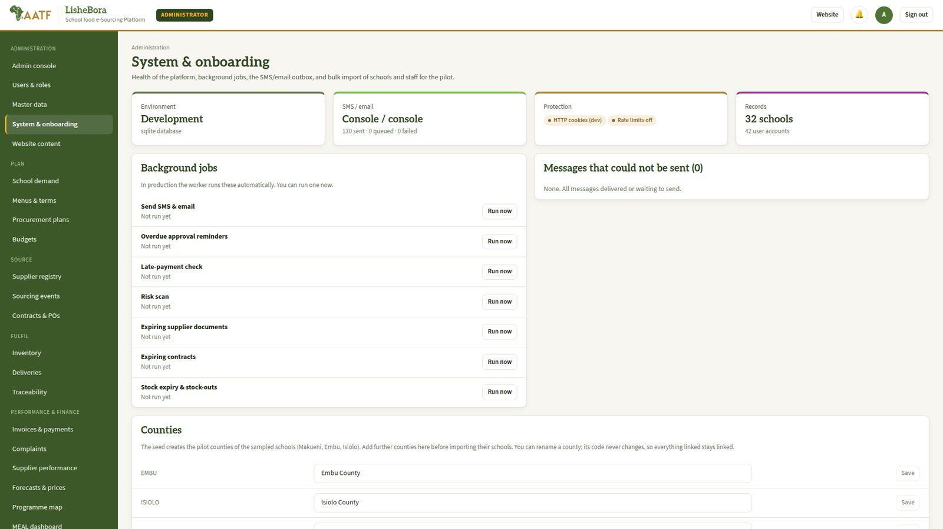
System & onboarding: CSV import of schools and staff, background jobs, message delivery.
Controls and tips
Administrator accounts cannot hold any other role and cannot sign in on the normal sign-in page.
Only the Super Administrator can create or change administrator accounts.
Operational records are read-only for administrators: they cannot approve, award or pay.

Stage 1: Suppliers register and are prequalified
Item | Details
Who does it | Supplier or farmer group (registers) → County Procurement Officer (verifies documents) → County Administrator (approves and prequalifies).
Before you start | A supplier registration notice has been published on the website (News).
Hands over to | Stage 5: the supplier can bid when a matching opportunity opens.

Steps
- Supplier: on the website click Register, choose the account type (farmer, group or cooperative, trader, aggregator), enter the details, pick the foods supplied and verify the phone number with the SMS code.
- Supplier: in My supplier profile upload the documents (registration certificate, KRA PIN, bank or M-Pesa details and so on) and submit.
- County Procurement Officer: open Supplier registry → the supplier → verify each document, then click Start review.
- County Administrator: approve the supplier, then Prequalify for the food categories they may supply (for example Legumes, Refined grains).
- Supplier: receives an SMS; from now on gets alerts for opportunities in the approved categories.
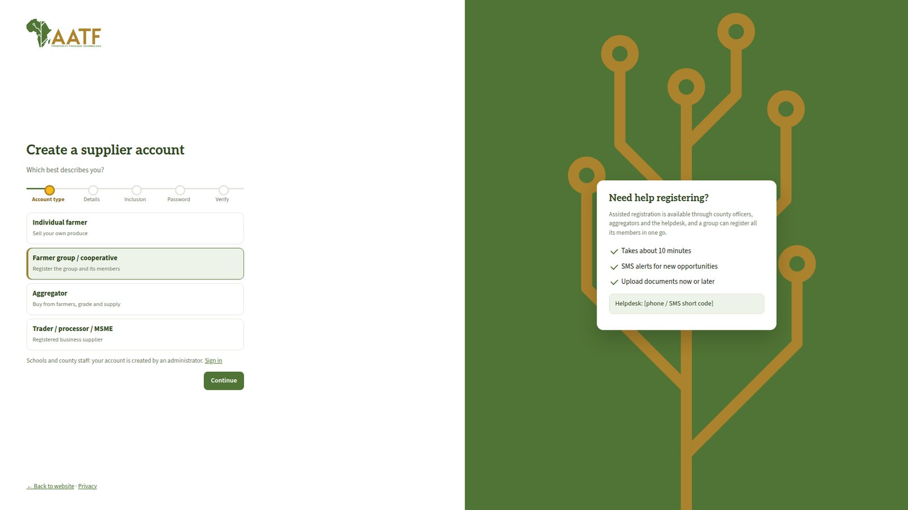
Supplier self-registration on the website.
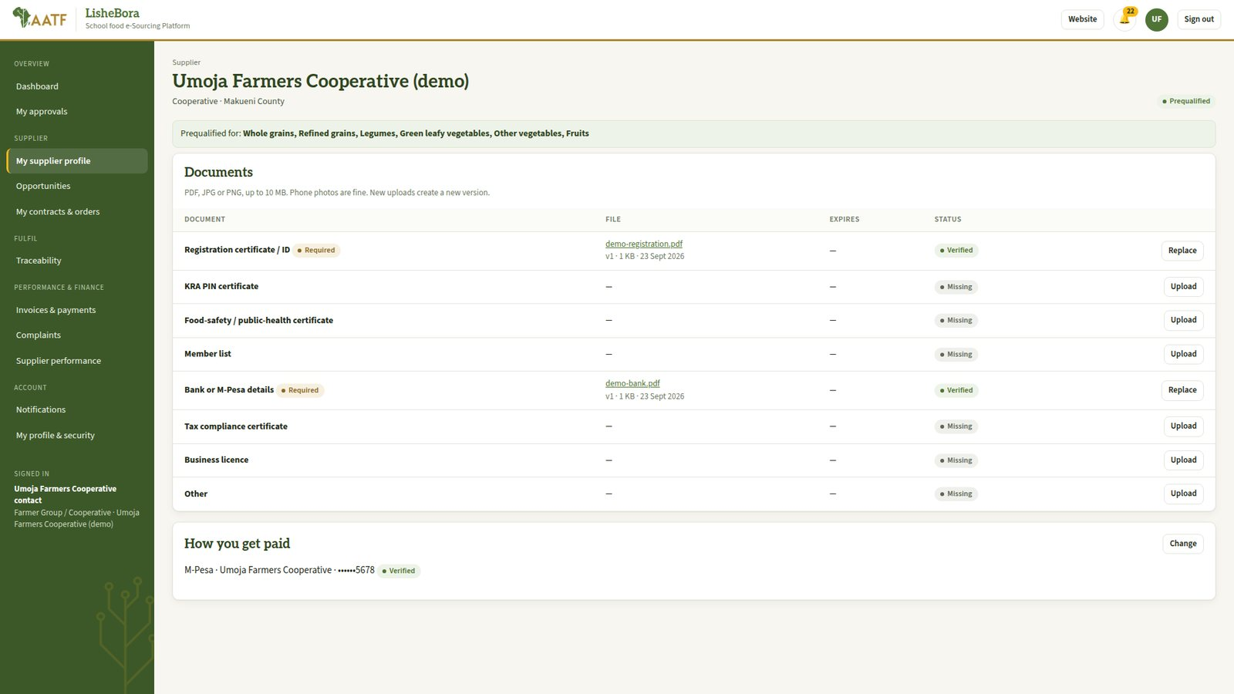
Supplier profile with documents and prequalified categories.
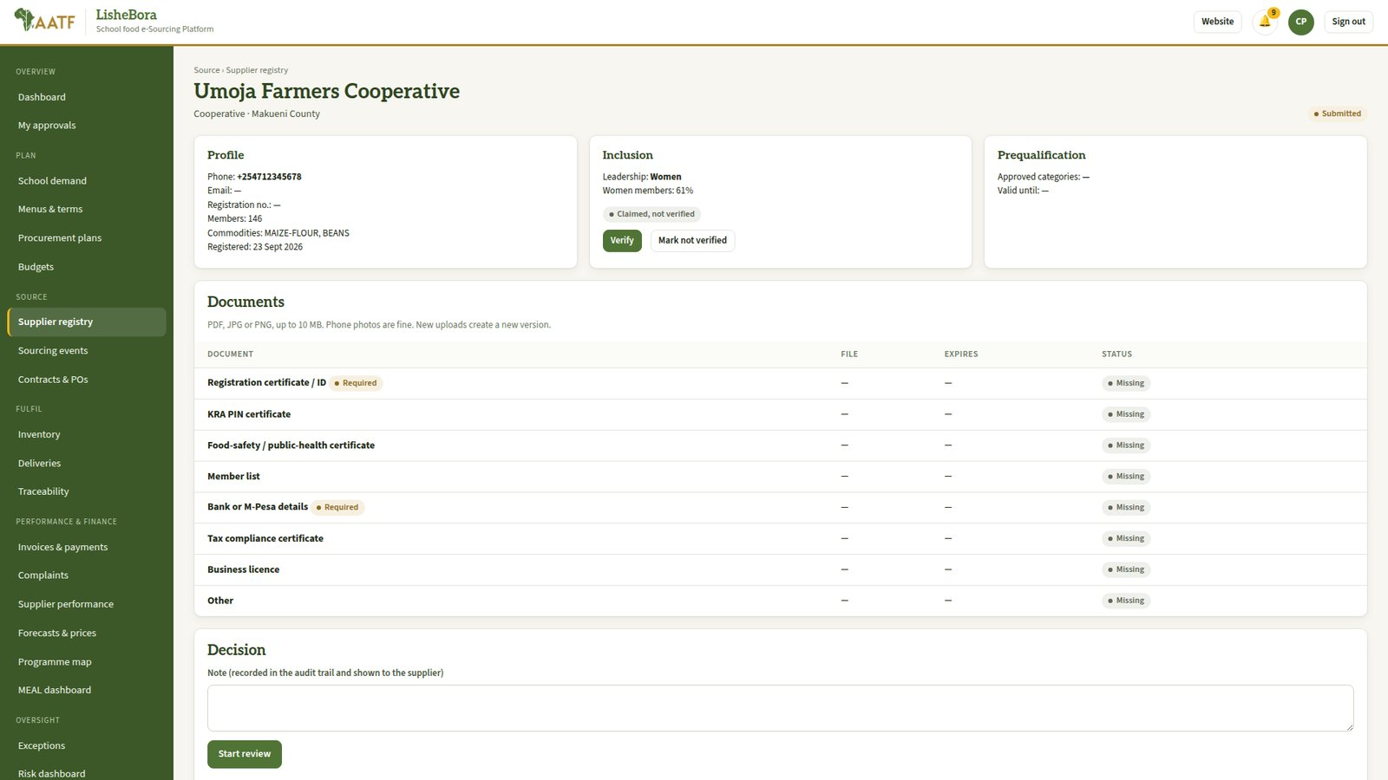
County review of a supplier: documents, inclusion status and decision.
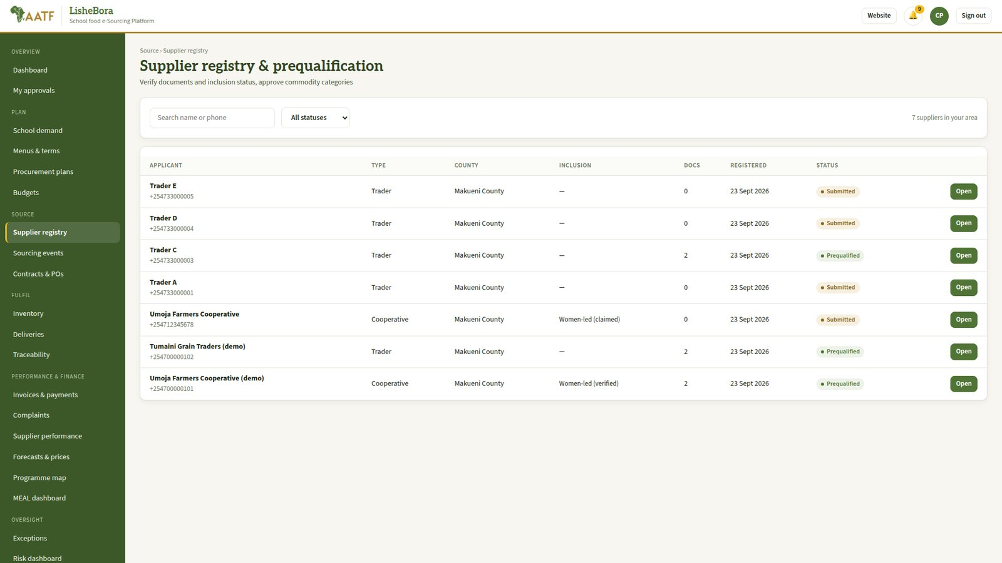
Supplier registry.
Controls and tips
Inclusion status (women-, youth-, PWD-led) is declared with consent and verified by the county.
A supplier cannot also be an evaluator, quality inspector or approving officer (segregation of duties).

Stage 2: Menus, school terms and budgets
Item | Details
Who does it | Nutrition Officer (menus) → a second nutrition officer validates. County Finance Officer (budget lines).
Before you start | Stage 0 is complete; the term calendar is agreed.
Hands over to | Stage 3: schools can plan with the approved menu; Stage 4: plans are checked against budget lines.

Steps
- Nutrition Officer: Menus & terms → create the standard menu (dishes per day and portions per learner), then submit it.
- Second nutrition officer: validates the menu. The platform checks how many food groups it covers across the week.
- Administrator or Nutrition Officer: check the school terms and feeding days.
- County Finance Officer: Budgets → create the budget lines for school feeding per term and funding source.
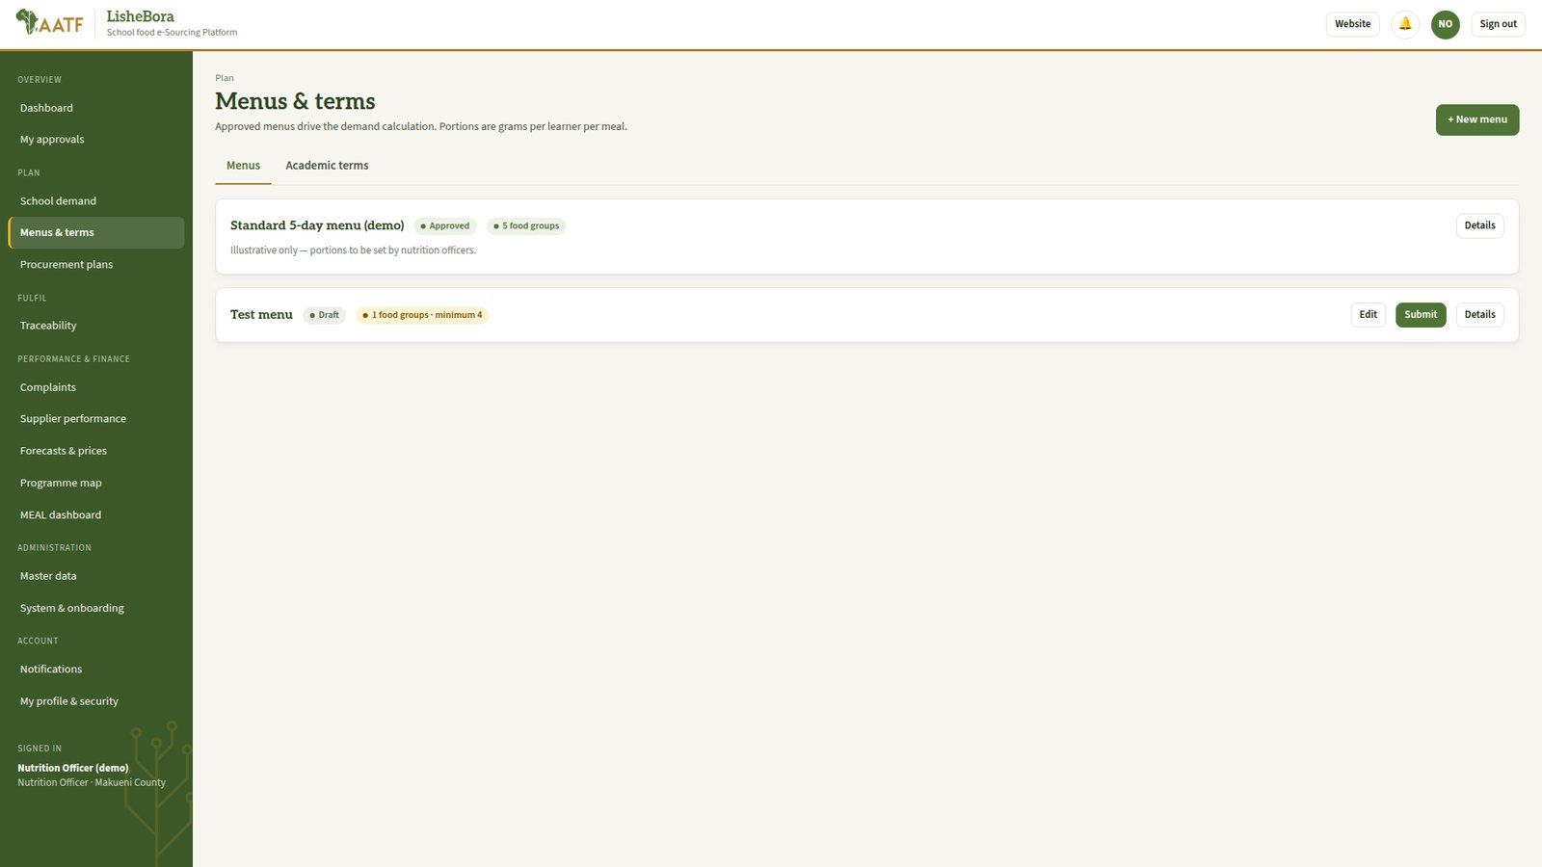
Menus and school terms.
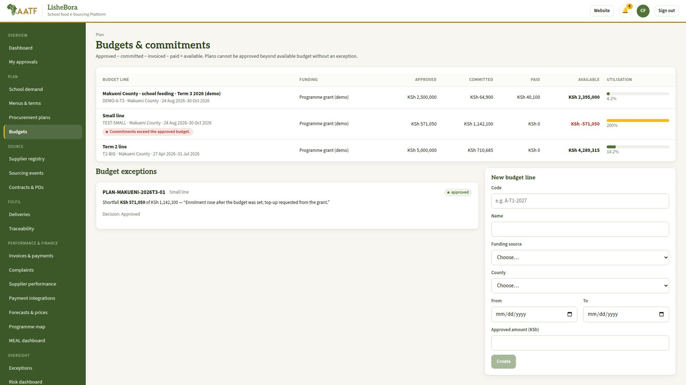
Budget lines, commitments and spending.
Controls and tips
The person who submits a menu cannot approve it.
Spending above an approved budget line needs a budget exception, approved by the County Administrator or an Approving Officer.

Stage 3: School demand plan
Item | Details
Who does it | School Meals Officer (prepares and submits) → School Administrator (validates and approves).
Before you start | An approved menu and the term exist. The school knows its enrolment and the food already in store.
Hands over to | Stage 4: the County Procurement Officer sees the approved demand.

Steps
- School Meals Officer: School demand → Start a demand plan: choose the school, term and approved menu; enter learners, attendance, feeding days and stock on hand. Click Create & calculate.
- School Meals Officer: check the calculated requirement per food and any warnings, then Submit.
- School Administrator: My approvals → validate, then approve the plan.
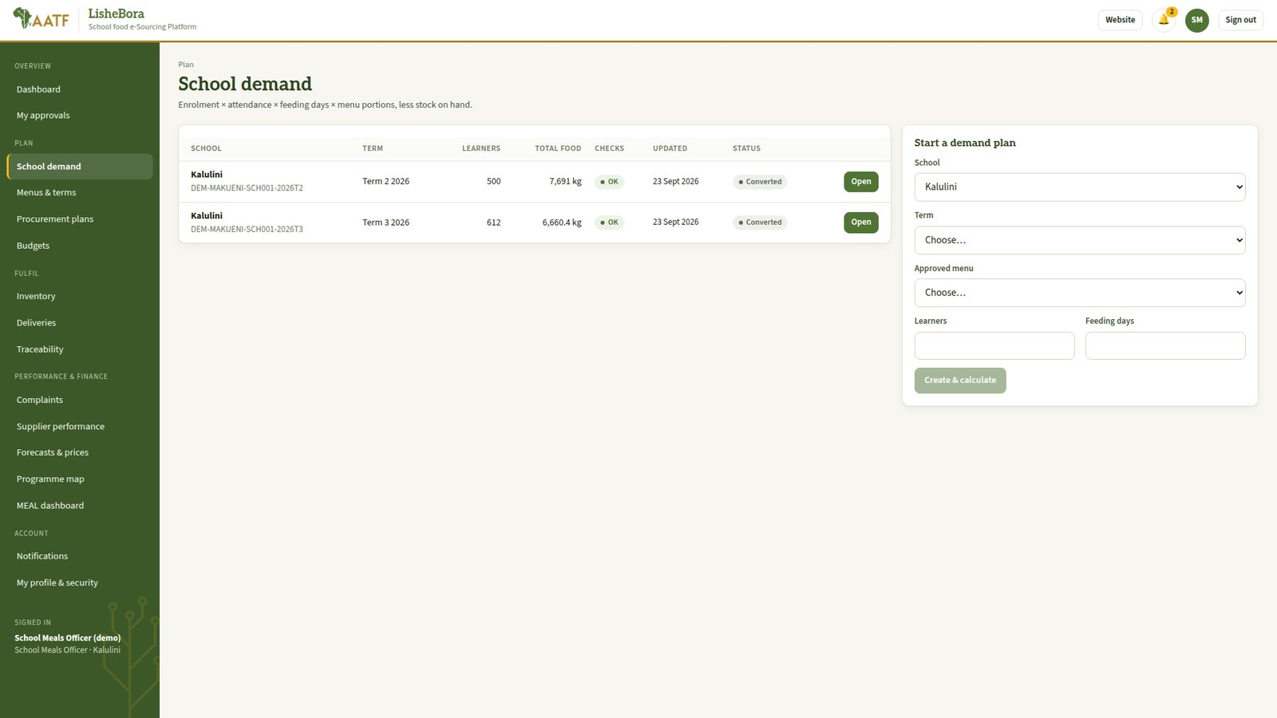
School demand plans.
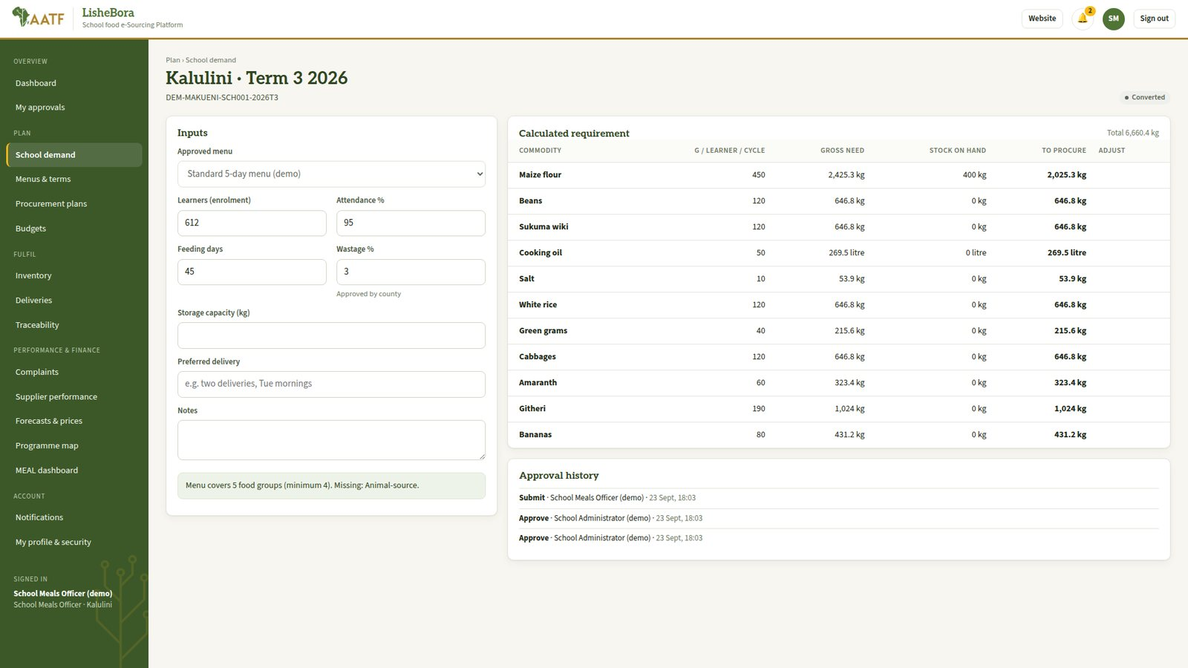
A demand plan: inputs, calculated requirement per food and approval history.
Controls and tips
Quantity = enrolment × attendance × feeding days × menu portions, less stock on hand, plus wastage.
Blocking checks: feeding days above the term calendar, or big changes in enrolment from last term.

Stage 4: Procurement plan
Item | Details
Who does it | County Procurement Officer (consolidates) → County Finance Officer (budget confirmation) → County Administrator (approval).
Before you start | Approved school demand plans for the term; a budget line exists.
Hands over to | Stage 5: sourcing events are created from the approved plan.

Steps
- County Procurement Officer: Procurement plans → create the plan for the county and term. Approved demand is combined into lots by food category.
- County Procurement Officer: link the budget line and submit.
- County Finance Officer: confirms that the budget covers the plan.
- County Administrator: approves the plan.
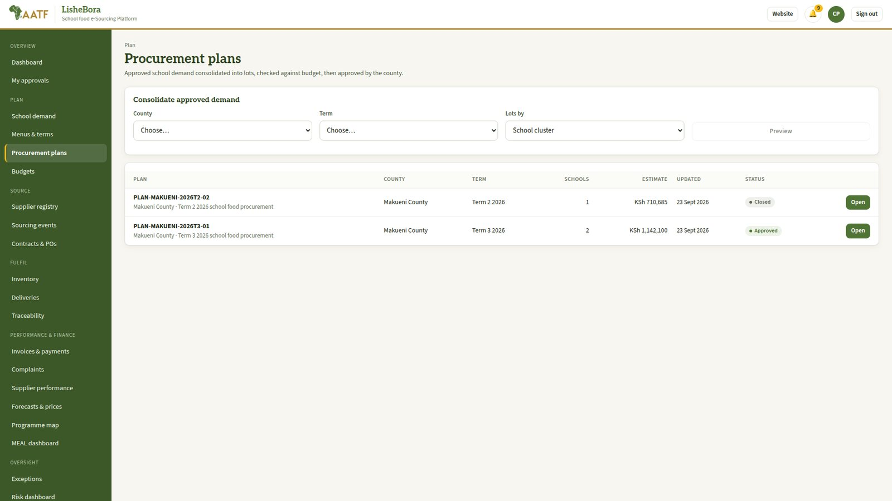
Procurement plans.
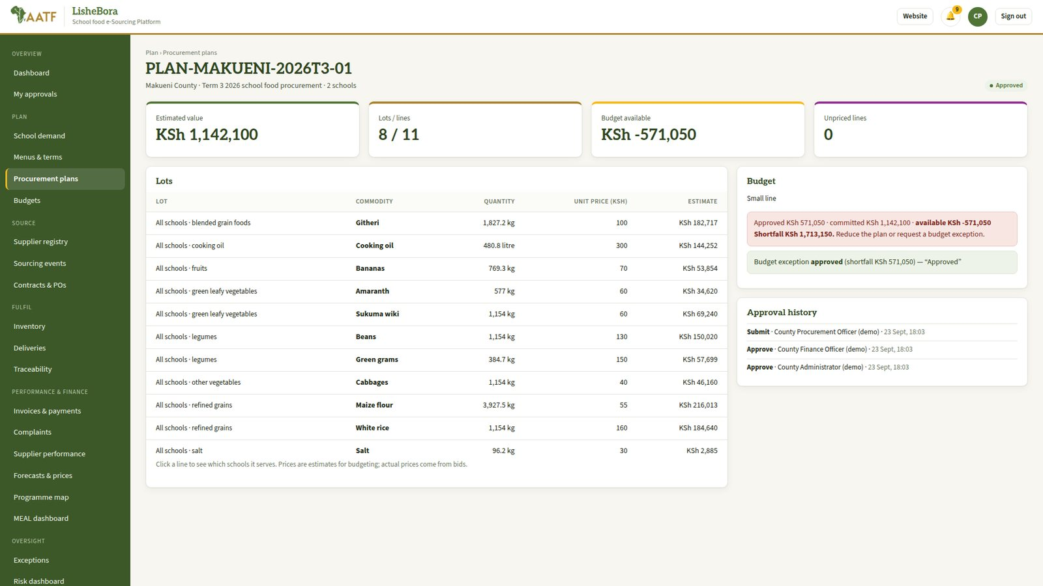
A plan: lots, estimated value, budget check and approval history.
Controls and tips
If the plan is above the available budget the platform flags it; a budget exception is then needed.

Stage 5: Sourcing event and sealed bids
Item | Details
Who does it | County Procurement Officer (creates) → Approving Officer (approves publication) → prequalified Suppliers (bid).
Before you start | An approved procurement plan.
Hands over to | Stage 6: the evaluation committee.

Steps
- County Procurement Officer: Sourcing events → New event from an approved plan: method (RFQ or tender), closing date, criteria and weights. Submit for approval.
- Approving Officer: approves publication. The notice appears on the website and matching suppliers get an SMS.
- Supplier: Opportunities → open the notice, ask clarification questions if needed, and submit a sealed bid before the deadline.
- County Procurement Officer: answers clarifications (published to all bidders), assigns the evaluation committee and opens the bids after the deadline.
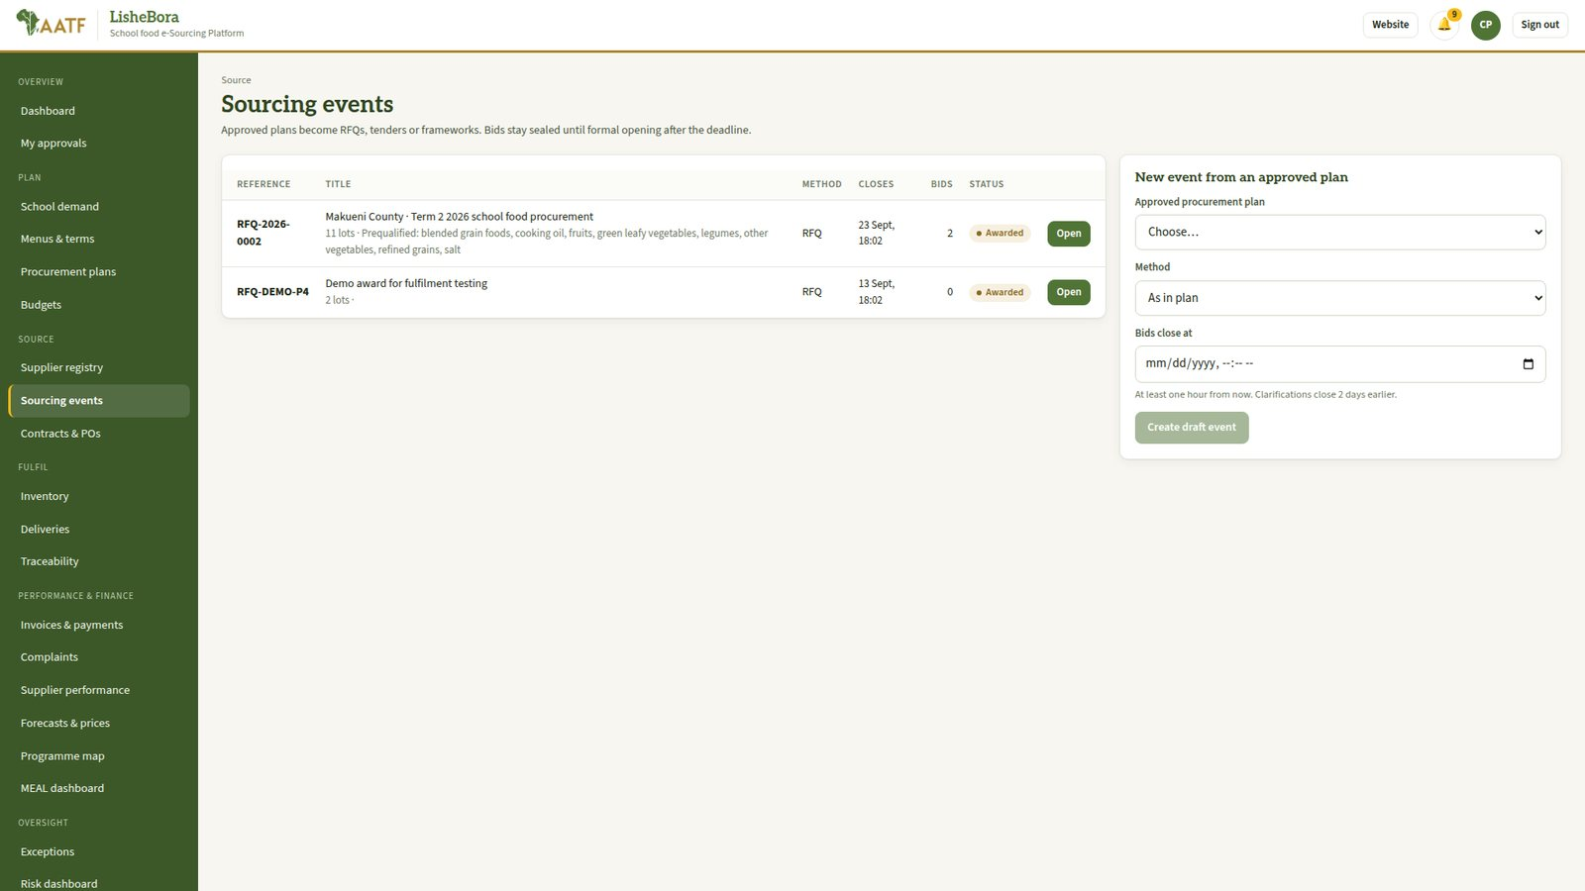
Sourcing events.
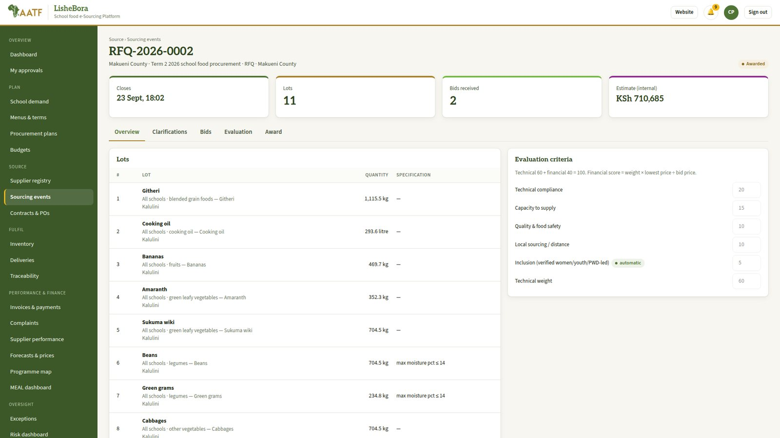
A sourcing event: lots, criteria, bids and evaluation tabs.
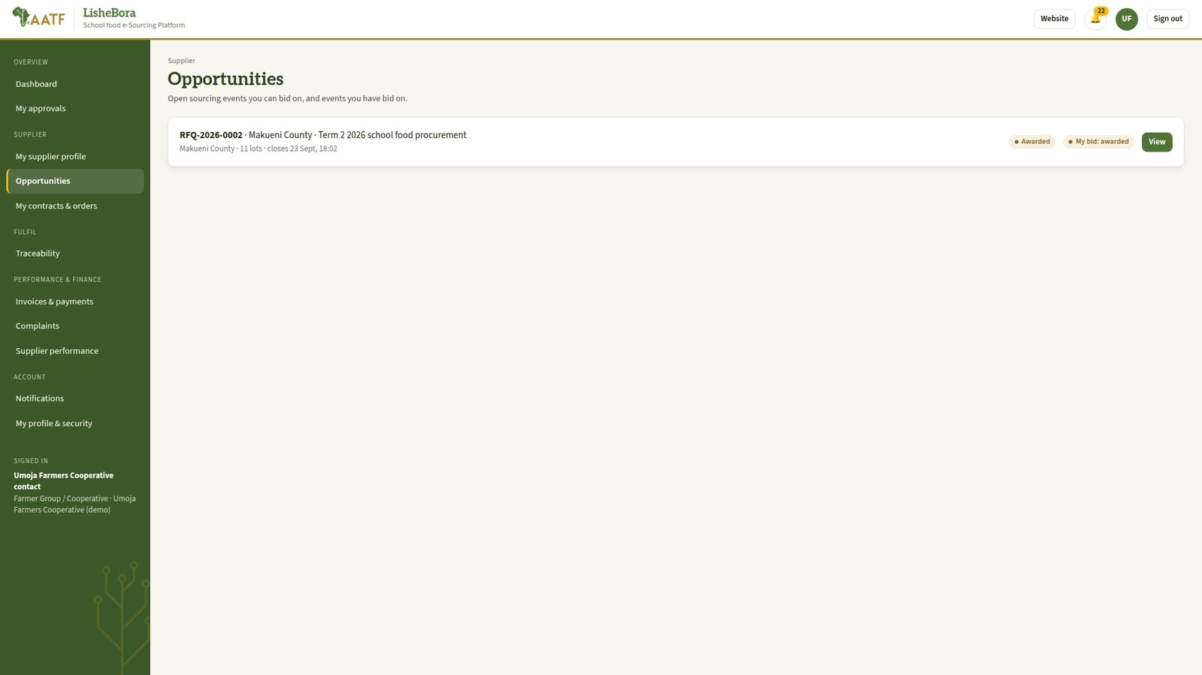
Supplier portal: opportunities to bid on.
Controls and tips
Bids are encrypted and nobody, including administrators, can read them before the opening.
Late bids are refused automatically.

Stage 6: Evaluation and award
Item | Details
Who does it | Evaluation Committee Members (score) → County Procurement Officer (recommendation) → County Finance Officer (commitment check) → Approving Officer (award approval).
Before you start | Bids have been opened.
Hands over to | Stage 7: contracts and purchase orders.

Steps
- Evaluation Committee Member: My evaluations → declare any conflict of interest, then score each bid against the published criteria and submit.
- County Procurement Officer: consolidates the scores and submits the award recommendation.
- County Finance Officer: confirms the commitment against the budget line.
- Approving Officer: approves the award. The award is published on the website.
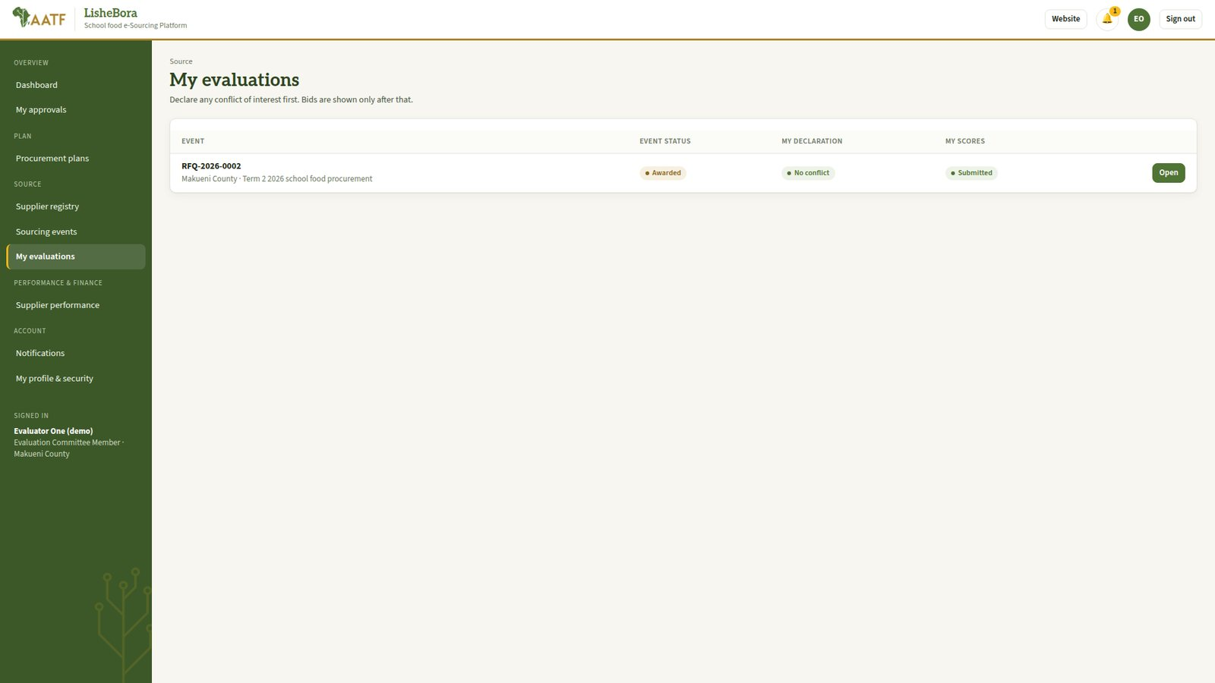
Evaluator view: conflict of interest declaration, then scoring.
Controls and tips
An evaluator with a conflict of interest is excluded from that event.
A supplier account can never be an evaluator.

Stage 7: Contract and purchase orders
Item | Details
Who does it | County Procurement Officer (issues) → Supplier (acknowledges).
Before you start | An approved award.
Hands over to | Stage 8: the supplier or its aggregation hub prepares the food.

Steps
- County Procurement Officer: Contracts & POs → create the contract and the purchase orders, with quantities per school and a delivery window.
- Supplier: My contracts & orders → acknowledge each purchase order.
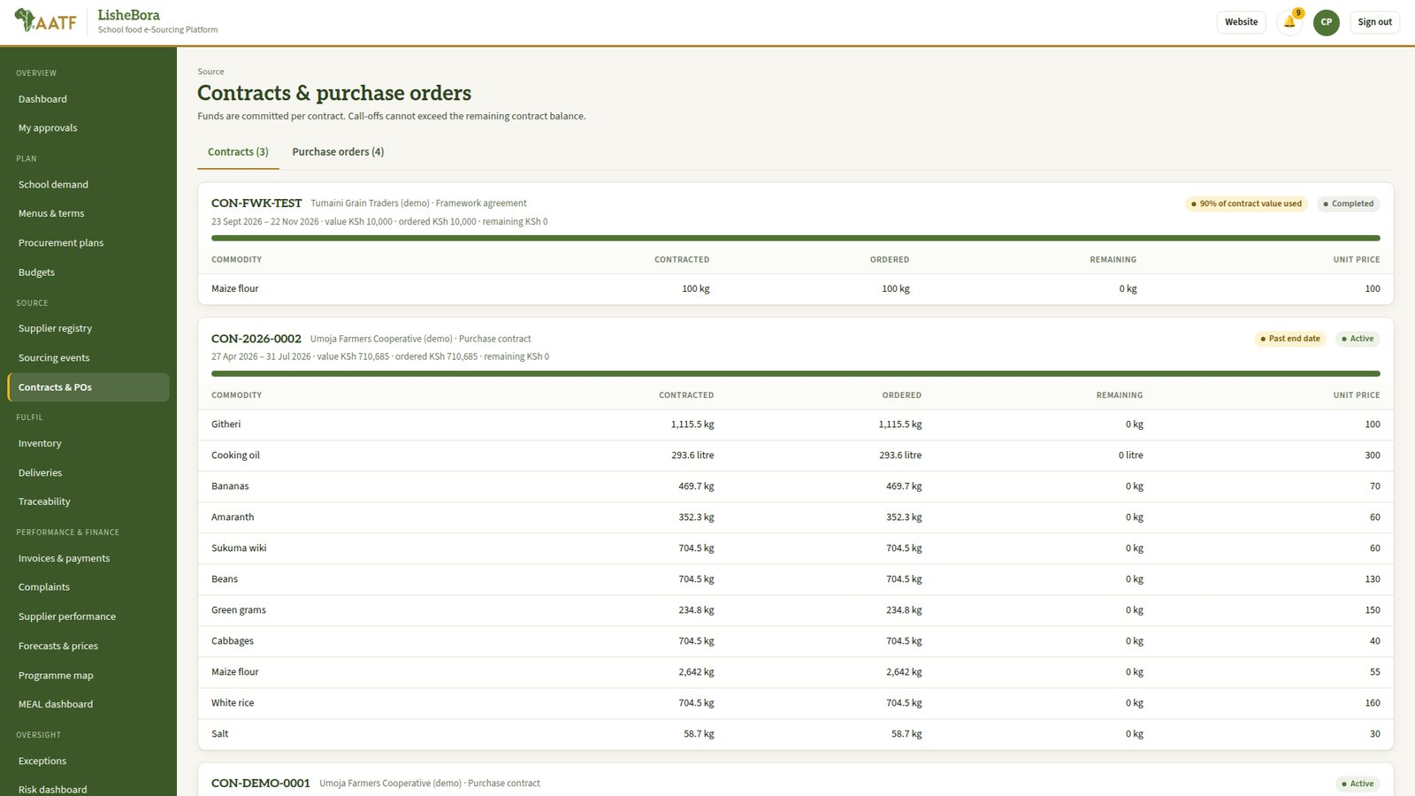
Contracts and purchase orders.
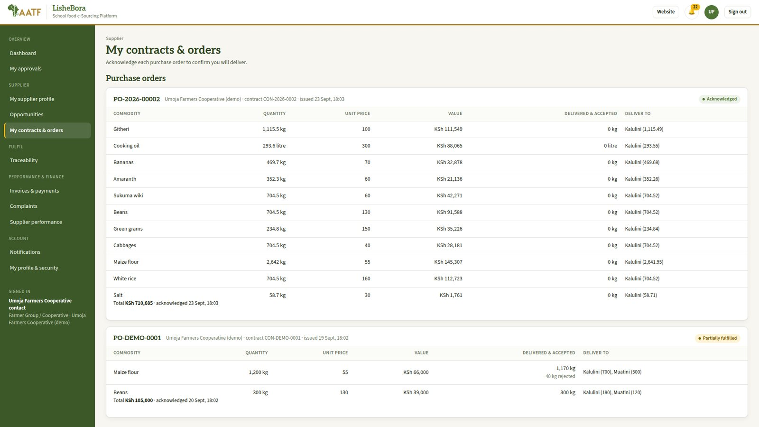
Supplier view of contracts and orders.
Controls and tips
Contract value is committed on the budget line, so later invoices draw it down.

Stage 8: Aggregation and quality inspection
Item | Details
Who does it | Aggregator (records intakes) → Quality Inspector (inspects).
Before you start | An acknowledged purchase order.
Hands over to | Stage 9: accepted batches are stored and dispatched.

Steps
- Aggregator: Aggregation & intake → record produce from each farmer or group (quantity, variety, source). This works offline and syncs later.
- Aggregator: group intakes into a batch and request inspection.
- Quality Inspector: Quality inspection → test the batch (for example moisture) and accept, downgrade or reject it.
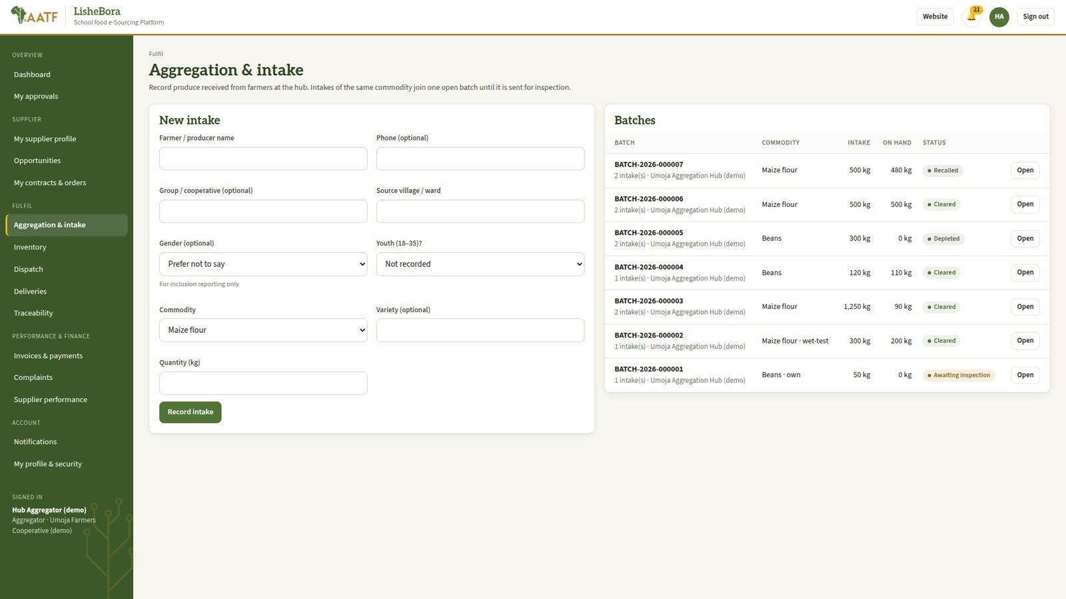
Aggregation and intake.
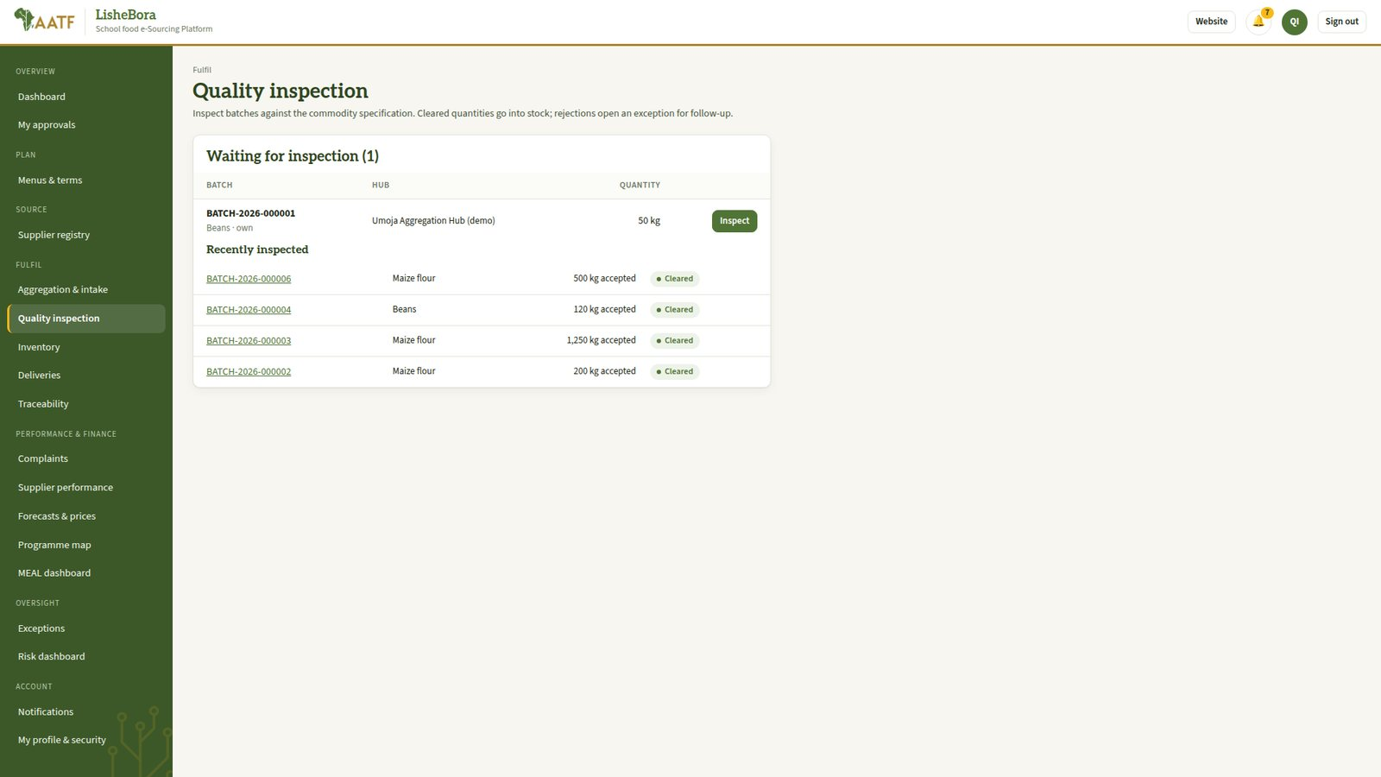
Quality inspection queue and results.
Controls and tips
An aggregator cannot also be the quality inspector.
Rejected batches create an exception case automatically.
Each batch gets a QR label for traceability.

Stage 9: Store and dispatch
Item | Details
Who does it | Warehouse Officer (stock) → Warehouse supervisor (verifies adjustments) → Logistics Officer (dispatch) → Driver.
Before you start | Accepted batches.
Hands over to | Stage 10: the school receives the delivery.

Steps
- Warehouse Officer: Inventory → receive stock by batch; record counts and any losses.
- Warehouse supervisor: verifies stock adjustments, write-offs and counts.
- Logistics Officer: Dispatch → create a dispatch against the purchase order: batches, quantities per school, vehicle, driver and planned date; optimise the route.
- Driver: sees the trip and records milestones on the way.
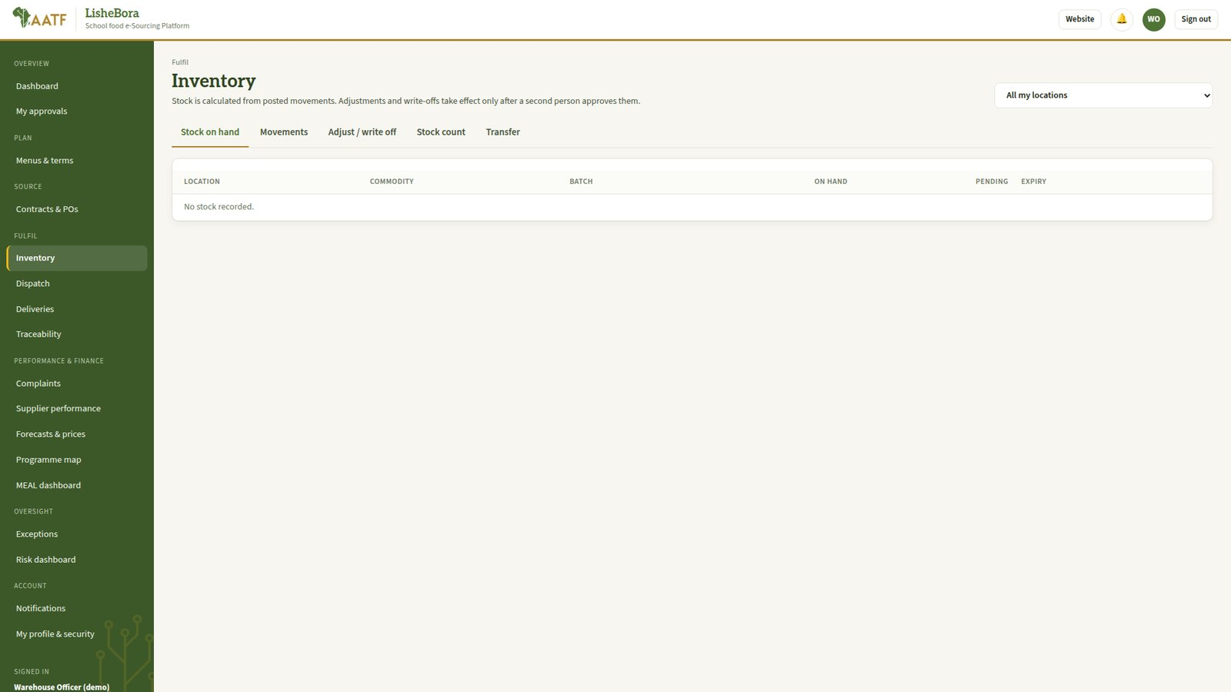
Inventory by batch and location.
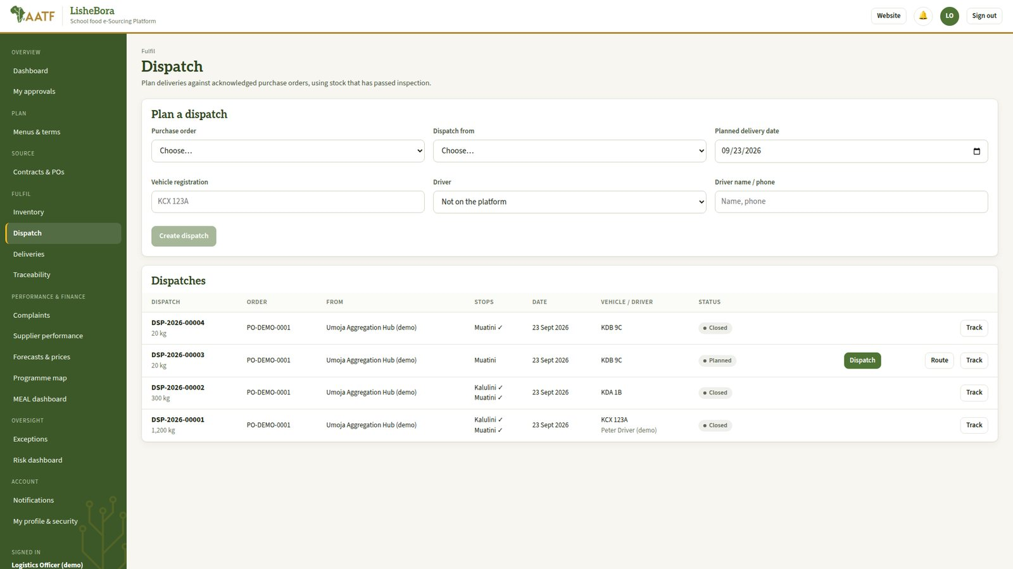
Dispatch planning and routes.
Controls and tips
A dispatch cannot exceed the quantity ordered for a school.
Stock adjustments need a second person to verify.

Stage 10: Delivery and proof of delivery
Item | Details
Who does it | Driver → School Administrator (confirms receipt).
Before you start | A dispatched delivery.
Hands over to | Stage 11: the accepted quantity is the basis for the invoice.

Steps
- School Administrator: Deliveries → open the delivery on a phone, count what arrived, note any shortage or damage, and confirm with a signature. This works without network and syncs later.
- School Administrator: if there is a problem, raise a complaint from the delivery.
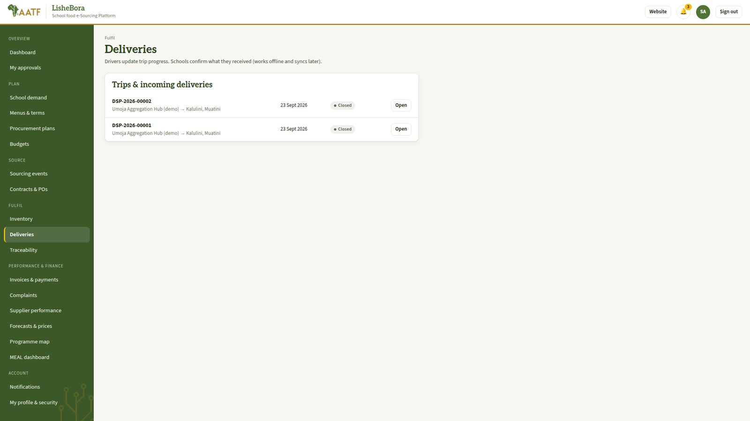
Deliveries and electronic proof of delivery.
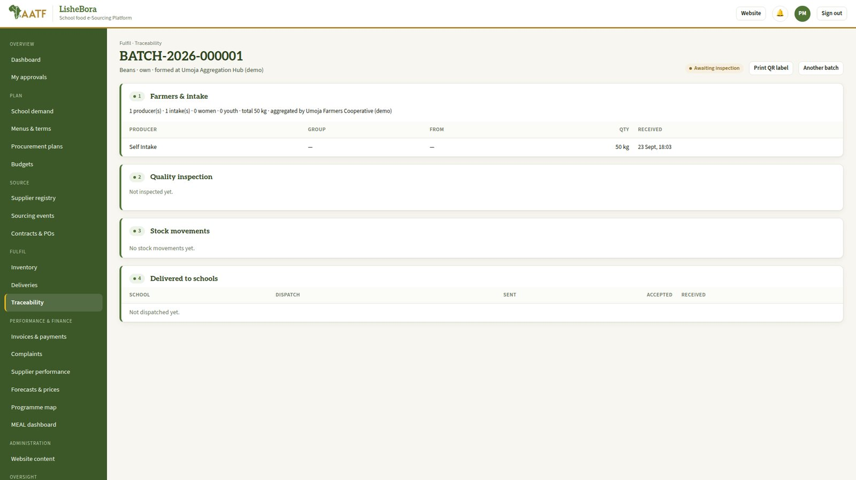
Traceability of a batch from the farmer group to the school.
Controls and tips
Only accepted quantities can be invoiced.

Stage 11: Invoice and payment
Item | Details
Who does it | Supplier (submits invoice) → Finance Officer, accounts (three-way match) → County Finance Officer (approves payment) → Finance Officer, payments (records payment).
Before you start | Delivered and accepted quantities.
Hands over to | Stage 12: payment data feeds performance and MEAL reports.

Steps
- Supplier: Invoices & payments → New invoice for the delivered quantities, and attach the invoice document.
- Finance Officer (accounts): Invoices & payments → verify the three-way match: purchase order, proof of delivery and invoice.
- County Finance Officer: approves the payment.
- Finance Officer (payments): records the payment (M-Pesa or bank) or exports the payment file; the supplier sees the status change to Paid.
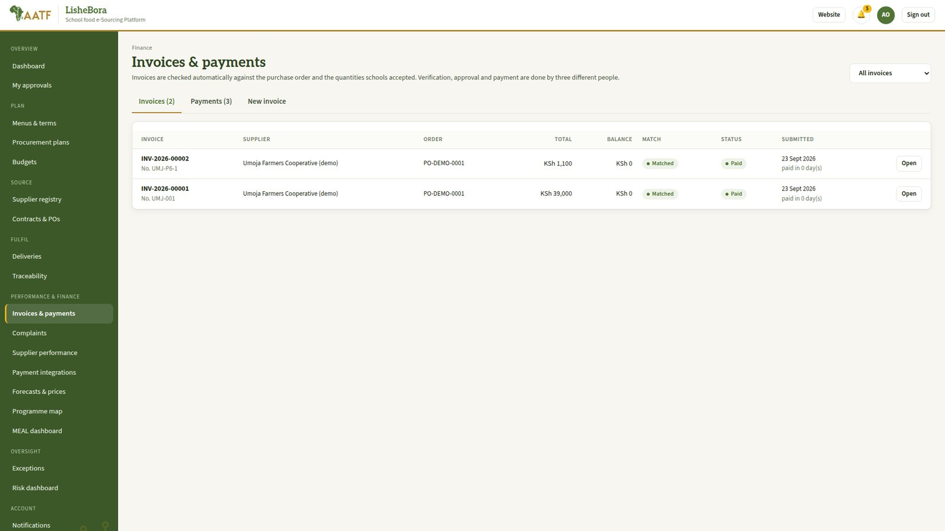
Invoices and payments.
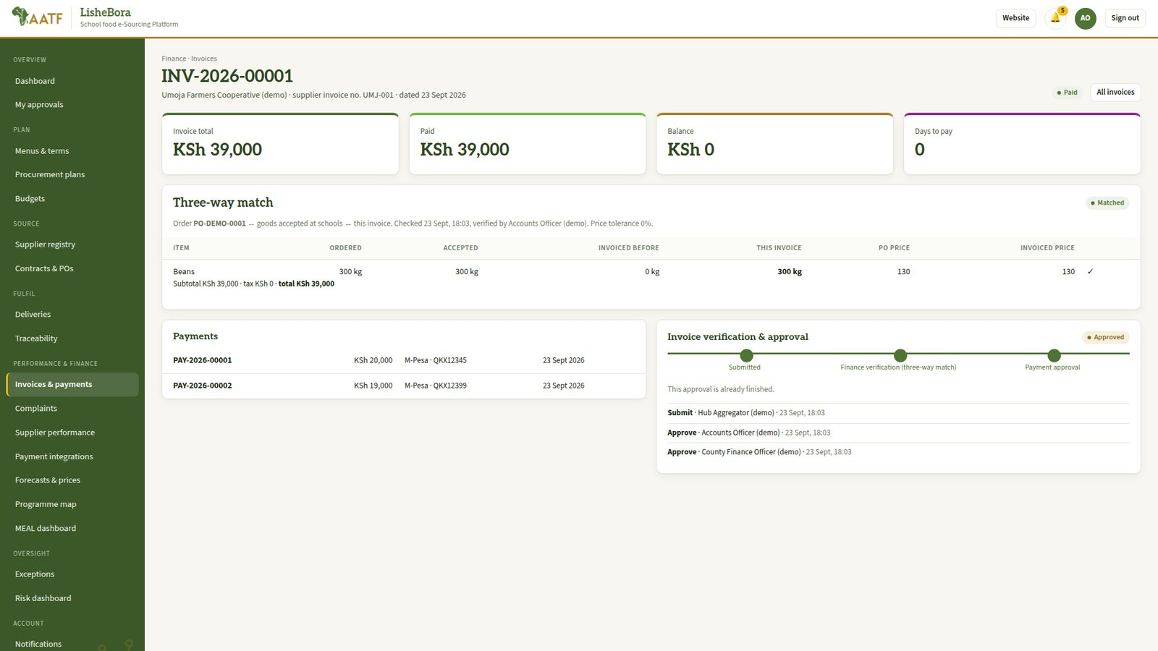
An invoice: three-way match, payments and approval steps.
Controls and tips
The same person cannot hold both finance roles (verify and approve and pay).
Late payments raise an exception automatically.

Stage 12: Monitor, learn and improve
Item | Details
Who does it | School Administrators and the public (complaints) · County Procurement (performance) · Programme MEAL Officer · Risk & Compliance Officer · Auditor.
Before you start | Activity in the earlier stages.
Hands over to | The next term starts again at Stage 3.

Steps
- Anyone: raise a complaint or grievance (portal or website Contact page); it is tracked to resolution.
- County Procurement Officer: Supplier performance → scorecards on delivery, quality and complaints, used in future evaluations.
- Programme MEAL Officer: MEAL dashboard, programme map and forecasts; export reports.
- Risk & Compliance Officer: Risk dashboard and Exceptions → follow up automatic risk flags and cases.
- Auditor: Audit trail → review every sign-in, change, approval and payment.
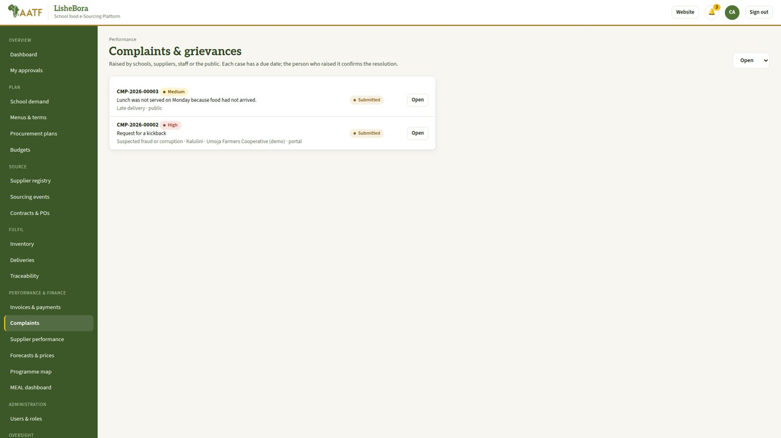
Complaints and grievances.
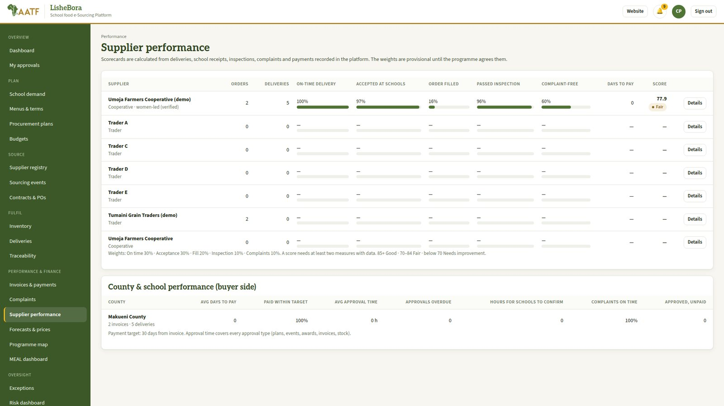
Supplier performance.
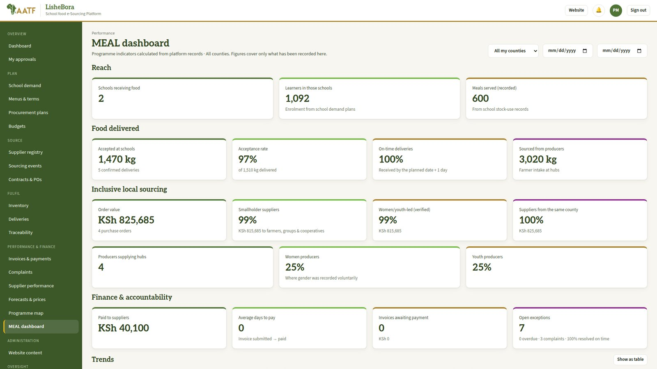
MEAL dashboard.
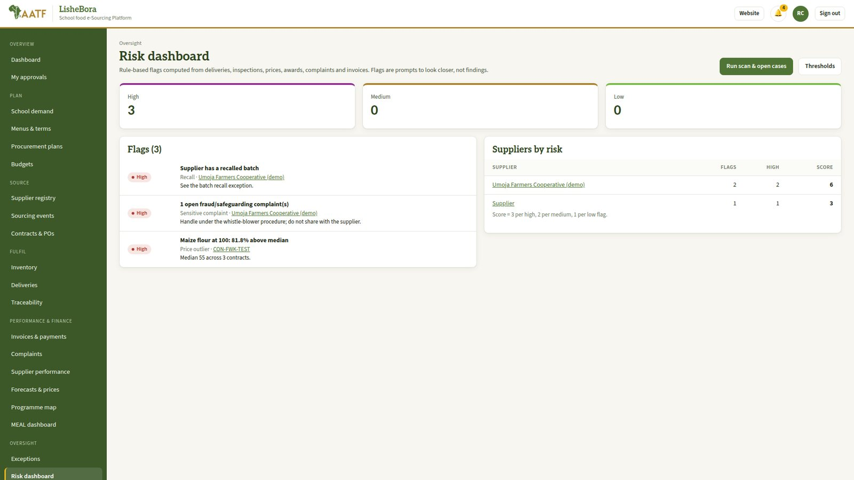
Risk dashboard.
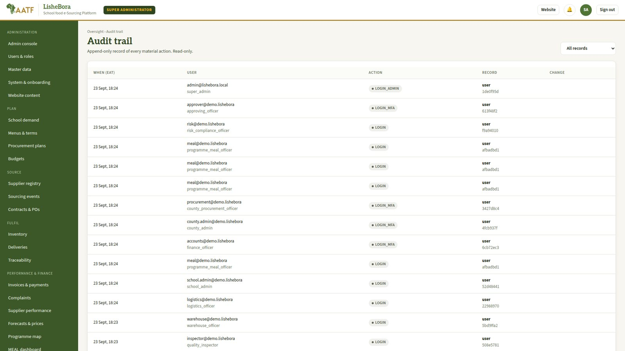
Audit trail.
Controls and tips
Sensitive complaints (fraud, safeguarding) are hidden from the supplier concerned.

Approvals and deadlines
Every approval is routed automatically to the people who hold the right role for that school or county. The deadlines below are the defaults: an overdue step sends a reminder, and after twice the deadline it is escalated to the County Administrator. Thresholds and deadlines are placeholders to be confirmed at inception.
Process | Steps | Who approves | Deadline
Menu | Nutrition validation | Nutrition Officer (not the submitter) | 3 days
School demand | Validation, then school approval | School Administrator | 2 + 2 days
Procurement plan | Budget confirmation, then county approval | County Finance Officer, then County Administrator | 2 + 3 days
Sourcing event | Approval to publish | Approving Officer | 2 days
Evaluation & award | Commitment check, then award approval | County Finance Officer, then Approving Officer | 2 + 3 days
Stock adjustment or count | Verification | Warehouse supervisor (a second warehouse officer) | 2 days
Invoice | Three-way match, then payment approval | Finance Officer, then County Finance Officer | 2 + 2 days
Budget exception | Exception approval | County Administrator or Approving Officer | 2 days

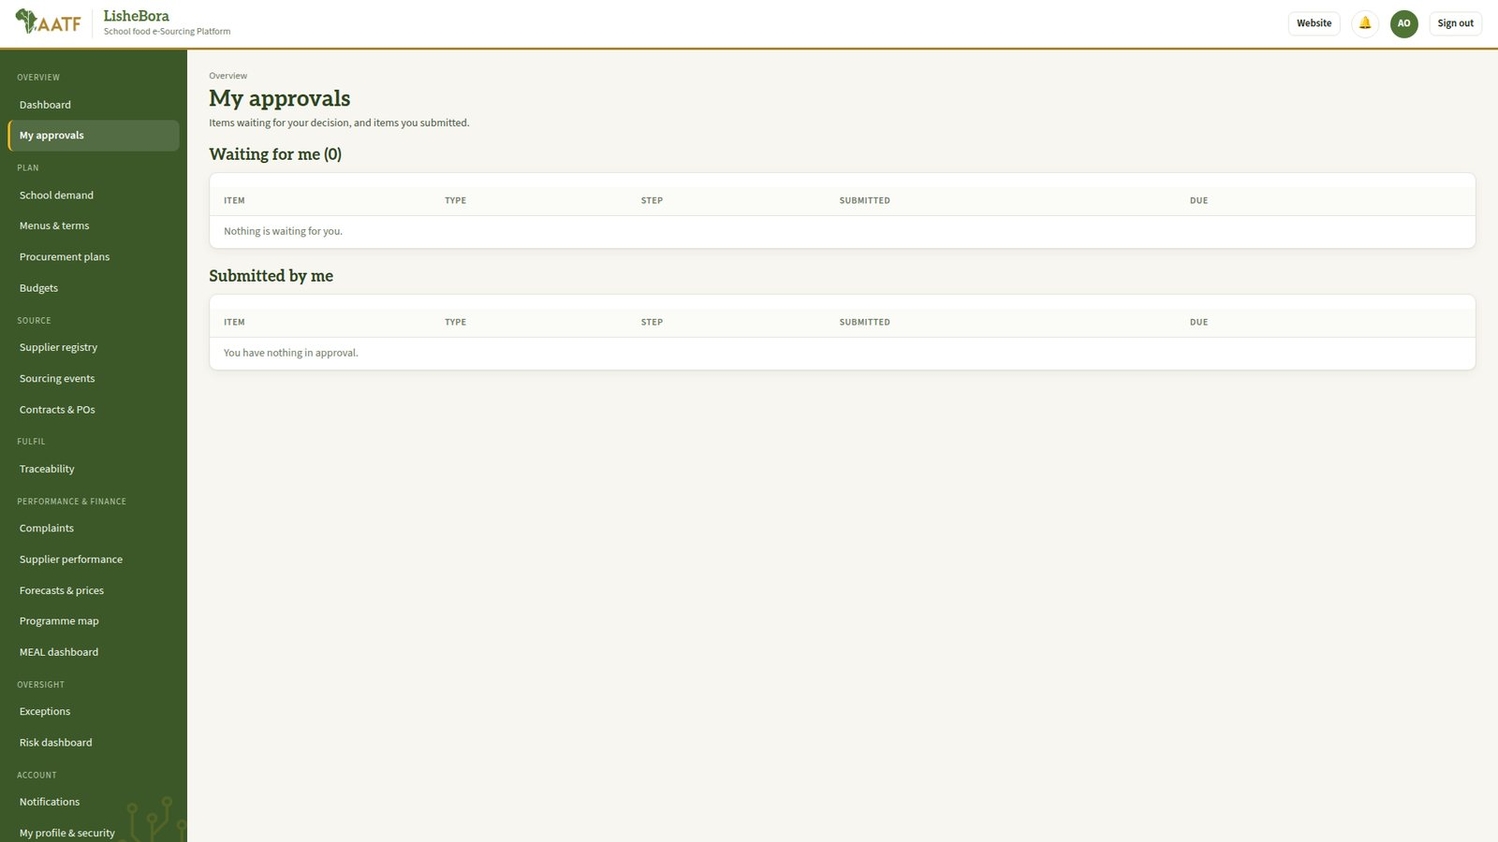
My approvals: every item waiting for the signed-in person.

Segregation of duties
The platform prevents one person from controlling a whole transaction:
- Nobody can approve something they submitted themselves (except school demand at a small school, where one head teacher may validate and approve).
- Nobody can change their own roles.
- These roles can never be held by the same person: Finance Officer and County Finance Officer; Supplier and Evaluation Committee Member, Quality Inspector or Approving Officer; Aggregator and Quality Inspector; Warehouse Officer and Approving Officer.
- Administrator accounts hold administrator roles only, and sign in separately.

Hand-off checklist: from whom to whom
From | To | What is handed over | Stage
Supplier | County Procurement Officer | Registration and documents | 1
County Procurement Officer | County Administrator | Supplier ready for approval | 1
Nutrition Officer | Nutrition Officer (second) | Menu to validate | 2
School Meals Officer | School Administrator | Demand plan | 3
School Administrator | County Procurement Officer | Approved demand | 3 > 4
County Procurement Officer | County Finance Officer | Plan for budget confirmation | 4
County Finance Officer | County Administrator | Plan for approval | 4
County Procurement Officer | Approving Officer | Sourcing event to publish | 5
Approving Officer | Suppliers | Published notice (SMS alert) | 5
Suppliers | County Procurement Officer | Sealed bids | 5
County Procurement Officer | Evaluation committee | Opened bids | 6
Evaluation committee | County Procurement Officer | Scores | 6
County Procurement Officer | County Finance Officer > Approving Officer | Award recommendation | 6
County Procurement Officer | Supplier | Contract and purchase order | 7
Aggregator | Quality Inspector | Batch for inspection | 8
Quality Inspector | Warehouse / Logistics | Accepted batch | 8 > 9
Logistics Officer | Driver > School Administrator | Dispatch | 9 > 10
School Administrator | Supplier and Finance | Proof of delivery | 10 > 11
Supplier | Finance Officer (accounts) | Invoice | 11
Finance Officer (accounts) | County Finance Officer | Verified invoice | 11
County Finance Officer | Finance Officer (payments) | Approved payment | 11

Demonstration accounts for training
Use these accounts on the demonstration or training server only. The password for all demo accounts is set in SEED_DEMO_PASSWORD (default Demo!2026pass). Never create them on the pilot server.
Email | Role and place
administrator@demo.lishebora | Administrator (at /admin/sign-in)
meals.officer@demo.lishebora | School Meals Officer, Kalulini
school.admin@demo.lishebora | School Administrator, Kalulini
nutrition@demo.lishebora | Nutrition Officer, Makueni
procurement@demo.lishebora | County Procurement Officer, Makueni
finance@demo.lishebora | County Finance Officer, Makueni
county.admin@demo.lishebora | County Administrator, Makueni
approver@demo.lishebora | Approving Officer
evaluator1@demo.lishebora | Evaluation Committee Member
supplier1@demo.lishebora | Umoja Farmers Cooperative (demo)
aggregator@demo.lishebora | Aggregator, Umoja hub
inspector@demo.lishebora | Quality Inspector
warehouse@demo.lishebora | Warehouse Officer
logistics@demo.lishebora | Logistics Officer
driver@demo.lishebora | Driver
accounts@demo.lishebora | Finance Officer (verifies invoices)
payments@demo.lishebora | Finance Officer (records payments)
meal@demo.lishebora | Programme MEAL Officer
risk@demo.lishebora | Risk & Compliance Officer
auditor@demo.lishebora | Auditor

Where to get help
Programme helpdesk: [phone / SMS short code] · [email address]
Technical documentation: README.md and docs/DEPLOYMENT.md in the project folder.
Walkthrough video: docs/media/LisheBora_System_Walkthrough (narrated).

