Description
This application’s purpose is to help an ROTC student keep their notes, OPORDs, squad members and any additional resources (i.e. maps for now) organized and all in one place. The program has storage for a full squad roster, the ability to add and remove OPORDs, a map storage table along with a current location, and a skeleton for a calendar.

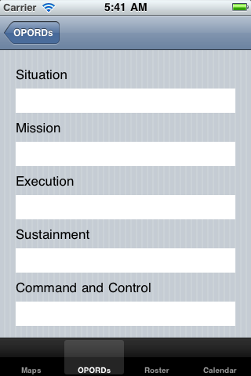
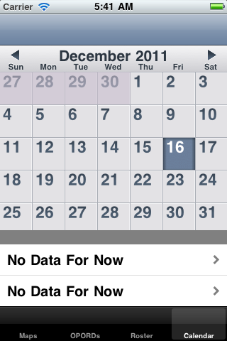
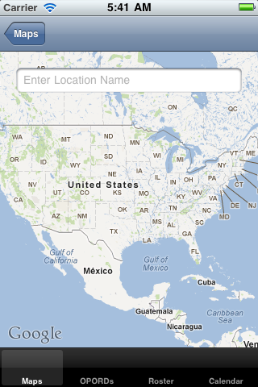
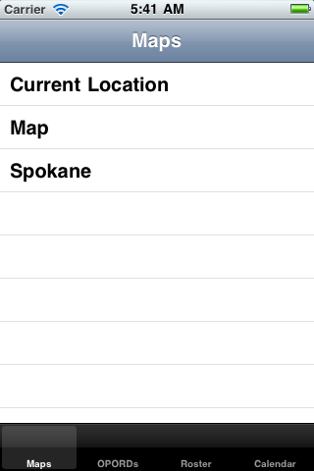
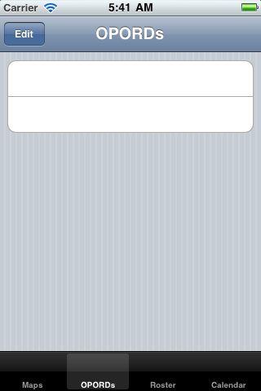
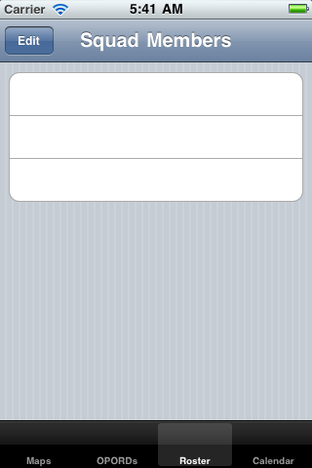
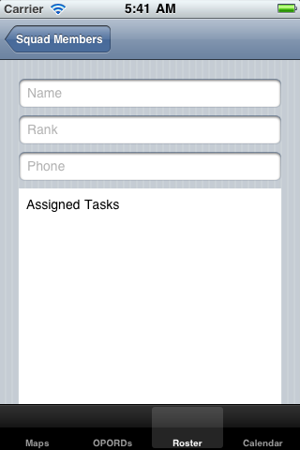
The idea for this application was because it would be something usable to me. I found iPhone interesting because it was a new style of coding that I had not experimented with. I was not able to finish implementing most of the ideas I had. The OPORD’s do save, but there is no way to import an OPORD and typing in all 6-10 pages of it on an iPhone is not practical. The calendar does not currently support any kind of data storage, and the current location does not allow a user to search for a location.

Class Concepts
Concepts I applied from class include:
        - map
        - table view
        - image view
        - file save/load
        - MKEvent (for the map)
The calendar was an entirely outside of class library that I found. As well, I added in scroll views and runtime addition/subtraction of table view cells. Though it does not work without the map search feature functioning, I also added in some loading animations with the little swirling gray circle to let a user know the phone is thinking.
Some concepts I did not use for class were XNA/Open GL, any video or sounds, the camera, accelerometer, or other devices on the phone. In the future I would add camera functionality to take pictures to add to the contact roster or for the maps/OPRODs. I might also look into using a database functionality for storage and addition of some of the big text blocks that a user does not want to type out on the phone.

Development Process
One of the biggest design struggles I had was using the TabBarController. Because this controller keeps all of the images of the subviews it holds drawn in memory, it can chew up a lot of processing power when it gets bigger. I really liked the way that it allowed a user to save their place between pages however so I stuck with it.
Before realizing that I did not have everything I needed to finish the file loading system over the internet, one concern I had was the loading and sending of documents. With large OPORDs, maps, and possibly pictures in the OPORDs data usage could become a large issue fast. Another data sponge would be the map feature, but on top of this running the map for extended periods will also deplete battery life. Good use was made of the screen size, though in the next version I would like to learn how to make the tabBar appear and disappear when a picture comes up or if a large block of text is taking the whole screen. Having a save feature available makes the application personal, at a later time storage back up via a username/password to an external server could help a user to get more usage of the application since they would not be as restricted by data size.
Many of the concepts of class were solidified by this project. I did not however dig into extra devices (camera, accelerometer, etc) or XNA/Open GL. I learned about internet access but was never able to implement it, and did implement file saving, different views, and attempted to get touch events working.
The biggest thing that went well is I have a working application. While it is buggy, and does not do everything correctly it builds and runs. On the poor side, I definitely bit off more than I could chew with this project, and probably could have broken it into more manageable phases so that I did not have a bunch of not working features at one point. This lead to me taking a week or so doing nothing but trying to get the application to build again so that I could see how if it actually works.
Other features I will add in version 2 I will definitely add database capabilities so that users can upload text files into the OPORD menu. I will also get the mapKit working properly, and give users a way to search for map images and download them, or possibly even take a picture with the camera that they can then store.

