Spatially explicit predictions of food web structure from regional level data

Introduction
Because species interactions vary in time and space, and because species show high turnover over larger spatial extents, adequately capturing the diversity of ecological networks is a challenging task (Jordano 2016). Most studies on food webs have previously focused on local networks limited in size and extent, and are rarely replicated in space or time (Mestre et al. 2022). Interactions can show important variations in space (Poisot et al. 2015; Zarnetske et al. 2017), yet available network data also show important geographical bias by focusing sampling efforts in a few areas or biomes, limiting our ability to answer questions in many biomes and over broad spatial extents (Poisot et al. 2021). Moreover, global monitoring of biotic interactions is insufficient to properly describe and understand how ecosystems are reacting to global change (Windsor et al. 2023). Approaches to predict species interactions (Desjardins-Proulx et al. 2017; e.g., Morales-Castilla et al. 2015) are increasingly used as an alternative to determine potential interactions; they can handle limited data to circumvent data scarcity (Strydom et al. 2021), but are still rarely used to make explicitly spatial predictions. As a result, there have been repeated calls for globally distributed interaction and network data coupled to repeated sampling in time and space (Mestre et al. 2022; Windsor et al. 2023), which will help understand the macroecological variations of food webs (Baiser et al. 2019).
Despite these limitations, food web ecologists often can infer a reasonable approximation of the network existing within a region. This representation, called a metaweb, contains all possible interactions between species in a given regional species pool (Dunne 2006), and provides a solid foundation to develop approaches to estimate the structure of networks at finer spatial scales.
When assembled by integrating different data sources (and potentially with additional predictive steps), the metaweb allows to overcome sampling limitations and to raise network data to a global scale. For example, Albouy et al. (2019) coupled data on fish distributions with a statistical model of trophic interactions to provide estimates of the potential food web structure at the global scale. Recent studies have focused on assembling metawebs for various taxa through literature surveys and expert elicitation (European terrestrial tetrapods, Maiorano et al. 2020) or using predictive tools (marine fishes, Albouy et al. 2019; Canadian mammals, Strydom et al. 2022a). At a finer spatial scale, the local food webs (i.e. the local “realization” of the metaweb when combined with species distributions, Poisot et al. 2012) reflect local environmental conditions but still retain the signal of the metaweb to which they belong (Saravia et al. 2022). Given this, Strydom et al. (2022b) defended that predicting the metaweb’s structure should be the core goal of predictive network ecology, as if there is a strong link between the metaweb and its local realizations, more accurante predictions of the metaweb will have the potential to bring us closer to producing accurate local (downscaled) predictions. Therefore, establishing or predicting the metaweb should be the first target in systems lacking information about local realizations. This is not the same as using interactions to improve predictions of species distributions, as recent studies have done (Lucas et al. 2023; Moens et al. 2022; Poggiato et al. 2022), although these are incredibly relevant and answer long-standing calls to include interactions within such models (Wisz et al. 2013). Instead, predicting networks in space is a different task, and it serves a different goal: focusing first on the distribution of network structures and its drivers rather than on the distribution of species.
Explicit spatial predictions (such as downscaled metaweb predictions) are essential as they will allow comparisons with extant work for species-rich communities. Recent approaches to metaweb downscaling combined a regional metaweb with species distribution maps to generate local assemblages for European tetrapods (Braga et al. 2019; Galiana et al. 2021; Gaüzère et al. 2022; O’Connor et al. 2020), Barents Sea marine taxa (Kortsch et al. 2019), and North Sea demersal fishes and benthic epifauna (Frelat et al. 2022). These downscaled assemblages allowed studying network structures in novel ways, for instance, assessing changes in food web structure across space (Braga et al. 2019), describing the scaling of network area relationships (Galiana et al. 2021). Other examples have shown that the metaweb can be used to investigate large-scale variation in food web structure, indicating high geographical connections and heterogeneous robustness against species extinctions (Albouy et al. 2019), which are only apparent when the local and global networks are both available. Further comparisons between network structure and other community properties are relevant as they may highlight new and surprising elements regarding network biogeography. For instance, Frelat et al. (2022) found a strong spatial coupling between community composition and food web structure, but a temporal mismatch depending on the spatial scale. Poisot et al. (2017) found that interaction uniqueness captures more composition variability than community uniqueness, and that sites with exceptional compositions might differ for networks and communities, because species distributions and species interactions had different bioclimatic drivers. Spatialized network data will allow these comparisons, identifying important conservation targets for networks and whether they differ geographically from areas currently prioritized for biodiversity conservation.
A key challenge remains in how to downscale a regional metaweb towards local network predictions that reflect the spatial variability of interactions. Even when the metaweb is known, local networks may vary substantially and differ both amongst themselves and from the metaweb (McLeod et al. 2021), emphasizing the need for methods to generate local, downscaled network predictions. A potential limitation to previous downscaling approaches is that they assume interactions are constant across space, which ignores well-documented interaction variability, and masks the effect of environmental conditions on interaction realization (Braga et al. 2019). In contrast, recent studies argued that seeing interactions as probabilistic (rather than binary) events allows us to account for their variability in space (Poisot et al. 2016) and that this should also be reflected at the metaweb level (Strydom et al. 2022b). Gravel et al. (2019) introduced a probabilistic framework describing how the metaweb can generate local realizations and showed how it could be used for modelling interaction distributions. This approach to downscaling is relevant when combined with in situ observations of interactions and local networks to train interaction models (in this case, with willow-galler-parasitoid networks). However, such data is rarely available across broad spatial extents (Hortal et al. 2015; Poisot et al. 2021; Windsor et al. 2023). Spatially replicated interaction data required for such models are especially challenging to document with large food web systems such as European tetrapod and Canadian mammal metawebs (Maiorano et al. 2020; Strydom et al. 2022a), where hundreds of species result in tens of thousands of species pairs that may potentially interact. We currently lack a downscaling framework that is both probabilistic and can be trained without replicated in situ interaction data. Additionally, a probabilistic view can allow propagating uncertainty, which can play a key role in evaluating the quality of the predictions. Assessing model uncertainty would enable us to determine to which degree we should trust our predictions and to identify what to do to improve the current knowledge.
Here, we present a workflow to downscale a metaweb in space, and illustrate it by spatially reconstructing local instances of a probabilistic metaweb of Canadian mammals. We do so using a probabilistic approach to both species distributions and interactions in a system without spatially replicated interaction data. We then explore how the spatial structure of the downscaled metaweb varies in space and how the uncertainty of interactions can be made spatially explicit. We further show that the downscaled metaweb can highlight important biodiversity areas and bring novel ecological insight compared to traditional community measures like species richness.

Methods
Fig. 1 shows a conceptual overview of the methodological workflow leading to the downscaled metaweb. Its components were grouped as non-spatial and spatial data, localized site steps (divided into single-species-level, two-species-level, and network-level steps), and the final downscaled and spatialized metaweb. Throughout these steps, we highlight the importance of presenting the uncertainty of interactions and their distribution in space. We argue that this requires adopting a probabilistic view and incorporating variation between scales.
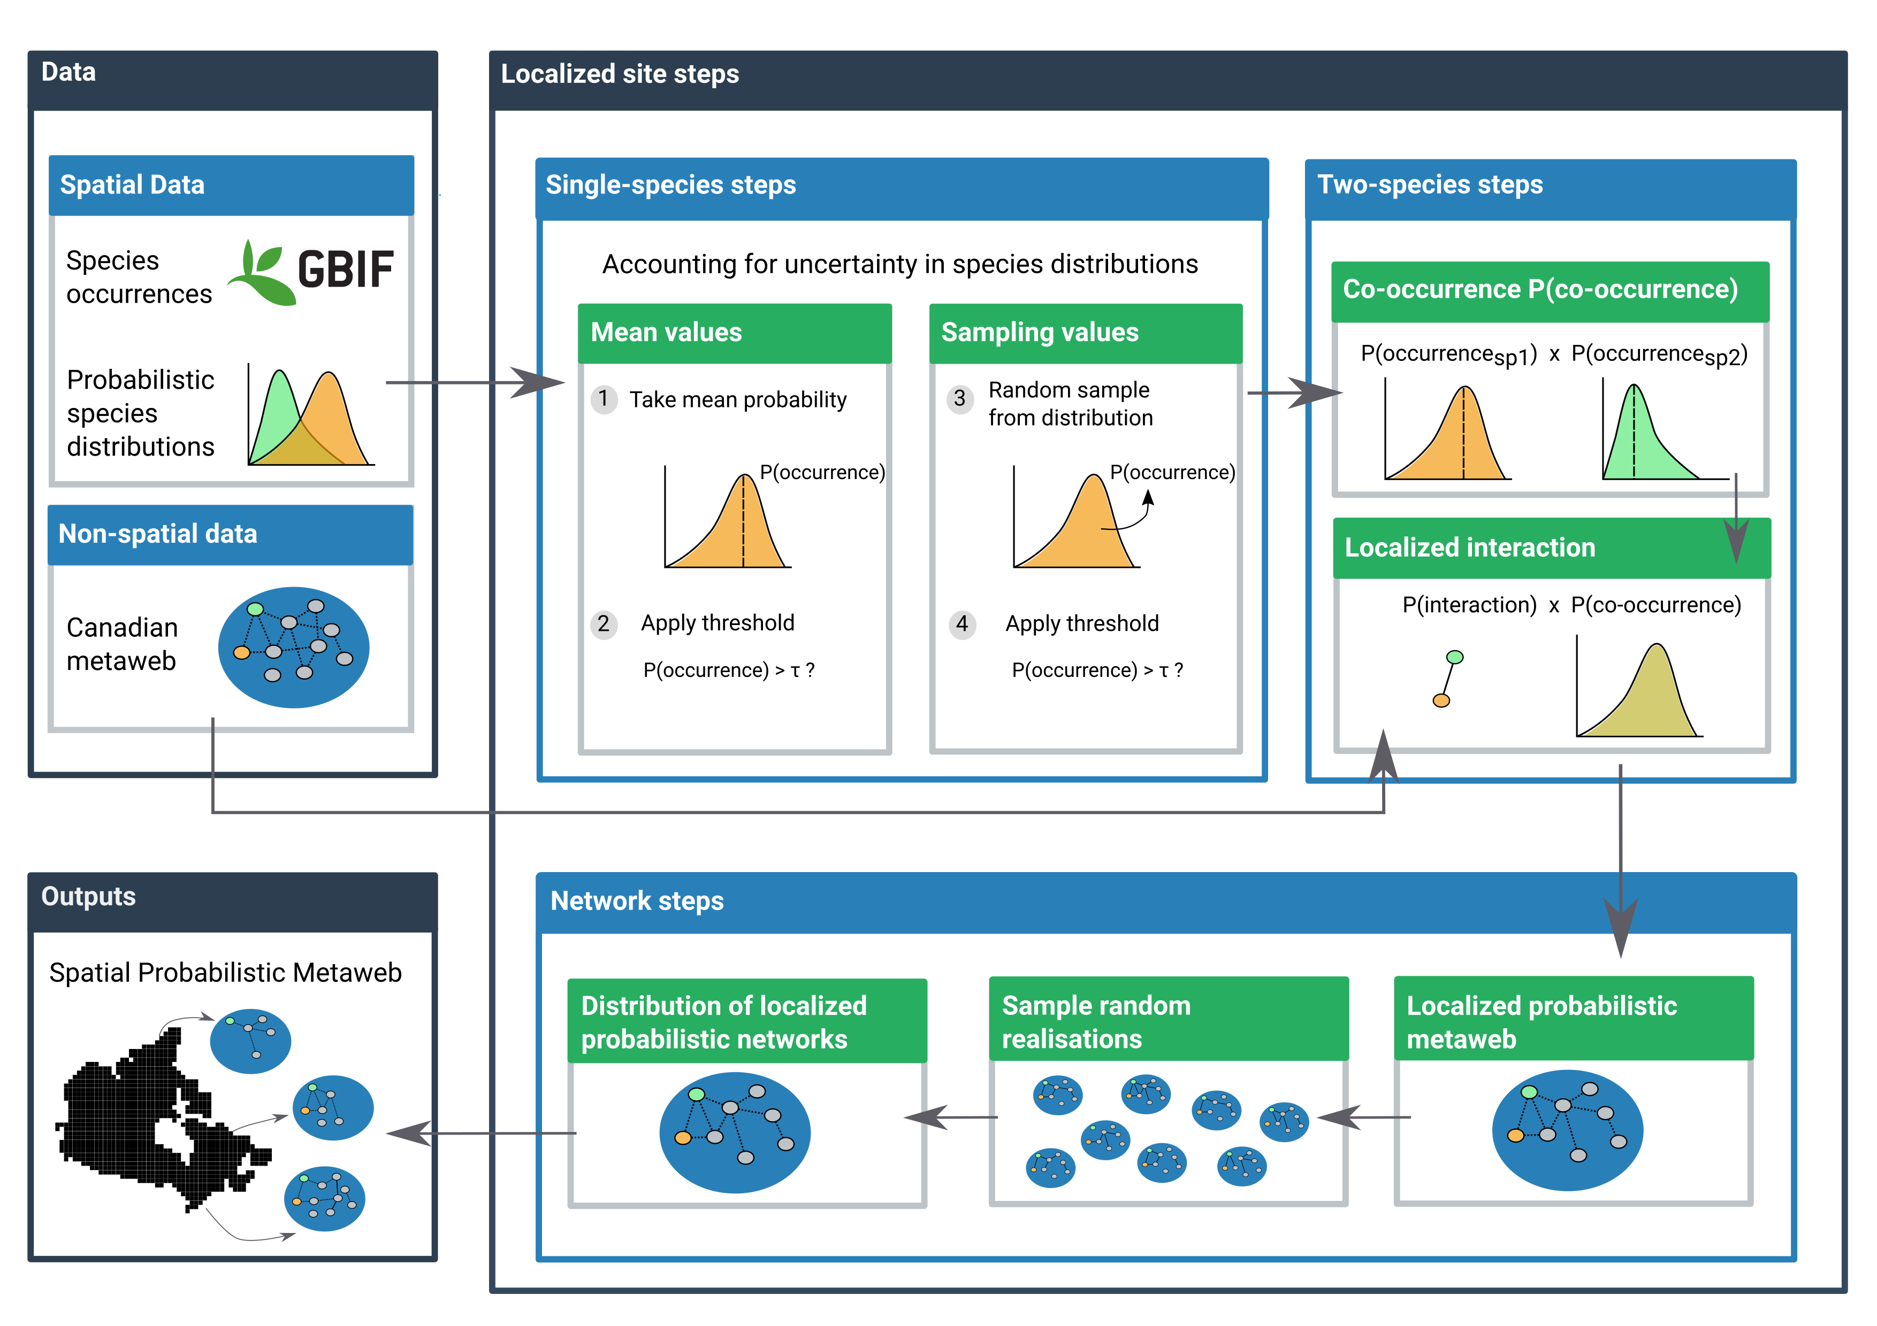
Figure 1: Conceptual figure of the proposed workflow used to downscale the probabilistic metaweb in space. The workflow has three components: the data, the localized steps, and the final spatial output. The data are composed of spatial data (with information in every cell) and non-spatial data (constant for all of Canada). The localized steps use these data and are performed separately in every cell, first at a single-species level (using distribution data), then for every species pair (adding interaction data from the metaweb), and finally at the network level by combining the results of all species pairs. The final output of the network-level steps contains a downscaled probabilistic metaweb for every cell across the study extent.

Data

Metaweb
The main source of interaction data was the metaweb for Canadian mammals from Strydom et al. (2022a), which is a-spatial, i.e., it represents interactions between mammals that can occur anywhere in Canada. The species list for the Canadian metaweb was extracted from the International Union for the Conservation of Nature (IUCN) checklist (Strydom et al. 2022a). Briefly, the metaweb was developed using graph embedding and phylogenetic transfer learning based on the metaweb of European terrestrial mammals, which is itself based on a comprehensive survey of interactions reported in the scientific literature (Maiorano et al. 2020). The Canadian metaweb is probabilistic, which has the advantage of reflecting the likelihood of an interaction taking place given the phylogenetic and trait match between two species. This allows incorporating interaction variability between species (i.e., taking into account that two species may not always interact whenever or wherever they occur); however, we highlight that other factors beyond trait and phylogenetic matching (e.g., population densities) will also contribute to observed interaction frequencies.

Species occurrences
The downscaling of the metaweb involved combining it with species occurrence and environmental data. First, we extracted species occurrences from the Global Biodiversity Information Facility (GBIF; www.gbif.org) for the Canadian mammals after reconciling species names between the Canadian metaweb and GBIF using the GBIF Backbone Taxonomy (GBIF Secretariat 2021). This step removed potential duplicates by combining species listed in the Canadian metaweb which were considered as a single entity by GBIF. We collected occurrences for the updated species list (159 species) using the GBIF download API on October 21st 2022 (GBIF.org 2022). We restricted our query to occurrences with coordinates between longitudes 175°W to 45°W and latitudes 10°N to 90°N. This was meant to collect training data covering a broader range than our prediction target (Canada only) and include observations in similar environments. Then, since GBIF observations represent presence-only data and most predictive models require absence data, we generated pseudo-absence data using the surface range envelope method, which selects random non-observed sites within the spatial range delimited by the presence data (Barbet-Massin et al. 2012).

Environmental data
We used species distribution models (SDMs, Guisan & Thuiller 2005) to project Canadian mammal habitat suitability across the country, which we treated as information on potential distribution. For each species, we related occurrences and pseudo-absences with 19 bioclimatic variables from CHELSA (Karger et al. 2017) and 12 consensus land-cover variables from EarthEnv (Tuanmu & Jetz 2014). The CHELSA bioclimatic variables (bio1-bio19) represent various measures of temperature and precipitation (e.g., annual averages, monthly maximum or minimum, seasonality) and are available for land areas across the globe. We used the most recent version, the CHELSA v2.1 dataset (Karger et al. 2021), and subsetted it to land surfaces only using the CHELSA v1.2 (Karger et al. 2018), which does not cover open water. The EarthEnv land-cover variables represent classes such as Evergreen broadleaf trees, Cultivated and managed vegetation, Urban/Built-up, and Open Water. Values range between 0 and 100 and represent the consensus prevalence of each class in percentage within a pixel (hereafter called sites). We coarsened both the CHELSA and EarthEnv data from their original 30 arc-second resolution to a 2.5 arc-minute one (around 4.5 km at the Equator) using GDAL (GDAL/OGR contributors 2021). This resolution compromised capturing both local variations and broad-scale patterns while limiting computation costs to a manageable level as memory requirements rapidly increase with spatial resolution.

Analyses

Species distribution models
Our selection criteria for choosing an SDM algorithm was to have a method that generated probabilistic results (similar to Gravel et al. 2019), including both a probability of occurrence for a species in a specific site and the uncertainty associated with the prediction. These were crucial to obtaining a probabilistic version of the metaweb as they were used to create spatial variations in the localized interaction probabilities (see next section). One suitable method for this is Gradient Boosted Trees with a Gaussian maximum likelihood from the EvoTrees.jl Julia package (https://github.com/Evovest/EvoTrees.jl). This method returns a prediction for every site with an average value and a standard deviation, which we used as a measure of uncertainty to build a Normal distribution for the probability of occurrence of a given species at all sites (represented as probability distributions on Fig. 1). We trained models across the extent chosen for occurrences (longitudes 175°W to 45°W and latitudes 10°N to 90°N), then predicted species distributions only for Canada. We used the 2021 Census Boundary Files from Statistics Canada (Statistics Canada 2022) to set the boundaries for our predictions, which gave us 970,698 sites in total. Performance evaluation for the single species SDMs are available on GitHub.

Building site-level instances of the metaweb
The next part of the workflow was to produce local metawebs for every site (Localized steps box on Fig. 1). This component was divided into single-species, two-species, and network-level steps.
The single-species steps represented four possible ways to account for uncertainty in the species distributions and bring variation to the spatial metaweb. We explored four different options to select a value (P(occurrence); Fig. 1) from the occurrence distributions obtained in the previous steps: 1) taking the mean from the distribution as the probability of occurrence (option 1 in Fig. 1); 2) converting the mean value to a binary one using a specific threshold per species (option 2); 3) sampling a random value within the Normal distribution (option 3); or 4) converting a random value into a binary result (option 4, using a separate draw from option 3 and the same threshold as in option 2). The threshold ( in Fig. 1) used was the value that maximized Youden’s J informedness statistic (Youden 1950), the same metric used by Strydom et al. (2022a) at an intermediate step while building the metaweb. The four sampling options were intended to explore how uncertainty and variation in the species distributions can affect the metaweb result. We expected thresholding to have a more pronounced effect on network structure as it should reduce the number of links by removing many of the rare interactions (Poisot et al. 2016). On the other hand, we expected random sampling to create higher spatial heterogeneity compared to the mean probabilities, as including some extreme values should confound the potential effects of environmental gradients. We chose option 1 to present our results as it is intuitive and essentially represents the result of a probabilistic SDM (as in Gravel et al. 2019), but results obtained with other sampling strategies are available in Supplementary Material, Fig. S1.
Next, the two-species steps were aimed at assigning a probability of observing an interaction between two species in a given site. For each species pair, we multiplied the product of the two species’ occurrence probabilities (P(co-occurrence); Fig. 1) (obtained using one of the sampling options above) by their interaction probability in the Canadian metaweb. For cases where species in the Canadian metaweb were considered as the same species by the GBIF Backbone Taxonomy (the reconciliation step mentioned earlier), we used the highest interaction probabilities involving the duplicated species.
The network-level steps then created the probabilistic metaweb for the site. We assembled all the local interaction probabilities (from the two-species steps) into a probabilistic network (Poisot et al. 2016). We then sampled several random network realizations to represent the potential local realization process (Poisot et al. 2015). This resulted in a distribution of localized networks, which we averaged over the number of simulations to obtain a single probabilistic network for the site.

Downscaled metaweb
The final output of our workflow was the downscaled metaweb, which contains a localized probabilistic metaweb in every site across the study area (Outputs box in Fig. 1). The metaweb sets an upper bound on the potential interactions (Strydom et al. 2022b), therefore, the downscaled metaweb is a refined upper boundary at the local scale that takes into account co-occurrences. It is still potential in nature and differs from a local realization, from which it should have a different structure. Nonetheless, from the downscaled metaweb, we can create maps of network properties (e.g. number of links, connectance) measured on the local probabilities of species interactions and occurrences, and compute some traditional community-level measures such as species richness. We chose to compute and display the expected number of links (measured on probabilistic networks following Poisot et al. 2016; see Gravel et al. 2019 for a similar example) as its relationship with species richness has been highlighted in a spatial context in recent studies (Galiana et al. 2021, 2022). We also computed the uncertainty associated with the community and network measurements (richness variance and link variance, respectively) and compared their spatial distribution (see Supplementary Material).

Analyses of results by ecoregions
Since both species composition and network summary values display a high spatial variation and complex patterns, we simplified the representation of their distribution by grouping sites by ecoregion, as species and interaction composition have been shown to differ between ecoregions across large spatial scales (Martins et al. 2022). To do so, we rasterized the Canadian subset of the global map of ecoregions from (Dinerstein et al. 2017; also used by Martins et al. 2022), which resulted in 44 different ecoregions. For every measure we report (e.g. species richness, number of links), we calculated the median site value for each ecoregion, as a way to avoid bias due to long tails in the distributions. We also measured within-ecoregion variation as the 89% interquantile range of the site values in each ecoregion (threshold chosen to avoid confusion with conventional significance tests; McElreath 2020).

Analyses of ecological uniqueness
We compared the compositional uniqueness of the networks and the communities to assess whether they indicated areas of exceptional composition. We measured uniqueness using the local contributions to beta diversity (LCBD, Legendre & De Cáceres 2013), which identify sites with exceptional composition by quantifying how much one site contributes to the total variance in the community composition. While many studies used LCBD values to evaluate uniqueness on local scales or few study sites (for example, da Silva & Hernández 2014; Heino & Grönroos 2017), recent studies used the measure on predicted species compositions over broad spatial extents and a large number of sites (Dansereau et al. 2022; Vasconcelos et al. 2018). LCBD values can also be used to measure uniqueness for networks by computing the values over the adjacency matrix, which has been shown to capture more unique sites and uniqueness variability than through species composition (Poisot et al. 2017). Here, we measured and compared the uniqueness of our localized community and network predictions. For species composition, we assembled a site-by-species community matrix with the probability of occurrence at every site from the species distribution models. For network composition, we assembled a site-by-interaction matrix with the localized interaction values from the spatial probabilistic metaweb. We applied the Hellinger transformation on both matrices and computed the LCBD values from the total variance in the matrices (Legendre & De Cáceres 2013). High LCBD values indicate a high contribution to the overall variance and a unique species or interaction composition compared to other sites. Since the values themselves are very low given our high number of sites (as in Dansereau et al. 2022), what matters primarily is the magnitude of the difference between the sites. Given this, we divided values by the maximum value in each matrix (species or network) and suggest that these should be viewed as relative contributions compared to the highest observed contribution. As with other measures, we then summarized the local uniqueness values by ecoregion by taking the median LCBD value and measuring the 89% interquantile range.
We used Julia v1.9.0 (Bezanson et al. 2017) to implement all our analyses. We used packages GBIF.jl (Dansereau & Poisot 2021) to reconcile species names using the GBIF Backbone Taxonomy, SpeciesDistributionToolkit.jl (https://github.com/PoisotLab/SpeciesDistributionToolkit.jl) to handle raster layers, species occurrences and generate pseudoabsences, EvoTrees.jl (https://github.com/Evovest/EvoTrees.jl) to perform the Gradient Boosted Trees, EcologicalNetworks.jl (Poisot et al. 2019) to analyze network and metaweb structure, and Makie.jl (Danisch & Krumbiegel 2021) to produce figures. Our data sources (CHELSA, EarthEnv, Ecoregions) were all unprojected, and we did not use a projection in our analyses. However, we displayed the results using a Lambert conformal conic projection more appropriate for Canada using GeoMakie.jl (https://github.com/MakieOrg/GeoMakie.jl). All the code used to implement our analyses is archived on Zenodo (https://doi.org/10.5281/zenodo.8350065) and includes instructions on how to run a smaller example at a coarser resolution. Note that running our analyses at full scale is resource and memory-intensive and required the use of computer clusters provided by Calcul Québec and the Digital Research Alliance of Canada. Full-scale computations required 900 CPU core-hours and peaked at 500 GB of RAM.

Results
Our workflow allowed us to display the spatial distribution of ecoregion-level community measures (here, expected species richness) and network measures (expected number of links; Fig. 2). We highlight that the community and network-level measures presented here are not actual predictions of the measure itself (e.g., we do not present a prediction of actual species richness at each location). Instead, they are the reflection of these metrics from the localized predictions of the communities and networks obtained from the downscaling of the metaweb, then summarized for the ecoregions (using the median value). Expected ecoregion richness (Fig. 2A) and expected number of links (Fig. 2B) displayed similar distributions with a latitudinal gradient and higher values in the south. However, within-ecoregion variability was distributed differently, as some ecoregions along the coast displayed higher interquantile ranges, while ecoregions around the southern border displayed narrower ones (Fig. 2C-D). All results shown are based on the first sampling strategy (option 1) mentioned in the Building site-level instances of the metaweb section, where we used the mean value of the species distributions as the species occurrence probabilities (results for other sampling strategies are shown in Supplementary Material, Fig. S1). Site-level results (before summarizing by ecoregion) are also provided in Supplementary Material (Figs. S2-S5).
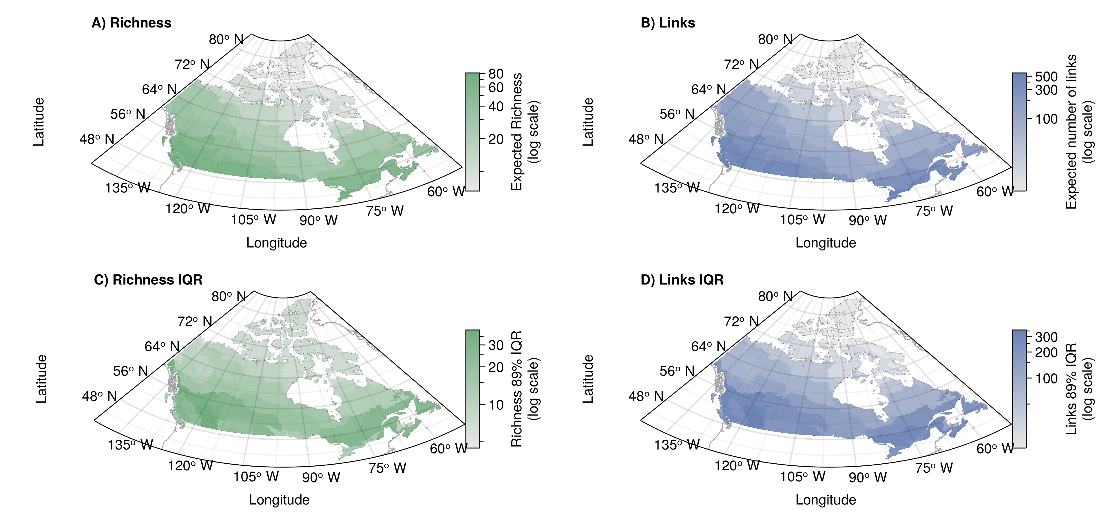
Figure 2: (A-B) Example of a community measure (A, expected species richness) and a network one (B, expected number of links). Both measures are assembled from the predicted probabilistic communities and networks, respectively. Values are first measured separately for all sites; then, the median value within each ecoregion was taken to represent the ecoregion-level value. (C-B) Representation of the 89% interquantile range of values within the ecoregion for expected richness (C) and expected number of links (D).
Direct comparison of the spatial distributions of species richness and expected number of links showed some areas with mismatches, both regarding the median estimates and regarding the within-ecoregion variability (Fig. 3). Median values for the ecoregions showed a similar bivariate distribution, with ecoregions in the south mostly displaying high species richness and a high number of links (Fig. 3A). The northernmost ecoregions (Canadian High Artic Tundra and Davis Highlands Tundra) displayed higher richness (based on the quantile rank) compared to the number of links. Inversely, ecoregions further south (Canadian Low Artic Tundra, Northern Canadian Shield Taiga, Southern Hudson Bay Taiga) ranked higher for the number of links than for species richness. On the other hand, within-ecoregion variability showed different bivariate relationships and a less constant latitudinal gradient (Fig. 3B). This indicates that richness and links do not co-vary completely (i.e. their variability is not highly correlated) although they may show similar distributions for median values.
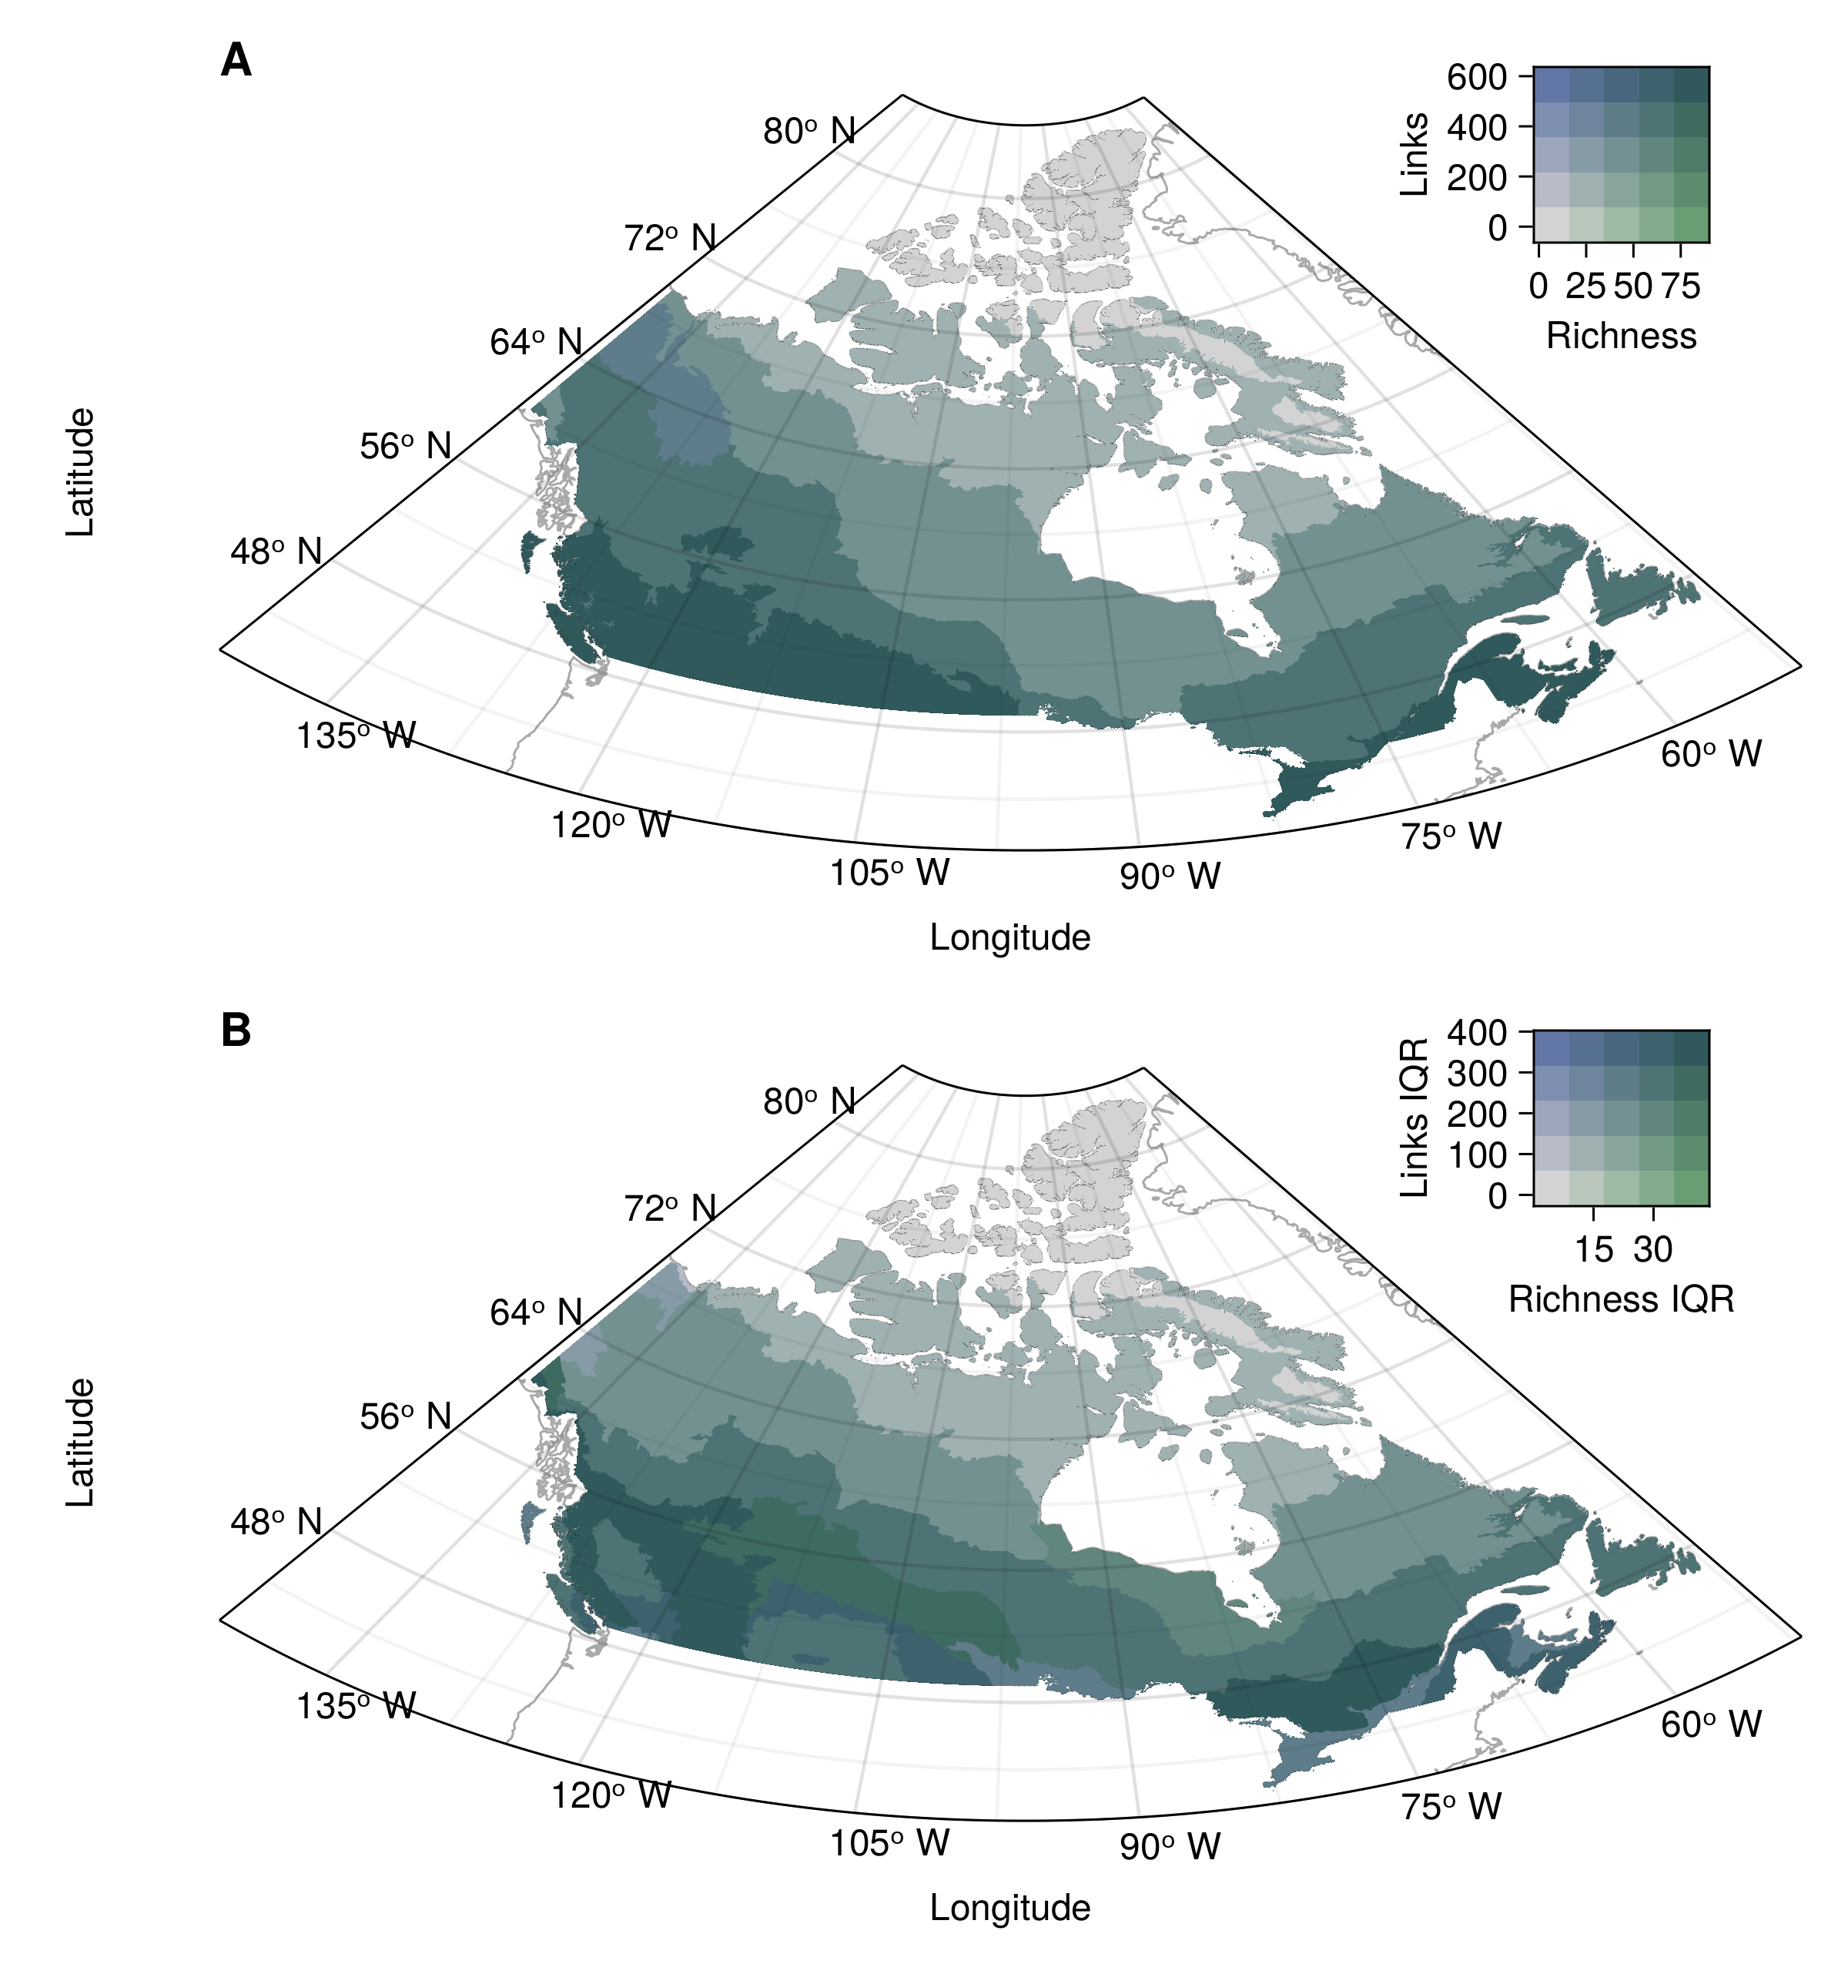
Figure 3: Bivariate relationship between community and network measures for the median ecoregion value (A) and the within-ecoregion 89% interquantile range (B). Values are grouped into three quantiles separately for each variable. The colour combinations represent the nine possible combinations of quantiles. Species richness (horizontal axis) goes left to right from low (light grey, bottom left) to high (green, bottom right). The number of links goes bottom-up from low (light grey, bottom left) to high (blue, top left).
Our results also indicate a mismatch between the uniqueness of communities and networks (Fig. 4). Uniqueness was higher mostly in the north and along the south border for communities, but only in the north for networks (Fig. 4A-B). Consequently, ecoregions with both unique community composition and unique network composition were mostly in the north (Fig. 4C). Meanwhile, some areas were unique for one element but not the other. For instance, the New England-Acadian forests ecoregion (south-east, near 70°W and 48°N) had a highly unique species composition but a more common network composition (Fig. 4C). Opposite areas with unique network compositions only were observed at higher between latitudes 52°N and 70°N (Eastern Canadian Shield Taiga, Northern Canadian Shield Taiga, Canadian Low Artic Tundra). Also, network uniqueness values for ecoregions spanned a narrower range between the 44 ecoregions than species LCBD values (Fig. 4D, left). Within-ecoregion variation was also lower for network values with generally lower 89% interquantile ranges among the site-level LCBD values (Fig. 4D, right). Moreover, mismatched sites (unique for only one element) formed two distinct groups when evaluating the relationship between species richness and the number of links (see Supplementary Material, Fig. S5). The areas only unique for their species composition had both a high richness and number of links. On the other hand, the sites only unique for their networks had both lower richness and a lower number of links, although they were not the sites with the lowest values for both.
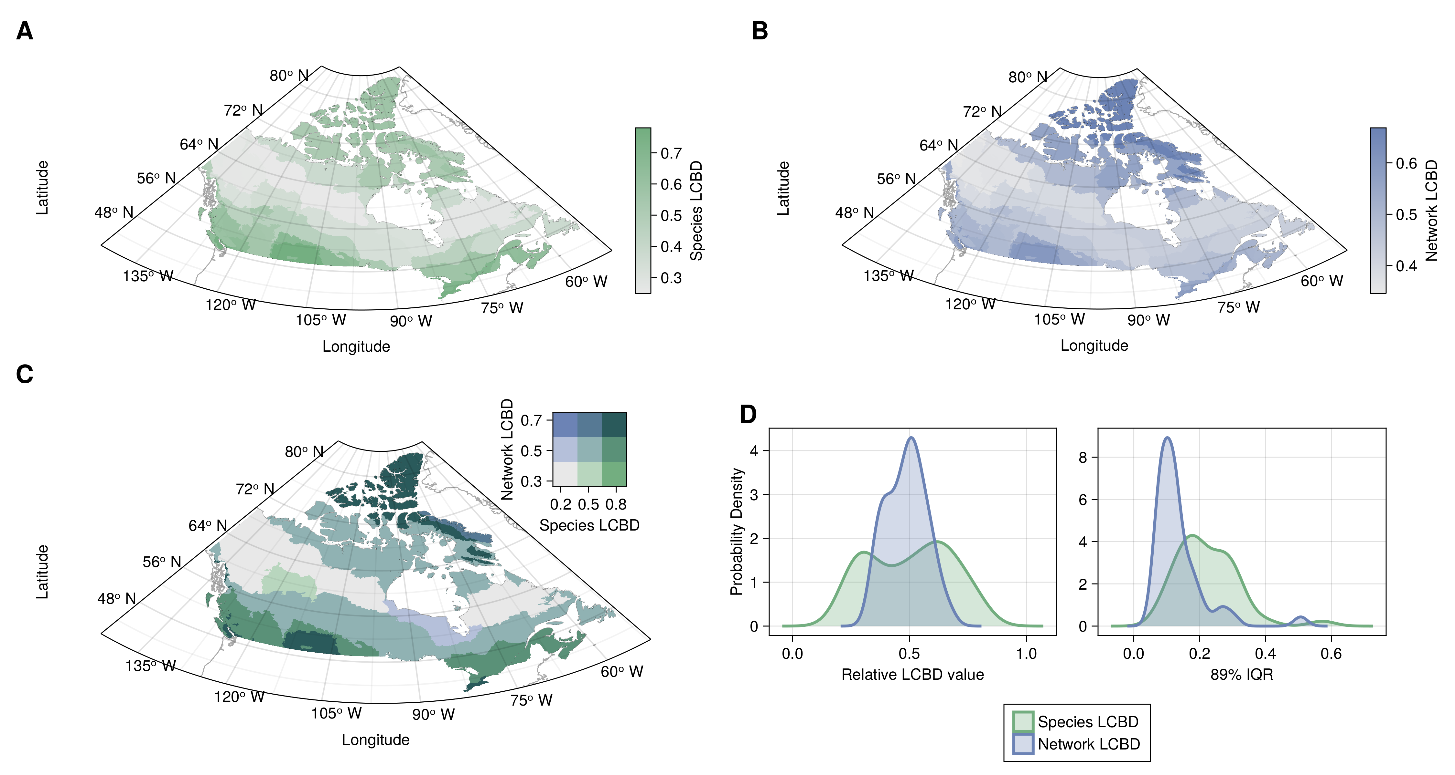
Figure 4: (A-B) Representation of the ecoregion uniqueness values based on species composition (a) and network composition (b). LCBD values were first computed across all sites and scaled relative to the maximum value observed. The ecoregion LCBD value is the median value for the sites in the ecoregion. (C) Bivariate representation of species and network composition LCBD. Values are grouped into three quantiles separately for each variable. The colour combinations represent the nine possible combinations of quantiles. The species uniqueness (horizontal axis) goes left to right from low uniqueness (light grey, bottom left) to high uniqueness (green, bottom right). The network composition uniqueness goes bottom-up from low uniqueness (light grey, bottom left) to high uniqueness (blue, top left). (D) Probability densities for the ecoregion LCBD values for species and network LCBD (left), highlighting the variability of the LCBD between ecoregions, and the 89% interquartile range of the values within each ecoregion (right), highlighting the variability within the ecoregions.

Discussion
Our approach presents a way to downscale a metaweb, produce localized predictions using probabilistic networks as inputs and outputs, and incorporate uncertainty, as called for by Strydom et al. (2022b). It gives us an idea of what local metawebs or networks could look like in space, given species distributions and their variability, as well as the uncertainty around species interactions. We also provide the first spatial representation of the metaweb of Canadian mammals (Strydom et al. 2022a) and a probabilistic equivalent to how the European tetrapod metaweb (Maiorano et al. 2020) was used to predict localized networks in Europe (Botella et al. 2023; Braga et al. 2019; Galiana et al. 2021; Gaüzère et al. 2022; O’Connor et al. 2020). Therefore, our approach could open similar possibilities of investigations on the variation of structure in space (Braga et al. 2019) and on the effect of land-use intensification (Botella et al. 2023) on North American food webs, particularly Canadian mammal food webs. Other interesting research applications include assessing climate change impacts on network structure (e.g., Kortsch et al. 2015) or investigating linkages between network structure and stability (Windsor et al. 2023).
As our approach is probabilistic, it does not assume species interact whenever they co-occur and incorporates variability based on environmental conditions (via projected species distributions), which could lead to different results by introducing a different association between species richness and network properties. Galiana et al. (2021) found that species richness had a large explanatory power over network properties, but mentioned this could potentially be due to interactions between species being constant across space. Here, we found mismatches in the distribution of species richness and interactions that were especially apparent in their within-ecoregion variability (Fig. 3), highlighting that interactions might vary differently than species distributions even over continental-scale gradients. Network density (links on Fig. 3A) were also lower in the north, contrarily to what was observed for all European terrestrial tetrapods (Braga et al. 2019; Galiana et al. 2021) and for willow-galler-parasitoid networks (Gravel et al. 2019), where connectance was higher in northern regions. Further research should investigate why these results might differ between the two continents and whether it is due to the methodology, data, or biogeographical processes.
Our LCBD and uniqueness results highlighted that areas with unique network composition differ from sites with unique species composition. In other words, the joint distribution of community and network uniqueness highlights different diversity hotspots. Poisot et al. (2017) showed a similar result with host-parasite communities of rodents and ectoparasitic fleas. Our results further show how these differences could be distributed across ecoregions and in a broad spatial extent. Areas unique for only one element (species or network composition) differed in their combination of species richness and number of links (Supplementary Material, Fig. S5), with species-unique sites displaying high values of both measures, and network-unique sites displaying low values. Moreover, LCBD scores essentially highlight variability hotspots and are a measure of the variance of community or network structure. Here, they also serve as an inter-ecoregion variation measure, which can be compared to the within-ecoregion variation highlighted by the interquantile ranges. The narrower range of values for network LCBD values and the lower IQR values indicate that both the inter-ecoregion and within-ecoregion variation are lower for networks than for species (Fig. 4). Additionally, higher values for network LCBD also indicate that most ecoregions can hold ecologically unique sites.
When to use the workflow we presented here will depend on the availability of interaction data or existing metawebs, and on the intent to incorporate interaction variability, as well as ecoregion-level variability. In systems where in situ interaction and complete network data are available, the approach put forward by Gravel et al. (2019) achieves a similar purpose as we attempted here, but is more rigourous and allows modelling the effect of the environment on the interactions themselves. Without such data, establishing or predicting the metaweb should be the first step toward producing localized predictions (Strydom et al. 2022b). Well-documented binary metawebs such as the European tetrapod metaweb could be partly combined with our approach if used with probabilistic SDMs and summarized by ecoregions (as they would only lack an initial probabilistic metaweb, but would still obtain a more probabilistic output). Our approach will essentially differ from previous attempts in how it perceives uncertainty and variability. For instance, rare interactions should not be over-represented (Poisot et al. 2016) and should have lesser effects over computed network measures. Furthermore, summarizing results by ecoregion allows for showing variation within and between ecologically meaningful biogeographic boundaries (Martins et al. 2022), which, as our results showed, is not constant across space and can help identify contrasting diversity hotspots.
The recent shift in focus towards building metawebs opens many opportunities for projections of networks in space through probabilistic downscaling, as we suggested here. Metawebs have been documented in many systems, allowing us to build new ones from predictions. How the European tetrapod metaweb (Maiorano et al. 2020) was used to predict the Canadian mammal metaweb (Strydom et al. 2022a) is one such case, but recent examples also extend to other systems. Metawebs have been compiled for many marine food webs (e.g., Barents Sea, Kortsch et al. 2019; North Scotia Sea, López-López et al. 2022; Gulf of Riga, Kortsch et al. 2021) and used to predict the probability of novel interactions (Artic food web of the Barents sea, Pecuchet et al. 2020). Olivier et al. (2019) built a temporally resolved metaweb of demersal fish and benthic epifauna but also suggested combining their approach with techniques estimating the probability of occurrence of trophic relationships to describe spatial and temporal variability more accurately. Lurgi et al. (2020) built a metaweb and probabilistic (occurrence-based) networks for rocky intertidal communities (and also showed that environmental factors do not affect the structure of binary and probabilistic networks in different ways). Albouy et al. (2019) predicted the global marine fish food web using a probabilistic model, showing the potential to describe networks across broad spatial scales. Similarly, predictive approaches are also increasingly used with other interaction types to highlight interactions hotspots on global scales (e.g. mapping geographical hotspots of predicted host-virus interactions between bats and betacoronaviruses, Becker et al. 2022; predicting the distribution of hidden interactions in the mammalian virome, Poisot et al. 2023). Our workflow offers the potential to bring these global predictions down to the local scale where they can be made more actionable, and vastly increases the diversity of ecological networks that can be projected in space.

Acknowledgements
We acknowledge that this study was conducted on land within the traditional unceded territory of the Saint Lawrence Iroquoian, Anishinabewaki, Mohawk, Huron-Wendat, and Omàmiwininiwak nations. GD is funded by the NSERC Postgraduate Scholarship – Doctoral (grant ES D – 558643), the FRQNT doctoral scholarship (grant no. 301750), and the NSERC CREATE BIOS² program. TP is funded by the Wellcome Trust (223764/Z/21/Z), NSERC through the Discovery Grant and Discovery Accelerator Supplements programs, and the Courtois Foundation. This research was enabled in part by support provided by Calcul Québec (calculquebec.ca) and the Digital Research Alliance of Canada (alliance​can​.ca) through the Narval general purpose cluster.

References
Albouy, C., Archambault, P., Appeltans, W., Araújo, M.B., Beauchesne, D., Cazelles, K., et al. (2019). The marine fish food web is globally connected. Nature Ecology & Evolution, 3, 1153–1161.
Baiser, B., Gravel, D., Cirtwill, A.R., Dunne, J.A., Fahimipour, A.K., Gilarranz, L.J., et al. (2019). Ecogeographical rules and the macroecology of food webs. Global Ecology and Biogeography, geb.12925.
Barbet-Massin, M., Jiguet, F., Albert, C.H. & Thuiller, W. (2012). Selecting pseudo-absences for species distribution models: How, where and how many? Methods in Ecology and Evolution, 3, 327–338.
Becker, D.J., Albery, G.F., Sjodin, A.R., Poisot, T., Bergner, L.M., Chen, B., et al. (2022). Optimising predictive models to prioritise viral discovery in zoonotic reservoirs. The Lancet Microbe, 3, e625–e637.
Bezanson, J., Edelman, A., Karpinski, S. & Shah, V.B. (2017). Julia: A fresh approach to numerical computing. SIAM Review, 59, 65–98.
Botella, C., Gaüzère, P., O’Connor, L., Ohlmann, M., Renaud, J., Dou, Y., et al. (2023). Land-use intensity influences European tetrapod food-webs (Preprint). Authorea.
Braga, J., Pollock, L.J., Barros, C., Galiana, N., Montoya, J.M., Gravel, D., et al. (2019). Spatial analyses of multi-trophic terrestrial vertebrate assemblages in Europe. Global Ecology and Biogeography, 28, 1636–1648.
da Silva, P.G. & Hernández, M.I.M. (2014). Local and regional effects on community structure of dung beetles in a mainland-island scenario. PLOS ONE, 9, e111883.
Danisch, S. & Krumbiegel, J. (2021). Makie.jl: Flexible high-performance data visualization for Julia. Journal of Open Source Software, 6, 3349.
Dansereau, G., Legendre, P. & Poisot, T. (2022). Evaluating ecological uniqueness over broad spatial extents using species distribution modelling. Oikos, 2022, e09063.
Dansereau, G. & Poisot, T. (2021). SimpleSDMLayers.jl and GBIF.jl: A framework for species distribution modeling in Julia. Journal of Open Source Software, 6, 2872.
Desjardins-Proulx, P., Laigle, I., Poisot, T. & Gravel, D. (2017). Ecological interactions and the Netflix problem. PeerJ, 5, e3644.
Dinerstein, E., Olson, D., Joshi, A., Vynne, C., Burgess, N.D., Wikramanayake, E., et al. (2017). An Ecoregion-Based Approach to Protecting Half the Terrestrial Realm. BioScience, 67, 534–545.
Dunne, J. (2006). The network structure of food webs. In: Ecological Networks: Linking Structure to Dynamics in Food Webs. pp. 27–86.
Frelat, R., Kortsch, S., Kröncke, I., Neumann, H., Nordström, M.C., Olivier, P.E.N., et al. (2022). Food web structure and community composition: A comparison across space and time in the North Sea. Ecography, 2022.
Galiana, N., Barros, C., Braga, J., Ficetola, G.F., Maiorano, L., Thuiller, W., et al. (2021). The spatial scaling of food web structure across European biogeographical regions. Ecography, 44, 653–664.
Galiana, N., Lurgi, M., Bastazini, V.A.G., Bosch, J., Cagnolo, L., Cazelles, K., et al. (2022). Ecological network complexity scales with area. Nature Ecology & Evolution, 1–8.
Gaüzère, P., O’Connor, L., Botella, C., Poggiato, G., Münkemüller, T., Pollock, L.J., et al. (2022). The diversity of biotic interactions complements functional and phylogenetic facets of biodiversity. Current Biology.
GBIF Secretariat. (2021). GBIF Backbone Taxonomy.
GBIF.org. (2022). GBIF occurrence download.
GDAL/OGR contributors. (2021). GDAL/OGR geospatial data abstraction software library. Manual. Open Source Geospatial Foundation.
Gravel, D., Baiser, B., Dunne, J.A., Kopelke, J.-P., Martinez, N.D., Nyman, T., et al. (2019). Bringing Elton and Grinnell together: A quantitative framework to represent the biogeography of ecological interaction networks. Ecography, 42, 401–415.
Guisan, A. & Thuiller, W. (2005). Predicting species distribution: Offering more than simple habitat models. Ecology Letters, 8, 993–1009.
Heino, J. & Grönroos, M. (2017). Exploring species and site contributions to beta diversity in stream insect assemblages. Oecologia, 183, 151–160.
Hortal, J., de Bello, F., Diniz-Filho, J.A.F., Lewinsohn, T.M., Lobo, J.M. & Ladle, R.J. (2015). Seven Shortfalls that Beset Large-Scale Knowledge of Biodiversity. Annual Review of Ecology, Evolution, and Systematics, 46, 523–549.
Jordano, P. (2016). Sampling networks of ecological interactions. Functional Ecology, 30, 1883–1893.
Karger, D.N., Conrad, O., Böhner, J., Kawohl, T., Kreft, H., Soria-Auza, R.W., et al. (2017). Climatologies at high resolution for the earth’s land surface areas. Scientific Data, 4, 170122.
Karger, D.N., Conrad, O., Böhner, J., Kawohl, T., Kreft, H., Soria-Auza, R.W., et al. (2018). Data from: Climatologies at high resolution for the earth’s land surface areas.
Karger, D.N., Conrad, O., Böhner, J., Kawohl, T., Kreft, H., Soria-Auza, R.W., et al. (2021). Climatologies at high resolution for the earth’s land surface areas.
Kortsch, S., Frelat, R., Pecuchet, L., Olivier, P., Putnis, I., Bonsdorff, E., et al. (2021). Disentangling temporal food web dynamics facilitates understanding of ecosystem functioning. Journal of Animal Ecology, 90, 1205–1216.
Kortsch, S., Primicerio, R., Aschan, M., Lind, S., Dolgov, A.V. & Planque, B. (2019). Food-web structure varies along environmental gradients in a high-latitude marine ecosystem. Ecography, 42, 295–308.
Kortsch, S., Primicerio, R., Fossheim, M., Dolgov, A.V. & Aschan, M. (2015). Climate change alters the structure of arctic marine food webs due to poleward shifts of boreal generalists. Proceedings of the Royal Society B: Biological Sciences, 282, 20151546.
Legendre, P. & De Cáceres, M. (2013). Beta diversity as the variance of community data: Dissimilarity coefficients and partitioning. Ecology Letters, 16, 951–963.
López-López, L., Genner, M.J., Tarling, G.A., Saunders, R.A. & O’Gorman, E.J. (2022). Ecological Networks in the Scotia Sea: Structural Changes Across Latitude and Depth. Ecosystems, 25, 457–470.
Lucas, P., Thuiller, W., Talluto, M., Polaina, E., Albrecht, J., Selva, N., et al. (2023). Including biotic interactions in species distribution models improves the understanding of species niche: A case of study with the brown bear in Europe.
Lurgi, M., Galiana, N., Broitman, B.R., Kéfi, S., Wieters, E.A. & Navarrete, S.A. (2020). Geographical variation of multiplex ecological networks in marine intertidal communities. Ecology, 101, e03165.
Maiorano, L., Montemaggiori, A., Ficetola, G.F., O’Connor, L. & Thuiller, W. (2020). TETRA-EU 1.0: A species-level trophic metaweb of European tetrapods. Global Ecology and Biogeography, 29, 1452–1457.
Martins, L.P., Stouffer, D.B., Blendinger, P.G., Böhning-Gaese, K., Buitrón-Jurado, G., Correia, M., et al. (2022). Global and regional ecological boundaries explain abrupt spatial discontinuities in avian frugivory interactions. Nature Communications, 13, 6943.
McElreath, R. (2020). Statistical rethinking: A bayesian course with examples in R and Stan. Second. Chapman and Hall/CRC, New York.
McLeod, A., Leroux, S.J., Gravel, D., Chu, C., Cirtwill, A.R., Fortin, M.-J., et al. (2021). Sampling and asymptotic network properties of spatial multi-trophic networks. Oikos, 130, 2250–2259.
Mestre, F., Gravel, D., García-Callejas, D., Pinto-Cruz, C., Matias, M.G. & Araújo, M.B. (2022). Disentangling food-web environment relationships: A review with guidelines. Basic and Applied Ecology, 61, 102–115.
Moens, M., Biesmeijer, J., Huang, E., Vereecken, N. & Marshall, L. (2022). The importance of biotic interactions in distribution models depends on the type of ecological relations, spatial scale and range.
Morales-Castilla, I., Matias, M.G., Gravel, D. & Araújo, M.B. (2015). Inferring biotic interactions from proxies. Trends in Ecology & Evolution, 30, 347–356.
O’Connor, L.M.J., Pollock, L.J., Braga, J., Ficetola, G.F., Maiorano, L., Martinez-Almoyna, C., et al. (2020). Unveiling the food webs of tetrapods across Europe through the prism of the Eltonian niche. Journal of Biogeography, 47, 181–192.
Olivier, P., Frelat, R., Bonsdorff, E., Kortsch, S., Kröncke, I., Möllmann, C., et al. (2019). Exploring the temporal variability of a food web using long-term biomonitoring data. Ecography, 42, 2107–2121.
Pecuchet, L., Blanchet, M.-A., Frainer, A., Husson, B., Jørgensen, L.L., Kortsch, S., et al. (2020). Novel feeding interactions amplify the impact of species redistribution on an Arctic food web. Global Change Biology, 26, 4894–4906.
Poggiato, G., Andréoletti, J., Shirley, L. & Thuiller, W. (2022). Integrating food webs in species distribution models improves ecological niche estimation and predictions (Preprint). Authorea.
Poisot, T., Bélisle, Z., Hoebeke, L., Stock, M. & Szefer, P. (2019). EcologicalNetworks.jl: Analysing ecological networks of species interactions. Ecography, 42, 1850–1861.
Poisot, T., Bergeron, G., Cazelles, K., Dallas, T., Gravel, D., MacDonald, A., et al. (2021). Global knowledge gaps in species interaction networks data. Journal of Biogeography, 48, 1552–1563.
Poisot, T., Canard, E., Mouillot, D., Mouquet, N. & Gravel, D. (2012). The dissimilarity of species interaction networks. Ecology Letters, 15, 1353–1361.
Poisot, T., Cirtwill, A.R., Cazelles, K., Gravel, D., Fortin, M.-J. & Stouffer, D.B. (2016). The structure of probabilistic networks. Methods in Ecology and Evolution, 7, 303–312.
Poisot, T., Guéveneux-Julien, C., Fortin, M.-J., Gravel, D. & Legendre, P. (2017). Hosts, parasites and their interactions respond to different climatic variables. Global Ecology and Biogeography, 26, 942–951.
Poisot, T., Ouellet, M.-A., Mollentze, N., Farrell, M.J., Becker, D.J., Brierley, L., et al. (2023). Network embedding unveils the hidden interactions in the mammalian virome. Patterns, 4, 100738.
Poisot, T., Stouffer, D.B. & Gravel, D. (2015). Beyond species: Why ecological interaction networks vary through space and time. Oikos, 124, 243–251.
Saravia, L.A., Marina, T.I., Kristensen, N.P., De Troch, M. & Momo, F.R. (2022). Ecological network assembly: How the regional metaweb influences local food webs. Journal of Animal Ecology, 91, 630–642.
Statistics Canada. (2022). Boundary files, reference guide second edition, Census year 2021. Second edition. Statistics Canada = Statistique Canada, Ottawa.
Strydom, T., Bouskila, S., Banville, F., Barros, C., Caron, D., Farrell, M.J., et al. (2022a). Food web reconstruction through phylogenetic transfer of low-rank network representation. Methods in Ecology and Evolution, 13, 2838–2849.
Strydom, T., Bouskila, S., Banville, F., Barros, C., Caron, D., Farrell, M.J., et al. (2022b). Predicting metawebs: Transfer of graph embeddings can help alleviate spatial data deficiencies.
Strydom, T., Catchen, M.D., Banville, F., Caron, D., Dansereau, G., Desjardins-Proulx, P., et al. (2021). A roadmap towards predicting species interaction networks (across space and time). Philosophical Transactions of the Royal Society B: Biological Sciences, 376, 20210063.
Tuanmu, M.-N. & Jetz, W. (2014). A global 1-km consensus land-cover product for biodiversity and ecosystem modelling. Global Ecology and Biogeography, 23, 1031–1045.
Vasconcelos, T.S., Nascimento, B.T.M. do & Prado, V.H.M. (2018). Expected impacts of climate change threaten the anuran diversity in the Brazilian hotspots. Ecology and Evolution, 8, 7894–7906.
Windsor, F.M., van den Hoogen, J., Crowther, T.W. & Evans, D.M. (2023). Using ecological networks to answer questions in global biogeography and ecology. Journal of Biogeography, 50, 57–69.
Wisz, M.S., Pottier, J., Kissling, W.D., Pellissier, L., Lenoir, J., Damgaard, C.F., et al. (2013). The role of biotic interactions in shaping distributions and realised assemblages of species: Implications for species distribution modelling. Biological Reviews, 88, 15–30.
Youden, W.J. (1950). Index for rating diagnostic tests. Cancer, 3, 32–35.
Zarnetske, P.L., Baiser, B., Strecker, A., Record, S., Belmaker, J. & Tuanmu, M.-N. (2017). The Interplay Between Landscape Structure and Biotic Interactions. Current Landscape Ecology Reports, 2, 12–29.

