Network monitoring
Abstract
Networks

Introduction
Here, we used simulations to test the efficiency of monitoring species interactions and species richness within BONs, testing several methods for design and optimization.
- Context
  - Biodiversity monitoring should encompass all facets of biodiversity
  - Species interactions are rarely considered in comparison to species richness metrics, in part due to their inherent sampling difficulty
  - Yet, interactions represent an biodiversity component which should be considered when implementing monitoring networks
  - As interactions are inherently challenging to sample, developing methods for optimizing strategies is even more relevant.
- Key questions
  - How should we implement monitoring programs across space to efficiently capture network composition and changes as essential components of biodiversity?
  - Can we monitor species interactions as efficiently as species ranges? What would be realistic expectations for monitoring species interactions?

Methods
We explored network sampling using simulations to generate networks, species ranges, and biodiversity observations networks (BONs). We used SpeciesInteractionSamplers.jl to generate networks, species ranges, and interaction realization and detection, following the approach introduced by Catchen et al. (2023).

Evaluating metaweb sampling
Our first idea was to investigate the efficiency of sampling networks across space to document a metaweb of interactions. Additionally, we aimed to compare this efficiency with the efficiency at which we can document species richness.
Our first step was to simulate networks with variation across space. To do so, we generated autocorrelated ranges (100 x 100 pixels) representing the distribution of 75 species (an arbitrary number) and generated a metaweb using the niche model with a connectance of 0.2 to define the feasible interactions between the species. Combining the species ranges and the metaweb information, we obtained the list of possible interactions in our landscape and for every pixel in the landscape, based only on the co-occurrence of species with feasible interactions. Next, we incorporated a consideration for species abundances, which influence both interaction realization and detection. For example, rare and low-abundance species are less likely to interact in a location because they are less likely to encounter one another, especially compared to abundant species, potentially leading to neutrally forbidden links (Catchen et al. 2023; Canard et al. 2012). We set an abundance profile for our set of species following a Normalized Log Normal distribution, then drew realized interactions at each location given the abundance of species. Finally, we defined the set of detected interactions by conditioning the detection of realized interactions on the abundance distribution (even if an interaction is realized in a location, we need to be there at that moment to detect, which is again less likely for low probability events; Catchen et al. (2023)).
Next, we generated spatially balanced Biodiversity Observation Networks (BONs) across our landscape, defining sites where to sample species and interactions. We tested all number of sites between 1 and 100 and used the BalancedAcceptance method to ensure spatial balance, aiming to distribute sampling evenly across space (for a given number of sampling sites). We then evaluated the sampling efficiency of each BON in terms of overall species richness and compared to the generated metaweb for a each interaction type. For species richness, we assumed we sampled all species present in a sampled location, combined this information across all sampled sites to determine the number of species encountered through sampling, and compared the result with the total species richness in the landscape (75 species). For interactions, we aggregated each interaction type separately (possible, realized and detected) for a given BON and evaluated the proportion of the metaweb recovered through sampling (and therefore for a given number of site). Since some interactions might never be observed in the simulated landscapes (e.g. interacting species who never co-occur), we also measured the proportion of sampled interactions compared to the number of interactions actually present in the landscape (instead of the metaweb) for each interaction type.
We ran simulations with 100 fully-independent replicates (different metaweb, species ranges, abundance distribution, realized interactions) for each number of site in a BON and for the two interaction references, yielding 20,000 simulations in total. Prior exploratory simulations showed the number of sites in the BON to be the main element affecting the proportion of sampled species or interactions compared to other model parameters such as metaweb connectance and landscape autocorrelation.

Focal sampling on single-species & optimization
In complement to the metaweb sampling approach, we also investigated the sampling efficiency on a single-species basis. We simulated a focal sampling where an observer would target one species and aim to retrieve all of its interactions (here known from the metaweb), but might have different information to optimize its sampling. Observation network design and efficiency needs to be evaluated beyond spatial balance, and also regarding their efficiency at meeting biodiversity monitoring objectives (Norman and Poisot 2025). Thus, the idea of our focal sampling exploration is to represent a simplified case with a clear objective (retrieving a species’ interactions) and where we do have prior knowledge about the system, either through empirical data or model predictions, which can be used to optimize sampling.
Optimizing focal sampling relies on two elements: the sampler algorithm used and the information provided for optimization. Species range represents an attainable level of information an interested observer could have, for instance based on expert knowledge or species distribution models. Therefore, we assumed the observer knew the species range across the landscape (presence or absence). We tested three sampling algorithms for comparison: simple random sampling (to represent uninformed sampling), weighted balanced acceptance sampling (aiming to balance sites across space while weighting favorably for species ranges) and uncertainty sampling (which targets locations with a higher value in the layer provided). Next, we tested three information layers for optimization: one with the focal species range (our attainable information knowledge for the observer), one with the location of realized interactions for the focal species (to represent a best-case scenario) and one with species richness across the landscape (to represent a holistic level of information for the system).
Using the approach described in the previous section, we generated a single* set of metaweb, species ranges, and locations for realized interactions (*counter-verified with 10 separate sets, which yielded conceptually similar results). We selected the species with the highest degree (number of interactions) in the metaweb as the focal species for the simulation. We then generated BONs of 1 to 500 sites (at interval increments of 5 sites) using the three possible algorithms and optimization layers, with 100 replicates for every number of sites. For each BON generated, we extracted the number of unique realized interactions sampled across all sites (essentially the monitored degree for the focal species).

Results
Our results for metaweb sampling highlight a marked difference between the proportions of sampled species and interactions (Figure 1). Sampled species saturated very quickly, with all species sampled with less than 25 sites in a BON across the landscape. Possible interactions, which depend on co-occurrence of species with a feasible interaction in the metaweb, also saturated quickly, reaching over 90% of interactions in the metaweb with 25 sites and increasing asymptotically afterwards. In contrast, realized and detected interactions, which account for the impact of species abundances, reach much lower proportions, both under 25% of the metaweb after 100 sites. While the proportion would keep increasing with a higher number of sites, the speed at which interactions accumulate is notably lower than for species richness and possible interactions, highlighting the need for a much higher expected sampling effort.
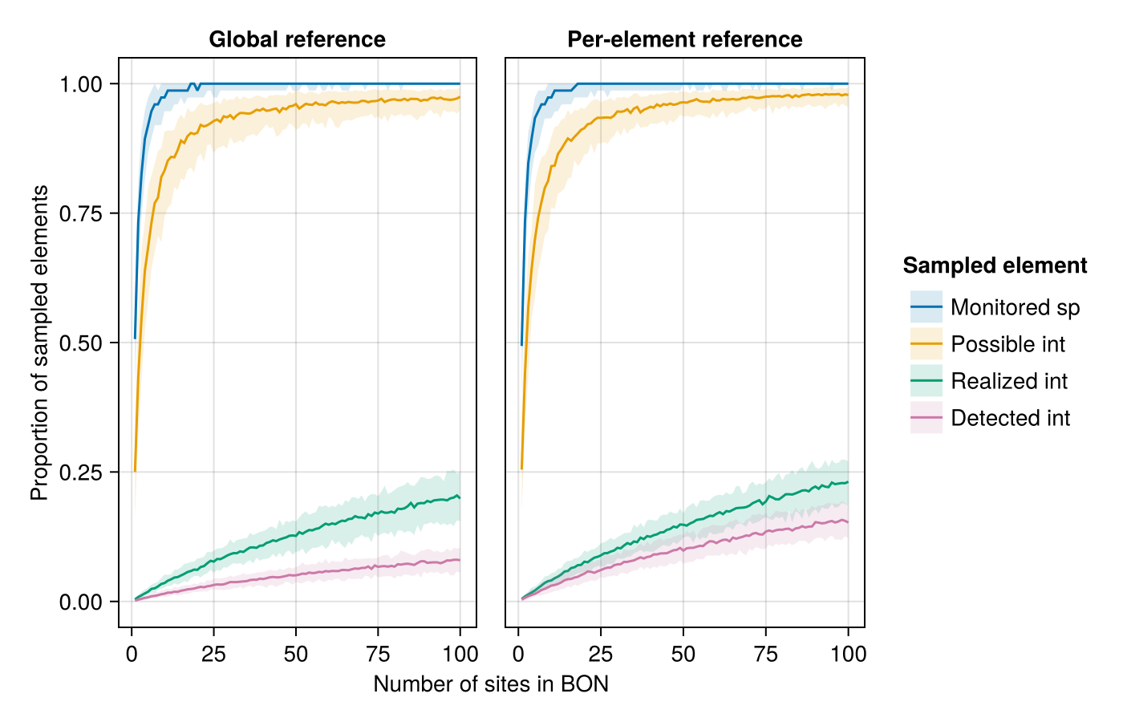
Proportion of sampled species and interactions for a given number of sampling sites in a Biodiversity Observation Network (BON) across the simulated landscape. The central line indicates indicates the median proportion for a given number of sites while the shaded bands delimit the 5th and 95th percentile across replicates. The global reference (left) uses total species richness and the total number of interactions in the metaweb as the maximum reference to calculate the proportion while the per-element reference (right) uses the maximum number of an interaction actually present in the simulated landscape.
Our focal sampling experiment showed the Uncertainty Sampling algorithm to be most efficient at optimizing BON-design based on a known species range and while aiming to maximize the sampling of interactions of a single focal species (Figure 2). Simple Random sampling, as a proxy for uninformed sampling, performed the worst among the algorithms tested. Weighted Balanced Acceptance performed notably less than Uncertainty Sampling at maximizing the efficiency for the focal species, although it maintained a better spatial balance across the landscape.
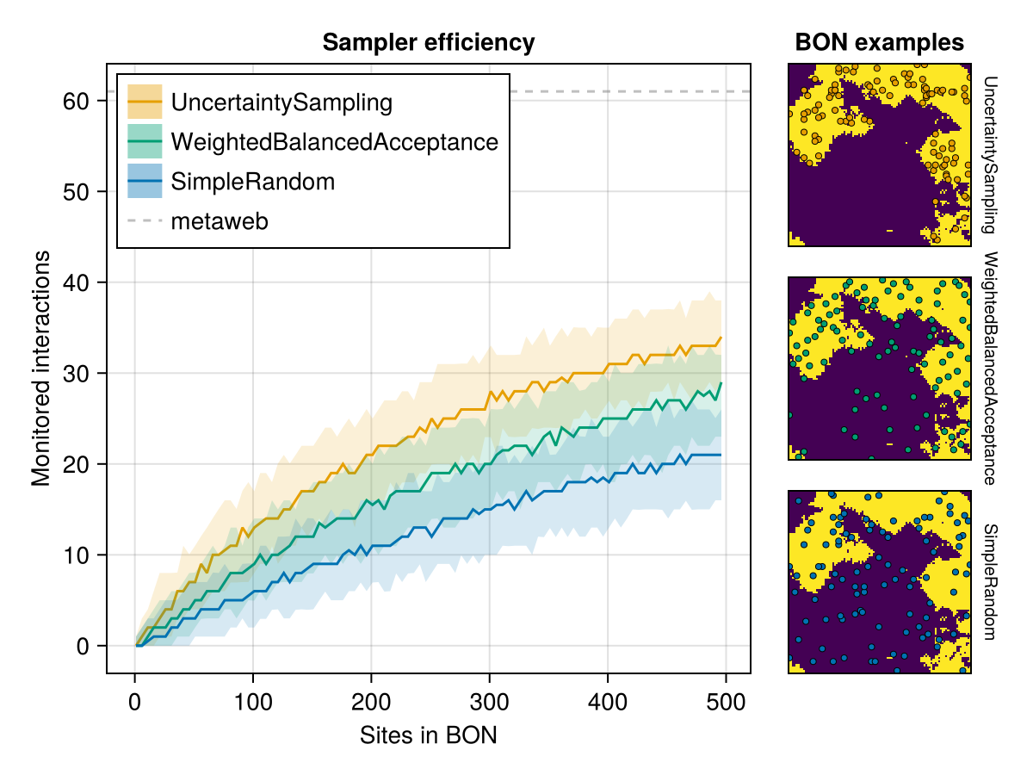
Efficiency of three sampler algorithms at sampling realized interactions for a given focal species within Biodiversity Observation Networks (BONs). The central line indicates indicates the median proportion for a given number of sites while the shaded bands delimit the 5th and 95th percentile across replicates. The right panels illustrate examples of BONs of 50 sites (coloured points) generated by each sampler over the focal species range (present at pixels in yellow).
Optimizing on the known species range, our proxy for an attainable level of information an interested user might have, was a more efficient strategy to retrieve the focal species’ interactions than optimization based on species richness (or interaction richness), effectively sampling more than half of the species’ interactions. In contrast, optimization based on the location of realized interactions, our best-case scenario requiring a higher level information, expectedly performed better, retrieving most of the species’ interactions.
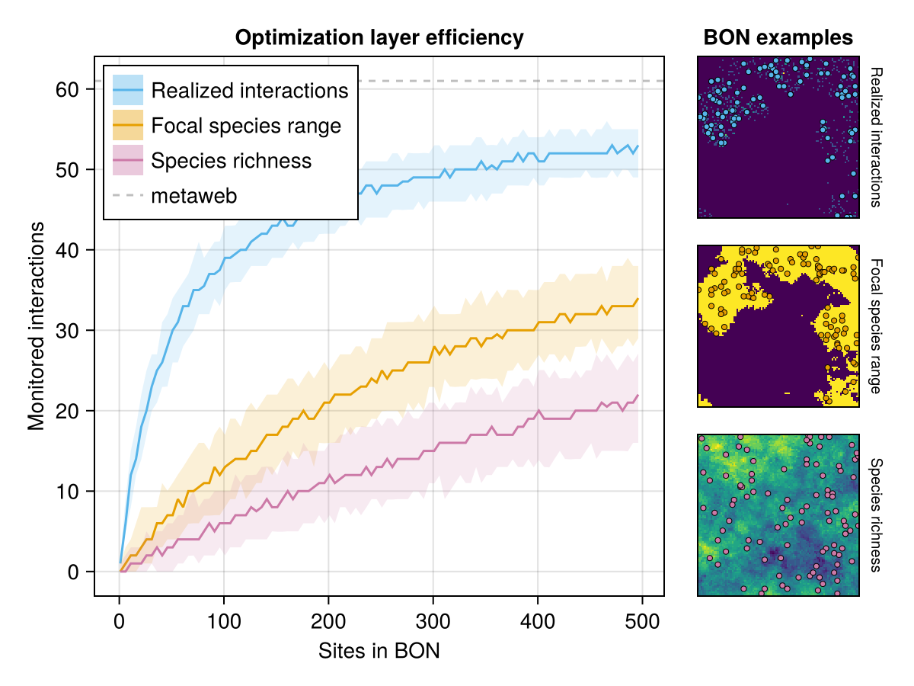
Efficiency of three optimization layers at sampling realized interactions for a given focal species within Biodiversity Observation Networks (BONs). The central line indicates indicates the median proportion for a given number of sites while the shaded bands delimit the 5th and 95th percentile across replicates. The right panels illustrate examples of BONs of 50 sites (coloured points) generated by each sampler over the focal species range (present at pixels in yellow).
Also explored but not tested with all sampler/optimization layer possibilities (potential supp. mat?):
- 4 species with different degree: proportion of interactions monitored was sometimes higher for a species with intermediate degree than for the species with highest degree (which makes sense given rare interactions). Otherwise, both the proportion and absolute number tended to be low for species with low or very low degree.
- Optimization for possible & detected interactions: not an interesting result. Possible interactions saturate way too fast, while detected interactions are always lower than realized interactions and don’t make sense as a pre-detection optimization target
- Optimisation with interaction richness: same as species richness, less efficient than species range
- Optimisation with richness of possible interactions for the focal species: same as species range, since they’re essentially the same

Discussion
What should be realistic expectations for sampling and monitoring of species interactions?
- Not as high as species richness and not as simple as co-occurrence of interacting species
- Expectations should be much lower given abundances, and our simulations highlight a way this could happen
- This means we can apply motoring to species interactions, with limits.
We can improve coverage with the right optimization method. But to do so, we need a clear and attainable sampling or monitoring objective.
- Again, we come back to a single species perspective as most attainable and understandable level of information while yielding relevant results.
- Optimizing on species range is an efficient strategy to retrieve its interactions (most attainable information), better than optimization based on species or interaction richness and surpassed only by knowledge of it’s realized interactions
Our results offer insights into defining realistic expectations for interaction monitoring. With the right target and optimization strategy, available information, such as species ranges, can guide observation network designs to monitor species interactions with a reasonable number of sites.

References
Canard, Elsa, Nicolas Mouquet, Lucile Marescot, Kevin J. Gaston, Dominique Gravel, and David Mouillot. 2012. “Emergence of Structural Patterns in Neutral Trophic Networks.” PLOS ONE 7 (8): e38295. https://doi.org/10.1371/journal.pone.0038295.
Catchen, Michael D., Timothée Poisot, Laura J. Pollock, and Andrew Gonzalez. 2023. “The Missing Link: Discerning True from False Negatives When Sampling Species Interaction Networks.” January 19, 2023. https://ecoevorxiv.org/repository/view/4929/.
Norman, Kari E., and Timothée Poisot. 2025. “Algorithm Selection for Optimal Ecological Monitoring Design,” February. https://ecoevorxiv.org/repository/view/8545/.

