Optimizing sampling and monitoring of species interactions within Biodiversity Observation Networks
Abstract
Optimal monitoring strategies should be designed to efficiently monitor all essential facets of biodiversity. Yet, species interactions are often overlooked in monitoring designs compared to spatial coverage and species richness, partly due to the inherent difficulty of sampling and monitoring interactions compared to species distributions. Here, we used simulations to test the efficiency of monitoring species interactions within Biodiversity Observations Networks (BONs). We tested several methods for designing and optimizing BONs to monitor species interactions and examined efficiency when increasing the number of monitored sites. We showed that the required sampling effort is considerably higher for interactions, especially when considering that interaction realization and detection realistically depend on species abundance. Thus, expectations to monitor a relevant proportion of interactions within a BON should be lower than expectations to monitor its species. However, from a single-species perspective, optimizing monitoring designs based on a known species range proved an efficient strategy to retrieve its interactions, outperforming designs based on total species or interaction richness. Further efficiency gains required detailed knowledge of where realized interactions occurred, highlighting the need for better knowledge of where interactions are likely to take place and integration of factors influencing interaction realization, such as species abundances. Our results were consistent even when the total species range was over- or underestimated by 10%, which shows a tolerance in the precision of the information required for optimization. Therefore, our results highlight how attainable levels of information can lead to efficiency improvements when designing BONs. With the right target and optimization strategy, and readily available information, such as species ranges, we can therefore guide observation network designs to monitor species interactions as central biodiversity components.

Introduction
Biodiversity monitoring should encompass all facets of biodiversity. Article 7 of the Convention on Biological Diversity [@UnitedNations1992ConBio] calls for Parties to “[i]dentify components of biological diversity important for its conservation and sustainable use”, and “[m]onitor, through sampling and other techniques, the components of biological diversity”. Biodiversity Observation Networks (BONs) are promising initiatives to improve monitoring across scales and biodiversity facets. BONs are coordinated monitoring networks designed to harmonize observation systems, assist reporting on international assessments, and reinforce scientific basis in biodiversity monitoring [@Navarro2017MonBio; @Gonzalez2023GloBio]. BONs can be thematic (Marine BON, Freshwater BON), national (China BON, French BON, Colombia BON) or regional (Asia-Pacific, Europe); some represent networks of monitoring sites for systematic monitoring (China BON) while others represent biodiversity data hubs (French BON) [@Xu2017OptMon; @Navarro2017MonBio]. Additional BONs are currently in the development or planification stages, notably in Europe [@Kissling2026BuiBac] and in Canada [@Gonzalez2025BioObs; @Simard2024ResSui], and could eventually be interlinked into the Global Biodiversity Observation System (GBiOS), a globally connected network providing capacity to monitor biodiversity change [@Gonzalez2023GloBio] and guiding actions needed for targets and goals of the Kunming-Montreal Global Biodiversity framework [@CBD2022DecAdoa].
Recent work highlighted the need for improved sampling designs in BONs and proper adjustment to monitoring goals. First, current sampling designs over large scales are often too sparse, at too coarse a scale, too infrequent, and without temporal replication [@Santana2025LarBio]. For example, recommendations for more effective spatial sampling designs in Europe included i) stratified random sampling (with stratification across environmental, anthropogenic and political gradients or classes, ii) incorporation of existing monitoring sites, and iii) filling of spatial gaps [@Kissling2026BuiBac]. Second, ecological monitoring design relies on site selection algorithms more often discussed regarding their capacity to achieve spatial balance and representative samples, and less frequently for achieving an ecological monitoring goal [@Norman2025SitSel]. Species richness is the most commonly used biodiversity measure in monitoring contexts [@Hillebrand2018BioCha], including in discussions over sampling designs. Maximizing richness can efficiently capture functional and phylogenetic diversity in conservation networks [@Willig2023ProBio]. Yet, the use of species richness to measure biodiversity change and guide biological conservation has also been criticized, mainly since trends in species richness do not properly capture local changes – neglecting species identities and functional roles – and fail to provide complete information on the persistence of biodiversity and ecosystem services [@Hillebrand2018BioCha; @FletcherJr.2025SpeRic; @Aguiar2024UntBio]. Thus, there is a need to better adjust BON sampling designs to biodiversity facets beyond species richness.
Species interactions are a central component of biodiversity [@Valiente-Banuet2015SpeLos; @Harvey2017BriEco; @McCann2007ProBio], critical for ecosystem functioning and health, yet are underrepresented in biodiversity monitoring and conservation [@Jordano2016ChaEco; @Dansereau2025OveDis]. Interactions mediate community and ecosystem responses to change [@Garzke2019TroInt] and can improve our ability to predict responses to climate change [@Abrego2021AccSpe]. They have their own spatial and macro-ecological dynamics [@Windsor2023UsiEco; @Mestre2022DisFoo; @Baiser2019EcoRul; @Dansereau2024SpaExp], and may be lost (or change) faster than species [@Valiente-Banuet2015SpeLos; @Dore2021RelEff]. Despite a lack of data at global scales and uneven data availability across different interaction types and environments [@Hortal2015SevSho; @Poisot2021GloKno], we now have sufficient conceptual tools to support the added value of species interactions in designing efficient management actions [@Dansereau2025OveDis; @Moracho2025RebEco]. Therefore, integrating species interactions into existing monitoring programs, such as BONs, is something we need to undertake in the near future.
Prior investigations of interaction sampling did not address how efficiently we should expect to monitor interactions within the BON framework, nor did studies on the effectiveness of BONs pay particular attention to the sampling of species interactions. Instead, much focus has been given on how to assess sampling completeness and diversity metrics (e.g. ) and how sampling effort affects network properties (e.g. ). Recent empirical [@Caron2024TraMod] and theoretical [@Poisot2023GuiPre] results have established that knowing the network structure (i.e. network properties) does not always allow knowing the list of interactions (and vice versa), therefore justifying the need to sample interactions as their own biological entities. A central challenge to do so is that the sampling effort required to detect interactions is much higher than for species (e.g. 500% vs 64% in ). Moreover, evaluating sampling completeness for interactions is more complex than for species, as it requires assessing the proportion of forbidden links (i.e. links that cannot occur) due to life history or morphological restrictions, which in turn requires knowledge of species natural history and traits [@Jordano2016SamNet]. While some network properties such as connectance can be approximated with lesser sampling effort, network composition assessments regarding the number of species and links will vary widely if interactions are missed [@Vizentin-Bugoni2016InfSam; @Poisot2012DisSpe].
One way to define expectations for interaction monitoring within BONs is to consider variation in local sampling from a spatially-explicit perspective—that is, quantifying sampling effort from specific sites where interactions are sampled—and use such expectations to improve monitoring efficiency. Previous evaluations of sampling effort relating to interactions have used spatial data, but were not tied to biodiversity monitoring efficiency in spatially-explicit way: they used dataset resampling to measure the variation of network composition and properties ( ), focused on the effect of spatial scale (showing that many network structure metrics are robust across scales, ), or assessed the ability to capture regional properties (showing that sampling larger to smaller lakes better captures regional metaweb properties ). We now have frameworks and models to describe and investigate the variation and detection of interaction networks in space and time [@Poisot2015SpeWhy; @Cirtwill2019QuaFra; @Catchen2023ProFra]; the next step is to consider how to optimize monitoring for species interactions. Simulations offer opportunities to explore such optimizations: for example, to anticipate sampling effects on estimated network properties compared to a known reference [@deAguiar2019RevBia], to determine optimal sampling frequency for monitoring [@Daugaard2024DepFor], and to examine how monitoring efficiency and trends detection are influenced by the number of monitoring sites under a range of scenarios and monitoring schemes [@Ficetola2018OptMon].
In this manuscript, we address three key questions. First, what expectations should we have for monitoring species interactions across space within Biodiversity Observation Networks? Second, what effect do sampling design strategies have on the efficiency with which we can detect interactions? Finally, what available information (e.g. from existing monitoring programs) could be used to optimize the design of future BONs for interactions and how precise should such information be to expect efficiency improvements?
We use spatially-explicit community simulations to test the efficiency of monitoring species interactions within BONs, and explore various algorithmic and design options for network sampling optimization. We aim to define realistic expectations for monitoring species interactions, in comparison to more commonly evaluated elements such as species richness and species ranges. We examine how to assess and compare monitoring efficiency using simulations. We conclude with recommendations on how this should influence the design of BONs to improve the monitoring of species interactions as an important biodiversity component.

Methods
We used simulations to generate species interaction networks, species ranges, and Biodiversity Observation Networks (BONs) with the goal of evaluating monitoring potential for interaction networks within BONs. We first detail the steps for the general model we used (Figure 1). We then go over the simulations we performed to investigate the monitoring of species interactions within BONs, aiming to 1) establish baseline expectations for the monitoring of interactions; 2) assess opportunities to improve the monitoring efficiency using different site selection algorithms and optimization targets; and 3) evaluate how precisely we need to know a species range to use it as a target for monitoring design.
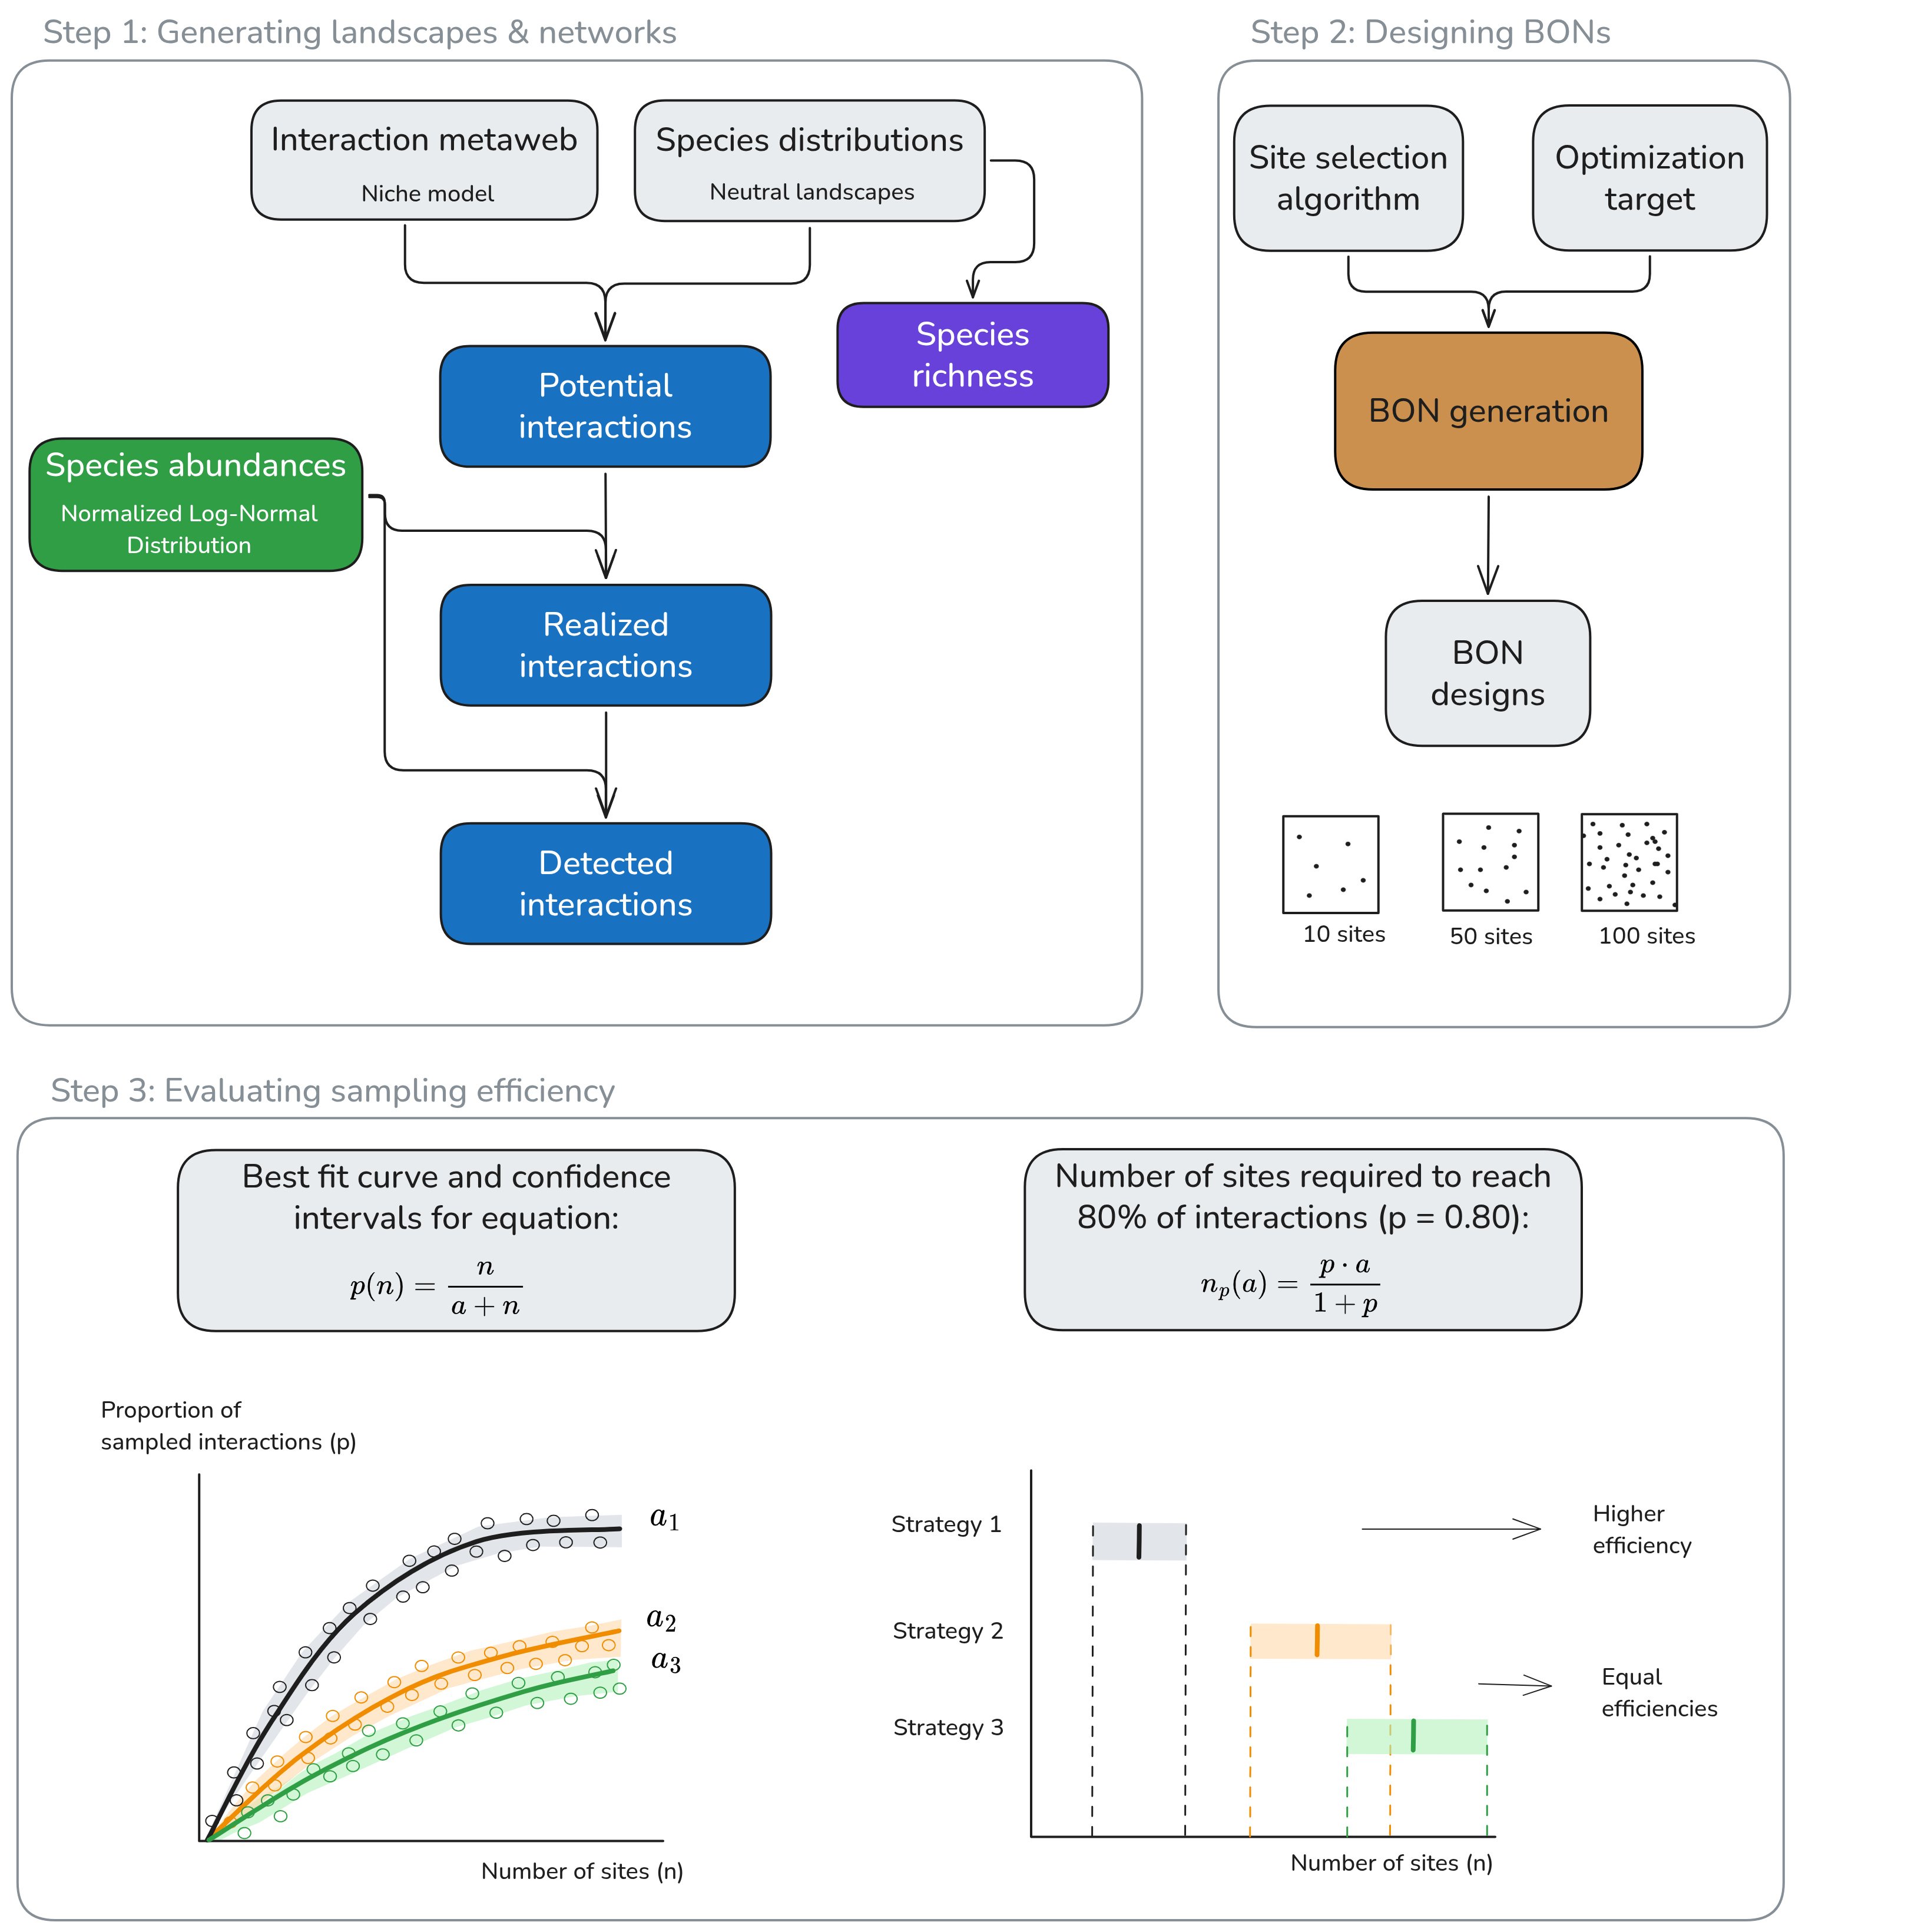
Figure 1: Conceptual diagram of the workflow and simulations. We used the spatio-temporal model by @Catchen2023ProFra to generate landscapes with spatial variation in species and interaction composition. We then designed biodiversity observation networks (BONs) across the simulated landscapes using a combination of site selection algorithms (samplers) and optimization targets. We measured the efficiency of the BON designs for sampling species interactions using a comparable measure (the number of sites required to detect 80% of the interactions, $n_{0.80}$) across all simulations. Note that $a$ is a single parameter describing the shape of the sampling curve and returning the best fit with a simulation’s results, as described in Simulation Study II.

General model
We followed the approach and process-based, spatio-temporal model introduced by @Catchen2023ProFra (building on ) to simulate interaction realization and detection while accounting for spatial variation in species occurrences – implemented in SpeciesInteractionSamplers.jl. This model broadly captures the different processes involved into turning a biologically feasible interaction into a realized one (i.e. an interaction that took place at a specified location), as outlined in @Morales-Castilla2015InfBio. To this generative model, we added the design of Biodiversity Observation Networks and the evaluation of sampling efficiency between and across simulations for species interactions (Figure 1). As implemented, our simulations most closely resemble predator-prey interactions in food webs. Yet, the approach is applicable for other network types (e.g. bipartite networks) provided that a metaweb of interactions and species presence-absence rasters can be obtained and that interaction rates can be defined based on species abundances or traits (see model details in ).

Step 1: Generating interaction networks with spatial variation
We simulated networks with variation in species and interaction composition across a simulated landscape (Figure 1, Step 1) to replicate an ecological context in which biodiversity monitoring could take place. Here, our intent is to represent broad-scale landscapes relevant for biodiversity monitoring where metawebs have recently been projected in space at national and continental scales—e.g., the spatial predictions of the Canadian mammal metaweb relevant for CAN-BON [@Dansereau2024SpaExp; @Gonzalez2025BioObs], or the spatial predictions of TETRA-EU and trophiCH relevant for the European BON [@Braga2019SpaAna; @RejiChacko2025SpeLos; @Kissling2026BuiBac].
First, we generated species ranges representing the distribution of species across a virtual landscape using neutral landscape models (NLMs, ). NLMs are used to replicate spatially-autocorrelated distributions similar to fragmented and patchy habitats in natural landscapes without a priori hypotheses or natural processes [@With1997AppNeu; @Wang2008NeuLan; @Hesselbarth2024ComMet]. NLMs have been used to generate realistic landscapes in contexts relating to biodiversity distribution and preservation, for instance to compare avian diversity between conservation approaches in coffee-growing landscapes [@Valente2022LanLan] or to assess the potential of a suggested umbrella species in an ecotone [@Duchardt2023UsiNeu]. NLMs have also been used with species interactions, for example to evaluate the effect of landscape structure in cross-species disease transmission between interacting species [@Forero-Munoz2025SpaLan]. Here, we generated species ranges following the implementation in SpeciesInteractionSamplers.jl [@Catchen2023ProFra], which 1) uses the fractal NLM Diamond-Square algorithm (, also used and described by ) to generate a probabilistic spatially-autocorrelated range for a species (default autocorrelation parameter $h$=0.85); 2) randomly draws a threshold based on a Beta distribution (default $α$ = 10, $β$ = 10); 3) converts the probabilistic range into a binary one, considering all sites with values higher than the threshold as presence and those with lower values as absence, and 4) repeates the process independently for all species (here 75 species). In the end, this process generates communities of known composition and species richness at every site in the simulated landscape.
Next, following the spatio-temporal model presented by @Catchen2023ProFra, we defined the feasible interactions between the species by generating a metaweb using the niche model [@Williams2000SimRul]. The niche model defines interactions by assigning species a niche position and feeding range, similarly to body-size relationships between predator and prey, and generates networks with structural properties similar to empirical food webs [@Williams2000SimRul; @Gravel2013InfFoo; @Delmas2019AnaEco]. It is widely used as a generative model, including in the context of investigating interaction sampling [@Poisot2012DisSpe; @Wood2015EffSpa]. Here, our feasible interactions should be thought of as trophic interactions within food webs well-aligned with the niche model, such as predator-prey interactions. Alternative generative models could be used at this step to extend the methodology to other systems and interactions types (e.g. bipartite networks).
Combining the species ranges and the metaweb, we verified where species with feasible interactions co-occur, to build a list of potential interactions [@Catchen2023ProFra] at every location in our landscape. Next, we defined realized interactions by conditioning potential interactions to species abundances. Rare and low-abundance species are less likely to interact in a location because they are less likely to encounter one another when compared to abundant species, leading to neutrally forbidden links [@Catchen2023ProFra; @Canard2012EmeStr]. The neutral model introduced by @Catchen2023ProFra first generates a distribution of species relative abundances from a log-normal distribution (followed by many empirical communities, ; the variance is controlled by a parameter $σ$). It then defines an interaction rate between species pairs based on the product of their relative abundances, scaled by a fixed realization energy parameter ($ϵ$) determining the total expected number of interactions. Finally, it draws realized interactions from a Poisson distribution parametrized on the interaction rate (see for full details).
Lastly, we defined the set of detected interactions by also conditioning the detection of realized interactions on species abundances. Even if an interaction is realized in a location, sampling must occur at the moment of interaction for its detection; this is again less likely for low probability events, like interactions between rare species. @Catchen2023ProFra first establish a per-species detection probability conditioned on relative abundance and a fixed scaling parameter ($α$); they then compute the interaction-level detection rate as the product of the per-species probability, and finally draw the detected interactions from a Binomial distribution parametrized on the number of realized interactions and the interaction detection rates.
The result of the general model is a landscape configuration with spatial variation in species and interaction composition and detection. Species composition, realized interactions, and detected interactions are based on the process model and known at all locations, allowing to compare the efficacy and efficiency of sampling strategies at retrieving interactions within the landscape configuration.

Step 2: Designing Biodiversity Observation Networks
We designed Biodiversity Observation Networks (BONs) across the simulated landscape and measured their efficiency at monitoring the generated species interaction networks. The objective of this step is to select the sites that will form the monitoring network—a BON being a monitoring network for biodiversity, and for which we here focus specifically on species interactions—similar to BON examples with grid designs at national (e.g. China BON, ) and subnational scales (Québec and Alberta in Canada, ). @Norman2025SitSel presented an overview of the design and site selection process accounting for ecological monitoring goals. The design process uses a site selection algorithm to designate candidate sites for the monitoring network. Key features of the site selection algorithms include the ability to balance sites across space for equal representation (see for reviews), to stratify across regions or populations, to use auxiliary site information (environmental or biological) to weight inclusion probability, and to produce master sampling networks that include current monitoring sites or from which to select a subset of sites for a specific monitoring project [@vanDam-Bates2018UsiBal; @Robertson2024WelSam].
Based on the landscape configurations generated in Step 1, we can use site selection algorithms (generally referred to as samplers) to distribute monitoring sites across the landscape, then measure each design’s efficiency at monitoring species interactions. Some algorithms can optimize the location of sites given different information such as species ranges, species richness or presence of realized interactions. For example, we can use the Balanced Acceptance Sampling algorithm [@Robertson2013BasBal] when aiming to balance sites across the landscape, given its computational efficiency and its ability to weight site inclusion probabilities using a layer of weights. On the other hand, active learning methods like the Uncertainty Sampling algorithm [@Lewis1994SeqAlg] can be used to optimize sampling given information on element uncertainty [@Settles2009ActLea]. Instead of focusing on uncertainty, we can apply this algorithm to target the sites that provide the highest information gain for the BON, given a layer of ‘information’ values to maximize. Examples of active learning relating to biodiversity monitoring and sampling site selection include improving species range estimation from a smaller number of actively selected sites [@Lange2023ActLea] and minimizing field data collection costs based on distances between samples [@Malek2019OptFie].

Step 3: Defining a comparable measure for sampling efficiency
As interaction composition is known at all locations in our simulated landscapes, we can determine the proportion of realized interactions (noted $p$) that can be sampled for every generated BON design (e.g. a BON of 50 sites using a specific site selection algorithm). This proportion can be seen as a ‘snapshot’ view of a given BON design’s sampling efficiency for that simulated landscape. The proportion of sampled interactions should increase with the number of sites in the BON ($n$), although the exact value of $p$ can fluctuate given randomness in the site selection algorithm. To ensure a consistent comparison across independent simulations, given their stochasticity, we state that the proportion of realized interactions sampled for a given number of sites in the BON, noted $p(n)$, follows an accumulation curve described by the equation:
$$p(n)=\frac{n}{a+n} (1)$$
where $a$ is the single parameter describing the shape of the sampling curve. The lower the value for $a$, the faster we reach a high proportion of sampled interactions. We can identify the value of $a$ yielding the curve with the best fit with a simulation’s results, as described in Simulation Study II.
Next, we derived an interpretable efficiency measure based on Equation 1. Although the parameter $a$ can be directly compared across samplers, optimization targets and independent simulations, its value is not intuitive in a monitoring context. Instead, we used the number of sites required to sample X% of the interactions, which can be tied directly to sampling effort and design. Solving Equation 1 for $n$, we obtain:
$$n_{p}(a)=\frac{p⋅a}{1−p} (2)$$
where $n_{p}(a)$ represents the number of sites required to sample a proportion of interactions $p$, following an efficiency curve described by the parameter $a$. Here, we fixed $p=0.80$ (80% of the interactions), a threshold representing a highly effective monitoring outcome (similarly used by ; ), for which we obtain $n_{0.80}=4⋅a$ using Equation 2. $n_{0.80}$ measures the speed at which realized interactions can be detected, and therefore the sampling efficiency of a BON design within a given landscape. We then used $n_{0.80}$ values to compare site selection algorithms and optimization targets in terms of their efficiency—i.e. which allow reaching a high proportion of sampled interactions more quickly.

Simulation studies
We performed three simulation studies to investigate the efficiency of monitoring species interactions within BONs. Across our simulations, we used landscapes of 100 x 100 pixels, 75 species, and a connectance of 0.2 to generate metawebs using the niche model. The connectance and number of species are within the range of values of well-characterized empirical food webs [@Williams2000SimRul; @Dunne2002NetStr; @Dunne2004NetStr; @Smith-Ramesh2017GloSyn] commonly used for reference [@Williams2008SucIts; @Baiser2010ConDet; @Wood2015EffSpa]. These parameters are also within the range of previous simulation studies on spatial ecological network dynamics, e.g. @Thompson2017DisGov. Next, we chose to keep internal parameters for the spatio-temporal model implemented in SpeciesInteractionsSamplers.jl constant to focus on differences between sampling strategies—ensuring that the variation in monitoring outcomes would only be due to the BON designs—and refer readers to @Catchen2023ProFra for the detailed discussion over these parameters’ effects. We used the following internal parameters: landscape autocorrelation of $h$ = 0.85, Beta distribution with $α$ = 10 and $β$ = 10 to threshold landscapes, variance of log-normal distribution for relative abundances $σ$ = 1.2, realization energy $ϵ$ = 50,000, and detection scaling $α$ = 50. We implemented our simulations in Julia v1.11.9 [@Bezanson2017JulFre]. All the code used to implement the simulations and perform the analyses is archived on Zenodo [@Dansereau2026GabNet]. Full computations were run on compute clusters provided by Calcul Québec and the Digital Research Alliance of Canada.

Simulation study I: Establishing baseline expectations for the monitoring of interactions
Our first simulation study aimed to establish baselines for the monitoring of interactions across space, defining expectations for how we could detect interactions in a metaweb using “an existing” BON. This is, we aimed to represent the case of testing the interaction sampling efficiency of BONs designed to cover a wide range of taxa and environmental conditions but not necessarily species interactions (e.g. Québec, China BONs). For this, we designed and tested spatially balanced BONs which is generally considered an effective way to cover environmental space [@Kermorvant2019SpaBal]. We used the Balanced Acceptance Sampling algorithm [@Robertson2013BasBal; @Robertson2017ModBal] with equal inclusion probabilities across the landscapes to generate candidate BONs with a number of sites between 1 and 500 at intervals of 10 sites, with 50 replicates for each number of sites, yielding 2,550 BON designs in total. For every design we used the general model (Step 1) to generate an independent landscape configuration: a specific metaweb, a set of species ranges, an abundance distribution for the species, and realized interactions. In every one, we evaluated the sampling efficiency of the spatially balanced BON design in terms of sampling interactions from the metaweb and in terms of recording species richness. For interactions, we evaluated each interaction type separately (potential, realized and detected), counting the number of distinct interactions sampled in the BON, then evaluated each with regards to the total interactions in the metaweb (specific to the landscape configuration, but generated with the same connectance of 0.2 using the niche model). For species richness, we assumed that all species present at sites in the BON were sampled, then compared the number of species sampled in the BON against the total species richness across the landscape (always 75 species). As a whole, these simulations compared four sampling targets (species richness, potential interactions, realized interactions, and detected interactions), establishing baselines for the monitoring of each.

Simulation study II: Evaluating strategies to optimize the monitoring of interactions for a focal species
Interaction network sampling and monitoring may be targeted at a focal species because of its endangered status (e.g. , because it is at the centre of conservation or restoration programmes (e.g. BearConnect), or even due to human-nature conflicts (e.g. ). Hence, we also investigated interaction sampling efficiency from a focal species perspective, by simulating a virtual observer that would aim to sample all the interactions of a given species (here known from the metaweb), but who might have different information on how to optimize the sampling design. Thus, the idea of this simulation study is to represent a simplified case with a clear objective (retrieving a species’ realized interactions) and where we have prior knowledge about the system, either through empirical data or model predictions, that can be used to optimize sampling.
Optimizing focal sampling relies on two elements: the site selection algorithm (sampler) used and the information provided for optimization. A species range represents an attainable level of information an interested observer could have, for instance based on expert knowledge, atlases, or species distribution models. Therefore, we investigated the case where an observer knows the species’ range across the landscape (presence or absence) and tries to optimize the BON design to retrieve its realized interactions. We tested four strategies for comparison: a Balanced Sampling spreading sites across the entire study area (using Balanced Acceptance Sampling, hereafter BAS), a Weighted Sampling favouring sites within the species range (adjusting the inclusion probability in BAS to higher values inside the species range), a balanced sampling only within the range of the focal species (hereafter called Balanced Within Range) and a Targeted Sampling selecting sites with higher ‘information’ values in the layer provided (using Uncertainty Sampling). Within the Targeted Sampling strategy, we tested four information targets for optimization: i) the exact focal species range (our attainable information knowledge for the observer), ii) a probabilistic range for the focal species (representing a less-informed case, similar to the output of a species distribution model), iii) species richness across the landscape (to represent a holistic level of information about the system, which an observer might have based on detailed knowledge about biodiversity in a region), and iv) the location the focal species’ realized interactions across the landscape (to represent a best-case scenario, where an observer would know exactly where to sample the species’ interactions).
We performed 200 independent simulations with independent landscape configurations (as described in Simulation study I). In each simulation, we selected the species with the highest degree (number of interactions) in the metaweb as the focal species for the simulation (this has been previously shown as an efficient strategy for sampling and conservation, ). We then generated BONs of 1 to 500 sites (at interval increments of 10 sites) using the three balanced strategies (Balanced Sampling, Balanced Within Range, Weighted Sampling) and the Targeted Sampling strategy with four optimization targets (focal species range, probabilistic range, species richness, realized interactions), with 50 replicates for every number of sites. For each BON generated, we extracted the number of unique realized interactions sampled across all sites for the focal species. We then performed a grid search across possible values of $a$ (from Equation 1) to identify the value yielding the curve with the best fit to the simulation’s results. To do so, we evaluated 10,000 evenly spaced values for $a$ in Equation 1, varying $n$ between 1 and 500 (by increments of 10), hence obtaining one curve of $p∼n$ per $a$ value. We defined our simulation reference results by extracting the median proportion of sampled interactions ($p$) across replicates for every number of sites in the BONs ($n$). We then selected the $a$ value yielding the curve that minimized the sum of squared errors with respect to the median results. We searched for values of $a$ between $e^{−5}$ and $e^{15}$, thus on an exponential scale, as it allowed for more gradual control over the curve shape and adjusted the limits to ensure they went beyond the fitted values on both the lower and higher side. After selecting the best-fit value for $a$, we evaluated the sampling efficiency for the simulation using the $n_{0.80}$ measurement described in Step 3 (number of sites required to detect 80% of the realized interactions).
Finally, we defined a confidence interval for our $n_{0.80}$ efficiency measurement. As the best-fit for $a$ depends on the median result across replicates, we used the confidence interval of the median to define a lower and upper bound for values of $a$. We calculated the order statistics delimiting an 90% equal-tailed interval using the normal approximation to the binomial distribution [@Gibbons2010NonSta] —e.g., at n=50, the 90% confidence interval for the median goes from the 19th and to the 31st value—and extracted the corresponding results from our simulations. We performed separate grid searches for the parameter $a$ using the lower and upper confidence intervals bounds of the median, thus delimiting the lower and upper bounds for $a$, and subsequently bounds for $n_{0.80}$. This approach returns a confidence interval for the sampling efficiency, which we used to compare site selection algorithms and optimization targets within a specific landscape configuration, given that the monitoring context is unique in each one (different metawebs and species ranges). Doing so, we identified which site selection algorithms or optimization target were more, less or equally efficient (with faster rates to reaching high proportions of sampled interactions indicating higher efficiency), while also quantifying the difference between strategies in a comparable way between independent simulations.

Simulation study III: Assessing the precision required when estimating a species range
Building on the Balanced Within Range strategy from Simulation study II, we assessed how precisely an observer should know the focal species range to achieve an efficient monitoring. To do so, we compared the Balanced Within Range strategy, where the balanced sampling design is only generated across the exact focal species’ range, with alternative scenarios where we over- and underestimated the species range for the BON design. We tested estimation offsets from 0 to 50% of the true range size, at 2% increment intervals, generating balanced designs within the over- or underestimated range. For a given landscape configuration, we extracted the true range size, calculated the number of sites to add or remove to reach the offset percentage, then used the non-thresholded probabilistic range (Step 1) to add the absence sites closest to the threshold (for overestimation) or remove the presence sites closest to the threshold (for underestimation).
We followed the same approach as in Simulation study II to design BONs and measure efficiency using the same 200 simulations with independent landscape configurations. We generated BONs of 1 to 500 sites for all the estimation offset ranges (again with 50 replicates at all number of sites), randomly re-assigning the BON sites across the adjusted ranges independently from the original one, and measured the efficiency at detecting interactions. We then compared the $n_{0.80}$ values of each estimation offset range to the $n_{0.80}$ for the true species range, which we expected would be the most efficient, and used the confidence intervals to determine which estimation offsets differed from the true range.

Results

Simulation study I: Lower sampling expectations for species interactions than species richness
Our results for the baseline spatially-balanced sampling designs highlight a marked difference between the proportions of sampled species and feasible interactions (Figure 2). Sampled species saturated very quickly, with all species sampled within less than 25 sites in a BON across the landscape. Potential interactions, which only depend on co-occurrence of species with a feasible interaction in the metaweb, also saturated quickly, reaching over 90% of the feasible interactions in the metaweb within 25 sites and increasing asymptotically afterwards. In contrast, realized and detected interactions, which account for the impact of species abundances on interaction realization and detectability, both remained under 25% of all feasible interactions in the metaweb at 100 sampling sites and under 50% at 500 sites. While realized and detected interactions would keep increasing with a higher number of sites ($n_{0.80}$ around 2100 and 7300, respectively), the speed at which they accumulate feasible interactions is notably lower than for species richness or potential interactions, highlighting the need for a much higher sampling effort for interactions within spatially-balanced BONs.
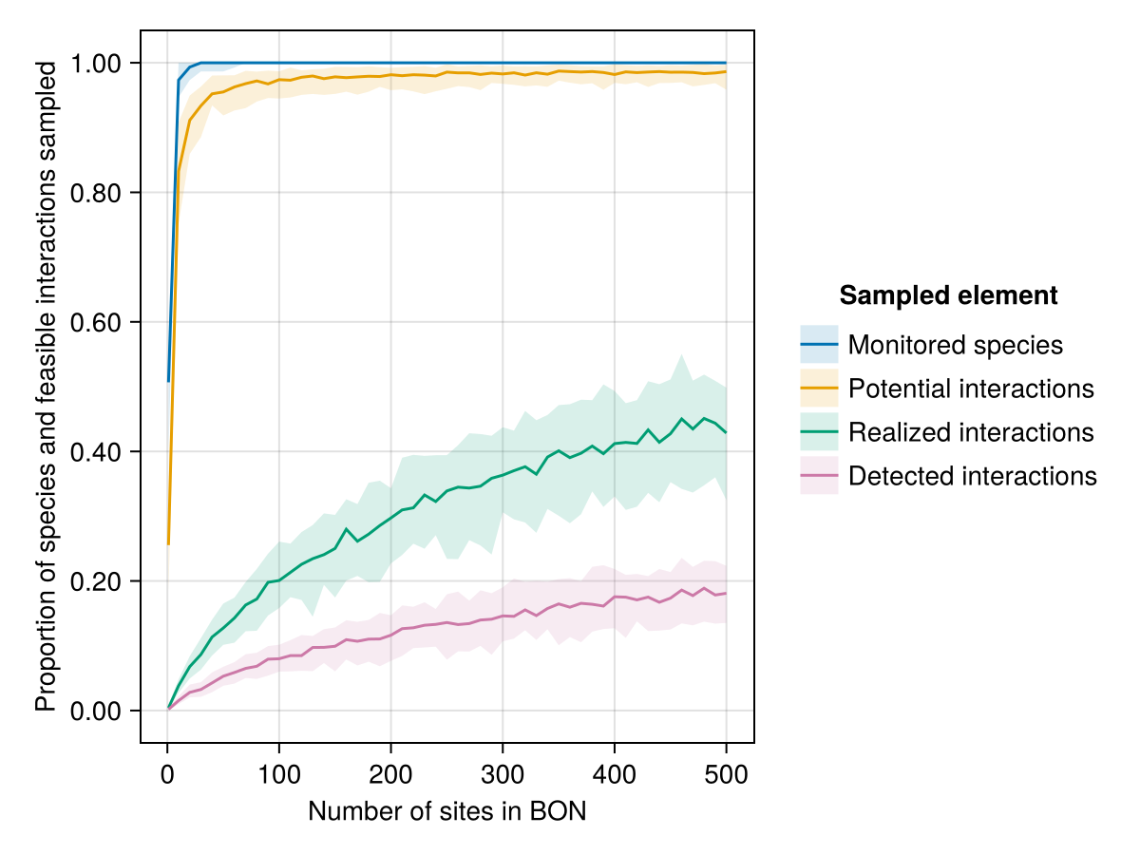
Figure 2: Proportion of sampled species and interactions for a given number of sampling sites in a spatially-balanced Biodiversity Observation Network (BON) across the simulated landscapes (Simulation Study I). We counted the number of distinct species and interactions (separately per interaction type) that can be sampled in every generated BON. Proportions were calculated with respect to the total species richness and the total number of interactions in the metaweb (‘feasible interactions’). Lines indicate the median proportion for a given number of sites, while the shading delimits the 5th and 95th percentiles across replicates (50 independent replicates per number of sites; 2,550 in total).

Simulation study II: Higher efficiency for Targeted Sampling and Balanced Within Range compared to spatially balanced strategies
To better illustrate the results of Simulation Study II, we first showcase the results for a representative landscape configuration (a unique set of metaweb, species ranges and realized interactions) on Figure 3; Figure 4. The conclusions for this landscape configuration are consistent across most simulations (200 independent simulations with different landscape configurations), as we highlight on Figure 5.
Our focal sampling experiment (which aimed to maximize the sampling of realized interactions of a single focal species) showed the Balanced Within Range and Targeted Sampling strategies to be most efficient at optimizing BON-design based on a known species range (Figure 3). Balanced sampling— i.e. a spatially balanced design unrelated to the focal species, similar to the baseline in Simulation Study I— performed the worst among the algorithms tested. Weighted Sampling maintained a better spatial balance across the landscape, but was notably worse than Targeted Sampling and Balanced Within Range at maximizing the efficiency for the focal species. Targeted Sampling and Balanced Within Range performed similarly.
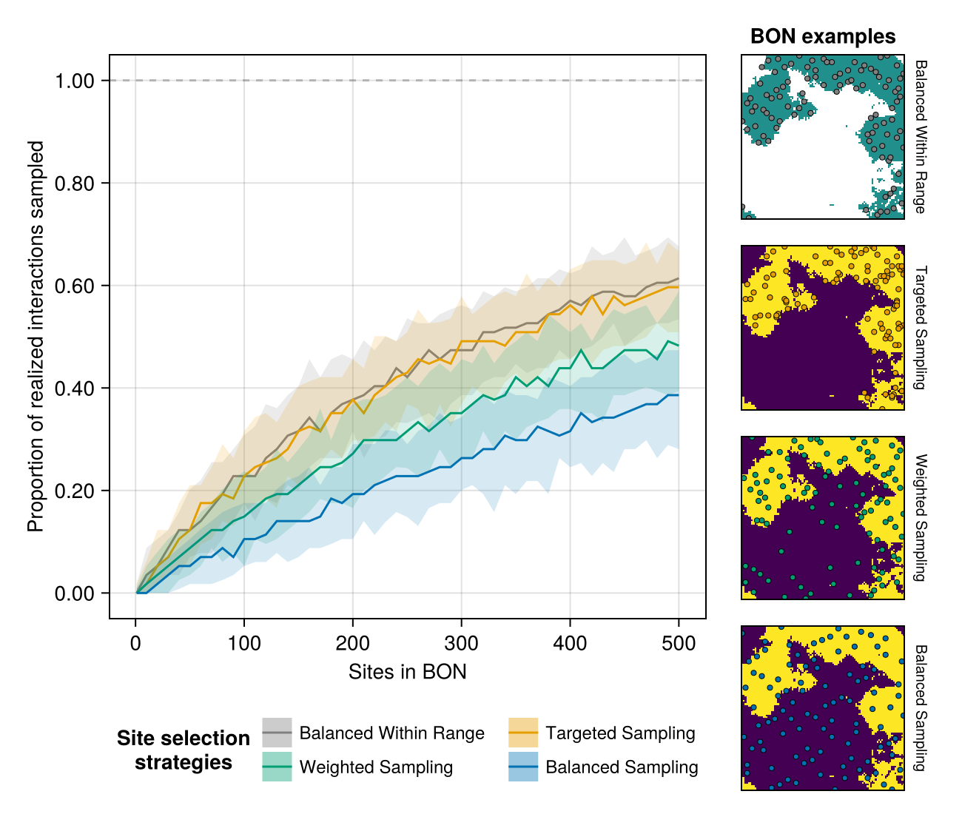
Figure 3: Efficiency of site selection strategies at sampling realized interactions for a given focal species within Biodiversity Observation Networks (BONs). This figure displays a representative example comparing four sampling strategies: three balanced strategies (across the entire area, across the focal species range only, and using weights to favour the species range) and a targeted strategy using the species ranges as a fixed optimization target (the species range). Solid lines indicate the median proportion for a given number of sites (50 replicates per number of sites), while the shaded bands delimit the 5th and 95th percentile across replicates. The panels on the right illustrate examples of BONs with 50 sites (coloured points) generated by each strategy over the same landscape (species presences in yellow, absence in purple, masked area in white). This showcased example is representative of the most common results across independent simulations.
Optimizing on the known species range, our proxy for an attainable level of information an interested user might have, was more efficient at sampling the focal species’ interactions than optimizing based on the probabilistic species range or on species richness, effectively sampling more than half of the species’ realized interactions (Figure 4). In contrast, optimization based on the location of realized interactions (our best-case scenario requiring a higher level information) expectedly performed better, retrieving most of the species’ realized interactions.
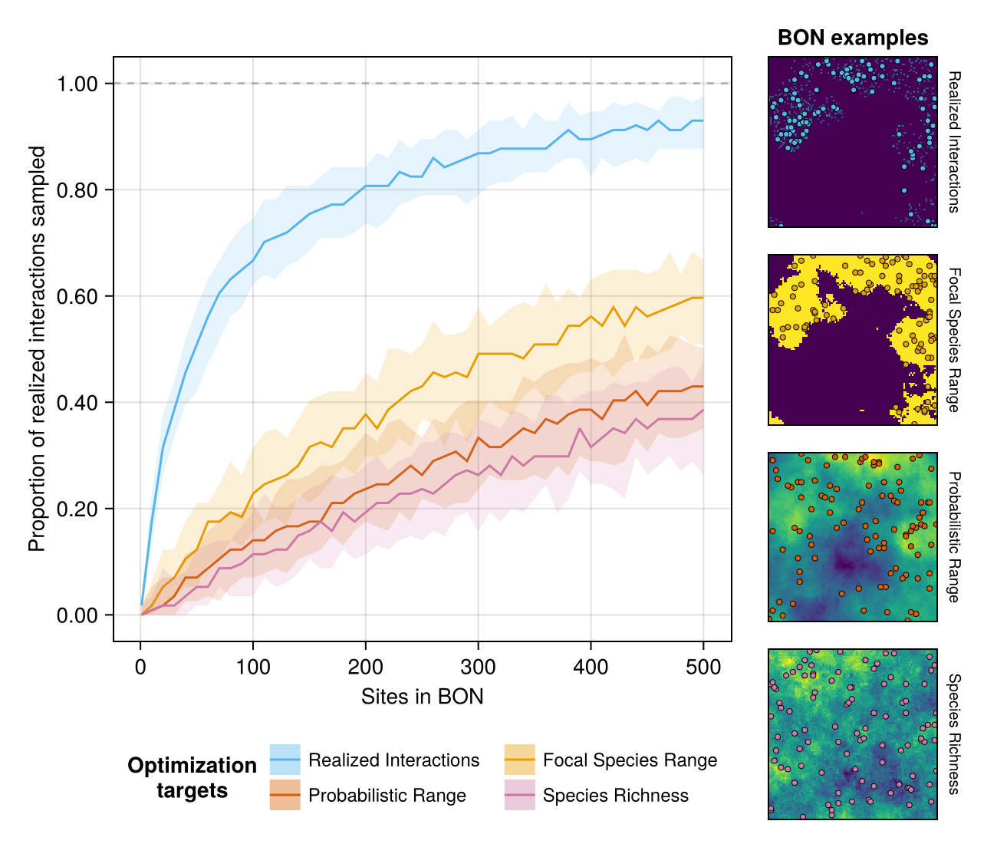
Figure 4: Efficiency of optimization targets at sampling realized interactions for a given focal species within Biodiversity Observation Networks (BONs). This figure displays a representative example comparing four optimization targets with a fixed targeted sampler (Uncertainty Sampling). Solid lines indicate the median proportion for a given number of sites, while the shaded bands delimit the 5th and 95th percentile across replicates. The panels on the right illustrate examples of BONs with 50 sites (coloured points) generated by each strategy over the target landscape (areas in yellow indicate a higher targetting probability, e.g. species presence or richness, while areas in purple indicate a lower probability).
Comparing optimization options clearly highlighted a consistently more efficient approach across landscape and metaweb contexts (Figure 5; see also Supp. Mat. for all pairwise comparisons), in line with with the single-simulation example (Figure 3, Figure 4). Targeted Sampling was more efficient than Weighted Sampling in 63% of simulations (lower value for $n_{0.80}$, indicating a faster detection of realized interactions), and both were more efficient than Balanced Acceptance in all simulations (Figure 5A). Targeted Sampling and Balanced Within Range were equally efficient in all cases. Among optimization targets used with Targeted Sampling (Figure 5B), optimizing on the focal species range was more efficient than on the probabilistic range or on species richness (78% and 90%, respectively), but always less efficient than optimizing on realized interactions.
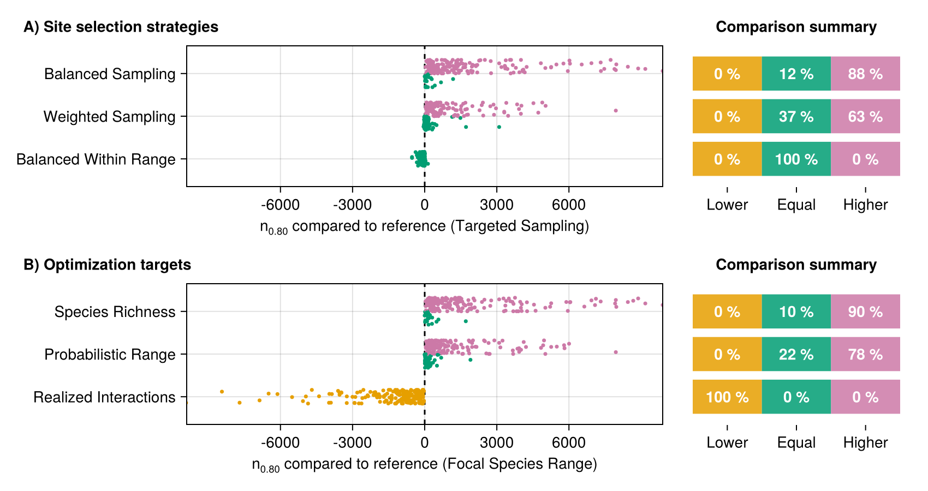
Figure 5: Within-simulation comparison of efficiency between site selection strategies and optimization targets for 200 independent simulations. The comparison value (x-axis) is the difference between the $n_{0.80}$ (number of sites required to detect 80% of the focal species’ realized interactions; see Equation 2) for a given strategy (A) or target (B) and the $n_{0.80}$ of the reference strategy/target (in parenthesis). Positive values indicate a higher sampling effort than the reference, while negative values indicate a lower effort and more efficient sampling (faster detection of interactions). Overlapping $n_{80}$ confidence intervals indicated no difference between compared options (Equal, green), whereas non-overlapping confidence intervals indicated positive (Higher, pink) or negative (Lower, orange) differences. The right-side summary panels display the percentage of simulations falling into each comparison category. Panels A and B use the same reference strategy and target (Targeted Sampling using the focal species range) to simplify the number of comparisons displayed. All pairwise comparisons are available in Supp. Mat.

Simulation Study III: Tolerance to over- and underestimation of the focal species range
Our results reveal some tolerance of the Balanced Within Range strategy to range over- and under estimation. Overestimating the range size up to 50% led to a linear increase in the value of $n_{0.80}$ compared to the $n_{0.80}$ value obtained using the exact species range (Figure 6A, right side). The $n_{0.80}$ was similar to the true range up to 10% range overestimation (based on overlapping confidence intervals); from thereon $n_{0.80}$ increased across all simulations, indicating lower sampling efficiency (notice the abrupt shift in proportions on Figure 6B). In contrast, underestimating the species range caused smaller departures in the median $n_{0.80}$ up to -50%, but a larger variance across simulations (Figure 6A, left side). While the $n_{0.80}$ was stable until a -10% offset and from there progressively increased, in the majority of simulations (> 70%) this change did not lead to significant departures even when ranges where underestimated by -50% (Figure 6B)—i.e., $n_{0.80}$ confidence intervals continued to overlap. In the remaining simulations (< 30%), the $n_{0.80}$ was almost always higher (less efficient) than for the true range.
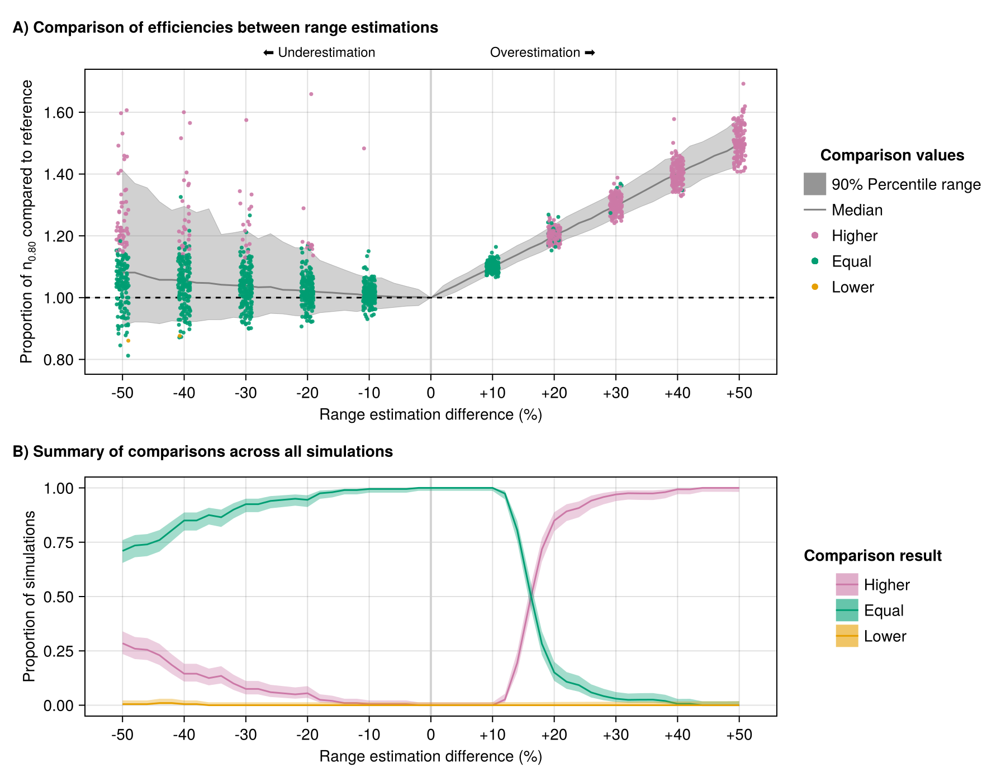
Figure 6: Comparison of efficiencies when over- and underestimating the focal species range for 200 independent simulations. Results are compared to the Balanced Within Range strategy applied on the exact species range, whose $n_{0.80}$ value is used as reference (specific to every simulation). In panel A, we use the over- and underestimation $n_{0.80}$ in proportion to the reference $n_{0.80}$ (y-axis) given the range estimation offset (x-axis) to highlight the linear trend and association with the offset percentage for overestimation. The dashed line at 1.00 indicates exactly equal $n_{0.80}$. Markers are presented at 10% increments to showcase the variation across simulations. In panel B, we summarize comparisons across all simulations to display the proportion of each comparison outcome (equal, higher, lower) at 2% increment intervals. The solid line represents the actual proportion value, while the shaded bands delimit the 90% confidence intervals for the proportion calculated using the Wilson interval method [@Brown2001IntEst implemented in HypothesisTests.jl].

Discussion
What should be realistic expectations for sampling and monitoring of species interactions?
Our simulations highlight that expectations for monitoring species interactions within spatially-balanced, general-purpose BONs should be much lower than for species and community composition. When interaction realization and detection are conditioned on species abundances, we need (much) higher monitoring efforts to detect interactions, especially rare interactions involving less-abundant species. Our observations are consistent with previous ones regarding higher sampling effort required to detect interactions in pollinator networks [@Chacoff2012EvaSam], yet here framed in the context of BON design and monitoring across space. Overall, these results reinforce the need for optimizing sampling designs for species interactions beyond and in complement to existing monitoring networks, and for recognizing them as a gap to fill in developing monitoring programs (e.g. European BON, ).
We can improve interaction coverage with the right optimization method, but efficiently doing so requires a clear and attainable monitoring objective. Adopting a single-species perspective (e.g. focusing on interactions for a keystone or high degree species, ) can yield relevant results while relying on attainable levels of information. For example, the Targeted Sampling and Balanced Within Range strategies can outperform spatially-balanced designs to monitor interactions for a focal species, while only relying on a known species range. While these strategies diverge from spatially-balanced designs, they are similar in intent to targeted design approaches taken by implemented BONs to improve community monitoring (e.g., complementarity-based site selection, ; dynamic off-grid monitoring, ) and are compatible with BONs focused on assembling information from several sources in a bottom-up approach (e.g. CAN-BON, ).
What strategies and available information are most efficient to optimize monitoring for species interactions?
Ecologically-relevant metrics are required to evaluate the performance of monitoring designs, beyond spatial balance [@Norman2025SitSel]. While many sampling algorithms can perform similarly for biodiversity monitoring in certain contexts [@Norman2025SitSel], our results highlighted better options when we can define a specific target for monitoring, such as a focal species. Optimizing on a known species range proved an efficient strategy to retrieve its realized interactions that was better than optimizing based on more holistic, community-level information such as species richness (Figures 4, 5) . This contrasts with earlier accounts where designs based on maximising species richness also proved efficient to conserve multiple biodiversity facets [@Willig2023ProBio]. Instead, our results highlight that more information about an entire system does not always lead to more efficient monitoring, and that efforts could instead be put towards identifying relevant targets with available information to guide monitoring design.
Optimizing based on the location of the realized interactions was, as expected, even more efficient than targeting the species range (Figures 4, 5). Yet, this represents a best case scenario that is likely beyond reach in an applied context: it assumes that there is already pre-existing knowledge on where species interactions can be observed, which is unlikely to exist for most interactions, species and locations across the globe, regardless of their relevance for monitoring. Nonetheless, it highlights that the most important efficiency gains will come from better knowledge of where interactions are likely to take place. On one hand, better incorporating factors influencing interaction realization and detection, such as species abundance in our simulations, will be crucial and potentially more impactful than improving knowledge or reducing uncertainty over species ranges. Integrating abundances into network evaluations could be based on species regional abundances [@RejiChacko2025SpeLos] and would echo similar calls for integration of abundances and processes into conservation [@FletcherJr.2025SpeRic; @Dornelas2023LooBac; @Tobias2025BioCon]. On the other hand, our result also suggest that monitoring will become more efficient over time as we keep gathering knowledge on interactions, especially if local knowledge of the system and species under focus is incorporated. Such opportunities should emerge in recent BON initiatives integrating Indigenous and local community knowledge for an inclusive view of biodiversity change and recognizing multiple ways of knowing (e.g. CAN BON, ). Overall, we should not wait for perfect knowledge: establishing operational monitoring frameworks to inform biodiversity conservation and management is possible as we keep gathering new information, and better ensures we translate knowledge into action [@Dansereau2025OveDis; @Buxton2021KeyInf].
How precise should estimations be to expect improvements in monitoring efficiency?
A similarly-efficient alternative to targeted sampling is to follow an approach such as our Balanced Within Range strategy, where we generate a spatially balanced design across the area believed to be more informative. Our results from Simulation Study III are encouraging in this sense, as they show we do not need perfect knowledge when using this strategy (Figure 6). The tolerance we observed to 10% over- and underestimation of the focal species range size offers an important margin that changes the completeness of information needed to guide BON design. For instance, our test case of underestimating a species range highlights that we could focus mainly on the most certain parts of a predicted species range (e.g. using conformal prediction and credible presence outcomes along with species distribution models, ) and expect similar monitoring efficiency. In certain cases, efficiency could be maintained even with highly restricted ranges (up to 50% estimation offsets), although such strategies would warrant further investigation before implementation given the high variance and wider range of possible outcomes we observed. On the opposite side, our range overestimation test case is more analogous to an approach focusing on the potential distribution rather than the realized distribution. While the 10% tolerance zone confirms some flexibility regarding overestimation, our results highlight that linear decreases in efficiency should be expected as non-informative sites (regarding the monitoring objective) are added to the BON. Yet, as this linear trend is predictable and showed lesser variance, losses in efficiency can be controlled for during the planning phase to balance exploration of potential areas of interest and exploitation of more certain ones (tying in with existing work on adaptive sampling, e.g. ).
Results and model applicability
We developed our results using the niche model, which aligns well with food webs of predator-prey interactions, yet our simulation approach could be extended to other systems. The niche model performs well at reproducing food web structure within the range of parameters we used here [@Williams2000SimRul; @Williams2008SucIts]; therefore, we expect our site-selection strategies and optimization test results to hold in similar systems. In contrast, the niche model tends to underestimate the proportion of herbivores and can perform worse at high species richness, poorly matching extremely rich and highly resolved food webs [@Williams2008SucIts; @Hale2024HigRes]. Our conclusions were not tested in such systems, where identifying target species for focal monitoring may in any case be challenging. In these cases, spatially balanced monitoring plans may be more effective. Nonetheless, our simulation approach is compatible with other network generators, including variations over the classical niche model or generators for different network types (e.g. bipartite and plant-pollinator, ), as well as documented or predicted metawebs. For instance, the niche model could be parameterized for specific, size-structured empirical systems [@Gravel2013InfFoo], while herbivory interactions could be included using documented food webs in place of a simulated metaweb [@Hale2024HigRes]. Future studies could explore multilayer networks with high potential to inform conservation and management by integrating several interaction types, information across levels of biological organization, as well as socio-ecological considerations into monitoring designs [@Madeira2024MulBio; @deJuan2023UndSoc].
Recommendations for monitoring
Species interactions are costly enough to sample that targeted approaches making use of available natural history information (e.g. species ranges or preferred habitats) might be crucial to integrate them into developing monitoring programs, where they are currently lacking (e.g. European BON and CAN BON, ; ). While spatially balanced designs are efficient for more generic biodiversity monitoring purposes, species interactions may be better sampled using optimized monitoring designs targeting focal species, or locations where species are known to exist. In this manuscript, we demonstrate how this can be achieved by selecting an appropriate target (e.g. the interactions of a focal species) and using attainable information (here the species range) to optimize monitoring designs efficiently. We show that there is a degree of tolerance to the level of information precision needed for optimization (which we explored via range over- and underestimation), highlighting that available information, albeit imperfect, can already be used to guide species interaction monitoring.

Acknowledgements
GD was funded by the NSERC Postgraduate Scholarship – Doctoral (grant ES D – 558643) and the FRQNT doctoral scholarship (grant no. 301750, https://doi.org/10.69777/301750). TP was funded through award no. 223764/Z/21/Z from the Wellcome Trust, by the Discovery Grant program of NSERC, through a donation from the Courtois Foundation. MDC is funded by an IVADO Postdoctoral Fellowship. This research was enabled in part by support provided by Calcul Québec (calculquebec.ca) and the Digital Research Alliance of Canada (alliancecan.ca). We thank the members of the Laboratoire d’Écologie Prédictive et Interprétable pour la Crise de la Biodiversité in Montréal, QC, and of the Predictive Ecology team at the Pacific Forestry Centre in Victoria, BC, for their constructive comments during discussions of this manuscript.

