Overcoming the disconnect between interaction networks and biodiversity conservation and management

Highlights
- Practitioners and scientists increasingly need multi-species and whole-ecosystem indicators that allow integrating species interaction networks into biodiversity conservation and management.
- Explicit and quantitative integration of ecological network indicators into conservation is still lacking due to challenges with network uncertainty and accessibility to practitioners.
- The resulting gap between network science and management leads to decisions being made without considering available scientific knowledge.
- We identify opportunities in closing this gap. Despite uncertainty, the field of network ecology is mature enough to offer quantitative insights into ecosystem responses to environmental changes.
- Simple network metrics that fit criteria important to decision-makers and can be used with current data and models, are promising starting indicators to inform conservation and management.

Can interaction network knowledge be quantitatively used for biodiversity conservation and management?
The need to shift from single-species conservation approaches to multi-species and whole ecosystem approaches has long been recognized [1,2]. Network information can provide a new perspective for whole ecosystem assessments in biodiversity conservation and management. Preserving species interactions can ensure long-term population persistence and maintain ecosystem functions and services [3,4]. Focusing on ecological networks as conservation targets promotes the stability of populations and ecosystem functions and minimises negative outcomes regarding species extinctions [5–7]. Recent reviews list specific interaction network metrics that decision-makers can use [8]. Implicit network information has already been integrated into conservation planning, for example through consideration of keystone species with disproportionate effects on their communities, which should facilitate the uptake of network-based biodiversity indicators in decision-making [2,9,10, see Box 1].
Despite the potential benefits, conservation practices rarely explicitly consider information derived from measures of the structure of ecological networks. Conservation policy and practice still heavily focus on single species and habitats. Uncertainty about network structure and responses to human disturbances mirrors concerns in macro-ecological and ecosystem models [11,12]. Additionally, identifying which interaction network metrics are suitable biodiversity indicators with clear interpretation for conservation remains challenging.
Decision- and policy-makers must act now to bend the curve of extinction and accelerate ecosystem recovery [13,14]. Ecologists need to provide them with useful network and ecosystem-wide information. For instance, protected area planning could prioritise regions where mutualistic interaction partners or prey and predators overlap [15], or where there is high trophic diversity and redundancy, enhancing robustness to extinctions [16]. Moreover, since interaction network structure is linked to ecosystem functioning and ecosystem service provision, focusing on network metrics changes for conservation targets should ensure ecosystem stability and service delivery [e.g., pollination, pest control, food production, 5,7,17]. Given the global goals to maintain ecosystem services [Goal B of the Kunming-Montreal Global Biodiversity Framework, 18], assessing network structure stability changes should help managers and decision-makers prioritise areas to maintain ecosystem functioning and resilience [5,19].
Here, we identify the major challenges and opportunities in incorporating interaction network information into biodiversity conservation and ecosystem management. We demonstrate how simple approaches and indicators can provide relevant information for managers. Our focus is on probabilistic and binary species interaction networks, where nodes represent species and links represent the probability or presence of an interaction [20], rather than energy flow networks already covered by Fath et al. [8]. Additionally, we present a perspective where networks are used as biodiversity indicators and, in a forecasting context, to evaluate network responses to future environmental change scenarios and management strategies. Despite challenges relating to uncertainty, interpretability and relevance, we argue that we have sufficient scientific evidence and tools to apply network concepts to management and conservation in the face of global change. In particular, testing and exploring network indicators can accelerate the establishment of operational monitoring frameworks.

Box 1 - Trophic role of keystone species
Explicitly considering networks in conservation and decision-making (i.e. by monitoring and managing for network-derived properties) is not a drastic shift, as networks are often implicitly included in conservation decisions and recovery plans. The keystone species concept, frequently mentioned in conservation literature [e.g., 2,21] and highlighted by initiatives focused on rewilding and ecological restoration [22,23], is linked to the disproportionate effects some species have on their (trophic) networks [24, also see 25 for the diverse roles of species identified as keystones]. Similarly, several large carnivores have been associated with trophic cascades, where effets of predator declines propagated across food webs to herbivores, mesopredators, and beyond [26]. This reflects network consideration through species’ effects on others, even if network-specific properties are not explicitly quantified – i.e. metrics like connectance, species trophic level, or centrality do not explicitly enter planning or decision-making.
Importantly, keystone species are often tied to quantified conservation targets. For example, prairie dogs (Cynomys spp.) are considered keystone species due to their important ecosystem functions and large impact compared to other herbivores, which are not replicated by other species [27,28]. The Recovery Strategy and Action Plan for the Black-tailed Prairie Dog (Cynomys ludovicianus) in Canada identifies it as a conservation priority due to its keystone status, crucial for the recovery of the Black-footed Ferret (Mustela nigripes) and serving as a vital food source for several other at-risk species [29]. Conservation targets for Black-tailed Prairie Dogs in Canada include maintaining a minimum area of occupancy of 1,400 ha across 20 colonies and a minimum average population density of 7.5 individuals/ha by 2040, ensuring at least an 80% probability of population persistence over 50 years [29].
The implicit consideration of network structure in conservation targets can facilitate the uptake of new network-based indicators by practitioners and decision-makers. Indeed, knowing this structure provides additional ways to identify which species are potential keystones, beyond their emblematic nature [30]. Other forms of network-thinking are similarly part of management considerations, such as spatial ecological networks planning [31] and ecosystem-based management [11]. Explicitly considering network-based indicators will complement these forms of network-thinking and enhance conservation assessments to include ecosystem-wide components.

Challenges & opportunities
The explicit integration of network information into management and conservation faces several challenges linked to uncertainties and lack of interpretability and relevance of network metrics for practitioners. These challenges will hinder making effective decisions, for example on what biodiversity and network-related properties need to be measured and monitored, what conservation targets and management actions should be applied, how often to re-evaluate decisions, etc. Hence, we can expect challenges at different stages of management planning and decision-making [e.g. 32], such as the evaluation of current conditions or upon decisions on possible actions (e.g. responsive, preventative, etc.).

Uncertainty

Network Structure and Composition:
There is uncertainty in network structure, composition, and variation across space and time, which affects conservation assessments and actions [33,34]. Empirical studies on networks are often spatially disjointed, biased geographically and depending on interaction types, and rarely replicated [35–37]. Sampling biases can distort reported network patterns [38,39]. Terrestrial and freshwater food webs are less studied than marine ones, often with different research objectives [e.g., determining the effect of environmental factors, rather than investigating management-related elements such as sustainability, 35,40]. Such deficits of information may prove problematic when conservation decisions need to be made.
Despite these challenges, existing methodologies can help integrate network information into conservation, while empirical data continue to be gathered. Networks can be constructed from extensive, long-term monitoring datasets to analyse food web structure and temporal stability [41,42]. Building metawebs of all potential interactions in a region or species pool, like the pan-European terrestrial tetrapod metaweb [TETRA-EU, 43], provides an “upper ceiling” for possible interactions [44,45]. Metawebs can inform broad-scale assessments and have already been used to derive spatially explicit network properties and generate conservation-relevant information [46–48]. For instance, Albouy et al. [46] used a metaweb to examine robustness to extinction scenarios for marine food webs, showing higher robustness in coastal waters compared to open waters and highlighting some potential to absorb perturbations. Moreover, metaweb inference approaches allow us to circumvent the lack of available local interaction data [45] and, when used with probabilistic networks, to integrate uncertainty and variation in network structure across space [49]. Network properties and their uncertainties can therefore be measured for broad-scale assessments of variation in network structure, and to derive network indicators that can be used to inform decisions and planning (Boxes 2-3). As new empirical data becomes available, these predictions can be evaluated, refined, and become more informative [50]. We discuss the challenges surrounding their validation in our Concluding Remarks.

Network Responses to Environmental Change:
Uncertainty exists in how networks will respond to environmental changes and disturbances, particularly for interaction rewiring and changes in interaction strength. Questions remain on the extent of rewiring due to species turnover versus prey switching and behavioural adaptation, and how these changes will propagate across trophic levels.
While data gaps exist, modelling and inference can explore the limits of network rewiring under current or future conditions (Box 3). Rewiring potential is likely captured in existing and inferred metawebs [51], which can be combined with simulations to anticipate network changes. For instance, Dansereau et al.’s [49] approach can be extended to explore climate change impacts on network structure, given the dual uncertainty in species interactions and future species ranges. Moreover, network models (and information) do not need well-constrained or low uncertainty predictions before they can inform management decisions on interventions like species eradication, especially if they tend to correctly identify whether effects on other species will be positive or negative [52]. Model uncertainty can also be high despite high quality data [52]. Regardless of its generality, this result suggests that the performance of a model should be monitored whenever new data are added. Similar trends of model change in performance with additional data have been reported in the study of species distributions [53].
Approaches to include specific types of network response uncertainty in conservation and management have also been proposed. Van Kleunen et al. [54] suggested a multi-step framework for decision-making under uncertainty for species introduction into ecological networks, based on conservation decision theory. This framework includes: the identification of management objectives, the evaluation of outcomes for management (including multiple outcomes, evaluation of trade-offs, and assessment of uncertainty), and the improvement of future predictions through an adaptive management framework. Van Kleunen et al.’s [54] decision-making approach can be applied now, despite uncertainties, to guide management of species introductions.

Compounding Uncertainty in Change Types:
There is compounding uncertainty in the type and strength of change applied to a network. Climate uncertainty, for instance, results from uncertainty in future greenhouse gases emissions (i.e. emission scenario uncertainty), in climate processes (general circulation model uncertainty) and their stochasticity (model run uncertainty). For networks, we add uncertainty in changes resulting from disturbance regimes (e.g. fire, drought, pests) and in species distribution predictions [which can result from direct impacts of abiotic change, of disturbance regimes and of biotic changes that may be linked to network structure itself, 55,56]. If accounted for simultaneously, these uncertainties will inevitably lead to high variance in predicted network responses.
We can estimate some uncertainty through backcasting: past environmental changes are used to predict changes in network metrics that are cross-validated against observed past networks. Fisheries data, for instance, allow reconstructing well-resolved networks over time, which can be related to known environmental changes [57–59] and be used to calibrate predictive network models, like bayesian networks [60]. Backcasting models, used as ex-ante scenarios of change, have been successfully used to simulate and assess the effectiveness of conservation actions on ecosystem services [61].
Simulating scenarios of change can also help delimit the possible changes in network structure [Box 3, 62]. When combined with metrics of network change and sensitivity to disturbance, these projections can be used to identify target areas that show fragility to an array of scenarios and are of special concern, or that show less fragility and could be considered refugia. They can also highlight problematic or incomplete sampling. Projections will also serve to perform validation and assess indicator behaviour in an empirical setting, whether through existing data or backcasting exercises, which could lead to network-specific monitoring programs.

Interpretability and relevance
Network metrics are often not intuitive or deemed relevant for practitioners and decision-makers. Many metrics are complex and may not clearly correlate with ecosystem- and species-level responses, particularly in applied contexts. For instance, omnivory and network motifs are tied to food web persistence and extinction risks [63,64], highlighting their ecological relevance. On the other hand, while network nestedness indicates a buffer against extinctions and fluctuations in mutualistic networks, this is less clear in antagonistic networks [7]. Connectance has also been tied in contrasting ways to network stability [e.g., higher connectance leading to increases or decreases of invasion success rates given invader trophic levels, 65; higher connectance linked to higher robustness to extinction, but larger extinction cascades, 66].
Not all network metrics are suitable as conservation indicators, nor do they need to be. Several have been reviewed for their relevance and limitations in achieving conservation goals (Louise O’Connor, PhD thesis, Université Grenoble Alpes, 2022i; see Table 1 therein). For example, prioritising trophic networks with stabilising motifs when selecting protected areas can help achieve ecological resilience goalsi. This information can already be used towards conservation planning but it needs to be both accepted by and available to decision-makers and managers.
First, metrics must meet decision-makers’ criteria. The ROARS (being Relevant, Objective, Available, Realistic, Specific) and SMART (Specific, Measurable, Achievable, Replicable, Time-bound) criteria [8; see Table 3 therein] focus on the decision-makers’ receptiveness to suggested indicators during the selection, paving a way to communicate network information with stakeholders and embed network indicators in ecological monitoring and ecosystem health assessments. Network indicators will then need to be evaluated in terms of usefulness to achieve conservation goals [as in O’Connor, 2022i] and decision-maker receptiveness [as in 8], as we move towards developing ecosystem management and monitoring frameworks that quantitatively and explicitly embed network indicators (see example in Box 2).
Second, network ecologists have the opportunity to expand their focus from the development of mathematical tools, theory and theoretical validation to involving decision-makers and meeting their needs [67]. Consensus for conservation goals can be achieved through mixed methodology such as iterative and anonymous Delphi panels [see 68 for applications in ecology]. Engaging stakeholders in this way would ultimately provide valuable guidance to prioritise new fundamental research questions and methodological development. Although they do not ultimately make the decisions, network ecologists must be proactive in this process, especially given the limited time and staffing resources across many institutions where decisions are made. This process takes time and co-production effort, and needs to be initiated by academics who can guide and support practitioners in designing management strategies and making conservation decisions using network information. Academics place a strong focus on the development of tools and knowledge, but ensuring their adoption (particularly for non-academics) will require delivering them in a form that can instantly be used with minimal additional work [69].
Finally, network ecologists can take concrete steps to ensure that network-based measures are perceived as relevant by decision-makers. Workshops and stakeholder involvement are essential to bridge the gap between science and practice [69] and can facilitate choosing appropriate metrics [8]. Involving a wide-range of ecosystem-management players, and creating new opportunities to actively involve stakeholders in deciding how network information can be applied, will be key to ensure receptiveness and a speedy uptake of indicators for management planning and actions. Forecasting changes in network structure under environmental and management scenarios (Box 3) and linking network indicators to ecosystem services [17] can enhance receptiveness. This will provide essential information on risks, on boundaries of change given environmental conditions, and on the effectiveness of certain management actions in achieving conservation targets [70].

Box 2 - Assessing the relevance of a potential network indicator for decision-making
Network metrics should be evaluated using criteria important to decision-makers to ensure their relevance as indicators and encourage adoption. In addition to the ROARS and SMART criteria, Fath et al. [8] suggest that effective indicators should also “describ[e] directional change [of ecosystems], [be] easily communicable to managers and policy makers, [be] integrative and indicative to a known response to a disturbance” [as per 71], and provide insight to ecosystem functioning and services.
As an example, trophic network robustness to targeted extinctions meets these criteria (Table 1) and can be a useful indicator of ecosystem integrity and stability to environmental change. The structural stability of trophic networks is closely linked to the stability of ecosystem functioning [see review by 72], with trophic interactions considered as ecosystem functions and services (e.g., top-down pest control by predators). Here we show a formulation of robustness derived from earlier works [73–75] that reflects the capacity of a network (or the ecosystem it represents) to withstand cascading extinctions:

where secondary extinctions are extinctions due to the loss of other species and secondary consumers are consumers of basal species (measured as network species richness minus the number of basal species).
Robustness is easy to interpret (see Specific in Table 1) and to calculate using binary trophic networks, which are more commonly available and can be derived from existing trophic metawebs – this allows us to derive initial (even if coarse) estimates of robustness at large, regional and local scales (see references in Table 1). It also relates to ecological issues that have a firm place in ecosystem management and conservation, and resonate with decision-makers – numerous directives, policies and management frameworks focus on avoiding species extinctions (see examples in Table 1).
Table 1 illustrates the potential of robustness as a network indicator and the process of detailing how it meets the criteria mentioned previously. Evaluating network metrics in this way is crucial for making them more relevant and acceptable to decision-makers, as it demonstrates why and how the indicator can be used effectively.
Table 1. Relevance of robustness as an indicator. Dale & Beyler’s [71], ROARS and SMART criteria for good ecological network indicators, as described by Fath et al. [8], and how they apply to robustness of trophic (non-energy flow) networks.

Box 3 - An accessible workflow applying robustness to inform decision-making
Effective decision-making requires indicators based on accessible and reproducible analysis workflows that evaluate a range of scenarios. We demonstrate the potential of robustness with a workflow that uses different network disturbance scenarios and open-access data (Fig. 1). By using extreme scenarios, we can explore the boundaries of robustness to forecasted environmental change. The framework can be applied spatially to identify target areas for management and conservation action (Fig. 2) or to single networks.
Workflow steps: - 1) Build local ‘reference networks’ by combining a regional metaweb of interactions with ‘reference’ local species presence/absence information (‘baseline’ referring to any reference period) – species that interact in the metaweb and are locally present, will appear and interact in the local network; - 2) For each reference network, calculate the number of secondary consumers (consumers of basal species) and other relevant network metrics (e.g., species and average trophic level, connectance, etc.) - 3) Build local ‘disturbed networks’, by combining the regional metaweb with species ranges projected under different scenarios; - 4) Calculate and map robustness and other network metrics (Fig. 2).
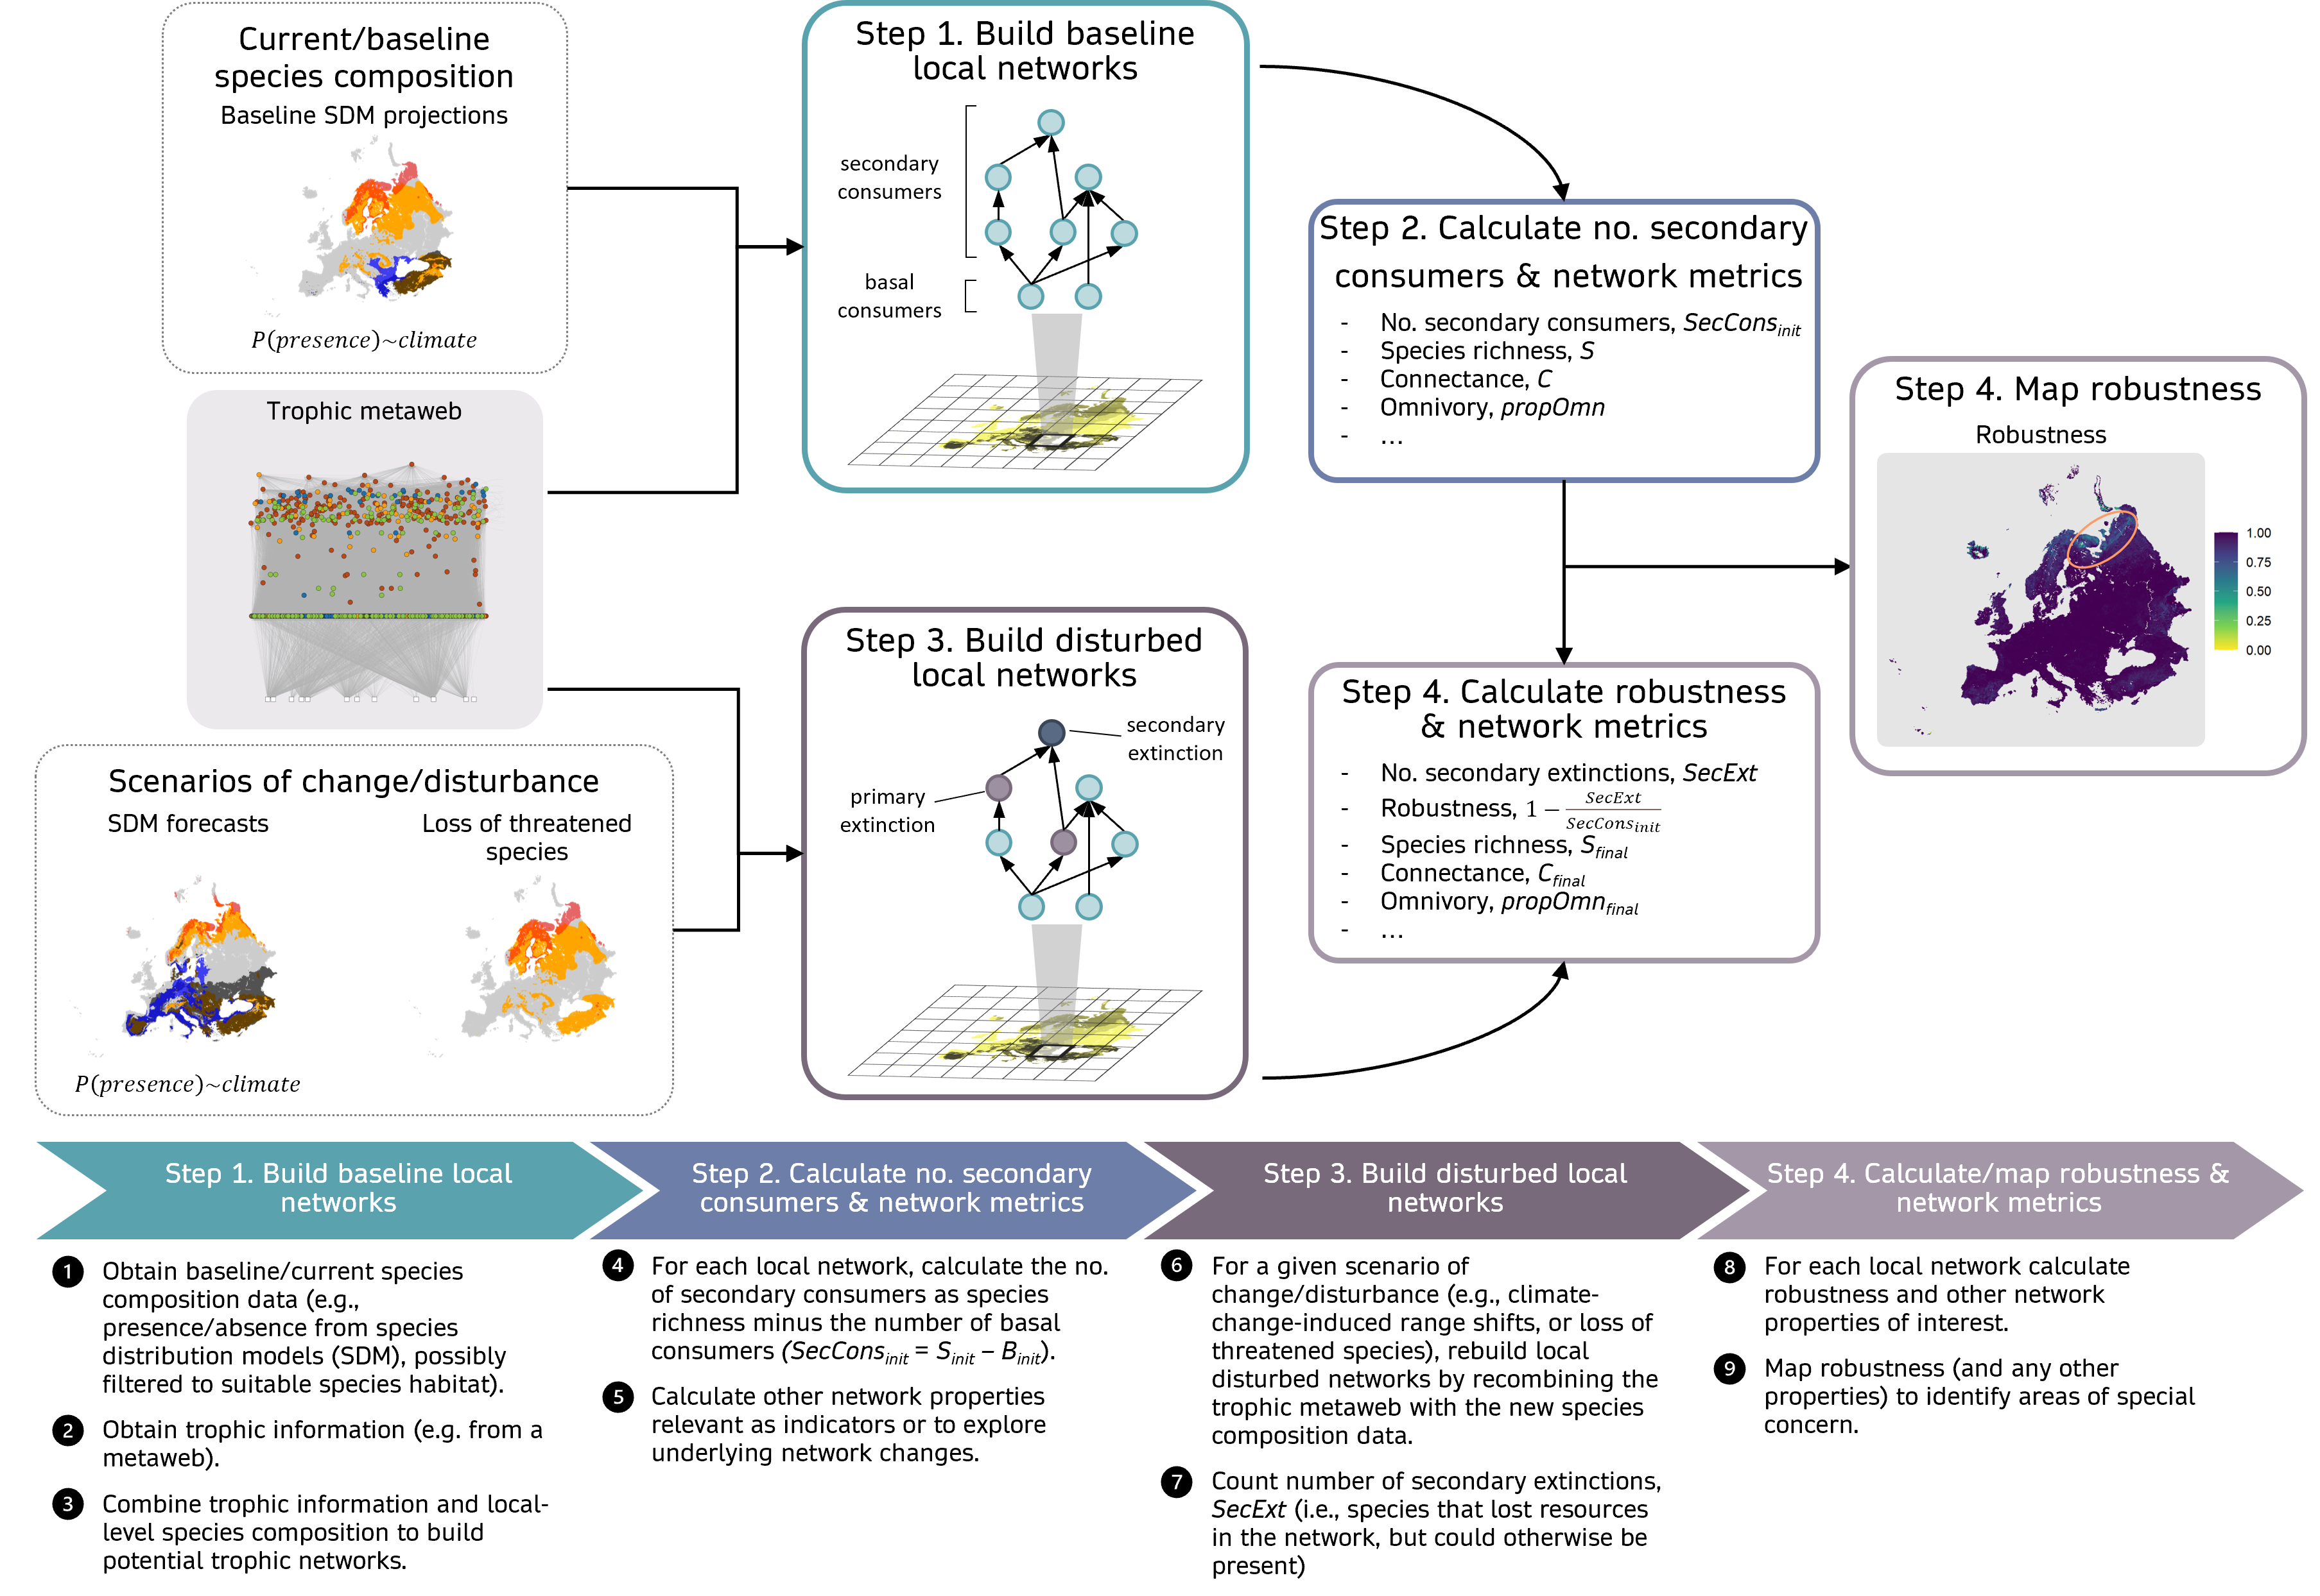
Workflow to calculate robustness. Simple network metrics like robustness can be incorporated into workflows to assess potential ecosystem fragility to scenarios of disturbance and inform management and decision-making at large scales. See supplemental information online for full workflow details.
Our example explores the lower boundaries of pan-European trophic network robustness by submitting vertebrate networks to two extreme scenarios: worst-case climate change (CMIP5 RCP 8.5, equivalent to CMIP6 SSP5-8.5), and failure to protect endangered species (IUCN levels: critically endangered, CR, endangered, EN, and vulnerable, VU; Fig. 2). Further analyses could be focused on investigating which species are forecasted to be lost, their roles in the networks and best strategies to protect these networks from a multispecies perspective. For instance, inspecting initial species richness and trophic positions of extinct species can help identify network- and species-level attributes that may be related to robustness (Fig. 2, lower panels). Antunes et al. [17] proposed a similar workflow to calculate network-provided Nature’s contributions to people. Ours differs from theirs in that it requires less sophisticated and less data-hungry methodological approaches. Together with the accessible automated pipeline [81], this should facilitate and accelerate uptake by practitioners, managers and decision-makers.
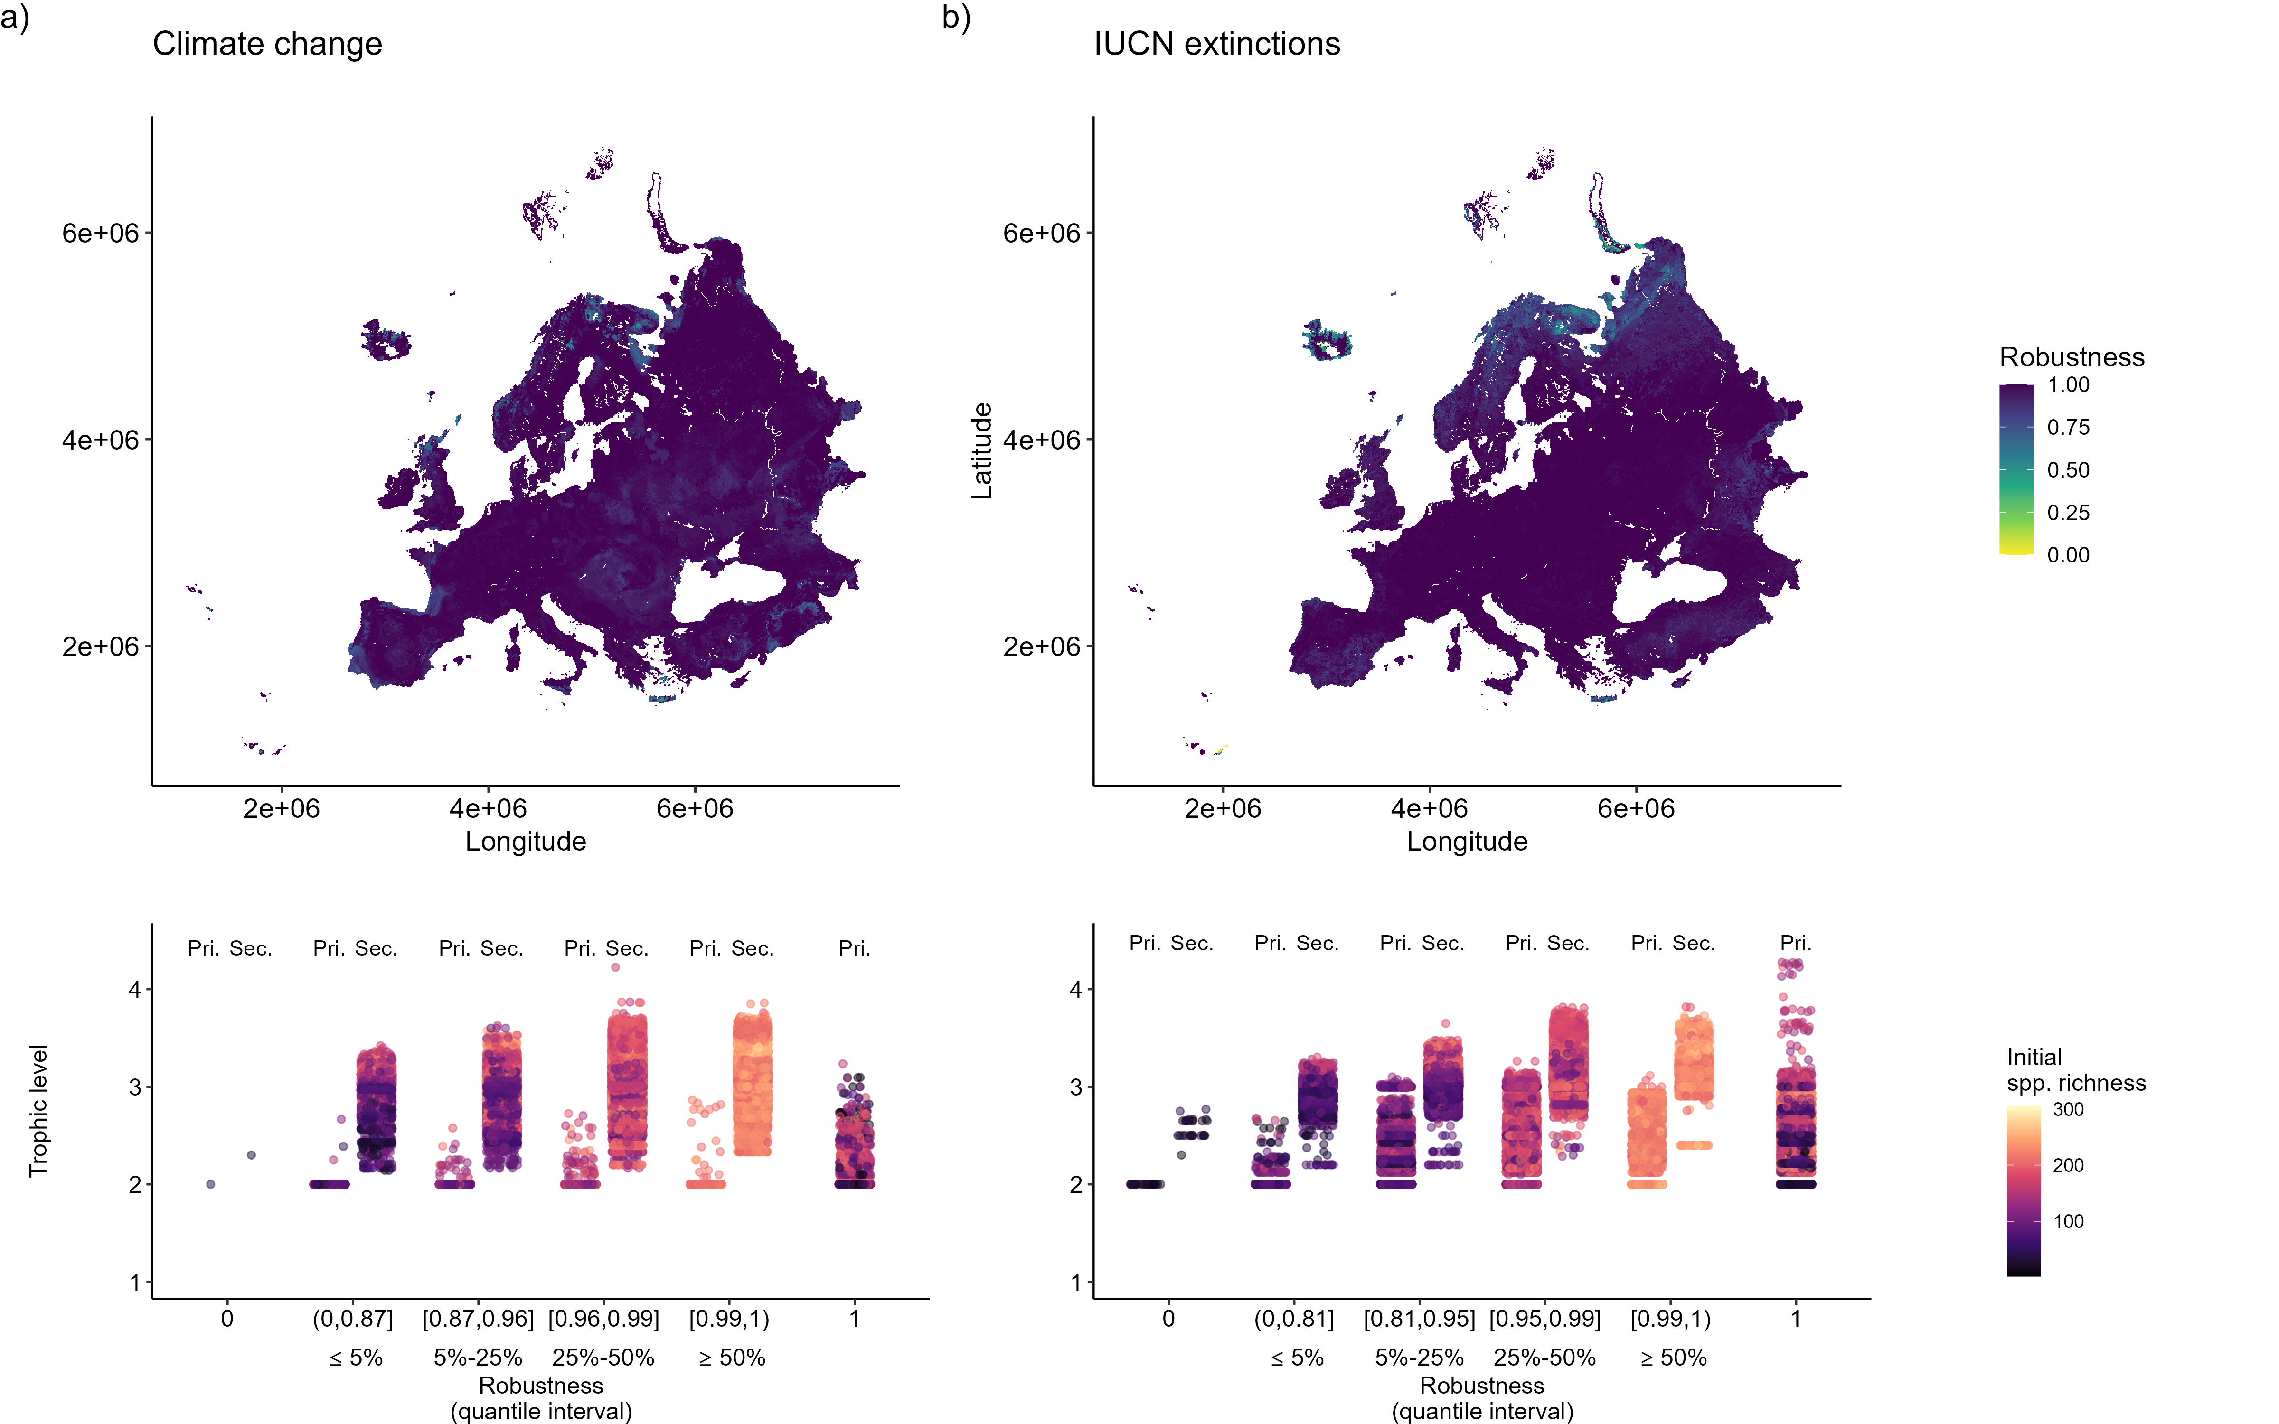
Robustness of European vertebrate networks to disturbance scenarios. Extreme scenarios of climate change and of species extinctions can be used to explore (lower) boundaries of network robustness and identify areas where we may expect a high number of cascading (secondary) extinctions and, consequently, larger disruptions to ecosystem functioning and services (upper panels). Further analyses of initial network metrics allow a deeper look into what may drive network robustness by comparing trophic information between primary and secondary extinctions (lower panels, here grouped by quantiles of robustness values). In this example, most networks are very robust to extinctions driven by a) climate change or b) the removal of endangered species listed in IUCN, but several networks in Northern Europe show lower robustness to targeted IUCN extinctions (upper panels). For networks that suffered secondary extinctions (where Robustness < 1; ‘Sec.’ bands on lower panels), larger networks (higher initial species richness) were more robust and, as expected, secondarily extinct species occupied higher trophic positions than primarily extinct species (‘Pri.’ bands). See supplemental information online for more detail. Data and analyses for this figure were adapted from Ceres Barros, PhD thesis, Université Grenoble Alpes, 2017iv.

Concluding remarks
Ecological networks already can and should be used as indicators in biodiversity conservation and ecosystem management. Sufficient data is available for initial assessments of network structures and responses to change. Additionally, we have relevant network indicators for ecosystem management and conservation that can be weaved into management frameworks and monitoring programs. Starting now ensures that future data will be useful to detect network changes and to address current knowledge gaps.
We recognize that the lack of empirical support for theory and scenarios of network responses (including robustness) to environmental change can refrain academics from providing guidance to practitioners. Robustness and extinction studies usually rely on simulations to investigate effects of species losses (rather than observations or experimental removals) and predictions remain mostly untested in the field [82; see Table 1 therein for some empirical validation examples]. Overcoming this barrier will require setting up empirical programs that go beyond documenting networks, and towards field and lab studies of network responses to realistic disturbances. Yet, despite this and other limitations (i.e., data, uncertainty, and interpretability challenges), we believe the field is sufficiently mature to make recommendations for ecosystem management and conservation as these programs are implemented.
We envision five important aspects for future directions (see also Outstanding Questions). First, there should be developments addressing evaluation, propagation, and communication of uncertainty in network structure and metrics. It will be key to a) integrate uncertainty robustly into management frameworks and move towards more transparent and informed decisions, but also to b) use existing tools and data to compare known network and ecosystem changes with predictions (e.g. backcasting), estimate boundaries of future network changes (e.g. forecasting), and assess the usefulness of network metrics as indicators of future change. Second, network considerations will need to be explicit in future sampling and monitoring designs, and in ecosystem conservation regulations and decisions. Third, current data, network models and indicators need to be more widely assessed for their usefulness for ecosystem management, which should actively involve stakeholders. Fourth, empirical programs focused on testing and measuring network (metrics’) responses to change will need to be set up. Finally, incorporating network information explicitly into conservation will require developing network-based targets—specific, quantified metrics to obtain and thresholds to respect based on whole network characteristics.

Outstanding questions
- How variable is network structure across space and time and does it influence the usefulness of network metrics as indicators of ecosystem functioning and stability?
- What network metrics are ubiquitous, reliable and applicable indicators of ecosystem functioning and stability?
- How much can we expect networks to change given uncertainty in future environmental conditions?
- How can current and future monitoring programs be improved to sample network information relevant for management?
- How can we put in place a strong empirical program to validate network indicators, which for now heavily rely on simulations?

Acknowledgements
G.D. is funded by the NSERC Postgraduate Scholarship – Doctoral (grant ES D – 558643), the FRQNT doctoral scholarship (grant no. 301750), and the NSERC CREATE BIOS2 program. T.P. is funded by the Wellcome Trust (223764/Z/21/Z), NSERC through the Discovery Grant and Discovery Accelerator Supplements programs, and the Courtois Foundation. WT, LOC and LM acknowledge support from the European Union’s Horizon Europe under grant agreement number 101060429 (project NaturaConnect). JMM acknowledges the support of Horizon Europe project BIOcean5D (award number 101059915) and the French Agence Nationale de la Recherche through LabEx TULIP (ANR-10-LABX-41).

Resources
i https://theses.hal.science/tel-04077711 ii https://www.iucnredlist.org/resources/spatial-data-download iii https://www.gbif.org/what-is-gbif iv https://theses.hal.science/tel-01685584

References

