A Study of an “Owl-Shaped Wine Vessel (*Zun*)”

Gabriel Drozdov

ARHA 182: Arts of Imperial China

December 17, 2015

The arts of imperial China gradually evolve as generations and dynasties pass by, and artistic movements change to match the needs and wants of society. At first, Chinese art was limited to national use, where sculptures were crafted out of bronze and bones in order to communicate with the spiritual world.[1] This form of art mostly pertains to ritual use, in which every detail plays a significant role in the work as a whole, and no details are unintentionally added. Following ritual art, Chinese artists developed new techniques that popularized paintings within the culture. Painters and calligraphers were skilled at their artistic fields, and artists worked on pieces that matched society’s philosophies at the time. Following the development of painting, factory art became particularly popular, especially with the production of blue-and-white porcelain[2]. Each new artistic development occupies a new subset of the Chinese art industry: bronzes filled a religious role, paintings filled an educational and artisanal role, and factory art filled an economic role. Nonetheless, bronze ritual art is still relevant because it represents a specific cultural period in Chinese history. To analyze the importance of this cultural period, I am going to discuss the characteristics and aesthetics of an “Owl-Shaped Wine Vessel (*Zun*)”, and its artistic and cultural role in China during the Shang dynasty’s Anyang phase.

While the work I am discussing predates further developments in painting, calligraphy, and ceramics, it may be pertinent to explore the different purposes of each art form. Ritual art is mostly found in tombs meant for individual worship, with the intention of communicating with the unseen world, or spirits. Although paintings were found in tombs as well, paintings stand out as representations of art meant for larger audiences, rather than for the spirits of deceased individuals. Thus, paintings have an entirely different purpose from bronze ritual sculptures, because paintings have to communicate ideas to the public. As a result, painters like Gu Kaizhi worked on pieces relevant to his time period’s society. For instance, Kaizhi’s *Admonitions of the Court Instructress* is a scroll that depicts the acceptable behavior for women in the Chinese court. This scroll was both an artistic achievement, as well as reflection of gender roles within the time period. Other works, like the *Eighteen Songs of a Nomad Flute*, focus on narratives that convey moral messages. For this work, the message was also relevant to gender roles, as it focused on the importance of a noble woman’s choice to stay true to her royal family regardless of the hardships that may transpire.[3] Text and calligraphy serve to document history through inscriptions in bronze ritual art,[4] while calligraphy takes on a more prominent role in later Chinese art. Calligraphy’s artistic role can be seen in Wang Xizhi’s “Preface to the Poems Collected from the Orchid Pavilion”, which is considered an artistic piece in its own right due to its beautiful semi-cursive calligraphy. Finally, ceramics prominently focused on China’s global influence, where different countries and continents would import luxurious blue-and-white porcelain. In contrast to later artistic developments, bronze ritual art is intimate, religious, and non-commercial.

An important factor in the study of bronze ritual art is excavation, because these works were meant to be placed in tombs. Archaeologists and historians have excavated tombs from the Anyang period, which lasted from around 1300 BC to 1050 BC.[5] These tombs are from the end of the Shang dynasty, which lasted from around 1600 BC to 1050 BC. While paintings and ceramics serve as the main artistic legacies of later generations, bronze art was the main legacy for the Anyang phase.[6] Since bronze art was not widely distributed during this time period, historians mainly see Anyang pieces in tombs, which are actually in Anyang. Likewise, the owl-shaped vessel must have been excavated from a tomb in Anyang. Although I am unsure which tomb the vessel came from, there are several possible locations. At first, Anyang excavations focused primarily on the Xibeigang tombs, but these discoveries were limited because the tombs were often looted, which drastically decreased the number of available artifacts.[7] Historians were originally drawn to these sites because animal bones were found with inscriptions that described divinations.[8] In 1976, archaeologists and historians made a large discovery, unveiling a tomb that had not been touched. The uncovered tomb was determined to be that of a royal woman named Fuhao, which was most likely determined through inscriptions in the bronze ritual objects found within the tomb. Although the burial was considered “modest,” there was still a wealth of artifacts found, including over two-hundred bronze vessels.[9] Most of these vessels do not depict animals, and several owl-shaped vessels have been found in the Xibeigang tombs, but it is also possible that the owl-shaped vessel for my study came from Fuhao’s tomb.[10]

The inscriptions in these vessels are necessary to consider in order to understand the details surrounding each piece. These inscriptions can either give historical accounts of events during the dynasty or phase, details about individual people, or information about the tomb in which the work was located.[11] The owl-shaped vessel does not seem to have any inscriptions, as the piece is completely covered in details pertaining to animals. Regardless, these animal details can be seen in other ritual objects. Even though the exterior is filled up, some animal-shaped objects do have inscriptions. For instance, the “Brudnage Rhino” has an inscription on its interior, while the exterior is entirely devoted to the naturalistic animal representation. While the owl-shaped vessel may not have any inscriptions on its exterior because of the figure’s details, its interior is mostly likely devoid of writing as well. This is because of the actual process by which the vessel is crafted and used, since the figure stands upright and has little to no space for an inscription to be read or written. Still, the owl-shaped vessel from Arthur M. Sackler collection has an inscription on its lid, but if the vessel of my study has a similar inscription, it is invisible from the outside.[12]

The animal features on the owl-shaped wine vessel are consistent with those observed on most bronze animal wine vessels. The most obvious detail about the owl-shaped vessel is its vessel shape, which consists of two parts: the head and the body. The head serves as the lid and the body serves as the container. The body is supported by two feet and a tail, which actually deviates from most *zun*. Most animals depicted on bronze ritual objects are quadrupeds, such as boars or buffalo.[13] Meanwhile, birds were depicted less often and strayed away from naturalistic representations, often focusing on mixing animals together in order to create a symbolic object that was appropriate for the occasion.[14] Although most bronze birds were difficult or impossible to identify, owls stood out as being both abundant and mostly naturalistic. The owls are therefore similar to the quadrupeds that were depicted, which almost always tended towards naturalistic representations that verged on realism.[15] Still, these bronze objects could never truthfully be realistic, as their details almost always depicted other animals instead of feathers or fur

The owl-shaped *zun* has both *taotie* details as well as other animal details. The central face is on the breast of the animal, which can be clearly identified because of its horns, ears, eyes, and nose. This figure is a combination of several other creatures, specifically a cicada in the body and a bovine in the head and horns.[16] Yet, there is one other creature represented in the *taotie* face that is also present in most bronze figures. The horns of the face are formed out of two dragons, which are referred to as *lung*. Whenever a creature cannot be identified as a real animal or resembles a form similar to that of a dragon, it is most often considered to be a *lung*.[17] The other animal details are seen on the wings, which are outlined by a snake’s body, whose head forms the outer part of each wing.[18] In terms of iconology, these faces and details can represent the specific animals that assist people when they pass away and cross from earth to heaven. Additionally, these animal features correlate to the idea of animal sacrifice, wherein animal spirits are released and therefore assist in the ascent of the deceased.[19] These interpretations are especially relevant because of the figure’s representation of an owl, due to its predatory nature and therefore its symbolism of death. These characteristics coincide with the use of the vessel in tombs, as these vessels were made for the dead to use, and not the living.[20]

In comparison to the other owl-shaped *zun*, the owl of my study is rather advanced. Even though the wings, breast, and head are covered in potentially distracting ornamental details, the overall shape can be clearly seen. This is because the owl has physical protrusions that resemble body parts. For instance, the ears, eyes, and nose all protrude from the head.[21] Meanwhile, an owl from the Arthur M. Sackler collection depicts the head in a much different way. The nose curves up instead of down, which gives the head an entirely different expression.[22] Instead of denoting a predatory gaze like the owl-shaped *zun* from the Yale University Art Gallery, the *zun* from the Sackler collection has a more human face, where the gap between the lid and the body almost gives the impression that the owl’s face is smiling and lively.[23] The whole face of the Sackler owl takes on a more friendly and symbolic approach, where the ears are replaced by a band on top of the owl’s head, and the eyes seem much less naturalistic that those on the Yale owl. Furthermore, the Sackler owl only hints at feathers, while the feathers are more clearly seen on the Yale owl through slight protrusions on the owl’s head and body. Other than these physical characteristics, there is an iconographic association with the Yale owl that gives it a more intimidating pose. The Yale owl seems very clearly associated with death, particular due to the cicada body on its *taotie* face, which is an actual symbol for death.[24] The Sackler owl simply does not seem intimidating, with stubby feet and a rounded body. Even so, the Sackler owl has similar dragon details, but these details are not nearly as intimidating as those on the Yale owl, because the dragons on the Yale owl make up the horns of the *taotie* face.

Even with the extensive work put into decorating the Yale owl, owl-shaped *zun* were eventually deemed inadequate for ritual use. This is because the owl form was something that had to abstractly imitate nature, while regular *zun* already borrowed their shape from nature.[25] Regardless, the Yale owl represents a significant cultural period within Chinese ritual art. The Yale owl has clear associations with death, which pertains to the general use of *zun*. Since these bronze objects are supposed to communicate with the spiritual world and the dead, it seems only relevant that the owl has heavy associations with death. The “Owl-Shaped Wine Vessel (*Zun*)” is undeniably a ritual object, and it serves as a physical representation of the legacy of the Shang dynasty’s Anyang Phase.

 

Fig. 1 and Fig. 2. Owl-Shaped Wine Vessel (Zun), bronze, 13th-11th century BC, Shang dynasty (1600-1050 BC) Anyang phase (1300-1050 BC), in the Yale University Art Gallery

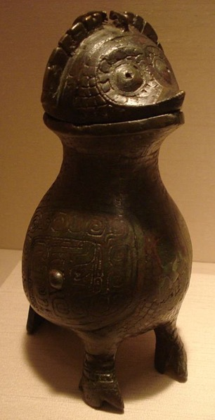

Fig. 3. From the Arthur M. Sackler Collection, bronze, Anyang Period, 12th-11th century BC



Fig. 4. Pouring vessel with dragon-head lid (guang), late 11th century B.C., Western Zhou Dynasty, at the Princeton University Art Museum, bronze

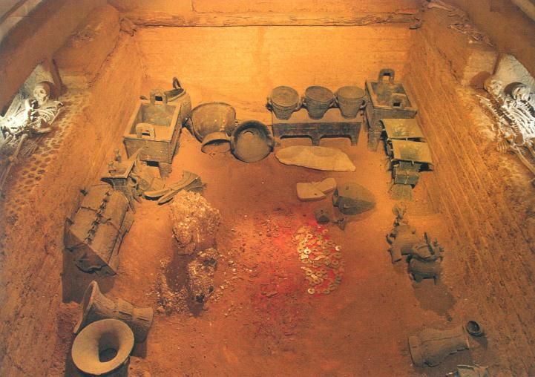

Fig. 5. Reconstruction of Yinxu Tomb No. 5 (Fuhao’s tomb). c. 1200 BCE, Anyang Period, late Shang., Anyang, Henan Province.

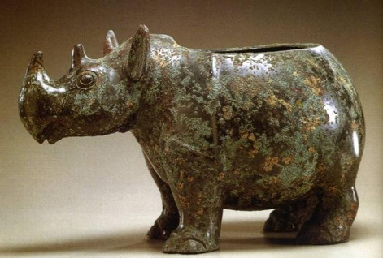 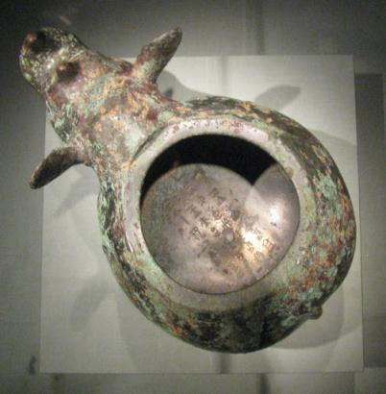

Fig. 6. and Fig. 7. *Yu rhino zun* (the Brudnage Rhino). Bronze, h. 22.9 cm. Early-mid 11th century BCE, late Shang. Asian Art Museum, San Francisco.

Bibliography

Aiguo, Zhao, Chang Tong, and William W. Moss. 1989. “Exquisite Art and Precious Archives: China's Records in Bronze.” *The American Archivist* 52 (1). Society of American Archivists: 94–98. http://www.jstor.org/stable/40293317.

Bagley, Robert W. "Anyang." *Grove Art Online*. *Oxford Art Online*. Oxford University Press. http://www.oxfordartonline.com/subscriber/article/grove/art/T003378 (accessed November 9, 2015).

Bagley, Robert W. "Owl-Shaped Zun." In Shang Ritual Bronzes in the Arthur M. Sackler Collection. Washington (D.C.): Publ. by the A. M. Sackler Foundation, 1987.

Chang, K. C. "The Animal in Shang and Chou Bronze Art." *Harvard Journal of Asiatic Studies* 41, no. 2 (1981): 527-54.

Midgette, Anne. 2002. “A Heartstrings Tug of War: Husband vs. Homeland.” The New York Times, sec 151.

Smith, D. Howard. "Chinese Religion in the Shang Dynasty." Numen 8, no. 2 (1961): 142-50.

Stoltman, James B., Zhichun Jing, Jigen Tang, and George (Rip) Rapp. "Ceramic Production in Shang Societies of Anyang." *Asian Perspectives* 48, no. 1 (Spring, 2009): 182-203. http://search.proquest.com/docview/199452434?accountid=14963.

Yale University Art Gallery. “Asian Art.” New Haven, Connecticut: Yale University Art Gallery, 1992.

1. Bagley, “Anyang;” animal bones were used in divinations, in which people would attempt to communicate with spirits in order to make good things happen in the real world.
2. Stoltman, Jing, Tang, and Rapp, "Ceramic Production in Shang Societies of Anyang,"197; although ceramics were produced during the Shang dynasty, they were not mass-produced or traded to far regions. These objects were made with extreme care and professional technique, and although they were available to the public, they did not have the same ritual functions as bronze objects.
3. Midgette, “A Heartstrings Tug of War: Husband vs. Homeland;” although this article talks about a modern production of the poem, the theme is consistent with the theme of the original paintings that illustrated the poem.
4. Aiguo, Chang, and William, “Exquisite Art and Precious Archives: China's Records in Bronze,” 96; inscriptions in vessels document specific events. For inscriptions in bronze vessels during the Anyang period, see Fig. 6 and Fig. 7, the “Brudnage Rhino” and the image of its inscription.
5. Bagley, “Anyang;” see the article for general information about the excavations made in Anyang.
6. Bagley, “Anyang;” “…bronze ritual vessels and jades are considered the chief artistic legacy of the Anyang civilization…”
7. Bagley, “Anyang;” excavators discovered a large number of tombs at Xibeigang, many of which were looted.
8. Bagley, “Anyang;” archaeologists realized that animal bones found in Anyang were inscribed, and that these bones were used in divinations.
9. Bagley, “Anyang;” “…more than 200 bronze vessels and 200 bronze weapons and tools (totalling 1600 kg of metal), 750 jade and stone carvings, 500 carved bone and ivory objects, 4 bronze mirrors, 7000 cowrie shells, and 16 sacrificial victims.” Part of the tomb can be seen in Fig. 5.
10. Bagley, “Owl-Shaped *Zun,*” 409; a bronze piece relating to owl-shaped *zun* has been identified from the Xibeigang tombs.
11. Aiguo, Chang, and William, “Exquisite Art and Precious Archives: China's Records in Bronze,” 94; while the article for the most part refers to the Western Zhou, the historical value of inscriptions was felt through various dynasties.
12. Bagley, “Owl-Shaped *Zun,*” 408; also see Fig. 3 for the owl-shaped vessel that has the inscription on the inside of its lid.
13. Bagley, “Owl-Shaped *Zun,*” 408-9; the quadrupeds listed are boars, buffalo, ram, rhinoceroses, and elephants. Furthermore, owl-shaped *zun* and quadruped *zun* both come from around the beginning of the Anyang period.
14. Bagley, “Owl-Shaped *Zun,*” 409.
15. Bagley, “Owl-Shaped *Zun,*” 408.
16. Yale, from “Owl-Shaped Wine Vessel (*Zun*);” the “composite creature” is an appropriate analysis because many creatures utilized different animal forms in one figure, such as with *guang* (see Fig. 4).
17. Chang, "The Animal in Shang and Chou Bronze Art," 532; the *lung* also often come in pairs, which is seen due to the symmetry of the owl.
18. Yale, from “Owl-Shaped Wine Vessel (*Zun*);” the coils of the snake can be seen on the outer part of the wing (Fig. 1 and Fig. 2).
19. Chang, 537.
20. Smith, "Chinese Religion in the Shang Dynasty," 148; there was an emphasis on a “post-mortem existence,” where the deceased were provided objects to use after their deaths.
21. See Fig. 1 and Fig. 2.
22. See Fig. 3.
23. Bagley, “Owl-Shaped *Zun,*” 407.
24. Yale, from “Owl-Shaped Wine Vessel (*Zun*).”
25. Bagley, “Owl-Shaped *Zun,*” 411.