That is a software that calculate and displays memberships fees for N (in this case 4) customers who are registered for membership in a sport center based in Victoria, Australia.

The amount paid by each customer is according to the table below.

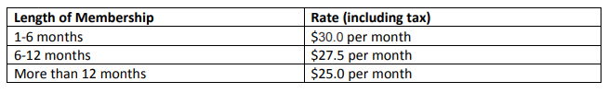

Obs: In the program created we assumed as standard that none of customers receive the special offer.

If a value out of the range between 1 and 60 for number of months is entered the program will not accept. As showed below:

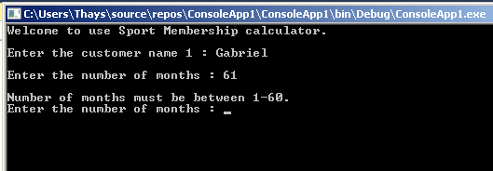

At the end is showed a display with all customers and who spend the most and who spend the least, a relation with who is registered under 6 months or more than 6 months also is displayed.

