Change 1, experiments 20-23:

This changes are activated by:
EMRTK_BALANCE_ENABLED = 1;
EMRTK_LEAVE_LITTLE3_ENABLED = 0;
EMRTK_MIGRATE_ENABLED = 1;
EMRTK_CBS_YIELD_ENABLED = 0;

EMRTK_CBS_ENVELOPING_PER_TASK_ENABLED = 1;
EMRTK_CBS_ENVELOPING_MIGRATE_AFTER_VTIME_END = 1;
EMRTK_CBS_MIGRATE_AFTER_END = 0;

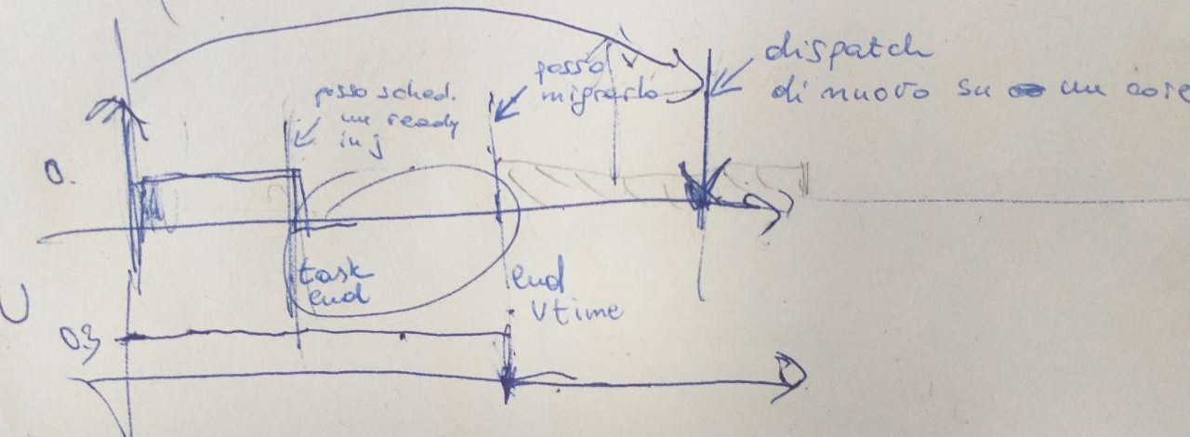
Periodic tasks are enveloped inside CBS servers, so to be throttled if they finish their budget.
* What I do when periodic tasks:
- end their WCET or are killed: schedule ready tasks on the ending core
- end of virtual time: try migrating ready tasks on other cores
- end of period=deadline: dispatch task on a core, preferring the older one.

Tests:
0) Wyhen tasks finish or are killed, you schedule next ready of core?
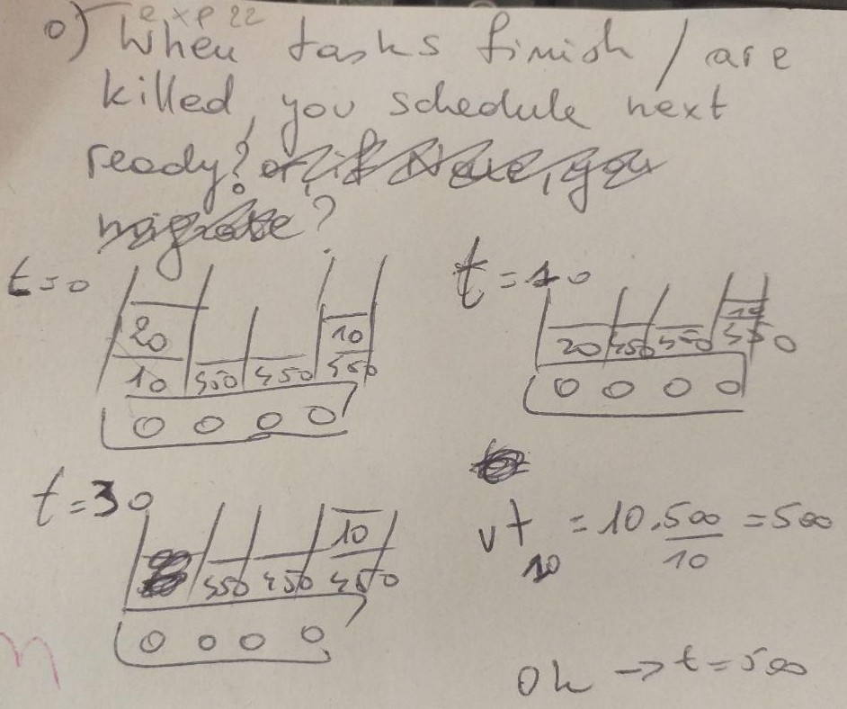
Assumed all tasks with equal period = deadline = 500. Considering only BIG island, with frequency fixed to 2 GHz.

2 and 3) Migration on ending core when virtual time ends

2) say pull is fine and you migrate a task, with WCET > DL of the ending task, to the ending core. At its next activation time = period = deadline, it can be kept where it was before

3) say pull is fine and you migrate a task, with WCET > DL of the ending task, to the ending core. At its next activation time = period = deadline, it must be moved away, because the migrated task has eaten up a part of its utilization.
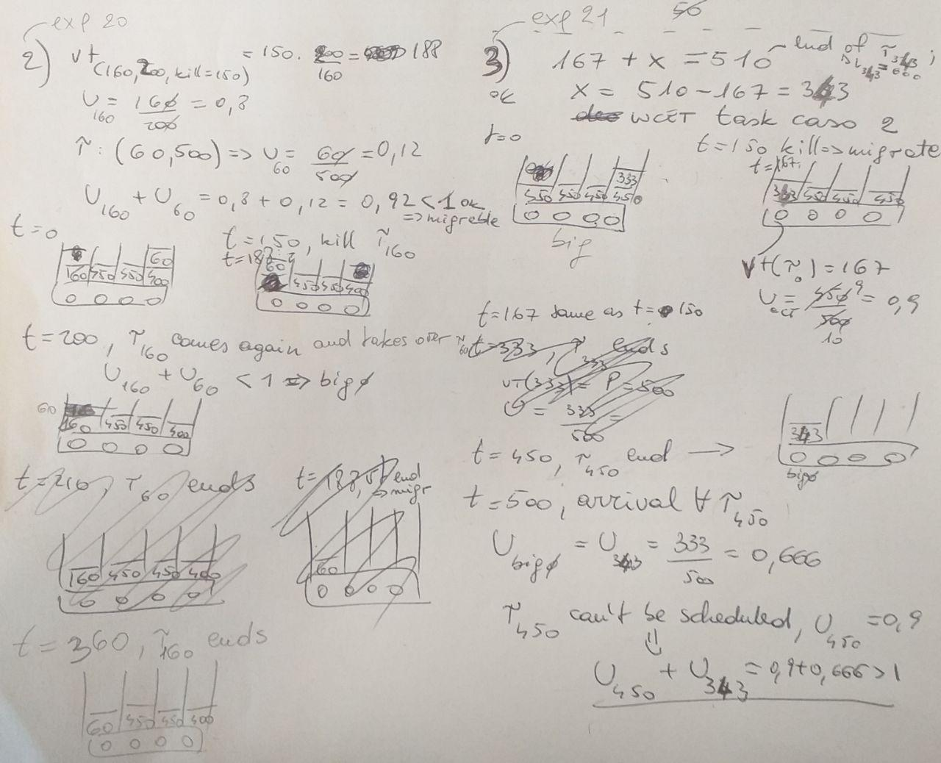

Change 2, experiments 24-

The figure below shows when this change is activated.

This changes are activated by:
EMRTK_BALANCE_ENABLED = 1;
EMRTK_LEAVE_LITTLE3_ENABLED = 0;
EMRTK_MIGRATE_ENABLED = 1;
EMRTK_CBS_YIELD_ENABLED = 0;

EMRTK_CBS_ENVELOPING_PER_TASK_ENABLED = 1;
EMRTK_CBS_ENVELOPING_MIGRATE_AFTER_VTIME_END = 1;
EMRTK_CBS_ENVELOPING_MIGRATE_AFTER_VTIME_END_RECL = 1;
EMRTK_CBS_MIGRATE_AFTER_END = 0;

A task finishes or is killed. As before, schedule the next ready task on the processor.
When virtual time is over and ending core is idle, instead:
- d_mig’ed <= a_vt, then you can migrated any ready task, without considering its utilization
- d_mig’ed > a_vt and Q_remaining < (a_vt – curr_time), then you can migrate any task, without considering its utilization
- d_mig’ed > a_vt and Q_remaining >= (a_vt – curr_time), then with Q_remaining_mig’ed = Q_r_m = Q_remaining_mig’ed – (a_vt – curr_time), you can migrate any ready task s.t. U_mig’ed = Q_r_m / (d_mig’ed – a_vt)
with
- d_mig’ed the deadline of the migrated task into the ending, idle core
- U_mig’e the utilization [...]
- a_vt the next arrival time = period of the task whose virtual time expires
- curr_time the current simulation time
- Q_remaining_mig’ed the remaining budget of the migrated task

