Experiments 20-23:
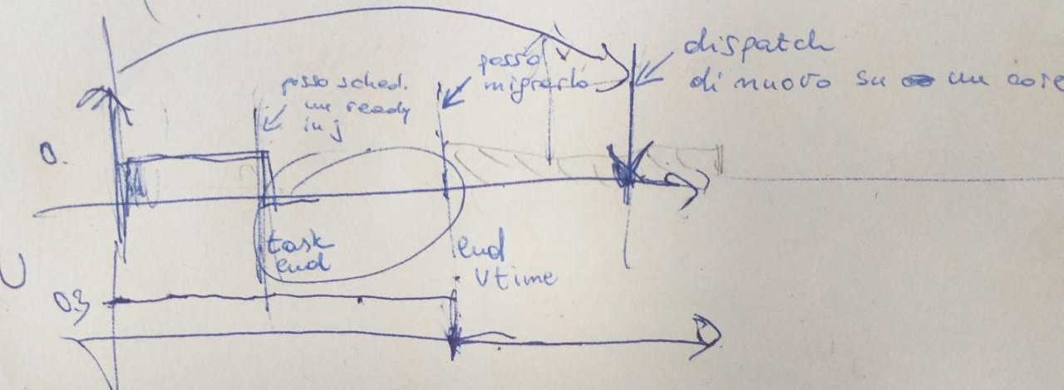
Periodic tasks are enveloped inside CBS servers, so to be throttled if they finish their budget.
* What I do when periodic tasks:
- end their WCET or are killed: schedule ready tasks on the ending core
- end of virtual time: try migrating ready tasks on other cores
- end of period=deadline: dispatch task on a core, preferring the older one.

Tests:
0) Wyhen tasks finish or are killed, you schedule next ready of core?
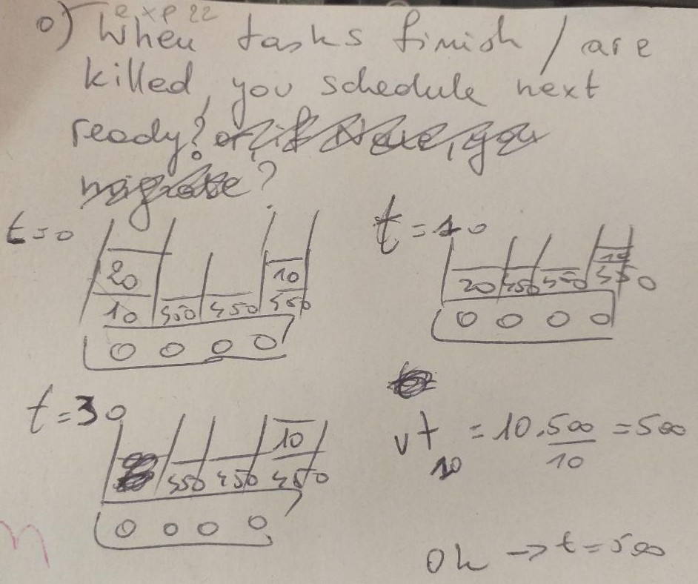
Assumed all tasks with equal period = deadline = 500. Considering only BIG island, with frequency fixed to 2 GHz.

2 and 3) Migration on ending core when virtual time ends

2) say pull is fine and you migrate a task, with WCET > DL of the ending task, to the ending core. At its next activation time = period = deadline, it can be kept where it was before

3) say pull is fine and you migrate a task, with WCET > DL of the ending task, to the ending core. At its next activation time = period = deadline, it must be moved away, because the migrated task has eaten up a part of its utilization.
