Library Instructions:

First, you have to insert a book in the list of books, because the list lives in local memory and it get erased every time you stop the Anypoint Studio.

To insert a new book in the list you have to make a post request with postman,using a json a json with the attributes of class book.java. For example something like this:

url: localhost:8081/book

method :POST

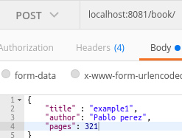

The api will return this body

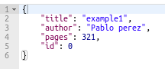

List:  
 If you want to list all the book you have to use this

url: localhost:8081/book

method:GET

Before i make this request i will add another book to the list

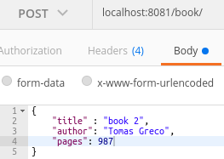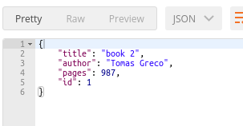

Now i am going to list all the books .

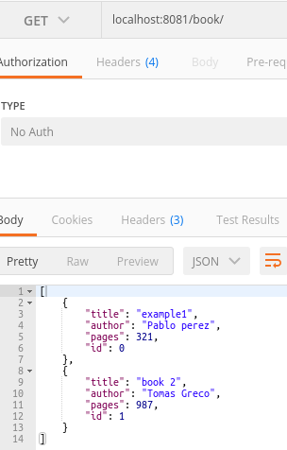

Update: To update a book you have to specify in the json the id of the book and the attributes you want to change.

url:localhost:8081/book/

method: PUT. Example to change the name of the book with id=1

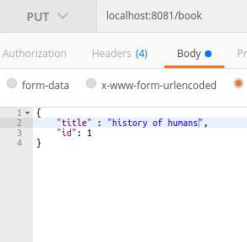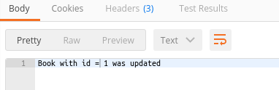

Now if we list the book you can see that the title of the book with id:1 have changed

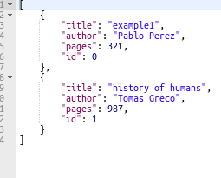

Delete: To delete a book you have to you have to specify the id of the book you want to delete as a query param using this url:localhost:8081/book/?id=1

method: DELETE. Example to delete book with id 1.

The api will return this body

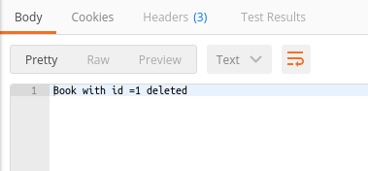

if the book was not found, the api will return this

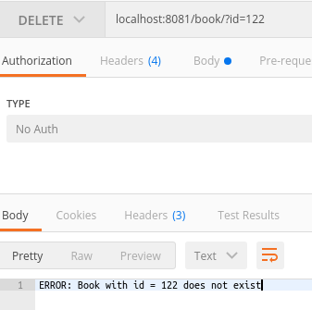

Find: To find a book you have to specify the id of the book using this url:localhost:8081/book/find?name=xxx

method: POST. Example to find a book with name = “example1 ”

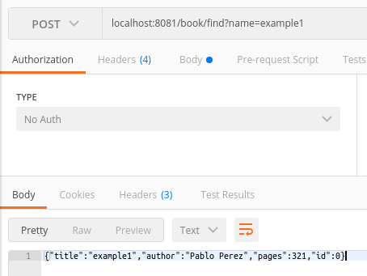

If the book does not exist in the list the api will return this 