METASPLOITABLE 192.168.50.101/24

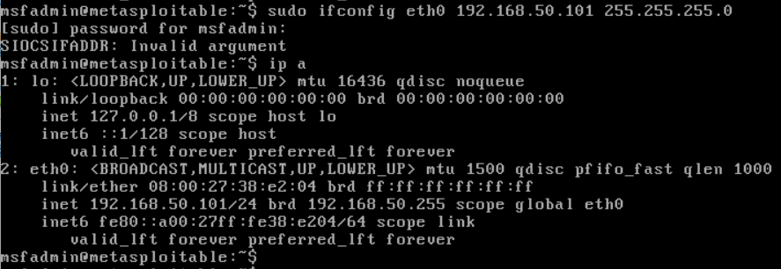

OS FINGERPRINT

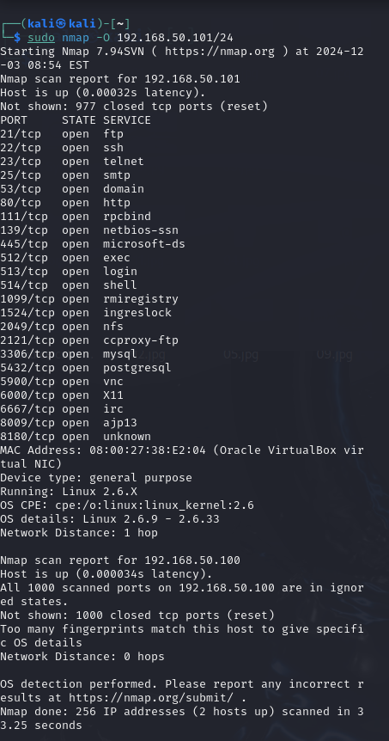

SYN SCAN

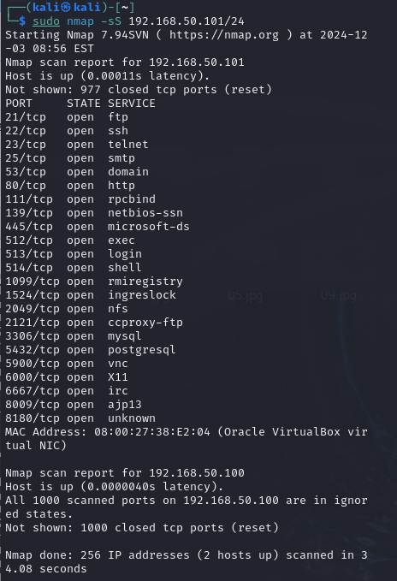

TCP CONNECT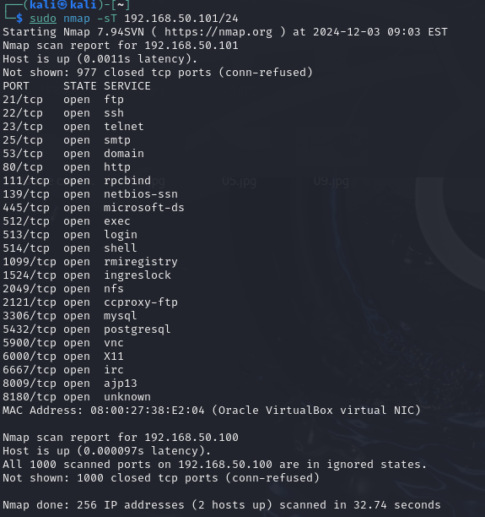

VERSION DETECTION 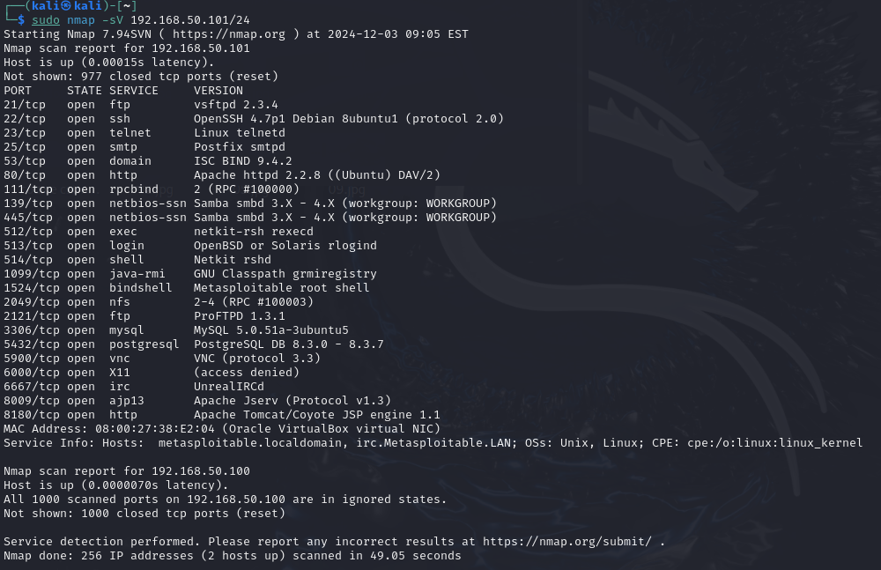

OS FINGERPRINT WINDOWS

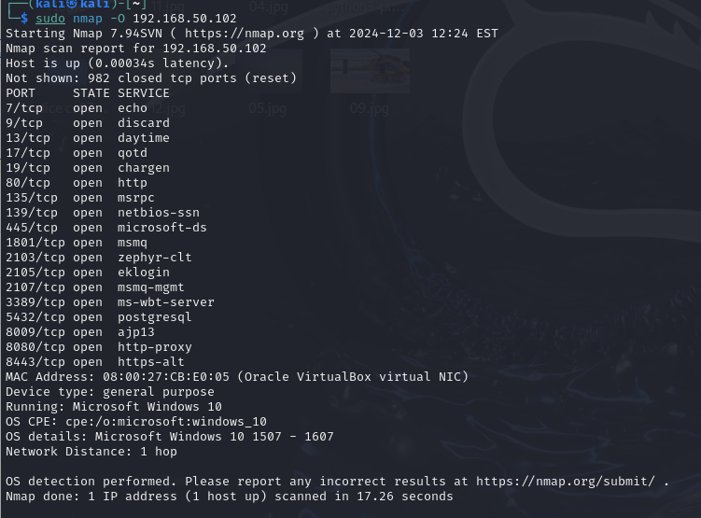

INDIRIZZO IP METASPLOITABLE: 192.168.50.101

INDIRIZZO IP WINDOWS:

192.168.50.102

SISTEMA OPERATIVO METASPLOITABLE:

OS CPE: cpe:/o:linux:linux_kernel:2.6

OS details: Linux 2.6.9 - 2.6.33

SISTEMA OPERATIVO WINDOWS:

OS CPE: cpe:/o:microsoft:windows_10

OS details: Microsoft Windows 10 1507 - 1607

PORTE APERTE METASPLOITABLE:

PORT

21/tcp open

22/tcp open

23/tcp open

25/tcp open

53/tcp open

80/tcp open

111/tcp open

139/tcp open

445/tcp open

512/tcp open

513/tcp open

514/tcp open

1099/tcp open

1524/tcp open

2049/tcp open

2121/tcp open

3306/tcp open

5432/tcp open

5900/tcp open

6000/tcp open

6667/tcp open

8009/tcp open

8180/tcp open

PORTE APERTE WINDOWS:

7/tcp open

9/tcp open

13/tcp open

17/tcp open

19/tcp open

80/tcp open

135/tcp open

139/tcp open

445/tcp open

1801/tcp open

2103/tcp open

2105/tcp open

2107/tcp open

3389/tcp open

5432/tcp open

8009/tcp open

8080/tcp open

8443/tcp open