Student: Gabriel Ferreira Barros de Sousa ID: c0692688 Date: 01/08/2018

**Vote Analyzer - Design Document**

**UI**

# Setup App

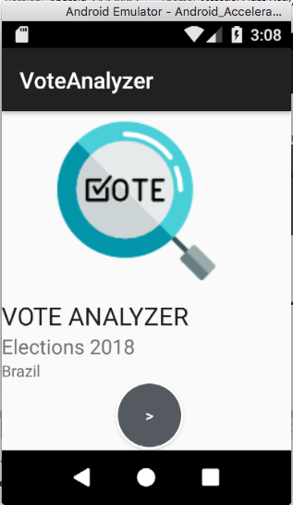 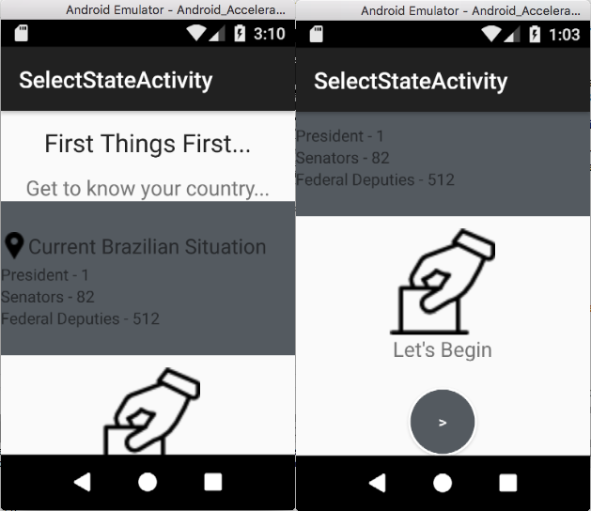

|  |  |
| --- | --- |
| This is the first screen that will be displayed. It shows the logo and redirects to setup the app. | This is the second screen. It displays information about how many elected are for each role in Brazil. It is just an informative screen. |

# Main Screen and Navigation to operations

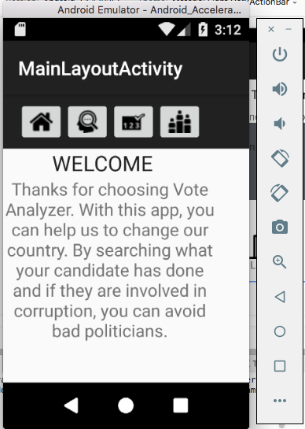

|  |
| --- |
| The main screen of the Vote Analyzer is a welcome page. At the top, the navigation is done by the buttons at the toolbar. You have the option to come back home, do the basic search, the emulation of elections and the ranking |

# Basic Search Operation

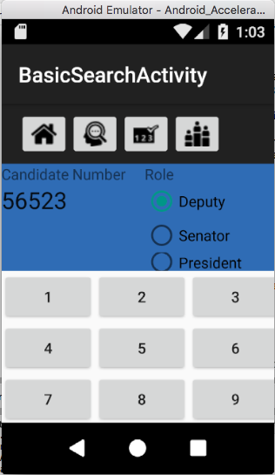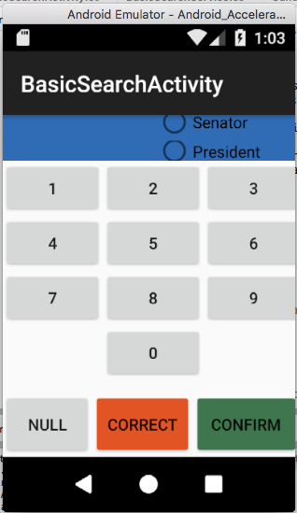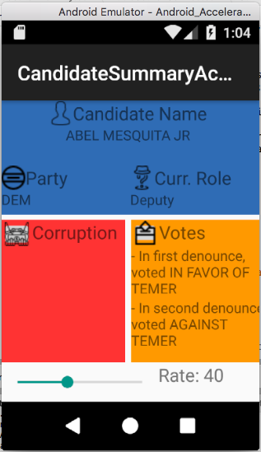

|  |  |  |
| --- | --- | --- |
| When selecting the operation Basic Search, this is the main screen. It simulates the layout of the electronic urn used on Brazilian’s election. Type the numbers and select which role you want to search | After typing the numbers and clicking the CONFIRM button. It will redirect you to the details page. In case you want to erase all, click NULL. | The details screen will be displayed. On the top, general information about the candidate will be displayed. On the middle, two columns will show the corruptions cases and how the candidate voted recently on the national discussions. At the bottom, a formula will display how we rank the candidate, based on those columns above. |

# Election Simulation Operation

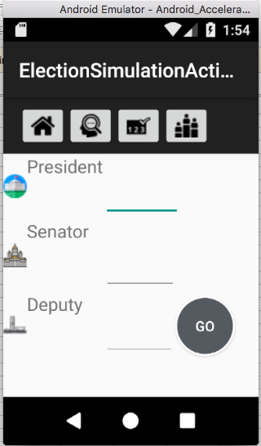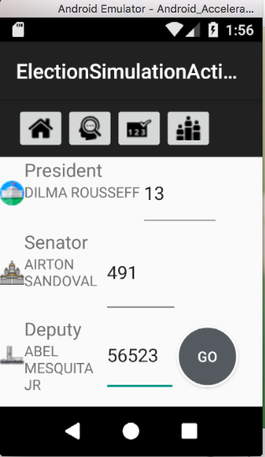

A list of the roles to be voted will be displayed, on this operation. The user will type the number for their candidate on each role, sequentially, using the default keyboard. By clicking GO, the app validates the candidates selected.

# Political Ranking Operation

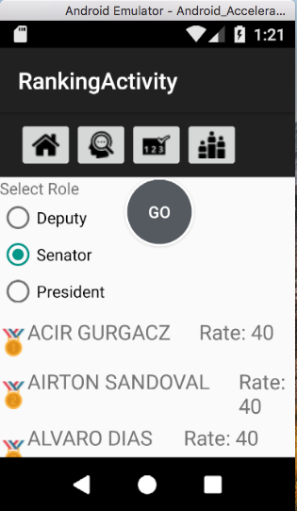

Based on each role, Vote Analyzer will use a math formula to provide a ranking of the most recommended politicians for each role. It is based on the corruption data and the votes that the politician gave on the most recent controversial themes and Brazilian’s congress.