Heifer Ranch Learning Expedition
Packing List
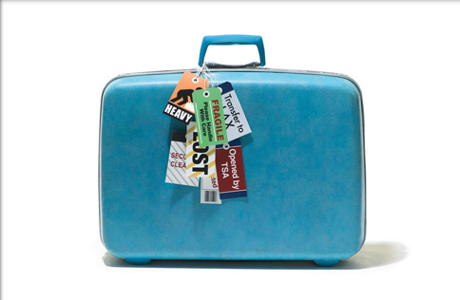
Required Items:
- Sleeping Bag…A WARM one!
- Warm Jacket or Coat…it’s in the 30’s-40’s
and even colder at night!
- Pillow
- Small Blanket for the bus
- Towel for the shower
- Sunscreen
- Rain Jacket
- Flashlight with extra batteries…it’s dark out there!
- Empty 24 oz (or larger) water bottle
- Notebook and Pen/Pencil
- $20 tip money for the bus drivers
- Comfortable clothing to layer…think warm!
- Gallon Size Bag with Student’s Name in Sharpie
For the Simulation | For the other two days
1 pair of warm comfortable pants | 1-2 pairs pants
1-2 warm shirts | 2 long sleeve shirts
warm socks | socks
underwear | underwear
Warm pj’s or thermal underwear | pjs
Comfy, CLOSED TOE shoes | Shoes (no flip flops or sandals!)
Jacket or coat | Hoodie or sweater
Hat or scarf and gloves | Additional toiletries as needed
Toothbrush, Toothpaste, deodorant

- Toiletries:
    - Travel Size Soap and Shampoo/Conditioner
    - Toothbrush and travel size toothpaste
    - Deodorant…please, or it will be a long bus ride for everyone!
    - Others items as necessary—saline solution, glasses, etc. but don’t go crazy!!
    - Medications—All med’s must be correctly labeled with the student’s name on it and be in the original container. Students may self-administer medication, provided parents have signed the consent to self-administer medications form. Otherwise all medications must be turned in to a teacher.

Optional Items:
- Snacks for the bus
- Insect Repellent
- Camera
- Cell phone, iPod, other electronics… Bring at your own discretion. All electronics will be locked up during the simulation at Heifer
- Souvenir money

