Territorial Information Retrieval from Heterogeneous Open Data: Extending a Water Data Warehouse from Mexico City to its Metropolitan Area
Gabriel Hurtado Avilés¹, Eduardo Uriel Velázquez Arrieta¹, Omar Fernando Pulido Morales¹, Emilio García López¹, Clara Aide Hernández Martínez¹ and Roberto Eswart Zagal Flores¹
¹ Escuela Superior de Cómputo (ESCOM), Instituto Politécnico Nacional, Mexico City, Mexico
Gabriel Hurtado Avilés: ghurtadoa@ipn.mx; gabrielhuav@gmail.com
Eduardo Uriel Velázquez Arrieta: evelazqueza1900@alumno.ipn.mx; velazquez.arrieta.uriel@gmail.com
Omar Fernando Pulido Morales: opulidom2000@alumno.ipn.mx; pulido.morales.omar@gmail.com
Emilio García López: egarcial2001@alumno.ipn.mx; egarlo@hotmail.com
Clara Aide Hernández Martínez: chernandezm1903@alumno.ipn.mx; claraahm11@gmail.com
Roberto Eswart Zagal Flores: rzagalf@ipn.mx
Corresponding author: gabrielhuav@gmail.com

Abstract. This work presents a data warehouse for the territorial information retrieval of water consumption in Mexico City, built from heterogeneous open sources and extended to its metropolitan area. The contribution lies in three elements: an ETL process that consolidates SACMEX data into a dimensional model of 70,886 records, a declarative R2RML mapping that republishes the star schema as an RDF knowledge graph, and a static deployment methodology. Against the 2020 Census, billed volumes amount to 47 litres per inhabitant per day, 38 % of published consumption, lowest in the periphery, and the atypical-consumption score structurally misses drops. The extension integrates 62 verified files into a warehouse of 2.79 million rows, with a metropolitan knowledge graph covering 63 municipalities: municipal volumes require a quality filter, and neighbourhoods with almost no billed volume report shortages nearly as often as the rest. Every map layer is a verified SQL query.  Keywords: Data warehouse, Open data, Knowledge graph, RDF Data Cube, Water consumption, Anomaly detection | Article information  Received:  Accepted:

1 Introduction
Mexico City faces a water crisis of aquifer overexploitation, network leaks and population growth. Open data on water consumption exist (SACMEX), but in poorly accessible formats and without query tools, which limits their use for evidence-based decision making.
This work addresses the problem from two perspectives proper to information processing: the extraction of structured information from heterogeneous open sources through an ETL process, and the retrieval of that information through a parameterised query interface, transforming dispersed datasets into a queryable dimensional repository that anyone can filter and visualise geospatially by neighbourhood and borough.
The contribution of this work is threefold: (i) a reproducible ETL process to consolidate official open data into a dimensional data warehouse, (ii) a declarative R2RML mapping that republishes it as a validated RDF knowledge graph, and (iii) a continuous-deployment methodology that preserves a demonstration that can be served without a database backend, combining a dynamic deployment connected to a database with a static version published in a public repository.
The analysis of the 70,886 consolidated records reveals that the boroughs of Cuauhtémoc and Miguel Hidalgo lead the total billed volume (Table 3), and that consumption varies across the available bimesters without a direct causal relationship with dry or rainy periods. The system serves citizens querying their own neighbourhood, public servants diagnosing territorial demand, researchers, journalists and civil organisations monitoring water management.
This article extends the version presented at ICOKG 2026 (Velázquez Arrieta et al., in press). It adds an account of what a consumption value in the source actually is (Section 3.4); a measure, against the 2020 Census, of how much of the city’s consumption the billed volumes represent and of how the borough ranking changes per inhabitant (Section 5.3); a sensitivity analysis showing that the deployed atypical-consumption statistic is structurally blind to drops (Section 5.5), with a diagnosis on the real data (Section 5.6); and the extension of the warehouse to the metropolitan area, published in a map whose layers are verified SQL queries and in a knowledge graph that crosses the city boundary (Sections 5.7 and 5.8).
Section 2 reviews related work, Section 3 describes the methodology, Section 4 derives the knowledge graph, Section 5 presents the results, Section 6 discusses them and Section 7 concludes.

2 Related Work

2.1 Foundations: Data Warehouses, Dimensional Modelling, and ETL
Dimensional modelling and the star schema constitute the consolidated basis for the design of analytical data warehouses. Kimball and Ross (2013) establish the canonical principles —fact and dimension tables, surrogate keys, slowly changing dimensions, and the ETL subsystems— that ground the model adopted in this work. On the integration phase, Vassiliadis (2009) offers a reference survey of Extract–Transform–Load technology, covering the conceptual and logical modelling of the processes and the cross-cutting extraction, transformation, and loading issues that methodologically support our pipeline.

2.2 Data Warehouses and Information Systems for Water Management
In the water domain, the most direct antecedent is that of Soares et al. (2019), who implement a data warehouse with an ETL process to monitor water supply and consumption, integrating meter readings, reservoir volumes, and geographic location from management-application databases and heterogeneous files. Abecker et al. (2014) present a hybrid sensor-semantic architecture (the WatERP project) that combines a relational/PostGIS store with a triple store for integrated resource management. These systems, however, mostly start from operational data, SCADA, or proprietary sensor networks, and not from open government data.

2.3 Water Consumption in Mexico City from Utility Records
Peer-reviewed spatial analyses of consumption in Mexico City come mainly from two groups, and both obtained their data from the utility rather than from the open portal. Medina-Rivas et al. (2022) analyse the 2019 records, the year of the open export used here, report a domestic consumption of 123 litres per person per day, and find two clusters of unequal consumption explained by discontinuous supply, dependence on external sources, altitude and socioeconomic status; a later study finds that per-capita domestic use fell by 40 % between 2010 and 2019 while its spatial distribution became more unequal (Medina-Rivas et al., 2025). Ramos-Bueno et al. (2021) obtained colonia-level consumption and metering for 2008–2013 through public-information requests and explain residential demand with spatial regression, after excluding colonias with zero consumption or no metering coverage, and a panel study by the same group extends the series to 2004–2022 (Ramos-Bueno et al., 2024). These works answer substantive questions with data a reader cannot obtain from the portal. The present one addresses the complementary problem of making the open export itself queryable and verifiable, and what it finds about the billing basis and about colonias without billed volume (Sections 3.4 and 5.6) is consistent with the exclusions those studies apply. Closer in method, Hernández-Vázquez et al. (2026) fuse SACMEX, INEGI and DENUE data in a GIS, with a layered architecture for historic data, and cluster consumption from boroughs to neighbourhoods, and Daowz Laguna et al. (2027) use large language models to turn citizen reports from social media and the web into features for analysing leak incidents. Both aim at spatial analysis; this work aims at a dimensional warehouse and a knowledge graph over the open sources.

2.4 The Gap: ETL over Heterogeneous Open Data and Data Quality
Integrating open government data into dimensional warehouses poses its own challenges. Berro, Megdiche, and Teste (2015) propose “content-driven” ETL processes that address precisely the semantic and structural heterogeneity, the absence of schemas, and the dispersion characteristic of open data, factors that overwhelm traditional ETL. Complementarily, Vetrò et al. (2016) define a quantitative measurement framework for the quality of Open Government Data (accuracy, completeness, consistency, traceability, and freshness) and empirically report that the most frequent problems are missing metadata, incomplete data, and the absence of update information —exactly the challenges our ETL faces over the SACMEX data.

2.5 Geospatial Information Retrieval and Visualisation
Purves et al. (2018) offer a reference monograph on Geographic Information Retrieval (GIR) —indexing, search, and spatial ranking— that theoretically frames the territorial information-retrieval component of this work.

2.6 Knowledge Graphs for Urban and Water Domains
Republishing a relational warehouse as RDF is a mature practice with W3C standards for both ends. The RDF Data Cube vocabulary (World Wide Web Consortium, 2014) models statistical observations over conformed dimensions, which is the same structure a star schema encodes; R2RML (World Wide Web Consortium, 2012) specifies the mapping declaratively, so the graph is derived rather than maintained by hand; and GeoSPARQL 1.1, documented by Car and Homburg (2022), supplies the geometry model and the topological vocabulary that a flat territorial dimension cannot express. In the water and urban domains the direction is established: Roussey et al. (2023) survey knowledge-graph technologies as the next frontier for food, agriculture and water. The closest graph in the water domain is the Water Health Open Knowledge Graph (Lippolis et al., 2025), built in a European project, which models water consumption together with pollution, extreme weather, infectious disease and drug distribution; we found no RDF knowledge graph built over Mexican utility water data. What these works share is the premise this article adopts: the graph is valuable for interoperability and topological querying, not as a replacement for the analytical store.

2.7 Reproducibility and Deployment of Scientific Demonstrations
Finally, Sandve et al. (2013) formulate widely cited rules for computational reproducibility (version control, documentation of preprocessing, public access to data and scripts) that ground our reproducible static version. Hill et al. (2023) provide a practical guide to developing and deploying an open-source, reproducible web dashboard for water-sanitation data, a close domain that supports the continuous-deployment methodology with reproducible artefacts.

2.8 Positioning of the Contribution
The contribution is the reproducible integration of the SACMEX open export rather than a new warehouse architecture. Operational water systems typically integrate controlled meter or sensor data (Abecker et al., 2014; Soares et al., 2019); here the ETL must resolve the structural heterogeneity and incomplete metadata of public files (Berro et al., 2015; Vetrò et al., 2016). The dimensional store supports territorial aggregation, while its declarative RDF projection supports graph traversal. Parameterised queries and a choropleth interface make both representations inspectable (Purves et al., 2018), and static exports preserve the demonstration without a running database service (Hill et al., 2023; Sandve et al., 2013). Consolidation of official open data was previously applied to seismic risk in Mexico (Villa Vargas et al., 2026). Within the literature reviewed, we did not identify a reproducible warehouse and RDF mapping over this same SACMEX export; this observation is limited to the works examined.

3 Methodology

3.1 General Architecture
The system follows a layered architecture: a data layer (PostgreSQL), a processing layer (ETL with Python and SQL), a query layer of parameterised SQL and, over it, a declarative RDF projection, and a presentation layer (HTML/CSS/JS frontend with Leaflet and Plotly). The warehouse implements a star schema over two fact tables —fact_consumo_agua, the subject of this article, and fact_clima, the climate series joined through the shared temporal dimension— and three conformed dimensions: dim_tiempo (date, year, bimester), dim_ubicacion (borough, neighbourhood, latitude, longitude) and dim_indice_des (development level). Identifiers are quoted verbatim from the published schema.

3.2 ETL Consolidation Process
The first contribution of the work is the ETL process that consolidates the SACMEX open data into the dimensional warehouse. The complete detail of the process —the DDL and the ETL scripts (ddl/0_schema.sql, etl/1_copy.sql, etl/2_dim.sql, etl/3_fact.sql) and the parameterised retrieval queries— is documented in the project’s public repository; this article presents only the architecture of the process. Figures 1 and 2 show the original retrieval views and the input corpora, respectively.
The pipeline operates in four phases. (1) Extraction: reading the open SACMEX CSV files. (2) Validation and cleaning: discarding records with empty fields, inconsistent coordinates, or incompatible formats. (3) Loading to staging and populating dimensions: COPY of the data into temporary tables and extraction of the unique values into dim_tiempo, dim_ubicacion and dim_indice_des. (4) Populating the fact tables: a join between staging and dimensions that populates fact_consumo_agua and fact_clima, finally dropping the staging tables. The information thus consolidated becomes available for retrieval through the parameterised queries distributed with the archived release.

3.3 Continuous Deployment Methodology
So that the demonstration survives without a server, the system is published in two modalities. The dynamic deployment keeps the complete architecture over PostgreSQL, serves parameterised queries and produced the results reported here. The static version exports the data as JSON and GeoJSON that the frontend consumes directly, so querying, filtering, aggregation and visualisation run on the client. The duality addresses the recurring problem that academic prototypes stop working shortly after evaluation (Hill et al., 2023; Sandve et al., 2013). The system is available at https://github.com/gabrielhuav/Data_Warehouse_static (repository), https://gabrielhuav.github.io/Data_Warehouse_static/ (static demo, no backend required) and https://github.com/gabrielhuav/data_warehouse_cdmx (warehouse, preservation fork).
What is preserved deserves precision. The archived release (https://github.com/gabrielhuav/Data_Warehouse_static/releases/tag/v1.5-icokg2026) distributes the warehouse itself —schema, ETL, both source files and the container definition that rebuilds the database, vendored unmodified from its author’s repository and additionally preserved as a fork— together with the static frontend, the R2RML mapping, a browser-side SPARQL explorer (https://gabrielhuav.github.io/Data_Warehouse_static/grafo.html) and the scripts that regenerate the exported data, so the JSON the demonstration consumes is an export of the warehouse and not a separate dataset. Citations refer to the frozen release; the repository head may evolve, the release will not.

3.4 Data Scope, Grain and Cleaning Criteria
Four properties of the source bound every result reported below. Extent: the resource is published as Consumo Agua (1° Semestre 2019) (SACMEX, 2026) and contains exactly that —the first three bimesters of 2019, one reading date each, in 71,102 records— so the warehouse is not a multi-year series and the seasonal variation it supports is a within-semester comparison. The bound is declared by the publisher in the title of the resource, not chosen by us, and when the portal migrated the resource in August 2026 it still held those three bimesters, identical in content to the file consolidated here (same MD5, 41495b03…, once line endings are normalised): a partial extraction published once, without versioning, which is the problem this article studies. Against the source becoming unavailable, both files the ETL consumes are redistributed with the archived release and the portal page is preserved in the Internet Archive. Grain: one fact row is one manzana (city block) for one billing period. The raw export contains 22,930 distinct coordinate pairs; loaded records retain 22,858 across 1,553 borough–neighbourhood pairs. The location dimension is coarser than the grain and every aggregate is a roll-up. Scale: the development index has four ordinal levels —alto, medio, bajo and popular— published with the dataset rather than derived here. Numeric NA subtotals are loaded as SQL NULL, not zero.
Billing basis: a consumption value is a billed volume, not a meter reading. The clarifying note that the publisher distributes with the data dictionary, grounded in the 2019 Fiscal Code of Mexico City, states that an intake is billed by its meter where one is installed and authorised, and otherwise by an average: the average of its cadastral colonia when at least 70 % of the intakes there are metered, or the average of the intake’s last six metered bimesters when its meter is broken or cannot be read. The export does not identify the billing basis of each record; aggregates may include imputed billing in an unknown proportion. Two consequences follow. A neighbourhood with unusually uniform consumption may reflect averaging rather than uniform behaviour, and a detector run on these values ranks departures in billing, which cannot establish changes in physical use without metering information. The same note defines the manzana as a cadastral unit, identified by digits of the cadastral account number rather than by the census geography, so joining the warehouse to census data requires a spatial join on the coordinates, not a key match; and it defines the development index as a statistical construct over socioeconomic variables aggregated to the block, which is why the knowledge graph treats the four levels as an ordinal scale rather than as measured quantities.
The exclusion criteria are deterministic and enforced structurally: the fact table is populated by inner joins against the three dimensions, so a record that fails to resolve a dimension member is not loaded. Table 1 quantifies each criterion rather than merely declaring data quality (Vetrò et al., 2016). The distribution is unusually clean and that is itself a finding: a single criterion accounts for every discarded record —the 216 rows carrying the literal NA in both territorial fields— and none is lost to a malformed measure or an unparseable date. This is a property of the SACMEX export rather than a merit of the process.
Table 1. Records discarded during validation and cleaning, over the 71,102 records of the source export.
Exclusion criterion | Records | % of source
Unmatched territorial label | 216 | 0.30
Missing development index | 0 | 0.00
Reading date absent from the time dimension | 0 | 0.00
Total discarded | 216 | 0.30
Loaded into the fact table | 70,886 | 99.70
Data sources and attribution. The meteorological series comes from Open-Meteo under CC BY 4.0 and the cartographic base of the interactive map is OpenStreetMap under the Open Database License, which requires attribution wherever the map is reproduced.

3.5 Frontend and Geospatial Visualisation
The frontend offers a dashboard with indicators, interactive charts (Plotly), and a choropleth map of the 16 boroughs (Leaflet + GeoJSON), where colour represents the billed volume and each borough displays a popup with its detail. Alongside it, and over the same exported data, a second view resolves territorial adjacency by traversing the knowledge graph of Section 4 rather than by filtering the cube: selecting a neighbourhood returns its neighbours ranked by consumption, together with the agua:nearbyWithin1500m query that produced them (Fig. 1b).
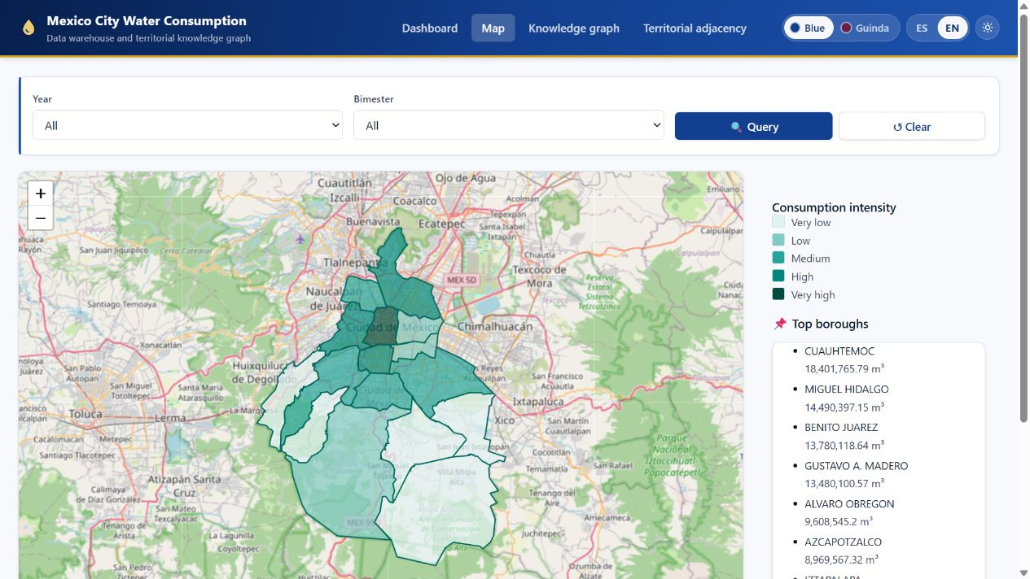 | 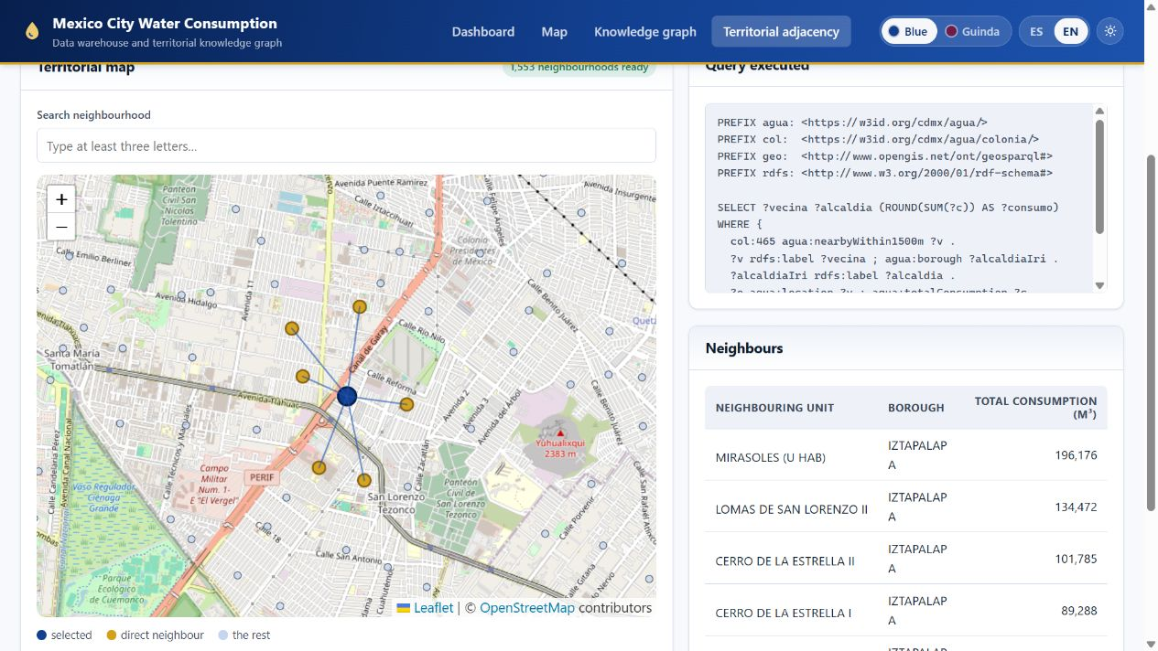
(a) Choropleth retrieval by borough.  https://gabrielhuav.github.io/Data_Warehouse_static/mapa.html | (b) Adjacency as graph traversal, with the agua:nearbyWithin1500m query and its result.  https://gabrielhuav.github.io/Data_Warehouse_static/vecindad.html?alcaldia=IZTAPALAPA&colonia=AO%20DE%20JUAREZ
Fig. 1. The two retrieval modes of the static demonstration, both running in the browser without a server; each caption links to the exact view captured. Base map © OpenStreetMap contributors (ODbL).
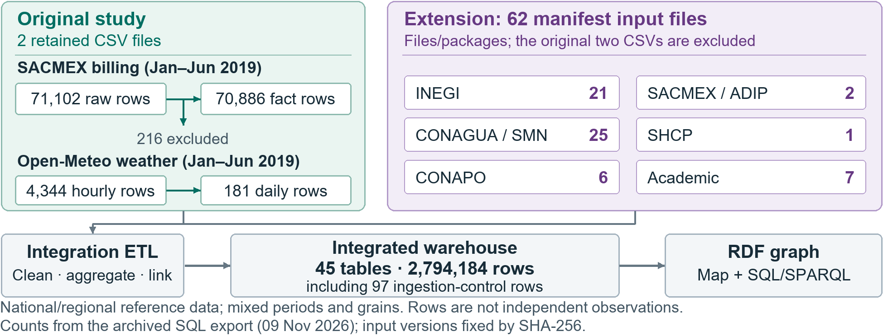
Fig. 2. Data provenance. Additional files follow the source manifest. Academic inputs: MexHiResClimDB (4), InSAR, Huerta-Vergara and Hidro-MX (1 each). Table totals follow the verified SQL export.

3.6 Implementation of the Atypical-Consumption Module
The current version replaces supervised prediction with an exploratory detection module oriented to analytical retrieval: because the open source carries no anomaly labels, the system computes statistical indicators over the retrieved records instead of training a model. The procedure runs unsupervised on the frontend. Consumption is aggregated by neighbourhood, each neighbourhood is compared against the others of its own borough, and the units with the largest deviation are ranked as candidates for inspection. Flagging patterns that require later review keeps the practical value of the component without presenting a prediction as if it had been trained against ground truth.
Formally, each neighbourhood g receives an atypicality score:
$A_{g}=\left|\frac{x_{g}−μ}{σ+ε}\right|,$ | (1)
where x_{g} is the aggregate consumption of a neighbourhood, μ and σ are the mean and standard deviation of the neighbourhoods of its own borough —the comparison set implemented in assets/atipicos.js—, and ε prevents division by zero. The groups with the largest A_{g} are reported in the interface as zones with atypical consumption.
Two clarifications delimit the module. It is exploratory and not a causal predictor: a high A_{g} states that a zone departs from its comparison set, not why. And it does not perform real-time leak detection, because the original module uses billing records without contemporaneous labelled leaks or network telemetry. Its evaluation in Section 5 rests exclusively on synthetically injected perturbations. Its role is the ranking function of the retrieval framework: the choropleth answers “how much volume is billed here”, the module answers “which units should I look at first”, which is the ordering problem at the centre of information retrieval (Purves et al., 2018).

4 From the Dimensional Model to a Knowledge Graph

4.1 Rationale: Why a Star Schema, and What a Graph Adds
The star schema was not chosen by default. The dominant workload is the repeated aggregation of one numeric measure over three conformed dimensions with filters chosen interactively, which is what dimensional modelling was designed for (Kimball & Ross, 2013): constant join depth and aggregation by a single grouped scan. A graph would pay a traversal cost for joins that foreign keys already resolve. What a graph adds is complementary: interoperability, since a standard vocabulary makes the resource linkable to other municipal datasets without prior schema agreement, the recurring obstacle in the open-data literature (Vetrò et al., 2016); topological expressiveness, since questions such as “which neighbourhoods adjacent to an atypical zone also exceed the borough mean” are natural traversals and awkward over a flat territorial dimension; and entity reconciliation, since stable identifiers would resolve the label heterogeneity our ETL absorbs through normalisation rules —the w3id namespace used here is not yet registered for dereferencing, which we leave as future work. We therefore keep the star schema as the analytical store and derive the RDF layer by a declarative mapping, so that neither representation is maintained by hand.

4.2 Vocabulary Alignment and R2RML Mapping
The correspondence between a star schema and the RDF Data Cube (World Wide Web Consortium, 2014) is close to mechanical, which is what makes this layer inexpensive to maintain: a fact row becomes a qb:Observation, the measures become qb:MeasureProperty, the time and location dimensions become qb:DimensionProperty, the neighbourhood entity becomes a geo:Feature with its geo:asWKT geometry, territorial adjacency becomes the project-defined agua:nearbyWithin1500m, and the development index becomes a skos:Concept in a declared skos:ConceptScheme with an explicit numeric rank. The mapping is expressed in R2RML (World Wide Web Consortium, 2012) and distributed with the archived release, declaring seven triples maps over both fact tables, the territorial dimension and its geometry, the derived adjacency, the temporal dimension and the index scheme. A companion schema.ttl supplies what the mapping alone cannot: the qb:DataStructureDefinition for both cubes, its components typed as dimension, measure or attribute, the cubic-metre unit and the ordinal scale. Loaded together with the browser graph, it satisfies the Data Cube integrity constraints IC-1, IC-2, IC-3 and IC-11 with zero violations, reproducible with scripts/validar_datacube.py; the check is stated for the published demonstration graph, not for the complete materialisation. The alignment is therefore a validated property rather than a nominal reuse of two terms. Materialising it yields on the order of 7.6 × 10⁵ triples over 71,067 observations, 1,553 territorial features, 181 temporal entities and the four index members.
Two properties of the geospatial layer bound what the traversal can claim. The warehouse stores points, not polygons: each neighbourhood is the centroid of its readings, recovered from coordinates present in the source export but dropped by the original loading schema. The substitution is defensible at this scale —the 22,858 valid coordinate pairs are never shared between two neighbourhoods and the median neighbourhood diameter is 0.63 km— though coarse for the ten neighbourhoods above three kilometres. Point centroids cannot establish shared territorial boundaries; relabelling a distance threshold as a standardised topological predicate would misstate what the data support. The mapping therefore declares its own agua:nearbyWithin1500m, documented in schema.ttl as centroid proximity below 1.5 km. Official polygons would allow geo:sfTouches in the strict sense; that is a substitution in the source data, and we leave it as future work. Section 5.8 takes that step for the metropolitan graph.

4.3 Territorial Retrieval as Graph Traversal
The value of the layer is that it makes a class of questions expressible that the tabular interface does not naturally support. GeoSPARQL supplies the geometry model (Car & Homburg, 2022); Listing 1 is the query the published interface executes verbatim, retrieving the neighbourhoods near a selected zone together with their own consumption, a single traversal that the relational interface resolves only through an ad-hoc spatial self-join.
Listing 1. Territorial traversal over the knowledge graph, as executed by vecindad.html.
PREFIX agua: <https://w3id.org/cdmx/agua/>
PREFIX col: <https://w3id.org/cdmx/agua/colonia/>
PREFIX rdfs: <http://www.w3.org/2000/01/rdf-schema#>

SELECT ?vecina ?alcaldia (ROUND(SUM(?c)) AS ?consumo) WHERE {
col:465 agua:nearbyWithin1500m ?v .
?v rdfs:label ?vecina ; agua:borough ?alcaldiaIri .
?alcaldiaIri rdfs:label ?alcaldia .
?o agua:location ?v ; agua:totalConsumption ?c .
} GROUP BY ?vecina ?alcaldia ORDER BY DESC(?consumo)
That the graph is queryable, and not merely declarable, is shown without any server: the static deployment ships a browser-sized subset of 140,499 triples with a SPARQL 1.1 engine vendored in the release itself, so the demonstration depends on no external service. The subset is an aggregate, not a slice: its observations live at the neighbourhood-period grain in a separate agua:aggobs/ namespace under agua:consumoCDMXDemo, linked to the complete dataset through PROV-O. Distinct identities avoid the contradictory RDF that reusing an IRI across grains would produce if the graphs were merged; the price is that a query written against the subset is not guaranteed to run unchanged against the full materialisation. The two representations agree where they overlap: aggregating consumption by bimester through SPARQL returns the same totals the reproduction script obtains in SQL.

5 Results and Evaluation

5.1 Integrated Data Volume
The cardinalities in Table 2 have different grains: the 1,553 locations are borough–neighbourhood pairs, coarser than the 70,886 manzana–period facts, and the four index levels are the published ordinal categories. The 181 time records are daily climate observations, not water-reading dates: consumption occupies only three dates, one per bimester. The shared daily temporal dimension allows both fact tables to be queried together.
Table 2. Data volume stored in the data warehouse
Table | Records
fact_consumo_agua | 70,886
dim_ubicacion | 1,553
dim_tiempo | 181
dim_indice_des | 4

5.2 Findings of the Consumption Analysis
The analysis of the 70,886 consolidated records reveals the following consumption patterns in Mexico City:
• Territorial concentration: The boroughs with the highest total billed volume are Cuauhtémoc and Miguel Hidalgo, followed by Benito Juárez and Gustavo A. Madero (Table 3).
• Temporal distribution: Consumption shows variations across the bimesters available in the warehouse. In the aggregated query by bimester, the highest total consumption was observed in bimester 2, followed by bimester 3 and bimester 1. Therefore, no direct causal relationship with dry or rainy periods is established: three bimesters cannot support one, even with the daily climate series that the warehouse integrates.
• Fiscal index and billing: The source assigns an index to billing records, not uniquely to neighbourhoods: 1,200 of the 1,553 borough–neighbourhood pairs contain multiple categories. The unweighted mean of consumo_total per record is 2,191.81 m³ for alto and 1,476.83 m³ for bajo. This compares recorded billing, not socioeconomic groups or household demand (evaluacion-ml/indice_fiscal_grano.py).
Table 3. Five boroughs with the highest total billed volume, all uses, January–June 2019
Borough | Billed volume (m³)
Cuauhtémoc | 18,401,765.79
Miguel Hidalgo | 14,490,397.15
Benito Juárez | 13,780,118.64
Gustavo A. Madero | 13,480,100.57
Álvaro Obregón | 9,608,545.20

5.3 Billed Volume and Consumption per Inhabitant
The conference version (Velázquez Arrieta et al., in press) warned that totals are not a per-capita indicator. Dividing the domestic billed volume of the semester by the residents of private dwellings counted in the 2020 Census, the nearest count to 2019 (Instituto Nacional de Estadística y Geografía, 2021), and by the semester’s 181 days gives the figures of Table 4. Two results follow. The first is that the ranking changes: Benito Juárez, third in total consumption, is first per inhabitant with 126.5 litres per day, while Gustavo A. Madero and Iztapalapa, fourth and seventh in totals, fall to tenth and fourteenth. The second matters more. The city-wide figure is 47.3 litres per inhabitant per day, or 53.9 including mixed-use billing, about 38 % of the 123 litres per day that Medina-Rivas et al. (2022) report for the same year from records provided by the utility. This comparison alone does not establish missing records. Annualised, its billed volume is about 243 million cubic metres, close to the 255 million that the utility reported as billed in 2021 in answer to a public-information request (Instituto de Transparencia, Acceso a la Información Pública, Protección de Datos Personales y Rendición de Cuentas de la Ciudad de México [INFO CDMX], 2022); this cross-year comparison does not establish equal coverage. The billing total is below the published estimate of water use: the export amounts to 7.7 m³/s, about half of the 15.44 m³/s of total consumption that Ramos-Bueno et al. (2024) estimate for the city. The shortfall is concentrated in the periphery, where 16.0 litres in Iztapalapa, 8.2 in Tláhuac and 2.5 in Milpa Alta cannot be the water people use. The publisher’s note covers metered and average billing only (Section 3.4). A 2019 city resolution under Article 172 provided fixed per-connection charges for designated domestic and mixed-use users receiving intermittent supply (Gobierno de la Ciudad de México, 2019). This provides administrative context but does not identify affected export records; attributing the gap to fixed charges remains a hypothesis. The open export describes reported volumetric billing, and Table 3 cannot be interpreted as a ranking of measured demand. This is a question of validity rather than of completeness (Vetrò et al., 2016): every record may be present and the measure still answer a different question.
Table 4. Domestic billed volume of the first semester of 2019 per resident of private dwellings (2020 Census), by borough, with the change in rank from total consumption (all uses) to consumption per inhabitant. Reproducible with scripts/per_capita_alcaldia.py.
Borough | Residents | Domestic (thousand m³) | Litres per inhabitant per day | Rank: total to per inhabitant
Benito Juárez | 432,259 | 9,894.9 | 126.5 | 3 to 1
Miguel Hidalgo | 412,529 | 8,640.5 | 115.7 | 2 to 2
Cuauhtémoc | 540,976 | 10,207.7 | 104.2 | 1 to 3
Azcapotzalco | 431,347 | 6,153.8 | 78.8 | 6 to 4
Iztacalco | 403,805 | 4,663.5 | 63.8 | 10 to 5
Venustiano Carranza | 443,120 | 5,007.0 | 62.4 | 9 to 6
Cuajimalpa de Morelos | 217,606 | 2,064.3 | 52.4 | 12 to 7
Álvaro Obregón | 757,117 | 6,590.2 | 48.1 | 5 to 8
Coyoacán | 612,130 | 5,128.3 | 46.3 | 8 to 9
Gustavo A. Madero | 1,162,914 | 9,196.4 | 43.7 | 4 to 10
Tlalpan | 695,308 | 2,843.1 | 22.6 | 11 to 11
La Magdalena Contreras | 246,785 | 845.0 | 18.9 | 14 to 12
Xochimilco | 438,038 | 1,304.1 | 16.4 | 13 to 13
Iztapalapa | 1,820,809 | 5,263.0 | 16.0 | 7 to 14
Tláhuac | 391,967 | 583.0 | 8.2 | 15 to 15
Milpa Alta | 152,682 | 69.1 | 2.5 | 16 to 16
Mexico City | 9,159,392 | 78,453.9 | 47.3

5.4 Quantitative Evaluation of the Atypical-Consumption Module
With no anomaly labels in the open source, the module is evaluated against injected ground truth. The protocol scores the deployed function itself, not a proxy: consumption is aggregated by neighbourhood, μ and σ are computed over the neighbourhoods of each borough, and A_{g} ranks them, which is exactly what assets/atipicos.js computes. The synthetic set reproduces the structure of the warehouse —1,553 borough–neighbourhood pairs over three bimesters— with 47 injected anomalies per run, and the experiment is repeated over 20 seeds. The three detectors are compared at equalised operating points, each emitting as many alerts as there are injected anomalies, so precision, recall and F1 coincide by construction. ROC-AUC and average precision (AP, non-interpolated and stored as PR-AUC in the CSV) characterise the ranking independently of any threshold (Table 5).
Table 5. Detection of injected anomalies, mean ± standard deviation over 20 seeds at equalised operating points. Reproducible with evaluacion-ml/eval_anomalias.py, a script reconstructed for this artefact.
Method | P = R = F1 | ROC-AUC | AP
A_{g} (deployed) | 0.581 ± 0.040 | 0.966 ± 0.013 | 0.677 ± 0.047
Isolation Forest | 0.650 ± 0.053 | 0.971 ± 0.013 | 0.728 ± 0.058
LOF | 0.493 ± 0.075 | 0.846 ± 0.036 | 0.464 ± 0.075
Isolation Forest (Liu et al., 2008) recovers 65 % of injected anomalies against 58 % for A_{g}. Paired by seed, it leads in 19 of 20 runs (mean difference 0.069, standard deviation 0.042) and has the higher AP in all 20 (evaluacion-ml/​comparacion_pareada.py). Similar ROC-AUC means therefore do not imply equivalent rankings. LOF (Breunig et al., 2000) performs less well under this magnitude-based injection model. The interpretable A_{g} remains an exploratory ranking, while Isolation Forest is the stronger baseline at this operating point.
Two limitations remain. The perturbations are synthetic and their magnitude is chosen, so the figures measure sensitivity to known deviations rather than field performance against real leaks, for which the system is not designed and no labelled data exist. And the comparison rests on a single injection model; a different anomaly shape could reorder the methods, which Section 5.5 tests.

5.5 Sensitivity of the Detection Module
We varied one injection factor at a time: prevalence (1, 3, 5 and 10 %), the share of spikes (10 to 90 %), and magnitude, from subtle (spikes ×1.5–2, drops ×0.50–0.67) through moderate (×2–3 and ×0.33–0.50) to the published strong setting (×3–6 and ×0.05–0.25). The ten distinct settings, the published one serving as the reference of all three factors, use the same 20 seeds, territorial identities, deployed function, baselines and equalised operating point. Recall is also reported separately for spikes and drops. The published setting reproduces Table 5; a fourth detector, log-A_{g}, applies Equation (1) to logarithms of aggregate consumption. With anomalies at most a tenth of the units, AP is more informative than ROC-AUC (Saito & Rehmsmeier, 2015). Code: evaluacion-ml/​sensibilidad_anomalias.py.
The deployed statistic turns out to be structurally blind to drops (Fig. 3a). Under the published setting it finds 82 % of the injected spikes and 2 % of the drops. The asymmetry is arithmetic. A drop can lower a neighbourhood’s consumption by at most its whole value, so a neighbourhood below its borough mean scores at most μ/σ, the inverse of the borough’s coefficient of variation, whereas large positive departures can outrank this bound. With the dispersion of the synthetic boroughs that ceiling is about 2.3, below the scores that ordinary neighbourhoods in the right tail already reach, so when the alert budget is spent on the largest scores most drops fall below the alert cut-off. At the equalised operating point, precision is the weighted mean of spike and drop recall; it falls to 0.12 when nine anomalies in ten are drops (Fig. 3b and Table 6).
Logarithms make reciprocal multiplicative changes symmetric around the original value, and log-A_{g} improves drop detection in the simulation: under the published setting it finds 71 % of spikes and 92 % of drops, raising precision from 0.581 to 0.770 and AP from 0.677 to 0.860, above Isolation Forest (0.650 and 0.728). The advantage holds across prevalences and compositions (Table 6) and fades as the anomalies weaken: at moderate magnitude it only ties Isolation Forest (0.398), and at subtle magnitude every detector stays below 0.20, where the limit is the magnitude of the departure rather than the scale of the score. The comparison is not neutral, however: the synthetic consumption is log-normal by construction, which makes log-A_{g} the matched statistic, so its synthetic advantage may overstate performance on real anomalies. Section 5.6 confronts both scores with the real distribution.
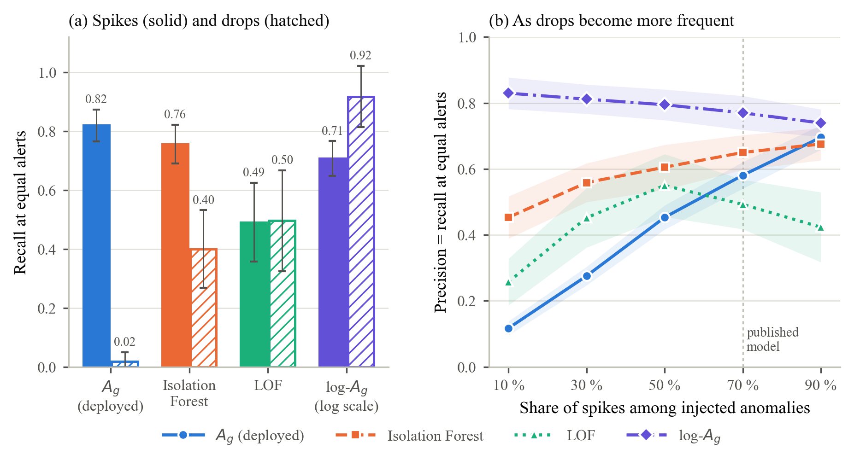
Fig. 3. Recall on injected spikes and drops under the published setting (a), and precision at the equalised operating point as the share of spikes varies (b). Mean over 20 seeds; bars and bands show one standard deviation.
Table 6. Precision at the equalised operating point (equal to recall and F1) for eight selected injection settings, mean over 20 seeds; standard deviations stay between 0.015 and 0.124. Published setting: 3 % prevalence, 70 % spikes, strong magnitude.
Setting | A_{g} | Isolation Forest | LOF | log-A_{g}
Published setting | 0.581 | 0.650 | 0.493 | 0.770
Prevalence 1 % | 0.491 | 0.544 | 0.600 | 0.709
Prevalence 10 % | 0.749 | 0.763 | 0.303 | 0.834
10 % spikes, 90 % drops | 0.117 | 0.453 | 0.257 | 0.830
50 % spikes, 50 % drops | 0.453 | 0.605 | 0.550 | 0.795
90 % spikes, 10 % drops | 0.696 | 0.676 | 0.423 | 0.739
Moderate magnitude | 0.365 | 0.398 | 0.304 | 0.398
Subtle magnitude | 0.181 | 0.183 | 0.122 | 0.173

5.6 The Deployed Ranking on the Real Data
The arithmetic bound does not depend on the synthetic generator, so it can be checked on the warehouse itself. Replicating the deployed computation over the 1,553 borough–neighbourhood totals of the published export, with no filter, shows totals that are strongly right-skewed within every borough but one (median skewness 1.98) and much less skewed in logarithms (median −0.76). The ceiling μ/σ for a neighbourhood below its borough mean has a median of 0.85 across boroughs (0.27 to 1.64), and the highest score any of the 1,022 below-mean neighbourhoods actually reaches is 1.46, whereas the fifteenth entry the interface lists scores 3.85. Not one of the 15 neighbourhoods the module shows, nor of the top 3 % (47), lies below its borough mean: as deployed, the evaluated rankings contain only above-mean billed totals.
The log-scale score does not settle the matter on real data; it inverts it. Because log totals are left-skewed, their long tail is the low one, and all 15 neighbourhoods at the top of the log-A_{g} ranking, and 45 of the top 47, lie below their borough mean; the two top-15 lists share no neighbourhood. A further 29 neighbourhoods have no billed volume at all over the semester, 27 of them with records in all three bimesters, concentrated in Tlalpan (12), Iztapalapa (6) and La Magdalena Contreras (5). A zero has no logarithm and may reflect a data gap rather than absence of use, consistent with studies that exclude unmetered or zero-volume colonias (Ramos-Bueno et al., 2021). We therefore separate excess and deficit, each ranked by log-A_{g} relative to the borough’s mean log volume, and flag zero totals apart. These observations concern the global, unfiltered semester ranking; filtering can change which units enter a shortlist. The extended interface implements the three lists (https://gabrielhuav.github.io/Data_Warehouse_IJCOPI/ijcopi/atipicos.html) and reproduces evaluacion-ml/​ranking_real.py. Neither ranking diagnoses leaks or unmet demand.

5.7 From the City to the Metropolitan Area
The warehouse now covers the official metropolitan delimitation of 2020 (Consejo Nacional de Población [CONAPO], 2025b): 63 municipalities (16 boroughs, 45 in the State of Mexico and two in Hidalgo). Sixty-two manifest-verified files have 97 table-level ingestion entries; the 45-table warehouse holds 2.79 million rows, linked through a conformed municipal dimension without altering the original facts. Sources cover municipal services and billing (Instituto Nacional de Estadística y Geografía, n.d.), water revenue (Secretaría de Hacienda y Crédito Público [SHCP], 2026), aquifers and wells (Comisión Nacional del Agua [CONAGUA], 2026a), dams (CONAGUA, 2026b), drought (Servicio Meteorológico Nacional [SMN], 2026), water quality (CONAGUA, n.d.), marginalisation (CONAPO, 2025a), land motion (Khorrami et al., 2023), gridded climate (Carrera-Hernández, 2025), historical vulnerability (Huerta-Vergara et al., 2022), streamflow (Sánchez-Ruiz et al., 2026) and 555,752 citizen reports (SACMEX, n.d.). The manifest fixes reference periods and download versions.
Municipal rates annualise volumes over 365 days using CONAPO mid-2019 population (the SACMEX semester is doubled); Table 4 uses 181 days and 2020 private-dwelling residents. Neighbourhood rates use census population assigned within 750 m to SACMEX points, aggregated as pob_sacmex, not the displayed CONAPO polygon population (pob_total). Units link to the polygon with their largest point share (at least 50 %); ties use the smallest numeric cve_col, with unique-name matching as fallback. Volumes and reports follow linked units without polygon clipping. Rates require positive assigned population in each linked unit; domestic rates also require an available domestic subtotal per unit. These checks ensure neither complete spatial nor temporal coverage.
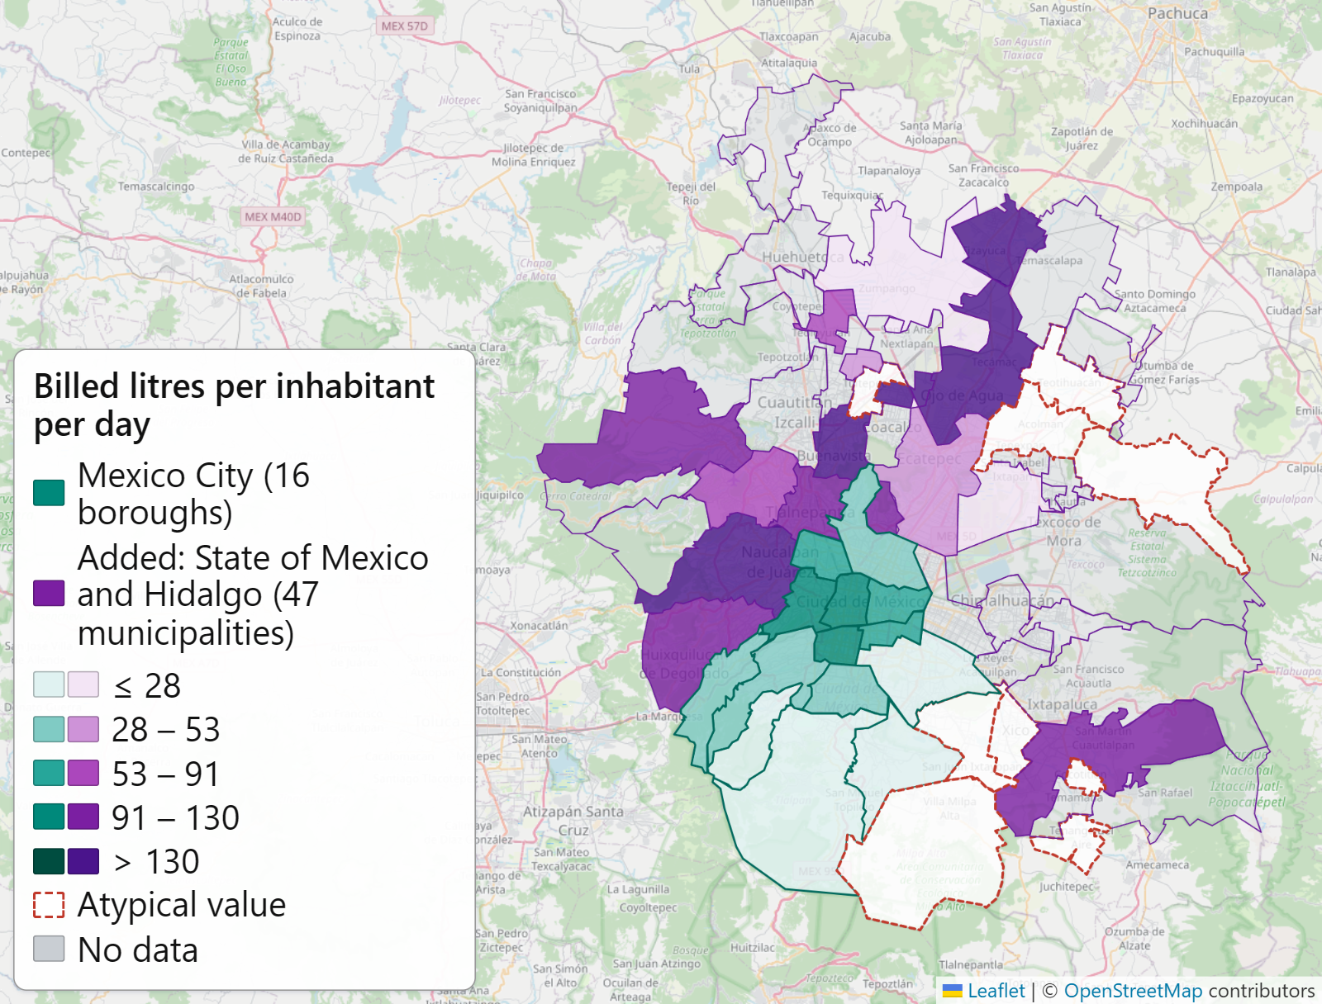 | 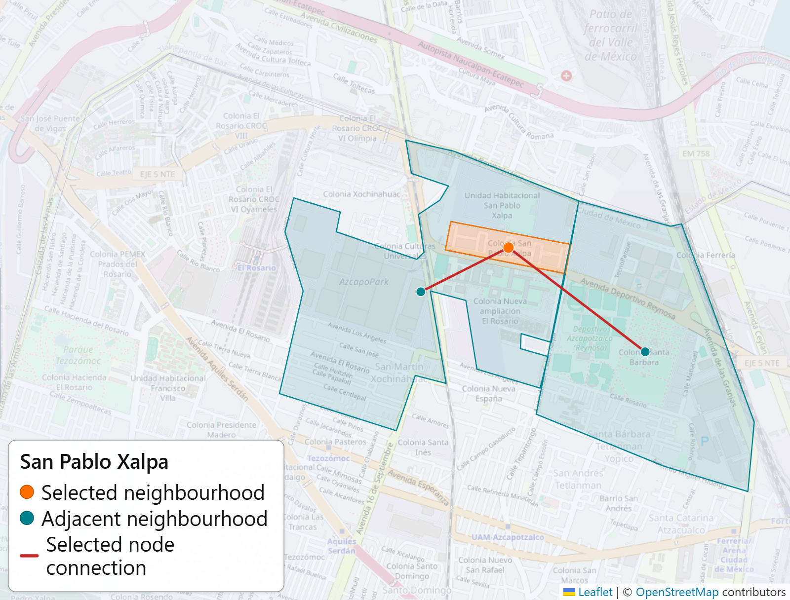
(a) Billed litres per inhabitant per day. | (b) San Pablo Xalpa (Azcapotzalco) and its two adjacent neighbourhoods.
Fig. 4. In (a), Mexico City is green and added municipalities purple; stronger colour marks a higher available value, not higher use, and a dashed border marks values outside the 10–400 litre band, which in Mexico City are the billing of Tláhuac and Milpa Alta (Table 4); in (b), the selected neighbourhood and its direct boundary connections are highlighted. Base map © OpenStreetMap contributors (ODbL).
Municipal volumes cannot be compared without a filter: of the 47 municipalities outside Mexico City, 24 report no volume, 7 fall outside a plausibility band of 10 to 400 litres per inhabitant per day and 16 remain (Fig. 4a), while declared water revenue does track federal records: across the 89 State of Mexico municipalities with both records for 2018, Spearman’s coefficient is 0.934 and Pearson’s only 0.322, a gap produced by a few extreme captures. The reports also bound what can be asked of 2019: the source records no leaks before 2021, so all 39,685 reports of the semester are water shortages. Across the 1,508 neighbourhoods with at least 500 inhabitants and known billing, billed litres per inhabitant barely rank shortage reports per thousand inhabitants (Spearman 0.18), and the 435 neighbourhoods billed below 10 litres per inhabitant per day file almost as many reports per thousand inhabitants as the rest (4.15 against 4.93 on average). Near-zero billing therefore does not mean near-zero demand, which supports the reading of Section 5.3. So does access: about 238,000 people in the metropolitan area live in dwellings without piped water, and in Mexico City the five boroughs with the largest share of them are among the six with the lowest billed volume per inhabitant. The four aquifers beneath the urban area extract between 1.49 and 1.96 times their recharge, and in wells read in both years the mean water table fell between 6.0 and 18.7 metres from 2010 to 2019.
Each layer of the map (https://gabrielhuav.github.io/Data_Warehouse_IJCOPI/ijcopi/mapa-zm.html) is the literal result of one of fifteen SQL queries distributed in the repository, exported to JSON with its hash, and verificar_mapa.py repeats every query and compares the result byte by byte with the published files. An earlier clean-clone rebuild reproduced all fifteen results; current exports are rechecked against PostgreSQL.

5.8 A Metropolitan Knowledge Graph
Official polygons extend the city graph (Section 4) beyond centroid proximity and the city boundary. A second R2RML mapping materialises 91,230 triples linked to the first graph’s boroughs and neighbourhoods. Its 5,830 neighbourhoods have 15,510 strict geo:sfTouches pairs. Municipal polygons overlap by up to 0.49 m², breaking the strict relation for adjoining pairs; agua:sharesBoundaryWith instead records 163 pairs sharing at least 50 m of boundary. Unreported values generate no triples; omission does not assert absence. Across the city limit, 18 municipal boundaries and 169 neighbourhood adjacencies link territories: Nezahualcóyotl sinks 23.5 cm per year beside Venustiano Carranza at 16.5 cm, and 21 municipalities without reported volume form 27 municipality–aquifer pairs above an extraction-to-recharge ratio of 1.5. Relations match warehouse tables; municipal nodes reveal neighbourhoods, their direct connections (Fig. 4b) and approximate centroid distances (https://gabrielhuav.github.io/Data_Warehouse_IJCOPI/ijcopi/grafo-zm.html).

5.9 Performance Metrics
Lighthouse 13.4.1, run against the permanent static deployment, scores 89 on emulated desktop (first contentful paint 0.2 s, largest 0.3 s, total blocking time 200 ms) and 76 on emulated mobile over throttled 4G; accessibility, best practices and SEO score 100 on both. The remaining bound is structural: the static version downloads the full 3.9 MB export and aggregates on the client, so what a server computes once is computed by each visitor.
Query Performance over the Total Data Volume. Frontend metrics do not characterise the retrieval layer, so four analytical workloads were timed directly against the warehouse over all 70,886 fact rows: a paginated retrieval, a full-scan aggregation by borough, a full-scan aggregation by neighbourhood and bimester —the heaviest query the dashboard issues— and a top-N ranking. Each ran 200 times after ten warm-up calls on twelve logical cores with 32 GB of RAM and PostgreSQL 16.14 in a container, which is what makes the reported percentile meaningful. These are SQL latencies measured at the database, excluding serialisation and transport.
The profile, reported in Table 7, is the expected one for a star schema of this size: the three workloads that resolve through the dimensions stay near 25 ms while scanning the full fact table, whereas the aggregation by neighbourhood and bimester costs four times more because it groups over 1,553 locations rather than sixteen. The heaviest interactive query returns in about a tenth of a second, and the gap between mean and p95 stays below 25 % throughout, indicating that the cost is dominated by the scan rather than by contention.
Table 7. Response time of the retrieval workloads over the complete warehouse (70,886 fact rows), 200 executions after ten warm-up calls.
Workload | Mean (ms) | p95 (ms) | Executions
Paginated retrieval (limit=100) | 32.3 | 35.2 | 200
Full aggregation by borough | 24.1 | 27.0 | 200
Aggregation by neighbourhood and bimester | 101.3 | 125.4 | 200
Top-10 neighbourhoods with ordering | 23.1 | 23.6 | 200

5.10 Functional Tests
The operation of the ETL processes, the persistence in PostgreSQL, the parameterised queries and the information retrieval was verified. The tests included queries parameterised by year, bimester, borough, and neighbourhood; aggregated retrieval (total and average consumption by neighbourhood); generation of JSON responses; geospatial retrieval for visualisation; and pagination with configurable limits. All modules produced results consistent with the expected structure. The dimensional model thus retrieves territorial information through combined filters of time, location and development index over the 70,886 records, supporting consumption queries by neighbourhood and borough, temporal aggregation, coordinate retrieval, geospatial exploration and ordering by total consumption.

6 Discussion
The reordered borough ranking (Table 4), mixed fiscal categories (Section 5) and weak association with shortage reports (Section 5.7) caution against reading billed volume as demand. Reported averages require metering and supply context; fiscal classes do not characterise every resident. Proximity joins and mixed reference years further limit causal interpretation.
Isolation Forest wins under the published injection model; log-A_{g} benefits from the log-normal generator. Neither result validates leak detection. Separating excess, deficit and zero totals makes billing inspectable without diagnosing low values.
Compared with operational water warehouses (Abecker et al., 2014; Soares et al., 2019), the contribution is reproducible provenance and preservation: consolidation rules, hashes, verified exports and declarative mappings. Static publication preserves an inspectable artefact without a database backend (Hill et al., 2023; Sandve et al., 2013), but cannot ensure external-source availability or establish physical use.

7 Conclusions and Future Work

7.1 Conclusions
The ETL consolidates 70,886 billing records and 1,553 locations across 16 boroughs in a PostgreSQL star schema, validated RDF projection and static demonstration. Cuauhtémoc and Miguel Hidalgo lead billed totals (Table 3), Benito Juárez per inhabitant (Table 4); neither contrasts nor bimester changes establish measured demand or climatic causation.
The 63-municipality extension adds quality-filtered context. Evaluated global A_{g} shortlists contain only above-mean totals; separate excess, deficit and zero lists expose both directions. Territorial retrieval remains subject to billing coverage, especially in the eastern and southern periphery, and municipal quality filters.

7.2 Threats to Validity and Limitations
Six limitations bound interpretation. First, three bimesters describe one semester, with only three aggregated points for any climate comparison. Second, synthetic injections measure sensitivity, not detection of real leaks; the sensitivity analysis retains a log-normal family. Third, the original graph uses centroids: agua:nearbyWithin1500m represents proximity within 1.5 km, not shared boundaries. The fourth concerns the fiscal index: record-level categories coexist within neighbourhoods; their billing averages do not establish a socioeconomic mechanism. The fifth is the billing basis and its coverage: records may include averaged billing in an unknown proportion; totals amount to about 38 % of published per-capita consumption, with the gap concentrated in the periphery. Territorial contrasts and atypicality scores therefore describe billing, and cannot establish physical use without metering information. The sixth concerns the metropolitan layers: they combine non-contemporaneous reference periods, the neighbourhood polygons are CONAPO’s rather than the utility’s, several joins rest on spatial proximity, and reports count what citizens file, not what is missing.

7.3 Future Work
Future work will enrich existing population data with density, land use and service access. Graph links could contextualise billed volumes geographically, using compatible territories, reference years and coverage, without establishing actual consumption or causation. Other priorities are persistent SPARQL access, dereferenceable identifiers, utility polygons alongside CONAPO’s, labelled-incident validation and a metropolitan data cube.

References
Abecker, A., Brauer, T., Magoutas, B., Mentzas, G., Papageorgiou, N., & Quenzer, M. (2014). A sensor and semantic data warehouse for integrated water resource management. In EnviroInfo 2014. BIS-Verlag.
Berro, A., Megdiche, I., & Teste, O. (2015). A content-driven ETL processes for open data. In N. Bassiliades et al. (Eds.), New trends in database and information systems II (pp. 29–40). Springer. https://doi.org/10.1007/978-3-319-10518-5_3
Breunig, M. M., Kriegel, H.-P., Ng, R. T., & Sander, J. (2000). LOF: Identifying density-based local outliers. In Proceedings of the 2000 ACM SIGMOD International Conference on Management of Data (pp. 93–104). ACM. https://doi.org/10.1145/342009.335388
Car, N. J., & Homburg, T. (2022). GeoSPARQL 1.1: Motivations, details and applications of the decadal update to the most important geospatial LOD standard. ISPRS International Journal of Geo-Information, 11(2), Article 117. https://doi.org/10.3390/ijgi11020117
Carrera-Hernández, J. J. (2025). Mexico’s High Resolution Climate Database (MexHiResClimDB): A new daily high-resolution gridded climate dataset for Mexico covering 1951–2020. Earth System Science Data, 17(12), 6911–6941. https://doi.org/10.5194/essd-17-6911-2025
Comisión Nacional del Agua. (n.d.). Indicadores de calidad del agua [Data set]. Retrieved October 31, 2026, from https://www.gob.mx/conagua/es/articulos/indicadores-de-calidad-del-agua?idiom=es
Comisión Nacional del Agua. (2026a). Aguas subterráneas [Data set]. datos.gob.mx. https://www.datos.gob.mx/dataset/aguas_subterraneas
Comisión Nacional del Agua. (2026b). Sistema de Información Hidrológica: Series diarias de presas [Data set, 15 CSV files]. Retrieved October 30, 2026, from https://sih.conagua.gob.mx/basedatos/Presas/VBRMX.csv
Consejo Nacional de Población. (2025a). Índices de marginación [Data set]. datos.gob.mx. https://www.datos.gob.mx/dataset/d8f2a534-bcee-4114-853d-82982a81ce24
Consejo Nacional de Población. (2025b). Las metrópolis de México, 2020 [Data set]. datos.gob.mx. https://www.datos.gob.mx/dataset/da65ccd9-888c-4ce8-b3b5-6bd867be344d
Daowz Laguna, E. E., Mata-Rivera, M. F., Zagal, R., Claramunt, C., & Hernández-Nava, C. (2027). Enhancing spatio-temporal analysis of urban water leak reports through LLM-based semantic enrichment and open data: A case study of Mexico City. In P. Peng & M. Jin (Eds.), Web and wireless geographical information systems (LNCS, Vol. 17231, pp. 62–76). Springer. https://doi.org/10.1007/978-3-032-42081-7_6
Gobierno de la Ciudad de México. (2019, April 1). Gaceta Oficial de la Ciudad de México (No. 62, pp. 39–40). https://data.consejeria.cdmx.gob.mx/portal_old/uploads/gacetas/989c31738f67577540092747c82e52f7.pdf
Hernández-Vázquez, I., Luna-Sánchez, A. J., Hurtado-Perez, A. B., Claramunt, C., Zagal-Flores, R., & Mata, F. (2026). Analyzing water consumption patterns in Mexico City: A GIS and data science approach. In M. F. Mata-Rivera, R. Zagal-Flores, & W. Siabato (Eds.), Web and wireless geographical information systems (LNCS, Vol. 15946, pp. 123–137). Springer. https://doi.org/10.1007/978-3-032-01723-9_9
Hill, D., Dunham, C., Larsen, D. A., & Collins, M. (2023). Operationalizing an open-source dashboard for communicating results of wastewater-based surveillance. MethodsX, 11, Article 102299. https://doi.org/10.1016/j.mex.2023.102299
Huerta-Vergara, A. R., Arciniega-Esparza, S., Pedrozo-Acuña, A., Matus-Kramer, A., & Vega-López, E. (2022). Assessment of vulnerability to water shortage in the municipalities of Mexico City. Boletín de la Sociedad Geológica Mexicana, 74(1), Article A071021. https://doi.org/10.18268/BSGM2022v74n1a071021
Instituto de Transparencia, Acceso a la Información Pública, Protección de Datos Personales y Rendición de Cuentas de la Ciudad de México. (2022). Resolución del recurso de revisión INFOCDMX/RR.IP.0679/2022. https://documentosobligaciones.infocdmx.org.mx/ST/LTAIPRC-2016-OT/Art133/Fr01/2022/T02-INFOCDMX.RR.IP.0679.2022.pdf
Instituto Nacional de Estadística y Geografía. (n.d.). Censo Nacional de Gobiernos Municipales y Demarcaciones Territoriales de la Ciudad de México, 2019 and 2021 editions [Data set]. Retrieved October 31, 2026, from https://www.inegi.org.mx/programas/cngmd/2021/
Instituto Nacional de Estadística y Geografía. (2021). Censo de Población y Vivienda 2020: Principales resultados por localidad (ITER), Ciudad de México [Data set, CSV]. INEGI. https://www.inegi.org.mx/programas/ccpv/2020/
Khorrami, M., Shirzaei, M., Ghobadi-Far, K., Werth, S., Carlson, G., & Zhai, G. (2023). Groundwater volume loss in Mexico City constrained by InSAR and GRACE observations and mechanical models. Geophysical Research Letters, 50(5), Article e2022GL101962. https://doi.org/10.1029/2022GL101962
Kimball, R., & Ross, M. (2013). The data warehouse toolkit: The definitive guide to dimensional modeling (3rd ed.). Wiley.
Lippolis, A. S., Lodi, G., & Nuzzolese, A. G. (2025). The Water Health Open Knowledge Graph. Scientific Data, 12(1), Article 274. https://doi.org/10.1038/s41597-025-04537-4
Liu, F. T., Ting, K. M., & Zhou, Z.-H. (2008). Isolation forest. In 2008 Eighth IEEE International Conference on Data Mining (pp. 413–422). IEEE. https://doi.org/10.1109/ICDM.2008.17
Medina-Rivas, C. M., Morales-Novelo, J. A., Rodríguez-Tapia, L., & Revollo-Fernández, D. A. (2025). Mexico City’s decline in per capita domestic water use: A comprehensive spatial-temporal study. Urban Water Journal, 22(1), 1–15. https://doi.org/10.1080/1573062X.2024.2423400
Medina-Rivas, C. M., Rodríguez-Tapia, L., Morales-Novelo, J. A., & Revollo-Fernández, D. A. (2022). Spatial inequality of domestic water consumption in Mexico City. Water Resources and Economics, 40, Article 100210. https://doi.org/10.1016/j.wre.2022.100210
Purves, R. S., Clough, P., Jones, C. B., Hall, M. H., & Murdock, V. (2018). Geographic information retrieval: Progress and challenges in spatial search of text. Foundations and Trends in Information Retrieval, 12(2–3), 164–318. https://doi.org/10.1561/1500000034
Ramos-Bueno, A., Galeana-Pizaña, J. M., & Perevochtchikova, M. (2024). Urban water consumption analysis through a spatial panel modeling approach: A case study of Mexico City, 2004–2022. Water Supply, 24(9), 3179–3195. https://doi.org/10.2166/ws.2024.191
Ramos-Bueno, A., Perevochtchikova, M., & Chang, H. (2021). Socio-spatial analysis of residential water demand in Mexico City. Tecnología y Ciencias del Agua, 12(2), 59–110. https://doi.org/10.24850/j-tyca-2021-02-02
Roussey, C., Guéret, C., & Laporte, M.-A. (2023). Editorial: Knowledge graph technologies—The next frontier of the food, agriculture, and water domains. Frontiers in Artificial Intelligence, 6, Article 1319844. https://doi.org/10.3389/frai.2023.1319844
SACMEX. (n.d.). Reportes de agua [Data set, CSV]. Portal de Datos Abiertos de la Ciudad de México. https://datos.cdmx.gob.mx/dataset/reportes-de-agua
SACMEX. (2026, August 28). Consumo de agua: Consumo Agua (1° Semestre 2019) [Data set with data dictionary and clarifying note]. Portal de Datos Abiertos de la Ciudad de México. Retrieved October 18, 2026, from https://datos.cdmx.gob.mx/dataset/consumo-agua
Saito, T., & Rehmsmeier, M. (2015). The precision-recall plot is more informative than the ROC plot when evaluating binary classifiers on imbalanced datasets. PLoS ONE, 10(3), Article e0118432. https://doi.org/10.1371/journal.pone.0118432
Sandve, G. K., Nekrutenko, A., Taylor, J., & Hovig, E. (2013). Ten simple rules for reproducible computational research. PLoS Computational Biology, 9(10), Article e1003285. https://doi.org/10.1371/journal.pcbi.1003285
Sánchez-Ruiz, D., Ramos Aguilar, E., Ramos-Aguilar, R., Reyes-Peña, C., Reyes-Cocoletzi, L., & García-Ramírez, J. (2026). Hidro-MX v2026.10: A reproducible hydroclimatic dataset for Mexican pilot basins (CONAGUA-SIH and INEGI) [Data set]. Zenodo. https://doi.org/10.5281/zenodo.23150556
Secretaría de Hacienda y Crédito Público. (2026). Derechos de agua municipal [Data set]. datos.gob.mx. https://www.datos.gob.mx/dataset/derechos_agua_municipal
Servicio Meteorológico Nacional. (2026). Monitor de Sequía de México: Municipios [Data set]. CONAGUA. https://smn.conagua.gob.mx/tools/RESOURCES/Monitor%20de%20Sequia%20en%20Mexico/MunicipiosSequia.xlsx
Soares, J., Leite, P., Teixeira, P., Lopes, N., & Silva, J. P. (2019). Data warehouse for the monitoring and analysis of water supply and consumption. In I. Ramos, R. Quaresma, P. Resende da Silva, & T. Oliveira (Eds.), Information systems for Industry 4.0 (pp. 1–12). Springer. https://doi.org/10.1007/978-3-030-14850-8_1
Vassiliadis, P. (2009). A survey of extract–transform–load technology. International Journal of Data Warehousing and Mining, 5(3), 1–27. https://doi.org/10.4018/jdwm.2009070101
Velázquez Arrieta, E. U., Pulido Morales, O. F., García López, E., Hernández Martínez, C. A., & Hurtado Avilés, G. (in press). Territorial information retrieval from heterogeneous open data through the construction of a data warehouse for water management in Mexico City. In Proceedings of the 5th International Conference on Ontologies and Knowledge Graphs (ICOKG 2026). Springer.
Vetrò, A., Canova, L., Torchiano, M., Orozco Minotas, C., Iemma, R., & Morando, F. (2016). Open data quality measurement framework: Definition and application to open government data. Government Information Quarterly, 33(2), 325–337. https://doi.org/10.1016/j.giq.2016.02.001
Villa Vargas, J. M., Hurtado Avilés, G., & Climent Hernández, J. A. (2026). Cuando México tiembla: La historia contada por los datos. AZCATL Revista de Divulgación en Ciencias, Ingeniería e Innovación, 4(6), 28–33. https://doi.org/10.24275/AZC2026E1004
World Wide Web Consortium. (2012, September 27). R2RML: RDB to RDF mapping language [W3C Recommendation]. https://www.w3.org/TR/r2rml/
World Wide Web Consortium. (2014, January 16). The RDF Data Cube vocabulary [W3C Recommendation]. https://www.w3.org/TR/vocab-data-cube/

Data Availability Statement: The source files, the warehouse, the R2RML mapping, the scripts and the static demonstration are distributed in the archived release https://github.com/gabrielhuav/Data_Warehouse_static/releases/tag/v1.5-icokg2026. The extended warehouse, its verified manifest of sources, the SQL queries and the metropolitan map and graph are in the repository https://github.com/gabrielhuav/Data_Warehouse_IJCOPI.
Declaration on the Use of Generative AI: The authors used a generative AI assistant, under their direction, for language editing, drafting assistance, locating data sources, and writing the scripts, queries, map and graph mapping distributed with the artefact. The research questions and the interpretation of the results are the authors’ own work. The authors take full responsibility for the content.
Conflicts of Interest: The authors declare that they have no conflicts of interest relevant to the content of this article.

SACMEX operates a proprietary platform integrating SCADA and multiple sources; it is distinguished from a reproducible academic work over open data such as this one.

