A web system for traceable exploration and analysis of heterogeneous earthquake catalogues
José Manuel Villa Vargas; Gabriel Hurtado Avilés¹*
¹ Escuela Superior de Cómputo (ESCOM), Instituto Politécnico Nacional, Mexico City, Mexico
*Corresponding author: Gabriel Hurtado Avilés. Email: ghurtadoa@ipn.mx.
ORCID: José Manuel Villa Vargas, https://orcid.org/0009-0009-2401-0661; Gabriel Hurtado Avilés, https://orcid.org/0009-0002-5686-1822.
Abstract
Earthquake catalogues are distributed across agencies and differ in coverage, fields and parameter versions. These differences complicate joint exploration and the reuse of derived information. This study develops and evaluates a web system for consultation, comparison and descriptive analysis while preserving provenance and interpretation limits. Its three contributions are the computational application, documented seismic inputs and reproducible analytical results. Four frozen catalogues from USGS, NRCan and SSN supply 287,936 source records. Source-specific adapters align their schemas without homogenizing magnitude scales or reconciling physical events. Six views connect source inventory, interactive maps, record inspection, descriptive analysis and retained revisions. Browser calculations separate magnitude summaries by catalogue and exact reported type, restrict depth statistics to documented kilometres, and expose annual counts and bounded magnitude-depth associations. CSV, JSON, HTML and ZIP exports preserve records, queries, summaries and evidence for subsequent analysis, study and research. For 659 North American USGS records reporting mww in 2020-2025 at magnitude at least 4.5, the mean is 5.311, sample standard deviation 0.524 and magnitude-depth Pearson coefficient -0.003260. Independent Python calculations agree with the JavaScript results within an absolute tolerance of 10⁻¹². These describe a selected record set, not source accuracy, causal relations or a complete physical population. Separate offline pipelines examine SSN coverage and retained revisions. A 36-event ComCat pilot contains 236 public origin-product versions; 13 of 31 same-type endpoint pairs change magnitude and four cross 5.5. Independent SQL evaluation agrees with 4,720 conditional retained projections. Explicit evidence contracts distinguish captured observations, calculations on retained versions and unsupported historical reconstructions. The resulting workflow produces traceable selections and descriptive information for further investigation without homogenizing magnitudes or inferring completeness, historical public states or earthquake forecasts. Source accuracy, historical reconstruction accuracy and usability with independent users remain unevaluated.
Keywords: earthquake catalogues; geovisualization; provenance; retained revisions; reproducibility; evidence contracts
1. Introduction
Earthquake catalogues differ in geographic windows, observation periods, measurement fields and revision practices. Researchers must account for these differences when selecting records and reproducing derived results. Established catalogue preparation addresses source heterogeneity, duplicates and magnitude compatibility (Weatherill et al., 2016); Mexican applications also require declustering and completeness assessment (Sawires et al., 2019). Aggregation alone does not perform these scientific operations.
The problem addressed here is how to make heterogeneous earthquake records jointly explorable and reusable without losing the distinctions needed to interpret them. The objective is a web system for consulting and comparing seismic catalogues and deriving traceable descriptive information for analysis and subsequent research. Users define selections, inspect records, derive summaries and retain the inputs and query. Derived information remains distinct from agency reports.
The article presents three connected contributions: the computational system with coordinated views, source inspection and reproducible exports; documented seismic inputs and transformations; and results demonstrating catalogue selection, SSN descriptive summaries and retained-revision analysis. These tasks address coverage, source attribution and parameter stability. They demonstrate functional capabilities rather than measured gains in productivity.
Temporal interpretation requires particular care. ComCat exposes versioned products and preferred summaries (U.S. Geological Survey, n.d.a, n.d.b, n.d.c), whose evolution has been studied by Thompson et al. (2020). Libcomcat, Timeline and INGV provide history capabilities (U.S. Geological Survey, n.d.d, n.d.e; Pintore, 2026). Building on those tools and resolution-aware query research (Sismanis et al., 2009; Gardezi and Bertossi, 2011), executable evidence contracts specify which derived calculations an externally acquired archive supports when historical completeness is unknown.
Following Villa Vargas et al. (2026), this work uses separately documented inputs and a newly acquired revision cohort. Figure 1 introduces the system's inputs, computational components and outputs. The system produces no earthquake predictions or damage estimates.
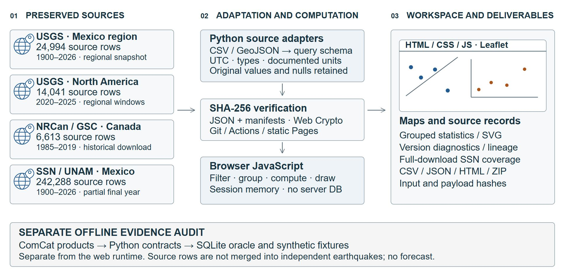
Figure 1. Implemented three-layer architecture, also displayed in Evidence/methods. Four preserved catalogue packages from three distributors enter explicit Python adapters and SHA-256-verified JSON delivery. Browser JavaScript, Leaflet and session memory support maps, statistics, native diagnostics and CSV/JSON/HTML/ZIP outputs. The lower block separates the offline Python/SQLite evidence audit from the web runtime. The maintained SVG diagram represents actual components, not an operational database server or generated seismic imagery.
2. Computational system and analytical methods
2.1. System architecture and browser workflow
Python adapters prepare preserved CSV inputs, JSON packages and SHA-256 manifests. The browser uses HTML, CSS, JavaScript, Leaflet 1.9.4 and Web Crypto integrity checks; GitHub Pages serves static assets without a database server, Docker, PHP or Java. SQLite supplies an independent offline validation oracle, not the application database. Python independently audits retained revisions and aggregates the complete SSN download. Six views comprise Home, Catalogue, Sources, Analysis, Revisions and Evidence/methods. Home opens directly on all 287,936 source rows (Figure 2). Loaded packages are hash-verified and cached in session memory; no persistent offline database or service worker is implied.
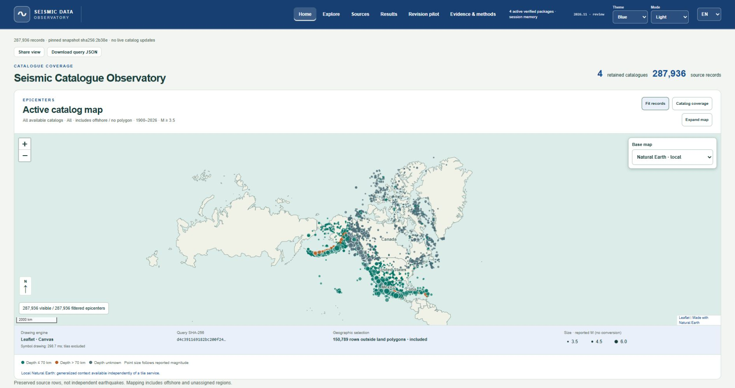
Figure 2. Home and integrated navigation captured from the local author-review system. The initial map displays all 287,936 source rows across the four catalogues. The upper bar retains six views, theme, light/dark appearance, language and active-package verification status. Grid north, a dynamic kilometre scale, reported-magnitude size key and query-evidence status accompany the map. These preserved observations are not independent earthquakes or a live feed.
Integration aligns schemas rather than scientifically homogenizing catalogues. Adapters map identifiers, explicit UTC origin time, coordinates, reported magnitude and documented depth. Original text and magnitude-type case remain unchanged; no conversion to Mw is made. Missing numeric values remain unknown; source-empty strings are retained, and absent columns become null in composition. SSN preserves native local/UTC strings. Canadian depth stays raw outside the kilometre field. Original ComCat IDs are retained; SSN/NRCan receive content-hash row keys with occurrence suffixes. The metadata relationship is row to catalogue, catalogue manifest, then source file/hash, not an event-to-event join between agencies. The Sources view exposes these distinctions and downloadable packages; Figure 3 shows source cards with integrity status, literal identifiers and downloads.
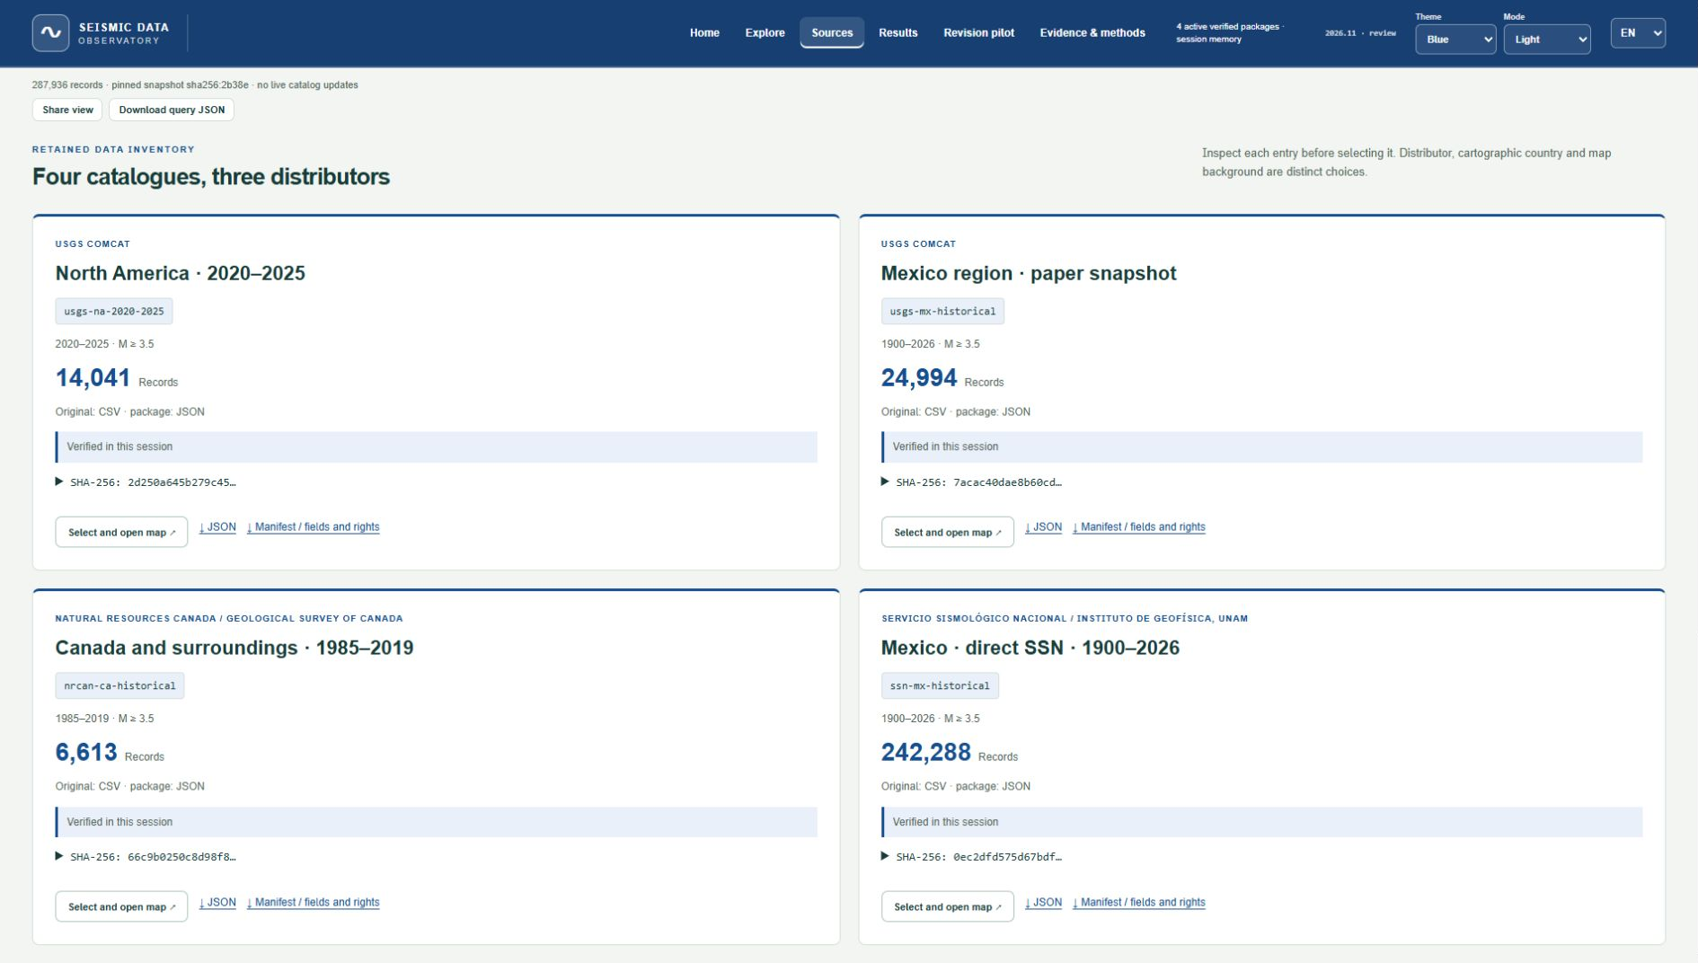
Figure 3. Source inventory view captured from the system's user interface. Four cards expose distributor, catalogue identifier, coverage, retained count, original CSV versus packaged JSON format, verified-session status and SHA-256 prefixes. Full hashes are expandable; JSON and manifests are downloadable. Four file-backed packages do not imply four independent observing agencies or database servers.
Composition preserves 287,936 rows in registry order using catalogId~packagedId keys, original key kinds, provider and snapshot. The 2,163 shared ComCat IDs are flagged without merging; no fuzzy or space-time cross-provider matching establishes independent earthquakes.
Country filtering uses 47 generalized Natural Earth 1:50 million land regions (Natural Earth, n.d.). Holes and antimeridian coordinates are retained; boundary, outside and invalid remain explicit. These are approximate land-containment classes, not nationality, maritime jurisdiction or nearest-country assignments. The sidecar SHA-256 9063e0c34412fec41debad30f69a653486c18e0f94d5983e6a061847befe27cb binds labels to unchanged event hashes and row order. Filters additionally cover UTC years, reported magnitude, exact type/agency, documented depth, missing horizontal error and ID/place text. Accent-insensitive search preserves source text.
Coordinated maps and tables follow established practice (Wu et al., 2020). Separate and combined views retain source provenance (Figure 4). Five backgrounds comprise local Natural Earth, OpenStreetMap, humanitarian OSM, USGS Topo and NASA Blue Marble's static August 2004 composite; attributed tiles load on demand. Three palettes, system/light/dark appearance, expanded-map return and Escape change presentation without changing the scientific selection. A grid-north indicator, dynamic scale and size legend support interpretation. Map status reports measured symbol-drawing time, geographic exclusions and a SHA-256 query identity digest binding input hashes, filters, geography and ordered keys; this digest is not a digital signature. Maps show snapshots, not live seismic feeds.
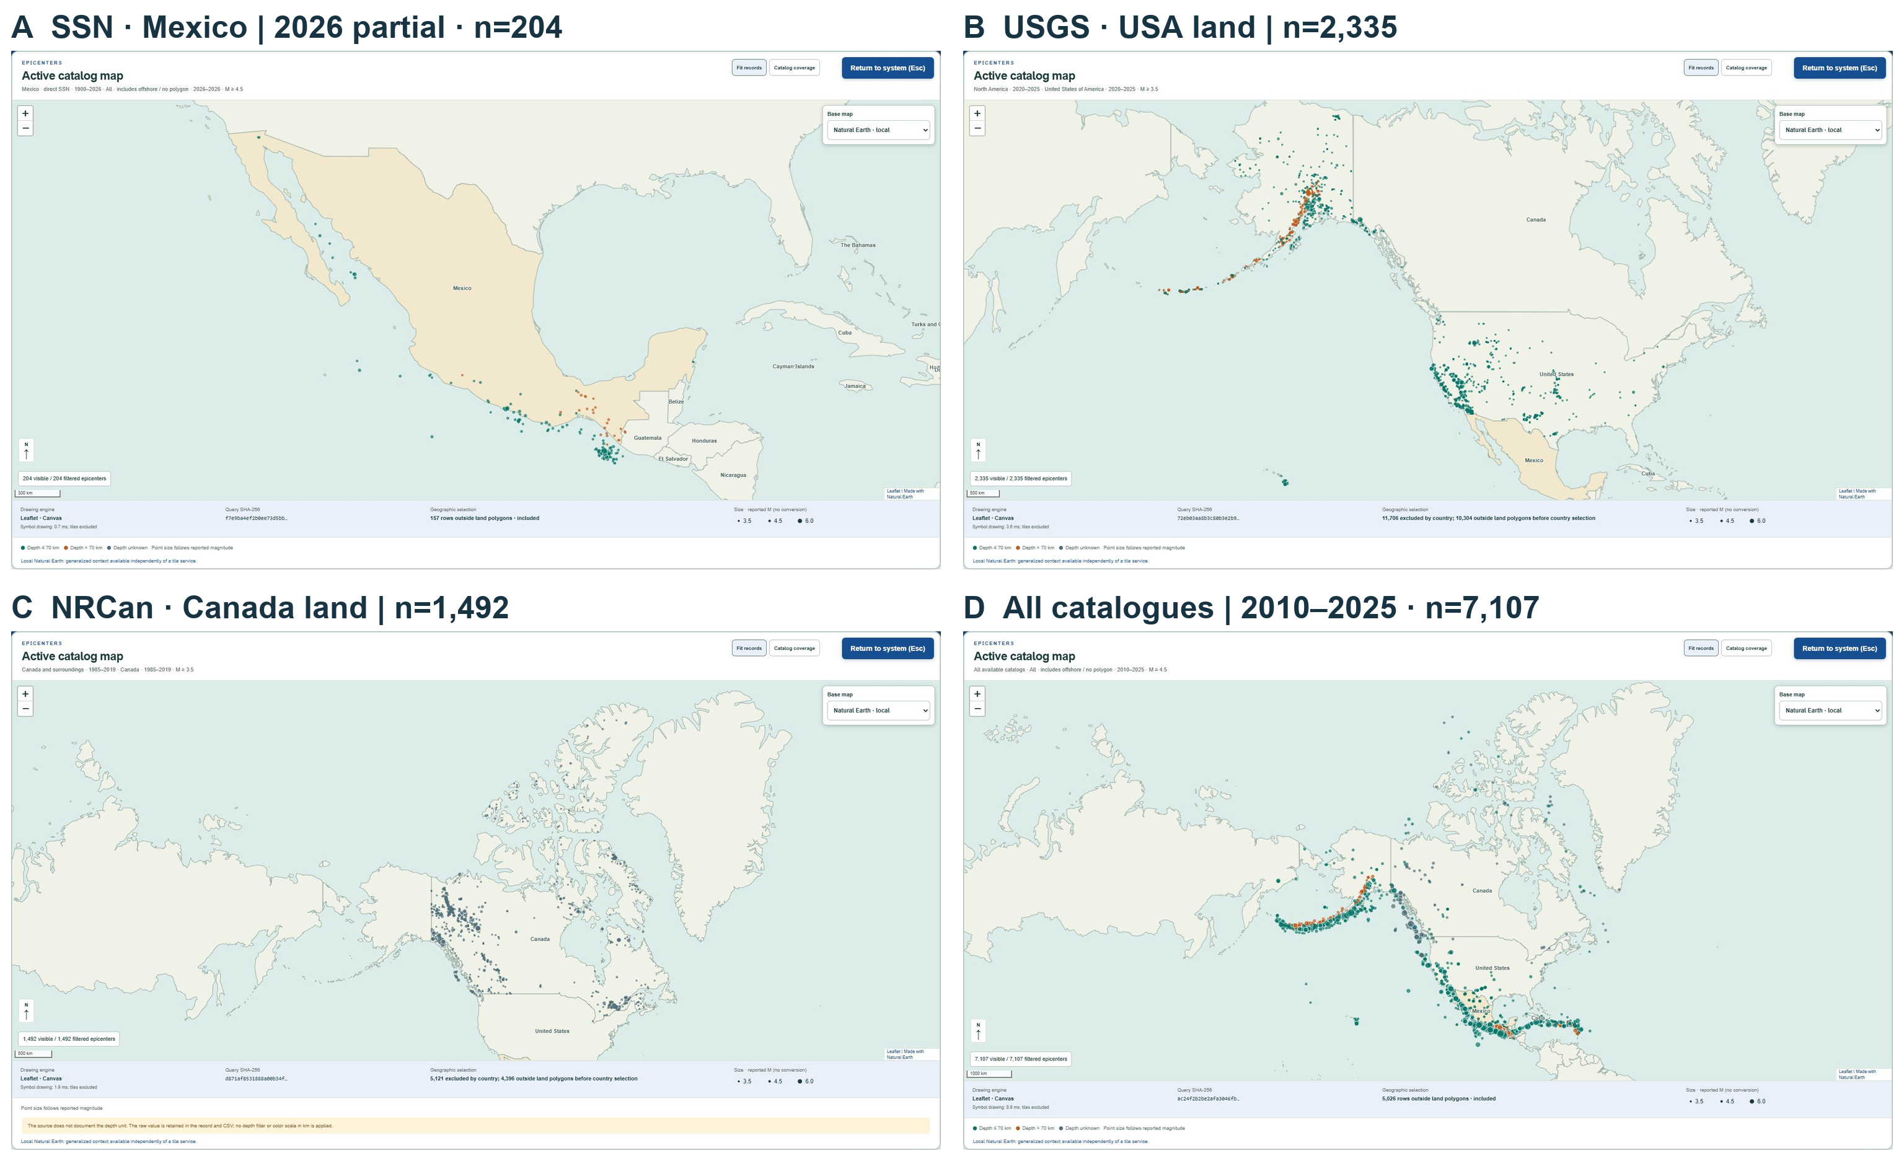
Figure 4. Four interactive map states captured with the same light theme, local Natural Earth background and panel geometry. (A) Direct SSN, partial 2026, reported M ≥ 4.5, all geographic classes: 204 rows. (B) USGS North America, 2020-2025, M ≥ 3.5, USA land class: 2,335 rows. (C) NRCan, 1985-2019, M ≥ 3.5, Canada land class: 1,492 rows. (D) All catalogues, 2010-2025, M ≥ 4.5, all classes: 7,107 rows. Grid north, scales, magnitude-size keys and query-evidence status remain visible. Distinct selections do not represent a common independent population. All-country views retain offshore/unassigned rows; country filters exclude other classes. Map extent does not restrict exports.
Analysis uses the same filtered records. It computes arithmetic mean, median, minimum, maximum and sample standard deviation separately by catalogue and exact reported magnitude type. Unknown types form a distinct numerical group, without asserted scale homogeneity. Depth summaries use only documented kilometres. Pearson magnitude-depth correlation requires a known type, one catalogue, at least three finite paired values and nonconstant variables; unavailable coefficients remain null. Annual bins count selected records, so zero does not establish physical absence or completeness. These descriptive operations estimate neither causal relations nor earthquake probabilities.
Outputs comprise filtered-record CSV, query JSON, statistics CSV, analysis JSON and printable HTML. A selectable ZIP bundles these outputs with per-file byte counts and SHA-256 hashes. The inline preview displays the generated HTML; printing can save it as PDF. Analysis JSON retains filters, input hashes and ordered keys. Native diagnostic SVG downloads preserve scope and input evidence. Query schema seismic-local-query/4 and v4 URLs retain geography and individual input evidence. Single-catalogue v3 and legacy v1/v2 links remain readable. The map viewport does not restrict exports; map-query statistics are computed locally, without remote catalogue queries. The revision workspace computes retained endpoints and lineage plots in JavaScript. SSN historical coverage instead renders a verified Python-aggregated annual summary of the complete CSV; its independent year controls do not apply the map filters.
Implementation and figures used OpenAI Codex assistance (OpenAI; GPT-6-based sessions, 6-8 November 2026). Figure 1 is a maintained SVG architecture diagram also displayed in the system. Figures 2-10 are genuine integrated-browser captures of the 8 November author-review build, including native SVG charts. View states and image hashes are retained; crops and panel composition preserve captured content. No generated seismic imagery is used.
2.2. Product identity and source roles
Product lineage is (source, type, code); updateTime identifies its version. Exact four-part repeats are deduplicated; conflicting content is rejected. The distributor remains distinct from origin-source, magnitude-source, eventsource and eventsourcecode, following PDL's product/event distinction. Missing values remain unknown.
Primary endpoint analysis requires source us, type origin and code equal to the canonical event identifier at capture. Filtering source alone would admit origins authored by another agency. Public origins remain separate from internal-origin and phase-data. Current identifiers and associations are not backdated.
2.3. Executable evidence contracts
The standard-library module implements three outputs (Table 1). The first queries captured summary bytes, retaining their hash and supplied receipt time; it neither authenticates that clock nor assumes an unchanged global catalogue during sequential retrieval.
The second selects each lineage's greatest producer updateTime not exceeding a cutoff, then filters attributes. Filtering first could retain an older above-threshold version after a newer version falls below the threshold. A selected DELETE is reported separately without restoring its predecessor. Multiple lineages remain multiple product records.
Table 1. Contract | Interpretation of the output | Principal boundary
snapshot_  observed | Query result on supplied current summary bytes at capture | Not a historical replay or a complete physical population
retained_  projection_  conditional | Latest retained version per lineage before a producer-time cutoff | Neither public availability nor historical preference is established
historical_  catalog_  not_  identifiable | Stronger historical catalog claim is declined | Missing historical evidence is not manufactured

Projection requires explicit acknowledgement of retained-only evidence, producer/publication clock differences and unknown past associations/preferences. Its selected_lineage_count counts lineages. The offline projection module supports magnitude bounds, exact magnitude/event types, coordinate bounds and half-open origin-time intervals. Null attributes fail value-dependent predicates; magnitudes are not converted.
The third output declines historical public-state reconstruction because past membership, first availability, retention completeness, preferences, management records and associations are unestablished. This does not assert that particular missing versions existed.
2.4. Endpoint and selected-field comparisons
Endpoints are the earliest and latest retained non-deletion versions, ordered by producer time, not necessarily first release and reference truth. Magnitude differences require available values and exactly matching, case-preserved types. Crossings compare their membership at inclusive thresholds 5.5, 6.0, 6.5, 7.0, 7.5 and 8.0; within-type variation across all retained versions is also checked.
Depth differences use reported kilometres. Haversine epicentral displacement uses radius 6,371.0088 km; it measures separation, not hypocentral distance, location error or accuracy improvement. Decimal precision supplies no uncertainty interval.
Adjacent versions are compared over 27 declared fields: time, coordinates, depth/type, magnitude/type, agencies, uncertainties, gap, station distance, phase/station counts and error-ellipse attributes. Numeric equality and missing values are preserved. “Unchanged selected fields” does not establish equality of other properties, embedded contents or phase picks.
2.5. Counterexamples and documented comparators
Three synthetic paired histories share supplied current evidence but differ in past public release, past preference, or an earlier withdrawn event absent from enumeration. Independent symbolic replay verifies identical current evidence and different past answers, demonstrating logical possibility rather than prevalence in ComCat.
Tests cover hashes, nulls, selection-before-filtering, deletions, conflicts, ambiguous associations and distributor/author separation. They validate code, not clock accuracy or archive completeness.
Documentation and accessible source interfaces establish capabilities of libcomcat, Timeline and INGV x-fdsnws-event; no runtime, accuracy or usability benchmark is performed. Timeline's inspected GitHub implementation is historical; its maintained code.usgs.gov destination was inaccessible, so current equivalence is not assumed.
2.6. Independent evaluation and controlled evidence loss
SQLite independently normalizes original products into relations and ranks versions by updateTime within (source, type, code) before attribute filtering, instead of Python dictionary selection. Decimal parsing and integer UTC times provide an additional implementation path. Comparisons inspect identities, timestamps, source roles, measurements/types, deletions and pre-filter counts.
Each distinct retained origin update is evaluated immediately before and at its timestamp. Ten queries cover unfiltered results, magnitude thresholds, exact mww/mb/mB, the regional rectangle, half-open 2017/2022 intervals and earthquake type. Empty mB results test case preservation without adding an observed sample. Input lengths and hashes are verified.
Eight deterministic synthetic histories exercise omitted magnitude/spatial revisions, deletion, absent publication/preference, withdrawn membership, filtering before selection and index/producer clock substitution. A regional filter and three magnitude variants (unbounded, ≥5.5, ≥6.1) apply to each. Complete histories, exports and omissions remain explicitly synthetic fixtures.
Independent public-action replay supplies event counts. Three illustrative backcasting policies use current enumeration/preference with producer-time selection, filtering first, or index-time substitution; they are not existing software implementations. Their event counts are compared with replay, while conditional lineage results are compared with SQL. Historical refusal is prescribed conservative behavior, not a detector of specific missing records.
3. Seismic data sources and study design
3.1. Documented catalogues and their coverage
Four catalogues demonstrate source-aware exploration (Table 2), separately from revision validation. Their three distributors are USGS ComCat, Natural Resources Canada / Geological Survey of Canada (NRCan/GSC), and Servicio Sismológico Nacional / Instituto de Geofísica, UNAM (SSN). Origin-time coverage is not a sequence of public catalogue states. Distributors can carry another agency's solution, and the catalogues can share observations.
Table 2. Catalogue and distributor | Origin-time coverage | Records | Interpretation limits
Mexico-region diagnostic / USGS ComCat | 1900-2026 (partial) | 24,994 | Earthquake records; regional rectangle; two quarry blasts excluded; not an independent SSN catalogue
North American regional windows / USGS ComCat | 2020-2025 | 14,041 | Earthquake records from twelve pinned CSVs; regional windows, not national assignments or a revision archive
Canada and surroundings / NRCan/GSC | 1985-2019 | 6,613 | Reported M ≥ 3.5; five repeats retained; original event IDs, event types and uncertainty/revision fields absent
Mexico and surroundings / direct SSN | 1900-2026 (partial) | 242,288 | Reported M ≥ 3.5 selected from 402,082 source rows; magnitude types, original IDs and revision fields absent; coverage is not completeness

Note. Final 2026 coverage is partial in both Mexico packages. The direct SSN download ends at reported origin 6 November 2026, 20:31:07 UTC; its full CSV is distinct from the M ≥ 3.5 cartographic subset.
The North American input combines latitude 14-84°, longitude -180 to -50°, with an Aleutian window at latitude 50-73°, longitude 170-180°. Its upstream manifest reports extraction on 26 October 2026. The 770 positive-longitude records retain their original coordinates; longitude wrapping affects display only. These windows include offshore and neighboring areas.
The official Canadian CSV was acquired on 6 November 2026 under the Open Government Licence-Canada (Natural Resources Canada, n.d.; Government of Canada, n.d.). Its 101,365 source rows yield 6,613 records after excluding 94,752 values below 3.5. Exact repeats are preserved as separate records, not asserted to be distinct physical earthquakes. All reported magnitude-type strings retain their case. Source dates contain an explicit UTC offset. Where original event IDs are absent, content-derived local row keys are marked as such. The particular CSV does not document a depth unit: its literal depth value is preserved, while the common kilometre field remains null. This licence applies to the linked Open Government resource, not automatically to the separate NEDB bulletin.
The official SSN download on 6 November 2026 requested 1900-2026-11-06 in UTC, all magnitudes, depths and states (Servicio Sismológico Nacional, 2026a). Its ten columns preserve UTC and local date/time, magnitude, coordinates, depth in documented kilometres, reference locality and literal status. The 402,082 rows comprise 384,433 numeric magnitudes and 17,649 no calculable values; the browser selects 242,288 with reported M ≥ 3.5. Original event IDs, magnitude/event types, uncertainty estimates, update times and revision histories are absent. Local content-derived keys identify rows; missing fields remain unknown. verificado and revisado are source statuses, not inferred revision sequences. The input hash fixes this download, whose 2026 coverage is partial. Its generation label, 13:57:07 central Mexico time, nominally corresponds to 19:57:07 UTC; the latest reported origin is 20:31:07 UTC. This discrepancy precludes treating the label as an atomic capture clock. Eight UTC/local pairs have atypical offsets; neither column is corrected. UTC analysis uses the explicitly labelled source columns.
Descriptive annual bins span every calendar year from 1900 to 2026. Years without source rows remain gaps; annual maxima are one scalar per observed year, with all tied rows retained as provenance. Reference localities do not assign territorial or tectonic regions. Magnitudes are not homogenized.
The SSN data-specific free-use terms permit use with source acknowledgement, preserved meaning and third-party rights, without institutional endorsement or unauthorized logos (Servicio Sismológico Nacional, 2026b). The original CSV's non-commercial reproduction notice is retained alongside those terms; no Creative Commons licence is inferred. Historical completeness is not transferred from another study: the public abstract of Zúñiga et al. (2000) identifies a reporting change in 1988 and M_d 4.3 completeness for 1988-1998, not a universal cutoff for this download.
3.2. A separate provenance diagnostic
A pinned upstream snapshot, commit 8fe055ffe635875f7290906d45f70562a7896621, supplies a separate CSV provenance diagnostic from the Actronix09 fuentes-alternas repository (https://github.com/Actronix09/fuentes-alternas/tree/8fe055ffe635875f7290906d45f70562a7896621/sismos-usgs). Its 46 files contain 24,996 unique identifiers: 24,994 earthquake records and two quarry blasts. Among the earthquake records, 9,749 have an exact unm value in locationSource or magSource; including the composite value us_unm gives 9,858 records. The official contributor directory (https://earthquake.usgs.gov/data/comcat/contributor/unm/) identifies UNM with the Instituto de Geofísica, UNAM. This demonstrates that a record accessed through USGS infrastructure cannot automatically be classified as an independent USGS determination. The EMSC contributor directory identifies UNM as the Servicio Sismológico Nacional at the Instituto de Geofísica, UNAM (European-Mediterranean Seismological Centre, n.d.). The explorer therefore labels its contributor access as SSN/UNAM via ComCat, preserving USGS as the distributor and the source codes.
3.3. A bounded cohort for revision analysis
The empirical pilot comprises two current-catalog queries for calendar years 2017 and 2022. Both require event type earthquake, preferred magnitude at least 5.5, latitude from 14 to 33 degrees and longitude from -118 to -86 degrees. This numerical selection uses reported preferred magnitudes and does not define a magnitude-homogeneous catalog. The rectangle includes offshore areas and neighboring countries; it is not a territorial classification of Mexican earthquakes. The year-specific origin-time intervals extend from 1 January at 00:00:00.000 UTC to 31 December at 23:59:59.999 UTC.
Acquisition started at 19:53:15.316 UTC and finished at 19:53:54.609 UTC on 5 November 2026. The count endpoint was checked for each cohort before retrieval. The workflow rejects a response exceeding the service maximum rather than accepting truncation. Query results must agree with the acquired count and contain unique event identifiers. For each returned identifier, a detail request uses format=geojson and includesuperseded=true. Original response bodies are saved without reserialization, alongside request and response URLs, retrieval start and completion times, response metadata, byte lengths and SHA-256 hashes.
Selection uses preferred parameters available during acquisition. Events that previously satisfied the filters but subsequently moved below the threshold, outside the rectangle, to another year, or out of the current catalog are not systematically recovered. Consequently, the cohort supports an audit of these retrieved events, not an estimate of all historical threshold crossings or withdrawals. The two years are demonstration cohorts, not a representative sample of catalog maintenance behavior.
4. Results from the system and reproducible analyses
4.1. From source selection to reusable information
The Sources view makes four retained catalogues inspectable as a table rather than only as map events (Figure 3; Table 2). Selecting a catalogue leads to its records, while manifests preserve field limits and original-byte hashes. Country filtering remains independent of the distributor. Native SSN supplies 242,288 packaged rows; its 204 records in partial 2026 at reported M ≥ 4.5 remain distinct from the older SSN/UNAM-via-USGS shortcut of 9,858 rows. At reported M ≥ 3.5, selecting the USA land class in USGS North America 2020-2025 returns 2,335 rows; selecting Canada in NRCan 1985-2019 returns 1,492. Selecting all catalogues, UTC 2010-2025 and reported M ≥ 4.5 returns 7,107 source records, without asserting unique earthquakes. The regional/source map panels demonstrate navigation of different explicitly labelled selections (Figure 4).
For a reproducible on-screen analysis, select USGS North America, UTC 2020-2025, reported M ≥ 4.5, literal type mww, and all country/territory classes. The result contains 659 records (Figure 5). Mean magnitude is 5.311168, median 5.2, range 4.5-8.2 and sample standard deviation 0.523513. All 659 have documented depths: mean 32.832339 km and median 15.14 km. The magnitude-depth Pearson coefficient is -0.003260; this near-zero linear association does not establish independence or a causal mechanism. Annual selected counts are 120, 104, 93, 75, 124 and 143 for 2020-2025.
Independent Python standard-library statistics and an explicit row predicate agree with JavaScript counts, summaries and correlation within absolute tolerance 10⁻¹². Ordered result identifiers also agree. This checks the computation on preserved inputs, not source accuracy or population representativeness. Automated checks exercise contracts, filters, bilingual labels, real-byte packages, native charts and ZIP integrity. Independent parsing of raw GeoJSON also agrees with all 36 browser endpoint calculations. Responsive inspection checks desktop and narrow-screen layouts, including expanded-map return.
The export workspace retains the same selection (Figure 6). Its generated HTML preview, selectable ZIP and machine-readable outputs expose results alongside query parameters, hashes and limits. The following revision diagnostics and full-download SSN coverage are also accessible in dedicated application modules; their independent scopes remain explicit.
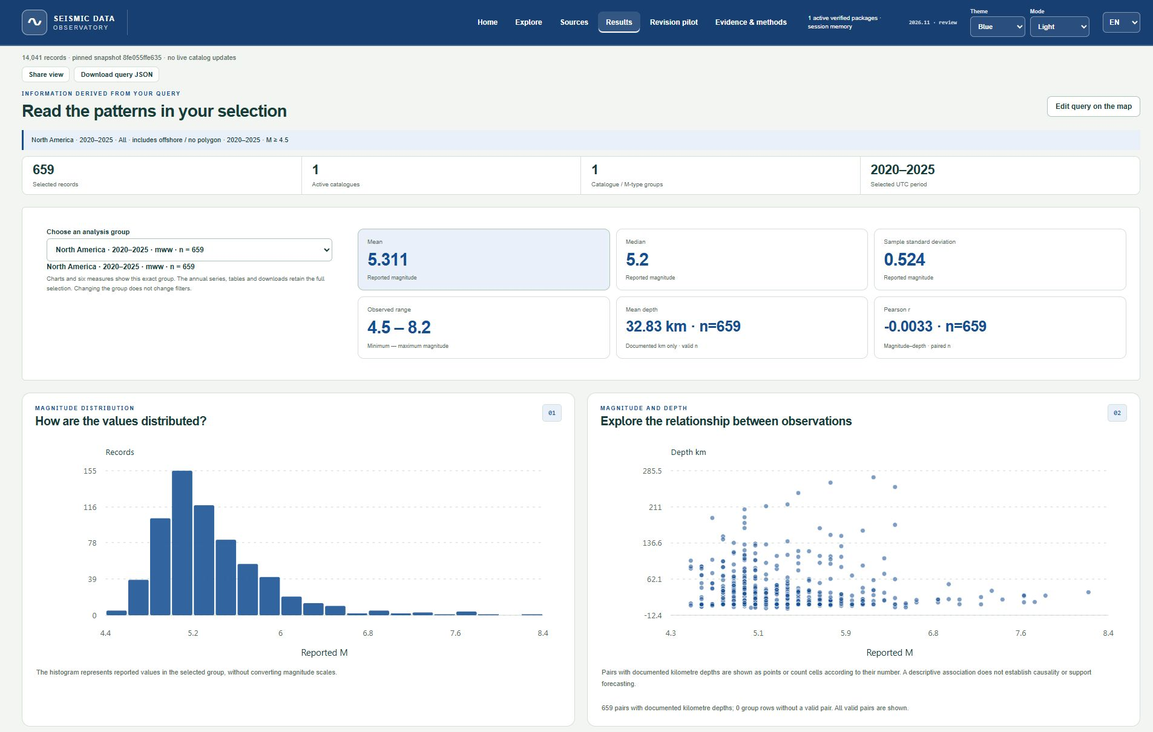
Figure 5. Unified descriptive workspace for 659 USGS North America records: UTC 2020-2025, reported M ≥ 4.5, literal type mww, all geographic classes. Group selection, six measures, magnitude distribution and magnitude-depth scatter are generated by the application. Independently recalculated mean is 5.311168, median 5.2, sample standard deviation 0.523513 and mean depth 32.832339 km; Pearson r is -0.003260 from 659 valid pairs. The capture shows descriptive results, without completeness, causality or forecasting claims.
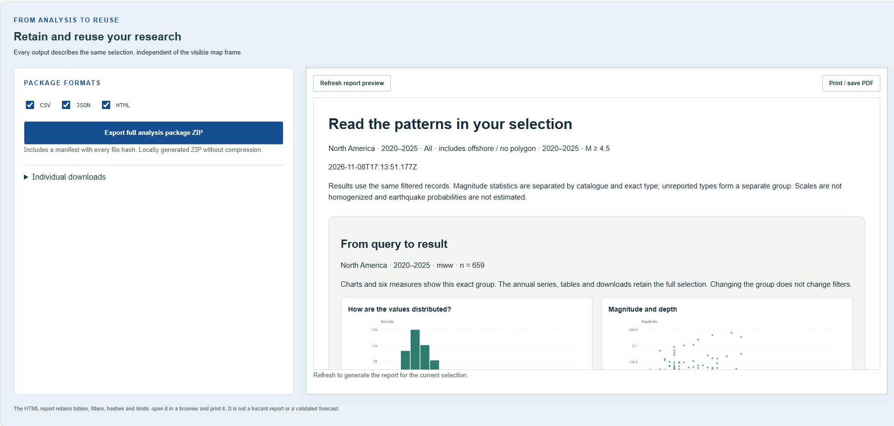
Figure 6. Export workspace for the same 659-record selection. CSV/JSON/HTML checkboxes select a single locally generated ZIP containing actual outputs and a payload-hash manifest. The adjacent preview displays the generated printable HTML report; its print control can save a PDF. Individual downloads remain available. The capture records the real application interface, not a report mock-up.
4.2. Derived source attribution in the revision pilot
The acquired cohorts contain 22 events for 2017 and 14 for 2022. Their detail responses contain 236 public origin-product versions, all with status UPDATE. All 36 captured canonical identifiers have a primary US origin lineage with multiple retained non-deletion versions; these lineages contain 205 versions. Superseded versions retain status UPDATE, so this count does not imply 205 simultaneously active solutions. Absence of retained deletion products in this selected cohort is not evidence that events were never withdrawn or that all versions have survived.
Table 3. Observed quantity | Value | Counting unit
Current-selected event identifiers | 36 | Captured events
Public origin-product versions | 236 | Retained versions
Versions in primary US origin lineages | 205 | Retained versions
Distributor source us | 226 | Public origin versions
Distributor source at / pt | 6 / 4 | Public origin versions
Origin author us / iscgem / missing | 205 / 21 / 10 | Public origin versions
Separate internal-origin / phase-data versions | 15 / 203 | Related products, excluded from primary analysis

Note. Slash-separated counts follow the corresponding labels in the same order. They count retained product versions, not independent earthquakes.
The difference between 226 US-distributed versions and 205 US-authored versions is explained here by 21 origins carrying iscgem authorship. The remaining ten public origins have missing solution-agency attributes in the fields inspected. No agency identity is imputed for them. These observed field relationships illustrate the need to retain source roles separately rather than treating each distributor code as an independent observational source.
4.3. Derived parameter changes and threshold membership
Across the 36 endpoint pairs, median epicentral displacement is 12.339 km and maximum displacement is 79.684 km. The latter belongs to us2000ahv7, whose endpoint magnitudes both remain 5.7 mb. Depth differences range from -38.48 to 12.39 km. Neither displacement nor depth change establishes which solution is closer to the physical source (Figure 7).
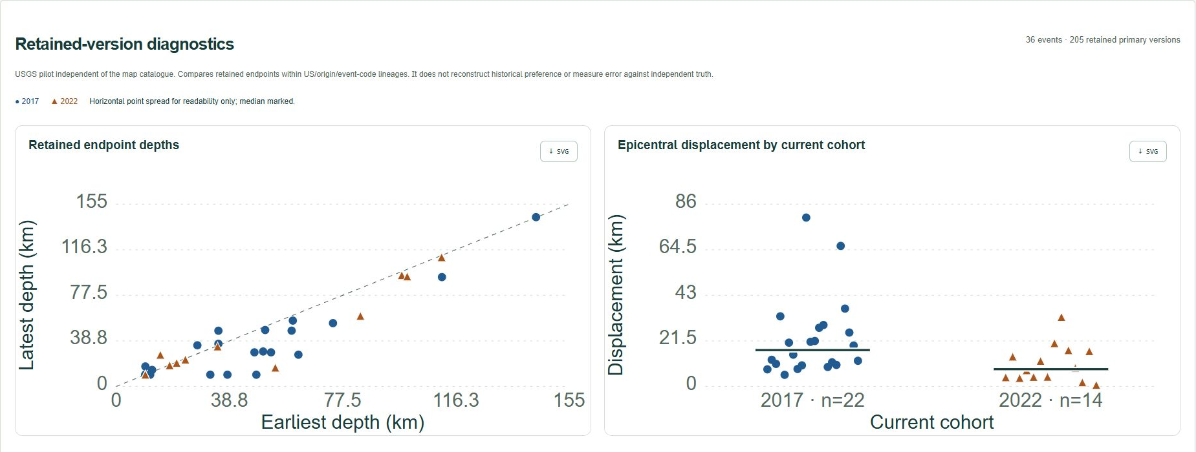
Figure 7. Native retained-version diagnostics in the application. Left: earliest versus latest retained non-deletion depths within primary US origin lineages for 36 events; the dashed line denotes equal endpoints. Right: epicentral displacement for the 2017 cohort (22 events, circles) and 2022 cohort (14 events, triangles). Deterministic horizontal offsets expose overlaps; strong bars mark medians. These JavaScript calculations match independent raw-product parsing. Differences do not estimate error against independent source locations.
Thirty-one events have comparable endpoint magnitudes with unchanged types: 30 mww pairs and one mb pair (Figure 8). Thirteen have a nonzero difference; the minimum, median and maximum differences are -0.1, 0.0 and 0.2 magnitude units. Five endpoint pairs have different reported types and are excluded from that subtraction. Same-type comparison controls one source of incompatibility but does not establish constant measurement procedures or remove selection bias.
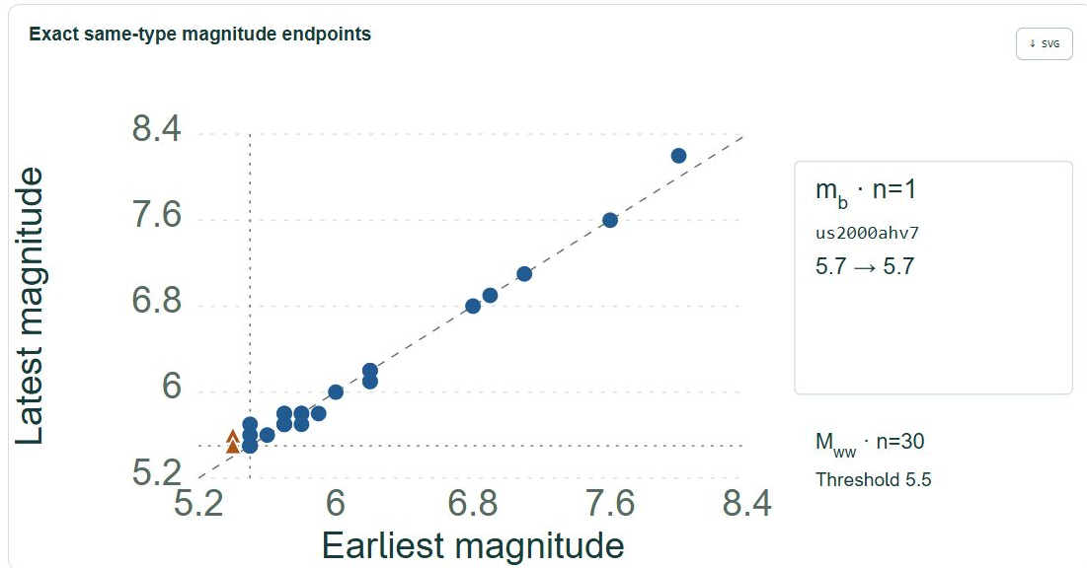
Figure 8. Application-generated magnitude endpoint comparison restricted to exact matching types. The main canvas shows 30 mww pairs (Mww notation); orange triangles mark four events crossing 5.5. Dotted lines denote 5.5 and the dashed line equal endpoints. Coincident pairs overlap. The smaller inset identifies the single mb pair separately. No scale conversion is performed. Current selection at magnitude at least 5.5 prevents treating crossings as an unbiased migration estimate.
Four endpoint pairs cross the 5.5 threshold, all within mww series in the 2017 cohort (Table 4). No comparable endpoint pair crosses the other examined thresholds. The within-type retained-series check identifies the same four events at 5.5. Because current magnitude at least 5.5 defined admission, the observed upward crossings cannot estimate a general rate or direction of catalog threshold migration.
Table 4. Event identifier | Earliest retained mww | Latest retained mww
us2000ailq | 5.4 | 5.5
us2000ap3b | 5.4 | 5.6
us2000aqji | 5.4 | 5.5
us1000arzf | 5.4 | 5.5

The primary lineages contain 169 adjacent version pairs. Selected fields differ in 117 pairs and remain unchanged in 52. These counts depend on the declared 27-field representation. They should not be interpreted as numbers of analyst actions, substantive revisions or redundant complete products.
4.4. Clock distinctions and conditional historical claims
For us2000ahv0, the seven retained primary US origins span endpoint values from magnitude 8.0 to 8.2 mww and depth 35.0 to 47.39 km. The latest retained primary origin update is dated 7 December 2017. A separate retained origin branch has an update in May 2022, while the captured event-summary update is dated 8 October 2026. Inspection of the captured products associates that latest summary timestamp with DYFI. It is consequently not the date of the primary hypocenter's latest retained revision. Figure 9 displays only retained versions within the primary US origin lineage, without combining other origin families or non-origin updates.
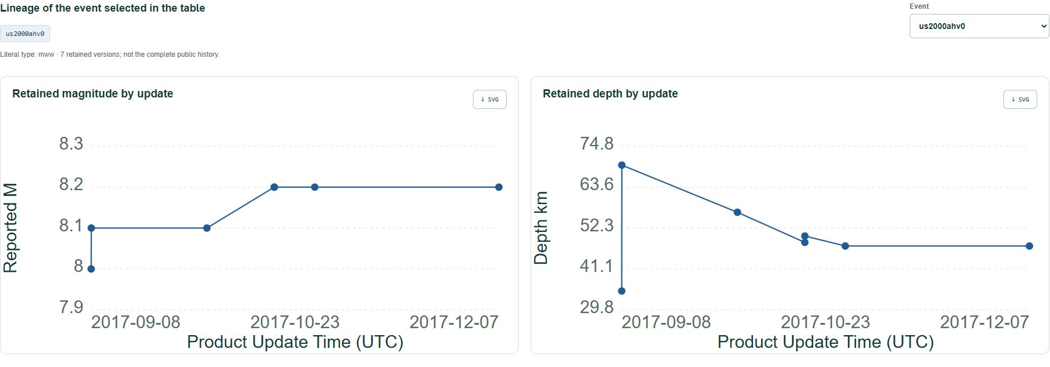
Figure 9. Native lineage view for event us2000ahv0, showing reported mww magnitude and documented depth for seven retained non-deletion versions of (us, origin, us2000ahv0). Both panels use Product Update Time (UTC). The selector changes the displayed event; unknown or mixed magnitude types do not produce a homogeneous joined magnitude curve. Connecting lines aid reading and do not reconstruct continuous source evolution, public availability or historical preference. Earliest retained does not mean first issued.
Ten of the 36 event summaries have an update timestamp later than every retained public origin timestamp. A summary timestamp may therefore reflect activity outside the origin products examined. Even where timestamps coincide, their equality alone does not establish publication latency or the historical preferred-origin sequence. Product update, indexing, retrieval and physical origin time remain different clocks.
The executable contracts preserve these distinctions. Captured summaries support capture-scoped counts, and supplied retained products permit explicitly conditional lineage projections. Neither operation supplies the missing evidence required for an unconditional past public catalog. The three synthetic counterexamples pass the replay checks while maintaining different past answers. Their logical result complements the observational audit; it is not an empirical estimate of how often a historical reconstruction would fail.
4.5. Differential validation and constructed evidence loss
The 36 captured details contribute 236 distinct event-specific origin update boundaries. Evaluating both sides gives 472 producer-time cutoffs and 4,720 query evaluations across the ten specifications. Selected records and declared deletions agree with the independent SQL implementation in every evaluation. This checks retained-projection implementation on the acquired inputs; it does not validate historical public availability, completeness or source accuracy. Real origin products all have status UPDATE, so their deletion comparisons are empty; deletion handling is exercised with synthetic inputs.
The eight constructed histories produce 24 synthetic query cases. Conditional retained projections agree with SQL in all 24 cases. Relative to known public event counts, producer-time backcasting with current preference differs in ten cases, filtering before temporal resolution in eleven, and index-time backcasting in ten. These policies share current-cohort and current-preference assumptions, so their failures can overlap and are not isolated causal effects of a single operation. The examples were constructed to exercise specified failure mechanisms and controls; the counts do not estimate operational error prevalence or establish superiority over existing catalog software.
All 24 unconditional historical claims are declined as designed. This outcome must not be interpreted as perfect loss detection: the contract declines the stronger claim regardless of whether a particular synthetic export omitted a version. Its conditional calculation remains reproducible, while the known public replay can differ because it uses additional retained-history, publication, membership or preference evidence.
4.6. Observed SSN coverage and annual summaries
Figure 10 distinguishes downloaded-record coverage from physical occurrence. Of 126 closed calendar bins in 1900-2025, 110 contain records and 16 contain none in this download. All 110 observed years retain at least one M ≥ 5 row: that threshold removes no additional national years. Across the full download, 1,901 rows have M ≥ 5. The partial 2026 bin contains 34,548 source rows, 14,875 with M ≥ 3.5 and 35 with M ≥ 5. These changing counts reflect reporting and selection as well as seismic activity; they establish neither completeness nor changing hazard.
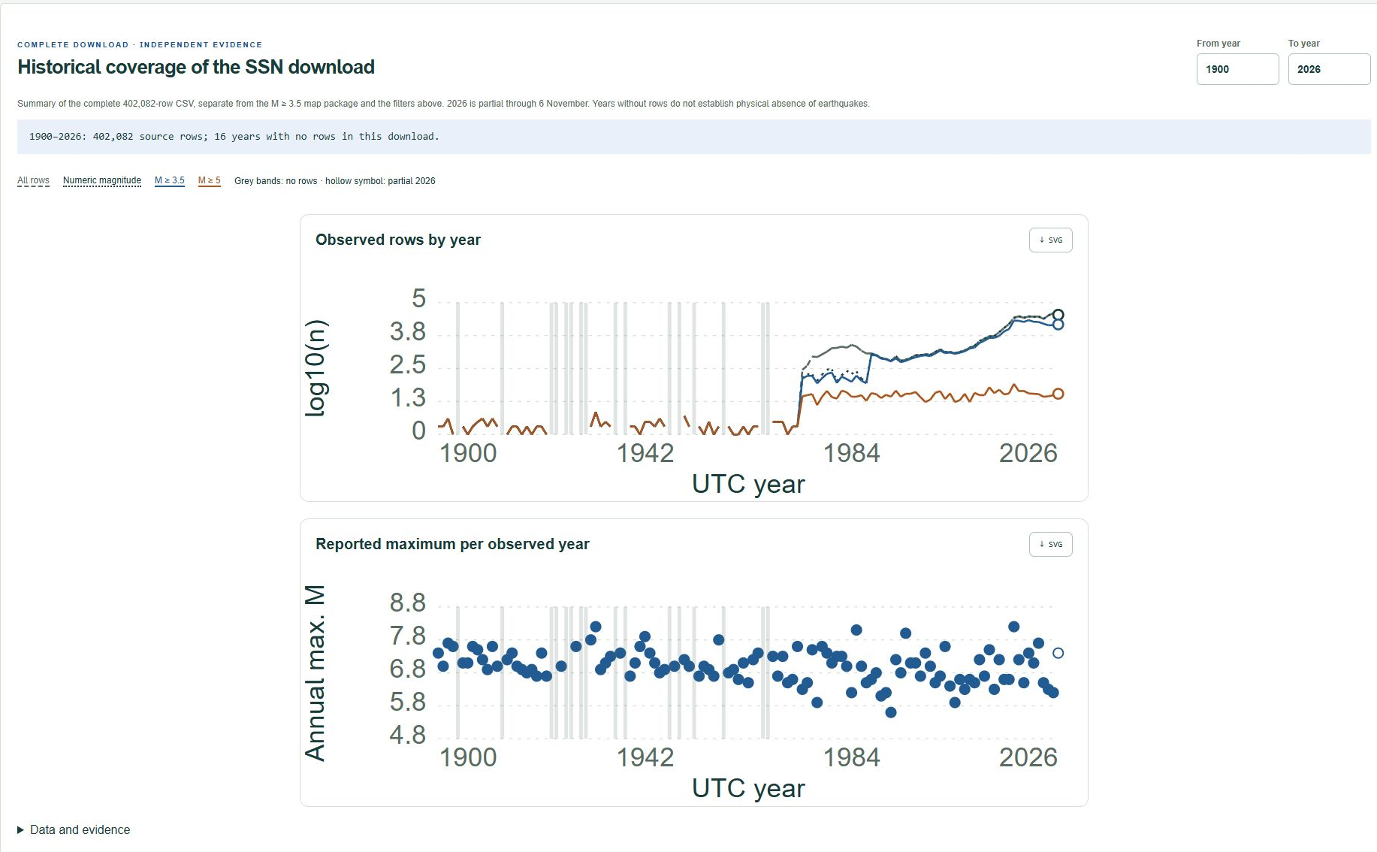
Figure 10. Interactive historical-coverage module for the full SSN download. Upper panel: log10 annual counts of all rows, numeric magnitudes, M ≥ 3.5 and M ≥ 5. Lower panel: maximum reported magnitude per observed year, with the same horizontal extent. Grey bands mark 16 years without rows; hollow symbols identify partial 2026. The browser renders a hash-verified Python summary of the complete 402,082-row CSV, separate from map filters and the 242,288-row map subset. Year controls change the displayed interval. No completeness, homogenized-scale, hazard or return-period claim follows.
The 110 closed-year maxima are attained by 118 rows because eight years have ties. Counting those rows as 118 independent annual maxima would change the statistical unit. Unknown magnitude types, uneven observation coverage and unverified stationarity prevent interpreting fitted tails as validated return periods. Accordingly, no occurrence forecast, regional independence claim or design magnitude is derived from these descriptive summaries.
5. Discussion
The system addresses the stated problem by connecting exploration to evidence that remains inspectable after export. Coordinated filters turn heterogeneous catalogues into explicit study selections; source-qualified records and hashes make those selections reusable. The demonstrations show how a researcher can isolate recent SSN records, inspect a Canadian entry and examine several sources together while retaining their differences. Descriptive outputs support the formulation of research questions and preparation of subsequent analyses. They do not remove the need for study-specific completeness assessment, magnitude harmonization or event reconciliation.
On-screen means and dispersion describe retained reported values within each catalogue/type group. The 659-record example demonstrates a traceable numerical answer, not a universal magnitude distribution. Pearson correlation neither links events across agencies nor supplies an occurrence probability. Applying Poisson or thesis-derived recurrence models would require separately justified completeness, sampling, scale compatibility and model assumptions; such estimates are not implemented or validated here.
The derived results also show why provenance affects interpretation. SSN annual counts and maxima expose coverage gaps and tied observations that matter when defining an annual analysis. The revision pilot shows how parameter changes affect a magnitude threshold or spatial comparison. Separating the distributor from the solution agency exposes ISC-GEM origins carried by USGS; separating summary updates from origin revisions avoids interpreting unrelated product activity as a hypocentral change. Evidence contracts attach these boundaries to the computation rather than leaving them implicit in a map.
This functionality builds on existing software rather than replacing its capabilities. Libcomcat documents product-history extraction; Timeline groups versions and presents their evolution. The INGV service resolves event versions before filtering and provides asofdate under an invariant that all public mutations pass through its API. That controlled maintenance boundary differs from a researcher retrieving evidence from another provider. The present prototype specifies which weaker calculations remain permissible when the stronger boundary cannot be established. This is a comparison of documented semantics, not proof of superior performance or a comprehensive absence of equivalent methods.
Parameter differences can alter spatial-window membership or threshold counts, but latest retained solutions are not reference truth. The SSN and Canadian integrations expose heterogeneous fields without providing additional revision validation. Local keys do not restore original event IDs; magnitude filtering does not establish scale equivalence. Catalogue origin-time coverage is not an archive of past public states. Additional controls and map backgrounds add no independent seismic evidence.
Retrospective selection omits events outside the current cohort, including possible downward crossings and withdrawals. Unknown retention, past associations and preferences prevent historical reconstruction; synthetic experiments cannot replace independently captured public states.
The demonstrations establish functional behavior, not improvements measured through independent users, comparative performance or research outcomes.
Further evaluation requires independent historical captures, additional cohorts and prespecified comparisons. SQL agreement and constructed-loss experiments establish neither historical accuracy nor operational error prevalence or transferability.
6. Conclusions
The developed web system supports consultation, comparison and exploration of heterogeneous earthquake catalogues while retaining the provenance required to interpret and reuse results. Its three connected outputs are the computational application, documented seismic inputs and traceable derived information. Source-specific and combined views, on-screen descriptive statistics and hash-linked exports demonstrate how users can turn dispersed records into explicit selections for analysis, study and subsequent research.
The browser produces grouped summaries, annual counts and bounded associations; offline pipelines additionally examine SSN coverage and annual maxima, source attribution and retained-parameter comparisons. In the 36-event pilot, magnitude changes, threshold crossings and epicentral differences provide concrete reasons to preserve parameter versions and source roles. SQL agreement validates the tested conditional computations; it does not establish historical public states or source accuracy. The system therefore supplies reusable evidence and bounded analytical results, with uncertainty and missing information visible. Independent user evaluation, broader scientific cohorts and independently preserved historical states are needed to evaluate its utility and generalizability beyond the demonstrations presented here.
Code and data availability
Released code, source manifests, the frozen ComCat evidence package and reproducible validation are available in the study repository (https://github.com/gabrielhuav/Seismic_Data_Geosciences). The map upgrade is publicly deployed at commit 1c797dce7f6fe9b28e2015a9de779d9364a39ae5. Figures 2-10 document the subsequent local author-review build dated 8 November 2026. Its new ZIP and diagnostic modules await release; the hosted version can therefore differ from these figures until that revision is published. The package retains initial-release revision/Mexico-summary bytes and catalogue-specific provenance: 36 event-detail responses and four cohort count/query responses with receipts and SHA-256 hashes. Run python scripts/prepare_public_evidence.py restore before python scripts/audit_revisions.py; offline restoration rejects different existing evidence. Live URLs cannot substitute for preserved bytes.
The separate CSV diagnostic is pinned by commit and hashes. Obtain missing files with python scripts/audit_sources.py --download --skip-ssn. Historical SSN-derived SQL is not redistributed or required. Source rights and contributor roles remain documented; MIT covers original software, not observations or third-party material. No archival dataset DOI is asserted.
The Canadian source CSV and its manifest are preserved in research-data/catalogs/nrcan-ca/ under the Open Government Licence-Canada; python scripts/build_canada_catalog.py reproduces its browser package offline. python scripts/build_catalogs.py --download obtains and verifies missing North American CSVs at the pinned upstream commit. The registry identifies each package separately, including hashes and provider-specific limits. The preserved native SSN CSV is research-data/catalogs/ssn-mx/ssn_19000101_20261106.csv, SHA-256 0601c65544bc95ef865d3440e5e6d84249acdebd8edfb379669597096543f993. python scripts/build_ssn_catalog.py reproduces its selection; python scripts/build_diagnostic_coverage.py reproduces its annual summary. The source catalogue DOI identifies the mutable SSN service, not an archival DOI for this download. Its original notice and observed data-use terms are retained; SSN, Instituto de Geofísica, Universidad Nacional Autónoma de México, is credited for the data. No institutional endorsement is implied.
Run python -m unittest discover -s tests for contract checks and python -m scripts.validate_evidence for the independent SQLite and synthetic controlled-loss evaluation. Generated manifests and tables distinguish original observed details from synthetic histories. The published browser explorer (https://gabrielhuav.github.io/Seismic_Data_Geosciences/) exposes source-file evidence and exports local-query specifications with input hashes and result identifiers; its map is not an operational prediction or alert service.
CRediT authorship contribution statement
José Manuel Villa Vargas: Conceptualization; Formal analysis; Supervision; Writing - original draft; Writing - review & editing.
Gabriel Hurtado Avilés: Data curation; Investigation; Methodology; Project administration; Resources; Software; Validation; Visualization.
Funding
This research did not receive any specific grant from funding agencies in the public, commercial, or not-for-profit sectors.
Declaration of competing interest
The authors declare no competing interests.
Declaration of generative AI assistance
OpenAI Codex (OpenAI; GPT-6-based agent sessions, 6-8 November 2026) assisted literature discovery, code development, reproducible figure scripts, automated testing, manuscript drafting and document formatting. The explanatory diagram and data plots are rendered from documented inputs and maintained code. The interface panels derive from genuine integrated-browser captures of the local preview on 8 November 2026. Cropping and panel composition preserve the captured content; no generative image creation or retouching of observations is used.
References
European-Mediterranean Seismological Centre, n.d. Data contributors. Accessed 6 November 2026. Contributor directory (https://emsc-csem.org/Earthquake_data/contributors.php).
Gardezi, J., Bertossi, L., 2011. Query Answering under Matching Dependencies for Data Cleaning: Complexity and Algorithms. Author preprint, arXiv:1112.5908. Preprint (https://arxiv.org/abs/1112.5908).
Government of Canada, n.d. Open Government Licence-Canada, version 2.0. Accessed 6 November 2026. Licence (https://open.canada.ca/en/open-government-licence-canada).
Natural Earth, n.d. About Natural Earth. Geographic data and boundary policy. Accessed 6 November 2026. Project documentation (https://www.naturalearthdata.com/about/).
Natural Resources Canada, n.d. Earthquakes in Canada. Open Government Portal, record 4cedd37e-0023-41fe-8eff-bea45385e469. Accessed 6 November 2026. Official dataset (https://open.canada.ca/data/en/dataset/4cedd37e-0023-41fe-8eff-bea45385e469).
Pintore, S., 2026. x-fdsnws-event: a reference implementation of a version-aware extension of the FDSNWS/event access model for reproducible seismic event catalogues. INGV software repository. Accessed 5 November 2026. Repository (https://github.com/INGV/x-fdsnws-event).
Sawires, R., Santoyo, M.A., Peláez, J.A., Corona Fernández, R.D., 2019. An updated and unified earthquake catalog from 1787 to 2018 for seismic hazard assessment studies in Mexico. Scientific Data 6, 241. Article (https://doi.org/10.1038/s41597-019-0234-z).
Servicio Sismológico Nacional, 2026a. Catálogo de sismos, México. Instituto de Geofísica, Universidad Nacional Autónoma de México. Downloaded 6 November 2026. Catalogue DOI (https://doi.org/10.21766/SSNMX/EC/MX).
Servicio Sismológico Nacional, 2026b. Aviso legal, uso de datos sísmicos y términos de libre uso. Observed 6 November 2026. Terms (http://www.ssn.unam.mx/aviso-legal/).
Sismanis, Y., Wang, L., Fuxman, A., Haas, P.J., Reinwald, B., 2009. Resolution-Aware Query Answering for Business Intelligence. Proceedings of the 25th IEEE International Conference on Data Engineering, 976-987. Publication (https://research.ibm.com/publications/resolution-aware-query-answering-for-business-intelligence).
Thompson, E.M., McBride, S.K., Hayes, G.P., Allstadt, K.E., Wald, L.A., Wald, D.J., Knudsen, K.L., Worden, C.B., Marano, K.D., Jibson, R.W., Grant, A.R.R., 2020. USGS near-real-time products; and their use; for the 2018 Anchorage earthquake. Seismological Research Letters 91(1), 94-113. Article (https://doi.org/10.1785/0220190207). Official publication record (https://www.usgs.gov/publications/usgs-near-real-time-products-and-their-use-2018-anchorage-earthquake).
U.S. Geological Survey, n.d.a. API Documentation; Earthquake Catalog. Accessed 5 November 2026. Documentation (https://earthquake.usgs.gov/fdsnws/event/1/).
U.S. Geological Survey, n.d.b. How Products Work in ComCat. Accessed 5 November 2026. Documentation (https://earthquake.usgs.gov/data/catalog/products.php).
U.S. Geological Survey, n.d.c. Product Distribution Layer; Indexer Processing. Accessed 5 November 2026. Documentation (https://usgs.github.io/pdl/indexer.html).
U.S. Geological Survey, n.d.d. libcomcat Application Program Interface. Accessed 5 November 2026. Documentation (https://github.com/usgs/libcomcat/blob/master/docs/api.md).
U.S. Geological Survey, n.d.e. ComCat Timeline. Historical source implementation and current developer-resource directory. Accessed 5 November 2026. Inspected implementation (https://github.com/jmfee-usgs/comcat-timeline/blob/master/src/Catalog.ts); Official directory (https://earthquake.usgs.gov/data/software/).
Villa Vargas, J.M., Hurtado Avilés, G., Climent Hernández, J.A., 2026. Cuando México tiembla: la historia contada por los datos. AZCATL Revista de Divulgación en Ciencias, Ingeniería e Innovación 4(6), 28-33. DOI: 10.24275/AZC2026E1004. Published antecedent (https://azcatl.azc.uam.mx/index.php/azcatl/article/view/75).
Weatherill, G.A., Pagani, M., Garcia, J., 2016. Exploring earthquake databases for the creation of magnitude-homogeneous catalogues: tools for application on a regional and global scale. Geophysical Journal International 206, 1652-1676. Article (https://doi.org/10.1093/gji/ggw232).
Wu, X., Poorthuis, A., Zurita-Milla, R., Kraak, M.-J., 2020. An interactive web-based geovisual analytics platform for co-clustering spatio-temporal data. Computers & Geosciences 137, 104420. Article (https://doi.org/10.1016/j.cageo.2020.104420).
Zúñiga, F.R., Reyes, M.A., Valdés, C., 2000. A general overview of the catalog of recent seismicity compiled by the Mexican Seismological Survey. Geofísica Internacional 39(2), 161-170. Public abstract and metadata consulted. Official record (https://repositorio.unam.mx/contenidos/4133493).

