

School of Computing and Mathematical Sciences

CO7201 Individual Project

Final Report Template

SongAssist

Gabriel Knight
gk247@student.le.ac.uk
249047672

Project Supervisor: Newman Lau
Principal Marker: Dr Martina Palusa

Word Count: XXX
25/07/25

DECLARATION
All sentences or passages quoted in this report, or computer code of any form whatsoever used and/or submitted at any stages, which are taken from other people’s work have been specifically acknowledged by clear citation of the source, specifying author, work, date and page(s). Any part of my own written work, or software coding, which is substantially based upon other people’s work, is duly accompanied by clear citation of the source, specifying author, work, date and page(s). I understand that failure to do this amounts to plagiarism and will be considered grounds for failure in this module and the degree examination as a whole.

Name: Gabriel Knight
Date: 27/06/25

Contents
1. Introduction 3
1.1 SongAssist Overview 3
1.2 Project Rationale 3
1.3 Aims and Objectives 3
2. Literature review 3
2.1 Workflow Interruptions 3
2.2 Stem Separation Tools 3
2.3 Generative AI 3
3. Technical Specification 5
2.1 High-Level Architecture 4
4. Implementation 6
5. Testing and Evaluation 6
6. Future Improvements 7
7. Generative AI Contributions 10
8. References 10

Introduction

SongAssist Overview
SongAssist is an all-in-one practice app for guitarists to learn new songs and refine their skills in a user-friendly, distraction-free environment. The application implements cutting edge stem-separation models to isolate the guitar from the rest of a track uploaded as an MP3. SongAssist also features AI-powered advice and tablature generation to give guitarists a deeper understanding of the song they are learning.

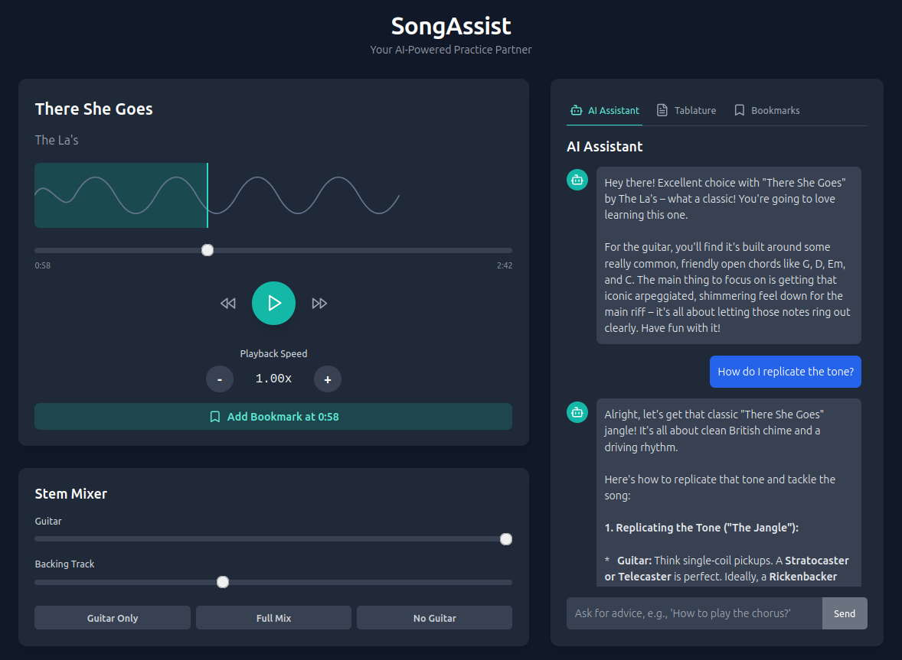Figure 1: Screenshot of SongAssist main screen

Project Rationale
Learning a new song as a guitarist, even in the age of modern technology, can present significant challenges. One of the most significant barriers in achieving this is often replicating nuances and intricacies in the songs guitar part which requires a deep understanding of the sound and technique [1]. By simply listening to a track it can be difficult to pick up on such subtleties, especially with all other instruments playing alongside the guitar track. Since the late 2010s stem-separation technology has been widely available as a proposed solution to this issue whereby each instrument in any given track can be isolated using deep learning AI models [2].

While existing stem-separation applications can isolate guitar tracks, no leading applications in this field cater specifically to guitarists by offering further insight on the isolated part; this leads to an incomplete user-experience where users can hear the isolated guitar but have to navigate to a separate app in order to fully learn how to play it through chord-sheets and tablature notation.
Literature Review

Workflow Interruptions
Research consistently shows that an excessive amount of information being presented to an individual at once can impair their ability to take in new information, this is known as cognitive load theory [11]. It is for this reason that a fragmented workflow is entirely unconducive to learning a new song as a guitarist. Developing a user-experience that supports simplicity and intuitiveness has shown to increase a user’s capacity to learn with many users in this study stating their lowered barriers to engagement after experiencing a straightforward user-interaction [12].

Stem Separation Software
With stem-separation having existed as a technology for over 20 years, it was mainly looked upon as a complex studio technique until the late 2010s. The introduction of deep neural networks led to significant advancements in this field, stem-separation went from being performed using frequency filtering to deep-learning models trained on specialized music datasets [13]. Some of the most powerful deep neural networks developed at this time include demucs, which features high quality at a high computational expense, and Spleeter, a simpler model with fast stem-separation at a lower quality [14].

Moises.ai is one of the leading stem-splitting web applications with its own proprietary high-quality separation models, it has been stated that the separation offered by the application can be ‘studio-quality’[15]. Although Moises.ai offers high-quality separation, it doesn’t provide any qualitative advice on how to replicate guitar tone or technique, another app is required for this functionality.

Technical Specification

High-Level Architecture
When a file is uploaded through the frontend, React sends this file to SongAssist’s Python-based FastAPI backend in order to be processed and separated by the htdemucs_6s model. Upon separation, the frontend then loads each individual audio stem to be manipulated by the user. The user can also ask questions to the Gemini assistant implemented through the @google/genai library.

Implementation

Testing and Evaluation

Future Improvements

Generative AI Contributions
References

- [1] J. R. Keebler, et al., “Shifting the paradigm of music instruction: implications of embodiment stemming from an augmented reality guitar learning system,” Frontiers in Psychology, vol. 5, p. 471, May 2014, doi: 10.3389/fpsyg.2014.00471.
- [2] C. Kefalis and A. Drigas, “Web Based and Online Applications in STEM Education,” International Journal of Engineering Pedagogy (iJEP), vol. 9, no. 4, pp. 76–85, 2019.
- [11] J. L. Plass, R. Moreno, and R. Brünken, Eds., Cognitive Load Theory. Cambridge University Press, 2010.
- [12] A. Chu, et al., “Usability of learning moment: features of an E-learning tool that maximize adoption by students,” Western Journal of Emergency Medicine, vol. 21, no. 1, p. 78, 2019.
- [13] E. Cano, et al., “Musical source separation: An introduction,” IEEE Signal Processing Magazine, vol. 36, no. 1, pp. 31–40, 2018.
- [14] Quality, Separation Audio, and Erika Rumbold. "Computer Science Department." (2022)
- [15] K. N. Watcharasupat and A. Lerch, “A Stem-Agnostic Single-Decoder System for Music Source Separation Beyond Four Stems,” arXiv preprint arXiv:2406.18747, 2024.

