CS 255 System Design Document Template

UML Diagrams

UML Use Case Diagram
Figure: UML Use Case Diagram

UML Activity Diagrams
Figure: UML Activity Diagrams
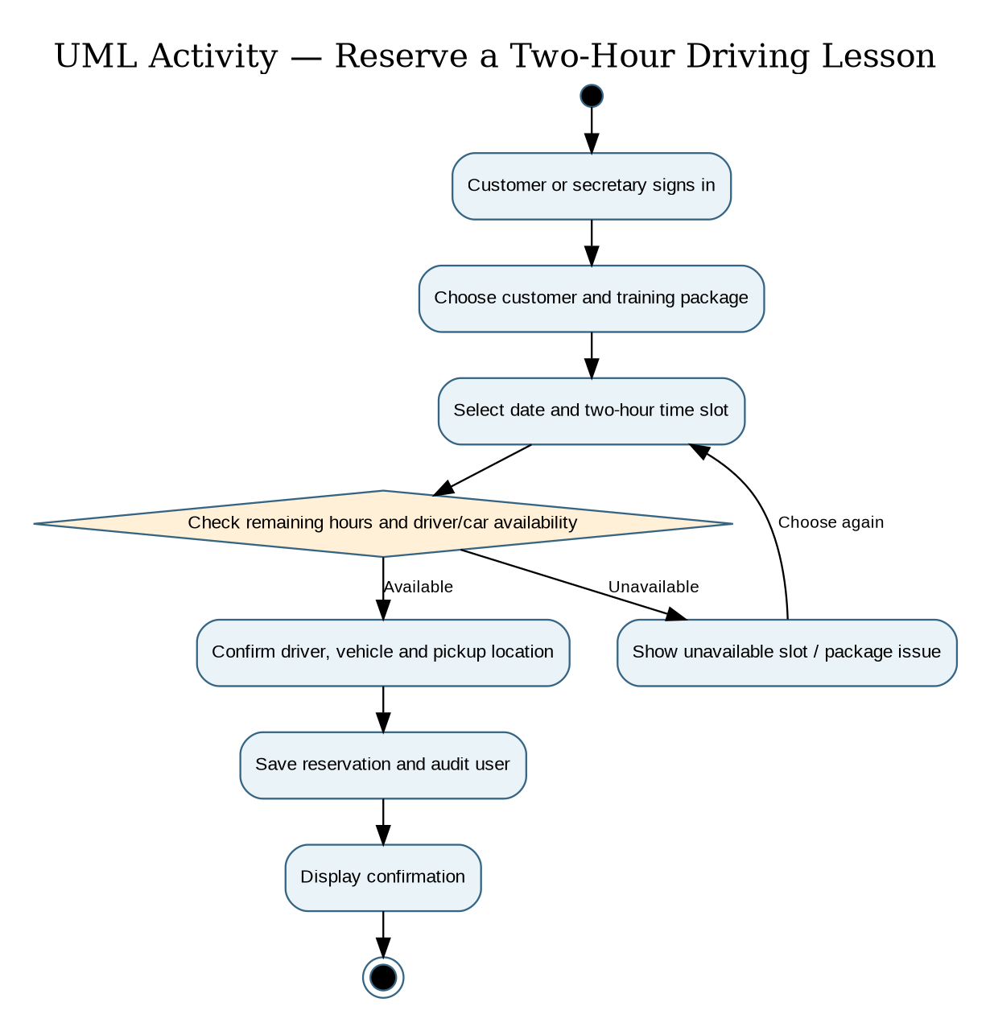
Figure: Practice Test Activity
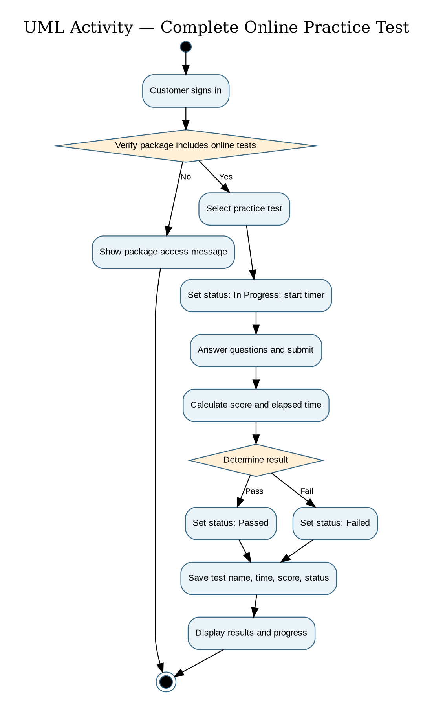

UML Sequence Diagram
Figure: UML Sequence Diagram
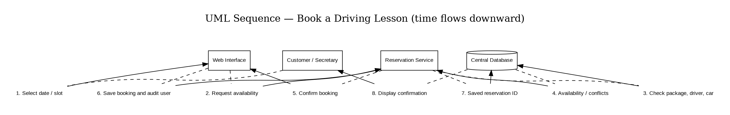

UML Class Diagram
Figure: UML Class Diagram
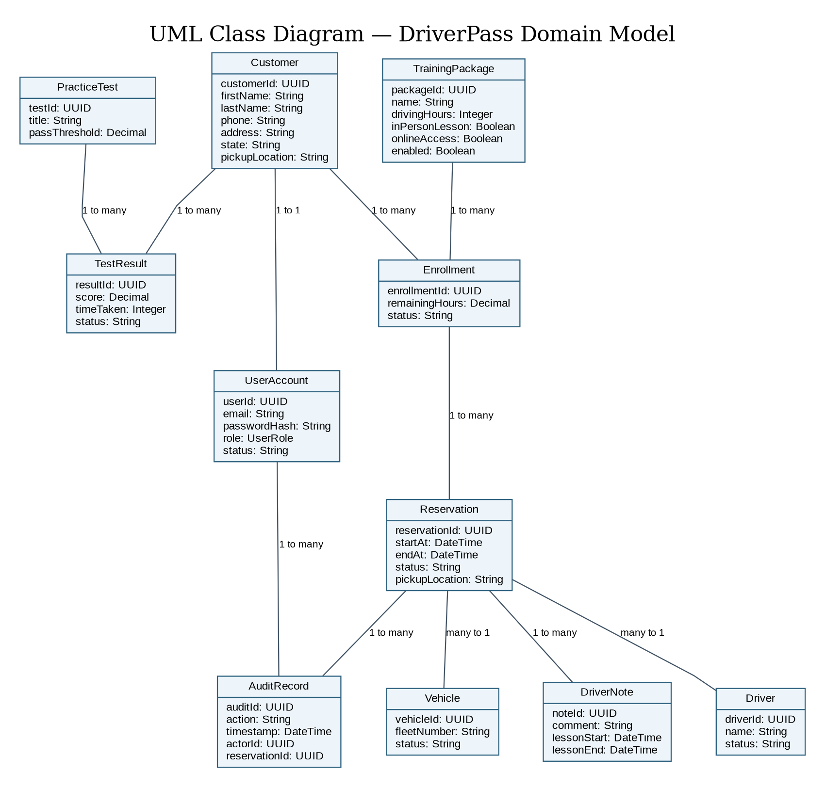

Technical Requirements

Hardware and Client Devices
Internet-connected desktop/laptop or mobile device with a modern browser for customers and staff.
Existing DriverPass office computers and mobile devices; no dedicated on-site application server required.
Ten training vehicles and assigned instructors remain operational resources for the booking process.
Software and Application Services
Cloud-hosted, responsive web application supporting customer, secretary, instructor, owner and IT administration roles.
Application service implementing two-hour lesson scheduling, package entitlements, conflict prevention, online practice tests, progress tracking, driver notes and activity reports.
Relational database storing customers, user accounts, packages, enrollments, reservations, vehicles, drivers, test results, notes and audit records.
Email delivery service for password reset and customer contact; export to spreadsheet-friendly format for offline review.
External DMV content-update integration or a supported notification/import mechanism; exact DMV interface to be confirmed.
Infrastructure, Security and Operations
Cloud hosting with HTTPS/TLS, encrypted data at rest, managed backup, restore testing and availability monitoring.
Role-based authorization and secure sign-in; self-service password resets for customers and privileged account controls for the IT officer.
Server-side input validation and atomic reservation updates to prevent overlapping assignments of drivers or vehicles.
Immutable or append-only reservation activity records containing actor, action and timestamp.
Payment processing should use a compliant third-party provider; do not retain card security codes after authorization.
Internet connectivity is required for live record changes; downloaded reports may be viewed offline but cannot synchronize edits.
Development and Quality Tools
Lucidchart or equivalent CASE tool for UML diagrams; version-controlled source repository and automated testing.
Test plans covering package permissions, scheduling conflicts, password recovery, audit logs, mobile layout and test-result status changes.
Monitoring, logging and a staging environment for verification before production updates.

