SECONDARY METABOLITEs AND their USEFULness TO MAN

PREPARED BY

AKANDE ESTHER AANUOLUWAPO

BC20200103873

SUPERVISED BY

DR. ADEGBOOLA

SUBMITTED TO:

DEPARTMENT OF BIOCHEMICAL SCIENCE

FEDERAL POLYTECHNIC EDE, OSUN STATE

INTRODUCTION

Metabolites are the intermediates and products of metabolism. The term metabolite is usually restricted to small molecules. Metabolites have various functions, including fuel, structure, signaling, stimulatory and inhibitory effects on enzymes, catalytic activity of their own (usually as a cofactor to an enzyme), defense, and interactions with other organisms. Plant produce a vast and diverse assortment of organic compounds the great majority of which do not appear to participate directly in growth and development. These substances, traditionally referred to as secondary metabolites, often are differentially distributed among limited taxonomic groups within the plant

kingdom.
Secondary metabolites (SMs) are generally defined as small organic molecules produced by an organism that are not essential for their growth, development and reproduction.

Secondary metabolites(SMs) are compounds are that not required for the growth or reproduction of an organism but are produced to confer a selective advantages to the organisms.
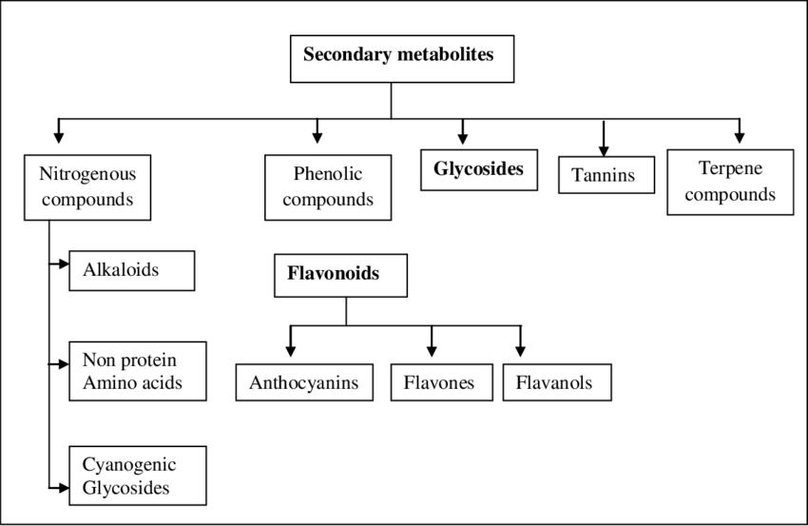
Secondary metabolites can be classified on the basis of chemical structure (for example, having rings, containing a sugar), composition (containing nitrogen or not), their solubility in various solvents, or the pathway by which they are synthesized (e.g., phenylpropanoid, which produces tannins). And usually classified according to their biosynthetic pathways. Three large molecule families are generally considered: Phenolic, Terpenes and Steroids, and Alkaloids, Flavonoids. Some of them can have severe Consequences.

Alkaloids

Alkaloids are originally defined as pharmacologically active, nitrogen-containing basic compounds of plant

origin. And they can block ion channels, inhibit enzymes, or interfere with neurotransmission, producing

hallucinations loss of coordination, convulsions, vomiting, and death.

Phenolic

Phenolic interfere with digestion, slow growth, block enzyme activity and cell division, or just taste awful.
Terpenes

Terpenes are among the most widespread chemically diverse groups of natural products. Terpenes are a unique group of hydrocarbon-based natural products whose structures may be derived from isoprene. Terpenes are classified by the number of 5-carbon units. The function of terpenes in plants is generally considered to be both ecological and physiological: Allelophathy, Insecticidal, Insect pollinators, Plant hormone (Abscisic acid, gibberlellin).

Flavonoids

With more than 4500 different representatives known thus far, the flavanoids constitute an enormous class of phenolic natural products. Present in most plant tissues, often in vacuoles, flavonoids can occur as monomers, dimmers and higher oligomers. Flavonoids comprise a diverse set of compounds and perform a wide range of functions. Specific flavonoids can also function to protect plants against UV-B irradiation. The flavonoids consist of various groups of plant metabolites which include chalcones, aurones,flavanones, isoflavonoids, flavones, flavonols, leucoanthocyanidins, catechins, and anthocyanins.
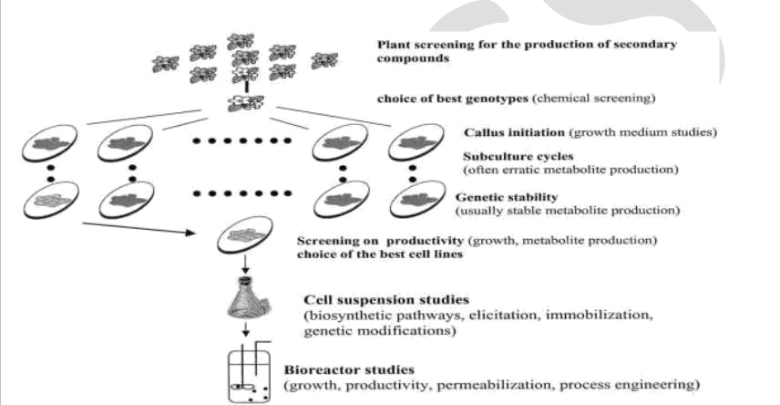

Fig.1-Guidelines for the production of secondary metabolites from plants cell
IMPORTANCE AND NATURAL FUNCTIONS OF SECONDARY METABOLITES

secondary metabolites including antibiotics are produced in nature and serve survival functions for the organisms producing them secondary metabolites serve:

- As competitive weapons used against other bacteria, fungi, amoebae, plants, insects, and large animals.

- As metal transporting agents.

- As agents of symbiosis between microbes and plants, nematodes, insects and higher animals.

- As sexual hormones.

- As cleanser for the immediate environment of competing microorganisms during germination.
CONCLUSION

Secondary metabolites are the useful natural products that are synthesized through secondary metabolism in the plants. The production of some secondary metabolites is linked to the induction of morphological differentiation and it appears that as the cells undergo morphological differentiation and maturation during plant growth. It is observed that in-Vitro production of secondary metabolites is much higher from differenced tissues when compared to non-differentiated or less –differentiated tissues. There are lots of advantages of these metabolites like there is recovery of the products will be easy and plant cultures are particularly useful in case of plants which are difficult or expensive and selection of cell lines for high yield of secondary metabolites will be easy. Many other examples could be presented with plant metabolic engineering as this research area is developing actively.

Metabolic engineering is probably a large step forward but playing on the genes will not solve all the problems that

have prevented the development of commercial success in the field of plant secondary metabolites.

And Advances in plant cell cultures could provide new means for the cost-effective, commercial production of even rare or exotic plants, their cells, and the chemicals that they will produce.
REFERENCES

Jian Zhaoa,T, Lawrence C. Davisb and Robert Verpoortec―Elicitor signal transduction leading to production of plant secondary

metabolites‖Biotechnology Advances,283 333, 23 (2005)

Fraenkel, and Gottfried S. "The raison d'Etre of secondary plant substances"Science 129 (3361)1466 470.doi:10.1126/science,129.3361,1466,PMID 13658975(May1959) "Chemical plants". Retrieved 2008-12-19.

Stamp, and Nancy"Out of the quagmire of plant defense hypotheses".The Quarterly Review of Biology78(1): 23 55,doi:10.1086/367580, PMID12661508, (March 2003).

Samuni-Blank, M., Izhaki, I., Dearing, MD.,Gerchman, Y., Trabelcy, B., Lotan, A., Karasov, WH., Arad, Z. "Intraspecific Directed Deterrence by the Mustard Oil Bomb in a Desert

Plant‖Current22(13): 1218–1220, doi:10.1016/j.cub.2012.04.051, (2012).

Srivastava S1,Srivastava AK.,―Hairy root culture for mass-production of high-value secondary metabolites‖Crit Rev Biotechnol,27(1):29-43.2007 Jan-Mar.

Smetanska I1.―Production of secondary metabolites using plant cell cultures‖Adv Biochem Eng Biotechnol.2008; 111:187-228. doi:

10.1007/10_2008_103.

[A. Kossel ―Uber die chemische Zusammensetzung der Zelle‖ Archiv fur Physiologie(1891)181-186

[9]J.B.Harborne , N.J.Walton,D.E.Brown―Classes and functions of secondary products in chemicals from Plants, Perspectives on Secondary plant products‖Imperial college press,pp.1-25, 1996.

F. Bourgaud,,A. Gravot,S. Milesi,E. Gontier―Production of plant secondary metabolites: a historical perspective‖Volume161,Issue5, Pages

839–851, October 2001.

Biology Encyclopedia.

