CODINGAN :

TEST 1

SELECT LEFT(transaksikuliah.nimhstrakm,2) AS progdi,

ROUND (AVG(transaksikuliah.sksemtrakm),2) AS rata2skspersemester

FROM transaksikuliah.transaksikuliah GROUP BY progdi ORDER BY progdi ASC

TEST 2

SELECT LEFT(transaksikuliah.nimhstrakm,2) AS progdi,

ROUND (AVG(transaksikuliah . nlipstrakm),2) AS rata2IPK

FROM transaksikuliah.transaksikuliah transaksikuliah GROUP BY progdi

ORDER BY rata2ipk DESC

TEST 3

SELECT provinsikabupaten.namaprovinsi,

(SELECT COUNT(mahasiswa.nmmhsmsmhs) FROM mahasiswa1.mahasiswa

WHERE provinsikabupaten.kdprovinsi = mahasiswa.assmamsmhs) AS jumlah

FROM mahasiswa1.provinsikabupaten GROUP BY provinsikabupaten.namaprovinsi;

TEST 4

SELECT YEAR(CURRENT_DATE())-RIGHT(mahasiswa.tglhrmsmhs,4) as umur,

prodi.nmpsttbpst as progdi, COUNT(mahasiswa.stmhsmsmhs)

as jumlahmhsbelumlulus FROM mahasiswa1.mahasiswa mahasiswa

INNER JOIN mahasiswa1.prodi prodi

ON prodi.kdpsttbpst = mahasiswa.kdpstmsmhs where mahasiswa.stmhsmsmhs != "L"

group by progdi, umur order by progdi ASC

SCREENSHOTNYA CODING :

TEST 1

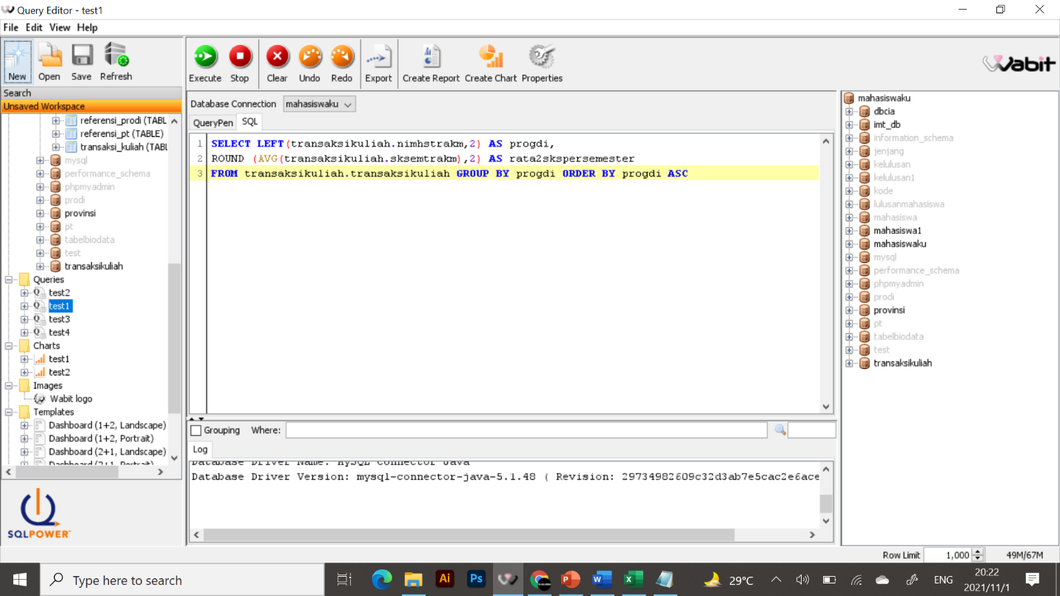

TEST 2

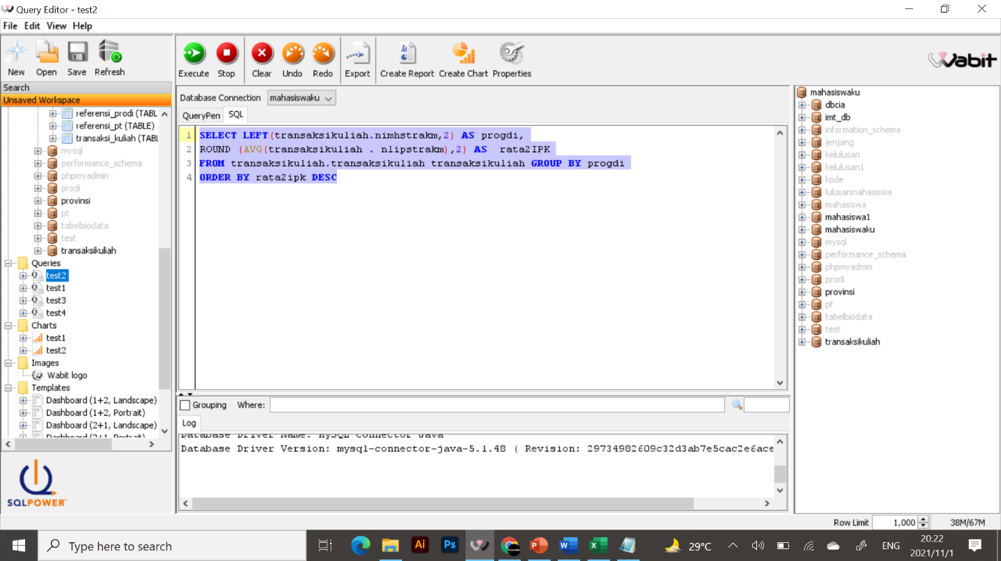

TEST 3

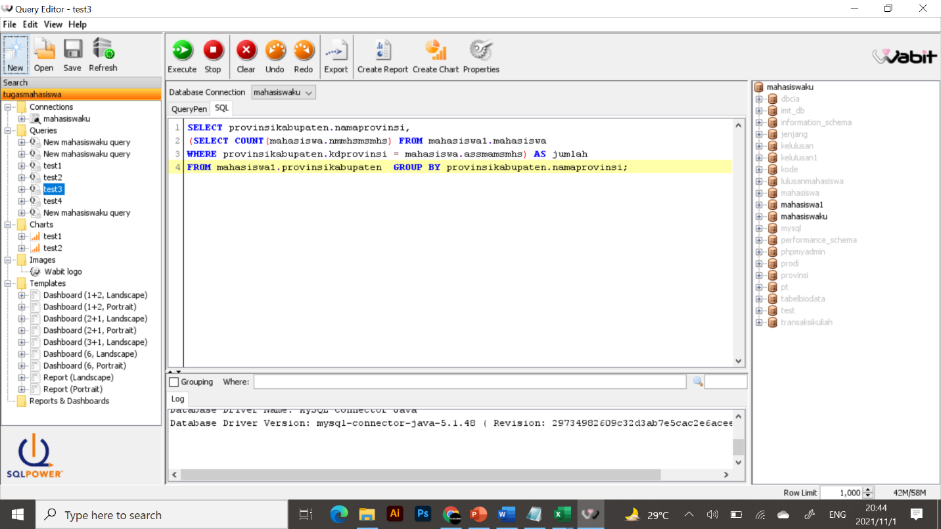

TEST 4

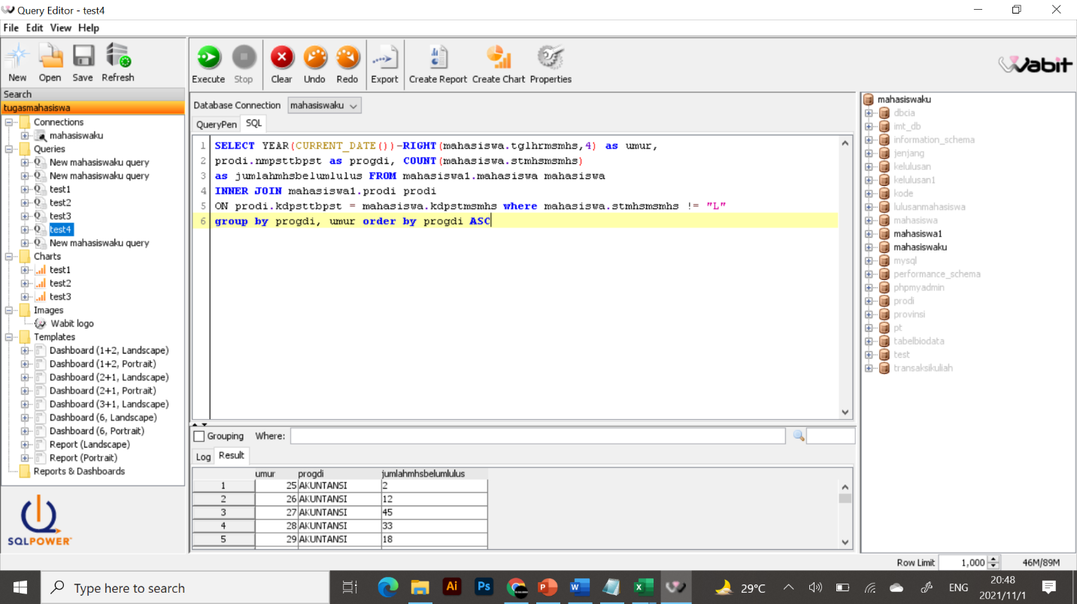

SCREEN SHOT CHART :

TEST 1

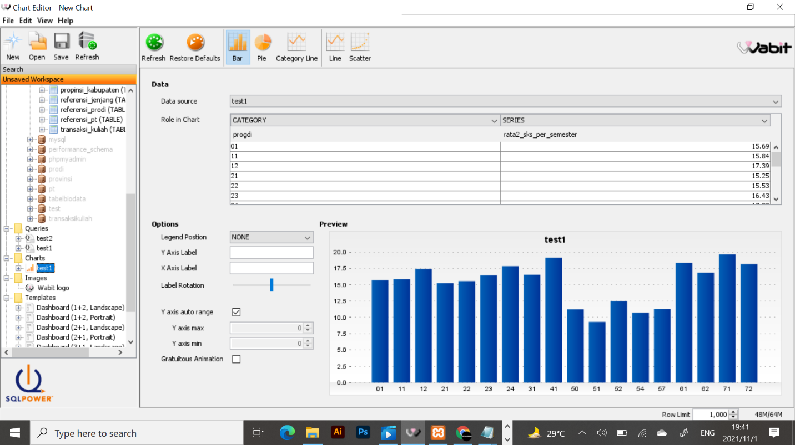

TEST 2

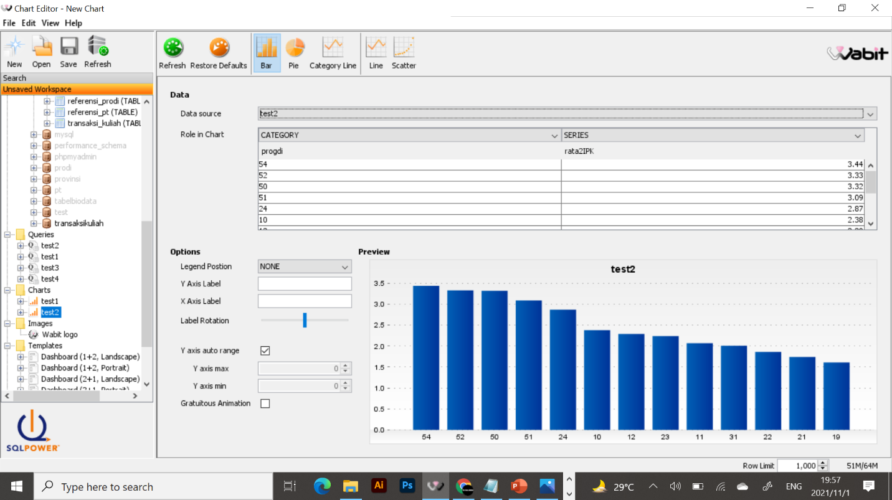

TEST 3

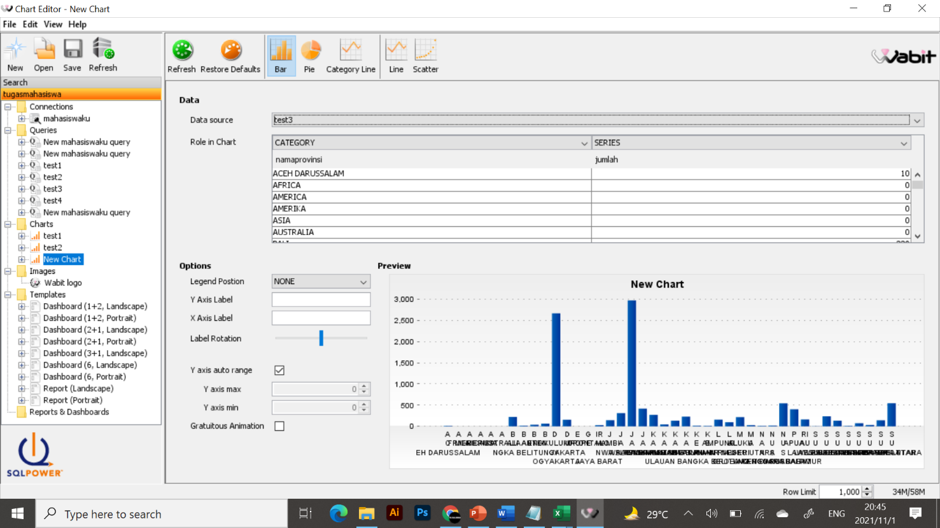

TEST 4

