**HOW PERCEPTIONS OF REUSING IDEAS IMPACT**

**CREATIVITY AMONG COVER MUSICIANS**

Intro to Text Analysis in Python: Final research project

Gabby Lamont-Dobbin

April 2023

**Introduction**

For my research project, I chose to focus on the second project I suggested in my original project proposal submission. I have been working on a research project for several years that examines how cover musicians who post music on social media think about the process of reusing other’s songs. Do they feel less original for relying on existing songs in their work rather than creating something from ‘scratch’? Do they feel that making covers is less respectable than making originals because covers are derivative?

For this research project, I originally interviewed 56 cover musicians who published content on YouTube. I asked them questions about reusing ideas and separated them into two groups, each with a specific perception of idea reuse. One group thought about reusing ideas as stealing and cheating – it was a way to get around the difficult work of generating a more original product. The other thought about reusing ideas as an opportunity to discover new music and thought of it as fundamental part of making music, especially for novices.

Ultimately, I hope to investigate how perceptions of reusing ideas can lead to more, or less creative outputs. While reusing ideas is widely accepted as a key part of creative work ([Simonton, 1999](https://www.jstor.org/stable/1449455)), there is little research about how people think about reusing ideas. This project aims to help fill this gap in this literature. I hypothesize:

1. Musicians who think of reusing songs primarily as stealing or cheating, tend to have less creative outputs.
2. Musicians who think of reusing songs primarily as fundamental to the process of making music tend to have more creative outputs.

In line with existing social psychology research on creativity (see [Amabile, 1982](https://psycnet.apa.org/record/1983-20083-001)), I tested the creativity of the musician outputs using expert evaluators. I had 7 experts, (i.e., professional musicians, PhDs in musicology) rate 20 cover songs on their creativity. We picked 10 songs from musicians in group 1 (perception of cheating/stealing), and 10 songs for musicians in group 2 (perception of fundamental to creative work).

As predicted, the experts rated songs by group 2 musicians as more creative. The chart below shows how experts rated songs by group 1(see red) and group 2(see blue) across 12 survey items used to rating creativity. The survey scale ranged from 1-7, with 1 as the lowest rating, and 7 as the highest. Confirming these results, I used an independent samples t-test, and found that cover musicians that I identified as having group 2 [perceptions (M= 5.56,  SD = 1.02) had significantly higher creativity ratings of their covers than those who I identified as having group 1 perceptions (M= 4.81, SD=1.30), p = 0.03. Likewise, covers by musicians with group 2 norms were significantly more likely to have higher aesthetic appeal (alpha = 0.70) ratings and demonstrated more craftsmanship/skill in their cover songs (alpha = 0.94). Chart, box and whisker chart

**Methods**

In our expert evaluator surveys, we also requested each of the 7 evaluators to write 300-600 word reviews about each cover song that they listened to, going over their initial thoughts about the covers, and justifying the rating of the cover.

Here is an example of one of these short reviews:

Living-room jam session style, which is fun—not intended to be overly creative or original. Two of the band members are obviously more committed than the other two (who are harmless), and the lead singer is really going for it. The feeling here is, "Hey, I love this song—let's jam on it and make a video for our friends and hopefully get some dates out of it, and maybe the best of us might attract some attention from an agent or a reality TV competition." The original form and melody, and harmony, is relatively close to the original, though it's got a kind of joyful spontaneity here that keeps the interest—a predictable format, but just enough high-quality unpredictability in the performance of the two guys on the left.

***We were left with 140 short reviews like this, 7 for each cover song that the experts listened to. This is my source of text data for my final project. My aim is to use the reviews to extract information about how expert evaluators perceived the creativity of cover songs created by musicians in groups 1 and 2.***

To do this, I used tf-idf with the Python library scikit-learn ([TfidfVectorizer](https://scikit-learn.org/stable/modules/generated/sklearn.feature_extraction.text.TfidfVectorizer.html" \t "_blank) from this library). I thought this would be the best tool to explore my data because I thought words that referenced creativity (i.e. surprising, novel, unique), might not be the most common, but I thought they were likely to be the most distinctively frequent and significant words.

I downloaded the reviews for each cover song from each evaluator in file from Qualtrics. I concatenated the reviews for each song from all evaluators into separate cells. I also included a column to distinguish group 1 from group 2 cover musicians (was the musician who created the cover song being evaluated a group 1 or group 2 musician?). In my code this column is called “orientation,” in reference to cover musician orientation toward reusing existing songs.

I read a .csv file with the review data into Jupyter Notebook. I then cleaned all the text data to prepare it for analysis (i.e. I removed stop words, stemmed all words, removed punctuation, made all words lower case). Then I ran TfidfVectorizer on all of the cleaned review text. And created a data frame with tf-idf scores for the terms in my text, and had a column that specified if the calculated tf-idf score and related term corresponded to reviews for a group 1 or group 2 musician.

This allowed me to compare the tf-idf scores and related terms for the reviews for group 1 and group 2 musicians. Please note, this data included duplicate terms for each set of reviews for each reviewed song. For the purposes of my project, I deemed this to not be a problem. It did not distort my results when I visualized the data.

**Results and Discussion**

To explore my data and examine differences in the reviews for group 1 vs. group 2 musicians, I generated several bar charts.

First, I made a bar chart which marked the cumulative tf-idf score for each term in the data, and demarcated the scores by musician orientation (Chart 1). This allowed me to visually compare which words came up in reviews for the two groups. The dark blue refers to terms from reviews about musicians in Group 1 (who perceived reusing ideas as stealing and/or cheating). The light blue refers to terms from reviews about musicians in Group 2 (who perceived reusing ideas as an opportunity and as fundamental to their work).

Chart 1(general):

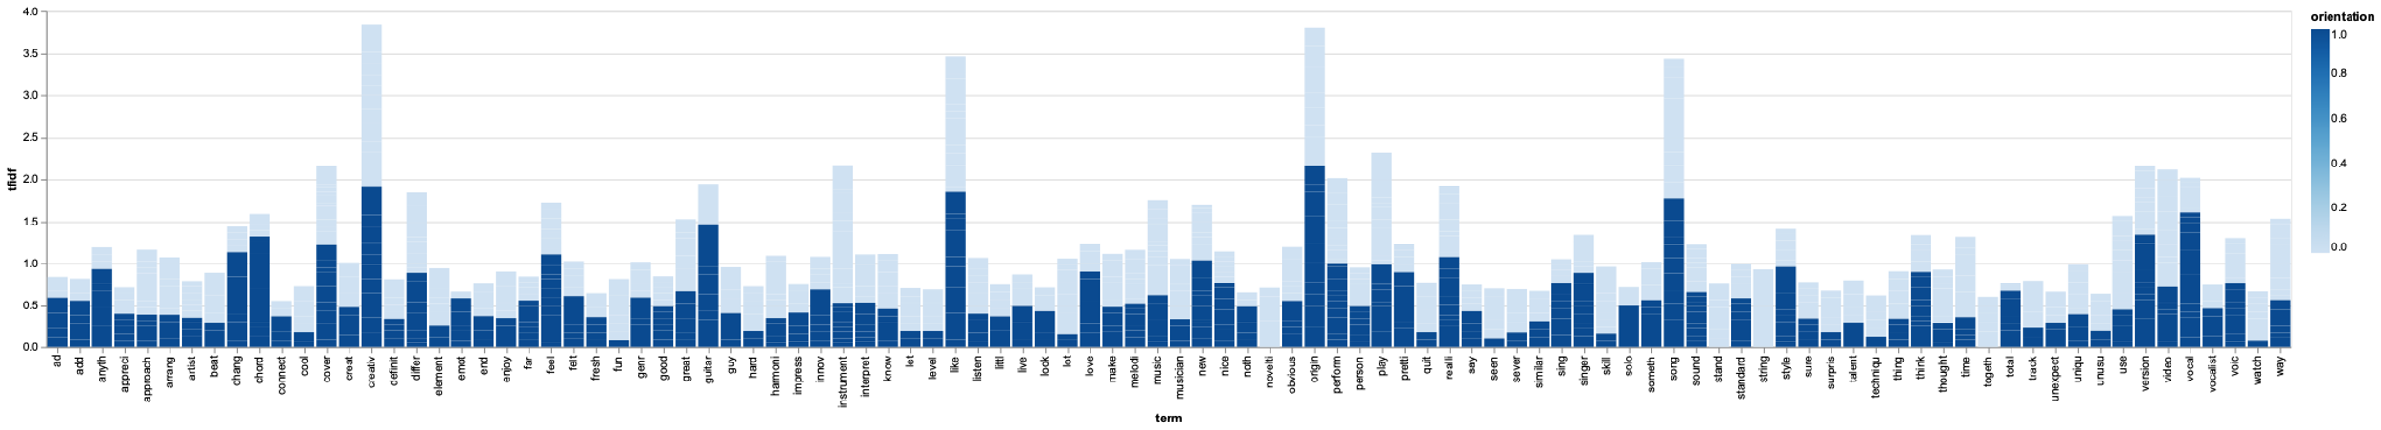

Then I looked at a bar chart with the tf-idf score for the top 50 (Chart 2), and the top 10 terms in my data (Chart 3), and also separated the data by musician “orientation.”

Chart 2:

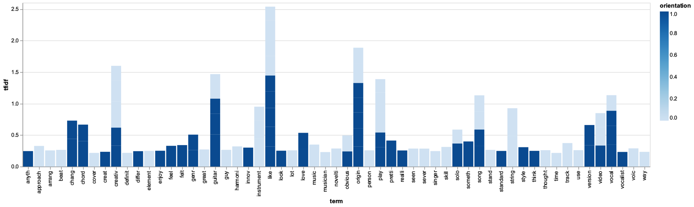

Chart 3:

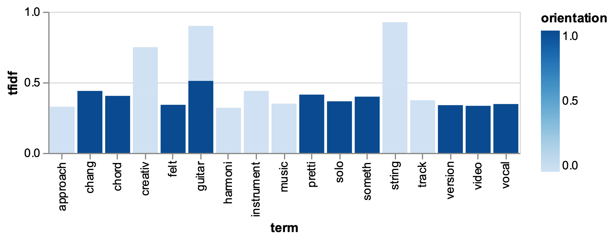

From Charts 2 and 3, I can observe that terms that had higher tf-idf scores for Group 1 include “chord”, “version”, “vocal” – term that are not as typically associated with creativity. In contrast, some of the terms that had higher tf-idf scores among Group 2 musicians include “uniqu-”, “skill”, “instrument”, and “supris-” – terms that are more often associated with creativity. I also made a bar chart which marked the cumulative tf-idf score for several terms in the data that were specifically related to creativity (Chart 4).

Chart 4:

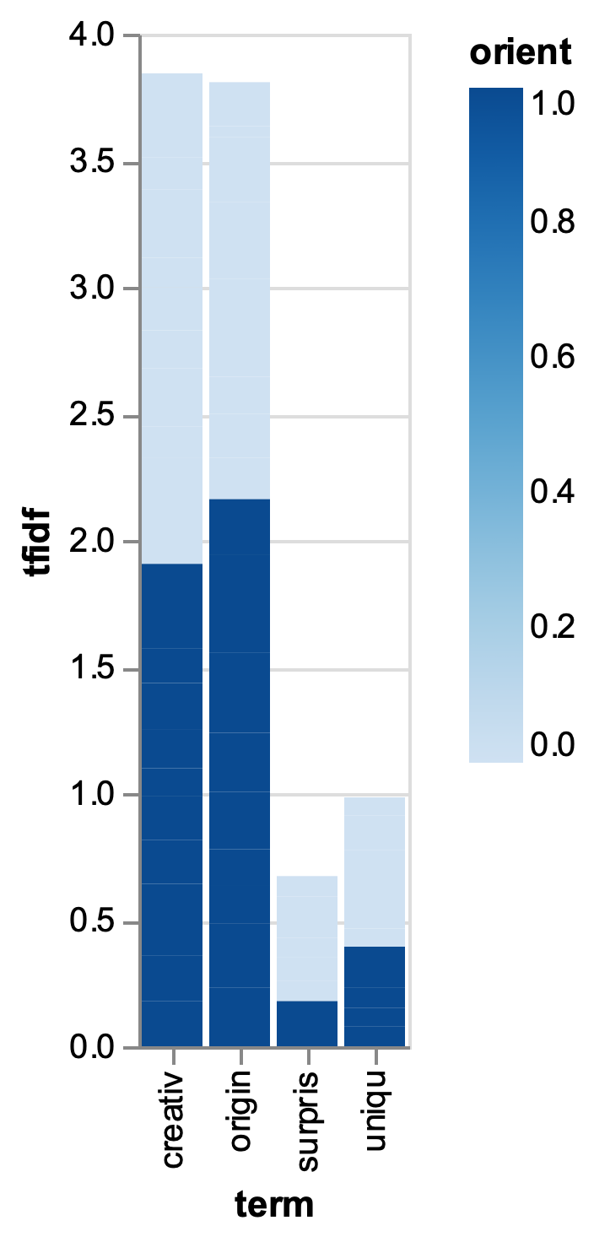

I found Chart 4 interesting because while it shows that some words related to creativity had higher tf-idf scores for both groups, other words (which I think of as more distinctive and significant – i.e. “uniqu-“) had higher td-idf scores for group 2. This makes sense to me, as tfi-idf focuses on finding significant rather than common words. Also see the code to create count bar charts in my code file. I do not examine these in this paper because I don’t think they add much additional substantive value.

In conclusion, I find that the tf-idf data can somewhat supplement and substantiate my empirical analysis of expert evaluator ratings of cover songs with musicians that have the two orientations we identified in my interviews. I suggested that reviews for cover songs by musicians that I identified as group 2 musicians, were more likely to have higher tf-idf scores for terms related to creativity, indicating that the reviewers associated the work of group 2 musicians with creativity more so than they did with the work of group 1 musicians.