**Abiotic tolerances of the foundational species *Eudistylia vancouveri***

by

Paige Amos, Genavieve Desjardin, and Gabrielle Languedoc

A report submitted in partial fulfillment of the requirements of

DIRECTED STUDIES AND APPLIED DATA ANALYSIS

at

Bamfield Marine Sciences Center

Instructors: Dan Wuitchik and Dr. Sara Wuitchik

Teaching Assistant: Jenna Fleet

©Paige Amos, 12/2021

Home University: University of Victoria

©Genavieve Desjardin, 12/2021

Home University: Simon Fraser University

©Gabrielle Languedoc, 12/2021

Home University: University of Victoria

**Abstract**

Climate change will have many consequences for marine ecosystems, including warming sea temperatures and increases in the frequency and intensity of storms. Foundational species provide habitat for many organisms and contribute to the stability of ecosystems. Thus, monitoring how they are impacted by climate change allows us to better predict changes in biodiversity. This study aims to address how tube growth rates of the foundational filter-feeding species *Eudistylia vancouveri* will be affected by temperature and salinity changes predicted with climate change. We hypothesized that *E. vancouveri* tube growth rates will be impacted by increases in temperature and decreases in salinity because these abiotic factors will require an increased allocation of resources towards survival. Our experiment consisted of five consecutive timesteps, each including a 12-hour acute stress period with a control (12°C, 35 ppt), a low salinity (12°C, 30ppt), or a high temperature (20°C, 35 ppt) treatment (N = 90) and a 36-hour recovery period. Tube growth was measured at the end of each 48-hour timestep. Data were analyzed using a GAMLSS model for total tube growth and a one-way repeated measures analysis of variance (ANOVA) for tube growth within each timestep. Total tube growth was 7% higher in our temperature treatment and 28% lower in our salinity treatment when compared to our control, though these differences were not statistically significant. Additionally, we found a 71% decrease in tube growth over the timesteps of our experiment that was statistically significant. This study contributes to the broader scientific knowledge of filter feeders’ tolerance to abiotic changes of increased temperature and decreased salinity. Here we demonstrate an excellent model system for understanding the robusticity of foundational species in the face of climate change.

**Keywords**

Northern feather duster worm, climate change, tube growth rate, salinity, temperature

**Introduction**

Rising sea temperatures and the increase in frequency and intensity of storms are substantial consequences of climate change for coastal marine communities (Harley et al*.*, 2006). As storm frequency increases, marine habitats experience acute events of decreased salinity caused by high volumes of freshwater runoff and increased levels of precipitation. Shifts in salinity can be devastating for intertidal invertebrate species that have narrow osmotic tolerance ranges (Beadle, 1931). Additionally, increasing sea temperatures due to climate change have considerable negative impacts on marine species distribution, life history events, and trophic interactions (Przeslawski et al*.*, 2008). Even in cases where a species can physiologically withstand drastic abiotic changes, the loss of neighbouring species within a community could lead to indirect consequences such as habitat loss or decreased prey abundance. As a result, foundational species are of particular interest to monitor in the context of climate change. Foundational species facilitate biodiversity and stability of the ecosystems by providing structure, mediating nutrient flow, or having a significant impact on the ecosystem by mere abundance of biomass (Ellison, 2019). For these reasons, the loss of foundational species has led to disproportionate declines in species abundance and biodiversity on a global scale. Notable examples include coral reefs, mangroves, and eelgrass beds that provide essential nursery habitats for other marine organisms (Angelini et al., 2011; Richardson et al., 2018). An additional group of interest to monitor in light of climate change are species that feed via filtration. These species provide ecosystem services by cycling nutrients and reducing toxin concentrations in the water column (Ostroumov, 2005). Important examples of this include bivalves whose filtration capacities range from tens to hundreds of litres per day, thereby substantially contributing to the stability of marine ecosystems (Ostroumov, 2005). As a result, it is critical to understand how foundational species, specifically those that are filter feeders, will be impacted by climate change and the possible ecological cascade effect this may have.

In the context of conservation, resources have historically been allocated to charismatic, rare, or endangered species rather than foundational groups (Gaston and Fuller, 2008; Gaston and Fuller, 2017). This management strategy can be problematic as many species targeted by conservation efforts rely upon foundational species indirectly or directly for ecosystem stability (Ellison, 2019). While certain foundational species may not be the most charismatic, their role in structuring ecosystems is essential. For example, the family *Sabellidae* contains worms that construct parchment tubes through filter-feeding and aid in the nutrient cycling of ecosystems. Despite their important ecological role, there is a significant gap in the literature examining how parchment tube worms and non-calcified invertebrate species are impacted by climate change (Prather et al., 2012).

The Northern feather duster worm (*Eudistylia vancouveri*; Kinberg, 1867) is an abundant foundational species found in low intertidal regions from Alaska to central California (Hiebert et al.,2016). This species is an accessible model system for understanding how the fitness of foundational filter-feeding organisms are impacted by climate change. Populations of *E.vancouveri* form non-calcareous tube networks called hummocks using secreted mucus and sediment obtained from filter-feeding (Hiebert et al., 2016). Hummocks provide a substrate to which algae and marine organisms can attach in soft, sandy, silty, or muddy sedimentary habitats where settlement is difficult (Bracken, 2018; Hiebert et al., 2016; Thomsen and McGlathery, 2005; Liversage, 2017). For example, a recent study examining the colonization of seaweeds in the genus *Ulva* found that in high disturbance boulder fields macroalgal presence was directly associated with tubeworm abundances (Liversage, 2017). This research suggests that tubeworm hummocks provide moist substrate, thereby reducing desiccation stress that restricts spore settlement (Liversage, 2017). While hummocks are important ecologically, tube growth can be used as a proxy for quantifying *E. vancouveri*’s fitness since the tube serves for protection and structural support that is essential to its survival (Vinn et al.,2018). Further, tubeworm species of the family *Sabellidae* can quickly regrow their tubes up to 30% faster after disturbances (Katzman andPaterson*,* 2018; Vinn et al., 2018). These characteristics of *E. vancouveri* provide a unique framework for quantifying the fitness of a foundational species under a relatively short time frame.

This study aims to address how tube growth rates of *E. vancouveri* will be affected by temperature and salinity. We hypothesize that *E. vancouveri* tube growth rates will be impacted by increases in temperature and decreases in salinity because these abiotic factors will require increased allocation of resources towards survival. We predict the temperature and salinity treatment will decrease tube growth rates, and consequently fitness.

**Materials and Methods**

Collection

*Eudistylia vancouveri* samples (N = 90) were collected from rope lines hanging off docks located in Bamfield, BC (48.8333 N, -125.1369 W) in November of 2021. To reduce stress, individuals were collected by cutting out segments of the rope line to which their tubes were attached rather than untangling the tubes from the lines. We attempted to collect bundles containing a minimum of ten individuals*,* however, multiple bundles were larger and included individuals of another tubeworm species, *Sabellastarte spectabilis*. These were interspersed with *E. vancouveri,* each bundle having approximately equal amounts of *S. spectabilis* wormsleft untouched to avoid the risk of damage during separation.

Bundles of *E. vancouveri* were placed into 18-gallon aquarium tanks at the Bamfield Marine Sciences Center (BMSC) research facility and suspended in their natural orientation with lines attached to metal rods that lay across the top of the treatment tanks (Fig. 1). The worms were left for 72 hours to acclimatize to lab conditions with constant seawater flow.

Experimental Setup

The experiment consisted of three treatment groups: control (12°C, 35 ppt), salinity (12°C, 30ppt), and temperature (20°C, 35 ppt). Each treatment had three replicates. The control temperature (12°C) and salinity (35 ppt) were measured from the ambient seawater of Bamfield inlet during November of 2021. Our high-temperature treatment (20°C) was based on the Intergovernmental Panel on Climate Change’s (IPCC) predicted rise of sea surface temperatures for Western North America by 2100 (IPCC, 2021). The low salinity of 30 ppt was determined from our pilot project that showed 50% mortality when reduced to 28 ppt using reverse osmosis water.

*E. vancouveri* were randomly assigned to one of the nine replicates so that each treatment had a total of at least ten marked study organisms. The three temperature treatment replicates were each fitted with individual heaters.

Our experiment consisted of five consecutive timesteps, each including a 12-hour acute treatment and a 36-hour recovery period. At the beginning of each acute treatment, the seawater flow was shut off for all aquariums to create a closed system. At this time, the salinity treatment replicates had their salinity lowered to 30 ppt using distilled water. The aquarium heaters in the temperature treatment replicates were turned on half an hour prior to the acute treatment to allow for time to reach 20°C. Seawater flow was turned back on at the end of the 12-hour acute treatment periods to restore temperature to 12°C and salinity to 35 ppt in all replicates for the 36-hour recovery period.

Growth Measurements

Growth measurements were modelled after Katzan and Paterson’s (2018) study on *E. vancouveri* tube growth rates. Following three days of acclimatization, the circumference of each tube of *E. vancouveri* was sewn with colourful thread, 20 mm from the tube’s anterior, of the tube to mark the initial tube length (Fig. 2). Tubes then were cut 15 mm down from the tube’s anterior end to simulate regenerative growth at an increased rate for our study period (Vinn et al.,2018). The exact amount of tube initially cut off was recorded and used as a fixed effect in our models. Tube length (from thread to the anterior end of the tube) was measured using callipers after the initial cut and then again at the end of each timestep for a total of 11 days. Tube growth (Gn) was calculated for each timestep by subtracting the previous tube length (Ln-1) from the current tube length (Ln) (Fig. 2).

Gn = Ln - Ln-1

Animal Care

Aquaria were cleaned of organic matter every other day. Air stones were added to all replicates to promote water movement and provide dissolved oxygen. At the beginning of each timestep, each replicate was fed 3 mL of brine shrimp to supplement food while the water was shut off.

Data Analysis

Statistical analyses were done through R studio software, version 2021.9.0.351 (RStudio Team, 2021). Data were tested for normality using a Shapiro-Wilk test (Shapiro and Wilk, 1965). The data for the total tube growth and the tube growth of each timestep varied from a normal distribution. The function “*fitDist ''* in the GAMLSS package (Stasinopoulos and Rigby, 2007) was then used to fit a distribution to the total growth data. Analysis was performed on the total growth data using a generalized additive model for location scale and shape (GAMLSS) with a skew power exponential type 2 (SEP2) distribution (i.e., growth ~ treatment + initial cut + mortality) (Stasinopoulos and Rigby, 2007; Salinas et al., 2007).The GAMLSS model incorporated the initial tube length cut-off (initial cut) as a fixed effect since cutting the tube was used to stimulate growth, and the amount cut varied between 1-3 mm. Additionally, mortality was added as a fixed effect in the model since deaths were observed. We conducted a one-way repeated measures analysis of variance (ANOVA) on tube growth with timestep as the explanatory variable (Chambers et al., 1992). Although the tube growth per timestep data did not meet the assumption of normality, these data are large enough to justify disregarding this assumption (n=30 per treatment, N=90) (Glass, 1972). We tested for extreme outliers in the timestep data with the function “*identify_outliers*” and found two extreme outliers (Kassambara, 2021). However, a one-way repeated measures ANOVA was conducted after the extreme outliers were removed and the results were not substantially affected thus, the ANOVA containing the extreme outliers were used. Finally, we conducted post-hoc tests on the timestep data, specifically, pairwise t-test comparisons between all the timesteps with p-values adjusted using Bonferroni multiple testing correction (Bonferroni, 1936).

**Results**

Total Tube Growth

Total tube growth for all treatments showed a trend of growth being highest in the temperature treatment with a mean tube growth of 6.7 mm (± 0.68 mm), followed by the control at 6.4 mm (± 0.59 mm), and the salinity treatment at 4.6 mm (± 0.35 mm) (Fig. 3; Table 1). Total tube growth in our temperature treatment was found to be 7% higher than our control, however this difference is not statistically significant (p = 0.69). Similarly, growth in our salinity treatment was 28% lower than our control, this difference was also not statistically significant (p = 0.22). Lastly, our GAMLSS model showed that the fixed effects mortality (p = 0.58) and initial tube length cut off (p= 0.78) did not have a significant effect on the total tube growth.

Tube Growth Over Timesteps

The rate of tube growth of all treatments decreased for each timestep over the course of the 11-day experiment. Timestep 1 had a mean growth of 2.0 mm (± 1.67 mm), timestep 2 at 1.09 mm (± 0.12 mm), timestep 3 at 0.86 mm (± 0.11 mm), timestep 4 at 0.79 mm (± 0.12 mm) and finally timestep 5 at 0.58 mm (± 0.079 mm) (Fig. 4; Table 2). There was a decrease in tube growth over the timesteps of our experiment shown by our one-way repeated measures ANOVA (F = 23.85, DF = 3.01, 268.12, p = 9.41e-14), this decrease was statistically significant. Further, tube growth rates decreased by 71% between the first and last timestep; this decline was also statistically significant (paired t-test, p-adj 1.54e-11). Additional pairwise t-test comparisons between timesteps showed significant decreases between timesteps 1-2 (p-adj = 2.08e-04), 1-3 (p-adj = 2.09e-06), 1-4 (p-adj = 1.26e-07), 2-5 (p-adj = 4.00e-03). Differences between all other timesteps found using pairwise t-test comparisons were not statistically significant: 2-3 (p-adj = 8.83e-01), 2-4 (p-adj =0.288), 3-4 (p-adj = 1.00), 3-5 (p-adj = 0.383), 4-5 (p-adj = 1.00).

Finally, we observed that tube growth rates decreased most substantially in the salinity treatment, followed by the control and finally the temperature treatment although no statistical analyses were performed on this trend (Fig. 5; Table 3).

Qualitative Observations

Spawning was observed in two of the salinity treatment replicates on the fifth day of our experiment in response to the 12-hour stress period. We observed two mortalities in two separate control replicates on the ninth and eleventh days of our experiment. Of these mortalities, one worm had visible gashes in its lower body while the other was missing the posterior end of its body. Both of these wounds were undetectable until the worms had left their tubes. In addition, we observed that the newest growth of each tube would appear as a thin fragile layer of parchment whereas the old growth was thicker. Finally, it was observed following each acute temperature treatment that the worm’s filtration appendages (radioles) were furrowed and deformed (Fig. 6). This effect would subside within a few hours of recovery.

**Discussion**

The objective of this study was to quantify the impact of decreased salinity and increased sea temperature on the foundational species *Eudistylia vancouveri*. Our study found a trend of increased total tube growth in the temperature treatment compared to our control. However, this result was not statistically significant and thus does not provide support for our hypothesis that *E. vancouveri* tube growth rates would be impacted by increases in temperature. Despite not being statistically significant, the pattern we observed is consistent with the research of Brockington and Clarke (2001), which highlights the relationship between an increase in seasonal sea temperatures and metabolism in marine invertebrates. Furthermore, Kristensen (1983) found that higher temperatures increased respiration in three other annelid species until 25°C, after which their metabolism declined. Since our temperature treatment was only 20°C, it was likely below the temperature threshold for *E. vancouveri*. Overall, we speculate that the observed increase in tube growth was likely driven by an increase in metabolism.

Additionally, our experiment found a 28% reduction in total tube growth in our salinity treatment compared to our control. This pattern was not statistically significant and, therefore, does not provide sufficient support for our hypothesis that tube growth rates would be impacted by decreased salinity. However, research studying the effects of osmotic stress on marine invertebrates does support the general patterns we observed. Specifically, Lange et al. (1972) found respiration decreased with reduced salinity in marine invertebrates. Further, the research of Rivera-Ingraham and Lignot (2017) shows that annelids of the polychaete class, such as *E. vancouveri,* are unable to regulate the osmotic conditions of their extracellular fluid and rely entirely on intracellular isosmotic regulation (Rivera-Ingraham and Lignot, 2017). As a result, responding to osmotic stress is an energetically costly process which limits resources that could be allocated to other areas such as development. We speculate that the decreased tube growth in our salinity treatments occurred because of the high energetic cost of intracellular isosmotic regulation. Overall, our results showed meaningful evidence that the fitness of *E. vancouveri* is negatively impacted by acute osmotic stress, and this observation is supported by the literature.

These results have broader implications in light of climate change as *E. vancouveri* is a foundational species whose presence in marine communities supports species abundance and biodiversity. From this study, we speculate that slight temperature increases may benefit *E. vancouveri* by increasing metabolic rates. Importantly, if the species that depend upon *E. vancouveri* for habitat can also withstand temperature increases, this could lead to maintained or even improved biodiversity. However, if sea surface temperatures increase as predicted (IPCC, 2021), they will likely surpass the thermal tolerances of *E. vancouveri,* decreasing metabolism and potentially leading to decreased population abundance. In contrast, we predict populations of *E. vancouveri* could be adversely affected by decreases in salinity caused by precipitation and stormwater runoff that will occur from climate change. This could consequently decrease the species abundance and biodiversity of organisms that rely on this foundational species for habitat. Additionally, increasing the duration of this experiment would allow us to observe the long-term effects of temperature and salinity on *E. vancouveri* and potential indirect effects on organisms within their marine community.

Another key finding of our study was the 71% decline in tube growth rates between the first and last timestep. This result was statistically significant and could be explained by the fact that the effect of cutting their tubes to stimulate growth had diminished. Alternatively, this pattern could be because, despite ample food, airflow, space and water, the stress from repeated acute closed system treatments decreased fitness. This result, in itself, was unpredicted and would be of interest to explore further in future studies. Lastly, we propose that tube growth may not be unidirectional as we suspect *E. vancouveri* builds a thin extension of its tube then allocates resources to increase its thickness. If this is the case, it would explain why we saw a decline in tube growth rates after eleven days. An extended study may be able to quantify these growth patterns further.

Interestingly, we observed that tube growth rates declined most substantially in our salinity treatment, followed by our control, and lastly our temperature treatment. The temperature treatment could have shown the smallest decline in tube growth because it was offset by increased metabolic rates (Kristensen, 1983). An important note, however, we noticed in our qualitative observations a temporary reduction in the surface area of the radioles after heat treatments (Fig. 6). Perhaps this morphological change highlights that the organisms were experiencing stress thus we saw a decline in growth. Contrastingly, the salinity treatment could have shown the most substantial decline in growth rate due to osmotic shock. We speculate that salinity stress causes organisms to allocate energy away from growth towards intracellular osmoregulation, and in extreme cases, reproduction (Rivera-Ingraham and Lignot, 2017). This interpretation would explain the stress spawning observed only in our salinity treatments. Further, the mortalities observed in our control suggest that two-thirds of our replicates may have experienced traumatic disturbances prior to our experiment. These fatal injuries could have lowered their fitness throughout the entire experiment, explaining the observed decline in tube growth rate in our control. However, these results are purely observational and would be of interest to explore further with statistical analysis.

Ecologically, declining growth rates are considerable as they may reduce the surface area for other organisms to settle on, perhaps leading to a decline in biodiversity and biomass. Additionally, the materials used to build tubes are acquired as byproducts of filter-feeding, therefore, reduced tube growth rates could imply a decrease in filtration. This is of interest because filter feeders contribute to maintaining the stability of marine ecosystems by regulating nutrient flow in the water column (Ostroumov, 2005). Importantly, filter feeders play an integral role in altering toxicant outcomes by acting as biofilters (Burge et al., 2016). This is relevant as *E. vancouveri* often colonises areas of high anthropocentric disturbance and pollution such as docks and wharves (Hiebert et al., 2016), which may have high toxin concentrations. Hence, declines in the filtration capacity of this species could be of concern to the overall integrity and health of those marine communities.

Limitations

Our study had limitations introduced due to the logistics of implementing abiotic conditions within a lab setting. Firstly, potential pseudoreplication may have affected our results despite our relatively large sample size of 90 individuals. Due to equipment availability, we had three replicates of each treatment separated by baffles in a single aquarium. Midway through the experiment, we noticed a leak in the baffle between two replicates of the salinity treatment meaning they were not fully isolated during the acute treatments. Further, because of this design, seawater would flow between replicates within each treatment tank during the recovery periods. Another limitation occurred after the third timestep, as we did not have access to distilled water needed for the salinity treatment. This forced the acute treatment back a day, ergo individuals had an extra day of recovery between timesteps. We measured the samples before the fourth timestep to standardize the time period of each timestep, but despite this, the growth on that extra day added towards the total growth. Moreover, due to unforeseen circumstances, the third acute temperature treatment reached only 16°C as there was a valve leakage that allowed small amounts of seawater to continuously flow.

Our collections methods resulted in a limitation in standardizing the size of all *E. vancouveri*. The bundles collected had individuals that varied in size and age, likely leading to differences in intrinsic rates of tube growth amongst the worms. Because of this, we were unable to account for the random variation across individuals in our models due to a lack of convergence. Overall, we did attempt to minimize the obstacles faced during our experiment however, these limitations are worth acknowledging and are aspects that should be mitigated in future research.

Future Research

To further understand the effects of climate change on the foundational species *E. vancouveri*, future studies should examine their entire life history, the additive effects of temperature and salinity, and the mechanism of tube growth. It is critical to consider all life stages of a species in the context of climate change as different morphologies can be more sensitive to environmental changes, disproportionately impacting the organism's overall fitness (Kindsvater et al., 2016; Marshall and Morgan, 2011). As life stages are linked, stress on the larval phase in our organism could have latent effects on the adult's fitness (Marshall and Morgan, 2011). Further, parental exposure to abiotic conditions can alter larval phenotypes, thus impacting the overall performance of the individual (Marshall and Morgan, 2011). Expanding our study to show transgenerational effects of temperature and salinity could provide insight into the adaptive ability of *E. vancouveri* and inform efficient conservation efforts to protect this foundational species.

Climate change will create a multitude of abiotic changes in the future. One factor may have a greater effect on a species than others, nonetheless, it is crucial to examine not only one abiotic factor but also the additive effects of multiple. These factors include decreases in ocean pH and salinity, and temperature increases (IPCC, 2021). In a study examining the development of sea urchin larvae, Brennand et al. (2010) observed that the additive effect of high temperatures and low pH resulted in abnormal larvae. Independently, these factors caused minimal deformities but it was only when the additive effects were investigated that the fatal impacts of their interaction were seen.

Including combinatorial treatments would aid in thoroughly understanding the tolerances of *E. vancouveri* and could be more relevant to future climate predictions.

As mentioned previously, we suspect growth patterns may not be strictly linear, for this reason, future research should use alternative methods for quantifying fitness. For example, the number of radioles could be used as a proxy of fitness since the number of radioles increases with the growth of *E. vancouveri* (Giangrande, 1991). Another approach to quantify fitness is by using radioles to measure respiration rates of *E. vancouveri* since 75% of their respiration occurs through their radiolar crown (Giangrande, 1991). In summary, creating a standardized measurement for growth in *E. vancouveri* would better allow us to use this as a model system for studying foundational species.

Conclusion

This experiment found that tube growth of the foundational species *Eudistylia vancouveri* increases in higher sea temperatures while it substantially decreases with lowered salinity. Underlying mechanisms driving these results may be improved metabolism with slight temperature increases and osmotic stress-causing reallocation of energy from growth towards survival. These results are considerable in light of climate change given *E. vancouveri’s* role as a filter-feeding, foundational species whose presence in marine communities determines species abundance, distribution and biodiversity. This study also provides a unique framework for studying underrepresented, non-calcified, marine foundational species in the context of climate change. As the effects of climate change will become long-standing norms rather than isolated episodes, understanding abiotic tolerances, particularly of foundational species, will become increasingly important.

**Acknowledgements**

We would like to humbly show our appreciation for the opportunity to learn about the territories we reside on this fall and the people who steward the lands. This project was conducted on the traditional territory of the Huu-ay-aht First Nations, a Nuu-chah-nulth Nation and signatory to the Maa-nulth First Nations Final Agreement. We would like to sincerely thank our supervisors Dan, Sara and Jenna for their incredible support and mentorship. Additionally, thank you to our peers who helped us in editing; Caitlin, Beth, Meridith, Joan, Lucy and Hannah. Finally, a huge thank you to Andrew who helped lift 55-gallon aquaria up three flights of stairs, and Lyubava and Caitlin that aided in worm collection and tunicate removal.

**References**

Angelini, C., Altieri, A.H., Silliman, B.R., Bertness, M.D., 2011. Interactions among foundation species and their consequences for community organization, biodiversity, and conservation. Biosci. J. 61 (10), 782–789. <https://doi.org/10.1525/bio.2011.61.10.8>

Beadle, L.C., 1931. The effect of salinity changes on the water content and respiration of marine invertebrates. J. Exp. Biol. 8 (3), 211–227. <https://doi.org/10.1242/jeb.8.3.211>

Bonferroni, C.E., 1936. Teoria statistica delle classi e calcolo delle probabilita. Pubblicazioni del R Istituto Superiore di Scienze Economiche e Commerciali di Firenze 8, 3-62

Bracken, M.E.S., 2018. When one foundation species supports another: Tubeworms facilitate an extensive kelp bed in a soft-sediment habitat. Ecosphere. 9(9), <https://doi.org/10.1002/ecs2.2429>

Brennand, H.S., Soars, N., Dworjanyn, S.A., Davis, A.R., Byrne, M., 2010. Impact of ocean warming and ocean acidification on larval development and calcification in the sea urchin *Tripneustes gratilla.* Plos One. 5 (6), [10.1371/journal.pone.0011372](https://doi.org/10.1371/journal.pone.0011372)

Brockington, S., Clarke, A., 2001. The relative influence of temperature and food on the metabolism of a marine invertebrate. J. Exp. Mar. Biol.and Ecol. 258 (1), 87–99. <https://doi.org/10.1016/s0022-0981(00)00347-6>

Burge, C.A., Closek, C.J., Friedman, C.S., Groner, M.L., Jenkins, C.M., Shore-Maggio, A., Welsh, J.E., 2016. The use of filter-feeders to manage disease in a changing world. Integr. Comp. Biol. 56 (4), 573–587. <https://doi.org/10.1093/icb/icw048>

Chambers, J. M., Freeny, A ., Heiberger, R. M., 1992. Analysis of variance; designed experiments. In: Chambers, J.M., Hastie, T.J., (Ed.1), Statistical Models in S, Routledge, Boca Raton, pp. 49-53

Ellison, A.M., 2019. Foundation species, non-trophic interactions, and the value of being common. IScience. 13, 254–268. <https://doi.org/10.1016/j.isci.2019.02.020>

Gaston, K., Fuller, R., 2008. Commonness, population depletion and conservation biology. Trends Ecol. Evo. 23 (1), 14-19. <https://doi.org/10.1016/j.tree.2007.11.001>

Gaston, K.J., Fuller, R.A., 2017. Biodiversity and extinction: Losing the common and the widespread. Prog. Phys. Geogr.: Earth Environ. 31 (2), 213-225. doi:[10.1177/0309133307076488](https://doi.org/10.1177/0309133307076488)

Giangrande, A., 1991. Behaviour, irrigation and respiration in *Eudistylia vancouveri* (*Polychaeta: Sabellidae*). J. Mar. Biol. Ass. U.K.. 71, 27-35. doi:10.1017/S002531540003736X

Glass, G.V., Peckham, P.D., Sanders, J.R., 1972. Consequences of failure to meet assumptions underlying fixed effects analyses of variance and covariance. Rev. Educ. Res.42, 237-288. <https://doi.org/10.3102/00346543042003237>

Harley, C.D.G., Randall Hughes, A., Hultgren, K.M., Miner, B.G., Sorte, C.J.B., Thornber, C.S., Rodriguez, L.F., Tomanek, L., Williams, S.L., 2006. The impacts of climate change in coastal marine systems. Ecol. Lett. 9 (2), 228–241. <https://doi.org/10.1111/j.1461-0248.2005.00871.x>

Hiebert, T., Butler, B., Shanks, A., 2016. Oregon Estuarine Invertebrates: Rudy’s Illustrated Guide to Common Species 3rd ed. Oregon Institute of Marine Biology.

IPCC, 2021: Climate Change 2021: The Physical Science Basis. Contribution of Working Group I to the Sixth Assessment Report of the Intergovernmental Panel on Climate Change [Masson-Delmotte, V., P. Zhai, A. Pirani, S.L. Connors, C. Péan, S. Berger, N. Caud, Y. Chen, L. Goldfarb, M.I. Gomis, M. Huang, K. Leitzell, E. Lonnoy, J.B.R. Matthews, T.K. Maycock, T. Waterfield, O. Yelekçi, R. Yu, and B. Zhou (eds.)]. Cambridge University Press. In Press.

Kassambara, A., 2021. Pipe-Friendly Framework for Basic Statistical Tests. Electronic document: https://rpkgs.datanovia.com/rstatix/. Accessed 2021-12-04

Katzman, D., Paterson E., 2018. Tube building rate in *Eudistylia vancouveri* Kinberg, 1867 after simulated predation and environmental damage. Tao Eastham, Directed Studies, Bamfield Marine Science Center, Bamfield BC. (Unpublished student report on file at the BMSC Library)

Kindsvater, H.K., Mangel, M., Reynolds, J.D., Dulvy, N.K., 2016. Ten principles from evolutionary ecology essential for effective marine conservation. Ecol. Evol. 6 (7), 2125–2138. <https://doi.org/10.1002/ece3.2012>

Kristensen, E., 1983. Ventilation and oxygen uptake by three species of Nereis (Annelida: Polychaeta). II. Effects of temperature and salinity changes. Mar. Ecol. Prog. Ser. 12, 299–306. <https://doi.org/10.3354/meps012299>

Lange, R., Staaland, H., Mostad, A., 1972. The effect of salinity and temperature on solubility of oxygen and respiratory rate in oxygen-dependent marine invertebrates. J. Exp. Mar. Biol. Ecol. 9 (3), 217-229. <https://doi.org/10.1016/0022-0981(72)90034-2>.

Liversage, K., 2017. First evidence of biogenic habitat from tubeworms providing a near-absolute habitat requirement for high-intertidal *Ulva* macroalgae. Plos One. 12 (5), <https://doi.org/10.1371/journal.pone.0176952>

Marshall, D.J., Morgan, S.G., 2011. Ecological and evolutionary consequences of linked life-history stages in the sea. Curr. Biol. 21 (18), <https://doi.org/10.1016/j.cub.2011.08.022>

Ostroumov, S.A., 2005. Some aspects of water filtering activity of filter-feeders. Hydrobiologia. 542 (1), 275–286. <https://doi.org/10.1007/s10750-004-1875-1>

Prather, C.M., Pelini, S.L., Laws, A., Rivest, E., Woltz, M., Bloch, C.P., del Toro, I., Ho, C.K., Kominoski, J., Newbold, T.A.S., Parsons, S., Joern, A., 2012. Invertebrates, ecosystem services and climate change. Biol. Rev. 88(2), 327–348. <https://doi.org/10.1111/brv.12002>

Przeslawski, R., Ahyong, S., Byrne, M., Worheide, G., Hutchings, P., 2008. Beyond corals and fish: The effects of climate change on noncoral benthic invertebrates of tropical reefs. Global Change Biol. 14 (12), 2773–2795. <https://doi.org/10.1111/j.1365-2486.2008.01693.x>

Richardson, J.P., Lefcheck, J.S., Orth, R.J., 2018. Warming temperatures alter the relative abundance and distribution of two co-occurring foundational seagrasses in Chesapeake Bay, USA. Mar. Ecol. Prog. Ser. 599, 65-74. <https://doi.org/10.3354/meps12620>

Rivera-Ingraham, G.A., Lignot, J., 2017. Osmoregulation, bioenergetics and oxidative stress in coastal marine invertebrates: Raising the questions for future research. J. Exp. Biol. 220 (10), 1749–1760. <https://doi.org/10.1242/jeb.135624>

Salinas, H.S., Arellano-Valle, R.B., Gómez, H.W., 2007. The extended skew-exponential power distribution and its derivation. Commun. Stat. - Theory Methods. 36(9), 1673–1689. <https://doi.org/10.1080/03610920601126118>

Stasinopoulos, D.M., Rigby, R.A., 2007. Generalized additive models for location scale and shape (GAMLSS) in R. J. Stat. Softw. 23(7), https://doi.org/10.18637/jss.v023.i07

Shapiro, S.S., Wilk, M.B., 1965. An analysis of variance test for normality (Complete samples). Biometrika. 52 (3), 591. <https://doi.org/10.2307/2333709>

Thomsen, M., McGlathery, K., 2005. Facilitation of macroalgae by the sedimentary tube forming polychaete *Diopatra cuprea*. Estuarine Coastal Shelf Sci. 62 (1–2), 63–73. <https://doi.org/10.1016/j.ecss.2004.08.007>

Vinn, O., Zatoń, M., Tovar-Hernández, M.A., 2018. Tube microstructure and formation in some feather duster worms (*Polychaeta, Sabellidae*). Mar. Biol. 165 (6), <https://doi.org/10.1007/s00227-018-3357-4>

**Figures and Tables**

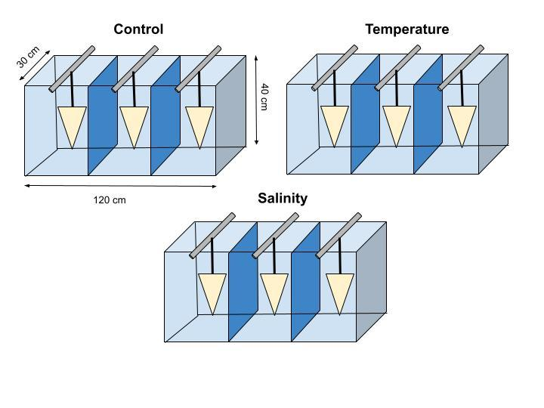

**Fig. 1.** Diagram of the experimental setup including aquaria labelled with their dimensions and treatments. All aquariums contain three replicates which are approximately 18 gallons. Triangles represent the samples of *E. vancouveri* (n = 10) suspended on a line tied to a crossbar. All three replicates in the temperature treatment aquarium contain heaters. During the acute stress periods, the control treatment was kept at 12°C and 35 ppt, the salinity treatment was kept at 12°C and 30ppt, and the temperature treatment was kept at 20°C and 35 ppt. The control temperature (12°C) and salinity (35 ppt) were measured from the ambient seawater of Bamfield inlet during November 2021.

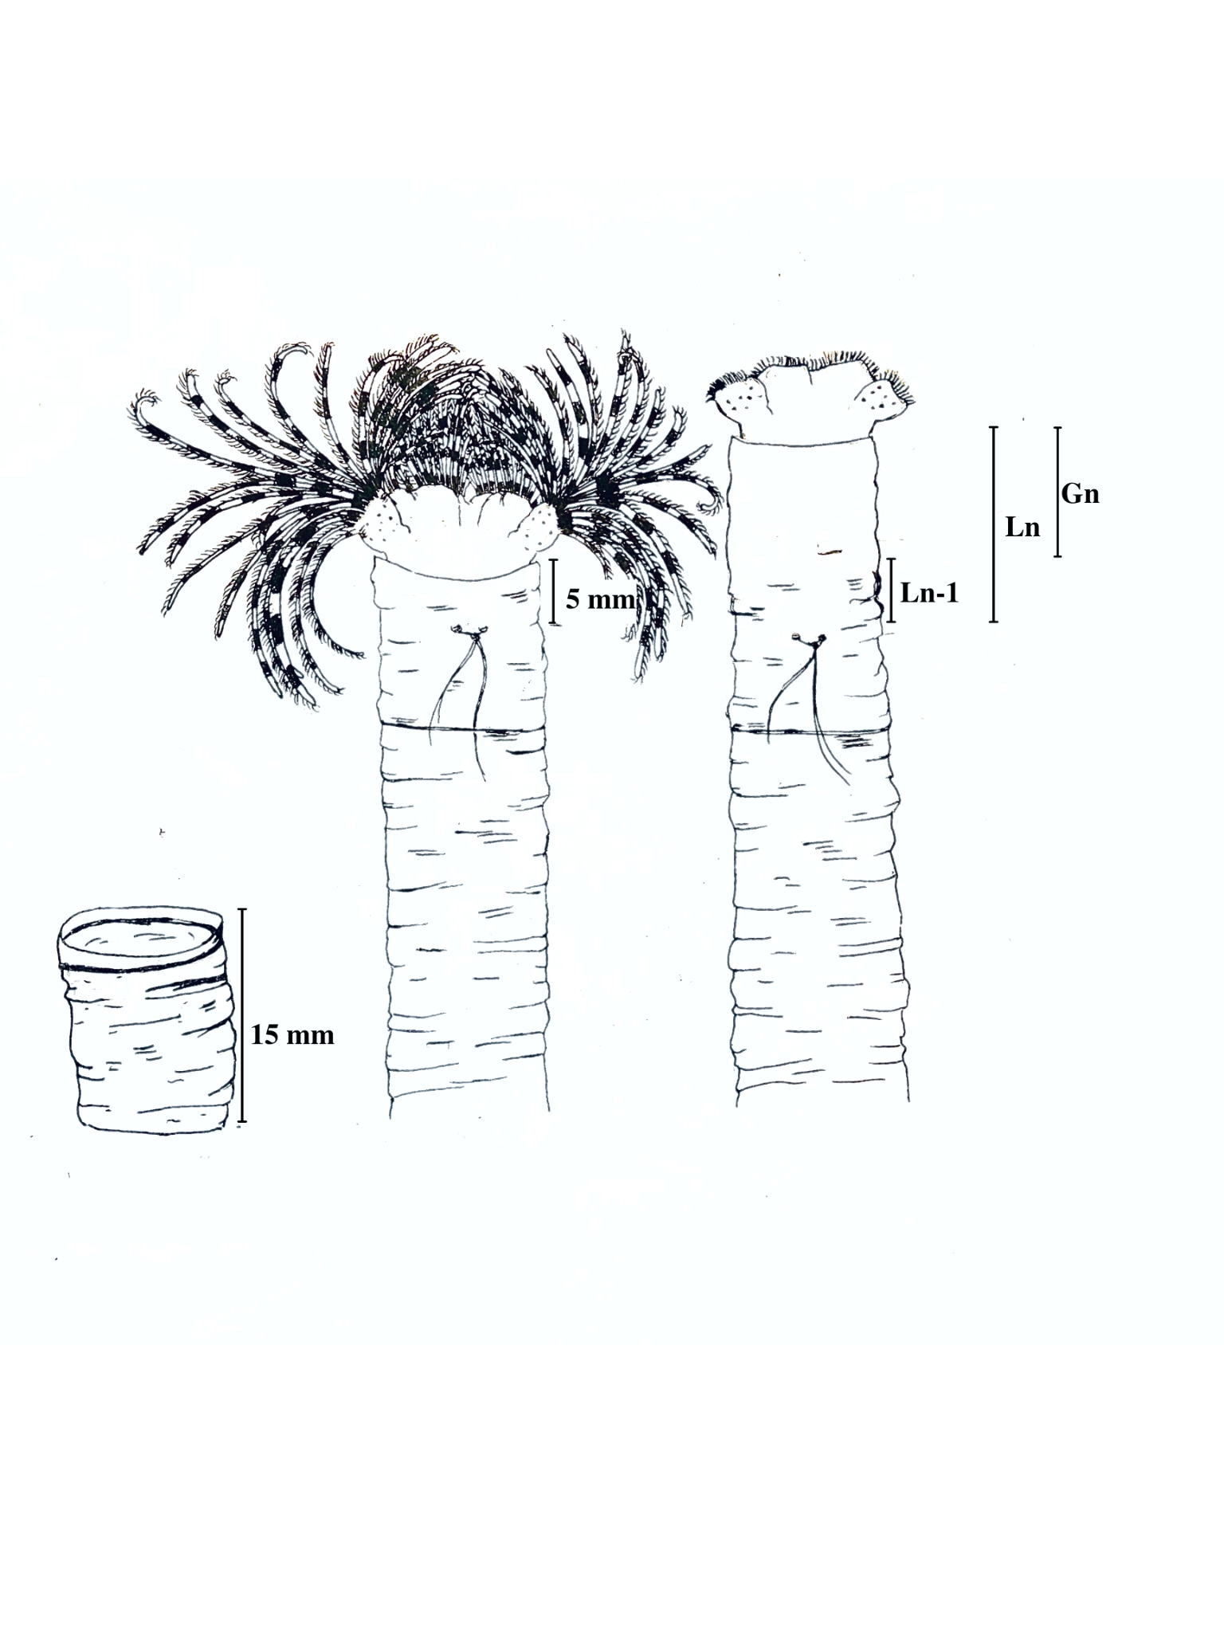

**Fig. 2.** Diagram of *E. vancouveri* tube measurements including; excess cut off (15 mm), the initial measurement from string to anterior and growth. The length from the string to the anterior end of the tube was measured every 48 hours during the experiment. Tube growth (Gn) was calculated for each timestep by subtracting the previous tube length (Ln-1) from the current tube length (Ln): (Gn = Ln - Ln-1)

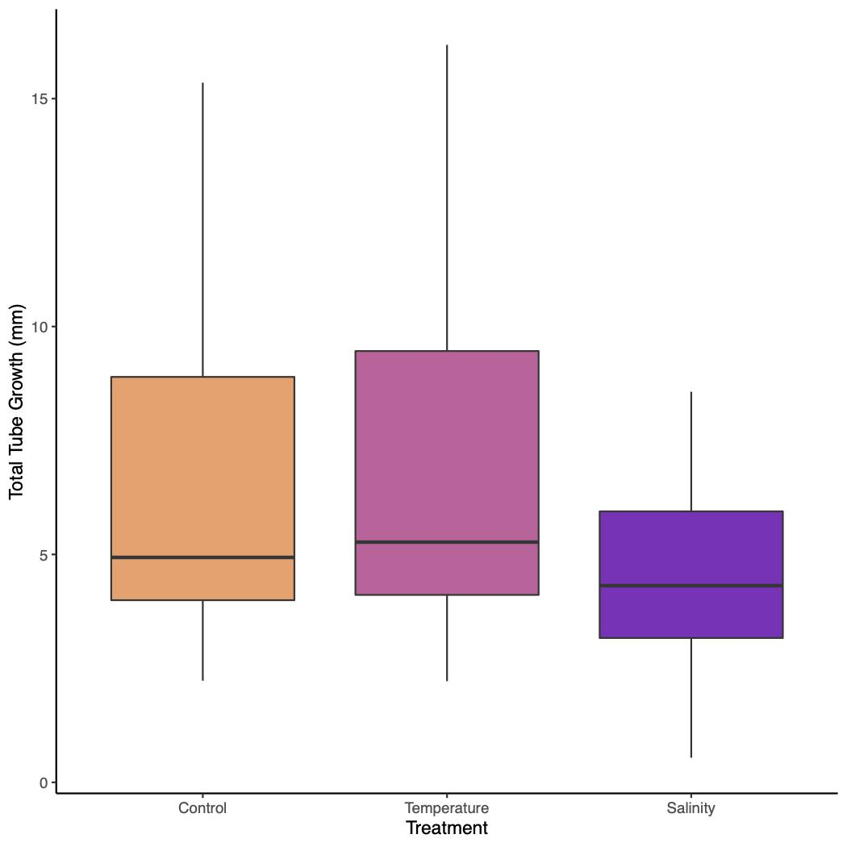

**Fig. 3.** Tube growth of *E. vancouveri* after eleven days of acute exposures: Control (12°C, 35 ppt), Temperature (20°C, 35 ppt), and Salinity (12°C, 30ppt). The control temperature (12°C) and salinity (35 ppt) were measured from the ambient seawater of Bamfield inlet during November 2021.

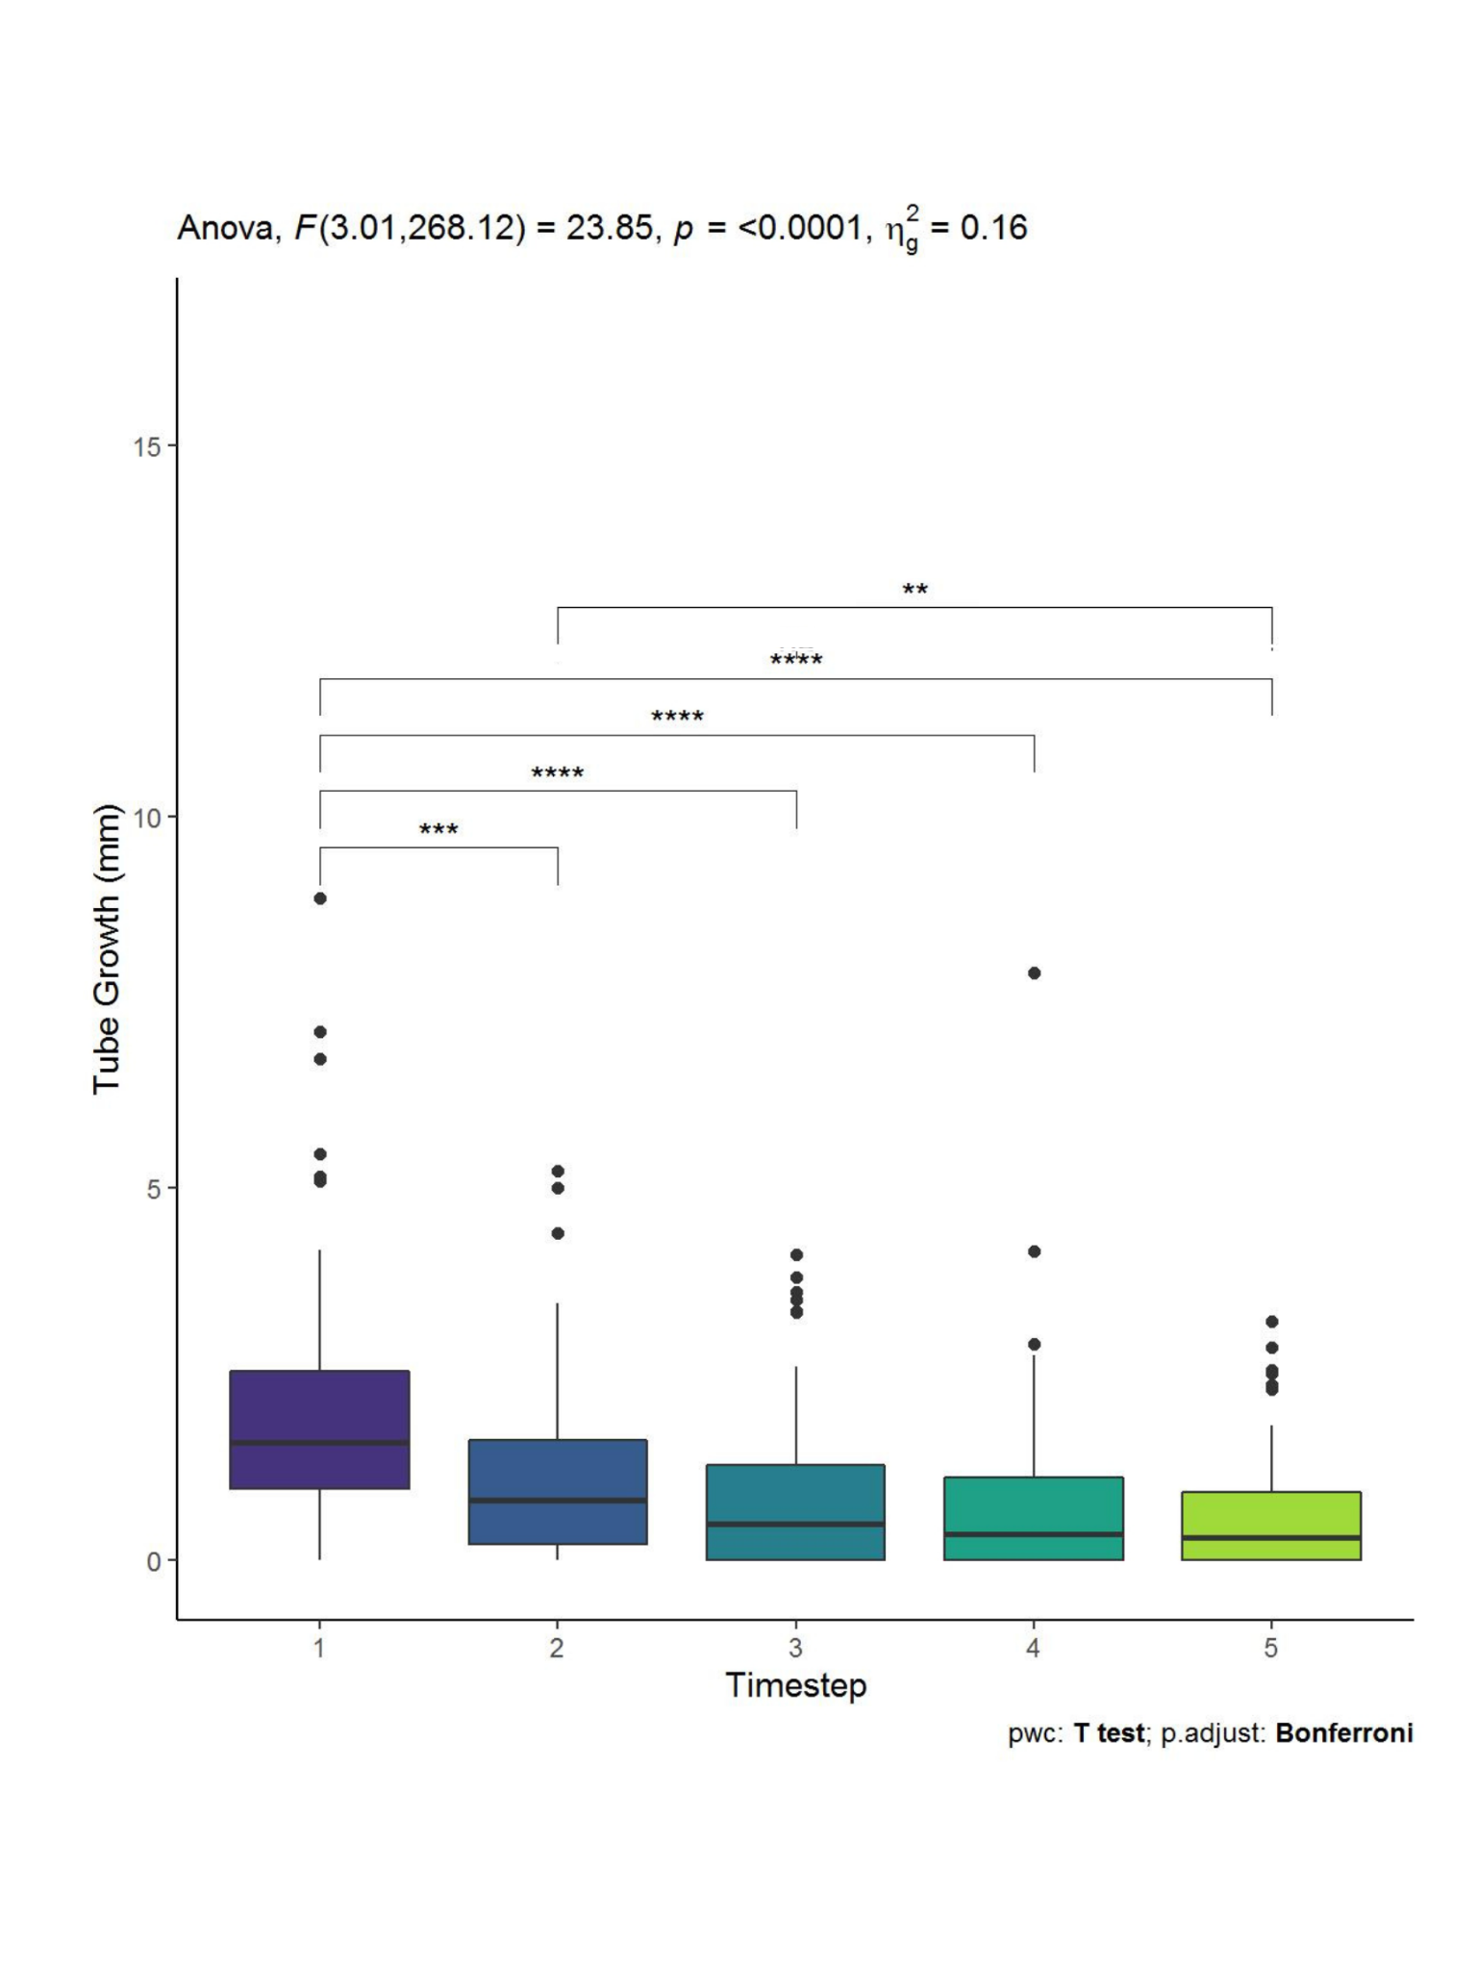

**Fig. 4*.***Tube growth (mm) in all *E.vancouveri* samples across five timesteps. Each timestep includes 12-hours of acute stress and a 36-hour recovery perid. Tube growth (mm) was measured at the end of each 48-hour timestep. The control temperature (12°C) and salinity (35 ppt) were measured from the ambient seawater of Bamfield inlet during November 2021. Pairwise t-test comparisons show significance denoted as: (**) P0.01, (***) P < 0.001, (****)P < 0.0001.

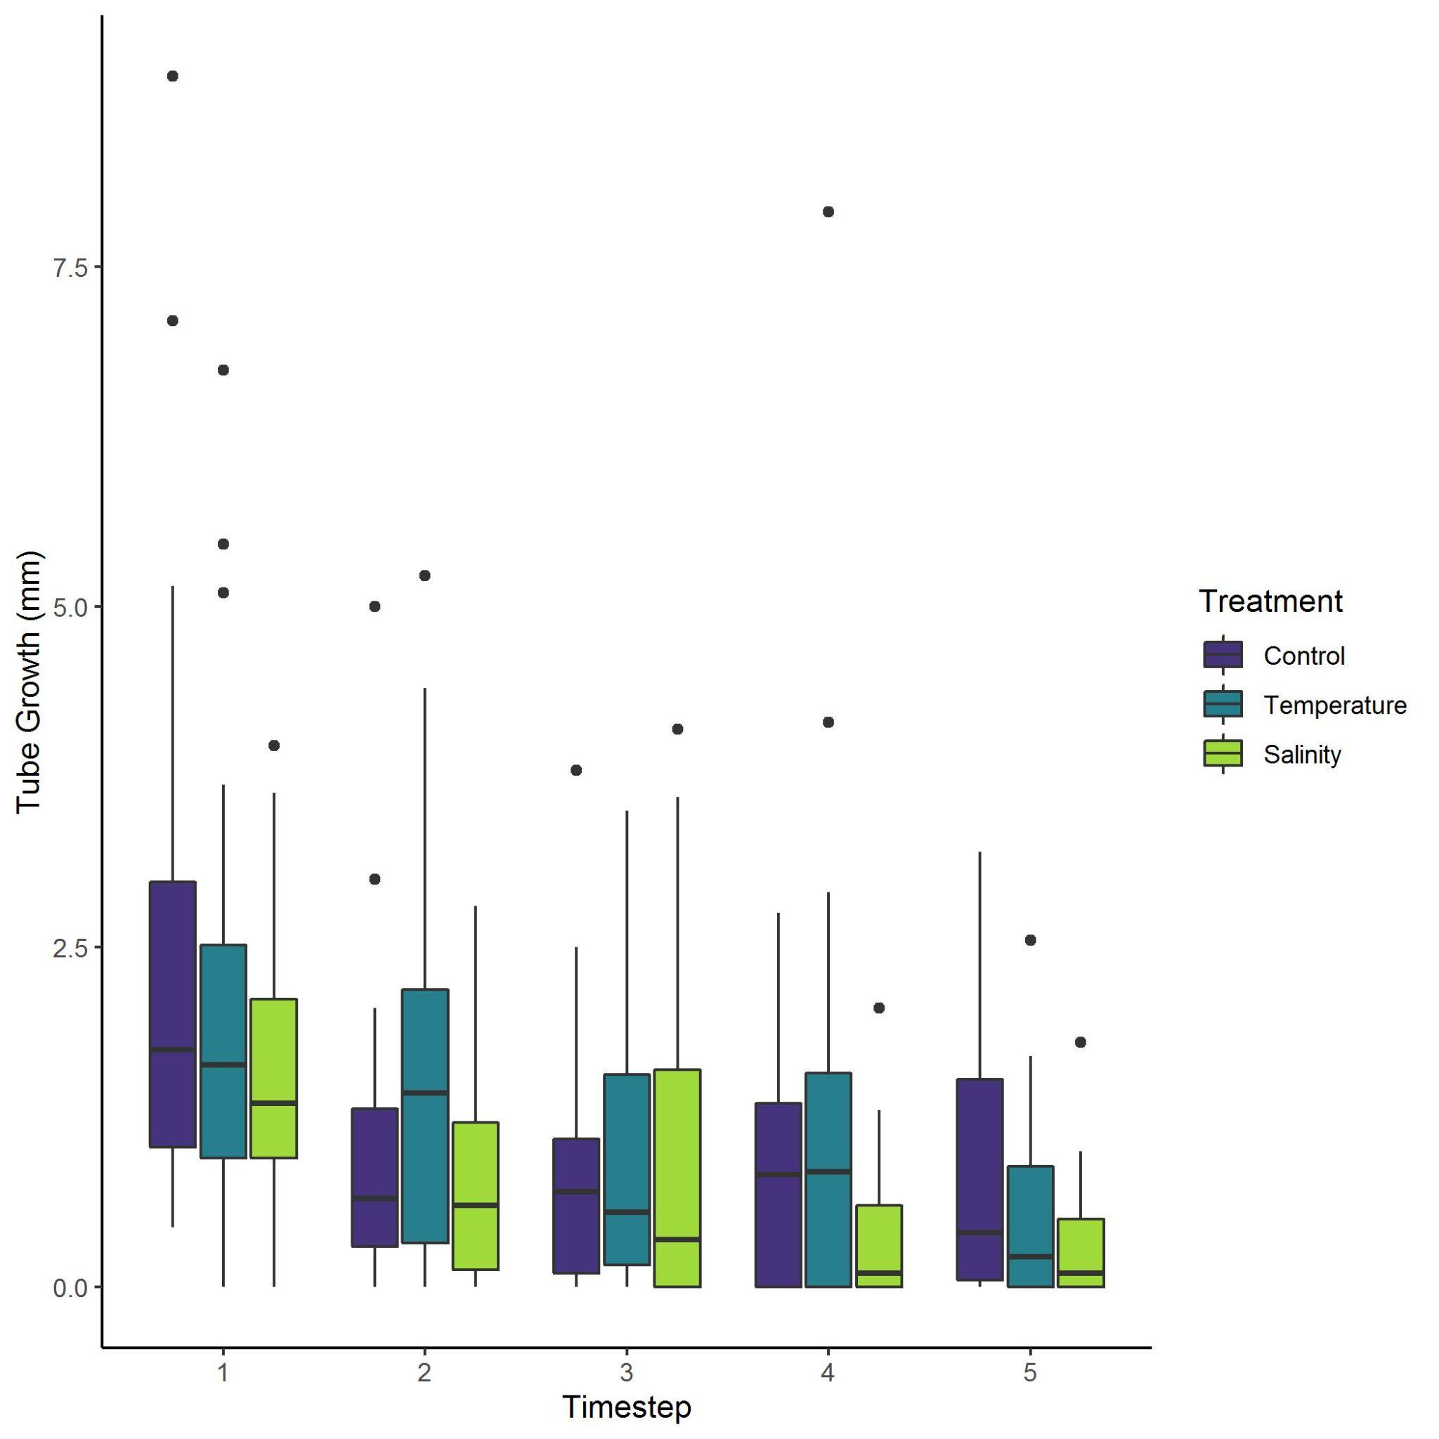

**Fig. 5.** The mean tube growth of *E. vancouveri* in each timestep. Timesteps included 12-hours of acute stress period for treatments of; control (12°C, 35 ppt), temperature (20°C, 35 ppt) or salinity (12°C, 30ppt) and a 36-hour recovery period. The control temperature (12°C) and salinity (35 ppt) were measured from the ambient seawater of Bamfield inlet during November 2021.Tube growth (mm) was measured at the end of each 48-hour timestep.

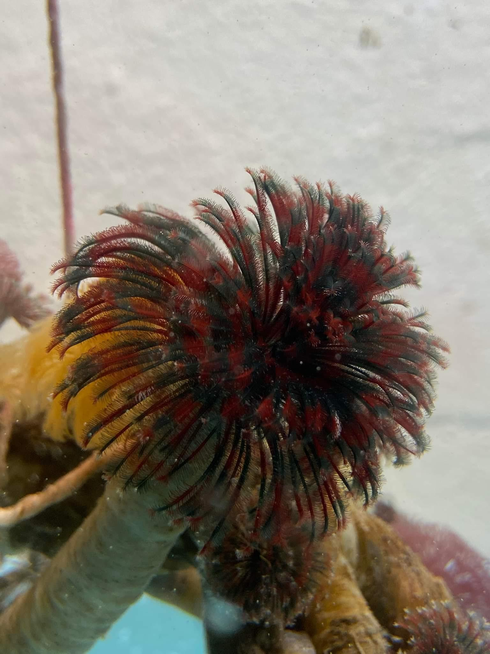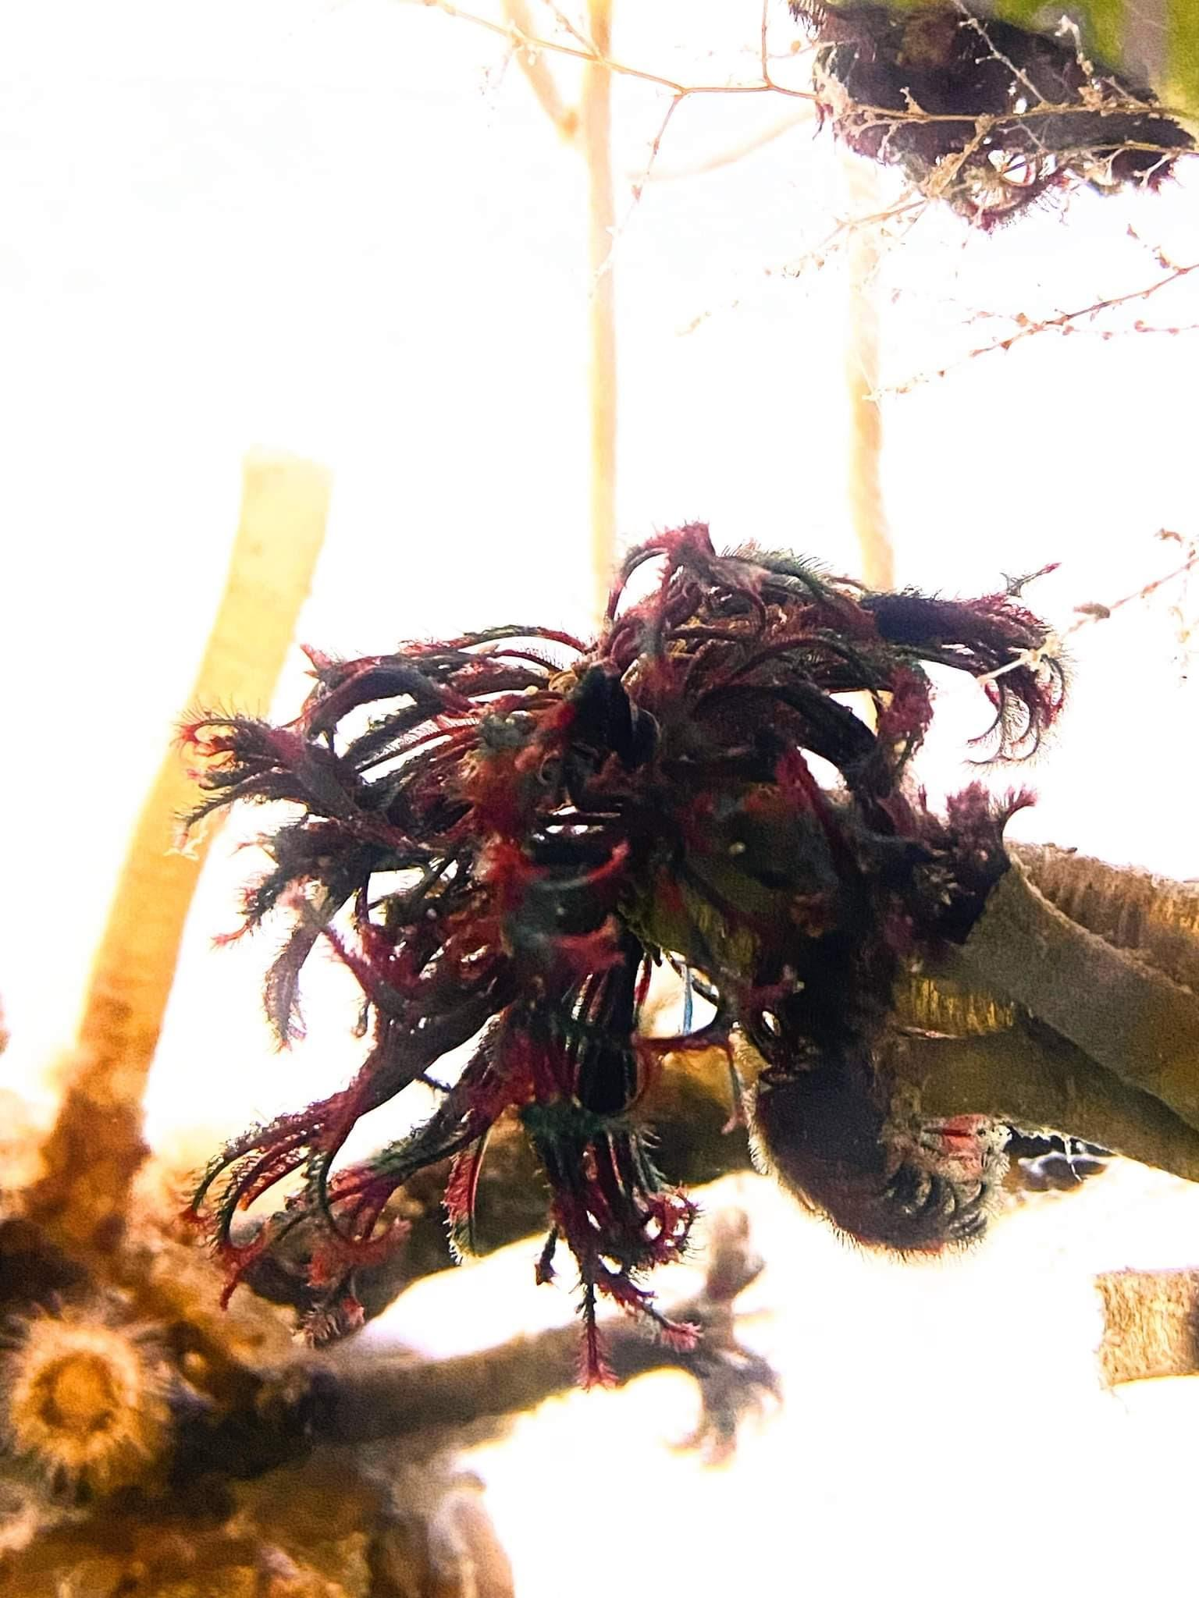

**A**

**B**

2 cm

**Fig. 6.** *E. vancouveri* radioles after A) 12-hour exposure to treatments of (20°C, 35 ppt) and B) after 36-hours of recovery in 12°C and 35 ppt conditions

**Table 1.** Tube growth (mean ± SE) for *E. vancouveri* with P values over eleven days when exposed to Control: 12°C and 35 ppt, Temperature: 20°C and 35 ppt, and Salinity: 12°C and 30ppt.

|  |  |  |
| --- | --- | --- |
| **Treatment** | **Mean Total Tube Growth (mm)** | **P Value** |
| **Control** | 6.35 ±0.59 | N/A |
| **Temperature** | 6.73 ±0.68 | 0.69 |
| **Salinity** | 4.56 ±0.35 | 0.22 |

**Table 2.** Tube growth (mean ± SE) of *E. vancouveri* samples with standard error during five 48-hour timesteps when exposed to Control: 12°C and 35 ppt, Temperature: 20°C and 35 ppt, and Salinity: 12°C and 30ppt.

|  |  |
| --- | --- |
| **Timestep** | **Mean tube growth (mm) during timestep** |
| **1** | 2.0 ±1.7 |
| **2** | 1.1 ±0.12 |
| **3** | 0.86 ±0.11 |
| **4** | 0.79 ±0.12 |
| **5** | 0.58 ±0.07 |

**Table 3.** Tube growth (mm) (mean ± SE) in each timestep for *Eudistylia vancouveri* exposed to treatments of: Control (12°C and 35 ppt), Temperature (20°C and 35 ppt), and Salinity (12°C and 30ppt). Each timestep was 48-hours divided into 12-hours of acute stress followed by 36-hours of recovery.

|  |  |  |  |  |  |
| --- | --- | --- | --- | --- | --- |
|  | **Timestep 1** | **Timestep 2** | **Timestep 3** | **Timestep 4** | **Timestep 5** |
| **Control** | 2.3 ±0.35 | 0.96 ±0.19 | 0.77 ±0.16 | 0.81 ±0.15 | 0.92 ±0.18 |
| **Salinity** | 1.7 ±0.20 | 0.75 ±0.14 | 0.95 ±0.22 | 0.37 ±0.093 | 0.34 ±0.082 |
| **Temperature** | 2.0 ±0.29 | 1.6 ±0.25 | 0.88 ±0.18 | 1.2 ±0.30 | 0.49 ±0.12 |