VB.Net Application:

**Hangman**

Silvestre, Gabrielle Anne S.L.

BS CpE V-3

Introduction

*VB.Net*

Visual Basic [.NET] (VB.NET) is a [multi-paradigm](https://en.wikipedia.org/wiki/Multi-paradigm_programming_language), [high-level](https://en.wikipedia.org/wiki/High-level_programming_language) [programming language](https://en.wikipedia.org/wiki/Programming_language), implemented on the [.NET Framework](https://en.wikipedia.org/wiki/.NET_Framework). Microsoft launched VB.NET in 2002 as the successor to its original [Visual Basic](https://en.wikipedia.org/wiki/Visual_Basic) language. Although the ".NET" portion was dropped in 2005, this article uses "Visual Basic [.NET]" to refer to all Visual Basic languages releases since 2002, in order to distinguish between them and the [classic Visual Basic](https://en.wikipedia.org/wiki/Visual_Basic). Along with [Visual C#](https://en.wikipedia.org/wiki/Microsoft_Visual_C_Sharp), it is one of the two main languages targeting the .NET framework.

Microsoft's [integrated development environment](https://en.wikipedia.org/wiki/Integrated_development_environment) (IDE) for developing in Visual Basic .NET language is [Visual Studio](https://en.wikipedia.org/wiki/Visual_Studio). Most of Visual Studio editions are [commercial](https://en.wikipedia.org/wiki/Commercial_software); the only exceptions are [Visual Studio Express](https://en.wikipedia.org/wiki/Visual_Studio_Express) and [Visual Studio Community](https://en.wikipedia.org/wiki/Microsoft_Visual_Studio#Visual_Studio_Community), which are [freeware](https://en.wikipedia.org/wiki/Freeware). In addition, [.NET Framework SDK](https://en.wikipedia.org/wiki/.NET_Framework_SDK) includes a freeware [command-line](https://en.wikipedia.org/wiki/Command-line) [compiler](https://en.wikipedia.org/wiki/Compiler) called vbc.exe. [Mono](https://en.wikipedia.org/wiki/Mono_(software)) also includes a command-line VB.NET compiler.

VB.NET uses [statements](https://en.wikipedia.org/wiki/Statement_(computer_science)) to specify actions. The most common statement is an expression statement, consisting of an [expression](https://en.wikipedia.org/wiki/Expression_(computer_science)) to be evaluated, on a single line. As part of that evaluation, [functions or subroutines](https://en.wikipedia.org/wiki/Subroutine) may be [called](https://en.wikipedia.org/wiki/System_call) and [variables](https://en.wikipedia.org/wiki/Variable_(programming)) may be [assigned](https://en.wikipedia.org/wiki/Assignment_(computer_science)) new values. To modify the normal sequential execution of statements, VB.NET provides several control-flow statements identified by reserved keywords. [Structured programming](https://en.wikipedia.org/wiki/Structured_programming) is supported by several constructs including one conditional execution construct (If … Then … Else … End If) and three iterative execution (loop) constructs (Do Until … Loop, For… To, and For Each).

*Hangman*

The word to guess is represented by a row of [dashes](https://en.wikipedia.org/wiki/Dash_(punctuation)), representing each letter of the word. In most variants, [proper nouns](https://en.wikipedia.org/wiki/Proper_noun), such as names, places, and brands, are not allowed. If the guessing player suggests a letter which occurs in the word, the other player writes it in all its correct positions. If the suggested letter or number does not occur in the word, the other player draws one element of a hanged man [stick figure](https://en.wikipedia.org/wiki/Stick_figure) as a [tally mark](https://en.wikipedia.org/wiki/Tally_marks).

The player guessing the word may, at any time, attempt to guess the whole word. If the word is correct, the game is over and the guesser wins. Otherwise, the other player may choose to penalize the guesser by adding an element to the diagram. On the other hand, if the other player makes enough incorrect guesses to allow his opponent to complete the diagram, the game is also over, this time with the guesser losing. However, the guesser can also win by guessing all the letters or numbers that appears in the word, thereby completing the word, before the diagram is completed.

Objectives:

* To create a VB.Net application that demonstrates some (or all) of the previous learnings obtained by the subject.
* To create a functioning VB.Net game entitled: Hangman.

Screenshots:

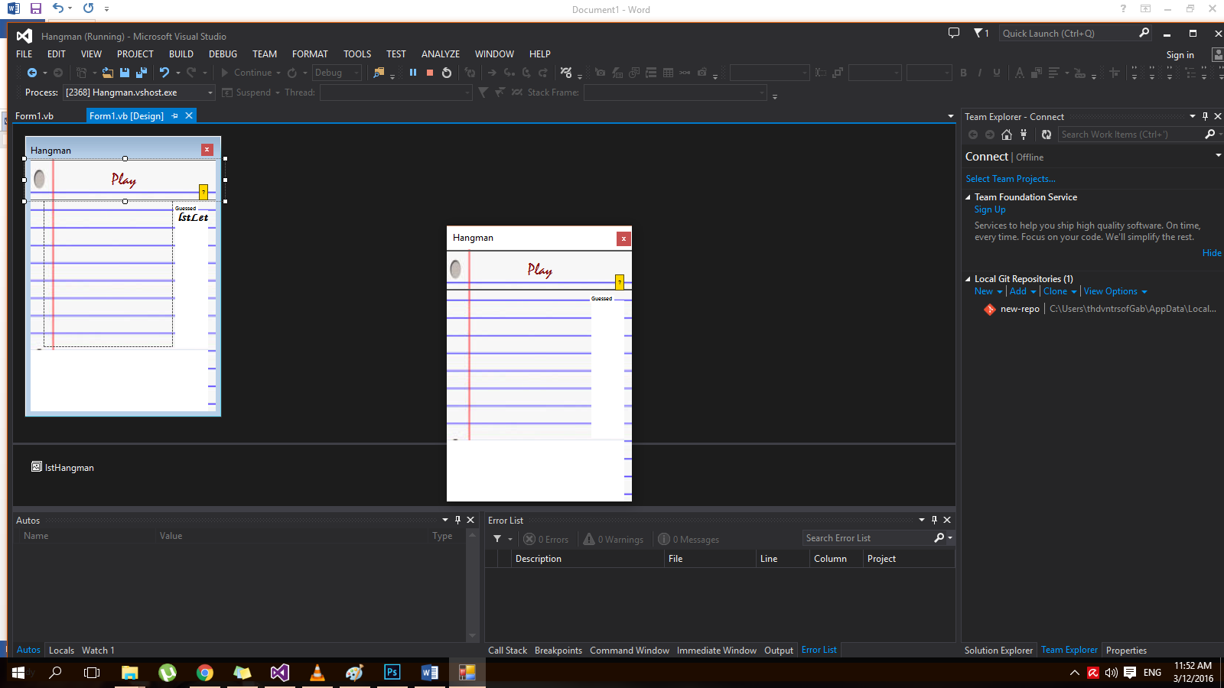 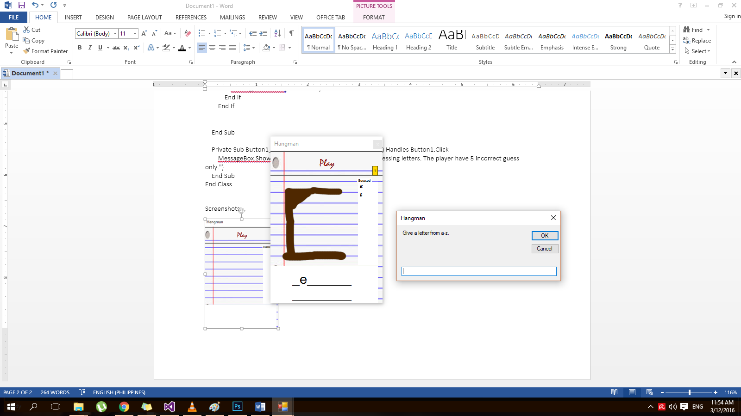

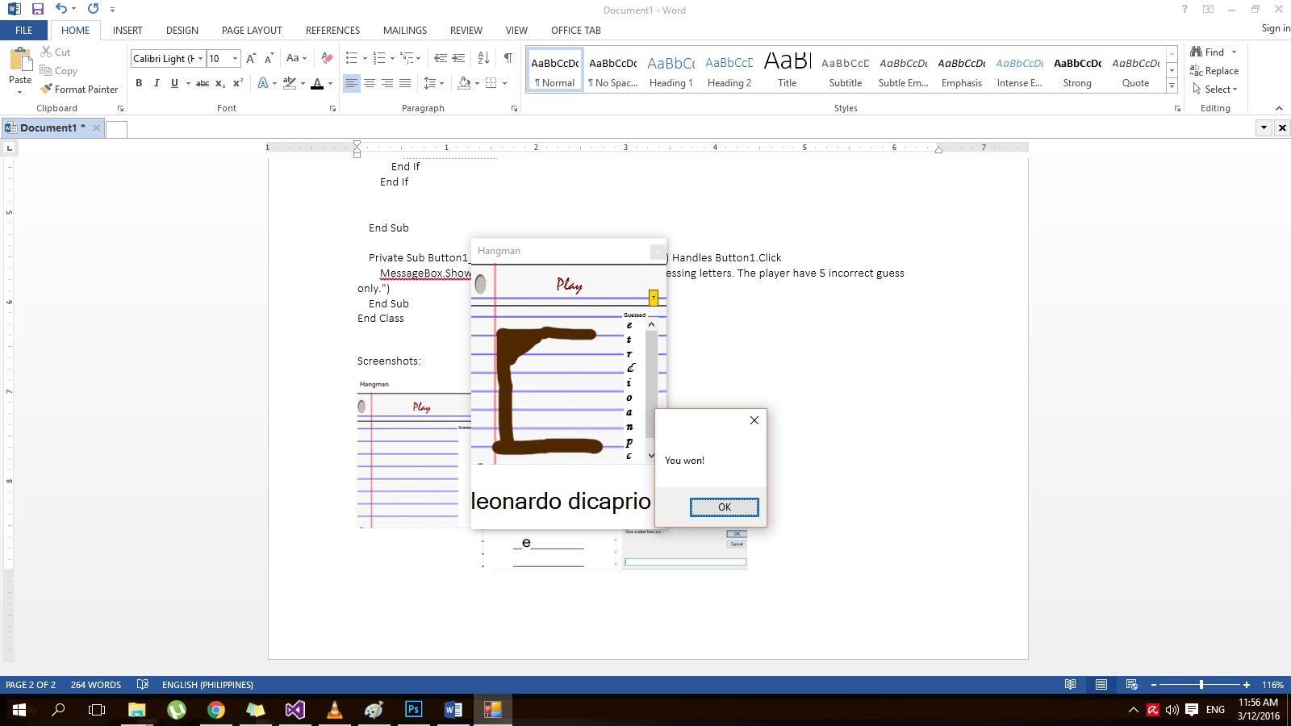 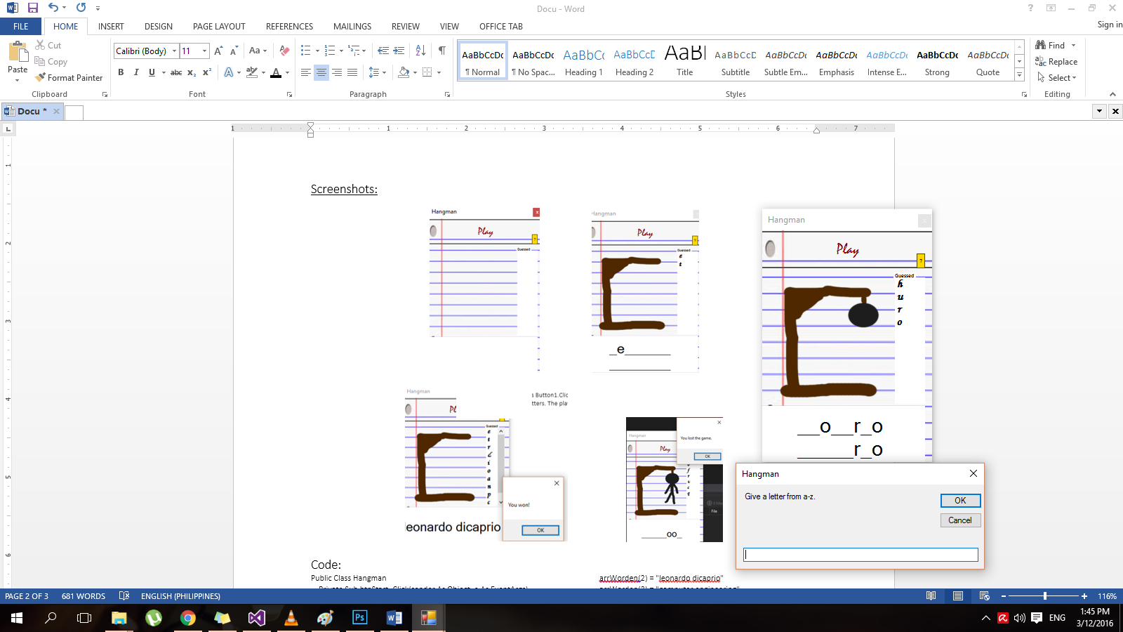 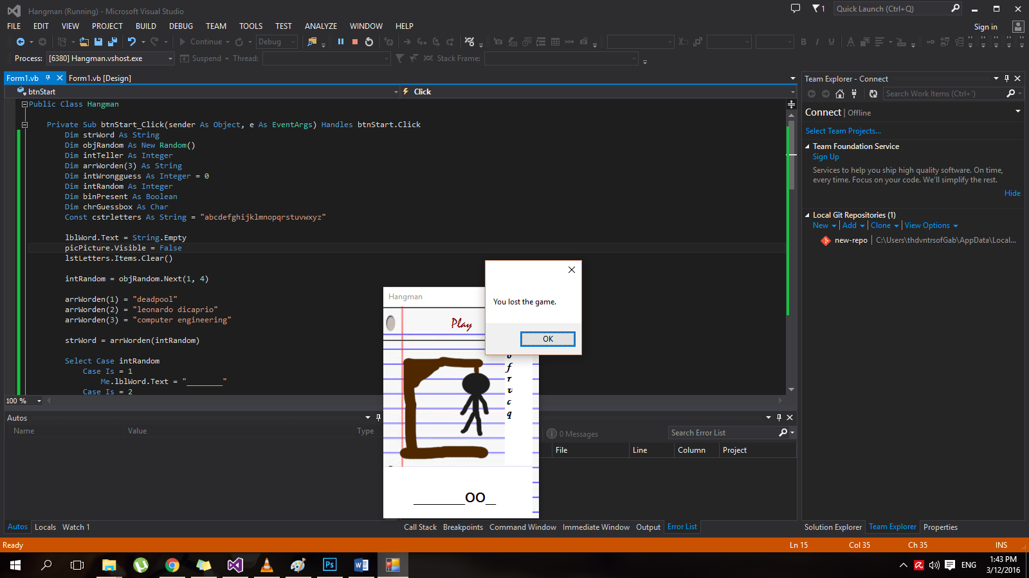

Source Code :

Public Class Hangman

Private Sub btnStart_Click(sender As Object, e As EventArgs) Handles btnStart.Click

Dim strWord As String

Dim objRandom As New Random()

Dim intTeller As Integer

Dim arrWorden(3) As String

Dim intWrongguess As Integer = 0

Dim intRandom As Integer

Dim binPresent As Boolean

Dim chrGuessbox As Char

Const cstrletters As String = "abcdefghijklmnopqrstuvwxyz"

lblWord.Text = String.Empty

picPicture.Visible = False

lstLetters.Items.Clear()

intRandom = objRandom.Next(1, 4)

arrWorden(1) = "deadpool"

arrWorden(2) = "leonardo dicaprio"

arrWorden(3) = "computer engineering"

strWord = arrWorden(intRandom)

Select Case intRandom

Case Is = 1

Me.lblWord.Text = "________"

Case Is = 2

Me.lblWord.Text = "________ ________"

Case Is = 3

Me.lblWord.Text = "________ ___________"

End Select

strWord.ToCharArray()

Do

chrGuessbox = InputBox("Give a letter from a-z.")

If InStr(cstrletters, chrGuessbox) = 0 Then

MessageBox.Show("You can only use letters.")

Else

If lstLetters.Items.Contains(chrGuessbox) = False Then

binPresent = False

lstLetters.Items.Add(chrGuessbox)

For intTeller = 0 To Integer.Parse(arrWorden(intRandom).Length - 1) Step 1

If strWord(intTeller) = chrGuessbox Then

Me.lblWord.Text = lblWord.Text.Remove(intTeller, 1)

Me.lblWord.Text = lblWord.Text.Insert(intTeller, chrGuessbox)

binPresent = True

End If

Next

If binPresent = False Then

picPicture.Visible = True

picPicture.Image = lstHangman.Images(intWrongguess)

intWrongguess += 1

End If

Else

MessageBox.Show("Letter already used before.")

End If

End If

Loop Until lblWord.Text = arrWorden(intRandom) Or intWrongguess = 5

If intWrongguess = 5 Then

MessageBox.Show("You lost the game.")

Else

If lblWord.Text = arrWorden(intRandom) Then

MessageBox.Show("You won!")

End If

End If

End Sub

Private Sub Button1_Click(sender As Object, e As EventArgs) Handles Button1.Click

MessageBox.Show("Try to guess what the phrase is by guessing letters. The player have 5 incorrect guess only.")

End Sub

End Class