1. JAVA and JAVA compiler:
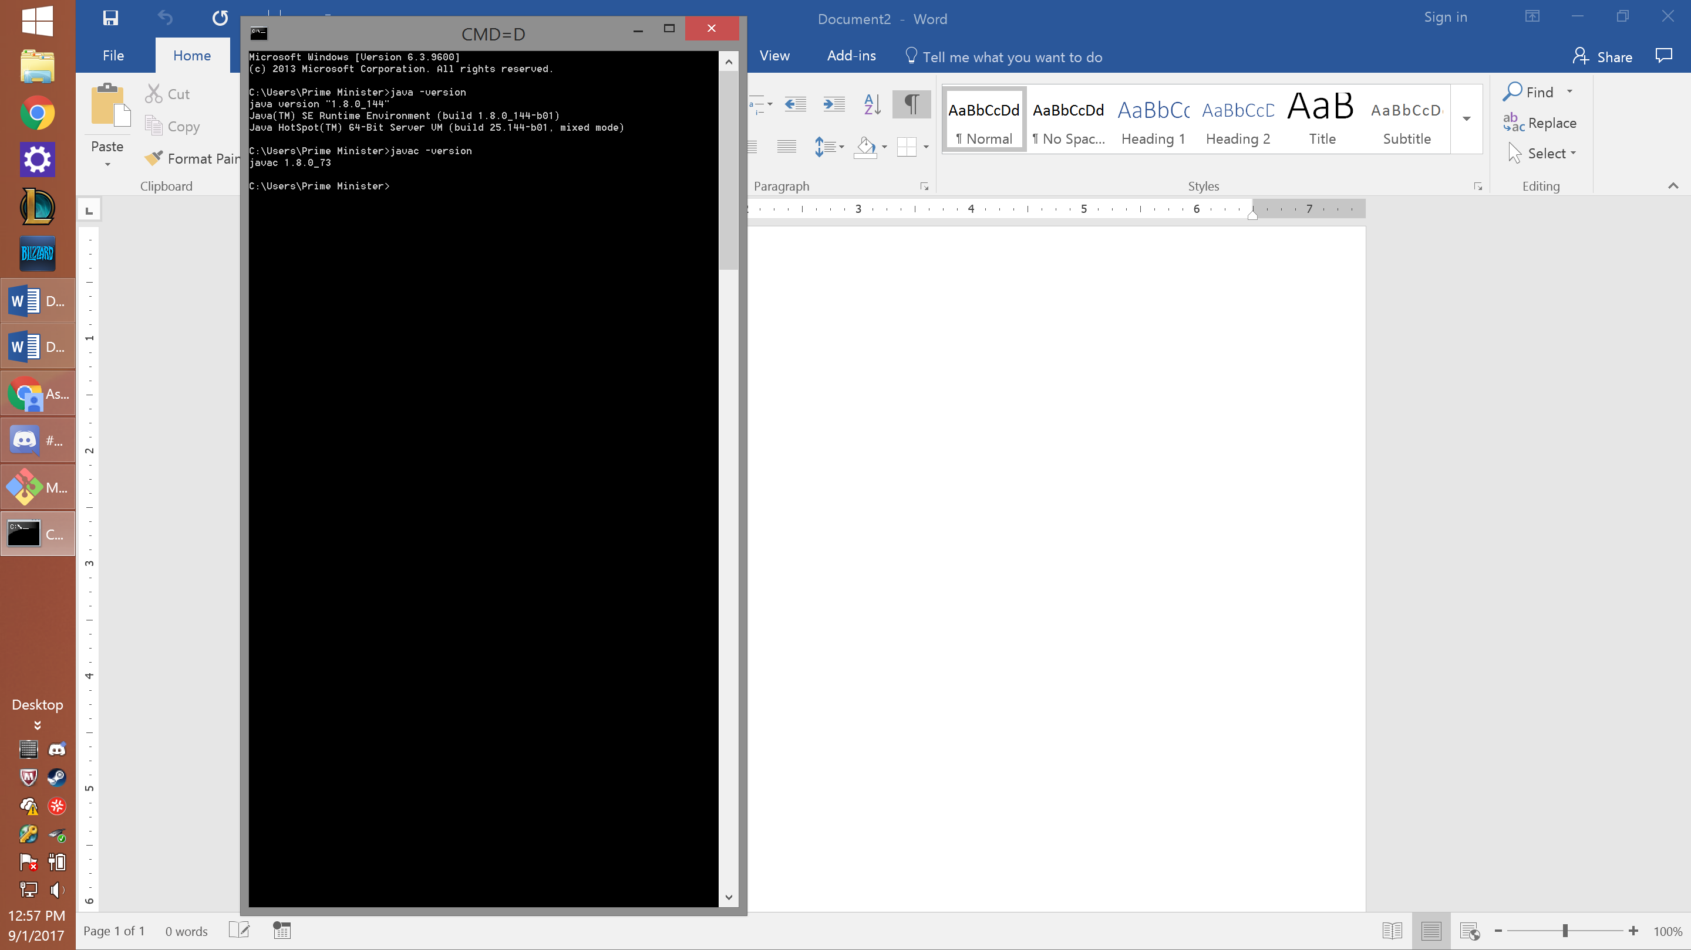
(I apologize for the small text; I cannot find a way to enlarge the text any more than that.)

2. Kattis account
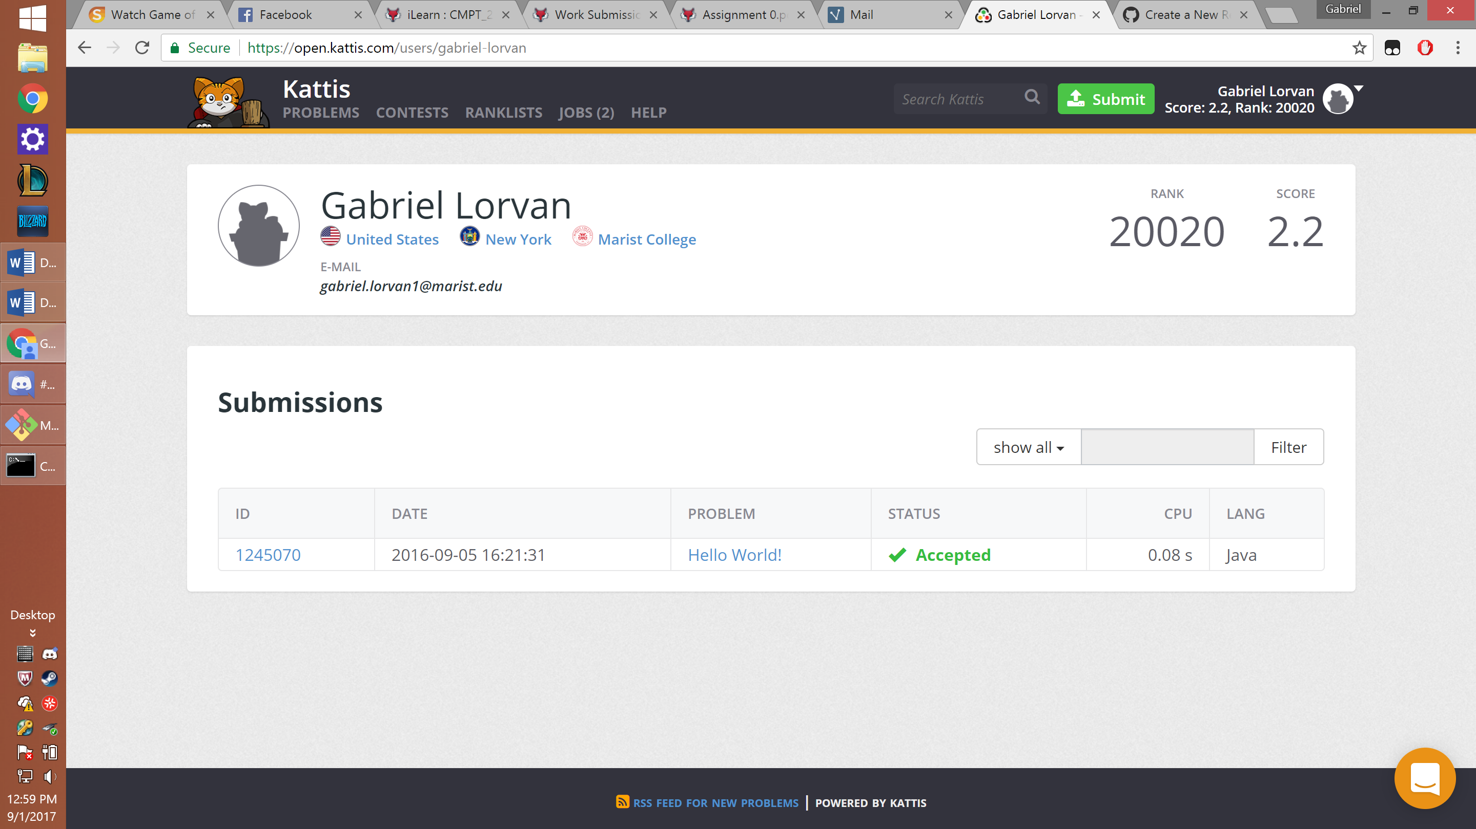
3. GitHub account
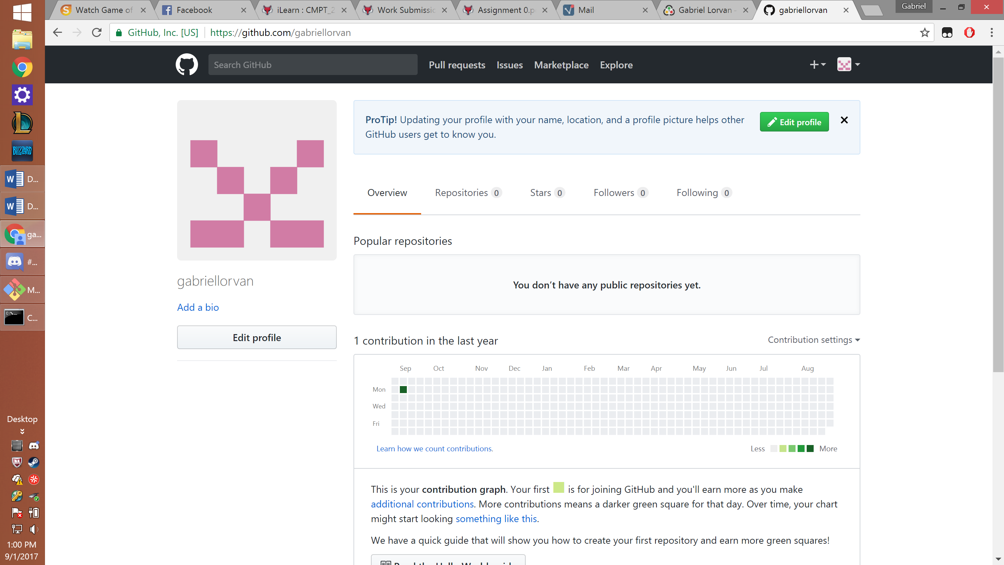

4. Repository set up
