Prologue
Introduction to the book
Who is this book for?
Who are we?
What is Sesam?
What problems do we seek to solve?
What should you expect to learn?
Innholdsfortegnelse og forklaring/justification for det.

Table of Contents
Prologue 1
Table of Contents 2
1. Architecture and Concepts 6
Introduction 6
Architecture 6
1.1 Architecture and Concepts: Beginner 6
1.1.1 Different types of Architectures 6
1.1.2 Datadriven architecture 7
1.1.3 Datahub 7
1.1.4 Sesam “sesam-world-map”? 7
1.1.5 The parts of sesam 7
1.1.6 The Sesam portal 7
1.1.7 Working language JSON 7
1.1.8 Namegiving conventions 7
1.1.9 Systems 7
1.1.10 Pipes 7
1.1.11 Datasets 8
1.1.12 Datasets vs. tables 8
1.1.13 Entities / JSON (Key-value pairs) 8
1.1.14 Globals as a concept 8
1.1.15 Special sesam attributes 8
1.1 Tasks for Architecture and Concepts: Beginner 8
1.2 Architecture and Concepts: Novice 8
1.2.16 Joining Data 8
1.2.17 Make namespaced identifieries for foreign keys [Make-ni] 9
1.2.18 Full Outer Join (Merge) 9
1.2.19 Left Join (Hops) 9
1.2.20 Global 9
1.2.21 Generic input pipes, custom output pipes 9
1.2.22 Filter entities on the way out 9
1.2.23 Tag your entities - Categorization of sub-concepts 9
1.2.24 Customize data structure for endpoints 9
1.2.25 Change tracking & data delta 10
1.2 Tasks for Architecture and Concepts: Novice 10
1.3 Architecture and Concepts: Intermediate 10
1.3.26 Hops 10
1.3.27 1.3.26 Incremental Database queries 10
1.3.28 Subset 10
1.3.29 Dynamic, Static & Timeseries Data 10
1.3.30 When to use a microservice 10
1.3 Tasks for Architecture and Concepts: Intermediate 10
1.4 Architecture and Concepts: Advanced 10
1.4.31 Choosing a source dataset for your pipe 10
1.4.32 Eventual Consistency 11
1.4.33 Create Child & Emit children 11
1.4 Tasks for Architecture and Concepts: Advanced 11
Epilogue 11
2 Systems 11
Introduction 11
2.1 Systems: Beginner 11
2.1.1 What is a system in Sesam? 11
2.1.2 Introduction to SQL & Json systems 11
2.1.3 Pipe interaction with systems. 11
2.1.4 How to create a system with Templates 11
2.1.5 Environment variables & Secrets 11
2.1.6 JSON Push & Pull protocol 12
2.1 Tasks for Systems: Beginner 12
2.2 Systems: Novice 12
2.2.7 What is a system in Sesam? 12
2.2.8 Systems as a pipe source 12
2.2.9 Systems as a pipe sink 12
2.2.10 [System?] Authentication methods 12
2.2.11 System Types 12
2.2 Tasks for Systems: Novice 12
2.3 Systems: Intermediate 12
2.3.12 Microservice System 12
2.3.13 HTTP Transforms 13
2.3.14 Chaining of Systems 13
2.3 Tasks for Systems: Intermediate 13
Epilogue 13
3 DTL – The language of Pipes 14
Introduction 14
What is DTL? 14
Why DTL? 14
Where is DTL used? – Can fit into 3.1.1 probably. 14
3.1 DTL: Beginner 14
3.1.1 Pipes, where DTL executes 14
3.1.2 Entities, pipes and _id 14
3.1.3 Entity Data model – Data Types 14
3.1.4 Syntax 14
3.1.5 Bootstrap 15
3.1.6 Pipe shortcuts 15
3.1 Tasks for DTL: Beginner 15
3.2 DTL: Novice 15
3.2.7 “Copy” 15
3.2.8 “Add” 16
3.2.9 “Concat” – Concatination 16
3.2.10 rdf:type 16
3.2.11 Namespace 16
3.2.12 “Make-ni” 16
3.2.13 “Eq” – Equality 16
3.2.14 Merge as a Source 16
3.2.15 Filter as a transform 16
3.2.16 Coalesce 16
3.2.17 Nested dictionaries 16
3.2.18 Apply – Custom Functions 16
3.2.19 Merge as a function 17
3.2.20 Hops 17
3.2.21 _ Properties 17
3.2.22 Type examples 17
3.2 Tasks for DTL: Novice 17
3.3 DTL: Intermediate 18
3.3.23 More on Pipes 18
3.3.24 Pipe Sink 18
3.3.25 if 18
3.3.26 Case &? case-eq 18
3.3.27 Multiple transforms 18
3.3.27 Dependency tracking in Hops 18
3.3.28 "Apply-hops" 18
3.3.29 Source Subset 18
3.3 Tasks for DTL: Intermediate 18
3.4 DTL: Advanced 18
3.4.30 Filter as an expression 18
3.4.31 _. Syntax and Functions 18
3.4.32 Map 19
3.4.33 _P & _R – Parent & Root 19
3.4.34 “Create-child” 19
3.4.35 Recursion in Hops & Apply 19
3.4.36 Key-values 19
3.4.37 Escape Namespaced Identifiers [NI] 19
3.4 Tasks for DTL: Advanced 19
Epilogue 19
Projects & Infrastructure 20
Introduction 20
4.1 Projects & Infrastructure Beginner 20
4.1.1 Portal GUI 20
4.1.2 sesam-CLI 20
4.1.3 4.1.3 Testing & Testdata 21
4.1.4 Dokumentasjon 22
4.1.5 JWT/Authentisering 22
4.1.6 Groups & Permissions 22
4.1 Tasks for Projects & Infrastructure: Beginner 22
4.2 Projects & Infrastructure: Novice 22
4.2.7 Node config? 22
4.2.8 Deployment 23
4.2.9 Monitorering 23
4.2.10 Arbeidsmetodikk 23
4.2 Tasks for Projects & Infrastructure: Novice 24
4.3 Projects & Infrastructure: Intermediate 24
5.2.8 dev/CI/test/prod-noder 24
5.2.9 CI/CD/TDD? 24
4.3.10 Workflow in Projects 24
4.3 Tasks for Projects & Infrastructure: Intermediate 25
Epilogue 25
5 Microservices 25
Introduction 25
5.1 Microservices: Beginner 25
5.1.1 What is a microservice? 25
5.1.2 Why use Microservices in Sesam? 26
5.1.3 How are Microservices used in Sesam? 26
5.1.4 Microservice hosting 26
5.1.5 Running a microservice in Sesam 26
5.1.6 Types of Microservices 26
5.1.7 Naming Convention 26
5.1 Tasks for Microservices: Beginner – Tasks 26
5.2 Microservices: Novice 26
5.2.8 Interacting with a Microservice in Sesam 26
5.2.9 Microservice Development Prerequisites 27
5.2.10 Changing a Microservice 27
5.2.11 Authentication with microservices 27
5.2.12 Sesam I/O 27
5.2.13 Using a Microservice as Input in Sesam 27
5.2.14 Looking inside an Input Microservice 27
5.2 Tasks for Microservices: Novice 28
5.3 Microservices: Intermediate 28
5.3.15 Using a Microservice as Output in Sesam 28
5.3.16 Looking inside an Output Microservice 28
5.3.17 Guidelines for Microservice Development 28
5.3.18 Microservices and GitHub [VCS] 29
5.3.19 Optimizing a Microservice 29
5.3.20 Microservice System types 29
5.3 Tasks for Microservices: Intermediate 29
5.4 Microservices: Advanced 29
5.4.21 Testing 29
5.4.22 Proxy Endpoint [Jonas] 30
5.4.23 Chaining 30
5.4. Tasks for Microservices: Intermediate 30
Epilogue 30
6. Sesam in the Wild [WIP] 30
Introduction 30
Sesam in the Wild: Beginner 30
6.1.1 Beginner topic 30
6.1 Tasks for Sesam in the Wild: Beginner 30
Sesam in the Wild: Novice 31
6.2.X: Novice topic 31
6.2 Tasks for Sesam in the Wild: Novice 31
Sesam in the Wild: Intermediate 31
6.3.X: Intermediate topic 31
6.3 Tasks for Sesam in the Wild: Intermediate 31
Sesam in the Wild: Advanced 31
6.4.X: Advanced topic 31
6.4 Tasks for Sesam in the Wild: Advanced 31
Epilouge 31
Appendix 31

Architecture and Concepts

Introduction
Sesam opens the door to running a data-driven business, but what is a data driven business and how does the journey towards it look?
In this chapter we will introduce you to Sesam as a way of not only developing but thinking. You will learn about overarching themes for designing integrations, the components you build with and the pitfalls to look out for along the way.
After reading you can expect to recognize and design a data driven Integration of your own.

Architecture
What do we mean about architecture

Architecture and Concepts: Beginner

Different types of Architectures @Jonas
When modelling data, integration architectures (IA) lay the foundation upon which data is shaped and structured as it moves through one system to another. Within IA, Point-to-point (P2P) and Enterprise Service Bus (ESB) have been used extensively. Recent trends, however, move away from these established integration principles and places data and its mobility at its center.
Albeit, before elaborating on how integration principles has undergone recent radical changes, you should first dive into P2P and ESB.

1.1.1.1 Point-to-Point
This kind of IA is a simple integration principle. As an example of P2P imagine sending a message generated in one system to a single receiver in another system. This simplified example shows both the pros and cons to using P2P. It is simple and therefore easy to manage, albeit what if another system is introduced and so multiple new messages need to be sent? Well, in this case P2P is not your best option, and the issue of scalability presents itself. To illustrate how complexity can make P2P a non-viable option look at the below Figure 1 – Point-to-Point:
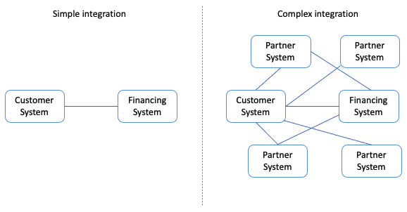
Figure 1 – Point-to-Point
As illustrated on the right-hand side of the above figure “Complex integration”, you have to maintain multiple connections separately which, in this case, will make P2P time consuming and expensive to manage. Therefore, amongst other things, new architectural principles have been developed. One of the more prominent ones being ESB.

1.1.1.2 Enterprise Service Bus
The ESB is a more robust IA and plays a critical role in connecting diverse systems and services in a Service Oriented Architecture (SOA). The ESB takes on the responsibility of ensuring that data sent from one system conforms to the requirements in another system. This core functionality is an important feature as to why the ESB is such an established architectural principle. In addition, the ESB aids in simplifying integration efforts when connecting differing applications that need to communicate with each other. See Figure 2 – Enterprise Service Bus.
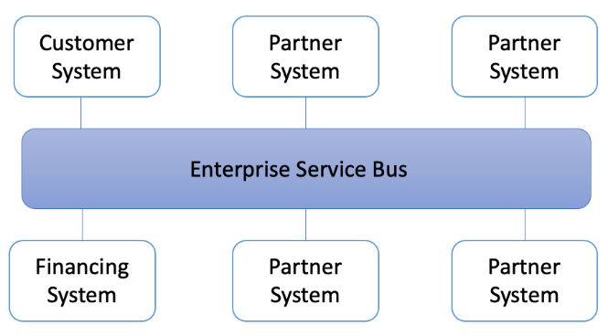
Figure 2 – Enterprise Service Bus
Taking into account the positives from using an ESB for your IA - some challenges still remain unresolved. Recent years transition towards more cloud-based solutions, hybrid solutions and the remaining tendency to focus on the systems in the ESB rather than the data itself has propelled what is called “Data Driven Architecture”.

Data Driven Architecture @Jonas
As opposed to both the P2P and the ESB integration principles the Data Driven Architecture (DDA) does not focus on systems – rather the data and how modelling a data-centric ecosystem takes precedence in order to realize an agile meanwhile robust IA, see Figure 3 – Data Driven Architecture.
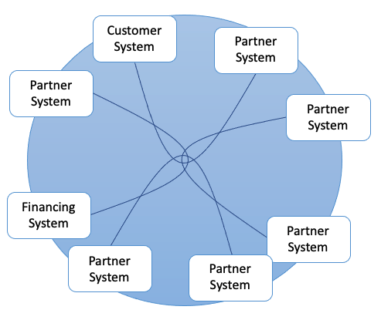
Figure 3 – Data Driven Architecture
As opposed to P2P and ESB, DDA is, respectively, scalable and agile - in that it does not need the “Bus” to orchestrate data flows, rather DDA relies on natural flows of connected data to trigger data flows. You may think that this also presents a risk - that is correct.
In order to utilize DDA you need to create logical, robust albeit flexible data flows. If done correctly nothing beats the scalability, cost-effectiveness and possibilities a DDA provides. A word of caution however, if such guidelines are not agreed upon and followed up on, you risk creating a waterfall of technical depth as time goes by and these natural flows of data grows unhinged.

Datahub @Jonas
Continuing the path of building data-centric solutions, the term “Datahub” comes into play. A datahub is recognized by its frictionless data flow and as such builds upon the architectural principles presented in DDA. A datahub can be described as a solution that consists of multiple different technologies, i.e., a data warehouse, microservices, databases etc.
A Datahub shares data by connecting generators of data with consumers of data. In practice this allows data to be delivered in endpoints that can interact with the datahub in terms of injecting data into the datahub or exposing data to an external system. As such, a datahub mediates and manages how data flows between systems and makes states of data visible to consumers outside the datahub.
In a sense, you could say that a datahub is a digital representation of an enterprise and also what SESAM often becomes when it is used properly. As with any other technologies there are pros and cons to any technology.
Some of these are listed below, so you might be able to recognize them – “down the road”.
Pros:
- Has enterprise scope, i.e., cloud, hybrid.
- Creates visibility into all data.
- Centralizes data control.
- Moves data in, close to, real time.
- Connects data.
Cons:
- Data does not persist.
- Demands advanced capabilities.
- Does not operate in silos.

Sesam “sesam-world-map”?

The parts of sesam @Erik
Terminology
Systems, pipes, datasets

In order to understand how Sesam works, it is important to understand the parts Sesam is made up of.

There are three central re-occurring concepts in Sesam which you will encounter in your everyday life working with the integration platform: systems, pipes and datasets. These are the fundamental parts which make up a Sesam integration pipeline. Figure 1.1.5A gives you an insight into how a standard Sesam integration pipeline would look.

- Systems: A system’s main feature is to import and export data into and out of the Sesam portal. They are therefore found in the beginning and end of the pipeline flows and are often referred to as “source systems” or “target systems” respectively. A system could connect to a REST API, directly to a database of simply send data to a waiting http server. Sesam has several of these system types built into the product to simplify the workings inside the portal. In situations where the built-in system types are not enough for your requirements Sesam also supports connecting systems to a microservice which in turn can manipulate and delegate data according to your own specifications, making Sesam a very robust and comprehensive tool.

- Pipes: Pipes handles the transformation of the data and specifies where the data is supposed to be sent. Manipulation of the data is done through Sesam’s own Data Transformation Language (DTL) which allows you to add, remove, transform and combine data according to you own needs. A pipe generally acquires data from a system or from a dataset depending on where the pipe is located inside the integration pipeline.

- Datasets: Datasets are Sesam’s storage units and can be compared to i.e., a table in an SQL database. This is where pipes store the data after configuring them and in a pipeline flow, they are generally found between pipes. Sesam stores data in order to be able to perform tracking and indexing, but you will learn more about these functionalities later in this book (maybe a link?).

- Entities: A dataset consists of a list of entities. Entities in Sesam can be compared to individual rows in an SQL table and can represent anything from a person, a mechanical part to a contract. An entity is defined by its primary key, which is represented in Sesam as the value belonging to the key ‘_id’.

The Sesam portal
Show basics of portal
(Here also refer to a full chapter for portal or from the projects chapter?)
Integrations, connections and configurations can all be accessed inside the Sesam portal; the user interface of the Sesam product, The Sesam portal can be accessed at portal.sesam.io, and in this section you will learn the most commonly used parts of the portal such that you can orient yourself, as well as manage existing integrations. For a full explanation if the workings and functionality of the Sesam portal, please look [here (with a link)].

When logging in to the portal you will be met with a page like figure 1.1.6A.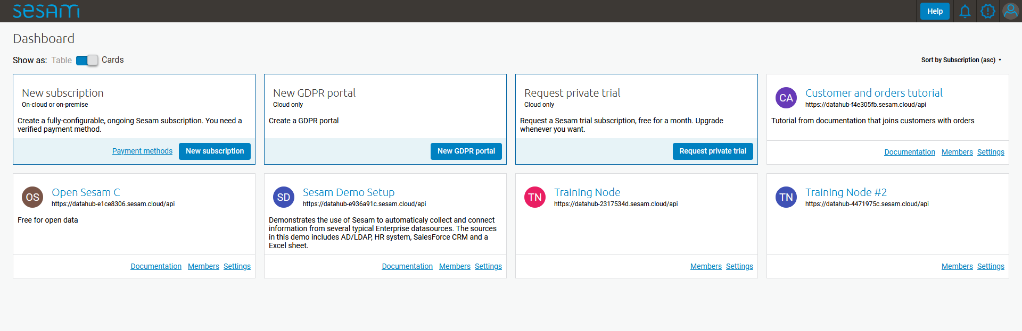
The cards on the Dashboard are often referred to as “subscriptions” or “nodes” and they represent separate instances of Sesam installations. Each node comes in different sizes (memory available) depending on the requirements of the customer/project/user. In this example you will be shown the portal inside the node called “Training Node”, but all nodes will have the same setup, only different set of systems, pipes and datasets.

When entering the “Training Node” you will be met with the page seen in figure 1.1.6B.

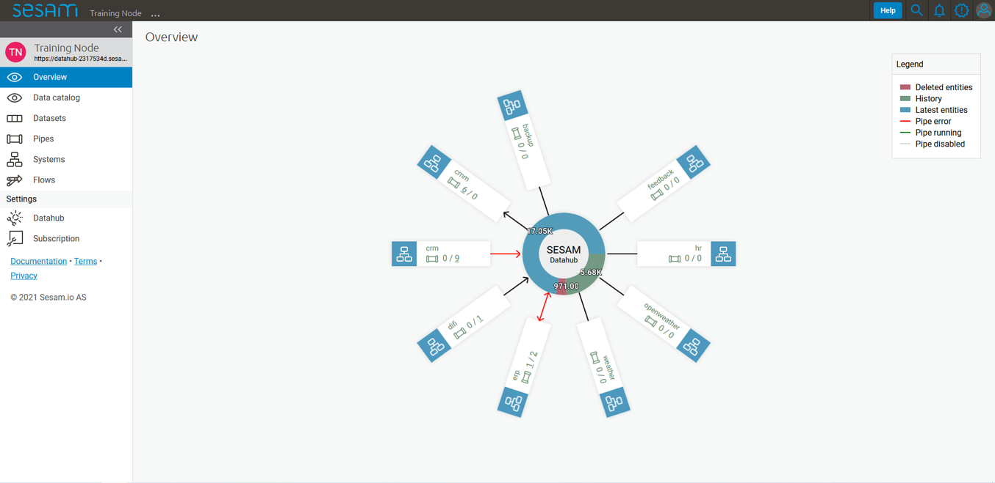

In this section we will only focus on the specific parts of the portal needed to start working with Sesam, namely the “Pipes” page and the “Systems” page.

Pipes
When entering the “Pipes” page you will be met by figure 1.1.6C. This figure shows you all the available pipes in your subscription as well as some of their corresponding meta-data. There are also several search and filter options available, which are specially handy when trying to located one, or a set of pipes, in a subscription with many pipes.

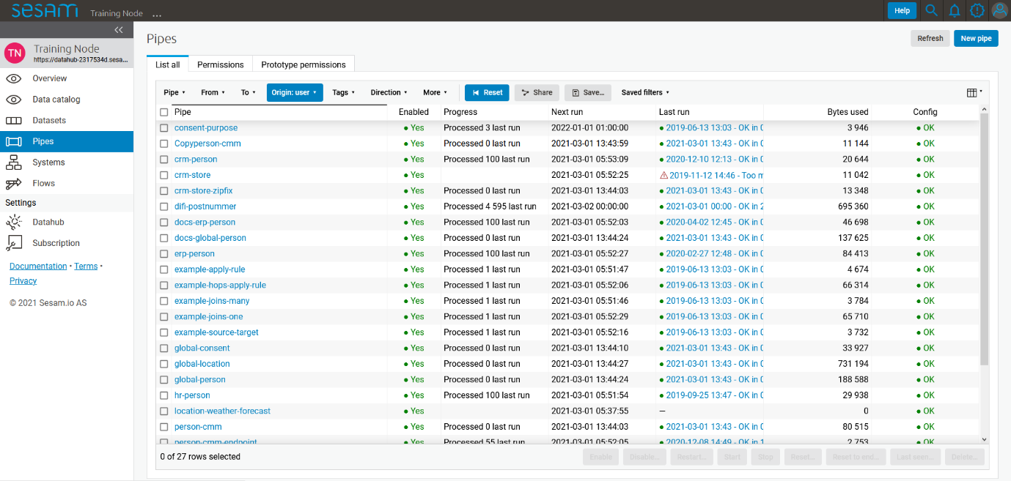
If you now enter the pipe called “person-cmm” we can look into more of details regarding how you may use the portal to navigate, troubleshoot and configure you pipes.

Upon entering a pipe, you will by default be sent to the pipe’s “Graph” view, as seen in figure 1.1.6D.
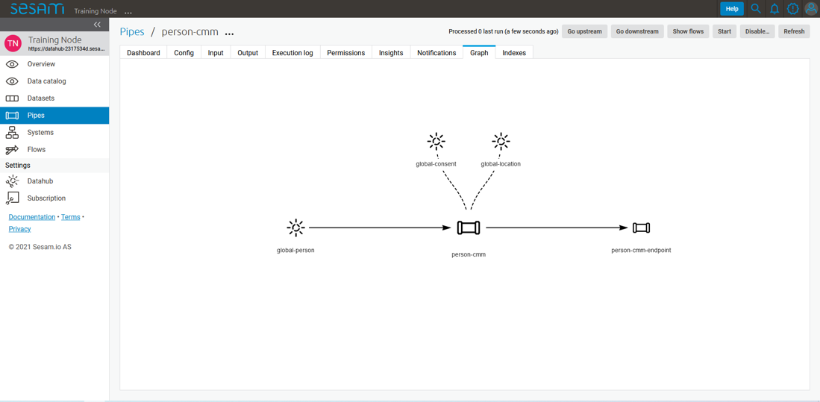
The graph view shows you which pipes are upstream and downstream to the specific pipe you have selected, and it also shows connections to related pipes (you will learn more about connected pipes later [link maybe?]). For now, we will focus on four of the pipe’s subpages: Config, Input, Output and the Execution log.
- Config: The config subpage is where the actual coding takes place. This is where you define what this specific pipe is supposed to do. A pipe config is written in DTL which you will learn more about in section [link]. One

- Input: Whenever a pipe uses one or several datasets as a source, the source entities will be displayed here. These are the entities the pipe will perform some sort of transformation on.

- Output: The output tab shows the entities after the DTL transformation. The way you see the output depends on whether the data is stored in a dataset or sent to a target system. There are some occasions where there is no output so be seen but for now you can assume that there will always be an output to be see for each pipe.

- Execution log: The execution log supplies us with information on the state of the pipe. If a pipe runs as it should the execution log will display information on how many entities it has processed, how much time the processing took and much more. If a pipe is not be able to process all the data, the execution log will display a failed pipe run as well as error messages which may assist you to locate the error. The execution log is a vital tool for troubleshooting as it not only tells you if a pipe works as it should, but also contains detailed information on why a pipe run fails and when they failed.

Systems
The systems tab looks very much like the pipe tab in figure 1.1.6C. For systems we will focus the three most commonly used tabs: Config, Secrets and Status.
- Config: Like with pipes, the config tab is where you specify what the system is supposed to do. There are many different types of systems and many of have very different configuration. There are however some common traits that apply to most system. These traits include authorization parameters, location parameters such as IP-addresses, URLs and database names and system types. In the case where your system relies on a Microservice you might also have a set of environmental variables used by the Microservice.

- Secrets: In the Secrets tab you may store sensitive information you do not wish everyone on the node to have access to. These secrets are often passwords or token used to authorization and authentication. Secrets stored in the system tabs are local secrets and may only be used by the specific system in which they are defined.

- Status: In the Status tab you can monitor the health of your system. When connected to built-in systems this tab shows you whether you are connected correctly. When connected to Microservices this tab displays connection status and logging provided by the Microservice.

Working language JSON
Something general about JSON
JSON configuration of pipes and systems
DTL also validated as JSON?

Naming convention
How (maybe a table) to give good names to the different parts in Sesam.
Why this is really important

When constructing an integration flow in Sesam the use of a standardized naming convention becomes essential. This becomes especially important when the integration project grows to more than a few pipes. A standardized naming convention helps you to easily structure your Sesam architecture such that:

- Localizing specific flows becomes easier.
- Troubleshooting becomes more efficient.
- Switching between integration projects, or joining a new project, becomes more intuitive.
- Support will be more efficient.

In Sesam we focus on naming pipes, datasets and systems in way that explains the function of that specific structure. The following points are the naming rules Sesam suggests you follow when constructing your integration flows.

Systems
A system name should describe the source/target system from the customers perspective, not from Sesam’s perspective. If a customer has employee data inside a HR system named “HR”, but the data from “HR” is supplied by an API provider called “API provider”, the Sesam system should be named “hr”. The same rule applies if the HR data was populated in a database which Sesam connects to. Naming the system after the database might seem intuitive at first glance but naming from the customers perspective makes communication and troubleshooting much easier in the long run.
Pipes
Input pipes:
Input pipes should be named according to endpoint/table they connect to in the source system and prefixed with the source system name such that there is a clear and intuitive way of tracking their content. Let us use the same example as for naming system. I this case the HR system in the previous example populate its data in two tables: employee and department. Our two input pipes connecting to the two tables containing HR data will therefore be named “hr-employee” and “hr-department”. The system name prefixed highlights that the HR system is upstream from the pipes.

Global pipes:
Global pipes should be named according to the semantic relation connecting the datasets used as the global pipes source and prefixed with “global”. These semantic relations may vary between projects and customers, but some are generally always occurring such as global-person, global-company, global-customer or global-project.

Preparation pipes:
Preparation pipe naming can be more diverse but should explain the type of data it transforms as well as the target system. If the input pipe importing a table “person” from a system “HR” is named “hr-person", the corresponding preparation pipe preparing data to be pushed to the table “person” should be named “person-hr". We use the system name as a postfix in this case to highlight the fact that this data has the HR system down-stream. In many cases you might require several preparations pipes between the global pipe and the endpoint pipe. In these cases, in addition to the type of data transformed as the downstream target system, the pipe name should reflect the functionality of that specific preparation pipe. As an example, if a preparation pipe splits entities into child entities, the children functionality should be part of the pipe name i.e., “person-child-hr".

Output pipes:
An output pipe should have the same name as the name of the pipe generating the output pipe’s source dataset, only postfixed with “output” i.e., “person-child-hr-endpoint”.

The following flow shows a typical Sesam flow with each pipe’s preferred name with an example:
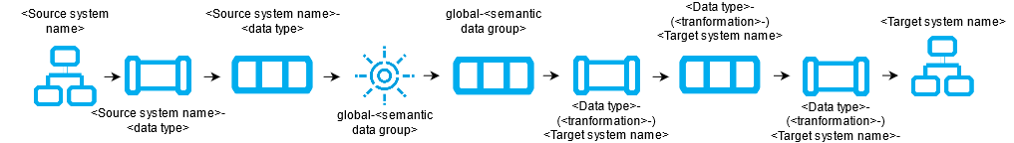
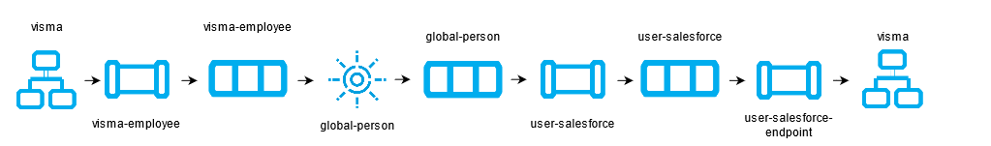

Systems
Short about systems (where in the sesam-world-map)
Something more general about pipes maybe in context of pipes and datasets
Very low level but enough to set up an inputpipe after maybe?
and refer to systems chapter
Namegivingconventions ref. 1.1.8
Where to make new ref 1.1.6

Systems are one of Sesam’s core sub-structures. Systems can connect to external providers such as an SQL database, a REST API or a Microservice to either import or export data to and from Sesam and are therefore the start and finish points of every integration flow. System may cover other functionalities as well, but we will cover those special cases in later parts [ref to later parts].

Pipes
Something more general about pipes maybe in context of systems and datasets
Inbound(Input?)/Preparation/Outbound(Output?)
Very low level but enough to connect to system?
and refer to pipes chapter
Pump
Input & output(sink)
Namegivingconventions ref. 1.1.8
Where to make new ref 1.1.6

Datasets
Something more general about pipes maybe in context of systems and pipes
Very low level but enough to see entities?
and refer to entities subchapter ref. 1.1.12
Namegivingconventions ref. 1.1.8
Where to make new ref 1.1.6

Datasets vs. tables
Examples end ref to 1.1.13

Entities / JSON (Key-value pairs)

Globals as a concept
Why globals
Golden records
Gjør data tilgjengelig
Ref. 1.2.19, 3.2.14

Special sesam attributes
Namespace
Rdf:type
_id

1.1 Tasks for Architecture and Concepts: Beginner
1. In what component is data stored in Sesam?
2. Which component moves data in Sesam?
3. What moves through Sesam?
4. Name the input pipe for this system & table:
System name : IFS
Table name: workorder
Pipe name: ______
5. in an entity representing a row, how would the column “personalid” with row value “123” look after it is read by a pipe named crm-person and stored inside an entity of the output dataset?
6. What is the difference between and entity stored as a row in a table vs in a Sesam Dataset?
7. What is the minimum required to define an entity?

Architecture and Concepts: Novice

Joining Data
The value of joining data
Short overview of what data joining is
1-1, 1-n, n-m

Make namespaced for foreign keys [make-ni]

Full Outer Join (Merge)
All data from input ends up in output

Left Join (Hops)
Data is appended to the output

Global
Golden – the best truth about common attributes of a concept collected from multiple sources
Coalesce, prioritization of source data (master data)

Generic input pipes, custom output pipes
Write about where globals fit into the bigger picture of data flows, how do pipes going in look and how do pipes going out look?

Filter entities on the way out
Filter gives the ability to stop entities from being sent by providing a logical gate.
On the other hand, it can make sure you only send the entities you wish to receive in an endpoint.
Makes sure the endpoint only receives the entities they want.
Can stop entities from triggering events they shouldn’t trigger.
+ + many examples
filtering on source data
on target data (from hops f.ex) – typical example, hop to global-classification and map status, if cancelled then filter

Tag your entities - Categorization of sub-concepts
Extra:type

Customize data structure for endpoints
Sesam has transformative functions to add, remove,Copy the attributes you want the end system to receive.
All changes to attributes you add to the target will cause an entity update.
Referring to namespace 1.1.15 to know property origin, rename, add, copy

Change tracking & data delta
All entities stored inside sesam have a _hash value. This is a quantification of an entity and is calculated every time an entity is processed by a pipe. If the _hash value changes or is new, the entity will be stored as a new version in dataset. We call this change in _hash value a data-delta.
Any data-delta for an entity in a dataset causes downstream pipes to see this as a new sequence number they haven’t yet read. This in turn makes the pipe process the entity. If the processed entity does not exist or gets a new _hash in the output of the pipe, it will cause an update to the output dataset.

Tasks for Architecture and Concepts: Novice

Architecture and Concepts: Intermediate

Hops
Dependency tracking
Stacking av hops (dvs flere datasett)
Indeksering

Incremental System queries
Dataset vs database-tabell (oppdatere data)

Subset
Grabbing the rdf:type or type of data you need from a global

Dynamic, Static & Timeseries Data
Dynamic data = frequent updates to the same object
Static data = rare/never update to the same object
Timeseries = Frequent new entities about the same object. (f.ex _id = meterpoint & timestamp and attribute attached is reading the last hour)

When to use a microservice
For everything Sesam is bad at or can’t do.

1.3 Tasks for Architecture and Concepts: Intermediate

1.4 Architecture and Concepts: Advanced

Choosing a source dataset for your pipe
Do not create children based on a hop, rather read from the dataset you hop to.

Eventual Consistency
Dependency tracking causes reprocessing of source entity in the pipe with the hops.
Idempotency

Create Child & Emit children
Change-tracking

1.4 Tasks for Architecture and Concepts: Advanced

Epilogue
Congratulations on making your way through this treacherous territory and finding your way out. Let’s have a quick chat about the path you’ve walked before moving on to greener pastures.

Systems

Introduction
In this chapter you will learn about Systems; the component which connects Sesam to the external world. They are an integral component of Sesam and have a wide array of uses, so we will start off by introducing the general knowledge you should have at-hand while setting one up.
Onwards you will learn how Systems interface with Pipes and how to use customized solutions when Sesams built-in systems cannot.

Systems: Beginner

What is a system in Sesam?
Everything external to the node

Introduction to SQL & Json systems

Pipe interaction with systems.
Input, output (mention transform?)

How to create a system with Templates

Environment variables & Secrets
How are secrets stored in the backend? – Discuss with product
How do systems read secrets? Encrypted and decrypted in transmission or passed as plain text?
$SECRET
$ENV

JSON Push & Pull protocol
Lots of info in docs.

Tasks for Systems: Beginner

Systems: Novice

What is a system in Sesam?
General introduction to what systems are and what problems they solve.
Everything external to the node

Systems as a pipe source
System configuration (mostly) defines the possibilities pipes have to pull data.
We need to write about what a system is in the context of a pipe source, with not only configs but explanations. Keep it simple don’t go into too many system types (json & SQL?). Write more text than configurations, draw stuff. (1-N)

Systems as a pipe sink
Same as above only with system as a sink. What is a system in the context of a sink? What does the pipe see? What does the system see? (1-N)

[System?] Authentication methods
Default authentication methods built in for systems handling URLS $SECRET()
Basic, Oauth2, JWT, microservices
Authentication methods for specific systems: ?? worth mentioning
SQL, oracle

System Types
Mention all built in system types, is there a common denominator?
refer to appendix/documentation for more information
“Type”: “system_XXXX”

Tasks for Systems: Novice

Systems: Intermediate

Microservice System
How does Sesam look at microservices?
What is a microservice?
How do I use one?
Don’t go too deep, we have a whole module for these.
Probably want to wait with this subchapter until we’ve written the microservices module.

HTTP Transforms
When you need to transform or append information which Sesam isn’t good at handling, you’d use an http_transform.
When you don’t want all the data from a system, but need to append it to the data you’re processing, you’d typically do a http_transform.
Example: You want to get the current weather for a location, but you don’t want to read all the weather around the world constantly into sesam. What you’re interested in is the weather for a location specified by an entity at runtime. You can get this by querying an API per entity being processed.vor
Example: You need to convert UTM to LatLong coordinates. Sesam doesn’t have a function to do this built in, so you make a microservice to do the conversion and call this with an http_transform.
General Example: appending time-dependent datapoints to your output without reading absolutely all of the time-dependented data.

Chaining of Systems
Microservices are easily re-used if they do generic stuff.
The point of chaining microservices or API’s is to use multiple generic, simple services to solve a bigger complex problem.
Pros: Usually re-use of microservices makes development time shorter
Cons: Debugging can be complex and unforeseen issues hard to find & pinpoint. Can’t see it in the graph, need to search the whole node configuration to find the systems.

2.3 Tasks for Systems: Intermediate

Epilogue
Summarize the topics the reader has gone through on a very high level.
In relation to the introduction, tell them what they’ve learned and what they should be capable of using this knowledge to do.

DTL – The language of Pipes

Introduction

What is DTL?
Data transformation language - Programming language, mix of JSON & func_programming etc

Why DTL?
What problems does it solve? Why did we need to make a new programming language?

Where is DTL used? – Can fit into 3.1.1 probably.
Where do you write it? Why only in pipes?

DTL: Beginner

Pipes, where DTL executes @Morten

(Repeting 1.1.5?)
Sesam consumes and produces streams of data in the form of lists of entities.
Streams of entities flow through pipes. A pipe has an associated pump that pull data entities from the source, push them through any transforms, and send the results to the sink. All of this is configured in the pipes configuration. As with water pipes, there is a flow inside the single pipe (segment), and pipes connect to other pipes and systems.
DTL (Data transformation Language) as the name implies is a transformation. It is part of the internal flow of the pipe and an entity enters and is transformed before the resulting entity is passed to the next step in the flow. Usually the sink.
A pipe do not strictly have to have a DTL-transform, but most pipes have one. DTL is not used outside pipes in Sesam.
Source and Target are two central concepts in DTL. Source is data entering the flow and target is data exiting the flow. In some DTL functions this is implicit, like copy and rename. For other DTL functions you use built-in Variables "_S." (Source) and "_T." (Target).
The simplest DTL transforms only copy or rename a subset of the fields from the source (single) entity that flows from pipe-source into DTL-transform. The source-concept is context based in pipes and DTL. You will see examples of this.

Example: (need to line up with other examples and have a nice layout)
(Link to short video?)
(pipe with only embeded data?? Make the dataset)
(pipe with this datasett as source??)
This is the config for a pipe that gets data entities from the dataset salesforce-lead and make new enteties from each entity and put them in
{
"_id": "dtl-test",
"type": "pipe",
"source": {
"type": "dataset",
"dataset": "salesforce-lead"
},
"transform": {
"type": "dtl",
"rules": {
"default": [
["copy",
["list", "_id", "Username"]
],
["rename","EmailAddress",":Contact-point"]
]
}
}
}

DTL is often more complex. E.g. it can pull and use data from other data sets in your Sesam node or deal with nested structures in the source entity.
DTL has many functions that you can use to transform data. You find an overview in the DTL Reference Guide. You will use this much.

What happens when a pipe runs?
What is the relationship of pipes and DTL?

Entities, pipes and _id @Geir Atle
What is an _id? Why do we need it? Is it used for the same thing always? What is it good for? Absolutely nothing quite a bit!

The reserved property _id
Everything in Sesam must have a unique identity, whether it is a system configuration, a pipe configuration, a dataset, an entity within a dataset, etc.
The reserved property named _id is used as unique identity for components in Sesam.
This unique identity allows for precise references between configurations and precise connections between data entities.
See <ref to _id restrictions> for more information on how to create valid identifiers.

System _id
The identity (_id) of a system must be unique within a Sesam node instance.
Once a system configuration is saved, its identity cannot be changed. If you need to change a system’s identity, you can Duplicate the system configuration, save the duplicated configuration with the desired identity, and then delete the original configuration.
Remember to also update any other configurations that were referencing the original system to reference the new identity.
In the Sesam Management Studio, when you view the list of all systems in the Systems menu, the System column will by default show you the identity of all the defined systems in that Sesam node.
If the name property is also defined for a system configuration, then the System column will show that value instead of the identity.
Regardless, if you need to reference a system configuration from another configuration in Sesam, you reference the system’s identity.
See <ref to naming conventions> for more information on system naming conventions.
See <ref to system config> for more information on how to define systems in Sesam.

Pipe _id
The identity (_id) of a pipe must be unique within a Sesam node instance.
Once a pipe configuration is saved, its identity cannot be changed. If you need to change a pipe’s identity, you can Duplicate the pipe configuration, save the duplicated configuration with the desired identity, and then delete the original configuration.
In the Sesam Management Studio, when you view the list of all pipes in the Pipes menu, the Pipe column will by default show you the identity of all the defined pipes in that Sesam node.
If the name property is also defined for a pipe configuration, then the Pipe column will show that value instead of the identity.
Regardless, if you need to reference a pipe configuration from another configuration in Sesam, you reference the pipe’s identity.
See <ref to naming conventions> for more information on pipe naming conventions.
See <ref to system config> for more information on how to define pipes in Sesam.

Dataset _id
The identity (_id) of a dataset must be unique within a Sesam node instance.
By default, a dataset will have the same identity as the pipe it is generated from.
You can override the default dataset identity by defining the dataset property in the pipe’s sink configuration. (reference to sink config).
Once a dataset is generated, its identity cannot be changed. If you need to change a dataset’s identity, you can edit the dataset property in the pipe’s sink configuration, delete the sink dataset, and restart the pipe. This will generate a new dataset with the new identity.
Remember to also update any other configurations that were referencing the original dataset to reference the new identity.
In the Sesam Management Studio, when you view the list of all datasets in the Datasets menu, the Dataset column will show you the identity of all the datasets in that Sesam node.
If you need to reference a dataset from another configuration in Sesam, you reference the dataset’s identity.

Entity _id
The identity (_id) of an entity must be unique within the dataset in which it resides. The identity of an entity is similar to a primary key in a database table.
What makes an entity unique is usually dictated by the source system the entity is imported from. This can typically be the primary key(s) of a database table.
This means that you usually define the identity for entities in inbound pipes.
If the source system has multiple properties that combined makes the entity unique, you must combine all these properties into the _id property to ensure that uniqueness is preserved in Sesam.
In some cases, you can handle this in the source configuration part of the inbound pipe. SQL sources, for example, allows you to specify multiple columns from the source database as primary keys. Sesam will then combine these columns automatically into the _id during import.
In other cases, you may have to explicitly add the _id property with DTL in a transform step in the inbound pipe. This may be relevant when the source configuration does not support specifying multiple properties as primary keys.

Entity _id and namespaces
By default, the pipe identity of the pipe where the entity originates is used as namespace for both the entity’s identifier and the entity’s properties.
Note that there is a slight, but significant, difference in the placement of the namespace for the entity’s _id property compared to its other properties.
For the _id property, the namespace prefixes the property value:
“_id”: ”<namespace>:<value>”
For other properties, the namespace prefixes the property name:
“<namespace>:property1”: ”<value>”
The reason the namespace is put into the value of the _id is to ensure that all entities are unique across all source systems.
Example:
An entity imported from a system called “crm” with a “user” table consisting of a primary key “userId” with value “123”, and a column “email” with value “john.doe@foo.no” would look something like this:
{
“_id”: “crm-user:123”,
“crm-user:userId”: “123”,
“crm-user:email”: “john.doe@foo.com”
}
Now imagine you have another source where one of the entities are also identified by “123”.
Unless the namespace is part of the property value of _id, both entities would have the same _id, namely “123”. So by prefixing this value with a namespace we ensure that these entities do not come into conflict with each other.
See <namespace ref> for more info on namespaces.
See <make-ni ref> for more info on namespaced identifiers and connecting data in Sesam.

The autogenerated property $ids
Should probably write something sensible about the connection between _id and $ids somewhere. Maybe related to merge pipes? – ‘Yea, or maybe add it to the _ Properties chapter’ -G

Entity Data model – Data Types @Gabriell

Entities, Dictionaries and _id
Sesams Entity Data model is based on JSON – JavaScript Object notation – and supports both the most common datatypes literally and the uncommon ones as strings. It is a dictionary built up by key-value pairs. The key is a string but the value can either be a literal value, a list or another dictionary.
There is however one crucial difference between JSON dictionaries and the Sesam Entity Data model; our entity model requires a primary key ‘_id’ as you have learned about in the previous topic. The value of the key “_id” must always be a string. In the dataset view it can be found in the list on the left hand side, on the top bar when viewing any entity or shown inside the entity dictionary by checking the box “Show System Attributes”.
An entity is therefore defined as a dictionary with the key
“_id” as shown in Example 3.1.3A: Entity
```
Example 3.1.3A: Entity
{“_id”: “primary-key-as-String”}.
```
Example 3.1.3B: Dictionary is not an entity, because it is missing _id.
```
Example 3.1.3B: Dictionary
{}
```

Data types
Sesam has many built in data types. I will list and explain them simply here and refer you to the documentation https://docs.sesam.io/entitymodel.html for further information.
Dictionary: `{“key”: value}`
Entity `{“_id”: “primary-key-as-String”}`.

List: `[“supports”, “different”, “types”,0, 0.01, true, null, {}, [], ]`
String: `“”`
Integer: `0`
Decimal, `0.01`
Float: `“~f123.456”`
Boolean: `true/false`
Null: `null`

Syntax

Within IT, syntax can be defined as: “the structure of statements in a computer language”.
Expanding upon your current knowledge of JSON, and how it is used in Sesam, a typical JSON syntax consists of the following:
[“<function>”, “<key>”, “<value>”]
i.e:
[“rename”, “EmailAddress”, “:Contact-point”], as shown in 3.1.1
Additionally, you will frequently be shaping JSON as data flows through Sesam. Typically, when shaping JSON, you will be working with the Source or Target that exists in a given pipe’s flow of data, as mentioned in 3.1.1.
In this sub-chapter, we will go through the functions [“copy”] and [“rename”], as also introduced earlier in this section, in addition to the [“add”] function.
[“copy”] lets you copy properties existing in your Source data, and the most typical way of using [“copy”] is to copy everything in the Source. To denote that you want to copy everything, you can use asterisk (*). Asterisk works like a wildcard, and therefore copies everything in the Source. This can look like the following:
{
"_id": "dtl-test",
"type": "pipe",
"source": {
"type": "dataset",
"dataset": "salesforce-lead"
},
"transform": {
"type": "dtl",
"rules": {
"default": [
["copy", "*"]
]
}
}
}

[“rename”] lets you define a new key for a given key in your Source. As such, let’s say we have:

{
“EmailAddress”: “thisIs@google.com”,
“PostCode”: 0461,
“Country”: “Norway”

}

In our Source, albeit you don’t want the key to be “EmailAddress” rather just “Email”, you could do the following in your pipe config:

{
"_id": "dtl-test",
"type": "pipe",
"source": {
"type": "dataset",
"dataset": "salesforce-lead"
},
"transform": {
"type": "dtl",
"rules": {
"default": [
["copy", "*"],
["rename", "EmailAddress", "Email"]
]
}
}
}

Which will produce the following dataset, when the pipe has completed a run:

{
“Email”: “thisIs@google.com”,
“PostCode”: 0461,
“Country”: “Norway”
}

Continuing on to the [“add”] function. [“add”] lets you define a new key and/or value. As such, it does not necessarily rely upon the Source or Target. The following pipe config lists such definitions by using [“add”].

{
"_id": "dtl-test",
"type": "pipe",
"source": {
"type": "dataset",
"dataset": "salesforce-lead"
},
"transform": {
"type": "dtl",
"rules": {
"default": [
["copy", "*"],
["add", "fakeKey", "fakeValue"],
["add", "fakeKey2", "_T. fakeKey "],
["add", "newEmail", "_S.Email"]
]
}
}
}

Which will produce the following dataset, when the pipe has completed a run:

{
“fakeKey”: “fakeValue”,
“fakeKey2”: “fakeValue”,
“newEmail”: “thisIs@google.com”,
“PostCode”: 0461,
“Country”: “Norway”
}

Having covered the above functions, you should now be able to do some basic shaping of your data as it flows into and out of a pipe. Albeit you will quickly experience the need to do more advanced shaping of your data. In order for you to do just that, you will now learn about the functions: [“string”], [“concat”], [“plus”] and [“minus”].

These functions work like expressions, i.e., you can add or subtract from an integer value by using [“plus”] and/or [“minus”]. The following Source data, pipe config and result after a run shows simple use cases of all of these functions.

Source data:
{
“favouriteSeries”: “Breaking Bad”,
“secondFavouriteSeries”: “Game of Thrones”,
“favouriteNumber”: 7,
“newEmail”: “thisIs@google.com”,
“PostCode”: 0461,
“Country”: “Norway”
}

Pipe config:
{
"_id": "dtl-test",
"type": "pipe",
"source": {
"type": "dataset",
"dataset": "salesforce-lead"
},
"transform": {
"type": "dtl",
"rules": {
"default": [
["copy", "*"],
["add", "postalCode", ["string", "_S.PostCode"]],
["add", "numberPlussed", ["plus", 1, "_S. favouriteNumber"]],
["add", "numberMinussed", ["minus", 1, "_S. favouriteNumber"]],
["add", "series", ["concat", "_S. favouriteSeries ", " and ", "_S. secondFavouriteSeries",]]
]
}
}
}

Result after run:

{
“favouriteSeries”: “Breaking Bad”,
“secondFavouriteSeries”: “Game of Thrones”,
“series”: “Breaking Bad and Game of Thrones”,
“favouriteNumber”: 7,
“newEmail”: “thisIs@google.com”,
“numberPlussed”: 8,
“numberMinussed”: 6,
“postalCode”: “0461”,
“PostCode”: 0461,
“Country”: “Norway”
}

DTL in Practice
Gå gjennom prosessen fra man trykker "New pipe" til "Save" til "Start" til "Restart"
- Sette _id
- Bruke templater
  - Source system "sesam:node" (refers to itself)
    - Provider: premade dataset
  - "add DTL transform"
- ["add", "hello", "world"]
- Save
- Starte
- ["add", "key", "value"]
- Save
- Start - ikke noe nytt i output
- Referer "Proessser ny data" over, vis det også.

Pipe shortcuts
Preview, Ctrl + Enter
Formatering alt + .
Save ctrl + s
Find/replace
Ctrl+space = Search/autocomplete

Tasks for DTL: Beginner

DTL: Novice

“Copy”
Explain copy, based on ref 3.1.4 above
Wildcard * [namespace:*]
"Copy" whitelist, blacklist

“Add”
Explain the add, based on ref 3.1.4 above

“Concat” – Concatination
Concatenation of strings, examples etc

rdf:type
Resource Description Framework (?) explain what it means in Sesam context

Namespace
Explain namespace in _id (value) and keys.
EXAMPLESSS

“Make-ni”
Declaraiton of foreign key in Sesam, explain /reference Namespace

“Eq” – Equality
Equality for joins [n-n]

Merge as a Source
Examples, steal from PP training, show in tables vs json, everything coming in goes out.
- Strategy
- Identidy - _id etter merge
- datasets

Filter as a transform
Explain in the context of reading from global pipes

Coalesce
ref 1.2.19

Nested dictionaries
As you can see in Example 3.2.17A: Dotted Notation, we can get attributes inside dictionaries by using “.”
Dotted notation
list of dicts can give you list of values from a single key.
A: [{“foo”:1},{“foo”:2}] -> _S.A.foo = [1,2]
- [“add”, “some-nested-attribute”, “_S.somedict.some-nested-attribute”]
Example 3.2.17A: Dotted Notation,

Apply – Custom Functions
Basic, bare bruk på data fra _S, forklar det uten å bruke hops

Merge as a function
Source type Merge VS Transformation Merge
Merging dictionaries up to the root level of entities.

Hops
Basics, uten apply

_ Properties
(_deleted, filtered, _id, _previous, _updated, _hash? REF 1.2.24)

Type examples

Type eksempler:
• Datettime
• Dict {}
• List
○ First
○ Unique/Distinct
○ Last
○ Count
○ nth
• String
• Integer
• Decimal
• Float
• Boolean
○ And
○ Or
○ Not
○ In
○ Eq
○ If-null
○ Is-empty

Tasks for DTL: Novice

DTL: Intermediate

More on Pipes
• Pump
○ Dead-letter…
• Metadata
• Reset-to-end
• Stop
• Enable/disable

Pipe Sink
Eksplisitt (vs implicit dataset) Sink - til system/fil

if

Case &? case-eq

Multiple transforms

3.3.27 Dependency tracking in Hops
When does dependency tracking work? How does it work? When doesn’t it work (multiple transforms) Ref 1.3.25

"Apply-hops"
Apply a function to the entities retrieved by your hop

Source Subset
You don’t really need to filter :P

Tasks for DTL: Intermediate

DTL: Advanced

Filter as an expression
VS as a transform (filter objects in list)

_. Syntax and Functions
_. : path, map, filter, what does it reference? How does it work?

Map
Map, map-values, map-dict

_P & _R – Parent & Root
How do I use _P. notation? Where does it point?

“Create-child”
1-N
dep. Tracking, $children, emit_child transform type (2 pipes necessary for all updates to propagate)

Recursion in Hops & Apply

Key-values

Escape Namespaced Identifiers [ni]
Add ::hello

3.4 Tasks for DTL: Advanced

Epilogue
Summarize the topics the reader has gone through on a very high level.
In relation to the introduction, tell them what they’ve learned and what they should be capable of using this knowledge to do.

4. Projects & Infrastructure

Introduction
@todo Gabriell

4.1 Projects & Infrastructure Beginner

Portal GUI
Bli kjent med gui
Datasets
previous version etc.

Task på å sette opp ting som gjøres når man er i prosjekt
Laste opp/ned node i tools
Legge til brukere
Legge til env-vars/secrets (system secrets vs secrets)
Lage JWT
se på Execution logs/system dataset
system:config-dataset
Lage grupp/tilganger

sesam-CLI
NB!! IKKE BRUK SYNCCONFIG TIL Å LASTE OPP/NED TIL AKTIVE NODER (PROD)
pre-requisite lære seg hvordan man installerer det.
lag en sesam-init <- feature request
setup
expected folder
test.conf.json
whitelist/blacklist
test.json
entiteter
env-var-folder
set up vars for different environments
test-env
.syncconfig
jwt, node
kommandoer
sesam upload/download
test
update
-print-scheduler-log
-vv
-use-internal-scheduler
wipe
restart
verify
run
-version

Hvordan funker expected output

Testing & Testdata
testing
Manuell testing med sesam-cli før opplasting til versjonskontroll
Manuell testing med config-group på live node
Automatisk testing med ci-node
Testdata
Bør lage data som reflekterer virkelige koblinger mellom data i systemer
Bør være nok for å beskrive de caser man kan møte i virkeligheten
Bør ikke være all data i prod
Bør være anonymisert
Bør reflektere *innkommende* data
Bør utvidet behov legges til data, ikke endre eksisterende
Bør gis navn utfra det case du vil teste, f.eks gi entiteten navn utfra casen
Dokumenter testdata
\\oppdater prosjekt i docs utfra hva vi skriver\\
Hvordan funker expected output

Dokumentasjon
Hvordan bruke docs.sesam.io
developer guide!!
ctrl + f "hva du tror funksjon heter"
Hvordan dokumentere
Schema definition
hva mener vi er dokumentasjon
Generell dokumentasjon
DTL dokumentasjon(comments)
clean code

JWT/Authentisering
Hvordan fungerer JWT’er?
NB: Skal snake mer om API I sesam-in-the-wild

Groups & Permissions
Hvordan virker det
Får man satt opp tilgangsstyring i Sesam?

Tasks for Projects & Infrastructure: Beginner

Projects & Infrastructure: Novice

Node config?
Mappestruktur
System
Pipes
Node-metadata.conf.json
+expected
Global metadata
Namespaces
Tag for å inkludere c++ ext.
Dependency tracking hops limit
signalling
Referer mye til dokumentasjon

Deployment
Når trenger man å resette pipes?/Når trenger man ikke det
Update last seen
reset to end
reset
Disable/enable pipes (spesifik endpoint)
Indexering

Monitorering
microservices
pipes
ekstern monitorering
Execution logs/system dataset

Arbeidsmetodikk
1. Dokumentere source-data og sink-data før en flyt
formater
datamengde
frekvens
2. Analysere innkommende data for globala dataset
3. Lage testdata
4. Drøfte behov & Løsninger
5. Velge løsning
6. Lag løsning
Mer?

Tasks for Projects & Infrastructure: Novice

Projects & Infrastructure: Intermediate

dev/CI/test/prod-noder
dev = personlig node der utvikling foregår
test = node som kjører samme config som prod med testdata for å finne bugs
CI = do tests for pull requests /deployments before deploying.
prod = live node som kjører live integrasjoner
Tagging av brancher for deployment

CI/CD/TDD?
ci-node
kjører med test-data
embedded data
NB!! nye cli fra 1.18.1(separat testdata-fodler)
NB!! ikke koblet til live systemer, ikke legg inn secrets som ikke skal være der
node-env
conditional source
embedded data
NB!! nye cli fra 1.18.1(separat testdata-folder)
conditional transform

Hvordan bruker vi versjonskontroll(git, vcs, svn)
initiere repo (se docs)
protected branches
merge regler
byggserver
Autodeploy/vs ikke

Workflow in Projects
Get task
[Document task]
Pull repo
Create branch
Do changes
Test changes
[Create more test cases]
Update expected data
Push changes
Document solution
Deploy to test
Test changes in test – go back to create branch if necessary.
Deploy to prod

Tasks for Projects & Infrastructure: Intermediate

Epilogue
Summarize the topics the reader has gone through on a very high level.
In relation to the introduction, tell them what they’ve learned and what they should be capable of using this knowledge to do.

Microservices

Introduction

Microservices: Beginner

What is a microservice?
Nevn bruksområder
språk
Docker

Why use Microservices in Sesam?
System som gjør ting andre systemer ikke kan

How are Microservices used in Sesam?
Ekte Use caser

Microservice hosting
Sesamcommunity Git & Docker
Intro til Hosting

Running a microservice in Sesam
Intro til Running I sesam
Forklare GUI
Pull & Restart
Status
Refresh
Forklare Config
Pipe source/sink/http

Types of Microservices
Interne
http-transform
Source, sink (begge i 1?)
Eksterne
Monitorering av Sesam

Naming Convention
_id standard system naming convention (source/sink system name)
Repo/microservice naming convention recommendation: sesam-<system>[-<special-functionality>]

Tasks for Microservices: Beginner – Tasks
Run a microservice in Sesam [could be sink, http, source]

Microservices: Novice

Interacting with a Microservice in Sesam
Sesam push/pull protocol
Error handling/logging
Pipes
Statuslogg [Hvordan bruke & Lese]
Log-level

Trigger/Call
Endepunkt i ms (/<paramater>)
Hvordan sender man info til ms fra sesam
url-i pipe
url-parameter

Microservice Development Prerequisites
Docker
User
Program
GitHub
User
CLI/Desktop

Changing a Microservice
Workflow
Fork [Vi må lage et repo]
Change
Test
Teste lokalt
Bygge docker konteiner
Pushe docker konteiner
Explanation of Bare Bones DockerFile
How DockerFiles run [Sequentally, cache]

Authentication with microservices
Docker hosting site login
Passing Env-vars/Secrets i Sesam
Oauth2 standard – Salesforce microservice

Sesam I/O
Common for sesams input & output
Sesam push/pull protocol
Sesam-json (formattering)
Lister av entiteter
query-parameter
url-parameter
is-first
is-last

Using a Microservice as Input in Sesam
Inside sesam
Best practise:
Delta/last seen
request-params
is-first
is-last

Looking inside an Input Microservice

Inside the microservice
Transparens (minst mulig transformasjon i microservice)
Måter å returnere entiteter på (Transform i MS vs transform i pipe)
Streaming
Logging
Gi gode feilmeldinger på http, catch spesifikke exceptions

Tasks for Microservices: Novice
Run a microservice in Sesam [could be sink, http, source]

Microservices: Intermediate

Using a Microservice as Output in Sesam
Ukjent: Business logikk

Eventual Consistency 1.4.30

NB!! _properties blir med ut!! NB!!
Filter
_filtered - blir ikke sendt videre
_deleted - blir sendt videre
Endpoints fjerner namespaces

Batching/streaming
NB! siste batch sendt fra sesam er alltid en tom liste

Looking inside an Output Microservice
Create vs update
Formattering
Transparens (minst mulig transformasjon i microservice)
transit-encoding fra sesam
Logging
Gi gode feilmeldinger på http, catch spesifikke exceptions
Batching/streaming
NB! siste batch sendt fra sesam er alltid en tom liste

Guidelines for Microservice Development
Check if it already exists
Documentation: Readme
Define Scope
Gjenbrukbarhet
Sesamutils
Templates
Env var for dynamiske MS’er
Videreutvikling
Release/tagging

Ref. Optimalisering 5.3.17

Requirements.txt

Microservices and GitHub [VCS]
Lisenser
For community bruk
For privat bruk
Community github/slack/stackoverflow
Krav til microservices i sesam-community
Videreutvikling
Release/tagging
Byggserver – Travis, Azure ContainerRegistry
For community bruk
For privat bruk
Reference the “5.2.8 Changing a Microservice” for workflow
Ref appendix with complete microservice workflow (create a sequence diagram Gabriell/Daniel?)

Optimizing a Microservice
Minnebruk
Streaming / Yield
Delta/last seen
Transparens (minst mulig transformasjon i microservice)

Microservice System types
Lots of examples!
How should microservices which read or write to/from these types work? What have we learned?
Source & Sink
Apier
Paging
Update VS Create
Filer
sFtp
SOAP

Tasks for Microservices: Intermediate
Run a microservice in Sesam [could be sink, http, source]
Create a microservice

Microservices: Advanced

Testing
Env vars
Lokal testing
Returnerer riktig format (json som sesam kan lese)
Unit testing
[Experimental] Undersøke:
[Experimental] Morten? (docker-compose att: Gabriell)
[Experimental] !!NB!! Definer testing i ms // Lag en test-ms-template // Implementer MVP testing på sesam-community [great expectations python-lib Daniel har info]!!

Proxy Endpoint [Jonas]
Kan lage en ms med frontend f.eks og eksponere den fra sesam

Chaining
Ref advanced system 2.4.13.

Tasks for Microservices: Intermediate
Run a microservice in Sesam [could be sink, http, source]
Create a microservice

Epilogue
Summarize the topics the reader has gone through on a very high level.
In relation to the introduction, tell them what they’ve learned and what they should be capable of using this knowledge to do.

Sesam in the Wild [WIP]

Introduction

Sesam in the Wild: Beginner

6.1.1 Beginner topic

6.1 Tasks for Sesam in the Wild: Beginner

Sesam in the Wild: Novice

6.2.X: Novice topic

6.2 Tasks for Sesam in the Wild: Novice

Sesam in the Wild: Intermediate

6.3.X: Intermediate topic

6.3 Tasks for Sesam in the Wild: Intermediate

Sesam in the Wild: Advanced

6.4.X: Advanced topic

6.4 Tasks for Sesam in the Wild: Advanced

Epilouge

Appendix
1.X.X
2.X.X
3.X.X
4.X.X
5.X.X

