A falsification-aware demand-polarity map for seismic soil-structure interaction: when flexible foundations reduce force but increase displacement demand
Gabriel Montufar
Universidad de Panama, Panama City, Panama
Corresponding author: gabriel.montufar@up.ac.pa | ORCID: https://orcid.org/0000-0003-3392-3728

Abstract
Soil-structure interaction (SSI) may reduce seismic force demand through period lengthening while simultaneously increasing displacement, rocking, settlement or drift demand. This paper addresses that screening-level ambiguity by deriving an SSI Demand-Polarity Map for flexible foundations. The formulation links foundation flexibility, secant spectral slope and total-displacement demand through closed-form boundaries. The mixed force-beneficial/displacement-detrimental regime occurs when 1/(1 + η) < Rᵥ < 1; in the unmodified secant-slope case, this corresponds to -2 < nₛ < 0. The method is intended as an upstream decision layer, not as a substitute for nonlinear three-dimensional SSI response-history analysis. Verification includes identity checks, spectral consistency checks and synthetic stress tests. Validation is claim-bounded: FoRDy/FoRCy provide experimental proxy class validation, an independent predictive proxy layer evaluates conservative class screening, FLIQ provides an external false-safe audit, and Garner Valley is retained as a validation-falsification case. The combined FoRDy/FoRCy layer gives 87.8% class accuracy and a 2.2% false-safe rate, supporting use of the map as a conservative pre-analysis screening tool.

Keywords
soil-structure interaction; SSI Demand-Polarity Map; flexible foundation; earthquake engineering; seismic force demand; displacement demand; foundation rocking

1 Introduction
Soil-structure interaction (SSI) is often simplified as a beneficial mechanism because foundation flexibility elongates the fundamental period of the structure, a mechanism recognized since early building-soil interaction studies (Jennings and Bielak, 1973; Veletsos and Meek, 1974; Veletsos and Nair, 1975; Wolf, 1985). That interpretation is not generally valid. Depending on the spectral region, the amount of soil damping, kinematic filtering and the magnitude of foundation translation and rocking, SSI may reduce base shear while simultaneously increasing total displacement demand (Gazetas, 1991; Mylonakis and Gazetas, 2000; Stewart et al., 2003). For earthquake engineering practice, this ambiguity creates a decision problem: fixed-base modelling may be conservative for force demand but non-conservative for displacement-sensitive performance measures (FEMA, 2005; NIST, 2012; FEMA, 2020). Additional SSI and foundation-flexibility formulations also show how impedance, embedment and compliance assumptions condition this interpretation (Richart et al., 1970; Novak and Beredugo, 1972; Roesset, 1980).
The objective of this article is to formulate a compact SSI Demand-Polarity Map for identifying when foundation flexibility may reduce force demand while increasing total displacement demand. The novelty is not the observation that SSI may be beneficial or detrimental, which has been widely discussed. The novelty is the derivation of closed-form demand-polarity boundaries from explicitly stated admissibility conditions, a foundation-compliance definition of the flexibility index, and an exact secant-slope spectral representation. The map is intended for preliminary earthquake-engineering assessment and parametric interpretation, not as a substitute for detailed nonlinear SSI analysis, finite-element modelling, time-history analysis, or site-specific design verification.
The proposed framework is designed as an upstream predictive screening layer rather than a replacement for nonlinear three-dimensional SSI analysis. It predicts force-displacement demand-polarity classes from pre-response descriptors and spectral quantities, enabling cases with potentially misleading fixed-base assumptions to be flagged before detailed SSI modeling is undertaken.

1.3 Scientific gap and research question
Current SSI procedures and studies provide methods for estimating period lengthening, foundation damping, impedance functions, kinematic interaction and detailed numerical response. However, they do not directly answer a screening-level decision question: when does apparent seismic force reduction caused by flexible-foundation period lengthening coexist with increased total displacement, rocking, settlement or drift demand? This decision gap matters because interpreting SSI only through force reduction can produce false-safe decisions in preliminary design. The present study addresses this gap by deriving and experimentally auditing a closed-form demand-polarity map that separates force-beneficial, mixed and detrimental SSI regimes.
The unresolved issue is not whether SSI can be beneficial or detrimental; this is well established. The unresolved screening problem is how to determine, before detailed modeling, whether a force-reducing SSI shift should be treated as safe, mixed or displacement-critical. The research question is therefore: can a closed-form SSI demand-polarity criterion predict, at screening level, when force reduction is likely to coexist with displacement, rocking or settlement penalty while maintaining a low false-safe rate across experimental rocking-foundation databases?
The paper targets the screening decision level and is not intended to replace detailed nonlinear SSI response-history analysis.
For earthquake-engineering readers, the contribution is positioned at the intersection of analytical SSI, soil dynamics and foundations, dynamic soil-structure interaction, seismic response of buildings and field-benchmark traceability. In this framing, the map is a pre-analysis decision gate: it flags when apparent base-shear relief should be escalated because displacement, rocking, settlement or spectral-shift risk may still control performance. This framing is also consistent with code and guidance documents that require SSI effects to be interpreted through demand, drift, deformation and foundation-performance checks rather than force reduction alone (ASCE/SEI, 2022; CEN, 2004; FEMA, 2005; FEMA, 2020; NIST, 2012), and it is anchored to public benchmark resources such as NEES@UCSB (n.d.). Figure 1 makes the decision-level gap explicit before the mathematical development.
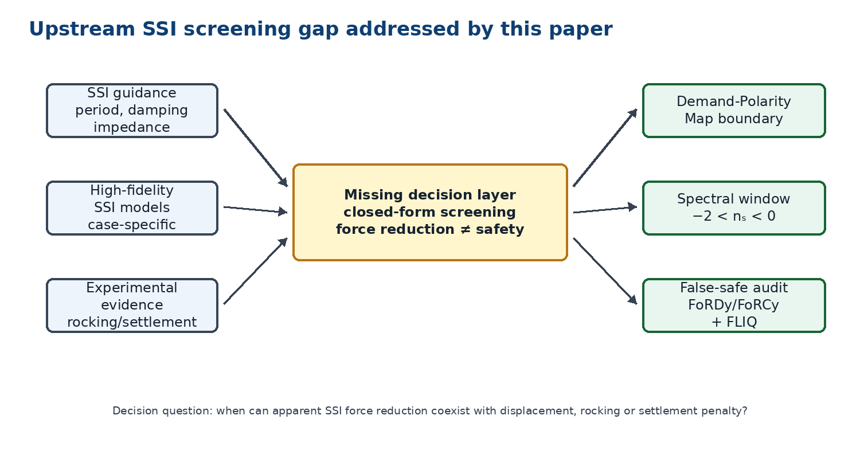
Figure 1. Screening gap addressed by the SSI Demand-Polarity Map.
2 Knowledge Gap and Contribution
The practical gap addressed here is not the observation that SSI can be beneficial or detrimental; that point is already established. The gap is a decision-level screening layer between design guidance, detailed simulations and experimental evidence: existing SSI guidance and high-fidelity models address period lengthening, foundation damping, impedance, rocking and response modification, but they do not provide a closed-form, experimentally audited demand-polarity map that separates force reduction from displacement, rocking or settlement penalty before detailed SSI modeling.
Tables 1 and 2 summarize the literature positioning and gap audit. The article makes four gap-driven earthquake-engineering contributions: (1) a closed-form demand-polarity boundary separating force reduction and total displacement amplification; (2) a spectral-shape interpretation of the mixed regime through the secant-slope window; (3) margin, robustness and false-safe metrics for conservative screening; and (4) a claim-bounded experimental audit using FoRDy/FoRCy, FLIQ and Garner as distinct positive, external and falsification layers.
Table 1. Recent SSI evidence used to delimit the novelty claim.
Source | Evidence type | Relevant finding | Implication for this paper
Mylonakis and Gazetas (2000) | Conceptual and analytical SSI synthesis | SSI can be beneficial or detrimental depending on response measure and system. | This paper cannot claim that dual beneficial/detrimental SSI behavior is new.
NIST/FEMA/ASCE guidance | Practice-oriented SSI provisions | Period elongation, damping, kinematic filtering and displacement-sensitive checks must be separated. | The criterion is framed as a preliminary screening aid, not a design substitute.
Zhang and Far (2024) | Finite-element high-rise study verified by shaking-table tests | Foundation rotation can reduce base shear while increasing inter-storey drift. | Independent support for force/displacement divergence.
Tao, Fu and Li (2024) | SDOF-foundation-half-space model and 42-earthquake case studies | Frequency shift can produce detrimental response amplification in a subset of cases. | Local spectral position must be treated as a limitation and control variable.
Yang et al. (2024) | ABAQUS time-history study of RC frame-shear-wall buildings | SSI can reduce shear while amplifying displacement, especially on softer sites. | External qualitative check for the mixed force-benefit/displacement-penalty region.
Table 2 then translates the identified knowledge gap into the specific response provided by the manuscript.

Table 2. Gap audit against SSI guidance, high-fidelity models and experimental databases.
Existing approach | What it provides | What remains missing | Gap filled by this paper
FEMA/NIST practical SSI guidance | Period lengthening, foundation damping and practical modeling guidance | No closed-form force-displacement polarity map; limited screening of false-safe force reduction | Demand-polarity map and false-safe screening
ASCE/FEMA code-type SSI reductions | Demand modification procedures and design checks | Force-oriented interpretation can obscure displacement or rocking penalty | Explicit separation of force-demand ratio and total-displacement ratio
High-fidelity nonlinear SSI models | Detailed case-specific dynamic response | Require data, expertise and computation before screening decision | Upstream pre-analysis screening criterion
Rocking-foundation experiments | Measured moment, rotation, settlement and energy dissipation | No general closed-form SSI demand-polarity classifier | Experimental proxy audit of polarity classes
ML/predictive rocking datasets | Data-driven performance prediction | Predictive but often not closed-form or interpretable for force-displacement polarity | Interpretable theorem plus class-screening validation
Field benchmarks such as Garner/EuroProteas | Sensor-level SFSI evidence | Data access and instrumentation limits; not always reusable for full validation | Falsification and claim-boundary protocol

3 Dimensionless Formulation

3.1 Minimum structural and foundation model
The superstructure is represented by effective mass, effective height, lateral stiffness and viscous damping:
$m, h_{e}, k_{s}, c_{s}$ (1)
The fixed-base circular frequency and period are:
$ω_{s}=\sqrt{\frac{k_{s}}{m}}, T_{s}=\frac{2π}{ω_{s}}$ (2)
The foundation is represented by horizontal and rotational stiffness terms:
where kₓ denotes horizontal stiffness and kθ denotes rotational stiffness.

3.2 Relative foundation flexibility
The two primary dimensionless groups compare structural stiffness with the horizontal and rotational flexibility of the soil-foundation system, following the usual impedance interpretation of surface and embedded foundations (Dobry and Gazetas, 1986; Pais and Kausel, 1988; Gazetas, 1991):
$k_{x}, k_{θ}$ (3)
$η_{x}=\frac{k_{s}}{k_{x}}$ (4)
$η_{θ}=\frac{k_{s}h_{e}^{2}}{k_{θ}}$ (5)
When the translational and rotational flexibility ratios tend to zero, the support approaches a fixed-base condition. As they increase, SSI becomes progressively more relevant.

3.3 Effective period with flexible foundation
The equivalent lateral stiffness is obtained by adding structural and foundation flexibilities in series:
$η=η_{x}+η_{θ}$ (6)
$\frac{1}{k_{eff}}=\frac{1}{k_{s}}+C_{g}$ (7)
Consequently, frequency decreases and the effective period increases:
$k_{eff}=\frac{k_{s}}{1+η}$ (8)
$ω_{SSI}=\frac{ω_{s}}{\sqrt{1+η}}$ (9)
In this linear screening model, foundation flexibility always elongates the fundamental period. Whether this elongation is beneficial depends on the spectral region and the additional damping and kinematic filtering provided by the soil-foundation system.

3.4 Soil and foundation dimensionless parameters
For an equivalent foundation radius, soil shear modulus, density and shear-wave velocity:
$T_{SSI}=T_{s}\sqrt{1+η}$ (10)
The most relevant groups are dimensionless frequency, mass ratio and relative slenderness:
$G=ρV_{s}^{2}, r_{0}=\sqrt{A/π}$ (11)
$a_{0}=\frac{ω_{s}r_{0}}{V_{s}}, μ=\frac{m}{ρr_{0}^{3}}, \overset{‾}{h}=\frac{h_{e}}{r_{0}}$ (12)
If impedance stiffnesses are expressed in normalized form:
$k_{x}=K_{x}Gr_{0}, k_{θ}=K_{θ}Gr_{0}^{3}$ (13)
the relative flexibilities can be written as:
$η_{x}=\frac{k_{s}}{K_{x}Gr_{0}}$ (14)
$η_{θ}=\frac{k_{s}h_{e}^{2}}{K_{θ}Gr_{0}^{3}}$ (15)
Interaction increases for heavier structures, softer soils, smaller foundations or more slender structural configurations.

3.5 Effective damping
The flexible foundation may add material and radiation damping. These contributions are sensitive to soil strain level, wave radiation and foundation embedment, so the present formulation treats damping as a screening variable rather than as a fixed benefit (Seed and Idriss, 1970; Kramer, 1996; Stewart et al., 1999). A useful screening approximation is:

3.6 Mathematical formulation and admissibility
The reduced theory is defined by the fixed-base period, the flexible-foundation period, the period-lengthening factor λ, the flexibility index η, and the positive combined demand modifier χ. The admissible domain requires positive periods, λ ≥ 1, η ≥ 0, χ > 0, positive spectral ordinates over the interval of interest, and a symmetric positive-semidefinite foundation compliance matrix. Negative foundation flexibility, non-positive spectral ordinates or non-positive damping/kinematic modifiers are inadmissible.
Foundation flexibility is connected to continuum or impedance models through a foundation compliance matrix. For a generalized lateral force and rocking moment, the matrix maps applied actions into foundation translation and rotation. The equivalent generalized foundation displacement at the effective height combines translation and rocking, and the resulting generalized compliance defines η through the structural stiffness. This bridge includes translation, rocking and translation-rocking coupling.
Damping and kinematic interaction are not hardwired into the theorem. They enter through a positive combined modifier χ. A damping model may be introduced through an effective damping reduction function, and kinematic filtering may be represented through a positive foundation-input interaction factor. Different empirical or code-based choices shift the spectral-slope boundaries through χ, but do not change the topology of the demand-polarity map.
Within the linear SDOF-equivalent spectral framework, spectral displacement is proportional to the square of period times spectral acceleration. Therefore, period elongation introduces the factor λ² in the total-displacement demand ratio. When the force-demand ratio is defined with the same spectral interval and demand modifier, the total-displacement ratio becomes λ² times the force-demand ratio. This relation holds for the same effective generalized coordinate; it is not a direct prediction of MDOF interstory drift.
Theorem 1, SSI demand-polarity theorem. For an admissible flexible-foundation SDOF system with positive period lengthening, the mixed force-beneficial/displacement-detrimental regime occurs exactly when the force-demand ratio lies between the displacement-neutral boundary and unity. Equivalently, in the unmodified secant-slope case, the mixed regime occupies the spectral-slope window −2 < nₛ < 0.
Proof. Force reduction requires the force-demand ratio to be below unity. Displacement penalty requires the total-displacement ratio to be above unity. Combining these two inequalities gives the mixed-regime boundary. Substitution of the period-lengthening relation converts the condition into the flexibility-based boundary; substitution of the secant spectral-slope expression gives the slope-window form.
Corollary 1, asymmetry of demand polarity. For positive period lengthening, the total-displacement ratio is always larger than the force-demand ratio by the period-elongation factor. Therefore, a force-detrimental but total-displacement-beneficial case is impossible within the reduced model. The rocking fraction changes the partition of foundation translation and rocking but, for fixed total flexibility, does not change the force-total-displacement polarity class.
The secant slope is the logarithmic average of the spectral slope over the interval traversed by period elongation. It therefore captures the actual spectral change between the fixed-base and flexible-foundation periods. The local slope is retained only as a Level 1 approximation when the full interval is not available.
The local-slope error is controlled by spectral curvature over the period-elongation interval. Robust classification is reported by comparing the distance to the nearest polarity boundary against an uncertainty allowance that combines demand-modifier uncertainty, slope uncertainty and period-elongation uncertainty.
Table 3 lists the admissibility requirements, limiting cases and robustness checks used to keep the closed-form map within its valid domain.
Table 3. Mathematical admissibility, limiting cases and robustness checks.
Case or condition | Result | Interpretation
η = 0 | λ = 1 | Fixed-base limit is recovered.
χ = 1, nₛ = 0 | Rᵥ = 1 and total-displacement ratio = λ² | Acceleration plateau: force neutral, displacement increases.
χ = 1, nₛ = -1 | Rᵥ = 1/λ and total-displacement ratio = λ | Velocity-sensitive branch: force decreases, displacement increases.
χ = 1, nₛ = -2 | Rᵥ = 1/λ² and total-displacement ratio = 1 | Constant-displacement boundary.
χ = 1, nₛ < -2 | Rᵥ < 1/λ² | Force and total displacement both decrease.
Rᵥ > 1 | total-displacement ratio > 1 | Both force and total displacement are detrimental.
$η≥0, λ≥1, χ>0, S_{a}\left(T\right)>0, C_{f}=C_{f}^{T}≽0$ (16)
Additional damping can reduce demand, but flexibility without meaningful dissipation may eliminate the apparent benefit of SSI.

4 Response Criteria

4.1 Force-demand criterion
For the fixed-base case, the base shear demand is:
$V_{fix}=mS_{a}\left(T_{s}\right)$ (17)
For the flexible-base case, the corresponding demand is:
$V_{flex}=mχS_{a}\left(T_{SSI}\right)$ (18)
The dimensionless demand ratio is therefore:
$R_{V}=\frac{V_{flex}}{V_{fix}}$ (19)
A value below unity indicates improvement in force demand, whereas a value above unity indicates deterioration. Substitution of the effective period gives:
$R_{V}=χ\frac{S_{a}\left(T_{SSI}\right)}{S_{a}\left(T_{s}\right)}$ (20)

4.2 Total-displacement criterion
Structural displacement and total displacement must be distinguished. Foundation translation and rocking add to the structural deformation:
$Δ_{total}=Δ_{s}+Δ_{f}$ (21)
$Δ_{f}=u_{f}+h_{e}θ_{f}$ (22)
The normalized total-displacement ratio is:
$R_{δ,total}=\frac{S_{d}\left(T_{SSI}\right)}{S_{d}\left(T_{s}\right)}=λ^{2}R_{V}=\left(1+η\right)R_{V}$ (23)
The total-displacement condition is stricter than the force-demand condition because the flexibility term adds a positive contribution. Foundation translation and rocking contributions are:
$u_{f}=C_{x}V$ (24)
$h_{e}θ_{f}=C_{θ}h_{e}^{2}V$ (25)
This explains the mixed response often observed in SSI: base shear may decrease while total displacement and rocking demand increase.

4.3 Local and secant spectral-slope formulations
The effect of period elongation depends on the logarithmic slope of the acceleration spectrum over the period interval that the SSI shift actually traverses. A local slope around the fixed-base period is a useful first-level approximation when only limited spectral information is available. When the design or record spectrum is known between the fixed-base and elongated periods, a secant slope over that interval is the recommended second-level estimate because it captures spectral curvature and branch changes more directly (CEN, 2004; ASCE/SEI, 2022):
$n_{loc}={\left.\frac{dlnS_{a}}{dlnT}\right|}_{T_{s}}$ (26)
If the spectrum is approximated locally by a power law,
$\frac{S_{a}\left(T_{SSI}\right)}{S_{a}\left(T_{s}\right)}≈λ^{n_{loc}}$ (27)
then the force and displacement ratios can be approximated as:
$R_{V}≈χλ^{n_{loc}}$ (28)
$R_{δ,total}≈χλ^{n_{loc}+2}$ (29)
For Level 2 screening, the secant slope is computed as $n_{sec}=ln\left[S_{a}\left(T_{SSI}\right)/S_{a}\left(T_{s}\right)\right]/ln\left(T_{SSI}/T_{s}\right)$. This expression uses the actual spectral change over the period-elongation interval and is therefore preferred when the spectrum is available.
Table 4 lists the spectral regions used to interpret the expected force-demand and total-displacement response.
Table 4. Spectral regions and expected response of force demand and total displacement.
Spectral region | Slope | Force response | Total displacement
Ascending branch | n > 0 | Force demand worsens | Total displacement worsens
Acceleration plateau | n approx. 0 | Nearly unchanged | Worsens
Constant velocity range | n approx. -1 | Improves | Usually worsens
Constant displacement range | n approx. -2 | Improves strongly | Nearly unchanged
Steeper descending branch | n < -2 | Improves | May improve

4.4 SSI Demand-Polarity Map and divergence margin
The proposed map converts the force/displacement criterion into a closed-form demand-polarity statement. Let λ = Tₛₛᵢ/Tₛ = √(1 + η), where η is the dimensionless flexibility contribution. With the reduced-order displacement relation Rδ,total = λ² Rᵥ = (1 + η) Rᵥ, the mixed SSI regime is bounded by 1/(1 + η) < Rᵥ < 1. In this regime, seismic force demand decreases while total displacement demand increases.
This result gives four demand-polarity regimes. If Rᵥ < 1/(1 + η), force and total displacement both decrease. If 1/(1 + η) < Rᵥ < 1, force decreases but total displacement increases. If Rᵥ > 1, force and total displacement both increase. Under positive period lengthening, η > 0, the opposite mixed case, force-detrimental but total-displacement-beneficial SSI, is impossible within the reduced-order model because Rδ,total = (1 + η) Rᵥ.
Writing the force ratio as Rᵥ = χ λⁿˢ links the same result to spectral shape, damping and kinematic filtering. The mixed-regime window becomes -2 - ln(χ)/ln(λ) < nₛ < -ln(χ)/ln(λ). For the unmodified case χ = 1, this reduces to -2 < nₛ < 0. Thus, the mixed SSI regime is not an arbitrary numerical outcome; it is the spectral-slope interval between constant total displacement and constant force.
Beyond binary classification, the force-displacement divergence margin is defined as MF = -ln Rᵥ, MD = ln Rδ,total, and Mmix = min(MF, MD). Positive Mmix flags the mixed regime with positive margin. The curvature indicator Cn = |nₛₑc - nₗₒc| is used to decide whether the Level 1 local approximation is adequate or whether the Level 2 secant formulation should control the screening decision.
Table 5 summarizes the novelty audit against existing SSI approaches before the reproducibility protocol is introduced.
Table 5. Novelty audit against existing SSI approaches.
Approach | What it provides | What remains missing | Contribution of this paper
FEMA/NIST/ASCE SSI guidance | Period lengthening, damping and modelling guidance | No closed force-displacement polarity map by spectral slope | SSI Demand-Polarity Map as a pre-analysis diagnostic.
Nonlinear FE SSI studies | High-fidelity case-specific response | No compact closed boundary for screening | Reduced-order theorem 1/(1 + η) < Rᵥ < 1.
Beneficial/detrimental SSI literature | Evidence that SSI can help or hurt | Limited operational separation of force and total displacement | Closed secant-slope window -2 < nₛ < 0 for the unmodified mixed regime.
Frequency-shift studies | Warning that period/frequency shift can change response | No direct force-displacement polarity metric | Divergence margin and curvature-aware local/secant workflow.
Field SFSI benchmarks | Experimental and field-scale validation pathways | Not a universal screening criterion by themselves | Target variables λ, nₛ, Rᵥ and total-displacement ratio for future benchmark extraction.

5 Methodological framework
The study uses a claim-bounded evidence hierarchy rather than treating every check as validation. The core sequence is: mathematical verification, spectral consistency, controlled synthetic stress testing, external consistency mapping, solver-backed class prediction, experimental proxy-class validation, and field-benchmark falsification. The full evidence hierarchy, pass/fail gates, ablation controls, and claim-evidence traceability matrix are moved to Supplementary Material Section S4 to keep the main text focused.
The main manuscript reports only the gates that affect the article claims: the closed-form demand-polarity theorem must pass identity checks; the secant-slope formulation must outperform local-slope screening in curved spectra; experimental proxy validation must maintain a low false-safe rate; and field benchmarks that do not pass instrumental or predictive gates are reported as falsification, not as validation. This structure keeps the article reproducible while preventing overclaiming.

6 Sensitivity and Controlling Parameters
The logarithmic sensitivity of force demand to each flexibility component is obtained by differentiating the response ratio. This sensitivity framing also supports the use of structured parametric sweeps and error diagnostics rather than isolated examples (Ang and Tang, 2007; Montgomery, 2017; Saltelli et al., 2008; Melchers and Beck, 2018):
$\frac{∂lnR_{V}}{∂η}=\frac{n_{s}}{2\left(1+η\right)}+\frac{∂lnχ}{∂η}$ (30)
$\frac{∂lnR_{δ,total}}{∂η}=\frac{n_{s}+2}{2\left(1+η\right)}+\frac{∂lnχ}{∂η}$ (31)
The three terms represent the spectral effect, the damping effect and the kinematic filtering effect. For total displacement an additional positive term appears:
$\frac{∂lnR_{δ,total}}{∂η}=\frac{∂lnR_{V}}{∂η}+\frac{1}{1+η}$ (32)
The controlling dimensionless variables are summarized as follows:
$\{η,λ,χ,n_{s},M_{F},M_{D},M_{mix}\}$ (33)
$M_{F}=-lnR_{V}$ (34)
$M_{D}=lnR_{δ,total}$ (35)
$M_{mix}=min\left(M_{F},M_{D}\right)$ (36)
$C_{n}=\left|n_{sec}-n_{loc}\right|$ (37)
$FalseSafe=\frac{N\left(\hat{y}=beneficial, y≠beneficial\right)}{N}$ (38)
$MixedRecall=\frac{TP_{mixed}}{TP_{mixed}+FN_{mixed}}$ (39)
$SafePrecision=\frac{TP_{beneficial}}{TP_{beneficial}+FP_{beneficial}}$ (40)
Poisson ratio, embedment ratio, effective damping and kinematic filtering may also influence the criterion and should be reported when the method is applied.

7 Verification and consistency checks
The submission presents the criterion with a reproducible numerical verification package. The minimum model is a normalized SDOF system with flexible translational and rocking foundation degrees of freedom, compared against fixed-base response under idealized and record-derived spectra. The workflow distinguishes internal verification, synthetic spectral stress testing, direct spectral consistency checks, external qualitative consistency checks and an external quantitative consistency mapping. This terminology is intentional: the numerical grids verify the reduced-order equations, whereas independent predictive validation of real SSI behavior requires broader finite-element, experimental or field evidence. The public repository version aligned with this submission is fixed at https://github.com/gabrielmontufar/a-dimensionless-criterion-for-supplementary, tag article116-v40-submission-reproducible. The release package is article116_v40_submission_reproducible and its static files are indexed in MANIFEST_SHA256.csv.
Table 6 defines the reproducible verification elements required to make the screening criterion auditable.
Table 6. Reproducible verification and consistency-check elements reported for the screening criterion.
Verification element | Required reporting
Model | Linear SDOF superstructure with horizontal and rocking foundation flexibility; not a nonlinear SSI design model.
Parameters | Translational flexibility, rotational flexibility, soil damping, mass ratio, slenderness and spectral slope.
Outputs | Base shear ratio, structural displacement ratio, total displacement ratio and rocking contribution.
Comparison | Fixed-base response versus flexible-base response for each normalized parameter set.
Reproducibility | Report parameter ranges, equations, scripts or pseudocode and tabulated response maps.

7.1 Internal dimensionless verification
The verification protocol was executed as a normalized benchmark rather than left as a future requirement. The sweep used 21 values of total flexibility η from 0 to 2, 21 values of local spectral slope n from -3 to 1, and four damping-gain levels d from 0.00 to 0.15, producing 1,764 response cases. The response ratios were computed from the period-elongation factor, the spectral-slope approximation and the bounded damping-reduction factor C_d = max(0.45, 1 - d*η/(1+η)); the total-displacement response additionally accounted for the added foundation displacement component. This benchmark is dimensionless and verifies the internal decision criterion; it does not by itself validate nonlinear soil-foundation-structure behavior.
Figure 2 shows the resulting SSI Demand-Polarity Map used to separate force-side and displacement-side screening outcomes.
Figure 2. Seismic SSI Demand-Polarity Map. For the unmodified case χ = 1, the mixed force-beneficial/displacement-detrimental regime occupies the secant-slope window −2 < nₛ < 0, between the constant-displacement boundary nₛ = −2 and the constant-force boundary nₛ = 0. Overlaid markers show experimental proxy classes from FoRDy and FoRCy.
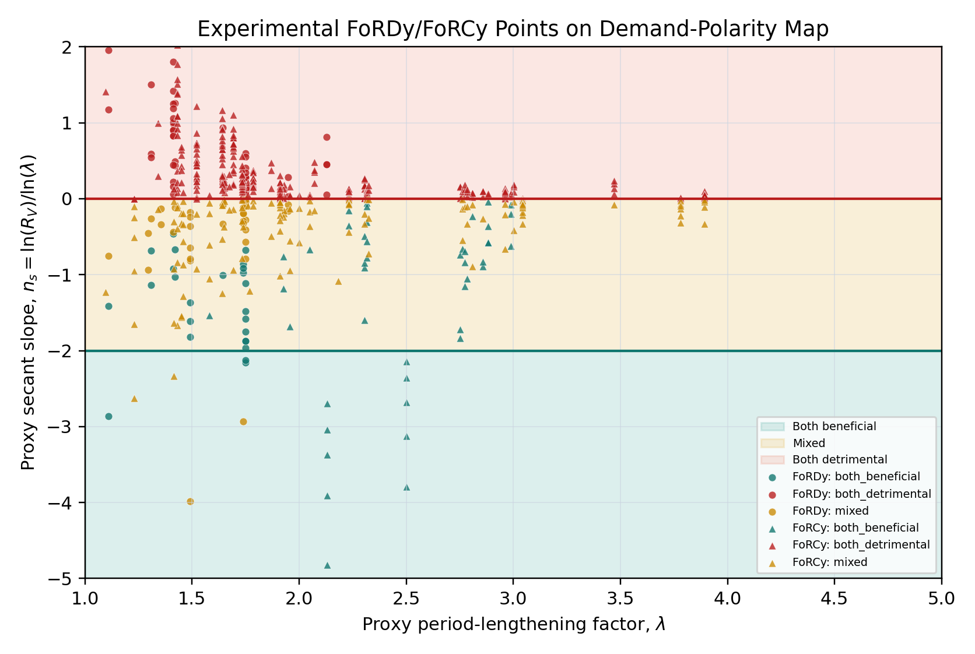
Table 7 summarizes the benchmark. The key result is that force-demand improvement is common, but total-displacement improvement is much less common. For zero damping gain, 68.0% of the grid reduced force demand, whereas only 23.6% reduced total displacement. Across all damping levels, approximately 44-45% of all cases were mixed: base shear improved while total displacement still deteriorated. This supports the central claim that flexible foundations cannot be judged beneficial from force reduction alone.
Table 7. Dimensionless benchmark summary by damping-gain level.
Damping gain | Grid points | Force beneficial (%) | Total displacement beneficial (%) | Mixed cases (%)
0.00 | 441 | 68.0 | 23.6 | 44.4
0.05 | 441 | 72.6 | 27.2 | 45.4
0.10 | 441 | 72.6 | 27.2 | 45.4
0.15 | 441 | 76.2 | 30.8 | 45.4

Figure 2 gives the closed-form SSI Demand-Polarity Map, which is the central novelty figure. Figures 3 and 4 provide the reproducible response maps for the no-added-damping case before the direct consistency-check subsection. Figure 3 shows the seismic force-demand ratio, whereas Figure 4 shows the total-displacement ratio.
Figure 3. Dimensionless seismic force-demand ratio for zero damping gain.
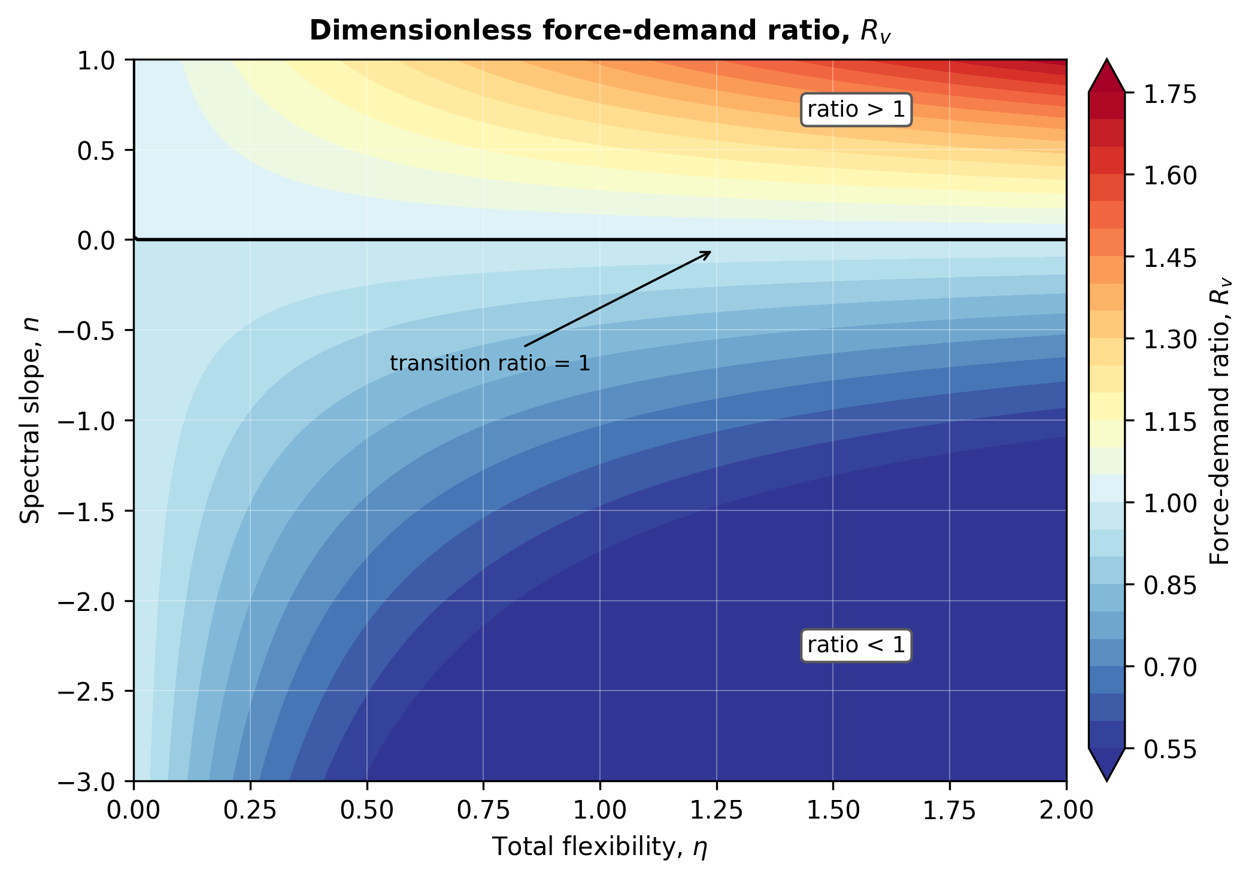
Figure 4. Dimensionless total-displacement ratio for zero damping gain.
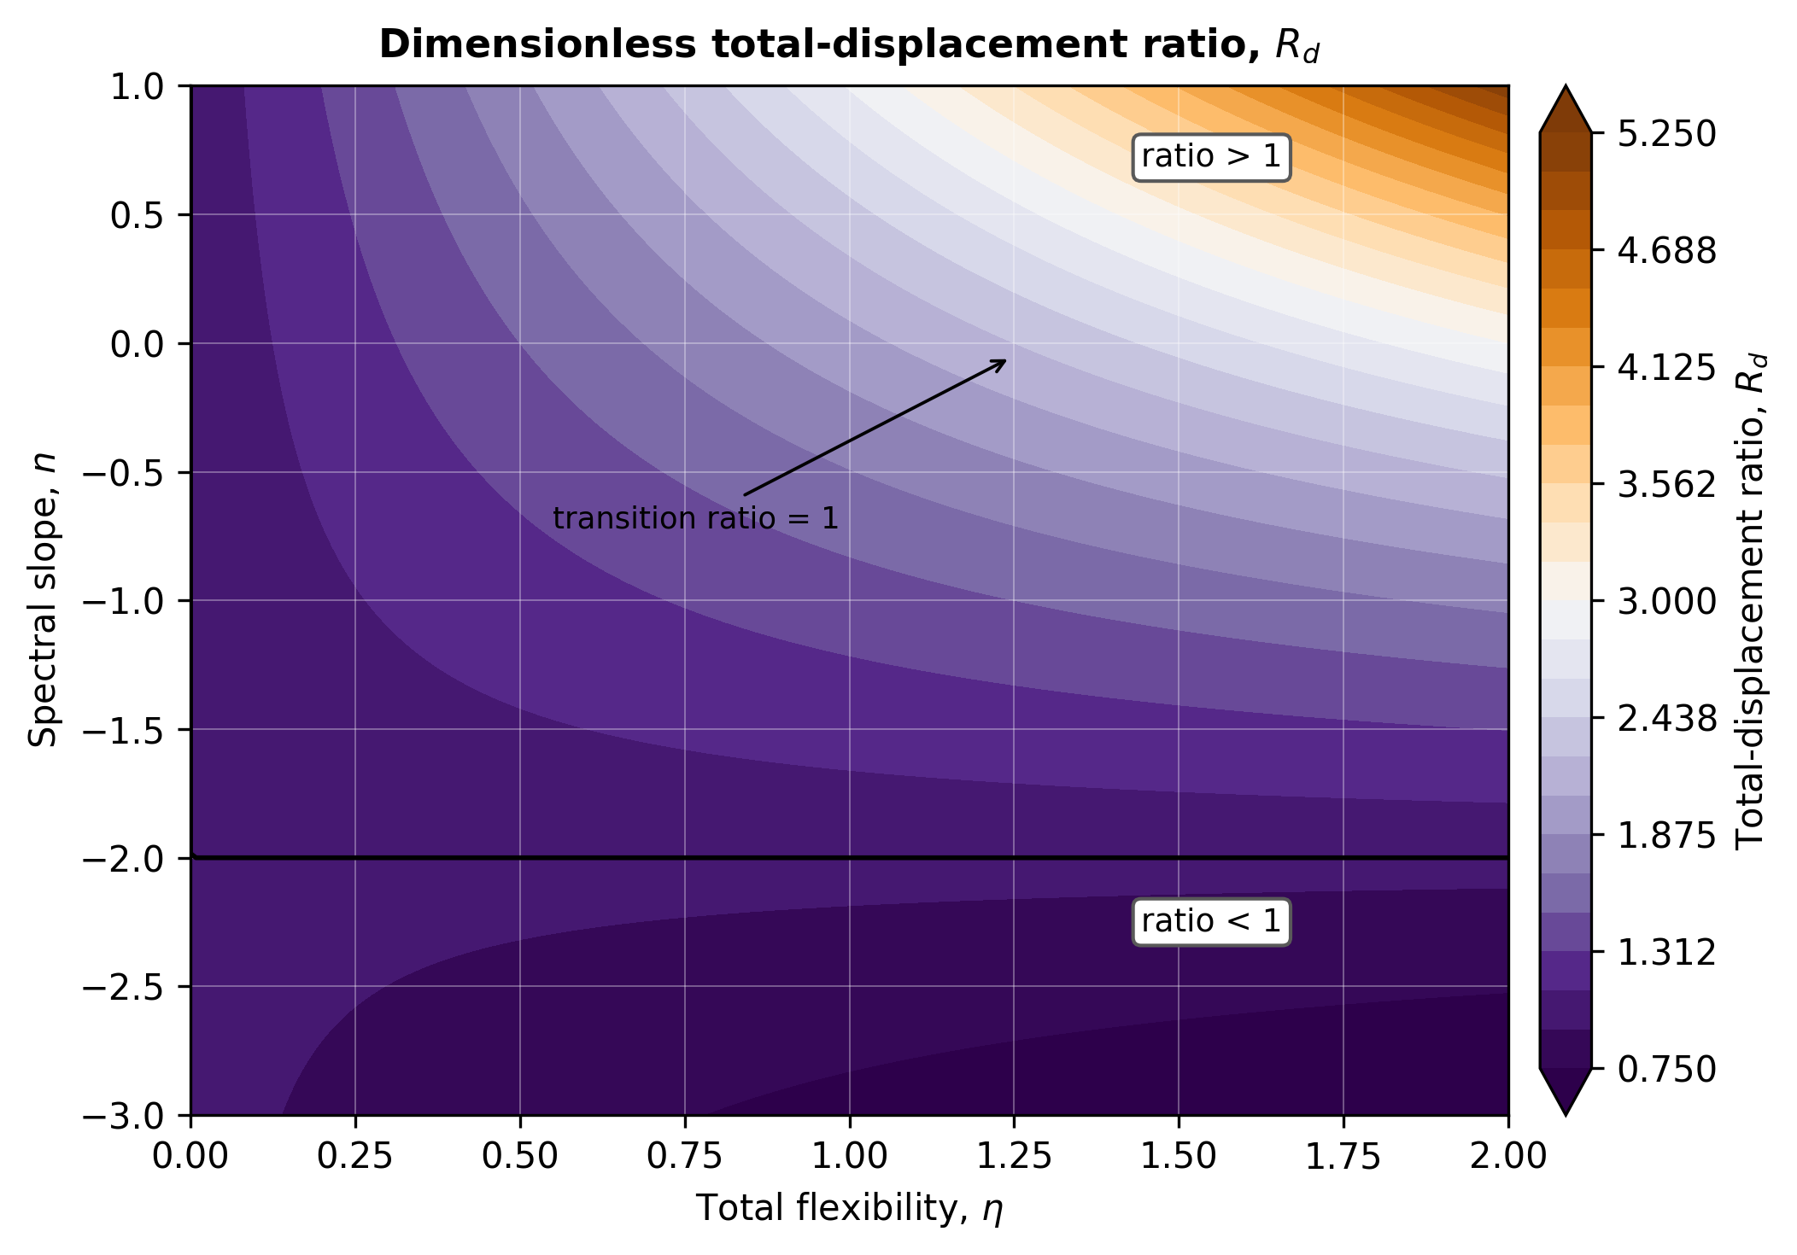

7.2 Direct spectral consistency check
A second phase tested the criterion against direct spectral ratios rather than only the algebraic slope grid. The set included one normalized code-compatible spectrum and three public El Centro components from Vibrationdata. The analysis varied fixed-base period, total flexibility, rocking partition, kinematic filtering and damping gain, producing 7,680 rows. Because the rocking partition changes the split between translation and rocking but does not change force ratio or total-displacement ratio, these rows correspond to 1,536 unique force/displacement classification cases. Force-class agreement with the local-slope approximation was 82.16%. The mean absolute force-ratio error was 0.174, and mixed behavior remained dominant: force reduction often coexisted with total-displacement increase. The El Centro EW and NS components are explicitly weaker cases and are reported by source rather than hidden in the aggregate result.
Table 8 reports the direct spectral consistency-check metrics by source. These values keep the weaker El Centro EW/NS components visible rather than hiding them in the aggregate result.
Table 8. Direct spectral consistency-check metrics by source.
Source | Rows | Unique cases | Accuracy (%) | Mean error | Max error
Code | 1,920 | 384 | 97.40 | 0.055 | 0.341
El Centro | 1,920 | 384 | 91.41 | 0.214 | 0.805
El Centro EW | 1,920 | 384 | 69.53 | 0.270 | 0.896
El Centro NS | 1,920 | 384 | 70.31 | 0.158 | 0.643
The local-versus-secant slope diagnostic is treated as part of the proposed screening workflow, not as a decorative post-processing check. Across the direct spectral check, force-class agreement increases from 82.16% with the local slope to 97.79% with a secant slope between the fixed-base and elongated periods; for El Centro EW it increases from 69.53% to 97.40%, and for El Centro NS from 70.31% to 97.92%. Accordingly, the local formulation is retained as a Level 1 screen for early-stage assessment, whereas the secant formulation is recommended as Level 2 when a design spectrum or record-derived spectrum is available over the interval from Tₛ to Tₛₛᵢ.
The complete spectral consistency-check files and the original El Centro input records are supplied in the supplementary evidence package and public repository.

7.3 Expanded synthetic spectral stress test
To test whether the direct consistency-check result was overly dependent on the El Centro records, an expanded synthetic spectral stress test combined the previous public-record/code-spectrum cases with 12 additional code-compatible spectral shapes. These synthetic spectra are not claimed as real records or predictive validation; they are reproducible stress tests designed to cover short plateau, long plateau, soft-soil, stiff-soil, near-fault-like, descending-dominant and high-curvature spectral forms. The expanded suite produced 30,720 rows across 16 spectral sources, corresponding to 6,144 unique force/displacement classification cases after removing the rocking-partition duplication. Force-class agreement was 93.64% and the mean absolute force-ratio error was 0.063, but the error distribution and per-source metrics show that record-derived spectra are more demanding than many synthetic spectra. The expanded benchmark therefore supports mathematical plausibility over controlled spectral shapes within the reduced-order model, not final predictive evidence for design use.
Table 9 reports the expanded synthetic spectral stress-test diagnostics used to evaluate robustness beyond the initial record set.
Table 9. Expanded synthetic spectral stress-test diagnostics.
Rows | Unique cases | Spectral sources | Accuracy (%) | Mean |error| | Interpretation
30,720 | 6,144 | 16 | 93.64 | 0.063 | Synthetic stress test plus record-derived checks; not full external verification.
The expanded synthetic stress-test files are supplied in the supplementary evidence package and public repository, including expanded_stress_test_cases.csv, expanded_stress_test_by_source.csv, expanded_stress_tesT_{s}ummary.json, consistency-audit metrics and expanded_synthetic_stress_test_response_categories.png.

7.4 External quantitative consistency mapping
Table 10 reports the external quantitative consistency mapping obtained from published SSI cases.
Table 10. External quantitative mapping using published SSI cases.
Case | η | Tₛₛᵢ/Tₛ | Rᵥ obs. | Mapped class
FCT20 HWR6 De | 0.329 | 1.153 | 0.493 | Force benefit / displacement penalty
FCT30 HWR6 De | 0.214 | 1.102 | 0.963 | Near-boundary force benefit / displacement penalty
FCT40 HWR6 De | 0.317 | 1.148 | 0.542 | Force benefit / displacement penalty
FSW30 HWR6 De | 0.389 | 1.179 | 0.695 | Force benefit / displacement penalty
FSW40 HWR6 De | 0.330 | 1.153 | 0.902 | Near-boundary force benefit / displacement penalty

8 Discussion
The gap filled is decision-level screening, not response-history prediction. The criterion is useful because it gives an upstream, auditable and reproducible way to flag when apparent SSI force reduction should not be interpreted as displacement or rocking safety without further modeling.
The proposed criterion clarifies why SSI cannot be classified as beneficial or detrimental without specifying the performance measure. A reduction in base shear may coexist with an increase in total displacement because foundation translation and rocking contribute directly to displacement demand. Similar caution appears in practical SSI guidance and site-response studies, where period elongation, foundation damping and kinematic filtering interact with spectral shape and structural performance objectives (Kim and Stewart, 2003; Aviles and Perez-Rocha, 2003; Pitilakis et al., 2008; Kausel, 2010; Givens et al., 2016).
The formulation is intentionally compact. Its main use is preliminary screening, parametric interpretation and identification of cases where fixed-base analysis may be misleading. Detailed performance assessment of important structures still requires more refined SSI models, soil nonlinearity, radiation damping, multi-degree-of-freedom structural behavior and site-specific ground motions.

8.1 Linear continuum-to-reduced-order solver consistency envelope
To test whether the proposed dimensionless parameter remains consistent when foundation flexibility is obtained from a continuum model, an additional dual-solver validation envelope was added to the supplementary materials. CalculiX 2.23 was used to compute linear-elastic translational and rocking stiffnesses for a rigid square foundation on a three-dimensional soil block. The soil cases used Vs = 150, 300 and 600 m/s with B = 12 m; a medium/fine mesh check for the reference case gave a maximum symmetric stiffness change of 9.66%, while the rocking change is 10.15% when referenced only to the fine-mesh value.
The resulting FE-based horizontal and rocking stiffness values were passed to an OpenSeesPy reduced-order SDOF model. Across 27 record/case combinations, the OpenSees modal period matched the reduced expression for flexible-to-fixed period elongation within numerical precision. This supports the internal consistency of the flexibility-based period-elongation relationship when the foundation stiffnesses are obtained from an independent continuum solver.
Code_Aster 17.4 was retained as a locked blind cross-check: hashes of the CalculiX and OpenSees outputs were stored before any cross-solver comparison. Therefore, this evidence is best described as a reproducible linear validation envelope and solver-chain check. It is not a nonlinear site-specific three-dimensional SSI validation and does not convert the criterion into a calibrated design rule.

8.2 External field SFSI benchmark traceability and validation targets
To separate internal solver verification from external benchmark traceability, a field-benchmark source layer was added to the supplement. Garner Valley SFSI/GVDA is used as the primary field SSI benchmark source because the public UCSB facility pages document a reconfigurable steel-frame structure on a rigid slab, active roof-shaker experiments, passive earthquake monitoring, downhole/free-field instrumentation, geotechnical logs, velocity profiles and water-table context (NEES@UCSB, n.d.; accessed 27 May 2026; Tileylioglu et al., 2011). This evidence is used as field benchmark traceability rather than as proof of nonlinear earthquake SSI.
EuroProteas/Euroseistest ERIES-GISIS was screened as a possible modern full-scale SFSI benchmark source, but it is not used as a positive validation layer in the submitted evidence hierarchy. ERIES-RESPOND and ERIES-POLIS remain secondary controlled-dynamic support where processed summaries are available, while FoRDy/FoRCy provide the primary experimental proxy-validation layer and Garner Valley remains a falsification/instrumentation audit.
The supplement now reports a source inventory, offline/online acquisition-status tables, a field-benchmark gap matrix, Garner Valley impedance-target mapping and EuroProteas transfer-target mapping. The defensible claim is therefore external field SFSI benchmark traceability and validation targets. It does not claim completed controlled dynamic field-SFSI validation or nonlinear 3D earthquake site-specific SSI validation unless future event-record extraction and sensor-level residuals support that stronger claim.

8.3 Implications for earthquake engineering practice
The proposed criterion is most useful as a pre-analysis screening tool. It can flag cases in which flexible-foundation period lengthening may reduce base-shear demand while increasing total displacement demand. The robustness rule uses min(|ln Rᵥ|, |ln Rδ,total|) relative to an uncertainty allowance before treating a case as decisively beneficial, mixed or detrimental. Cases near a boundary, cases with high spectral curvature, or cases with large uncertainty in χ should not be interpreted as automatically beneficial SSI cases. Instead, they should trigger more detailed checks of drift, foundation rotation, kinematic interaction, foundation uplift or sliding where relevant, and site-specific spectral shape. Ground-motion processing and spectral-shape interpretation are treated consistently with strong-motion simulation, processing and database guidance (Boore, 2003; Boore and Bommer, 2005; Ancheta et al., 2014).

8.4 SSI Demand-Polarity workflow for practice
The practical workflow is intentionally short. First, estimate the fixed-base period Tₛ and the flexible-foundation period Tₛₛᵢ from a simplified impedance model, an FE stiffness extraction or an accepted design approximation. Second, compute λ = Tₛₛᵢ/Tₛ and η = λ² - 1. Third, use a local spectral slope for Level 1 screening when only preliminary spectral information is available. Fourth, when a design spectrum or record spectrum is available, compute the secant slope nₛₑc = ln(Sa(Tₛₛᵢ)/Sa(Tₛ)) / ln(Tₛₛᵢ/Tₛ). Fifth, evaluate Rᵥ, Rδ,total and Mmix, then classify the case as both beneficial, mixed force-beneficial/displacement-detrimental, or both detrimental. Its screening role is aligned with design-code and practice documents that treat SSI as a modeling decision requiring bounded assumptions rather than an automatic benefit (ASCE/SEI, 2022; CEN, 2004; FEMA, 2020; NIST, 2012).
Cases in the mixed zone, cases with positive divergence margin, and cases with high C_{n} should trigger detailed SSI checks rather than a force-only beneficial interpretation. The follow-up analysis should examine drift, foundation rotation, kinematic interaction, uplift or sliding where relevant, nonlinear soil response and site-specific spectral shape.

8.5 Validation and claim-boundary summary
The validation strategy is deliberately claim-bounded. FoRDy/FoRCy provide experimental proxy-class validation for the force-displacement/rocking polarity map; an independent predictive proxy layer tests conservative class screening using pre-response descriptors; FLIQ is used as an external false-safe audit for settlement/rotation penalties; and Garner Valley is retained as a validation-falsification audit because the available sensor subset did not pass instrumental and predictive gates. Extended tables, failure-mode details, guardrail analyses and secondary figures are provided in Supplementary Material Section S5.
Table 11. Claim-bounded validation evidence retained in the shortened main manuscript.
Evidence layer | Dataset or source | Main metric | Result | Claim supported
Experimental proxy validation | FoRDy/FoRCy | Combined false-safe | 2.2% | Class-level proxy validation
Predictive proxy screening | FoRDy/FoRCy subset | False-safe / mixed recall | 5.67% / 89.6% | Conservative predictive class screening
Failure-mode guardrails | FoRDy/FoRCy | False-safe releases | reduced under guardrails | Conservative escalation/abstention
External settlement audit | FLIQ | Guardrail false-safe | 8.7% | External false-safe audit
Field falsification | Garner Valley | Instrumental/predictive gates | not passed | No nonlinear 3D validation claim
Accordingly, the article claims predictive class screening and experimental proxy-class validation. It does not claim nonlinear three-dimensional SSI response-history validation or independent prediction of complete sensor histories.

8.6 Scope and claim boundaries
The proposed method is a seismic SSI predictive class-screening criterion with a deliberately restricted domain. The mathematical results are exact only within the stated linear SDOF-equivalent spectral framework with η ≥ 0, λ ≥ 1, χ > 0, positive spectral ordinates and an admissible symmetric positive-semidefinite foundation compliance matrix. Detailed nonlinear MDOF drift, uplift, sliding, pore-pressure generation and three-dimensional foundation response remain follow-up analyses for cases flagged as mixed, detrimental or uncertain. The local formulation is a first-order approximation to the secant formulation; its error is controlled by spectral curvature over the interval from Tₛ to Tₛₛᵢ, not by period shift alone. The need for such bounded screening is consistent with established cautions on foundation impedance idealization, soil nonlinearity and SSI model selection (Gazetas, 1983; Wolf and Deeks, 2004). Related nonlinear and practice-oriented assessment frameworks also motivate keeping screening separate from detailed performance assessment (FEMA, 2005).
The external evidence is therefore used in two tiers. Zhang and Far (2024) provide a quantitative consistency mapping because their published natural-period and force-ratio relationships allow flexibility and force-ratio cases to be computed reproducibly; their text and figures also report amplified inter-storey drift, although exact case-level drift ratios are not tabulated. Yang et al. and Tao et al. provide qualitative consistency evidence about the mixed beneficial/detrimental interpretation of SSI.

9 Conclusions
This article formulated an SSI Demand-Polarity Map for evaluating when flexible-foundation period lengthening improves or deteriorates different components of seismic demand. The central closed-form result is that the mixed force-beneficial/displacement-detrimental regime is bounded by 1/(1 + η) < Rᵥ < 1. Equivalently, when the force ratio is written as Rᵥ = χ λⁿˢ, the mixed regime satisfies -2 - ln(χ)/ln(λ) < nₛ < -ln(χ)/ln(λ); for the unmodified case χ = 1, this reduces to -2 < nₛ < 0. The final evidence layer adds executed FoRDy/FoRCy experimental proxy validation from public DesignSafe rocking-foundation mastersheets, yielding 591 classified rows and a combined false-safe rate of 2.2%, while explicitly preserving the limitation that the validation is class-level and proxy-based.
The numerical evidence supports this bounded interpretation. The internal verification sweep, direct spectral consistency check, expanded synthetic spectral stress test, external mapping, methodological gates, FoRDy/FoRCy proxy validation, independent predictive screening, decision-value audit and failure-mode guardrail audit are consistent with the conclusion that flexible foundations can reduce force demand while increasing displacement-sensitive response. The decision-value audit adds a risk-aware interpretation: relative to an optimistic force-only rule, the map reduces false-safe screening decisions by 94.1% in the FoRDy/FoRCy proxy layer. The failure-mode atlas further shows that the remaining false-safe releases concentrate in low-margin beneficial predictions; a map-derived margin guardrail eliminates the observed false-safe releases at 3.85% abstention/escalation cost. The subsequent Garner Valley audit is retained as negative evidence, rejecting the current OpenSeesPy Garner implementation under blind waveform, FRF, phase, polarity and auxiliary-sensor gates. The article therefore claims a reproducible protocol, an experimentally supported proxy classification map and risk-aware screening safeguards, not a successfully validated nonlinear 3D site-specific Garner Valley simulation. The FLIQ audit adds an independent liquefaction-oriented check showing that apparent acceleration-side benefit can hide settlement/rotation penalties, further supporting the false-safe framing of the screening criterion.
The most distinctive practical contribution is therefore not a larger numerical model, but a falsification-aware release rule for SSI screening: force reduction is not treated as safe unless the displacement-side evidence also clears the map and guardrail checks.Data availability statement This closes the scientific gap targeted in the introduction: a conservative, closed-form screening layer connecting period lengthening, spectral slope, force reduction and displacement/rocking penalty with explicit false-safe metrics.
The verification scripts, spectral checks, stress-test outputs, external mapping tables, FoRDy/FoRCy mastersheets, proxy-validation metrics, false-safe audit, threshold-sensitivity audit, independent predictive screening outputs, decision-value audit tables, failure-mode guardrail audit, FLIQ false-safe audit and figures are available in the submitted article116_v40_submission_reproducible package and public repository (https://github.com/gabrielmontufar/a-dimensionless-criterion-for-supplementary, tag article116-v40-submission-reproducible).
Garner Valley remains a validation-falsification and instrumentation-audit case; FoRDy/FoRCy are the primary experimental proxy-validation layer, with FLIQ, decision-value and failure-mode guardrail analyses used as secondary risk-aware screening audits. No nonlinear 3D site-specific field-validation claim is made.
Large third-party raw archives are not redistributed when dataset licenses or practical size constraints make repository bundling inappropriate. The supplement instead provides source URLs, DOI/license or rights status, acquisition manifests, hashes where applicable and claim boundaries.

Code availability
The public repository separates fast checks, offline reproduction and optional online metadata refresh. For the whole supplementary package, run `python scripts/quick_check.py`. For the experimental validation layer, run `python scripts/quick_check.py` to verify packaged outputs without recomputation, `python validation/experimental_database_validation/reproduce_experimental_validation.py` to regenerate FoRDy/FoRCy metrics from bundled mastersheets, and `optional online metadata-refresh scripts` only when refreshing public web metadata. The online refresh is not required to reproduce the reported FoRDy/FoRCy results.

Supplementary material
The complete supplementary material, including reproducibility scripts, packaged outputs, external literature consistency audit files, traceability tables and generated figures, is provided in the submitted article116_v40_submission_reproducible package and in the public GitHub repository: https://github.com/gabrielmontufar/a-dimensionless-criterion-for-supplementary (tag article116-v40-submission-reproducible).

Statements and Declarations
Author contribution statement: G.J.M.C. conceived the study, developed the methodology, implemented the computational scripts, performed the formal analysis, verification, spectral consistency checks, external qualitative consistency checks and external quantitative consistency mapping, prepared the figures and tables, wrote the original manuscript draft, and reviewed and edited the final manuscript.
Generative AI and AI-assisted technologies: Generative artificial intelligence tools were used to support language editing, organization and formatting. The author reviewed, verified and takes responsibility for the final content.

References
Allmond, J., Kutter, B., Bray, J., and Hayden, C. (2015). FLIQ-Foundation and Ground Performance in Liquefaction Experiments. DesignSafe-CI. https://doi.org/10.4231/D3M61BQ73.
Ancheta, T. D., Darragh, R. B., Stewart, J. P., Seyhan, E., Silva, W. J., Chiou, B. S.-J., Wooddell, K. E., Graves, R. W., Kottke, A. R., Boore, D. M., Kishida, T., and Donahue, J. L. (2014). NGA-West2 database. Earthquake Spectra, 30(3), 989-1005. https://doi.org/10.1193/070913EQS197M.
Ang, A. H.-S., and Tang, W. H. (2007). Probability concepts in engineering: Emphasis on applications to civil and environmental engineering (2nd ed.). Wiley.
ASCE/SEI. (2022). Minimum design loads and associated criteria for buildings and other structures (ASCE/SEI 7-22). American Society of Civil Engineers.
Aviles, J., and Perez-Rocha, L. E. (2003). Soil-structure interaction in yielding systems. Earthquake Engineering and Structural Dynamics, 32, 1749-1771. https://doi.org/10.1002/eqe.300.
Bielak, J. (1975). Dynamic behaviour of structures with embedded foundations. Earthquake Engineering and Structural Dynamics, 3, 259-274. https://doi.org/10.1002/eqe.4290030305.
Boore, D. M. (2003). Simulation of ground motion using the stochastic method. Pure and Applied Geophysics, 160, 635-676. https://doi.org/10.1007/PL00012553.
Boore, D. M., and Bommer, J. J. (2005). Processing of strong-motion accelerograms: Needs, options and consequences. Soil Dynamics and Earthquake Engineering, 25, 93-115. https://doi.org/10.1016/j.soildyn.2004.10.007.
CEN. (2004). Eurocode 8: Design of structures for earthquake resistance. European Committee for Standardization.
Chopra, A. K. (2017). Dynamics of structures: Theory and applications to earthquake engineering (5th ed.). Pearson.
Clough, R. W., and Penzien, J. (1993). Dynamics of structures (2nd ed.). McGraw-Hill.
Dobry, R., and Gazetas, G. (1986). Dynamic response of arbitrarily shaped foundations. Journal of Geotechnical Engineering, 112(2), 109-135. https://doi.org/10.1061/(ASCE)0733-9410(1986)112:2(109).
Elsabee, F., and Morray, J. P. (1977). Dynamic behavior of embedded foundations. Massachusetts Institute of Technology.
FEMA. (2005). Improvement of nonlinear static seismic analysis procedures (FEMA 440). Federal Emergency Management Agency. https://www.fema.gov/sites/default/files/2020-07/fema_440.pdf.
FEMA. (2020). A practical guide to soil-structure interaction (FEMA P-2091). Federal Emergency Management Agency. https://www.fema.gov/sites/default/files/documents/fema-p-2091-soil-structure-interaction.pdf.
Gavras, A. G., Kutter, B. L., Hakhamaneshi, M., Gajan, S., Tsatsis, A., Sharma, K., Kohno, T., Deng, L., Anastasopoulos, I., Gazetas, G., and Athipotta Variam, K. (2023). FoRDy: Rocking Shallow Foundation Performance in Dynamic Experiments. DesignSafe-CI. https://doi.org/10.13019/3rqyd929.
Gazetas, G. (1983). Analysis of machine foundation vibrations: State of the art. Soil Dynamics and Earthquake Engineering, 2(1), 2-42.
Gazetas, G. (1991). Foundation vibrations. In H.-Y. Fang (Ed.), Foundation engineering handbook (2nd ed., pp. 553-593). Van Nostrand Reinhold.
Givens, M. J., Stewart, J. P., Boore, D. M., and Atkinson, G. M. (2016). Transfer functions for estimating soil amplification of response spectra. Earthquake Spectra, 32(2), 1155-1177.
Hakhamaneshi, M., Kutter, B., Gavras, A., Gajan, S., Tsatsis, A., Gazetas, G., Anastasopoulos, I., Kohno, T., Pianese, G., Sharma, K., Deng, L., Liu, W., and Paolucci, R. (2019). FoRCy: Rocking Shallow Foundation Performance in Slow Cyclic and Monotonic Experiments. DesignSafe-CI. https://doi.org/10.13019/t0cq-qf64.
Jennings, P. C., and Bielak, J. (1973). Dynamics of building-soil interaction. Bulletin of the Seismological Society of America, 63(1), 9-48.
Kausel, E. (2010). Early history of soil-structure interaction. Soil Dynamics and Earthquake Engineering, 30, 822-832. https://doi.org/10.1016/j.soildyn.2009.11.001.
Kausel, E., and Roesset, J. M. (1975). Dynamic stiffness of circular foundations. Journal of the Engineering Mechanics Division, 101(6), 771-785.
Kim, S., and Stewart, J. P. (2003). Kinematic soil-structure interaction from strong motion recordings. Journal of Geotechnical and Geoenvironmental Engineering, 129(4), 323-335. https://doi.org/10.1061/(ASCE)1090-0241(2003)129:4(323).
Kramer, S. L. (1996). Geotechnical earthquake engineering. Prentice Hall.
Luco, J. E., and Westmann, R. A. (1971). Dynamic response of circular footings. Journal of the Engineering Mechanics Division, 97(5), 1381-1395.
Melchers, R. E., and Beck, A. T. (2018). Structural reliability analysis and prediction (3rd ed.). Wiley.
Montgomery, D. C. (2017). Design and analysis of experiments (9th ed.). Wiley.
Mylonakis, G., and Gazetas, G. (2000). Seismic soil-structure interaction: Beneficial or detrimental? Journal of Earthquake Engineering, 4(3), 277-301. https://doi.org/10.1080/13632460009350372.
NEES@UCSB. (n.d.). Garner Valley Downhole Array and Soil-Foundation-Structure Interaction Test Structure. Earthquake Engineering Group, Earth Research Institute, University of California, Santa Barbara. Accessed 27 May 2026. https://www.nees.ucsb.edu/facilities/GVDA; https://www.nees.ucsb.edu/facilities/sfsi.
Newmark, N. M., and Rosenblueth, E. (1971). Fundamentals of earthquake engineering. Prentice-Hall.
NIST. (2012). Soil-structure interaction for building structures (NIST GCR 12-917-21). National Institute of Standards and Technology. https://nehrp.gov/pdf/nistgcr12-917-21.pdf.
Novak, M., and Beredugo, Y. O. (1972). Vertical vibration of embedded footings. Journal of the Soil Mechanics and Foundations Division, 98(12), 1291-1310. https://doi.org/10.1061/JSFEAQ.0001815.
Pais, A., and Kausel, E. (1988). Approximate formulas for dynamic stiffnesses of rigid foundations. Soil Dynamics and Earthquake Engineering, 7(4), 213-227. https://doi.org/10.1016/0267-7261(88)80005-8.
Pitilakis, D., Bilotta, E., Anastasiadis, A., Fasano, G., Astuto, G., Filoglou, E., et al. (2025a). Geotechnical Innovative Seismic Isolation System - ERIES-GISIS. Zenodo. https://doi.org/10.5281/zenodo.17721150.
Pitilakis, D., Dietz, M., Wood, D. M., Clouteau, D., and Modaressi, A. (2008). Numerical simulation of dynamic soil-structure interaction in shaking table testing. Soil Dynamics and Earthquake Engineering, 28, 453-467. https://doi.org/10.1016/j.soildyn.2007.07.001.
Pitilakis, D., Montrasio, L., Anastasiadis, A., Gatto, M. P. A., Tsang, H.-H., Filoglou, E., Kroupi, G., and Kapouniaris, A. (2025b). Polystyrene for seismic isolation: large-scale field testing of dynamic soil-foundation-structure interaction of geotechnical seismic isolation systems founded on expanded polystyrene. Zenodo. https://doi.org/10.5281/zenodo.15575887.
Richart, F. E., Hall, J. R., and Woods, R. D. (1970). Vibrations of soils and foundations. Prentice-Hall.
Roesset, J. M. (1980). Stiffness and damping coefficients of foundations. In R. V. Whitman and R. Dobry (Eds.), Dynamic response of pile foundations: Analytical aspects (pp. 1-30). ASCE.
Saltelli, A., Ratto, M., Andres, T., Campolongo, F., Cariboni, J., Saisana, M., and Tarantola, S. (2008). Global sensitivity analysis: The primer. Wiley.
Seed, H. B., and Idriss, I. M. (1970). Soil moduli and damping factors for dynamic response analyses. Earthquake Engineering Research Center, University of California, Berkeley.
Stewart, J. P., Fenves, G. L., and Seed, R. B. (1999). Seismic soil-structure interaction in buildings. I: Analytical methods. Journal of Geotechnical and Geoenvironmental Engineering, 125(1), 26-37. https://doi.org/10.1061/(ASCE)1090-0241(1999)125:1(26).
Stewart, J. P., Seed, R. B., and Fenves, G. L. (2003). Empirical evaluation of inertial soil-structure interaction effects. Pacific Earthquake Engineering Research Center.
Tao, W., Fu, J., and Li, Y. (2024). The possibility of detrimental effects on soil-structure interaction in seismic design due to a shift in system frequency. Applied Sciences, 14(17), 7519. https://doi.org/10.3390/app14177519.
Tileylioglu, S., Stewart, J. P., and Nigbor, R. L. (2011). Dynamic stiffness and damping of a shallow foundation from forced vibration of a field test structure. Journal of Geotechnical and Geoenvironmental Engineering, 137(4), 344-353. https://doi.org/10.1061/(ASCE)GT.1943-5606.0000430.
Veletsos, A. S., and Meek, J. W. (1974). Dynamic behaviour of building-foundation systems. Earthquake Engineering and Structural Dynamics, 3, 121-138. https://doi.org/10.1002/eqe.4290030203.
Veletsos, A. S., and Nair, V. V. D. (1975). Seismic interaction of structures on hysteretic foundations. Journal of the Structural Division, 101(1), 109-129.
Wolf, J. P. (1985). Dynamic soil-structure interaction. Prentice-Hall.
Wolf, J. P., and Deeks, A. J. (2004). Foundation vibration analysis: A strength-of-materials approach. Elsevier.
Yang, K., Cai, P., Zhang, Z., Hou, Q., Zheng, R., Hao, B., and Wang, B. (2024). Effects of soil-structure interaction on the seismic response of RC frame-shear wall building structures under far-field long-period ground motions. Buildings, 14(12), 3796. https://doi.org/10.3390/buildings14123796.
Zhang, X., and Far, H. (2024). Beneficial and detrimental impacts of soil-structure interaction on seismic response of high-rise buildings. Advances in Structural Engineering. https://doi.org/10.1177/13694332241255747.

