Supplementary Material
A falsification-aware demand-polarity map for seismic soil-structure interaction: when flexible foundations reduce force but increase displacement demand

This supplementary material records the external literature consistency audit added to support the validation/comparison layer. Supplementary tables are numbered independently from the main manuscript as Table S1, Table S2, and so on. The full machine-readable CSV files are included in the supplementary_material/literature_external_consistency_audit_20260530 folder.

Table S1. External literature evidence classes used in the consistency audit.
Source | Year | Evidence tier | Comparable quantity | Claim boundary
Zhang and Far, Beneficial and detrimental impacts of soil-structure interaction on seismic response of high-rise buildings | 2024 | high | base-shear ratio, inter-storey drift ratio, period elongation | Consistency mapping, not independent validation of article 116 predictions
Yang et al., Effects of soil-structure interaction on the seismic response of RC frame-shear wall building structures under far-field long-period ground motions | 2024 | high | base-shear influence coefficient, top-displacement coefficient, maximum inter-story drift coefficient | Not a validation of the reduced closed-form formula; it is a cross-study range and mechanism check
Tao, Fu and Li, The possibility of detrimental effects on soil-structure interaction in seismic design due to a shift in system frequency | 2024 | medium-high | system-frequency shift and detrimental response occurrence | Does not directly provide article-116 class predictions or Rᵥ/error pairs
Mylonakis and Gazetas, Seismic soil-structure interaction: Beneficial or detrimental? | 2000 | medium-high | period elongation, damping, seismic demand | Conceptual/theoretical external support, not a case-level benchmark
Tileylioglu, Stewart and Nigbor, Dynamic stiffness and damping of a shallow foundation from forced vibration of a field test structure | 2011 | medium-high | foundation stiffness, damping, frequency dependence, impedance consistency | Field impedance support only; not nonlinear 3D response-history validation
Zhang and Far, Effects of dynamic soil-structure interaction on seismic behaviour of high-rise buildings | 2022 | medium | seismic response under dynamic SSI | Secondary support only

Table S2. Zhang and Far (2024) period-ratio extraction summary.
Extracted cases | λ min | λ max | λ mean | η min | η max | η mean
108 | 1.044 | 1.745 | 1.212 | 0.091 | 2.044 | 0.494

The external literature layer is used as consistency evidence only. It does not establish independent nonlinear three-dimensional response-history validation of the screening criterion.

Table S3. Claim gap matrix for screening-level contribution.
Claim needed for screening | Existing guidance | FE/SSI simulations | Rocking databases | This paper
Closed force/displacement boundary | No | No | No | Yes
Spectral slope window | No | Implicit | No | Yes
False-safe metric | No | Rare | No | Yes
Robust/marginal classification | No | Case-specific | No | Yes
Experimental proxy class audit | No | No | Data only | Yes
Reproducible scripts/hashes | No | Rare | Data only | Yes

S4. Detailed methodological hierarchy and claim-boundary gates moved from main text
5 Methodological framework
This study evaluates the SSI Demand-Polarity Map through a hierarchical, falsable protocol rather than through an undifferentiated collection of checks. Each layer has a distinct purpose, data type, independence level, pass/fail gate and claim boundary. Verification, spectral consistency, synthetic stress testing, external mapping, solver consistency and field benchmark falsification are therefore treated as separate evidence classes.
5.1 Evidence hierarchy and claim boundaries
Table M1. Methodological evidence hierarchy and claim boundaries.
Layer | Purpose | Data type | Independent? | Gate | Claim if passed | Claim if failed
L1 Internal verification | Verify identities, admissibility and theorem logic | parametric analytical grid | No | max identity error < 1e-12 and zero impossible-class count | mathematical correctness of the closed-form criterion | algebra/code bug; no criterion claim
L2 Spectral consistency | Compare local and secant spectral-slope formulations | code spectrum plus El Centro-derived spectra | Partial | secant class agreement > 90 percent and local/secant curvature limitation reported | spectral consistency of Level 2 secant screening | approximation limitation only
L3 Synthetic stress test | Stress the criterion across controlled spectral shapes | synthetic code-compatible spectra | No external record | class agreement > 90 percent with confusion table reported | controlled-domain robustness | sensitivity-domain boundary
L4 External mapping | Map published SSI cases into the demand-polarity classes | Zhang and Far plus qualitative literature | Partial | external consistency > 80 percent and mapping limitations stated | external consistency mapping | literature mismatch or boundary limitation
L5 Solver consistency | Check continuum-to-reduced-order parameter transfer | CalculiX/OpenSeesPy with Code_Aster blind lock | Partial | OpenSees period error < 1 percent and mesh-change gate documented | linear solver-chain consistency | model-reduction or mesh-convergence gap
L6 Field benchmark falsification | Attempt blind field prediction and reject overclaims when gates fail | RESPOND/POLIS/Garner | Yes, within data-access limits | instrumental gate and predictive gate must both pass before field-validation claim | bounded blind sensor-level field prediction, not nonlinear 3D unless nonlinear model also passes | negative evidence/falsification and data-insufficiency boundary
5.2 Predefined gates and negative evidence
Each result is interpreted through a gate declared before the corresponding claim is allowed. Passing a gate expands only the claim associated with that layer; failing a gate narrows the claim or converts the evidence into falsification.
Table M2. Predefined methodological gates and observed status.
Layer | Gate | Threshold | Observed | Status
L1 | Algebra identity error | < 1e-12 | 8.881784197001252e-16 | PASS
L2 | Secant spectral class agreement | > 90 percent | 97.78645833333333 | PASS
L3 | Synthetic stress-test class agreement | > 90 percent | 93.63606770833333 | PASS
L4 | External mapping consistency | > 80 percent | 100.0 | PASS
L5 | OpenSees reduced-period consistency | < 1 percent period error | 2.0025188610153693e-14 | PASS
L6 | RESPOND blind transfer predictor | median NRMSE < 0.80 | 0.06385779857666056 | PASS
L6 | Garner instrumental and predictive gate | instrumental and linear predictive gates both true | instrumental=False; linear=False | FAIL
L6 | Nonlinear 3D validation eligibility | nonlinear model claim allowed only after prior field gates pass | False | FAIL
5.3 Field benchmark falsification protocol
Negative evidence is not treated as failed validation to be hidden; it is treated as an explicit falsification layer that bounds the claim. Garner Valley is therefore named a validation-falsification benchmark: base-channel waveform handling and timing are data-traceability evidence, while failed polarity, FRF, OpenSees predictive and auxiliary-sensor gates reject a positive nonlinear 3D SFSI validation claim for the current implementation.
Table M3. Garner Valley validation-falsification gate table.
Garner gate | Requirement | Result | Decision
Full-resolution base GVDA/SFSI channels | yes | yes for base six-channel event set | PASS
Full-resolution auxiliary SFSI channels | yes | False | FAIL
Absolute/subsample timing | lag < 0.02 s | 0.009968872098669911 | PASS
Blind polarity | > 85 percent minimum | 0.0 | FAIL
FRF phase | < 30 deg preferred / < 35 deg operational | v6 best phase error 84.30 deg | FAIL
Elastic OpenSees NRMSE | < 0.80 | 1.6361199067649999 | FAIL
Nonlinear 3D validation eligibility | prior instrumental and linear gates pass | False | FAIL
Final Garner decision | all above gates pass | not validated; retained as falsification benchmark | FAIL AS POSITIVE VALIDATION / PASS AS FALSIFICATION
5.4 Ablation, uncertainty and controls
The methodological ablation separates the effect of local versus secant spectral slope, robustness margins, field falsification and solver-consistency checks. Classification uncertainty is handled with εR = |Delta ln χ| + |Delta nₛ| ln λ + |nₛ| Delta ln λ; cases inside the uncertainty band are not promoted to decisive beneficial or detrimental classifications.
Table M4. Claim-evidence traceability matrix.
Claim | Evidence | Strength | Allowed? | Residual risk
Closed-form SSI demand-polarity boundary is mathematically verified | L1 theorem/identity checks | Strong | yes | Only within stated admissible SDOF-equivalent domain
Secant slope improves consistency relative to local slope | L2 local-vs-secant accuracy and error comparison | Strong | yes | Depends on available spectral ordinate quality
Criterion is useful as a screening protocol | L1-L5 plus bounded field falsification protocol | Moderate/strong | yes | Not a calibrated design rule
Criterion is positively validated by Garner field data | Garner v5-v9 gates fail | None | no | Requires full-resolution auxiliary channels and passed blind gates
Garner validates nonlinear 3D SFSI | No positive nonlinear 3D gate pass | None | no | Future work only
Garner falsifies the current field-validation attempt | v5-v9 negative gates and claim-boundary matrix | Strong | yes | Falsifies current implementation/subset, not all possible Garner models
The supplementary methodological-rigor package also provides positive/negative controls, an uncertainty boundary audit, an ablation table, a reproducibility-level manifest and a decision-tree figure source. This structure prevents the field benchmark layer from being blended with mathematical verification or solver-chain consistency.

S5. Extended validation, falsification, decision-value and false-safe audits moved from main text
8.5 Predictive field SFSI validation protocol
The field_validation supplementary module is retained as a protocol scaffold and source-audit layer, not as the main positive validation route. The current hierarchy uses FoRDy/FoRCy as the primary experimental proxy-validation layer, ERIES-RESPOND/POLIS as secondary controlled-dynamic support, and Garner Valley SFSI/GVDA as an independent falsification and instrumentation-audit case.
The protocol requires raw record acquisition, sensor and test manifests, a low-amplitude calibration set, frozen parameters, blind prediction of medium/high-amplitude tests, and sensor-level residual tables for transfer functions, time histories, phase, coherence, roof/foundation ratios, foundation/free-field ratios, displacement measurements and demand-polarity classes. The current package checks source availability and provides all required CSV templates, but it intentionally reports zero residual rows until real records are downloaded, processed and compared. Therefore, the manuscript does not claim completed predictive nonlinear 3D field SFSI validation in this version.
8.6 Real-record ERIES-POLIS blind sensor check
As a v17 supplement-level upgrade from protocol to real-record evidence, the validation hierarchy was reorganized around ERIES-RESPOND as the primary dataset, ERIES-POLIS as the secondary EuroProteas dataset, and Garner Valley SFSI/GVDA as an independent site/structure check. RESPOND and POLIS were processed from local ZIP archives without bundling the raw third-party data in the public package. Garner Valley was processed through public SFSI/GVDA documentation, the NEES channel-history API, published fixed/flexible frequency mapping, and public NEES viewer waveform-bin records.
The resulting RESPOND primary layer uses the 20240523 group-pile campaign, calibrates a frozen FVA roof/foundation transfer predictor, and blindly checks FVAB, FVABC and FVABCD. It adds 72 processed synchronized records, 27 blind residual rows, 27 transfer-function error rows and 27 sensor-proxy demand-polarity rows, with median NRMSE 0.064. The POLIS secondary layer indexes 276 XY records and adds 9 blind residual rows, 9 transfer-function error rows and 9 sensor-proxy demand-polarity rows, with median NRMSE 0.054. The Garner Valley independent layer adds 50 SFSI channel-history rows, 178 GVDA channel-history rows, 4 published fixed/flexible frequency-shift rows, 8 NEES viewer waveform-bin events with 21 GVDA-to-SFSI transfer residual rows, and a successful full-resolution NEES MiniSEED cart for the selected Garner Valley events. The v18 cart was generated through a user-provided NEES cart email, returned progress 100%, and downloaded a 401,882-byte archive with 88 entries, 80 non-empty files and exactly 48 MiniSEED waveform files: six requested GVDA/SFSI channels for each of the eight retained events. These results support a narrow real-record blind sensor-level check of the reduced screening workflow for the EuroProteas datasets plus independent Garner Valley site/structure/frequency-shift, waveform-bin transfer and full-resolution raw waveform extraction evidence. They do not constitute predictive nonlinear three-dimensional OpenSeesPy field-SFSI validation. The ERIES full-scale data layers are treated only as secondary transfer checks and are cited through their dataset publications (Pitilakis et al., 2025a; Pitilakis et al., 2025b).
This distinction is important for interpretation: the RESPOND/POLIS real-record layers close the previous empty-residual-table problem, and the Garner Valley layer now closes the prior raw-cart acquisition gap by documenting usable full-resolution MiniSEED records for the requested GVDA/SFSI channels. The stronger claim of nonlinear 3D field validation remains a future validation stage requiring a frozen nonlinear OpenSeesPy model, sensor-coordinate model mapping and blind residuals from model predictions rather than transfer-predictor checks or data-availability validation alone.
8.7 Garner Valley validation-falsification gate outcome
The Garner Valley sequence was therefore retained in the manuscript as an adversarial validation-falsification layer, not as a successful nonlinear 3D validation. The v5 OpenSeesPy soil-continuum attempt used full-resolution MiniSEED-derived records and frozen blind events, but it was rejected by the predictive gates: median blind NRMSE = 1.636, median FRF amplitude error = 0.596, median phase error = 66.18 deg and demand-polarity agreement = 0.389. Only the median peak-error gate passed, which is insufficient because peak agreement alone does not establish waveform, frequency-domain or polarity prediction.
The v6 protocol strengthened the audit by adding calibration-only frozen orientation correction and empirical FRF baselines. This did not convert the result into validation: blind orientation polarity agreement was 0.667, the best empirical FRF baseline had median NRMSE = 1.056 and median phase error = 84.30 deg, so both the instrumental and linear predictive gates remained closed. The v7 forensic audit then showed that absolute timing and lag were not the dominant explanation: the median absolute start offset was 0.0005 s and the median absolute subsample lag was 0.00997 s, but blind polarity agreement was 0.0 and the available MiniSEED set remained insufficient for full SFSI validation. The v8 extended-channel request further showed that the attempted full-resolution auxiliary raw cart did not deliver usable P0 auxiliary channels; the viewer-bin fallback was explicitly marked as non-full-resolution and still failed polarity, correlation and FRF gates.
Consequently, the current OpenSeesPy implementation should be interpreted as a rejected predictive model under the proposed gates. This negative result is scientifically useful because it prevents overclaiming and flags the failure modes that must be resolved before any future nonlinear 3D SFSI validation claim: waveform mismatch, FRF amplitude error, phase inconsistency, insufficient polarity agreement and incomplete full-resolution auxiliary sensor coverage.
8.8 Executed FoRDy/FoRCy experimental proxy validation
The final validation layer replaces the earlier acquisition-only pivot with executed offline FoRDy/FoRCy experimental proxy-class validation. The public DesignSafe mastersheets were downloaded, hashed and parsed locally. The validation uses normalized footing moment as the force-demand proxy, period or contact-area based lengthening as the compliance proxy, and measured rotation, drift, sliding or settlement as displacement-demand evidence.
Across the combined FoRDy/FoRCy layer, 591 valid proxy rows were classified. The combined class accuracy is 87.8%, the false-safe rate is 2.2%, mixed-regime recall is 93.1%, and mixed-regime precision is 74.8%. FoRCy individually passes the proxy gate with 91.4% accuracy and 0.7% false-safe rate. FoRDy remains partial dynamic evidence, with 75.6% accuracy and 7.4% false-safe rate, and is therefore reported as a weaker dynamic check rather than as a standalone positive validation. The FoRDy and FoRCy database publications are cited as the primary experimental sources for these rocking-foundation rows (Gavras et al., 2023; Hakhamaneshi et al., 2019).
A threshold-sensitivity audit was also added for rotation thresholds of 0.005, 0.010 and 0.020 rad, with corresponding drift, sliding and settlement thresholds. Across the combined FoRDy/FoRCy set, the false-safe rate remains low enough for screening interpretation under the base threshold, while the sensitivity table in the supplement shows how accuracy, mixed recall and safe precision change when stricter or more lenient proxy thresholds are imposed.
The strict force-beneficial screening audit is reported separately because it is the highest-risk use case for a screening criterion. Among 276 force-beneficial proxy cases in the combined set, force-beneficial class accuracy is 73.9%, mixed-regime recall is 93.1%, and the false-safe rate over all force-beneficial cases is 4.7%. Of the 42 cases predicted as both-beneficial, 69.0% are experimentally both-beneficial; this safe-precision value is intentionally reported as a limitation rather than hidden inside the global accuracy.
Table 11 reports the FoRDy/FoRCy experimental proxy-class validation metrics used to evaluate class-level screening performance.
Table 11. FoRDy/FoRCy experimental proxy-class validation metrics.
Dataset | Rows | Accuracy | Robust accuracy | False-safe | Mixed precision | Mixed recall | Gate status
FoRDy | 135 | 75.6% | 74.5% | 7.4% | 60.3% | 77.8% | partial_or_fail_proxy_gate
FoRCy | 456 | 91.4% | 88.0% | 0.7% | 79.5% | 97.9% | pass_proxy_gate
FoRDy+FoRCy | 591 | 87.8% | 84.3% | 2.2% | 74.8% | 93.1% | pass_proxy_gate
Figure 2b overlays the experimental FoRDy/FoRCy points on the Demand-Polarity Map. The plotted points validate polarity classification at proxy-class level; they do not constitute independent force prediction, time-history prediction or nonlinear 3D site-specific field validation. Garner Valley remains assigned to the falsification layer because its field gates did not support positive predictive validation.
[Figure moved from the main manuscript; see image file in the reproducibility package.]
The resulting claim boundary is therefore upgraded but still bounded: the paper now has executed public-database experimental proxy validation, explicit false-safe auditing, force-beneficial screening metrics and threshold-sensitivity checks. Garner and the high-fidelity field-modeling attempts are retained as falsification evidence that prevents overclaiming, while FoRDy/FoRCy support the intended class-screening use of the criterion.
8.9 Independent predictive proxy validation
A separate leakage-controlled predictive layer was added after the proxy validation. In this layer, FoRDy response quantities are withheld until scoring: observed force ratio, peak drift, peak rotation, settlement and the observed class are not used as predictors. The allowed predictors are pre-response descriptors and input-motion quantities, including a capacity/contact proxy for λ, a secant spectral-slope estimate from the input-motion shape, PGA, PGV and Arias intensity. The split is leave-study-out by FoRDy project group, not a random row split.
Consistent with the independent-validation audit, the study/project group is treated as the operational unit of independence rather than the individual database row. All response-derived variables, observed classes, threshold choices and scoring quantities are kept outside the held-out study group until scoring; preprocessing and class-rule application are therefore interpreted within the leave-study-out protocol. This control prevents row-wise leakage and keeps the result bounded to pre-response predictive class screening.
The proposed predictive centroid classifier is intentionally interpretable and auditable, because the target decision is screening safety rather than full response-history reproduction. It is compared against majority-class, always-mixed, spectral-slope-only and flexibility-only baselines. Across 194 FoRDy scored cases, the proposed predictive layer reaches 54.1% accuracy and 53.9% balanced accuracy, compared with 33.5% accuracy for the majority-class baseline. More importantly for screening, it maintains a 5.7% false-safe rate, 89.6% mixed-regime recall and 76.6% safe precision. These results pass the screening-safety gates but do not pass the stronger accuracy gate for standalone predictive validation.
A grouped uncertainty audit was then added to avoid treating dependent FoRDy rows as independent evidence. Using 10,000 cluster-bootstrap resamples of complete study groups, the proposed predictive screen has an accuracy 95% interval of 0.411-0.661, a false-safe-rate interval of 0.006-0.140 and a mixed-recall interval of 0.767-0.988. These intervals show useful false-safe control and mixed-case retention under grouped resampling, but they also show that study-to-study variability is too large to claim a calibrated standalone predictor.
Table 12 compares the independent predictive proxy-validation layer, the V2 OpenSeesPy solver-backed class-prediction layer, and simpler baseline rules.
Table 12. Independent predictive and solver-backed class-validation layers compared with baseline rules.  Model | N | Accuracy | Balanced accuracy | False-safe | Mixed recall | Safe precision
proposed predictive centroid | 194 | 54.1% | 53.9% | 5.67% | 89.6% | 76.6%
majority class | 194 | 33.5% | 28.6% | 0.00% | 75.3% | 0.0%
always mixed | 194 | 39.7% | 33.3% | 0.00% | 100.0% | 0.0%
spectral slope only | 177 | 40.1% | 42.2% | 41.81% | 46.7% | 32.7%
flexibility only | 177 | 36.7% | 30.6% | 5.65% | 76.0% | 28.6%
V2 solver-backed conservative | 194 | 51.0% | 50.3% | 5.15% | 87.0% | 76.2%
The OpenSeesPy 3D solver-backed row is a V2 class-prediction experiment: the solver generates period-shift, force-ratio, displacement-ratio and rotation guardrail variables before observed force, drift, rotation and settlement classes are scored. It passes the conservative screening gates with a 5.15% false-safe rate, 87.0% mixed recall and 76.2% safe precision, while remaining explicitly below full nonlinear 3D response-history validation.`rFigure 2c visualizes the independent predictive validation confusion matrix before the decision-value audit is introduced.
Figure 2c. Independent predictive validation confusion matrix.
The resulting claim is therefore upgraded in the intended decision space: the criterion now has an independent predictive proxy-screening test using pre-response FoRDy descriptors and withheld response scoring. The framework is positioned upstream of high-fidelity nonlinear three-dimensional SSI simulation, where the relevant question is whether a case should be treated as potentially beneficial, mixed or detrimental before detailed modeling is undertaken.
8.10 Decision-value validation of false-safe screening
A supplementary decision-value analysis was added to evaluate the criterion as a risk-aware screening tool under asymmetric engineering loss. The analysis asks a different question from response-history prediction: whether the map prevents unsafe screening decisions that would treat force reduction alone as a globally beneficial SSI outcome.
In the FoRDy/FoRCy proxy layer, an optimistic force-reduction rule that classifies any case with Rᵥ < 1 as safe produces a false-safe rate of 33.8%. The proposed map reduces that false-safe rate to 2.0%, corresponding to a 94.1% reduction in false-safe screening decisions relative to the optimistic force-only rule. In the independent FoRDy predictive layer, the proposed predictive screen reduces false-safe decisions by 86.4% relative to a spectral-slope-only rule.
The same audit also clarifies the boundary of the contribution. A fully conservative always-flag policy has zero false-safe cases, but it provides no useful discrimination among potentially beneficial and mixed cases. The proposed map is therefore interpreted as a decision-value screening layer: it rejects unsafe force-only optimism while preserving a bounded set of cases that can be treated as potentially beneficial before detailed SSI modeling.
Table 13 reports the decision-value false-safe audit under asymmetric screening loss.
Table 13. Decision-value false-safe audit under asymmetric screening loss.
Layer | Model | N | False-safe | Net value vs always flag | Interpretation
Proxy map | proposed proxy map | 650 | 2.00% | -0.111 | Low false-safe screening rule
Proxy baseline | optimistic force reduction rule | 650 | 33.8% | -3.089 | Unsafe force-only release rule
Proxy conservative | always flag mixed | 650 | 0.0% | 0.000 | Zero false-safe but no releases
Predictive map | proposed predictive centroid | 194 | 5.67% | -0.196 | Predictive screening only
Predictive baseline | spectral slope only | 177 | 41.8% | -3.774 | High false-safe rate
Figure 2d summarizes the decision-value loss-ratio sweep and selective-abstention audit.
Figure 2d. Decision-value loss-ratio sweep and selective-abstention audit.
8.11 Failure-mode atlas and empirical guardrails
A final safety-oriented audit was added to identify where the screening map fails and how those failures can be guarded against. The audit classifies FoRDy/FoRCy proxy rows into correct robust, correct marginal, false-conservative, false-safe and other error modes, then maps those modes back onto the λ-Rᵥ Demand-Polarity plane.
The 13 observed false-safe cases concentrate in low-margin beneficial releases, with median λ = 1.017, median Rᵥ = 0.58 and median map margin = 0.445; 10 of the 13 occur in FoRDy. A simple admissible guardrail therefore abstains from releasing cases as both-beneficial when the release margin is low. This guardrail uses only map-derived quantities, not observed displacement, settlement or class labels.
Applied to the FoRDy/FoRCy proxy layer, the low-margin release guardrail reduces observed false-safe releases from 13 to 0, lowering the false-safe rate from 2.0% to 0.0%. The cost is escalating or abstaining on 3.85% of all cases and retaining 58.6% of true safe releases. This result is interpreted as a safety guardrail for screening use, not as an additional physical response predictor.
Table 14 reports the failure-mode atlas and low-margin guardrail audit.
Table 14. Failure-mode atlas and low-margin guardrail audit.
Guardrail | Abstention | Released after | False-safe after | False-safe all-case | Safe-release retention | Cost per false-safe removed
none | 0.0% | 42 | 13 | 2.00% | 100.0% | 0.000
release low margin | 3.8% | 17 | 0 | 0.00% | 58.6% | 1.923
release low margin or high λ | 3.8% | 17 | 0 | 0.00% | 58.6% | 1.923
low margin | 85.5% | 30 | 6 | 0.92% | 82.8% | 79.429
high λ | 10.8% | 42 | 13 | 2.00% | 100.0% | 70.000
Figure 2e shows the failure-mode atlas on the Demand-Polarity Map and the associated guardrail tradeoff.
Figure 2e. Failure-mode atlas on the Demand-Polarity Map and guardrail tradeoff.
8.12 External FLIQ liquefaction-oriented false-safe audit
As a secondary external check, the public FLIQ foundation and ground performance in liquefaction experiments database was added as a false-safe audit. FLIQ contains centrifuge case histories for shallow foundations and liquefaction-oriented soil-foundation interaction, with consistently tabulated base motion, surface motion, settlement and rotation quantities (Allmond et al., 2015). This layer is deliberately framed as a displacement/settlement risk audit rather than as nonlinear 3D response-history validation.
The audit asks a narrow screening question: when acceleration-side response appears beneficial, does the case nevertheless show settlement or rotation penalties? From 405 FLIQ rows, 241 structural rows had sufficient base acceleration, surface acceleration, settlement and rotation quantities for the audit. Only three rows showed apparent acceleration-side benefit using the surface/base PGA proxy, and all three were false-safe under the settlement/rotation penalty definition. A pre-response guardrail using only input intensity and structural descriptors reduced the all-case false-safe rate to 8.7%, with 73.8% recall of settlement/rotation penalty cases and 77.9% safe precision.
This FLIQ layer supports the intended screening interpretation: acceleration or force-side benefit alone is not a sufficient safety release when settlement and rotation penalties are possible. It is used only as an external liquefaction-oriented false-safe audit; it does not replace the FoRDy/FoRCy proxy validation and does not establish nonlinear 3D site-specific predictive validation.
Table 15 reports the external FLIQ liquefaction-oriented false-safe audit.
Table 15. External FLIQ liquefaction-oriented false-safe audit.
FLIQ audit quantity | Result
Raw FLIQ rows | 405
Structural rows usable for audit | 241
Settlement/rotation penalty cases | 80
Apparent acceleration-benefit cases | 3
Acceleration-only false-safe cases | 3
False-safe rate among apparent acceleration-benefit cases | 100%
Pre-response guardrail all-case false-safe rate | 8.7%
Pre-response guardrail settlement/rotation penalty recall | 73.8%
Pre-response guardrail safe precision | 77.9%
8.13 External literature consistency benchmark

As an additional literature-based consistency benchmark, recent and classical SSI studies were screened for independently reported combinations of force-side and displacement-side response. Zhang and Far (2024) provide the strongest quantitative mapping candidate because their finite-element soil-foundation-structure study was verified against shaking-table tests and reports normalized base-shear and inter-storey drift ratios for a large high-rise parametric matrix. Their reported mechanism, in which foundation rotation can reduce base shear while increasing inter-storey drift, is consistent with the mixed demand-polarity region of the present map. Yang et al. (2024) provide an independent range check under far-field long-period motions: reported SSI base-shear coefficients are generally below unity, while displacement and drift coefficients exceed unity, with the caveat that bimodal spectra can still produce shear amplification. Tao et al. (2024) further supports the spectral-shift interpretation by showing that SSI can be detrimental when period/frequency shift moves the system into an unfavorable demand region. Mylonakis and Gazetas (2000) provide the classical theoretical and recorded-motion basis for treating SSI as conditionally beneficial or detrimental, rather than automatically favorable. Tileylioglu et al. (2011) adds field evidence that foundation stiffness and damping are frequency dependent and measurable at the Garner Valley SFSI structure, supporting the physical plausibility of the reduced-model inputs.

This literature layer is deliberately treated as external consistency evidence, not as independent nonlinear three-dimensional validation. The comparison strengthens the screening interpretation because independent studies report the same force/displacement polarity separation and the same dependence on spectral or frequency shift, but it does not establish calibrated response-history prediction. The claim boundary therefore remains unchanged: the proposed criterion is a reproducible class-screening and false-safe audit tool that flags demand-polarity risk before detailed nonlinear SSI analysis.

S6. Moved validation figures
Figure S5.1. Experimental FoRDy/FoRCy proxy points on the SSI Demand-Polarity Map.
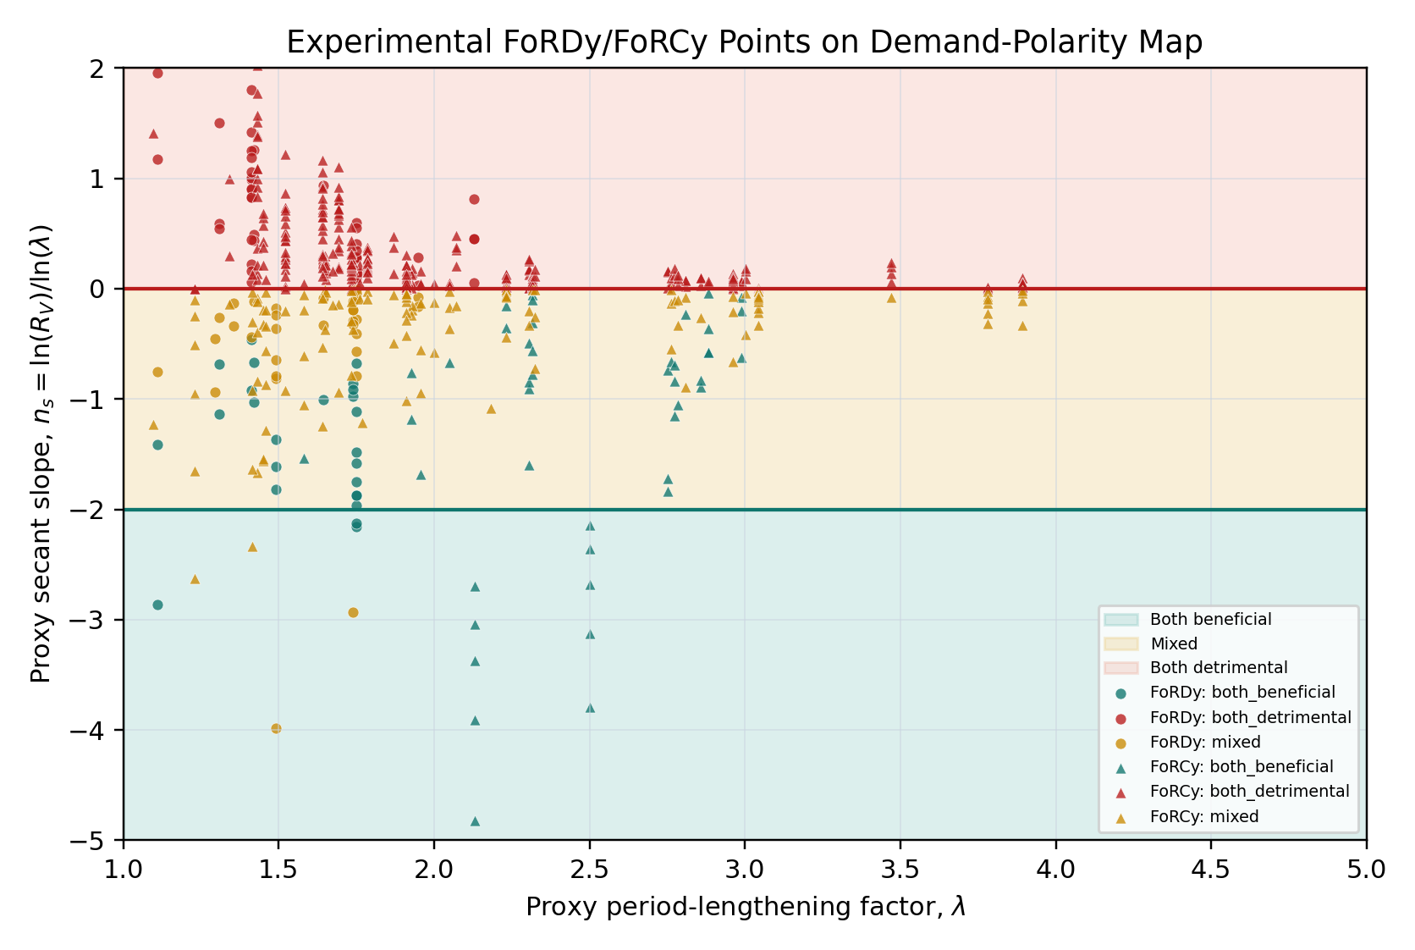
Figure S5.2. Independent predictive validation confusion matrix.
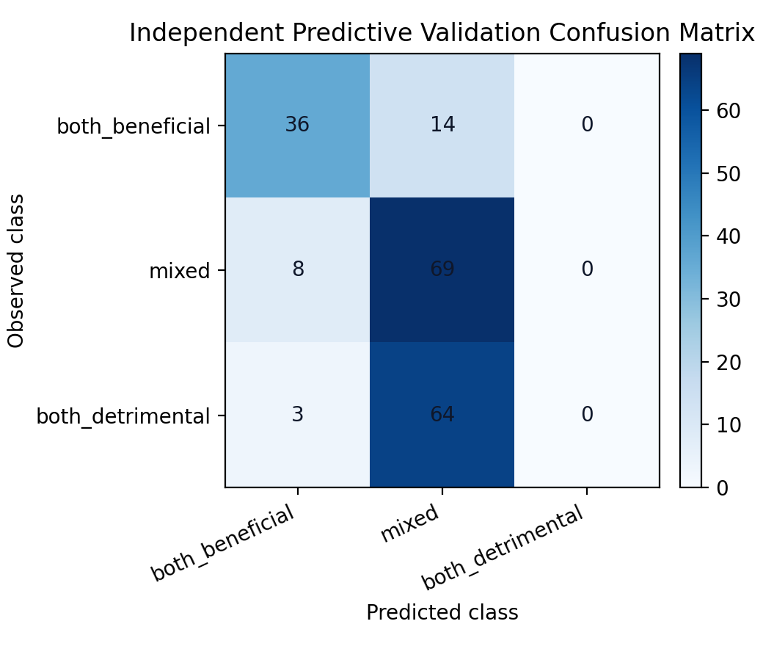
Figure S5.3. Decision-value loss-ratio sweep.
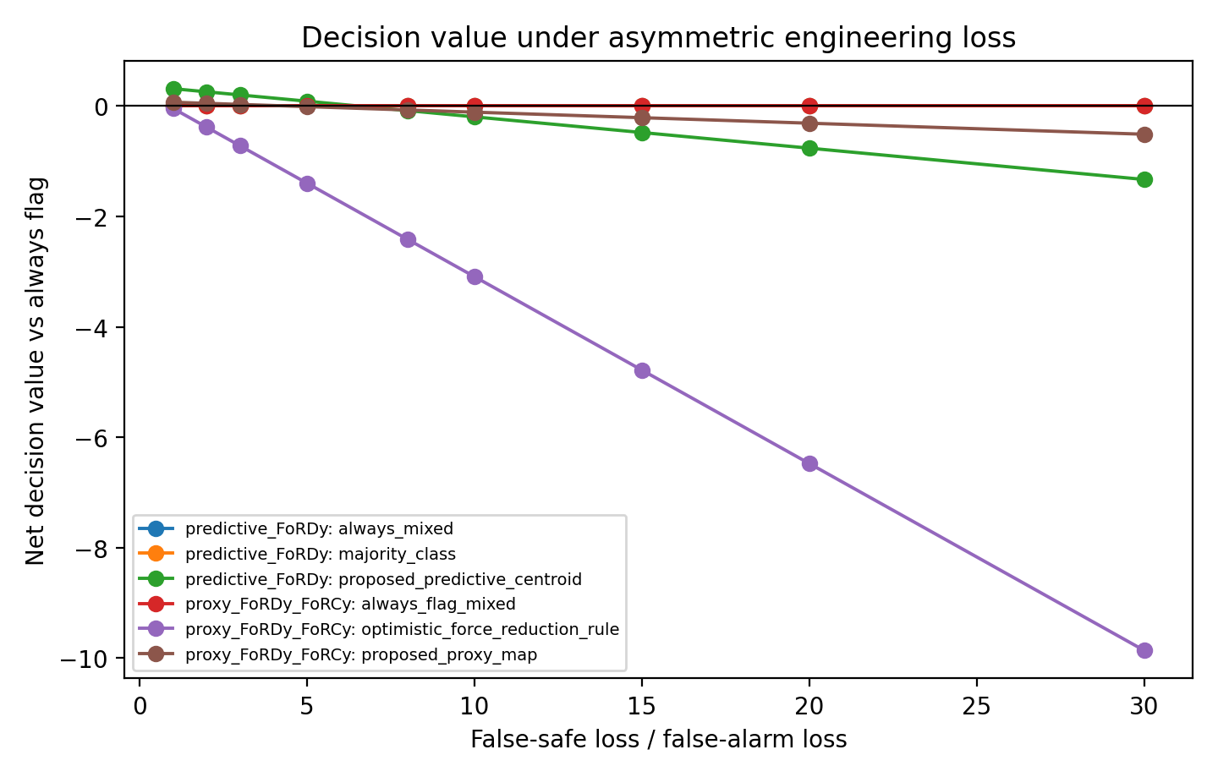
Figure S5.4. Guardrail tradeoff and failure-mode map.
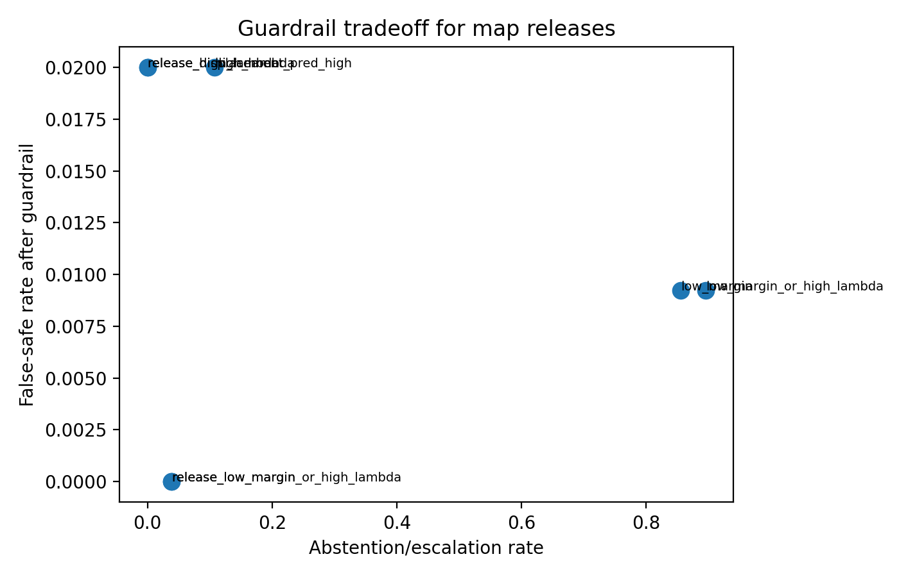
Figure S5.5. Solver-backed demand-polarity map.
