Supplementary Material: Reliability-Based Pre-Design of Shallow Foundations on Degrading MICP-Treated Sand
This document contains the lower-demand benchmark, external validation details, calibration tables, Bayesian updating demonstration, validation-scope evidence, robustness checks, practical calibration workflow, time-dependent reliability interpretation, and computational extensions moved from the main manuscript to satisfy the 30-page double-spaced ASCE target.
Main-Manuscript Notation and Benchmark Conventions Moved to Supplement
Notation and benchmark conventions
Table 2. Symbol definitions, units, and benchmark conventions.

Symbol | Units | Definition | Benchmark use / convention
B | m | Foundation width. | 2.0 m in the benchmark.
Df | m | Embedment depth. | 1.0 m in the benchmark.
H | m | MICP-treated thickness. | Reported through H/B.
zp | m | Influence depth used to normalize w(z). | Set to 3B in the benchmark; represents the finite bearing influence zone for the screening integral.
kz | - | Exponential decay scale for w(z). | Used only in the normalized treated-zone weighting function.
kH | - | Depth-benefit scale for chi_H. | 0.70 in the benchmark; caps treated-depth benefit.
chi_H | - | Finite-thickness treated-zone factor. | 1-exp[-H/(kH B)].
chi_E | - | Serviceability-depth modifier. | 1-exp[-H/(0.55B)], separate from chi_H.
eta(t,z) | - | Active cementation fraction. | eta=1 at reference treatment; eta_r is residual cementation.
eta_eff(t) | - | Depth-averaged effective cementation used in benchmark plots and serviceability proxy. | eta_eff denotes the depth-averaged cementation state used in the fragility and serviceability expressions.
eta_r | - | Residual cementation fraction. | 0.22 baseline; sensitivity ranges 0.20-0.35.
lambda_e | 1/yr | Effective degradation rate. | lambda in tables/text refers to lambda_e.
epsilon_p(t,z) | - | Accumulated plastic-strain damage measure. | Set to zero in the benchmark; retained for future cyclic or settlement-linked implementations.
ap, bp | - | Plastic-strain damage coefficients in c' and tan(phi') updates. | Inactive in the benchmark because epsilon_p=0.
cm' | kPa | Untreated matrix cohesion. | Zero for clean sand in the benchmark.
cb0' | kPa | Reference cemented cohesion increment. | 20 kPa baseline; bounded from published UCS/plate-load anchors.
Delta tan phi | - | Cementation-induced tangent friction increment. | Computed from target treated and untreated friction angles.
phi_m' | deg | Untreated matrix friction angle. | Used to compute the untreated matrix bearing-capacity factors.
theta_R | - | Resistance model factor. | Resistance-side model uncertainty factor used in the reliability calculation.
theta_Q | - | Load model factor. | Demand-side model uncertainty factor used in the reliability calculation.
chi_s(t) | - | Fragility/localization limiter. | max[chi_min, 1-rs eta_eff(t)^2].
chi_min | - | Lower bound for fragility factor. | 0.72 in the benchmark.
rs | - | Fragility curvature coefficient. | 0.18 in the benchmark.
aE | - | Serviceability stiffness coefficient. | 4.2 baseline; varied in sensitivity checks.
sI | - | Serviceability index. | Screening proxy, not settlement prediction.
Table 3 gives the random variables used in the benchmark. The distributions are intentionally transparent and bounded because the objective is reproducibility and screening, not calibration to a single proprietary case history.
Table 3. Random variables used in the reliability benchmark.
Variable | Distribution | Mean | COV | Bounds
B | Normal | 2.0 m | 0.04 | 1.65-2.35 m
H/B | Normal | 1.0 | 0.18 | 0.25-1.75
η0 | Normal | 0.95 | 0.08 | 0.55-1.15
ηr | Normal | 0.20 | 0.30 | 0.03-0.45
λ | Lognormal | 0.035 1/yr | 0.35 | positive
cb0 | Lognormal | 20 kPa | 0.22 | positive
φm | Normal | 32 deg | 0.047 | 27-38 deg
qservice | Lognormal | 900 kPa | 0.12 | positive
θR, θQ | Lognormal | 1.0 | 0.10, 0.08 | positive
The deterministic benchmark uses a 2.0 m wide shallow foundation, 1.0 m embedment, H/B=1.0, with two demand levels reported in the main text: a 500 kPa lower-demand service illustration and a 900 kPa high-demand stress test, φm′=32 deg, cb0′=20 kPa, η0=1.0, ηr=0.22, and λe=0.035 1/yr. The fixed assumptions in Table 4 define the geometry, unit weight, depth-weighting scale, serviceability-screening constants, and model factors. Figure 2 defines the footing geometry and the treated-zone weighting.
The influence depth zp is set to 3B for normalization of w(z), which keeps the screening integral within the classical bearing-influence region below a shallow footing while avoiding claims about a unique plastic-zone boundary. The depth factor chi_H uses kH=0.70 to saturate the benefit of deep treatment; chi_E uses 0.55B because serviceability improvement is expected to be more concentrated near the loaded zone than ultimate bearing resistance. The service pressures of 900-950 kPa are high-demand stress tests; the supplementary sensitivity files also report 250-650 kPa cases to show behavior under more typical demand levels.
The service pressures of 900-950 kPa are intentionally high benchmark demands selected to stress-test the degradation and reliability calculation. They should not be read as typical allowable pressures for lightly loaded shallow foundations on sand. A lower-demand service case is now reported directly in the main text, while the high-demand case is retained because it exposes whether the initial cementation credit can become unconservative over a 50-year service life.
Table 4. Fixed benchmark assumptions used in the reproducible screening example.
Assumption | Value | Role
Footing width B | 2.0 m | Reference shallow foundation width
Embedment depth Df | 1.0 m | Surcharge depth in bearing-capacity calculation
Effective unit weight γ′ | 18 kN/m3 | Benchmark drained unit weight
Friction enhancement Δtanφ | 0.0753 | Initial tangent-space increment, tan(35 deg)-tan(32 deg)
Depth-weight scale kH | 0.70 | Scale in χH=1-exp[-H/(kHB)] for bearing capacity
Serviceability scale aE | 4.2 | Illustrative stiffness benefit multiplier; χE uses 0.55B depth scale
Serviceability threshold sI | 0.045 | Non-calibrated screening flag, not settlement limit
Cementation exponent m | 1.15 | Exponent in cb=cb0η^m
Fragility factor rs | 0.18 | Bounded reduction of cemented contribution
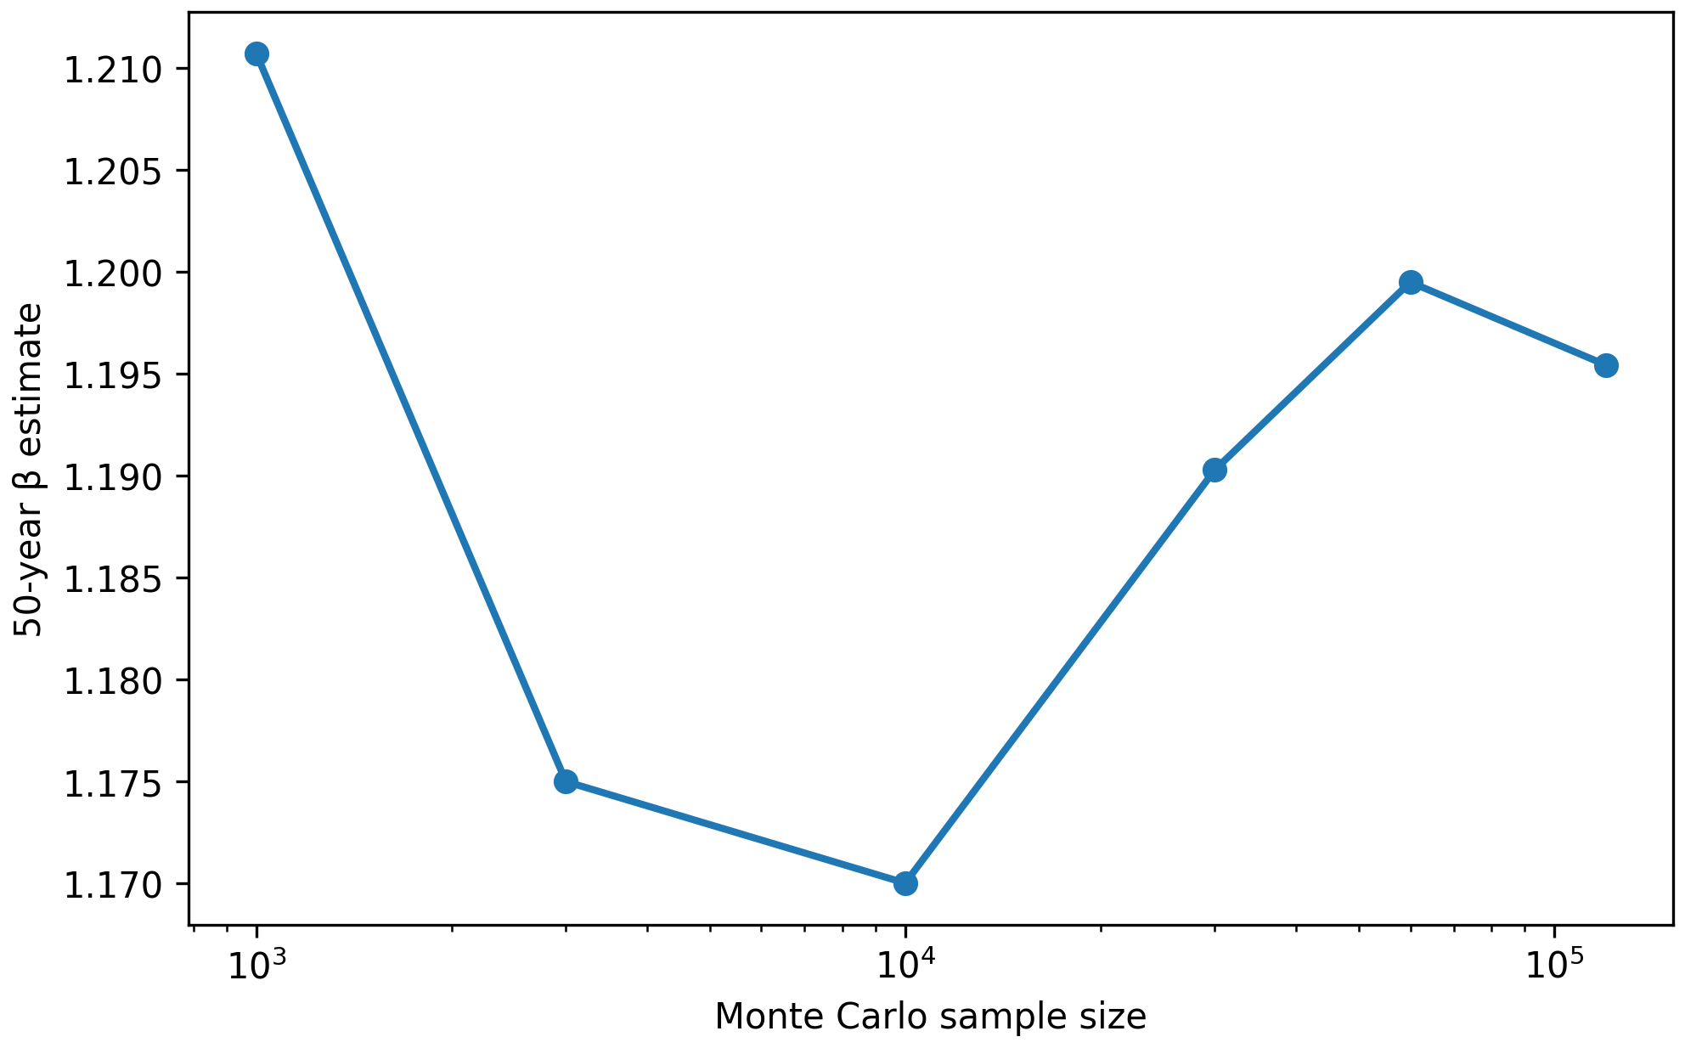
Fig. 2. Shallow foundation, treated depth, and normalized depth-weighting function.
Fig. 3 shows the degradation of η(t), the normalized cemented cohesion contribution, and the equivalent friction angle. The friction angle is reported only after the tangent-space update of Eq. (3).
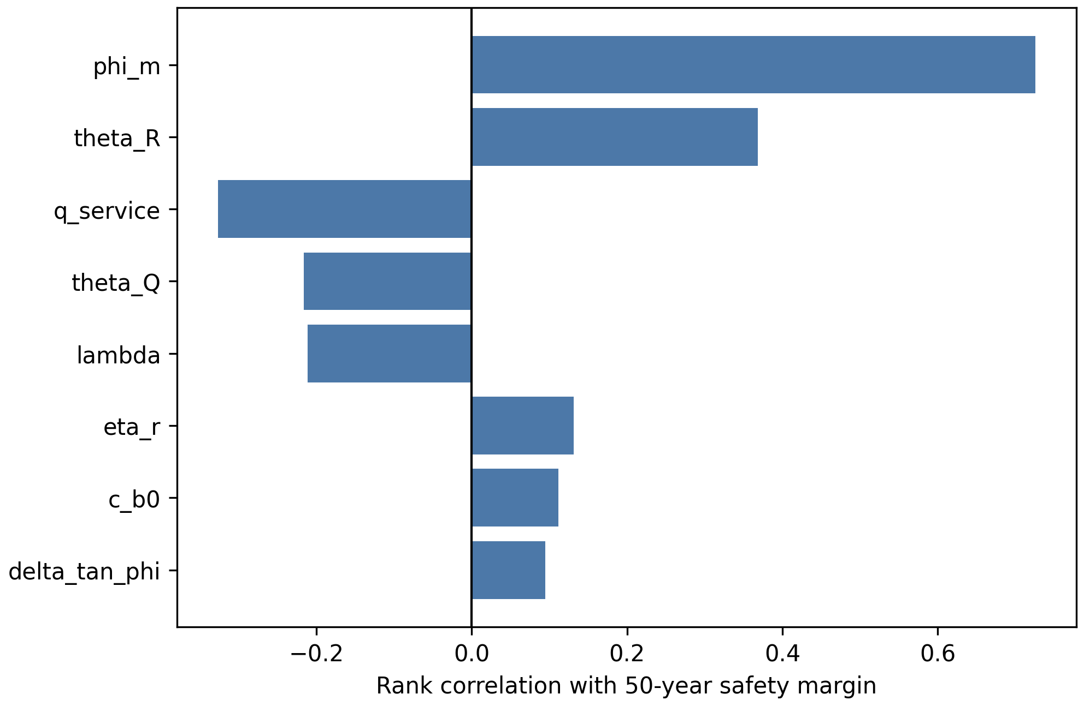
Fig. 3. Degradation of cementation state, cemented cohesion contribution, and equivalent friction angle.
The computational evidence includes limiting-case checks, Monte Carlo simulation, a first-order second-moment reliability approximation, a parametric design matrix, rank-correlation sensitivity, dataset-level load-settlement calibration, environmental-cycling durability-retention calibration, an open-source layered limit-analysis audit, an OpenSeesPy FEM capacity-trend benchmark, and a CalculiX three-dimensional solid FEM settlement benchmark. All calculations use fixed seeds, digitized source-data tables, or reproducible input files and are exported as CSV files. An exposure-driven environmental degradation benchmark was also added to distinguish the stationary lambda_e clock from chemistry, flow, and wetting-drying histories. A repeated-loading plastic-strain damage module was added to activate the epsilon_p terms for cyclic or variable loading while preserving the static benchmark as the zero-cyclic-damage case.

Typical-service lower-demand benchmark
Two demand levels are now reported in the main text. A lower-demand service case is included to show the implications of the model under more moderate working pressures, while the 900-950 kPa case is retained as a deliberately severe stress test of the degradation-aware calculation. The 900-950 kPa demand is retained as a high-demand stress test, not as a representative allowable pressure for all shallow foundations on sand.
The lower-demand service benchmark changes only the service-pressure level; the geometry, degradation model, capacity model, random-variable structure, and serviceability proxy are otherwise unchanged. The 500 kPa case is used as a practitioner-oriented lower-demand illustration, not as a universal typical pressure. The comparison also includes 250, 650, and 900 kPa to show how the same degraded capacity history maps into different design interpretations.
Table 8. Lower-demand service benchmark compared with high-demand stress test.
Case | qservice mean (kPa) | qu50 deterministic (kPa) | FS50 | pf50 | beta50 | P(sI>0.045) | Interpretation
Low service-demand illustration | 250 | 1253.1 | 5.01 | 1.70e-12 | 6.96 | 3.81e-06 | Ultimate reliability remains high; serviceability proxy is low.
Lower-demand service case | 500 | 1253.1 | 2.51 | 3.68e-05 | 3.96 | 0.0695 | Degradation reduces reserve but does not control ultimate reliability at 50 years.
Moderate-to-high service case | 650 | 1253.1 | 1.93 | 0.0023 | 2.83 | 0.3648 | Reliability margin remains positive but serviceability becomes more relevant.
High-demand stress test | 900 | 1253.1 | 1.39 | 0.0772 | 1.42 | 0.8556 | Stress test exposes sensitivity to permanent initial cementation credit.
Table 9. Time history for the 500 kPa lower-demand service case.
Year | FS(t) | sI(t) | pf_U(t) | beta_U(t) | P(sI>0.045) | pf_life | beta_life
0 | 3.70 | 0.0108 | 1.15e-08 | 5.59 | 4.71e-10 | 3.68e-05 | 3.96
10 | 3.30 | 0.0147 | 1.58e-07 | 5.11 | 8.71e-07 | 3.68e-05 | 3.96
30 | 2.77 | 0.0238 | 7.13e-06 | 4.34 | 0.0035 | 3.68e-05 | 3.96
50 | 2.51 | 0.0319 | 3.68e-05 | 3.96 | 0.0695 | 3.68e-05 | 3.96
At qservice=500 kPa, the 50-year deterministic factor of safety is 2.51 and the propagated ultimate failure probability is 3.68e-05, corresponding to beta50=3.96. The same degraded 50-year capacity evaluated at the high-demand 900 kPa stress-test level gives FS50=1.39, pf50=0.077, and beta50=1.42. Thus the high-demand case is useful for exposing the unconservatism of permanent initial cementation credit, whereas the lower-demand case shows that degradation can reduce reserve capacity without necessarily controlling ultimate reliability under moderate service demand.
The serviceability proxy remains informative. For the 500 kPa case, the deterministic serviceability index increases from 0.0108 at year 0 to 0.0319 at year 50, below the nominal sI=0.045 threshold, but the uncertainty-propagated probability of exceeding that threshold reaches about 0.069 by year 50. This comparison shows that the framework should not be read as predicting unacceptable performance for all MICP-treated shallow foundations; it identifies when service demand, degradation rate, residual cementation, and treated depth combine to erode either ultimate or serviceability margin.
Fig. 7. Reliability trajectories for lower-demand and high-demand service pressures.
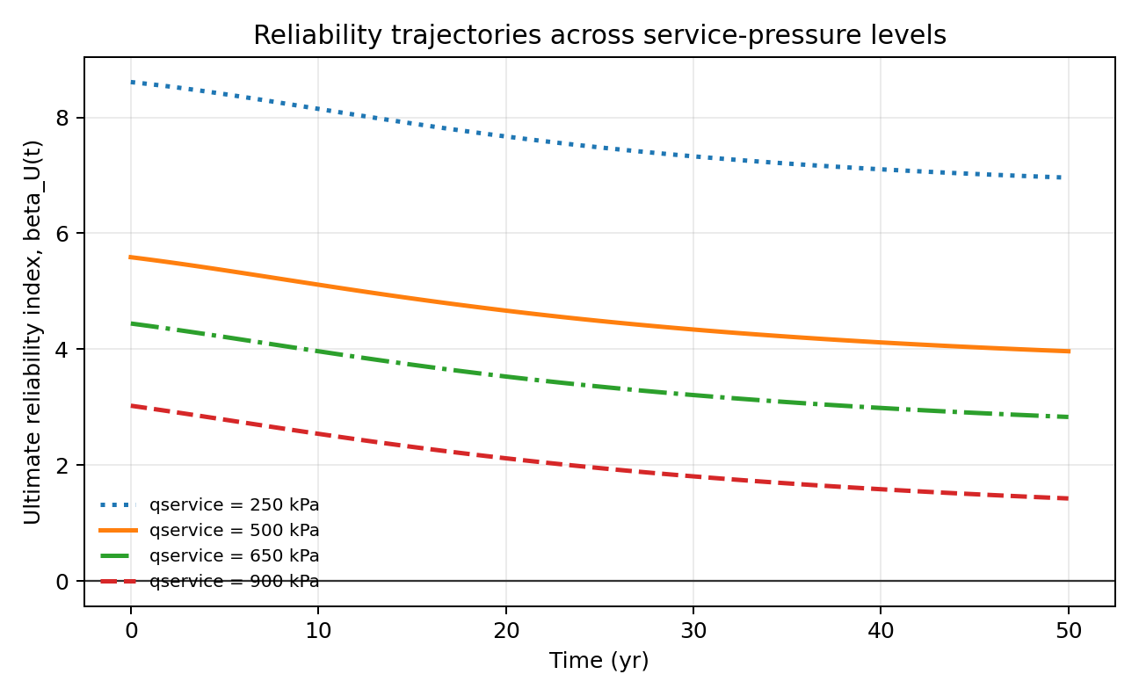
Fig. 7 separates practitioner interpretation from stress testing. Lower service pressures maintain substantially higher reliability indices over the 50-year horizon, whereas the high-demand stress test shows a steadily declining margin as the treated contribution degrades. The two cases therefore serve different purposes: the lower-demand case supports service-level interpretation, and the high-demand case tests the robustness of the degradation-aware formulation.
Fig. 8 verifies Monte Carlo convergence, and Figure 9 identifies the dominant uncertainty drivers. The rank-correlation results show that the untreated friction angle, resistance model factor, service pressure, load model factor, and degradation rate are the leading contributors to the 50-year margin in this benchmark. Initial cemented cohesion and treated depth remain design levers, but their marginal rank correlations are lower for the chosen parameter ranges.
Additional sensitivity checks were added to the supplement. The service-pressure sweep shows that the same 50-year capacity corresponds to substantially larger safety margins at 250-500 kPa than at the high-demand 900-950 kPa benchmark. The serviceability-parameter sweep varies aE and the sI threshold to document that the serviceability screen is a conservative flag rather than a calibrated settlement prediction. A layered-capacity bound check compares Eq. (8) with the untreated matrix lower bound and the fully treated upper calculation as H/B varies; Eq. (8) remains between those bounds because only incremental capacity-factor terms are depth weighted.
The layered-capacity bound check is not a substitute for finite-element or rigorous limit-analysis validation. Its purpose is narrower: it verifies that the proposed decomposition remains bracketed between the untreated matrix calculation and the corresponding fully treated upper calculation as H/B varies. This removes one possible algebraic failure mode. The supplementary limit-analysis, OpenSeesPy, and CalculiX checks added below provide independent mechanistic audits, but Eq. (8) should still be treated as a bounded screening rule rather than as a general bearing-capacity theorem for layered cemented profiles.

Fig. 8. Monte Carlo convergence of the 50-year reliability estimate.

Fig. 9. Rank-correlation sensitivity of the 50-year safety margin.
Table 10 provides an external trend-validation check. It is not claimed to be a full calibration because the benchmark does not digitize individual load-settlement curves. Instead, it verifies that the parameter ranges used in the framework can reproduce the order of magnitude and direction of published plate-load and durability observations without changing the governing equations.
Table 10. External trend-validation anchors from published MICP studies.
Published source | Published observation | Model mapping | Model result | Interpretation
Kulkarni et al. 2021 | MICP plate-load tests reported ultimate bearing-capacity improvement ratios of about 2.95 to 5.80 | Initial high-treatment scenario, H/B=1.75 and cb0=40-100 kPa | bearing-capacity ratio 2.84-5.01 | Model reproduces the published order of magnitude without changing the bearing-capacity equation
Kulkarni et al. 2021 | MICP plate-load tests reported settlement-reduction ratios of about 1.70 to 3.31 | Serviceability index ratio between untreated and high-treatment initial states | normalized serviceability-improvement ratio 1.8-3.4 over cb0=40-100 kPa | Model trend is consistent with reduced settlement demand after cementation
Sharma et al. 2021 | Wetting-drying and ageing affected durability of biocemented sand, but substantial strength gain could remain after ageing | Residual cementation ηr=0.20-0.35 and degradation-rate sweep λ=0.012-0.060 1/yr | 50-year capacity remains 1.16-1.93 times untreated matrix depending on λ and ηr | Model represents durability as partial persistence rather than all-or-nothing loss
Table 11 reports the limiting-case verification. These checks are important because the framework must reduce to standard bearing-capacity behavior when treatment vanishes and to an initial-improvement design when degradation is suppressed.
Table 11. Limiting-case verification.
case | η(50 yr) | φ′(50 yr) | cb′(50 yr) | qu(50 yr)
untreated matrix | 0 | 32 | 0 | 961
non-degrading biocementation | 1 | 35 | 20 | 1850
full residual at 50 yr | 0.2 | 32.62 | 3.142 | 1114
vanishing treated layer | 0.339 | 33.04 | 5.765 | 961
deep treated layer | 0.339 | 33.04 | 5.765 | 1325
no environmental degradation | 1 | 35 | 20 | 1850

External quantitative validation and anti-double-counting check
Table 12. Quantitative external benchmarking anchors used to constrain the screening benchmark.

Source | Quantity | Observed range | Model range | Audit comparison
Kulkarni et al. 2021 | Circular-plate bearing-capacity ratio | 2.95-5.80 | 2.84-5.01 | Model lower endpoint differs by 0.11 ratio units; upper endpoint is 0.79 below the largest published ratio, so the benchmark is conservative at the high end.
Kulkarni et al. 2021 | Square-plate bearing-capacity ratio | 3.71-4.22 | 3.64-4.38 | Model range brackets the reported square-plate range with endpoint differences of 0.07 and 0.16 ratio units.
Kulkarni et al. 2021 | Circular-plate settlement-reduction factor | 1.70-2.00 | 1.80-2.08 | Model range is within 0.10 ratio units at the lower end and 0.08 at the upper end.
Kulkarni et al. 2021 | Square-plate settlement-reduction factor | 2.38-3.31 | 2.42-3.40 | Model range brackets the reported square-plate settlement reduction with endpoint differences of 0.04 and 0.09 ratio units.
Kulkarni et al. 2021 | UCS gain for 0.5 mm sand, 0.05 to 0.20 L/kg BCC at 14 days | 114.3-180.8 kPa; 58.18% increase | cb0 calibration band 20-35 kPa maps to design-screening ratios used in the bearing benchmark | Used to bound the cemented cohesion increment rather than to claim a direct UCS-to-footing conversion.
Sharma et al. 2021 | Durability under wetting-drying and ageing | UPV, shear modulus, UCS, STS and mass loss measured after 0-20 wetting-drying cycles and 0-6 months ageing | eta_r=0.20-0.35 and lambda=0.012-0.060 1/yr leave 1.16-1.93 times untreated capacity at 50 years | Used as a durability-persistence envelope, not as a digitized time-history calibration.
This comparison is not presented as a universal calibration. It is a quantitative plausibility check against published ranges and a constraint on the benchmark parameters. The checks deliberately include plate-load bearing-capacity ratios, settlement-reduction ratios, UCS and durability observations so that the screening model is not supported only by simulation-only evidence. The model intentionally does not force the highest reported circular-plate bearing-capacity ratio, because doing so would over-credit long-term cementation in the service-life examples. The remaining limitation is narrower: the dataset-level checks below are source-specific and should be repeated with project-specific plate-load and exposure-history data before final design.
The same decomposition also defines the calibration rule used to avoid double counting. The untreated matrix terms are computed only once from the untreated friction angle. The bracketed part of Eq. (8) contains only increments relative to that matrix baseline: the cemented cohesion term, the surcharge-factor increment, and the unit-weight-factor increment. Therefore, when H/B tends to zero, or when the cemented increments are set to zero, the expression collapses to the untreated matrix capacity. In a project calibration, cb0 and Delta tan phi should be estimated from independent strength components; if a data set provides only a single composite strength gain, one of the two increments should be fixed or set to zero during fitting.

Dataset-level calibration and external benchmarking
To move beyond trend-level external anchoring, the framework was additionally tested against digitized experimental load-settlement and durability-retention data. The load-settlement check uses the open Kulkarni et al. (2021) plate-load curve for the 120 mm x 120 mm square footing. The individual circular-plate curves are not visible in the open PDF, so Table 6 circular/square summary values are retained in the supplement but are not presented as full curve data. The comparison therefore uses the square-footing curve for a direct dataset-level calibration and reserves later pre-ultimate points as validation points.
The curve was fitted with a hyperbolic wrapper q(s,t)=k0(t)s/[1+k0(t)s/qu,BDC(t)]. The untreated branch identifies the matrix stiffness km, while the treated branch identifies an equivalent treated stiffness multiplier. The ultimate pressures are fixed to the tangent-defined Table 6 values, so plotted post-qu points are retained as digitized observations but are not used to calibrate the asymptotic branch. This prevents the load-settlement wrapper from being forced outside the definition of qu used by the source paper.
Fig. 10. Dataset-level load-settlement calibration and held-out external check against digitized Kulkarni et al. (2021) plate-load data.
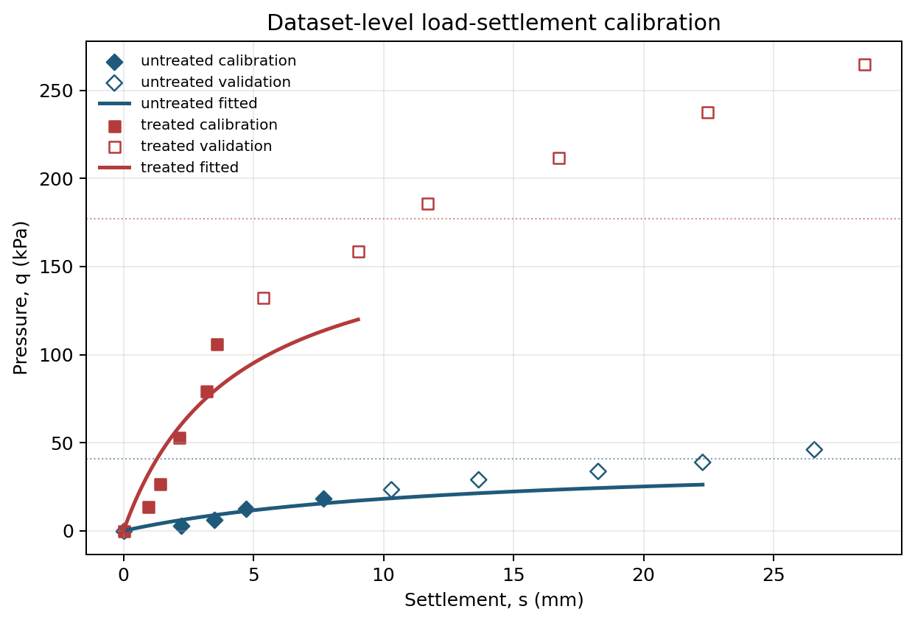
Table 13. Dataset-level load-settlement calibration and held-out check metrics.
Source | Geometry | Role | Treatment | NRMSE | MAPE | qu error (%) | SRF error (%) | Interpretation
Kulkarni et al. 2021 | square 120 mm x 120 mm | calibration | untreated | 0.057 | 23.6 | 0.0 | - | Pre-ultimate branch defined by Table 6 qu.
Kulkarni et al. 2021 | square 120 mm x 120 mm | validation | untreated | 0.221 | 26.9 | 0.0 | - | Pre-ultimate branch defined by Table 6 qu.
Kulkarni et al. 2021 | square 120 mm x 120 mm | calibration | treated | 0.084 | 48.2 | 0.0 | 14.0 | Pre-ultimate branch defined by Table 6 qu.
Kulkarni et al. 2021 | square 120 mm x 120 mm | validation | treated | 0.205 | 25.0 | 0.0 | 14.0 | Pre-ultimate branch defined by Table 6 qu.
A second dataset-level check was performed for durability-retention data. The Geoderma wetting-drying and ageing article by Sharma and Satyam (2021) confirms the exposure grid and response variables, but the institutional record does not provide open figure data. Therefore, the reproducible dataset check uses the open numerical durability series reported by Sharma, Satyam, and Reddy (2021): UCS strength reductions of 4.2%, 8.3%, 17%, and 35% after 5, 10, 15, and 20 freeze-thaw cycles. This is reported as a controlled environmental-cycling check rather than as wetting-drying calibration.
The retention data were fitted with the same residual exponential structure used for the cementation state, eta(E)=eta_r+(1-eta_r)exp(-lambda_E E). Early-cycle data were used for calibration and later cycles were reserved for validation. The validation error is reported directly; it shows that the main degradation parameters are experimentally identifiable, while also warning that late-cycle damage can be more severe than a single exponential clock fitted only to early cycles.
Fig. 11. Dataset-level environmental-cycling durability-retention calibration and held-out check.
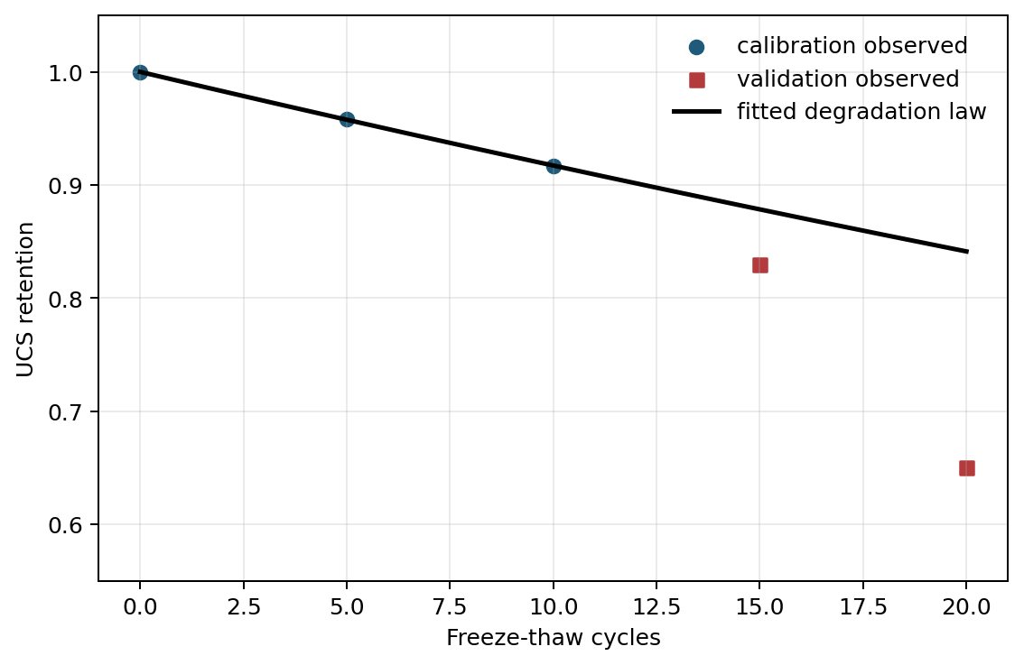
Table 14. Dataset-level durability-retention calibration and held-out check metrics.
Source | Exposure type | Variable | Role | RMSE | MAPE | R2 | Final-retention error (%) | Interpretation
Sharma et al. 2021 | freeze-thaw cycles | UCS retention | calibration | 0.000 | 0.0 | 1.000 | 0.0 | Controlled environmental cycling series; used as durability-identifiability check.
Sharma et al. 2021 | freeze-thaw cycles | UCS retention | validation | 0.139 | 17.6 | -1.401 | 19.1 | Controlled environmental cycling series; used as durability-identifiability check.
These calibrations are not presented as universal because the digitized datasets correspond to specific sands, treatment protocols, curing histories, boundary conditions, and environmental exposures. Their purpose is narrower: they show that the proposed stiffness, cementation, and degradation parameters are identifiable from complete experimental response data and can be propagated through the same screening framework before project-specific design calibration.
An additional open-source limit-analysis benchmark was therefore added for the layered treated-zone problem. The benchmark uses a transparent punch-through mechanism for a cemented crust over untreated sand, with lower, central, and upper side-resistance assumptions derived from lateral stress bounds and mobilized cemented cohesion. The calculation was implemented with Python, NumPy, Pandas, and Matplotlib and is provided in the supplementary code. It is independent of Eq. (8) and is intended as a mechanistic audit, not as a substitute for project-specific finite-element calibration.
The comparison is deliberately conservative in interpretation. At the 50-year degraded state, Eq. (8) remains below the fully treated capacity cap for all H/B cases, but it exceeds the central punch-through estimate by about 17-21% for H/B between 0.5 and 1.5 and falls within about 4-12% for H/B between 2.0 and 2.5. This result supports use of Eq. (8) as a screening rule for sufficiently deep treated zones, while flagging shallow crusts as cases where the depth factor should be calibrated or capped against a layered limit-analysis or FEM model before final design.
Table 15. Open-source limit-analysis benchmark for the degraded 50-year treated-zone state.
H/B | Eq. (8) q_ult (kPa) | Limit-analysis central (kPa) | Punch-through upper (kPa) | Eq. (8) - central (%)
0.0 | 961.0 | 961.0 | 961.0 | 0.0
0.5 | 1157.2 | 991.5 | 1046.8 | 16.7
1.0 | 1253.2 | 1038.6 | 1184.6 | 20.7
1.5 | 1300.2 | 1102.6 | 1345.3 | 17.9
2.0 | 1323.2 | 1183.3 | 1345.3 | 11.8
2.5 | 1334.5 | 1280.8 | 1345.3 | 4.2
Fig. 12. Open-source layered punch-through limit-analysis benchmark compared with Eq. (8).
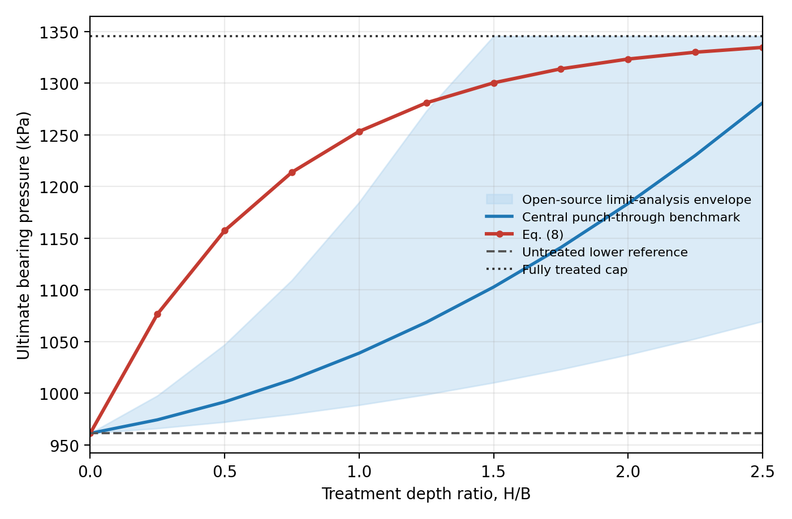
The OpenSeesPy benchmark was run in a reproducible Python environment using OpenSeesPy 3.8.0. The model uses a two-dimensional plane-strain mesh of four-node quadrilateral elements, a displacement-controlled rigid strip footing, and Drucker-Prager materials for the untreated sand and the degraded treated layer. The comparison is normalized by the untreated FEM capacity so that the result is used as a trend benchmark rather than as a site-calibrated absolute prediction.
The OpenSeesPy benchmark gives a monotonic capacity-ratio increase from 1.00 at H/B=0 to 1.30 at H/B=2.0. Eq. (8) follows the same increasing trend but is higher than the FEM trend by about 19.7% at H/B=0.5-1.0, 9.0% at H/B=1.5, and 5.7% at H/B=2.0. The screening rule adopted here is therefore explicit: for H/B<1.5, the closed-form capacity should be capped or recalibrated against layered limit analysis or FEM; for H/B>=1.5, it is acceptable for ranking alternatives when the relative error remains below about 10-12% and final design is independently checked.
Table 16. OpenSeesPy Drucker-Prager FEM benchmark normalized by the untreated case.
H/B | OpenSeesPy FEM ratio | Eq. (8) ratio | Difference (%)
0.00 | 1.00 | 1.00 | 0.00
0.50 | 1.01 | 1.20 | 19.69
1.00 | 1.09 | 1.30 | 19.71
1.50 | 1.24 | 1.35 | 9.03
2.00 | 1.30 | 1.38 | 5.73
Fig. 13. OpenSeesPy FEM layered-footing benchmark compared with Eq. (8).
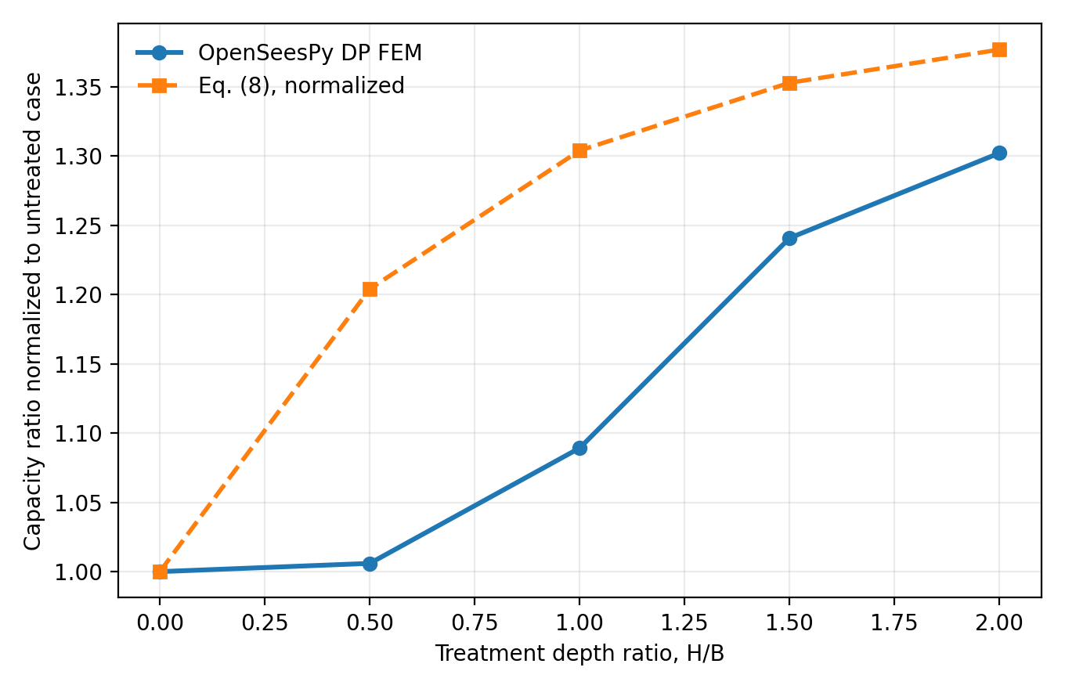
A third open-source numerical check was added with CalculiX 2.23 to provide a true three-dimensional solid-element benchmark. The model uses a linear-elastic C3D8 brick mesh, a square loaded footing area, roller side boundaries, a fixed base, and a treated square column beneath the footing whose depth varies with H/B. Because this check is elastic, it is used to audit settlement and stiffness trends rather than ultimate collapse capacity.
The CalculiX benchmark gives a monotonic settlement reduction from 0% at H/B=0 to 24.3% at H/B=2.0, with a normalized stiffness increase from 1.00 to 1.32. This provides a conservative 3D elastic lower-bound trend for serviceability: the simplified serviceability proxy is used for screening and ranking, while final settlement prediction should be replaced by a calibrated load-settlement curve or 3D numerical model.
Table 17. CalculiX 3D solid FEM settlement benchmark normalized by the untreated case.
H/B | Mean settlement (mm) | 3D FEM stiffness ratio | Settlement reduction (%)
0.0 | 3.862 | 1.000 | 0.0
0.5 | 3.330 | 1.160 | 13.8
1.0 | 3.082 | 1.253 | 20.2
1.5 | 2.977 | 1.297 | 22.9
2.0 | 2.925 | 1.320 | 24.3
Fig. 14. CalculiX 3D solid FEM settlement benchmark compared with the screening stiffness proxy.
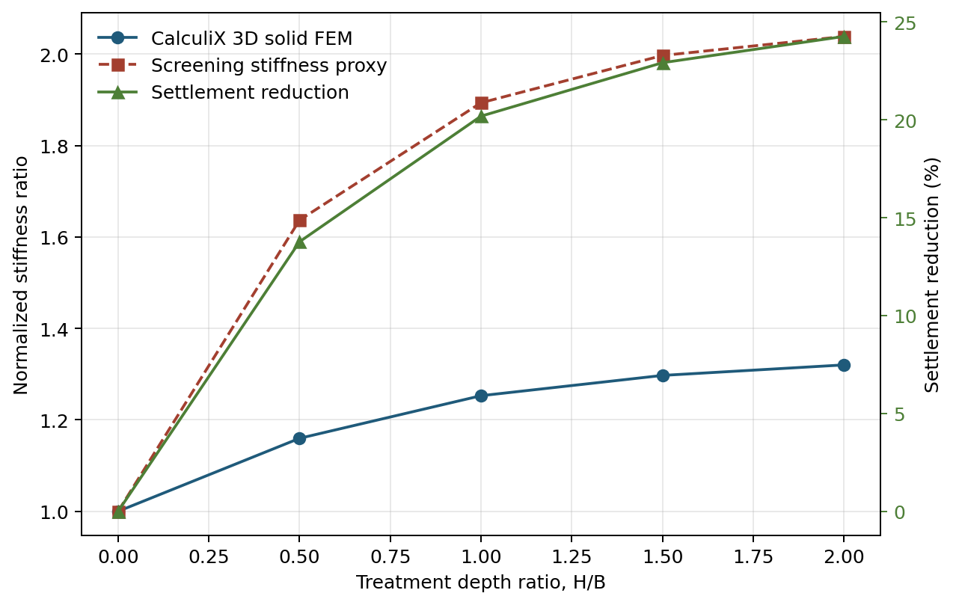

Bayesian updating demonstration
The Bayesian module is kept deliberately small and auditable. The updated parameter vector is theta={lambda_e, eta_r}, because lambda_e controls the rate at which cementation credit is lost and eta_r controls the long-term residual credit. The priors follow the same bounded ranges used in the benchmark: lambda_e is lognormal and truncated to 0.001-0.10 1/yr, while eta_r is a scaled beta distribution on 0.03-0.65. The likelihood uses retention observations y_j=eta_r+(eta0-eta_r)exp(-lambda_e t_j)+epsilon_j, with epsilon_j~N(0,sigma_y^2). The demonstration uses the digitized late-retention points from the Sharma et al. durability dataset as a published-retention update, not as a full degraded-footing validation.
A transparent 2D grid Bayes calculation evaluates the joint prior, likelihood, and normalized posterior. Posterior samples are then propagated through the same screening reliability mapping used for the 50-year service-life calculation. To avoid a second capacity convention, the Bayesian reliability surrogate is anchored so that the prior reproduces the main-text reliability-inversion threshold qservice,max=556 kPa for beta>=3. The update reduces the mean degradation rate from 0.034 to 0.025 1/yr, increases eta50 from 0.44 to 0.50, and changes beta50 from 1.25 to 1.38 at qservice=900 kPa. This favorable update lowers pf50 from 0.115 to 0.086 and raises the beta>=3 service-pressure threshold from 556 to 576 kPa, but it does not make the 900 kPa design acceptable. The design consequence is therefore not automatic acceptance; the posterior confirms that service pressure must be reduced or the site must provide stronger project-specific evidence.
Table 20. Prior-to-posterior update and reliability consequences.
Quantity | Prior | Posterior | Design consequence
lambda_e | 0.034 1/yr | 0.025 1/yr | slower degradation inferred from late retention evidence
eta_r | 0.27 | 0.29 | residual cementation credit updated
eta50 | 0.44 | 0.50 | 50-year cementation retention increased
beta50 | 1.25 | 1.38 | qservice=900 kPa still fails beta>=3
pf50 | 0.115 | 0.086 | posterior risk decreases but remains design-governing
qservice,max | 556 kPa | 576 kPa | allowable pressure for beta>=3 remains below 900 kPa
The posterior decision table is consistent with the automated decision export: qservice=900 kPa fails beta>=3; updated qservice,max is reported for screening Figure S4 in the supplement plots prior/posterior lambda_e and eta_r, eta(t), and beta(t); the accompanying CSV files provide the observations, posterior summaries, trajectories, samples, and design decisions.

V4-level coupled validation using experimental component datasets
This study does not claim V5-V6 validation. Instead, it builds a V4-level validation chain in which experimental component datasets constrain the MICP strengthening, degradation, and stiffness submodels, and an independently implemented degraded-footing simulation tests the coupled response against held-out evidence and numerical falsification criteria. The component data include Kulkarni et al. plate-load/load-settlement response, Sharma et al. durability-retention data, and triaxial strength constraints from Rezende et al.; sources that require additional curve digitization are flagged in the supplement. The virtual-footing evidence is therefore used as coupled indirect validation, not as experimental validation.
Table 21. V0-V6 validation scale and V4 status.
Level | Meaning | Evidence required | Status
V0 | internal algebraic consistency | limits, units, monotonicity, extreme cases | met; limiting cases and bounded decomposition retained
V1 | numerical verification | Monte Carlo convergence, FOSM comparison, seed-controlled scripts | met; MC/FOSM and convergence files available
V2 | independent model comparison | limit analysis, FEM/DEM, different implementation | met for screening; open-source limit analysis, OpenSeesPy, and CalculiX audits
V3 | experimental component validation | plate/load-settlement, UCS, triaxial, UPV/Vs, durability retention | met at component level using published datasets
V4 | coupled indirect validation | experimental components + virtual degraded footing + hold-out/falsification | target status; V4-level architecture, not direct footing validation
V5 | direct physical degraded-footing validation | plate/footing test on degraded MICP-treated sand | not claimed; no accessible direct degraded-footing test located
V6 | field-scale validation | field footing/plate with service-life exposure | not claimed
Calibration and testing are separated by component. Initial strength and stiffness are calibrated from plate-load, UCS, triaxial, and pre-ultimate load-settlement evidence; degradation is calibrated on early retention cycles and tested on later cycles; service response is checked against held-out load-settlement behavior; and H/B effects are audited by independent limit-analysis, OpenSeesPy, and CalculiX calculations. The M8 virtual model freezes these component-calibrated parameters before the degraded-footing run, so disagreement is handled by capping, domain restriction, or FEM recalibration rather than by post-hoc tuning.
Table 22. V4 falsification criteria for the coupled virtual-footing validation.
Test | Weakens model if | Strengthens model if | Action if failed
retention law | selected law cannot predict hold-out | hold-out MAPE <20-25% | use Weibull/bilinear and update posterior
capacity | closed form overpredicts >25% | capped error <15% | make capping mandatory or require FEM
service | q-s trend not reproduced | NRMSE <0.25 for pre-ultimate branch | replace sI with calibrated q-s curve
H/B trend | FEM/limit trend contradicts closed form | monotonic/capped trend consistent | recalibrate kH and chi_s
rival model | fixed reduction M2 matches M3/M7 decisions | degradation changes critical decision | simplify or justify dynamic coupling
uncertainty | posteriors do not discriminate designs | beta thresholds separate safe/unsafe region | declare non-identifiability

Benchmark anchoring and model-form robustness
The benchmark was strengthened by treating parameter choice and validation level as auditable parts of the method rather than as free synthetic inputs. The updated validation scale distinguishes V0 algebraic checks, V1 numerical verification, V2 independent numerical audits, V3 experimental component validation, V4 coupled indirect validation, V5 direct degraded-footing tests, and V6 field-scale evidence. The present manuscript claims V4-level coupled virtual-footing support only: component datasets constrain the submodels, independent virtual-footing simulations test coupled behavior, and held-out plus falsification criteria define when the closed-form equation, the capping rule, or FEM-based recalibration should be used.
Table 23. Parameter anchoring audit used to reduce synthetic benchmark dependence.
Parameter | Current value | Class | Current source | Technical risk | Strengthening action
eta0 | 0.95 mean | D | treatment/CaCO3/Vs/UCS mapping | dominant but indirectly measured | Use CaCO3+UCS/Vs prior and update with site data
eta_r | 0.20 mean | B/C | Sharma 2021 retention fit + sensitivity | late-cycle fit nonunique | Use exposure-specific retention curves and bootstrap
lambda_e | 0.035 1/yr | D | baseline synthetic; lambda_E fit exists | maps cycles to years | Use environmental-history conversion and retention data
cb0 | 20 kPa | C | UCS/PLT bounded | double-counting with friction | Fit one strength component while holding the other fixed
Delta tan phi | 0.0753 | C/D | tan35-tan32 target | not directly isolated | Infer from triaxial/direct shear or set to zero in conservative fit
kH | 0.70 | D | synthetic depth fit; FEM/limit audit | dominates shallow crust response | Calibrate to PLT/FEM depth series; cap H/B<1.5
kz | not active in Eq.8 tables | D | synthetic CPT profile | nonunique without profile data | Fit to before-after CPT/Vs/CaCO3 profile
chi_s, rs | 0.72 min, 0.18 | D | sensitivity envelope | can mask brittle localization | Calibrate with post-peak/strain-localization or FEM back-analysis
aE, sI | 4.2, threshold 0.045 | B/C | Kulkarni load-settlement calibration and CalculiX audit | proxy may overstate stiffness | Use hyperbolic q-s curve and report as screening flag
theta_R, theta_Q | 1.0 lognormal | C | geotechnical reliability convention | tail controls pf | Test distributions/correlation and report pf CI
H/B, qservice | 1.0, 900 kPa stress test | D | parametric matrix | decision sensitive | Report thresholds and lower-demand case
Model-form robustness was checked against null and rival assumptions and paired with degradation-law selection. For the available Sharma et al. retention points, the residual exponential law had the lowest BIC among exponential, Weibull, and bilinear-plus-exponential candidates; however, all forms produced similar late-cycle hold-out errors, so model-form uncertainty is retained. Under the high-demand stress test, M1 permanent credit gives the least conservative reliability interpretation, whereas M3/M4/M5/M7 all fail the beta>=3 target and expose the need for redesign. A one-at-a-time threshold analysis showed that, under baseline uncertainty, beta>=3 is reached by reducing qservice to about 556 kPa; varying only H/B, cb0, eta_r, or lambda_e over the tested ranges did not recover beta>=3. This is treated as a design finding, not a limitation note.
Table 24. M0-M8 model-form comparison and design-decision robustness.
Model | Description | Data used | Prediction | External error | beta50 | pf50 | qmax | Decision
M0 | untreated no MICP credit | baseline inputs | untreated reference |  | 0.26 | 0.397 |  | fails beta target
M1 | permanent MICP credit | initial component response only | non-degrading response |  | 2.62 | 0.004 |  | over-credit risk
M3/M4 | degrading closed-form models | durability-calibrated degradation | time-dependent reliability | model-form spread | 1.13 | 0.129 |  | fails beta target
M7 | degrading model with H/B cap | FEM/limit audit plus degradation | capped time-dependent reliability | thin-layer conservative | 0.60 | 0.273 |  | fails beta target
M8 | V4 coupled virtual-footing model constrained by component datasets | component-calibrated strength, service, degradation; independent FEM/limit trend | degraded-footing response with no global retuning | screening if capped error <=15%; otherwise FEM recalibration | 1.38 | 0.086 | 576 | V4 support, not V5; qservice=900 fails
Table 25. Final multilevel validation acceptance criteria applied to the manuscript.
Dimension | Minimum criterion | Status | Evidence / remaining gap
Novelty | no complete close model found | met | Bosch et al. close but lacks service-life reliability
Initial response | PLT/load-settlement error within screening range | met for screening | Kulkarni held-out NRMSE about 0.20-0.22
Degradation | law selected by AIC/BIC and hold-out reported | partly met | exponential BIC-best; late-cycle MAPE 17.6%
Service | calibrable curve replaces arbitrary settlement claim | met for screening | sI kept as flag; final settlement requires curve
FEM/limit | H/B>=1.5 error <=10-15%; H/B<1.5 capped | met for screening | OpenSees 5.7% at H/B=2; 19.7% at H/B<=1
Rival models | M3/M4/M7 alter over-credit interpretation | met | M1 overcredits; degrading models fail beta target
Beta target | thresholds reported, not hidden | met | for high-demand case beta>=3 requires qservice about 556 kPa or redesign
Reproducibility | scripts, CSV, seeds, generated outputs | met | all new validation tables stored as CSV

Practical calibration and inference workflow
The framework is intended to be used with staged evidence rather than with a single fitted parameter set. A practical project application would first define the untreated matrix parameters and load model, then estimate the initial cementation state from carbonate content, treatment records, and geophysical indicators. Element-scale strength tests and plate-load response can then separate the cemented cohesion increment from the frictional enhancement, while durability-retention tests and exposure descriptors constrain the degradation rate and residual cementation. This staged workflow is important because the same apparent bearing-capacity gain can be produced by different combinations of eta0, cb0', Delta tan phi, treated depth, and localization loss.
For that reason, the model should be updated in layers. Carbonate content and treatment uniformity provide a prior on eta0 and spatial variability; UCS, triaxial, direct-shear, or bender-element data constrain strength and stiffness increments; plate-load or footing-scale data check the depth-weighted capacity response; and wetting-drying, flushing, salinity, pH, or cyclic loading observations update lambda_e and eta_r. The reliability calculation then translates these measurements into beta(t), pf(t), lifetime failure probability, and inspection or retreatment triggers. This measurement-to-reliability link is a central practical contribution of the paper because it turns MICP treatment quality and durability observations into explicit design consequences.
Table 27. Project measurements used to update MICP reliability parameters.
Measurement source | Primary parameters informed | Reliability role | Identifiability caution
Treatment schedule, CaCO3 content, spatial uniformity | eta0, treated-zone variability | Defines initial cementation credit and possible under-treated zones | Carbonate mass alone does not uniquely determine bond effectiveness
UCS, triaxial, direct shear, Vs/UPV, CPT/CPTu | cb0', Delta tan phi, stiffness modifier | Converts material improvement into resistance and serviceability inputs | Composite strength gains can double count cohesion and friction increments
Plate-load or footing-scale tests | kH, kz, chi_s, capacity scale | Checks treated-depth benefit and shallow-crust localization | A single load-settlement curve cannot identify all modifiers independently
Durability-retention and exposure-history data | lambda_e, eta_r, environmental acceleration | Controls service-life loss of capacity and inspection timing | Late-cycle damage may be more severe than early-cycle exponential fits
Monitoring and staged Bayesian updating | Posterior distributions for model parameters | Updates beta(t), pf(t), and retreatment decisions as evidence accumulates | Updating requires independent data streams to avoid non-unique compensation
This workflow also clarifies how the supplemental modules should be read. They are not separate claims of novelty competing with the main formulation; they are implementation pathways for projects with richer data. The main manuscript therefore retains the governing equations, core reliability results, and a compact calibration map, while the repository provides the detailed scripts needed to reproduce or extend each step.

Time-dependent reliability interpretation
The terminal-year reliability used in the main benchmark is exact only for the monotonic case considered here: cementation degrades, the loading statistics are stationary, and the safety margin does not recover with time. Under those assumptions, failure over the service life is equivalent to failure at the final year. This equivalence is useful for design screening because it makes the lifetime calculation transparent and reproducible, but it should not be generalized to foundations subjected to non-monotonic loading, episodic environmental exposure, or inspection and retreatment actions.
Table 28. Reliability interpretation used for the main benchmark and extensions.
Interpretation | Appropriate use | Status in this paper
Terminal-year reliability | Monotonic degradation with stationary loading | Main benchmark; exact under stated assumptions
First-passage reliability | Non-monotonic histories where failure can occur before the final year | Supplemental extension
Outcrossing/hazard form | Time-varying demand or exposure with yearly crossing rates | Supplemental extension
Discrete environmental states | Inspection intervals or exposure categories such as benign, moderate, aggressive | Supplemental extension
Stochastic-process form | Continuous uncertainty in environmental and load paths | Supplemental extension
This distinction matters for engineering use. If groundwater chemistry improves, treatment is renewed, or service loads change, the lowest margin may occur before the final design year. In that case the same cementation-state model should be evaluated with a first-passage or hazard formulation. Keeping these interpretations separate prevents the proposed framework from overstating reliability while still allowing a simple terminal-year benchmark for the monotonic screening problem.

Supplementary computational extensions
The random-field, non-monotonic first-passage, environmental-history, repeated-loading, modifier-updating, Markov/stochastic-process, and MICP-parameter-inference modules are retained as supplemental reproducibility material. They are not required to establish the central contribution of the paper, which is the coupling of a degrading cementation state, treated-depth weighting, bearing-capacity decomposition, and service-life reliability check. Their role is to show how the same framework can be extended when project data are available for spatial variability, environmental exposure histories, cyclic demand, or staged Bayesian updating of eta0, cb0', Delta tan phi, lambda_e, kH, kz, and chi_s.
Additional Main-Text Practice Positioning and Applicability Material Moved to Supplement
Novelty relative to design practice
The proposed calculation is intentionally built from familiar geotechnical components so that the new contribution is auditable rather than opaque. Prior BCHM and constitutive models can represent MICP treatment processes, strength and deformation, reactive bonds, or shallow-foundation strengthening; these studies are close enough that the manuscript should not imply conceptual uniqueness of MICP foundation modeling. The design gap addressed here is more specific: conventional treated-foundation calculations often credit post-treatment strength as a fixed property, whereas this framework transforms cementation persistence into service-life reliability, over-credit diagnostics, inverse design thresholds, capping decisions, and posterior updating. The numerical Bayesian demonstration strengthens this claim because the updating route is no longer only procedural: new retention evidence changes the degradation posterior, changes beta50 and pf50, and directly revises qservice,max while preserving the beta-target decision rule.
This distinction is the main scientific value of the manuscript. The paper does not claim that MICP strength gain, durability loss, bearing-capacity theory, Monte Carlo simulation, FEM verification, or BCHM modeling are individually new. Its contribution is the explicit coupling that shows when a foundation acceptable under initial treated properties may become unacceptable after degradation, and how measurable MICP inputs can be propagated into inspection, retreatment, or recalibration decisions. That framing also explains why the model is presented as a calibrated screening framework rather than as a replacement for project-specific finite-element or constitutive design.
A reviewer can reproduce the central claim by following a short chain of checks: recover the untreated baseline when the cementation state is zero; recover the permanent-improvement comparison when degradation is suppressed; activate degradation and track the decline in reliability over the design life; vary treated depth and demand level to identify whether capacity, serviceability screening, or degradation rate controls; and compare the screening trend with the independent layered and FEM audits. The contribution is therefore a decision framework for testing whether long-term credit for biocementation is defensible before a more detailed site-specific model is selected.
Table 26. Assumptions, risks, and recommended actions for screening use.
Assumption | Use in manuscript | Justification | Risk if violated | Recommended action
Drained vertical loading | Base benchmark and Eq. (8) | Matches intended preliminary footing screen | Inclined/eccentric load changes mechanism | Use calibrated FEM/limit analysis.
General shear | Main bearing-capacity interpretation | Consistent with dense/sufficiently treated sand screen | Punching or local shear may control | Cap with punch-through or FEM audit.
MICP as cementation state | eta(t,z), cb0, Delta tan phi | Makes treatment credit auditable | CaCO3 mass may not equal bond effectiveness | Calibrate with strength/stiffness tests.
Monotonic degradation | Terminal-year benchmark | Transparent conservative service-life screen | Recovery, retreatment, or episodic exposure changes pf(t) | Use first-passage/hazard extension.
Depth weighting | kH, kz, chi_s | Screens finite treatment thickness | Thin crusts may overpredict capacity | Fit to plate-load, FEM, or limit analysis.
Serviceability proxy | Preliminary settlement flag | Ranks alternatives before load-settlement calibration | Could overstate settlement performance | Replace with calibrated curve for final design.
No calibrated cyclic law | Repeated-loading module only supplemental | Avoids unsupported fatigue claim | Plastic strain accumulation may dominate | Require cyclic lab/FEM calibration.
Numerical audits are checks | Layered, OpenSeesPy, CalculiX comparisons | Bounds trend and mechanism consistency | Not universal experimental validation | Treat as audit, not final proof.
Applicability to Geotechnical Pre-Design and Required Verification
The proposed bearing-capacity expression should be interpreted as a degradation-aware screening formulation rather than as a general theory for cemented or biocemented layered profiles. Its purpose is to propagate explicit loss of cementation into ultimate and serviceability reliability estimates during the design life, using parameters that can be updated from site-specific tests or monitoring data. The formulation is most appropriate for preliminary comparison of drained, vertically loaded shallow foundations on treated sand where the dominant mechanism is compatible with general shear and where the treated zone can be summarized through a calibrated depth-weighting factor.
The formulation should not replace calibrated finite-element, DEM/FEM, rigorous limit-analysis, or load-test-based design when the treated layer is thin, the profile is strongly stratified, groundwater chemistry or suction is complex, loading is inclined or eccentric, punching is plausible, degradation is non-monotonic, or cyclic loading produces uncalibrated plastic accumulation. Parameters such as kH, kz, chi_s, lambda_e, eta_r, cb0', and Delta tan phi are therefore not universal constants; they are project-specific quantities that must be fitted or bounded by material tests, plate-load response, monitoring data, and independent numerical checks before final design decisions are made.
Table 29. Applicability of the screening framework for common design scenarios.
Application | Suitable for screening? | Requires FEM/limit analysis? | Comment
Homogeneous MICP sand under vertical drained footing | Yes | For final design | Best-fit use case after calibration.
Deep treated layer relative to footing width | Yes | Recommended check | Depth trend is most defensible.
Thin cemented crust | Caution | Yes | Punching/localization may control.
Strongly stratified profile | Limited | Yes | Layered mechanisms need independent analysis.
Inclined or eccentric loading | Limited | Yes | Not covered by base equation.
Complex groundwater/suction/chemistry | Limited | Yes | Reaction transport may control durability.
Non-monotonic degradation or retreatment | Supplemental only | Likely | Use first-passage/hazard formulation.
Cyclic loading/plastic accumulation | Supplemental only | Yes | Needs calibrated cyclic law.
Final design of critical work | No as sole basis | Yes | Use as decision support, not final proof.

Comparative Positioning Table Moved from Main Manuscript
Table 1. Comparative positioning against prior MICP and reliability models.
Prior study type | Representative sources | What they provide | Remaining design gap addressed here
BCHM/FEM MICP models | Bosch et al. 2024; Wang and Nackenhorst 2022; Alidekyi et al. 2026 | MICP transport, treatment evolution, strength/deformation | This paper uses a simpler screening calculation focused on service-life reliability and design decisions.
Constitutive cemented-soil models | Fauriel and Laloui 2012; Gajo et al. 2015; Gai and Sánchez 2018 | Bond evolution, chemo-mechanics, cemented-soil response | These models motivate state variables but do not provide a shallow-foundation pre-design reliability workflow.
Data-driven MICP uncertainty models | Zhang et al. 2026 | Probabilistic strength prediction for bio-cemented soils | Uncertainty is addressed at material strength level rather than footing service-life reliability level.
Durability and stiffness-degradation studies | Rawat and Satyam 2024; Valencia-Galindo et al. 2025; Marin and Long 2024 | Evidence that treated-soil properties degrade with exposure or time | These studies support the degradation concern but do not convert it into qservice,max, capping, and updating decisions.

Design Output and Decision-Rule Tables Moved from Main Manuscript
Table 18. Design outputs of the proposed pre-design procedure.
Output | Meaning | Design use
beta(t), pf(t) | service-life reliability | accept or reject long-term MICP credit
qservice,max | admissible service pressure for beta target | reduce load, redesign, or recalibrate
Omega_PC | permanent-credit overestimation | avoid unconservative constant-credit design
Delta beta_PC | reliability loss from permanent-credit assumption | quantify safety overstatement
qu_safe | capped bearing capacity | avoid overprediction in thin treated layers
H/B capping status | thin-layer applicability | require FEM or limit analysis when needed
posterior beta(t) | updated reliability | incorporate laboratory, field, or monitoring evidence
inspection/retreatment flag | service-life management trigger | schedule monitoring, recalibration, or retreatment
Table 19. Design decision rules for long-term MICP strength credit.
Condition | Design interpretation | Recommended action
beta50 >= beta target and serviceability acceptable | MICP credit acceptable for pre-design | proceed to project-specific verification
beta50 < beta target | long-term credit insufficient | reduce qservice, increase treatment, or recalibrate
Omega_PC > 10 | permanent credit dangerously unconservative | do not use time-invariant MICP credit
qservice > qservice,max | service pressure not admissible | reduce load or redesign
H/B < 1.5 | thin treated layer risk | apply capping or FEM/limit analysis
capping changes decision | closed-form expression overcredits capacity | use capped reliability
posterior beta improves but remains below target | favorable evidence insufficient | maintain restriction and collect more data
complex groundwater, layering, eccentric or inclined load | outside screening scope as final design | FEM/load-test verification required

References Associated with Supplementary Material Moved from Main Manuscript
Ahenkorah, I., Rahman, M. M., Karim, M. R., and Beecham, S. (2023). Unconfined compressive strength of MICP and EICP treated sands subjected to cycles of wetting-drying, freezing-thawing and elevated temperature: Experimental and EPR modelling. Journal of Rock Mechanics and Geotechnical Engineering, 15(5), 1226-1247. https://doi.org/10.1016/j.jrmge.2022.08.007
de Rezende, I. M., Prietto, P. D. M., Thomé, A., and Dalla Rosa, F. (2022). Mechanical behavior of microbially induced calcite precipitation cemented sand. Geotechnical and Geological Engineering, 40, 1997-2008. https://doi.org/10.1007/s10706-021-02006-4
Lin, H., Dong, Y., Park, J. S., and Montoya, B. M. (2023). Cementation stress characteristic curve for sands treated by microbially induced carbonate precipitation. Journal of Geotechnical and Geoenvironmental Engineering, 149(12), 04023110. https://doi.org/10.1061/JGGEFK.GTENG-11403
Zhang, A., Magnanimo, V., Cheng, H., Heimovaara, T. J., and Dieudonné, A. C. (2024). DEM investigation into the small-strain stiffness of bio-cemented soils. Acta Geotechnica, 19, 6809-6823. https://doi.org/10.1007/s11440-024-02387-9
Yang, Z. X., Jardine, R. J., Zhu, B. T., Foray, P., and Tsuha, C. H. C. (2008). Sand grain crushing and interface shearing during displacement pile installation in sand. Geotechnique, 58(6), 469-482.
Lu, L., Dao, V. H., Kumar, P., Ramuhalli, P., Karniadakis, G. E., and Tartakovsky, A. M. (2021). Physics-informed neural networks with hard constraints for inverse design. SIAM Journal on Scientific Computing, 43(6), B1105-B1132.
Kutz, J. N., Brunton, S. L., Brunton, B. W., and Proctor, J. L. (2016). Dynamic Mode Decomposition: Data-Driven Modeling of Complex Systems. SIAM, Philadelphia.
Choi, S.-G., Chang, I., Lee, M., Lee, J.-H., Han, J.-T., and Kwon, T.-H. (2020). Review on geotechnical engineering properties of sands treated by microbially induced calcium carbonate precipitation (MICP) and biopolymers. Construction and Building Materials, 246, 118415. https://doi.org/10.1016/j.conbuildmat.2020.118415
Konstantinou, C., Martinez-Paneda, E., Biscontin, G., and Fleck, N. A. (2023). Fracture of bio-cemented sands. Extreme Mechanics Letters, 64, 102086. https://doi.org/10.1016/j.eml.2023.102086
Alidekyi, S. N., Wang, J., Yin, L., Yan, S., Long, Y., Abbasi, N. S., Ahmed, B., and Asghar, A. (2026). Thermo-bio-chemo-hydro-mechanical coupled model framework investigating factors influencing strength and failure of microbial induced carbonate precipitation (MICP) treated soils. Environmental Earth Sciences, 85, 183. https://doi.org/10.1007/s12665-026-12913-5
Wang, X., and Nackenhorst, U. (2022). Micro-feature-motivated numerical analysis of the coupled bio-chemo-hydro-mechanical behaviour in MICP. Acta Geotechnica, 17, 4537-4553. https://doi.org/10.1007/s11440-022-01544-2
Fauriel, S., and Laloui, L. (2012). A bio-chemo-hydro-mechanical model for microbially induced calcite precipitation in soils. Computers and Geotechnics, 46, 104-120. https://doi.org/10.1016/j.compgeo.2012.05.017
Gajo, A., Cecinato, F., and Hueckel, T. (2015). A micro-scale inspired chemo-mechanical model of bonded geomaterials. International Journal of Rock Mechanics and Mining Sciences, 80, 425-438. https://doi.org/10.1016/j.ijrmms.2015.10.001
Gai, X., and Sánchez, M. (2018). An elastoplastic mechanical constitutive model for microbially mediated cemented soils. Acta Geotechnica, 14, 709-726. https://doi.org/10.1007/s11440-018-0721-y
Zhang, A., Wang, L., Zhang, W., Zhao, C., and Zhang, P. (2026). Bayesian Neural Network Prediction and Uncertainty Analysis of Bio-Cemented Soil Strength. International Journal for Numerical and Analytical Methods in Geomechanics, 50(3), 1349-1366. https://doi.org/10.1002/nag.70170
Rawat, V., and Satyam, N. (2024). Enhancing the durability of coastal soil treated with fiber-reinforced microbial-induced calcite precipitation (MICP). Applied Ocean Research, 150, 104106. https://doi.org/10.1016/j.apor.2024.104106
Valencia-Galindo, M., Saez, E., Ovalle, C., and Obreque, J. (2025). Small strain stiffness degradation of MICP-treated sand and silt. Soil Dynamics and Earthquake Engineering, 199, 109606. https://doi.org/10.1016/j.soildyn.2025.109606
Savvides, A. A., and Papadopoulos, L. (2024). A neural network approach for the reliability analysis on failure of shallow foundations on cohesive soils. International Journal of Geo-Engineering, 15, 15. https://doi.org/10.1186/s40703-024-00217-1
Marin, R. J., and Long, M. (2024). Deterioration models for geotechnical slopes: A systematic review on the long-term behaviour of earthwork assets. Structure and Infrastructure Engineering. https://doi.org/10.1080/15732479.2024.2344662

