Evidence-Governed Pre-Design Screening of an ERIES-Aligned Laterally Loaded 2x2 Pile Group under Cyclic Degradation
Gabriel Jesús Montúfar Chiriboga
Universidad de Panamá, Panama City, Panama
Corresponding author: gabriel.montufar@up.ac.pa; ORCID: https://orcid.org/0000-0003-3392-3728

Abstract
Laterally loaded pile groups are commonly sized from a small set of regular layouts before nonlinear p-y, commercial group-analysis or continuum models are justified. The gap is not only computational: preliminary choices often lack an auditable link between screening assumptions, model-form evidence, uncertainty and the point at which escalation is required. This paper presents an evidence-governed fixed-topology pre-design screening workflow for a fixed ERIES-aligned 2x2 pile group under cyclic lateral loading. The workflow enumerates diameter, embedded length and spacing choices, applies cyclic-degradation and group-interaction screening factors, evaluates serviceability, soil reaction, bending and fatigue utilization, and records each numerical conclusion in a V4-S decision-validation passport with a Claim Support Index. For the declared case, the selected candidate is D = 0.60 m, L = 8.0 m and s/D = 2.5; displacement, rather than bending or fatigue, governs the decision. The central preliminary head displacement is 4.83 mm, with a FEM-anchored deterministic screening band of 3.219-6.439 mm and a separate 25.81 mm severe-degradation stress-test envelope. Evidence support is hierarchical: CalculiX and OpenSeesPy p-y implementations, a localized 3D interface-layer benchmark, uncertainty propagation and bounded GEOLAB/ERIES external checks support the screening-scale decision without claiming field calibration. The method is intended for auditable preliminary selection and escalation, not final design or site-specific nonlinear p-y/contact-FEM validation.
Keywords: pile groups; lateral loading; p-y curves; cyclic degradation; pre-design screening; soil-structure interaction; reproducibility

1 Introduction
Laterally loaded pile groups are usually narrowed to a small number of regular layouts before project-specific nonlinear p-y analysis, commercial group-analysis software or three-dimensional finite-element modelling is justified. That early decision is consequential: the selected diameter, embedded length and spacing establish cost, constructability, displacement reserve and the scale of the later validation study. Yet preliminary decisions are often documented as disconnected calculations, making it difficult for a reviewer or designer to identify which assumptions control the selected candidate and which claims are actually supported by evidence.
This paper addresses that early decision stage for an ERIES-aligned 2x2 pile group subjected to cyclic lateral loading. The goal is not to replace nonlinear p-y modelling, field load testing or high-fidelity continuum analysis. Instead, the goal is to make the pre-design selection itself reproducible, auditable and resistant to overstatement. The proposed workflow evaluates a finite diameter-length-spacing search, identifies the lowest-cost feasible 2x2 candidate, separates displacement quantities by role, and attaches each claim to a specific evidence class.
This distinction is especially relevant for pile groups because the same notation can hide very different physical assumptions. A p-y spring model, a Winkler magnitude check, a bonded 3D continuum and a measured load-displacement curve may all report pile-head displacement, but they do not carry the same validation meaning. The manuscript treats those quantities as different evidence objects instead of forcing them into a single apparent validation score.
The scientific problem is therefore framed as evidence-governed screening rather than final design prediction. A screening model can be valuable only if it has explicit boundaries: it must say what it can rank, what it can estimate, what it cannot validate, and when the decision must be escalated. This framing is especially important for cyclic lateral loading because degradation, group interaction and soil-pile interface behaviour can dominate displacement response. The paper consequently treats validation as a structured hierarchy rather than a single pass/fail comparison.

2 State of the art and contribution
Recent 2024-2026 research has continued moving pile-response modelling toward more mechanistic and data-supported formulations, including cyclic p-y models, strain-wedge approaches, multi-directional lateral loading, small-strain stiffness, three-dimensional soil-pile idealizations and open computational workflows. These advances improve model physics, but they do not by themselves solve a practical pre-design question: how should an engineer document a mixed discrete-continuous pile-group screening decision before a high-fidelity project model is available?
The study contributes an auditable bridge between hand-level sizing and later nonlinear verification. Its four elements are a fixed finite design space, a consistently applied cyclic-degradation metric, a multi-model preliminary displacement band kept separate from the severe-degradation envelope, and a V4-S passport that states allowable and prohibited claims.
The novelty is therefore not a new empirical p-y curve or universal optimizer, but the claim-governed integration of fixed 2x2 enumeration, degradation-aware screening, solver checks, external blind curve-scale evidence and escalation rules. The output is an optimum plus an evidence passport that limits overinterpretation.
Table 1 maps this contribution to the journal scope, and Figure 1 summarizes the workflow. The paper complements recent detailed p-y and numerical formulations by documenting the upstream decision layer that selects which geometry deserves expensive analysis.
Table 1. Fit-to-journal relevance map for the International Journal of Geotechnical Engineering.
Journal interest | Manuscript element
Geotechnical analysis and design | Laterally loaded pile-group pre-design under cyclic degradation.
Soil-structure interaction | p-y/Winkler screening, group-efficiency factor, CalculiX p-y and 3D continuum checks.
Numerical and computational geotechnics | Finite enumeration, reproducibility scripts, QA gates and open-source solver evidence.
Engineering practice relevance | Escalation rules separate screening use from final design requirements.
Evidence and reporting quality | V4-S passport, blind validation protocol and supplementary audit trail.
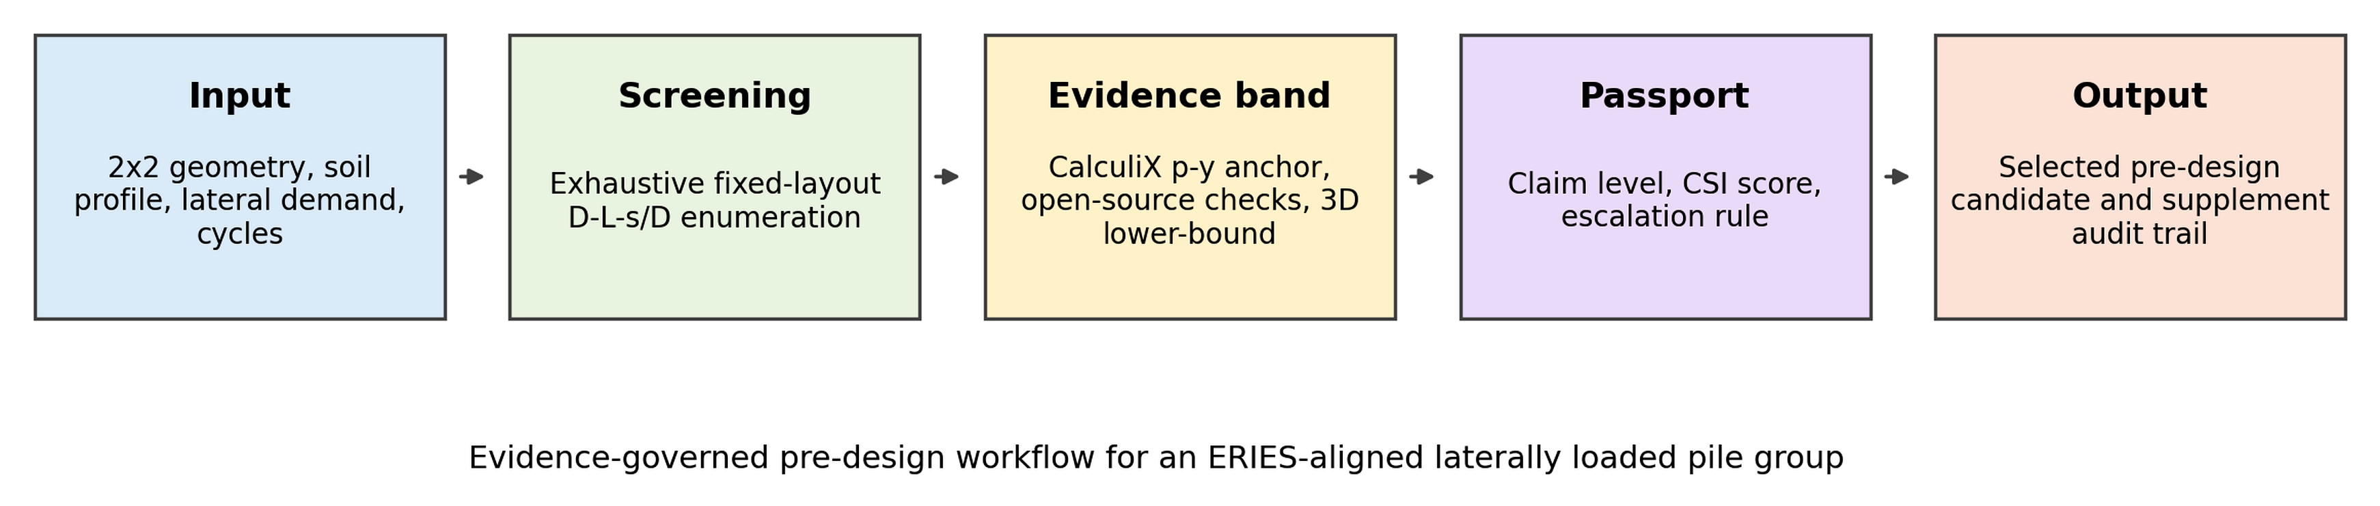
Figure 1. Evidence-governed pre-design workflow for an ERIES-aligned laterally loaded pile group.

3 Methodology
The design vector is x = {D, L, s/D} for a fixed 2x2 pile arrangement. Diameter D, embedded length L and spacing ratio s/D are selected from finite sets, giving 175 alternatives for the final ERIES-aligned study. Exhaustive enumeration is used because the design space is intentionally small enough to make heuristic optimization unnecessary. This choice is important for reproducibility: every feasible and infeasible candidate is available in the audit trail, and the selected design can be checked directly from the canonical CSV files.
For each candidate, the screening branch computes pile bending stiffness EI, an equivalent degraded lateral soil modulus, a spacing-dependent group-efficiency factor, an equivalent pile-head stiffness index and five utilization ratios. The characteristic Winkler length is T = (EI/(kD))^0.25. The effective length is bounded as Le = min(L, lambda_T T), which prevents unbounded stiffness extrapolation while retaining a compact preliminary model. These expressions are used as screening idealizations; the supplementary material documents the dimensional audit and boundary-condition sensitivity.
Cyclic degradation is represented through layer-specific degraded stiffness values and a depth-weighted equivalent modulus. The degraded modulus affects displacement utilization and therefore the feasibility decision. Group interaction is represented through a spacing-efficiency factor calibrated only at the level of trend consistency with published spacing effects. The paper avoids describing this term as full physical calibration because the available evidence does not support that stronger claim.
A candidate is feasible when the maximum utilization across displacement, rotation, bending/stress, soil demand and fatigue does not exceed 1.0. The objective is the normalized index C_norm = C_raw/1000, where C_raw combines concrete volume, total pile length and pile-cap footprint. The objective is therefore an auditable screening proxy, not a contractor cost estimate. This distinction is kept throughout the text because economic claims would require project-specific unit prices and construction constraints.
All model components are stored in the reproducibility package so that a reader can trace the selected value back to its source table or CSV file. The manuscript keeps only the essential equations and decision rules in the main text, while Online Resource 1 and Online Resource 2 retain the long trace tables, QA gates, blind-validation files and detailed evidence hierarchy. This split was made to satisfy the journal word limit without weakening reproducibility.
The finite enumeration also makes failure modes visible. If no candidate is feasible, the workflow reports infeasibility and triggers a larger search space, reduced demand, altered improvement assumption or detailed modelling. If several candidates are feasible, the normalized cost index ranks them only within the declared grid. Table 2 condenses the formulation and claim boundaries.
Table 2. Declared fixed 2x2 screening formulation.
Component | Definition used in main study | Claim boundary
Design variables | D, L and s/D over a finite 2x2 grid | No claim of global topology optimization.
Demand case | 100 kN lateral screening load with cyclic degradation | Single screening case, not full load history design.
Feasibility | max utilization <= 1.0 | Pre-design feasibility only.
Objective | C_norm = C_raw / 1000 | Normalized cost index, not bid cost.
Displacement reporting | 3.219-6.439 mm preliminary screening band | Not an absolute final displacement prediction.

4 Reproducible design study
The final reproduced search contains one topology, five diameters, seven lengths and five spacing ratios. The selected case uses an idealized three-layer profile and is aligned with the 2x2 ERIES-RESPOND benchmark geometry. The fixed topology is a deliberate change from broader topology-aware language: it makes the comparison with external and software checks cleaner, and it avoids claiming support for layouts that were not part of the final validation story.
The selected candidate is D = 0.60 m, L = 8.0 m and s/D = 2.5. It is the least-cost feasible candidate in the declared search. Displacement is the governing screening quantity; stress, soil reaction and fatigue remain inactive relative to their limits. This matters because it changes the engineering interpretation from strength sizing to lateral-serviceability screening.
The reproducible design study therefore acts as a controlled numerical experiment. The variables are limited, the assumptions are stated, and the audit files preserve each candidate. That structure is more useful for publication than a larger but opaque optimization because it lets the reader identify whether disagreement comes from the search space, the degradation model, the objective function or the validation interpretation.
The selected spacing is not presented as a universal optimum. It is the least-cost feasible result for the chosen geometry, soil profile, 100 kN lateral demand and screening equations. Figure 2 shows the layout and stratified profile, while Table 3 summarizes the selected candidate and its governing values.
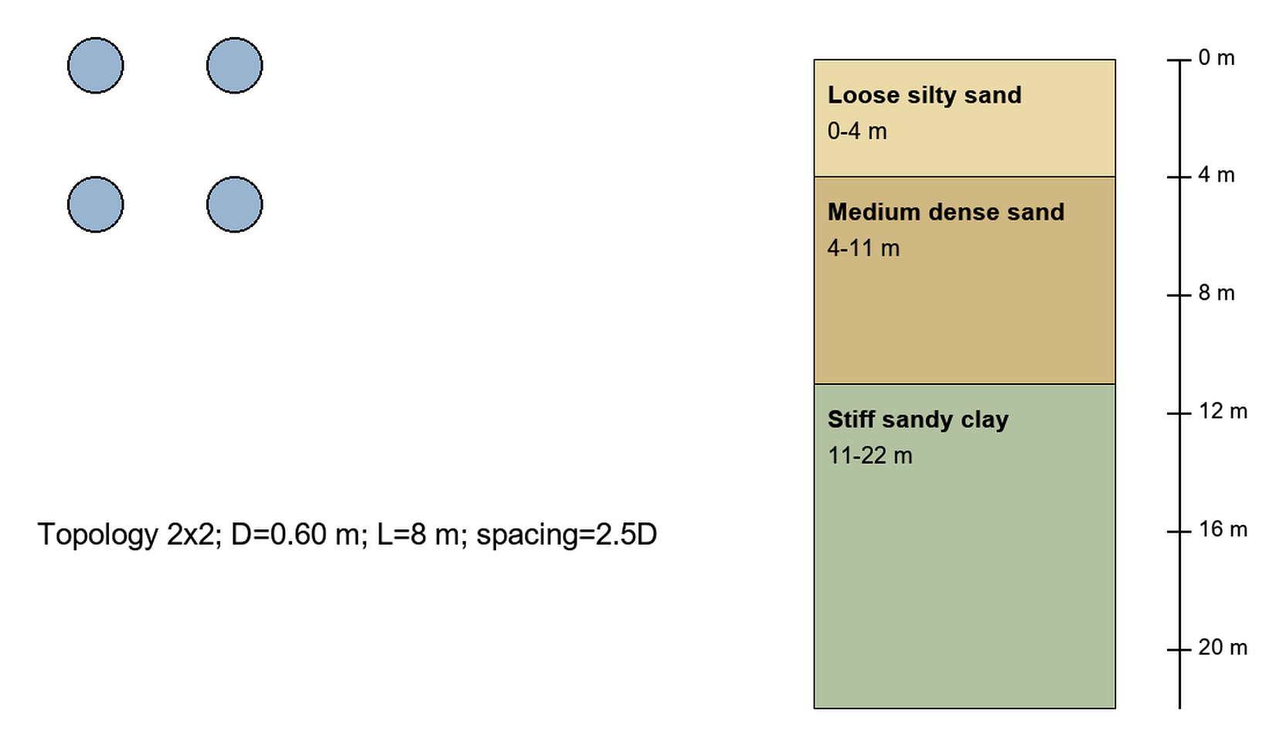
Figure 2. Selected pile-group layout and idealized stratified profile.
Table 3. Selected least-cost feasible screening candidate.
Metric | Value
Topology | 2x2
D (m) | 0.60
L (m) | 8.0
s/D | 2.5
C_norm | 12.116
Governing utilization | 0.860
Central band value (mm) | 4.829
Stress-test envelope (mm) | 25.814

5 Results
Figure 3 shows that the selected design lies on the low-cost feasible side of the declared 2x2 enumeration. The feasibility boundary is controlled by displacement rather than strength, so subsequent high-fidelity modelling should focus on lateral stiffness, soil degradation and group-interaction assumptions.
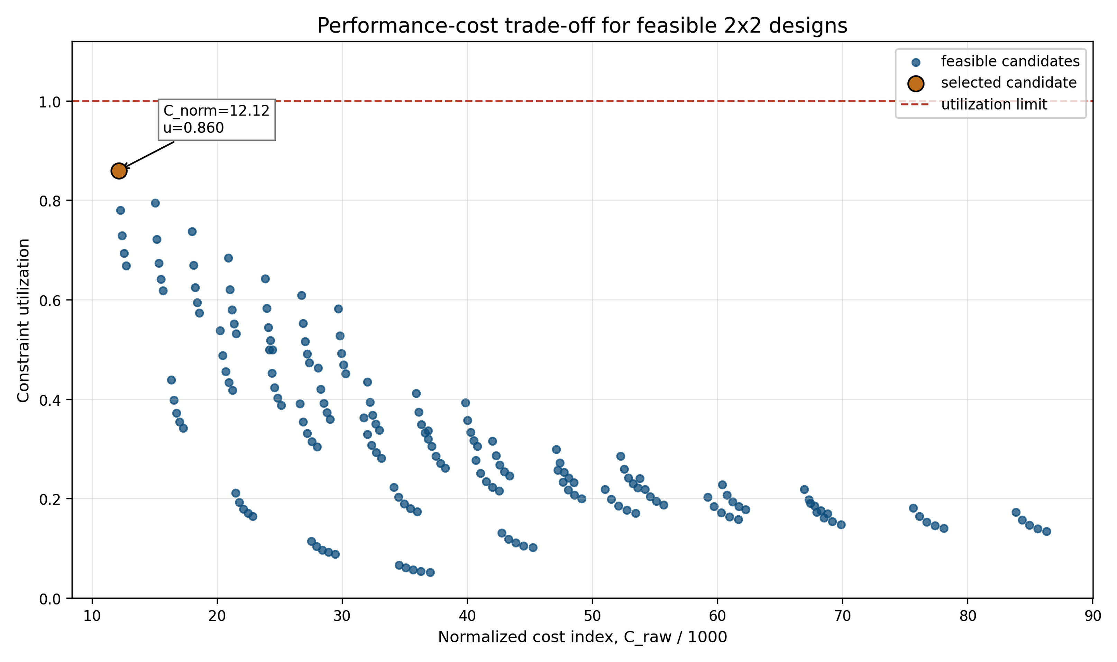
Figure 3. Performance-cost trade-off for feasible 2x2 designs.
Figure 4 reports the local sensitivity around the selected candidate. Increasing lateral load raises utilization almost proportionally over the tested band, while reducing soil stiffness raises utilization as expected for a serviceability-controlled problem. Cycle-multiplier changes affect reserve through degraded stiffness and spacing response, but do not overturn the selected dimensions across most of the tested range.
Figure 5 tests whether the selected candidate is fragile. The same D = 0.60 m, L = 8.0 m and s/D = 2.5 solution remains selected for utilization limits of 1.00, 0.95 and 0.90; only at the stricter 0.85 limit does spacing increase to s/D = 3.0.
The selected candidate is consequently best understood as a screening decision with reserve, not as a single deterministic truth. The sensitivity and reserve checks answer different reviewer questions. Sensitivity asks whether the utilization responds physically to input perturbations. Reserve asks whether the design decision survives stricter acceptance thresholds. Together they make the selection harder to dismiss as a coincidental output of one run.
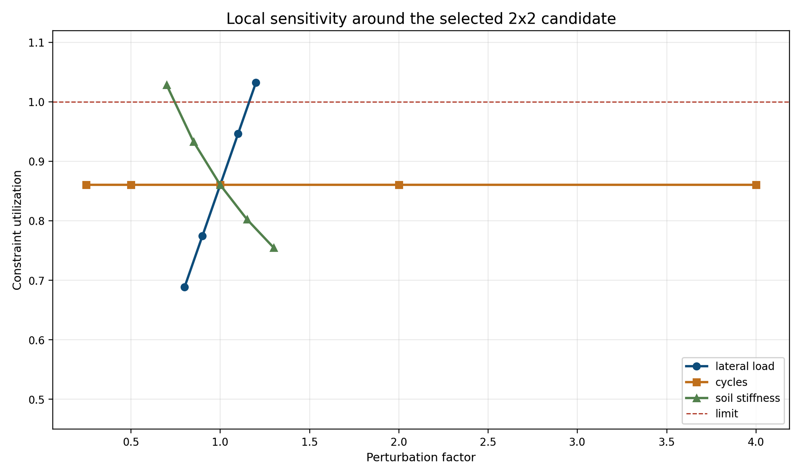
Figure 4. Local sensitivity around the selected 2x2 candidate.
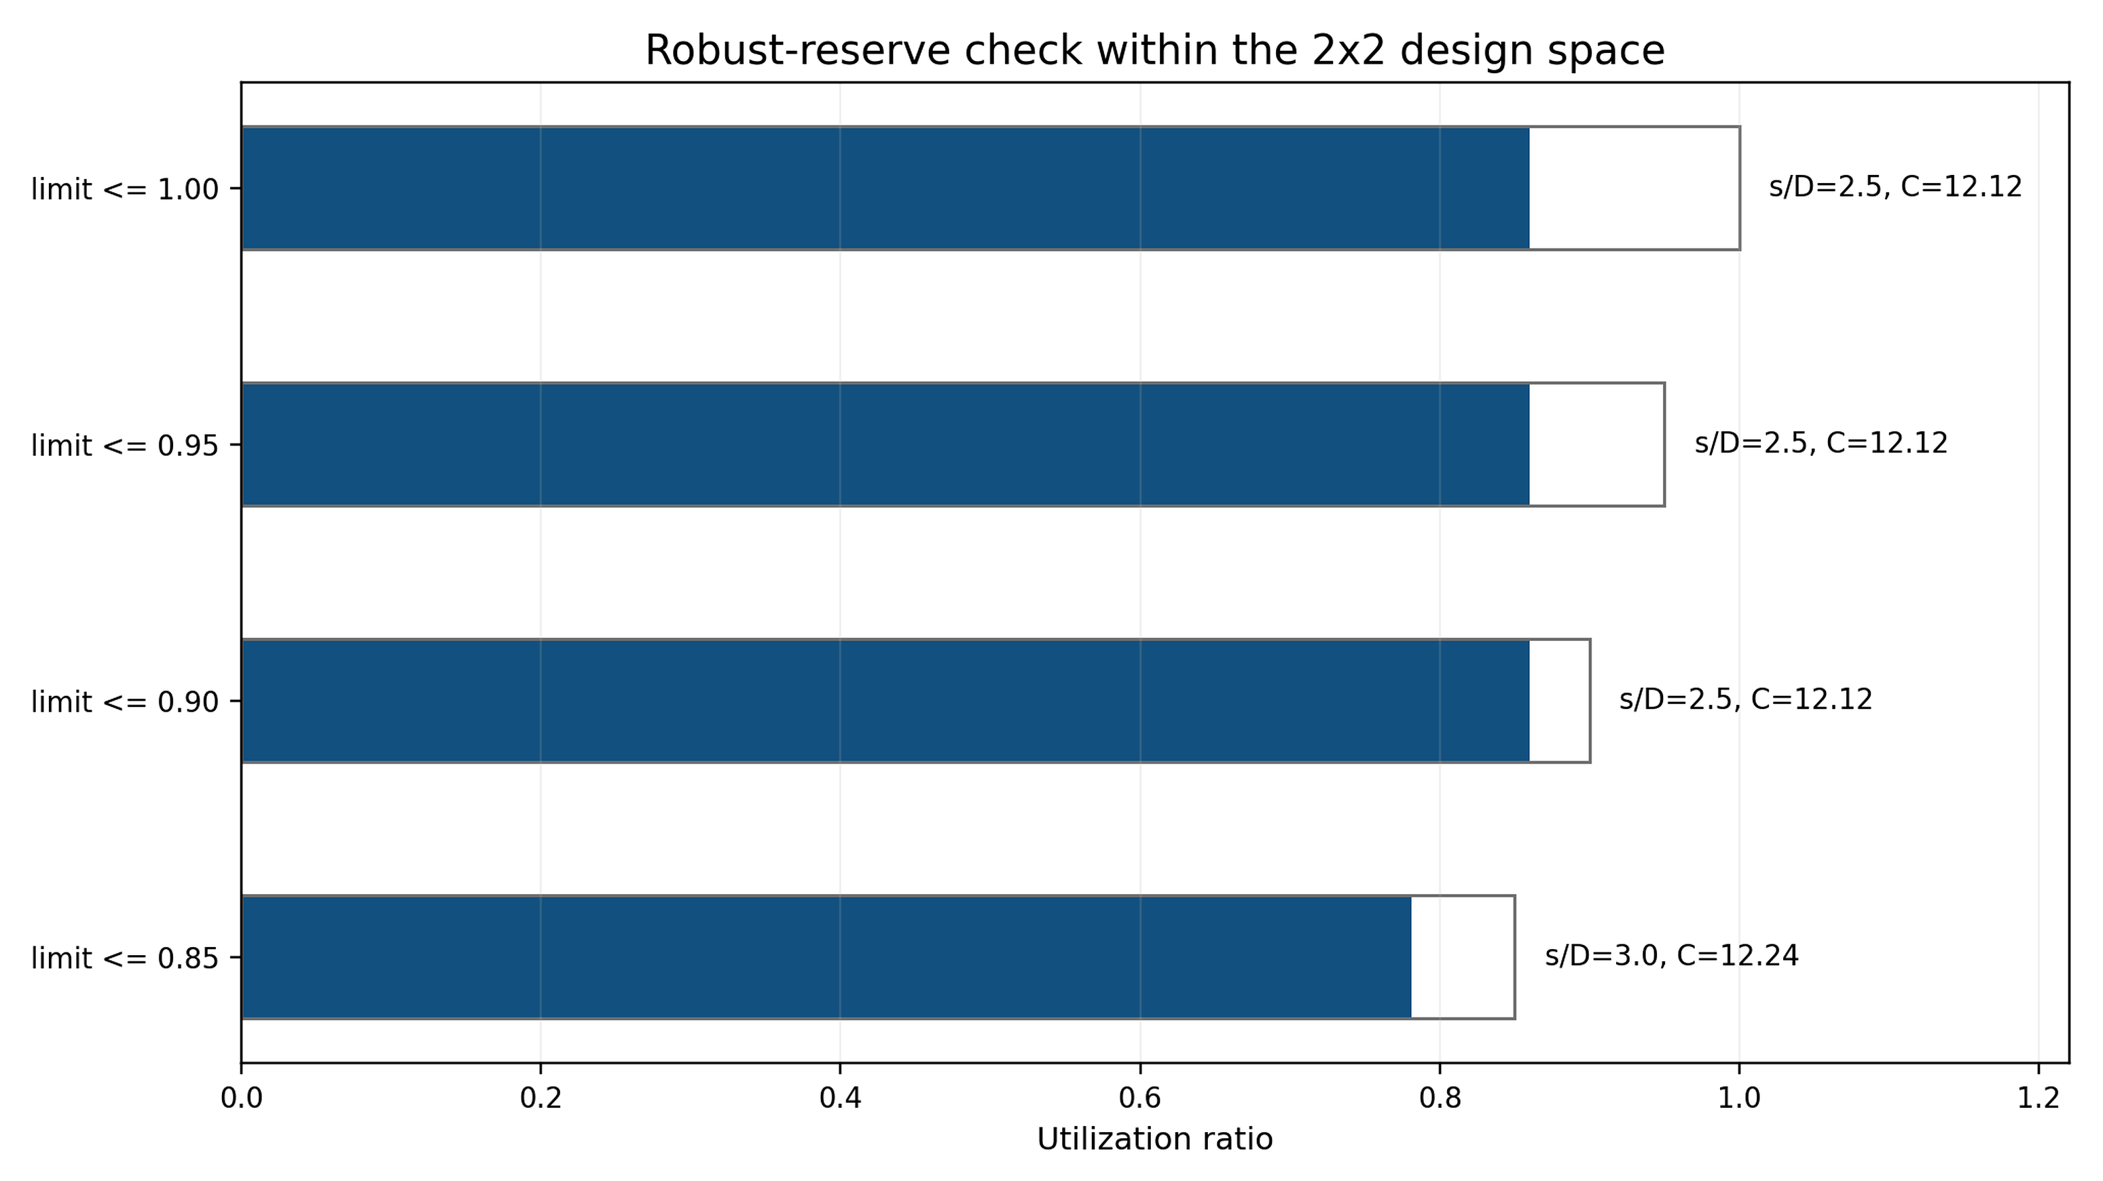
Figure 5. Robust-reserve check within the 2x2 design space.

6 Validation and evidence hierarchy
The strengthened validation strategy separates verification, synthetic benchmark, external evidence and validation. Verification means that scripts reproduce the reported tables, figures and selected candidate. Synthetic benchmark evidence means that independent implementations of the same idealization give compatible selected-case displacement magnitudes. External evidence means that published or third-party curves support trend or order-of-magnitude behaviour. Validation, in the strict sense, would require direct measured cyclic force-displacement data for the same selected 2x2 design and soil conditions; that evidence is not claimed.
The primary reportable displacement is a preliminary screening band. The CalculiX p-y anchor gives 3.219 mm; applying gamma_FEM in [1.0, 2.0] gives 3.219-6.439 mm, with a central value of 4.829 mm. Figure 6 places this band in the full evidence hierarchy, and Figure 7 separates it from the 25.814 mm severe-degradation stress-test envelope.
The CalculiX 3D continuum check is intentionally described as a stiff lower-bound or compliance-sensitivity check. Its bonded shared-node interface is too stiff to validate the central displacement directly, but its compliance-convergence study supports the order of magnitude when interface/soil compliance is varied. The p-y solver cluster is stronger for the selected screening idealization, while the continuum model is stronger as an adversarial lower-bound check. The final claim therefore uses both without overstating either one.
The validation terminology is deliberately strict. A regenerated script is verification. A p-y solver comparison is a synthetic benchmark within the same modelling family. A published curve comparison is external evidence. A measured cyclic force-displacement record for the same geometry, soil and load history would be direct validation. The manuscript uses these terms consistently so that the reader can see exactly where the evidence is strong and where it remains incomplete.
The external blind protocol adds a different type of evidence. Its cases do not share the exact ERIES geometry and are not used to tune the selected 2x2 candidate after the fact. Their value is procedural and adversarial: inputs are separated from outputs, predictions are frozen, measured curves are then revealed, and hashes document the sequence. This prevents the comparison from becoming a retrospective visual fit. The resulting errors are interpreted as curve-scale plausibility checks across published pile-group responses.
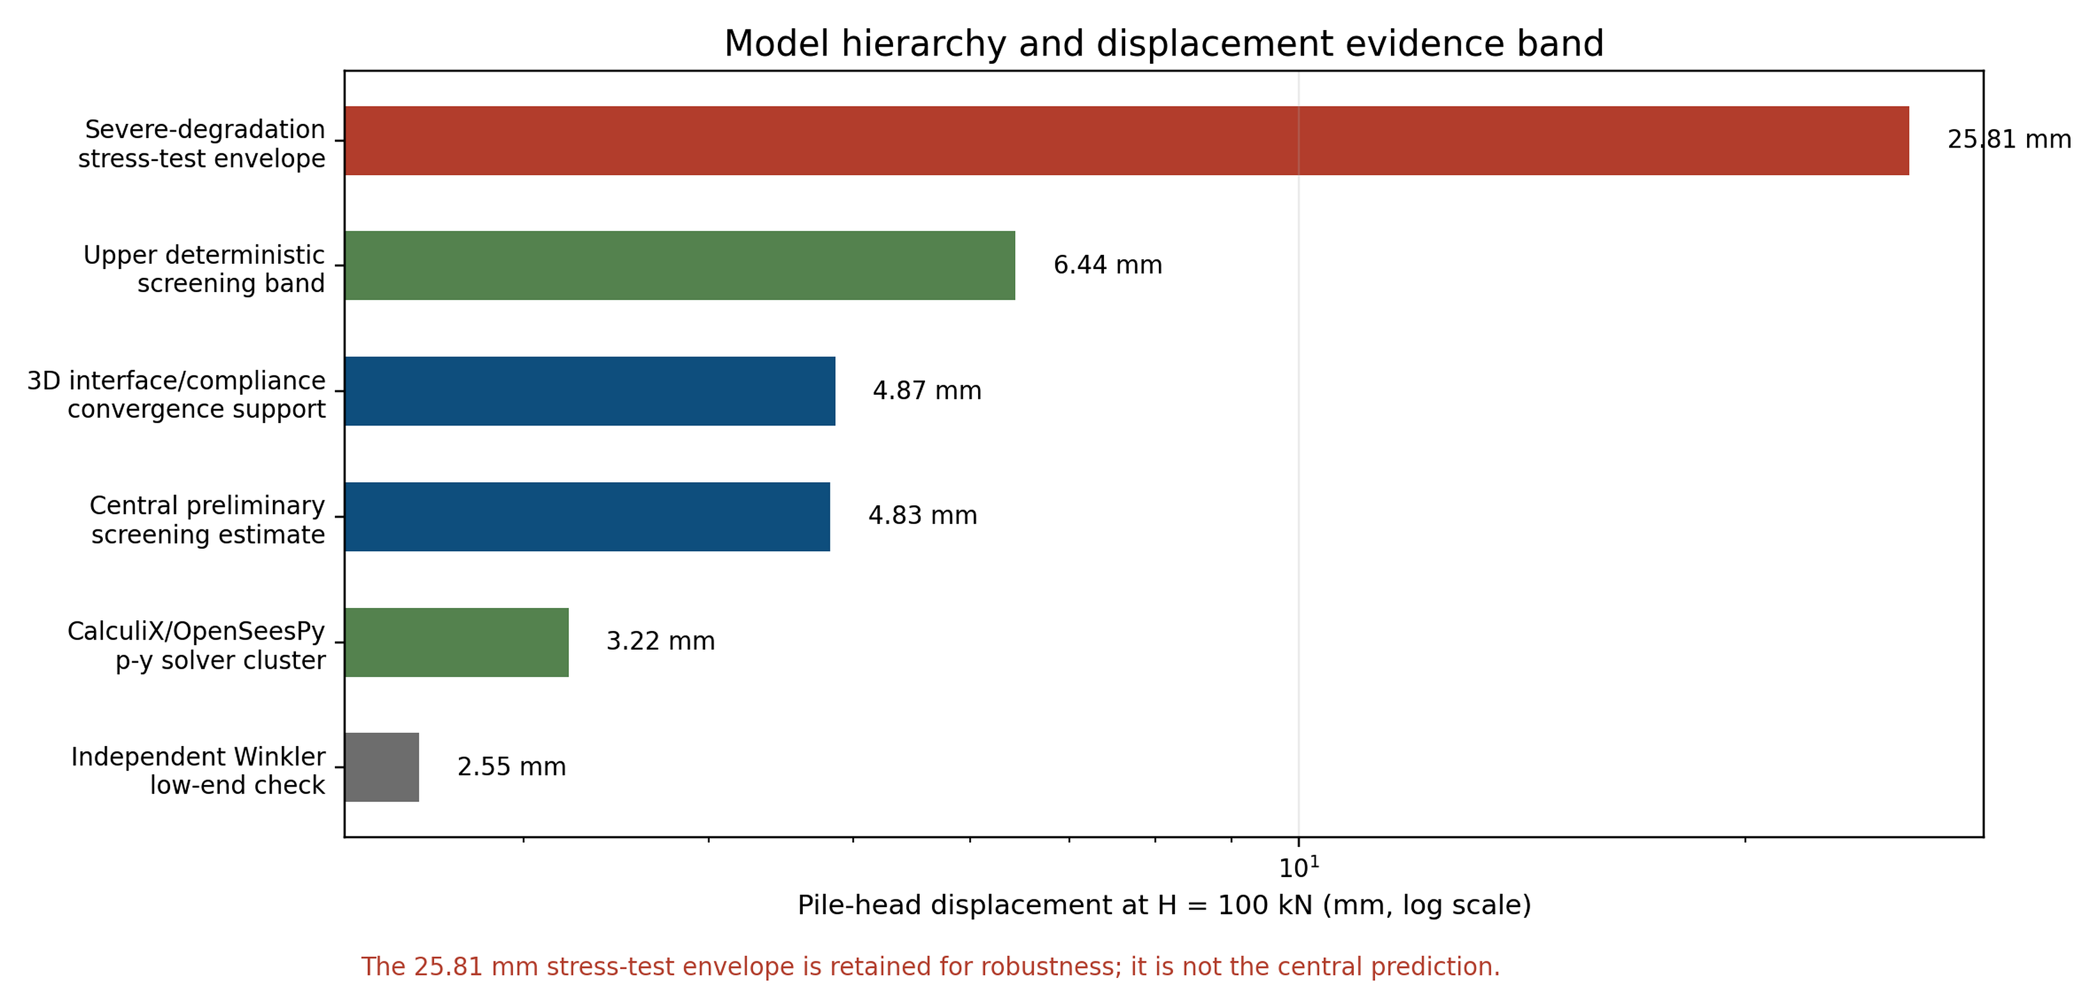
Figure 6. Model hierarchy and displacement evidence band for the selected 2x2 case.
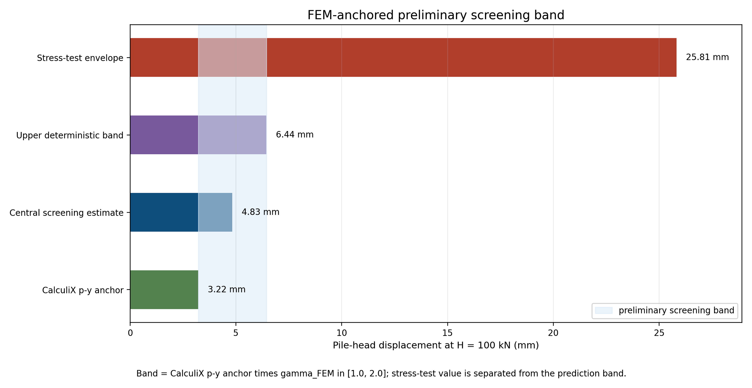
Figure 7. FEM-anchored preliminary screening band and severe-degradation stress-test envelope.

External blind validation protocol
A non-GEOLAB external blind curve-scale check was added to the supplementary package. Three third-party pile-group curves were prepared as blind inputs, predictions were frozen, measured outputs were then revealed, and SHA-256 hashes document the sequence. Table 4 defines the allowed claim level for each evidence item, while Table 5 reports normalized RMSE values of 0.115, 0.229 and 0.166. This remains curve-scale external evidence, not direct cyclic calibration of the selected ERIES 2x2 design.
Table 4. Evidence hierarchy and allowed claim level.
Evidence item | Role | Allowed claim | Prohibited claim
Canonical enumeration | Reproducibility verification | Selected 2x2 candidate is exactly reproducible | Global optimum across all pile-group topologies
CalculiX/OpenSeesPy p-y checks | Solver-level benchmark | Selected-case p-y magnitude is internally consistent | Field validation of soil-pile response
3D continuum lower-bound/compliance check | Adversarial stiffness check | Continuum idealization bounds the response family | Complete nonlinear contact FEM validation
External blind curve-scale check | Third-party trend evidence | Order-of-magnitude/trend behaviour is plausible | Direct cyclic calibration of the selected ERIES case
Table 5. External blind validation summary.
Case | Source type | Geometry class | Normalized RMSE | Interpretation
BV-Rollins2005-9pile-sand | Published third-party curve | 9-pile group in sand | 0.115 | Good curve-scale agreement for external trend evidence.
BV-Christensen2006-9pile-sand | Published third-party curve | 9-pile group in sand | 0.229 | Moderate agreement; retained as adversarial evidence.
BV-Walsh2005-3x5-sand | Published third-party curve | 3x5 pile group in sand | 0.166 | Good order-of-magnitude curve-scale evidence.

7 Discussion
The main engineering benefit is not final displacement prediction; the workflow converts a preliminary design into a traceable decision. A reviewer can see which geometry was selected, which constraint governed, which evidence supports the estimate and when escalation is mandatory.
The V4-S passport keeps the article useful without overstating the model. It allows claims about reproducible screening, reserve sensitivity, selected-case evidence and external curve-scale plausibility, while prohibiting site-specific cyclic calibration, final design validation and universal topology optimization.
The framework is transferable to other layouts, profiles or load cases only if their search space, assumptions and evidence classes are rebuilt. The current result remains an ERIES-aligned fixed 2x2 pre-design case.
The principal limitation is the absence of a direct cyclic lateral load test for the same 2x2 geometry, soil profile and loading history. The manuscript treats that absence as an escalation trigger, not as a minor caveat.
Detailed trace tables remain in Online Resource 2, allowing the main text to stay compact while preserving the audit trail needed for technical scrutiny.

8 Conclusions
- An evidence-governed pre-design workflow was developed for a fixed ERIES-aligned 2x2 laterally loaded pile group under cyclic degradation.
- The selected candidate is D = 0.60 m, L = 8.0 m and s/D = 2.5, with normalized cost index 12.116 and governing displacement utilization 0.860.
- The reportable displacement result is a preliminary screening band of 3.219-6.439 mm with central value 4.829 mm; the 25.814 mm value is retained only as a severe-degradation stress-test envelope.
- The validation package combines reproducibility verification, p-y solver checks, a 3D continuum lower-bound/compliance study and non-GEOLAB external blind curve-scale evidence.
- The V4-S passport states the allowable claim level and forces escalation to nonlinear p-y/FEM or measured data when final design conclusions are required.

References
Achmus, M., Abdel-Rahman, K., and Kuo, Y. S. 2009. Numerical modelling of large diameter steel piles under monotonic and cyclic horizontal loading. International Journal for Numerical and Analytical Methods in Geomechanics 33: 1431-1450.
API. 2014. API Recommended Practice 2GEO: Geotechnical and Foundation Design Considerations. Washington, DC: American Petroleum Institute.
Arora, J. S. 2017. Introduction to Optimum Design. 4th ed. London: Academic Press.
Ashour, M., Norris, G., and Pilling, P. 1998. Lateral loading of a pile in layered soil using the strain wedge model. Journal of Geotechnical and Geoenvironmental Engineering 124 (4): 303-315.
Baecher, G. B., and Christian, J. T. 2003. Reliability and Statistics in Geotechnical Engineering. Chichester: Wiley.
Brown, D. A., Morrison, C., and Reese, L. C. 1988. Lateral load behavior of pile group in sand. Journal of Geotechnical Engineering 114 (11): 1261-1276.
Brown, D. A., Shie, C. F., and Kumar, M. 2001. P-y curves for laterally loaded piles in sand. Transportation Research Record 1772: 28-36.
Burd, H. J., Taborda, D. M. G., Zdravkovic, L., Abadie, C. N., Byrne, B. W., Houlsby, G. T., Gavin, K. G., Igoe, D. J. P., Jardine, R. J., Martin, C. M., McAdam, R. A., and Potts, D. M. 2020. PISA design model for monopiles for offshore wind turbines: application to a stiff glacial clay till. Geotechnique 70 (11): 1030-1047.
Byrne, B. W., McAdam, R. A., Burd, H. J., Houlsby, G. T., Martin, C. M., Zdravkovic, L., Taborda, D. M. G., Potts, D. M., Jardine, R. J., Sideri, M., Schroeder, F. C., Gavin, K. G., Doherty, P., Igoe, D., Muir Wood, A., Kallehave, D., and Skov Gretlund, J. 2015. New design methods for large diameter piles under lateral loading for offshore wind applications. Frontiers in Offshore Geotechnics III: 705-710.
Coello Coello, C. A., Lamont, G. B., and Van Veldhuizen, D. A. 2007. Evolutionary Algorithms for Solving Multi-Objective Problems. 2nd ed. New York: Springer.
Deb, K., Pratap, A., Agarwal, S., and Meyarivan, T. 2002. A fast and elitist multiobjective genetic algorithm: NSGA-II. IEEE Transactions on Evolutionary Computation 6 (2): 182-197.
DNV. 2017. DNVGL-RP-C212: Offshore Soil Mechanics and Geotechnical Engineering. Oslo: DNV GL.
El-Garhy, B. M., Alahmari, T. S., and Abdel Galil, A. M. 2025. A procedure for nonlinear analysis of laterally loaded single piles and pile groups. Civil Engineering Journal 11 (9): 3630-3652. https://doi.org/10.28991/CEJ-2025-011-09-05.
Fenton, G. A., and Griffiths, D. V. 2008. Risk Assessment in Geotechnical Engineering. Hoboken: Wiley.
Fleming, W. G. K., Weltman, A. J., Randolph, M. F., and Elson, W. K. 2009. Piling Engineering. 3rd ed. London: Taylor & Francis.
Goldberg, D. E. 1989. Genetic Algorithms in Search, Optimization, and Machine Learning. Reading, MA: Addison-Wesley.
Haftka, R. T., and Gurdal, Z. 1992. Elements of Structural Optimization. 3rd ed. Dordrecht: Kluwer.
He, R., and Pan, L. 2026. Development and validation of unified p-y curves for laterally loaded flexible and rigid piles. Marine Structures 105: 103919. https://doi.org/10.1016/j.marstruc.2025.103919.
Hicks, M. A., Nuttall, J. D., and Chen, J. 2019. Influence of heterogeneity on 3D slope reliability and failure consequence. Computers and Geotechnics 107: 198-208.
Hong, Y., Chen, X., Wang, L., Wang, L., and He, B. 2024. A bounding-surface-based cyclic p-y+M-theta model for unified description of laterally loaded piles with different failure modes in clay. Canadian Geotechnical Journal 61 (10): 2104-2123. https://doi.org/10.1139/cgj-2023-0310.
Kallehave, D., Byrne, B. W., LeBlanc Thilsted, C., and Mikkelsen, K. K. 2015. Optimization of monopiles for offshore wind turbines. Philosophical Transactions of the Royal Society A 373 (2035): 20140100. https://doi.org/10.1098/rsta.2014.0100.
Kennedy, J., and Eberhart, R. 1995. Particle swarm optimization. Proceedings of IEEE International Conference on Neural Networks 4: 1942-1948.
Pitilakis, D., Di Laora, R., Anastasiadis, A., Rovithis, E., Anoyatis, G., Francois, S., de Sanctis, L., Kapouniaris, A., Filoglou, E., Kroupi, G., and Amendola, C. 2025. Real scale experimental assessment of pile group dynamic impedance (ERIES-RESPOND). Zenodo. https://doi.org/10.5281/zenodo.15518567.
Di Laora, R., Cesaro, R., Rovithis, E., de Sanctis, L., Anoyatis, G., Francois, S., Filoglou, E., Amendola, C., Kroupi, G., Anastasiadis, A., and Pitilakis, D. 2025. Real Scale Experimental Assessment of Pile Group Dynamic Impedance. In Engineering Research Infrastructures for European Synergies, Lecture Notes in Civil Engineering 718, 125-131. Springer. https://doi.org/10.1007/978-3-031-98893-6_13.
Pitilakis, D., Tsagdi, K., Anastasiadis, A., Pitilakis, K., Senetakis, K., Kapouniaris, A., and Taherzadeh, R. 2023. Field testing of gravel-rubber mixtures as geotechnical seismic isolation. Bulletin of Earthquake Engineering 21: 483-523. https://doi.org/10.1007/s10518-022-01541-6.
Li, B., Song, Q.-K., Qi, W.-G., and Gao, F.-P. 2025. An interpretable ML-based model for predicting p-y curves of monopile foundations in sand. arXiv:2501.06232. https://doi.org/10.48550/arXiv.2501.06232.
Little, R. L., and Briaud, J. L. 1988. Full-scale cyclic lateral load tests on six single piles in sand. Miscellaneous Paper GL-88-27. Vicksburg, MS: U.S. Army Engineer Waterways Experiment Station.
Long, J. H., and Vanneste, G. 1994. Effects of cyclic lateral loads on piles in sand. Journal of Geotechnical Engineering 120 (1): 225-244.
Matlock, H. 1970. Correlations for design of laterally loaded piles in soft clay. Offshore Technology Conference, Paper OTC 1204.
McClelland, B., and Focht, J. A. 1956. Soil modulus for laterally loaded piles. Transactions of the American Society of Civil Engineers 123: 1049-1086.
McVay, M., Casper, R., and Shang, T. I. 1998. Lateral response of three-row groups in loose to dense sands at 3D and 5D pile spacing. Journal of Geotechnical and Geoenvironmental Engineering 124 (5): 436-441.
Schlager, T., Moormann, C., Jafarian, Y., van Eekelen, S., Zwaan, R., and Schiewe, H. E. 2024. GEOLAB-InstaLatPile-Deltares: Small-scale experiments on influence of installation effects on the performance of laterally loaded pile groups. Zenodo. https://doi.org/10.5281/zenodo.13373774.
Phoon, K. K., and Kulhawy, F. H. 1999. Characterization of geotechnical variability. Canadian Geotechnical Journal 36 (4): 612-624.
Poulos, H. G., and Davis, E. H. 1980. Pile Foundation Analysis and Design. New York: Wiley.
Randolph, M. F. 1981. The response of flexible piles to lateral loading. Geotechnique 31 (2): 247-259.
Reese, L. C., Cox, W. R., and Koop, F. D. 1974. Analysis of laterally loaded piles in sand. Offshore Technology Conference, Paper OTC 2080.
Reese, L. C., and Van Impe, W. F. 2011. Single Piles and Pile Groups under Lateral Loading. 2nd ed. Leiden: CRC Press.
OpenBrIM. 2026. Liquefied sand Rollins lateral soil model. https://docs.openbrim.org/technical-background/soil-structure-interaction/lateral-soil-models/liquefied-sand-rollins-rollins-et-al-2005. Accessed 14 May 2026.
OpenSeesPy. 2026. LiquefiedSand p-y material documentation. https://openseespydoc.readthedocs.io/en/latest/src/LiquefiedSand.html. Accessed 14 May 2026.
Rollins, K. M., Peterson, K. T., and Weaver, T. J. 1998. Lateral load behavior of full-scale pile group in sand. Journal of Geotechnical and Geoenvironmental Engineering 124 (6): 468-478.
Rollins, K. M., Gerber, T. M., Lane, J. D., and Ashford, S. A. 2005. Lateral resistance of a full-scale pile group in liquefied sand. Journal of Geotechnical and Geoenvironmental Engineering 131 (1): 115-125.
Rollins, K. M., Olsen, R. J., Egbert, J. J., Jensen, D. H., Olsen, K. G., and Garrett, B. H. 2005. Pile spacing effects on lateral pile group behavior: load tests. Journal of Geotechnical and Geoenvironmental Engineering 131 (10): 1262-1271.
Jiang, J., and Chai, W. 2025. The pile-soil integrated element analysis method for laterally loaded pile in sand based on three-dimensional conical strain wedge model. Computers and Geotechnics 184: 107277. https://doi.org/10.1016/j.compgeo.2025.107277.
Yang, Z., and Jeremic, B. 2005. Study of soil layering effects on lateral loading behavior of piles. Journal of Geotechnical and Geoenvironmental Engineering 131 (6): 762-770.
Zeng, F., and Jiang, C. 2025. Cyclic p-y curve modeling for laterally loaded two-pile group in sand based on strain wedge model. Computers and Geotechnics 187: 107499. https://doi.org/10.1016/j.compgeo.2025.107499.
Zeng, F., Jiang, C., Chen, Z., and Liu, P. 2025. A two-dimensional p-y model for piles under multi-directional cyclic loading considering the effects of sand collapse. Computers and Geotechnics 186: 107413. https://doi.org/10.1016/j.compgeo.2025.107413.
Zhang, L., Silva, F., and Grismala, R. 2005. Ultimate lateral resistance to piles in cohesionless soils. Journal of Geotechnical and Geoenvironmental Engineering 131 (1): 78-83.
Zhu, J., Huang, M., Yu, J., and Shen, K. 2025. Cyclic response of laterally loaded piles in undrained clay: A bounding surface approach incorporating small-strain stiffness. Ocean Engineering 340: 122360. https://doi.org/10.1016/j.oceaneng.2025.122360.

Statements and Declarations

Data availability
The data, code, input files, digitized external blind-validation records, QA scripts, CSV outputs and figure-generation traces supporting this study are available in the public GitHub repository https://github.com/gabrielmontufar/article119-pile-group-screening. The compact reproducibility capsule is available at https://github.com/gabrielmontufar/article119-pile-group-screening/tree/main/eries_aligned_2x2_screening_capsule, and the external blind-validation protocol is available at https://github.com/gabrielmontufar/article119-pile-group-screening/tree/main/blind_validation. The repository also contains the submitted supplementary archive and the extended-evidence document.

Supplementary material
Online Resource 1 contains the reproducibility package for the fixed 2x2 screening workflow, V4-S evidence passport, multi-model evidence band, ERIES-aligned capsule, external blind-validation protocol, QA scripts, CSV outputs and figure-generation traces. The submitted supplementary archive and Online Resource 2 are available from the GitHub supplementary directory: https://github.com/gabrielmontufar/article119-pile-group-screening/tree/main/supplementary. The blind-validation files are available separately at https://github.com/gabrielmontufar/article119-pile-group-screening/tree/main/blind_validation.

Funding
No funding was received for this research.

Competing interests
The author declares no competing interests.

Author contribution
Gabriel Jesús Montúfar Chiriboga: conceptualization, methodology, software, formal analysis, investigation, validation, visualization, writing-original draft, and writing-review and editing.

Use of generative artificial intelligence
Generative artificial intelligence tools were used to support language editing, organization and formatting. The author reviewed, verified and takes responsibility for the final content.

