Online Resource 2 - detailed tables and extended evidence
This supplementary document retains the detailed tables, extended evidence hierarchy, model-component documentation and secondary validation material moved out of the main manuscript to respect the International Journal of Geotechnical Engineering research-article word limit. The main manuscript remains the authoritative narrative; this file preserves auditability and table traceability.

Detailed Tables from Full Technical Version
Table 1a. Fit-to-journal relevance map for the International Journal of Geotechnical Engineering.
Journal interest | Manuscript element
Laterally loaded pile groups | ERIES-aligned fixed 2x2 pile-group screening case
Soil-pile interaction | p-y screening, group-interaction factor and continuum/interface checks
Cyclic loading/degradation | degradation-aware serviceability and feasibility evaluation
Numerical modelling | CalculiX, OpenSeesPy and localized 3D interface-layer evidence
Innovative applications | claim-level V4-S passport and Claim Support Index for pre-design decisions
Design practice | D-L-s/D candidate selection, active constraint diagnosis and escalation rules
Reproducibility | CSV files, scripts, figures, QA gates and supplementary screening capsule
Table 2a. Dimensional consistency audit for the equivalent-stiffness screening branch.
Symbol | Expected unit | Expression | Dimensional result | Consistent? | Correction
EI | force x length^2 | pile bending stiffness | F L^2 | Yes | none
k | force/length^3 | subgrade modulus | F L^-3 | Yes | state convention
T | length | (EI/(kD))^0.25 | L | Yes | none
Le | length | min(L, 3.5T) | L | Yes | screening cutoff
k_single | force/length | 3EI/Le^3 | F L^-1 | Yes | none
K_group | force/length | n eta_g k_single | F L^-1 | Yes | eta_g dimensionless
u | length | H/K_group | L | Yes | screening displacement
C_norm | index | C_raw/1000 | normalized index | Yes | not price
g_j | dimensionless | demand/capacity | 1 | Yes | keep <= 1
Table 1. Constraint definitions used in the degradation-aware optimization framework.
Constraint | Screening expression | Limit | Purpose
Pile-cap displacement | uH / ulim | 1.0 | Controls lateral serviceability
Pile-cap rotation | theta / thetalim | 1.0 | Controls serviceability and superstructure compatibility
Bending stress | sigma / sigmalim | 1.0 | Prevents structurally unrealistic pile demand
Soil reaction | Hpile / pultDLe | 1.0 | Checks mobilized soil reaction against degraded resistance
Fatigue | (stress ratio / reference)^3 N/Nref | 1.0 | Flags cyclic structural accumulation
Table 2 defines the design variables and bounds evaluated in the reproducible fixed-topology search. The present optimization is intentionally restricted to the ERIES-aligned 2x2 topology. Diameter, length and spacing are optimized, but topology is not varied in the final design space. Table 3 defines the idealized three-layer soil profile. The values are not presented as a site investigation; they define a consistent computational example that can be rerun and modified. Supplementary material includes the Python code, CSV outputs, figure files, a limited Rollins liquefied-sand p-y scale check that is not profile matched, a holdout p-y calibration capsule and a limited ERIES-RESPOND 2x2 acceleration-based dynamic-impedance consistency check and GEOLAB group-response calibration needed to reproduce the checks.
dimension | values | count
Topology | 2x2 | 1
Diameter | 0.60, 0.75, 0.90, 1.05, 1.20 m | 5
Length | 8, 10, 12, 14, 16, 18, 20 m | 7
Spacing | 2.5, 3.0, 3.5, 4.0, 4.5 D | 5
Total | 1 x 5 x 7 x 5 | 175
Table 2b. Cardinality of the fixed 2x2 design enumeration.
result | text | table | figure | csv_script | matches | action
fixed layout | 2x2 fixed | Table 5 | Fig. 2 | canonical_2x2_design_space.csv | yes | retained
D | 0.60 m | Table 5 | Fig. 2 | selected_candidate.csv | yes | verified
L | 8.0 m | Table 5 | Fig. 2 | selected_candidate.csv | yes | verified
spacing | 2.5D | Table 5 | Fig. 2 | selected_candidate.csv | yes | verified
u_CalculiX | 3.219 mm | Table 20/21 | Fig. 18/19 | calcix_checks_trace.csv | yes | verified
u_FEM anchored | 4.83 mm | Table 21b | Fig. 19 | gamma_fem_sensitivity.csv | yes | verified
anchor band | 3.219-6.439 mm | Table 21c | Fig. 19 | gamma_fem_sensitivity.csv | yes | verified
u_stress | 25.81 mm | Table 5/21c | Fig. 19 | canonical_2x2_design_space.csv | yes | verified
utilization | 0.860 | Table 5 | Fig. 5 | canonical_2x2_design_space.csv | yes | verified
C_raw | 12116.2 | cost trace | Fig. 3 | canonical_2x2_design_space.csv | yes | verified
C_norm | 12.1 | Table 5 | Fig. 3 | canonical_2x2_design_space.csv | yes | verified
alternatives | 175 | Table 2 | none | 01_generate_design_space.py | yes | verified
feasible alternatives | 14 | canonical CSV | Fig. 3 | 02_evaluate_candidates.py | yes | verified
reserve change | changes at 0.85 | Table 7 | Fig. 6 | 05_reserve_check.py | yes | verified
cycle multiplier | spacing changes at 4.0x | Table 8 | Fig. 7 | 06_degradation_sweep.py | yes | verified
cost weights | candidate unchanged | Table 9 | none | 07_cost_weight_sensitivity.py | yes | verified
Table 2c. Reproducibility and traceability checks for the canonical 2x2 results.
Variable | Values | Role
Topology | 2x2 only | Fixed ERIES-aligned layout; topology is not varied in the final reproduced search
Pile diameter D | 0.60, 0.75, 0.90, 1.05, 1.20 m | Size variable within the fixed topology
Pile length L | 8, 10, 12, 14, 16, 18, 20 m | Embedded-length variable
Spacing | 2.5D, 3.0D, 3.5D, 4.0D, 4.5D | Interaction and cap-footprint variable
Load case | H = 100 kN; M = 0 kN m; N = 100,000 cycles | Cyclic lateral service demand
Table 2. Design variables used in the fixed 2x2 ERIES-aligned diameter-length-spacing search.
Layer | Depth (m) | Unit weight (kN/m3) | Static k (MN/m3) | pult (kPa) | alpha
Loose silty sand | 0-4 | 18.0 | 18 | 145 | 0.18
Medium dense sand | 4-11 | 19.0 | 45 | 320 | 0.14
Stiff sandy clay | 11-22 | 19.5 | 70 | 520 | 0.10
Table 3. Idealized soil profile used for the degradation-aware p-y screening calculation.
Metric | Value
Topology | 2x2
Number of piles | 4
Diameter | 0.60 m
Length | 8.0 m
Spacing | 2.5D (1.50 m)
Group efficiency | 0.694
FEM-anchored preliminary displacement | 4.83 mm
Deterministic screening band | 3.219-6.439 mm
Severe-degradation stress-test displacement | 25.81 mm
Governing utilization | 0.860, based on the 25.81 mm stress-test envelope
Preliminary-prediction displacement utilization | 0.161, based on 4.83 mm / 30 mm
Raw weighted cost C_raw | 12116.2
Normalized cost index C_norm = C_raw / 1000 | 12.1
Table 4. Selected least-cost feasible screening candidate, governing utilization and normalized cost index.
Topology | Status | D (m) | L (m) | Spacing | FEM-anchored disp. (mm) | Stress-test disp. (mm) | Utilization basis | Normalized cost index C_norm
2x2 | Feasible | 0.60 | 8 | 2.5D | 4.83 | 25.81 | 0.860 from stress-test envelope | 12.1
Table 5. Selected least-cost feasible candidate within the 2x2 ERIES-aligned design space.
Case | Topology | D (m) | L (m) | Spacing | Soil k (kN/m3) | T (m) | Le (m) | Utilization | Normalized cost index C_norm
no cyclic degradation | 2x2 | 0.60 | 8 | 2.5D | 23220 | 1.92 | 6.7 | 0.640 | 12.1
design cyclic degradation | 2x2 | 0.60 | 8 | 2.5D | 15649 | 2.12 | 7.4 | 0.860 | 12.1
Table 6. Baseline comparison with and without cyclic degradation. Cyclic degradation increases utilization from 0.640 to 0.860 while keeping the fixed 2x2 layout and normalized cost index C_norm unchanged.
Reserve limit | Topology | D (m) | L (m) | Spacing | Utilization | Normalized cost index C_norm
1.00 | 2x2 | 0.60 | 8 | 2.5D | 0.860 | 12.1
0.95 | 2x2 | 0.60 | 8 | 2.5D | 0.860 | 12.1
0.90 | 2x2 | 0.60 | 8 | 2.5D | 0.860 | 12.1
0.85 | 2x2 | 0.60 | 8 | 3.0D | 0.781 | 12.2
Table 7 and Fig. 6 address the concern that a near-limit design may be numerically fragile. For utilization limits of 1.00, 0.95 and 0.90, the selected ERIES-aligned 2x2 candidate remains unchanged with normalized cost index C_norm = 12.1 and utilization 0.860. Only when the reserve limit is tightened to 0.85 does the selected spacing change from 2.5D to 3.0D, increasing C_norm slightly to 12.2.
Cycle multiplier | Fixed layout | D (m) | L (m) | Spacing | Soil k (kN/m3) | Stress-test disp. (mm) | Feasible designs | Utilization | Normalized cost index C_norm
0.00 | 2x2 | 0.60 | 8 | 2.5D | 23220 | 19.20 | 175 | 0.640 | 12.1
0.25 | 2x2 | 0.60 | 8 | 2.5D | 18889 | 22.42 | 175 | 0.747 | 12.1
0.50 | 2x2 | 0.60 | 8 | 2.5D | 17287 | 23.96 | 175 | 0.799 | 12.1
1.00 | 2x2 | 0.60 | 8 | 2.5D | 15649 | 25.81 | 175 | 0.860 | 12.1
2.00 | 2x2 | 0.60 | 8 | 2.5D | 14075 | 27.95 | 175 | 0.932 | 12.1
4.00 | 2x2 | 0.60 | 8 | 3.0D | 12614 | 27.54 | 174 | 0.918 | 12.2
Table 7. Robust-reserve check for stricter utilization limits within the ERIES-aligned 2x2 design space.
Cost-weight case | Fixed layout | D (m) | L (m) | s/D | Reweighted normalized index C_norm,w | Comparable to baseline | Utilization
baseline weights | 2x2 | 0.60 | 8.0 | 2.5 | 12.1 | yes | 0.860
concrete weight -20% | 2x2 | 0.60 | 8.0 | 2.5 | 10.7 | no; weights changed | 0.860
concrete weight +20% | 2x2 | 0.60 | 8.0 | 2.5 | 13.5 | no; weights changed | 0.860
installation weight -20% | 2x2 | 0.60 | 8.0 | 2.5 | 11.2 | no; weights changed | 0.860
installation weight +20% | 2x2 | 0.60 | 8.0 | 2.5 | 13.0 | no; weights changed | 0.860
cap-footprint weight -20% | 2x2 | 0.60 | 8.0 | 2.5 | 12.0 | no; weights changed | 0.860
cap-footprint weight +20% | 2x2 | 0.60 | 8.0 | 2.5 | 12.2 | no; weights changed | 0.860
Table 8. Sensitivity of selected screening candidate and feasible-count to cyclic-degradation multiplier.
Reference case | Topology | Spacing | Reported/anchor | Screening | Abs. diff.
ERIES-RESPOND full-scale 2x2 geometry, 2.5D | 2x2 | 2.50D | - | 0.694 | -
Rollins et al. 2005 spacing-effect trend, 3.3D | 2x2 | 3.30D | - | 0.799 | -
monotonic spacing trend | 2x2 | 3.00D | - | 0.765 | -
monotonic spacing trend | 2x2 | 3.30D | - | 0.799 | -
monotonic spacing trend | 2x2 | 4.00D | - | 0.861 | -
monotonic spacing trend | 2x2 | 5.00D | - | 0.918 | -
monotonic spacing trend | 2x2 | 5.65D | - | 0.942 | -
monotonic spacing trend | 2x2 | 6.00D | - | 0.952 | -
Table 9. Cost-weight sensitivity for the normalized objective function. Reweighted values are not directly comparable to the baseline except for the baseline-weight row.
Topology | Stress-test disp. (mm) | Independent Winkler disp. (mm) | Winkler/stress-test ratio | Role
2x2 | 25.81 | 2.55 | 0.10 | single-case magnitude and stiffness cross-check
Table 10. Quantitative external trend-consistency check for spacing-dependent group efficiency.
Method | Source/provenance | Group interaction | Cyclic degradation | p-multiplier or eta_g | Head stiffness / solver | Predicted head disp. (mm) | Ratio to 4.83 mm | Ratio to 25.81 mm | Ratio to CalculiX p-y | Maximum defensible claim
Single-pile p-y baseline without group reduction | same degraded profile and stiffness expression; eta_g set to 1.0 | none | 0.674 | 1.000 | 5580.0 | 17.921 | 3.710 | 0.694 | 5.567 | single-pile/no-group-reduction reference for model-to-model comparison only
Proposed screening stress-test envelope | this paper, eta_g equation and degraded profile | eta/p-multiplier | 0.674 | 0.694 | 3873.9 | 25.814 | 5.344 | 1.000 | 8.018 | conservative screening envelope for selected 2x2 benchmark
Proposed FEM-anchored preliminary estimate | 1.5 times CalculiX p-y FEM result | eta/p-multiplier | not implemented | - | 20703.9 | 4.830 | 1.000 | 0.187 | 1.500 | FEM-anchored preliminary estimate, not measured validation
Brown/Reese-style row p-multiplier baseline | Brown et al. 1988/Morrison-Reese 3D sand row multipliers summarized in open FHWA/NIST-style man... | eta/p-multiplier | 0.674 | 0.600 | 3348.0 | 29.869 | 6.184 | 1.157 | 9.278 | practice-style p-multiplier sensitivity baseline; not selected-profile calibration
API/DNV-style p-y practice baseline | API/DNV cited as p-y practice references; no public case-specific group p-multiplier formula im... | not implemented | not implemented | - | - | - | - | - | - | practice context only; not a numerical comparator
Modern cyclic group p-y formulation | Zeng and Jiang 2025 / related cyclic group p-y literature cited; formula not fully reproducible... | not implemented | not implemented | - | - | - | - | - | - | compatibility gap identified; no numerical validation claimed
CalculiX nonlinear p-y FEM | this paper, B31 beam piles with nonlinear SPRINGA p-y springs | eta/p-multiplier | 0.674 | 0.694 | 31061.5 | 3.219 | 0.667 | 0.125 | 1.000 | solver-level p-y implementation check; not field validation
Table 11. Independent Winkler displacement check for the selected 2x2 case.
Method | Original calibration domain | Soil type | Pile/group type | Loading type | Spacing range | Output quantity | Compatible with selected 2x2 case | Reason | Used numerically
Single-pile p-y baseline | same screening profile; artificial no-group reference | selected stratified profile | 2x2 treated as four independent piles | static-equivalent lateral service load | not applicable | head displacement | medium | same profile and load; omits group interaction | yes
Proposed screening/FEM-anchored estimate | this selected 2x2 benchmark | selected stratified profile | 2x2 fixed topology | static-equivalent cyclic screening | 2.5D selected | stress-test envelope and preliminary estimate | high | defined for this benchmark | yes
Brown/Reese-style p-multiplier | full-scale/experimental sand pile-group p-multiplier practice, commonly cited at about 3D spacing | sand; not the full selected stratified profile | row-based pile groups; adapted here to 2-row average | lateral loading; cyclic effects not profile-specific | open values used at 3D, adapted to 2.5D without interpolation | model-to-model head displacement | medium-low | useful sensitivity baseline but not selected-profile calibration | yes
API/DNV-style p-y practice | design practice p-y guidance | varies by guidance | not enough public group p-multiplier detail for this benchmark | practice p-y analysis | not implemented | not implemented | not implemented | no auditable public formula/table for this case in evidence package | no
Modern cyclic group p-y | recent mechanism-specific cyclic group p-y formulations | method-specific sand/clay settings | method-specific, often fixed group configurations | cyclic/multidirectional in source papers | not mapped to current benchmark | not implemented | not implemented | formula/parameters not reproducible from current evidence package | no
CalculiX nonlinear p-y FEM | solver implementation of this paper's p-y idealization | selected degraded stratified profile | 2x2 beam-spring model | static-equivalent 100 kN lateral load | 2.5D selected | head displacement | high as numerical check | same benchmark, independent solver implementation | yes
Table 18. CalculiX p-y FEM model definition and reproducibility metadata.
Item | Value | Source/file | Units | Mesh/load | Boundary/extraction | Interpretation | Maximum claim
solver/version | CalculiX 2.23.0 | stdout; CSV | kN, m | - | - | solver-level reproducibility check | not field validation
element type | B31 beams + nonlinear SPRINGA springs | py_fem_model.inp | kN, m | 64 beams; 64 springs | - | independent p-y implementation | same idealization family
geometry | 2x2; D=0.60; L=8.0; s=2.5D | selected_design.csv | m | 4 piles | head nodes TOP | same selected case | geometry-specific check
mesh | 132 nodes | py_fem_model.inp | - | 0.5 m vertical spring spacing | - | auditable discretization | solver traceability
material | E=30,000,000; nu=0.20 | py_fem_model.inp | kN/m2 | linear elastic pile | - | elastic structural model | not nonlinear concrete check
spring law | multilinear nonlinear p-y curves | py_fem_model.inp | kN/m | degraded profile; eta_g=0.694 | SPRINGA | screening p-y reproduced in solver | not lab calibration
boundary condition | tips fixed; ground spring nodes fixed | py_fem_model.inp | - | head nodes laterally loaded | static-equivalent | not cyclic time-history | implementation check
load | 100 total; 25 per pile in +x | py_fem_model.inp | kN | 4 loaded head nodes | CLOAD | service load | not dynamic loading
result extraction | mean/max TOP Ux = 3.219/3.219 | py_fem_model.dat | mm | TOP set | last increment | supports numerical traceability | not field calibration
Table 19. CalculiX 3D continuum model definition and reproducibility metadata.
Item | Static case | Degraded case | Source/file | Units | Boundary/interface | Extraction | Maximum claim
solver/version | CalculiX 2.23.0 | CalculiX 2.23.0 | stdout/CSV | kN, m | - | - | solver-level continuum check
element type | C3D8 solid | C3D8 solid | continuum_static/degraded.inp | - | single solid mesh | - | no p-y springs
soil block | 7.2 x 7.2 x 8.0 | 7.2 x 7.2 x 8.0 | inp coordinates | m | finite block | - | not infinite-domain SSI
mesh | 2601 nodes; 2048 elements | 2601 nodes; 2048 elements | inp parser | - | 1920 soil + 128 pile elements | - | auditable lower-bound mesh
interface | shared-node bonded no-slip/no-gap | shared-node bonded no-slip/no-gap | shared nodes | - | no contact/gap/slip | - | stiff lower-bound idealization
soil stiffness | static layer moduli | cycle-degraded layer moduli | SOIL1/2/3 materials | kN/m2 | linear elastic | - | not nonlinear soil validation
boundary condition | bottom fixed; side normal fixed; top free | same | continuum inp | - | C3D8 continuum | - | bounded stiffness check
load | 100 on 36 TOPPILE nodes | 100 on 36 TOPPILE nodes | CLOAD records | kN | 2.7778 per top node | - | static-equivalent load
result extraction | mean/max Ux = 0.286/0.294 | mean/max Ux = 0.403/0.413 | dat TOPPILE set | mm | last increment | TOPPILE Ux | lower-bound stiffness check
Table 20 and Fig. 18 summarize the resulting model hierarchy. The CalculiX p-y FEM is a solver-level independent implementation of the same p-y idealization, whereas the CalculiX 3D continuum is a stiff lower-bound check because its shared pile-soil nodes impose a bonded no-slip/no-gap interface. Neither model is treated as calibrated field validation or final design verification. The editorial decision recorded in Supplementary material is Route 2: report the FEM-anchored preliminary displacement of 4.83 mm and keep the original 25.81 mm value as a stress-test envelope; 25.81 mm is not the principal displacement prediction.
Soil/interface modulus scale | Mean top displacement (mm) | Error vs 4.83 mm (%) | Inside 3.219-6.439 mm band
1.00000 | 0.403 | -91.65 | no
0.05000 | 3.124 | -35.32 | no
0.04000 | 3.447 | -28.62 | yes
0.02500 | 4.093 | -15.25 | yes
0.02000 | 4.370 | -9.53 | yes
0.01500 | 4.689 | -2.92 | yes
0.01250 | 4.868 | 0.78 | yes
0.01000 | 5.061 | 4.79 | yes
Table 24o. CalculiX 3D compliance-convergence sensitivity.
Question | Result | Manuscript claim allowed
Why was the original continuum too stiff? | The shared-node/bonded continuum gives 0.403 mm, 91.65% below the 4.83 mm preliminary estimate. | It is a useful stiff lower-bound, not the final independent displacement validation.
What reconciles the bonded-continuum discrepancy? | Scaling the effective soil/interface compliance to 0.01250 gives 4.867612 mm, only 0.78% from 4.83 mm. | The bonded 3D continuum can reproduce the selected-case displacement scale when missing compliance is represented through a scalar soil-modulus sensitivity.
What remains prohibited? | The factor is a selected-case compliance calibration, not blind field-test validation. | The paper may claim V4-S pre-design convergence, not final cyclic field calibration.
Table 24p. Interpretation of the 3D continuum convergence evidence.
Model | Interface | Mesh/domain | u_head (mm) | Inside band? | Claim allowed
3D-0_bonded_reference | bonded | hxy=0.600, hz=1.000; B=3.600 | 0.403 | no | band-stable E4 model-form benchmark
3D-4_interface_high | t=0.300 m; Eint/Esoil1=0.10000 | hxy=0.600, hz=1.000; B=3.600 | 0.844 | no | band-stable E4 model-form benchmark
3D-5_interface_medium | t=0.300 m; Eint/Esoil1=0.03000 | hxy=0.600, hz=1.000; B=3.600 | 1.501 | no | band-stable E4 model-form benchmark
3D-6_interface_low | t=0.300 m; Eint/Esoil1=0.01000 | hxy=0.600, hz=1.000; B=3.600 | 2.599 | no | band-stable E4 model-form benchmark
3D-6b_interface_very_low | t=0.300 m; Eint/Esoil1=0.00300 | hxy=0.600, hz=1.000; B=3.600 | 4.143 | yes | band-stable E4 model-form benchmark
3D-6c_interface_extreme_low | t=0.300 m; Eint/Esoil1=0.00100 | hxy=0.600, hz=1.000; B=3.600 | 5.202 | yes | band-stable E4 model-form benchmark
3D-6d_interface_thick_low | t=0.600 m; Eint/Esoil1=0.00300 | hxy=0.600, hz=1.000; B=3.600 | 5.185 | yes | band-stable E4 model-form benchmark
3D-7_recommended_coarse | t=0.300 m; Eint/Esoil1=0.00300 | hxy=0.750, hz=1.000; B=3.600 | 4.096 | yes | band-stable E4 model-form benchmark
3D-7_recommended_medium | t=0.300 m; Eint/Esoil1=0.00300 | hxy=0.600, hz=1.000; B=3.600 | 4.143 | yes | band-stable E4 model-form benchmark
3D-7_recommended_xy_fine | t=0.300 m; Eint/Esoil1=0.00300 | hxy=0.450, hz=1.000; B=3.600 | 4.097 | yes | band-stable E4 model-form benchmark
3D-7_recommended_z_fine | t=0.300 m; Eint/Esoil1=0.00300 | hxy=0.600, hz=0.500; B=3.600 | 5.734 | yes | band-stable E4 model-form benchmark
3D-7_recommended_fine | t=0.300 m; Eint/Esoil1=0.00300 | hxy=0.450, hz=0.500; B=3.600 | 5.643 | yes | band-stable E4 model-form benchmark
3D-1_domain_large | t=0.300 m; Eint/Esoil1=0.00300 | hxy=0.600, hz=1.000; B=5.400 | 4.154 | yes | band-stable E4 model-form benchmark
Table 20f. Open-source E4 evidence matrix for the selected 2x2 case.
Evidence source | Level | u (mm) | Role | Maximum defensible claim
CalculiX 3D bonded continuum | E4 lower-bound | 0.403105 | continuum check without p-y springs | stiff lower-bound caused by bonded shared-node no-slip/no-gap idealization
CalculiX 3D soil-modulus compliance sweep | E4 selected-case convergence | 4.867612 | open-source continuum compliance-convergence benchmark | supports physical scale of selected preliminary displacement; not blind field validation
CalculiX nonlinear p-y FEM | E3 solver anchor | 3.219416 | open-source p-y solver check | solver-level p-y implementation consistency
OpenSeesPy beam-zeroLength p-y model | E3 independent open-source solver | 3.213030 | independent implementation/model-form check | confirms p-y implementation scale using a second open-source solver
Independent Winkler stiffness expression | E1-E2 magnitude check | 2.550000 | simple closed-form stiffness comparison | lower magnitude check; not physical validation
Deterministic gamma_FEM upper bound | E3 derived band bound | 6.438832 | declared preliminary screening-band upper bound | bounded model-bias allowance around open-source p-y anchor
Table 20g. Physically parameterized 3D interface-layer benchmark.
comparison | equivalence | level | type | supports | does_not_support | action
ERIES-RESPOND | same 2x2 geometry but different amplitude/output | E1-E2 | small-amplitude dynamic impedance | geometry-aligned dynamic-impedance consistency | 100 kN static/cyclic displacement validation | retain brief main-text role and full details in supplement
CalculiX nonlinear p-y FEM | same selected case | E3 | same-family solver-level check | numerical p-y consistency and gamma_FEM anchor | independent field validation | name as solver-level check only
CalculiX 3D continuum | same geometry/profile/load; bonded interface simplification | E4 partial | independent continuum trend check | primary independent selected-case numerical comparison under stiff interface | calibrated nonlinear contact/gap/slip response | use as primary independent comparison with bounded claim
Winkler check | same selected case but simplified elastic formula | E1-E2 | order-of-magnitude numerical check | alternative stiffness magnitude | group field validation | secondary consistency evidence
Brown/Rollins p-multiplier surrogate | same selected geometry/load but practice-style surrogate | E2-E3 | practice-equivalent p-multiplier benchmark | sensitivity to standard p-multiplier assumptions | profile-matched calibration | secondary benchmark
GROUP demo | not selected case | E2 | non-equivalent commercial output | software-scale sanity check | selected-case validation | supplementary/non-equivalent only
GROUP-matched benchmark | matched to GROUP demo, not ERIES selected case | E2-E5 for separate benchmark | commercial stiffness anchoring capsule | framework can be re-anchored to commercial stiffness for a matched demo | selected ERIES-case validation | secondary capsule; do not use as main selected-case comparator
Rollins liquefied-sand p-y backbone | not profile-matched | E1 | severe external p-y scale check | context for severe degraded p-y scale | selected stratified profile displacement | brief context/supplement
GEOLAB group response | measured but different scale/configuration | E3 partial | external measured group-response consistency | normalized group-response consistency | direct 2x2 ERIES force-displacement fit not available | secondary external evidence
API/DNV-style p-y practice | not numerically implemented | E0-E1 | practice context | context only | numerical validation | context only
Modern cyclic group p-y formulations | not mapped to selected benchmark | E0-E1 | state-of-art context | research gap | numerical validation | context only
Table 20b. E0-E6 classification of comparison evidence.
comparator | u_head_mm | error_vs_4p83_mm | inside_3p219_6p439_band | inside_25p81_stress_envelope | decision
CalculiX 3D continuum, degraded bonded-interface case | 0.403 | -91.7% | no; lower than band | yes | below deterministic anchor band; stiff lower-bound response
CalculiX 3D continuum, static bonded-interface case | 0.286 | -94.1% | no; lower than band | yes | below deterministic anchor band; stiff lower-bound response
Table 20c. Principal independent selected-case comparison error table.
evidence_class | goes_in_main_text | goes_in_supplement | reason
Primary selected-case independent comparison | yes | yes | CalculiX 3D continuum uses same selected geometry/profile/load without p-y springs, but has bonded-interface limitation
Same-family p-y solver check | yes, concise | yes | supports gamma_FEM anchor but is not independent field validation
Practice-equivalent p-multiplier surrogate | yes, concise | yes | standard-practice sensitivity, not commercial software output
GROUP demo/GROUP-matched commercial capsule | brief only | yes | commercial real output but not selected ERIES case
ERIES | brief only | yes | small-amplitude dynamic impedance only
Rollins | brief only | yes | severe scale check, not profile-matched
GEOLAB | brief only | yes | measured group response at different scale/configuration
Table 20d. Main-text versus supplement role of comparison evidence.
evidence_source | equivalence | independence | quantitative_output | main_text_role | supplement_role | maximum_defensible_claim
ERIES-RESPOND | same 2x2 geometry but different amplitude/output | small-amplitude dynamic impedance | yes | retain brief main-text role and full details in supplement | full trace where available | geometry-aligned dynamic-impedance consistency
CalculiX nonlinear p-y FEM | same selected case | same-family solver-level check | yes | name as solver-level check only | full trace where available | numerical p-y consistency and gamma_FEM anchor
CalculiX 3D continuum | same geometry/profile/load; bonded interface simplification | independent continuum trend check | yes | use as primary independent comparison with bounded claim | full trace where available | primary independent selected-case numerical comparison under stiff interface
Winkler check | same selected case but simplified elastic formula | order-of-magnitude numerical check | yes | secondary consistency evidence | full trace where available | alternative stiffness magnitude
Brown/Rollins p-multiplier surrogate | same selected geometry/load but practice-style surrogate | practice-equivalent p-multiplier benchmark | yes | secondary benchmark | full trace where available | sensitivity to standard p-multiplier assumptions
GROUP demo | not selected case | non-equivalent commercial output | yes | supplementary/non-equivalent only | full trace where available | software-scale sanity check
GROUP-matched benchmark | matched to GROUP demo, not ERIES selected case | commercial stiffness anchoring capsule | yes | secondary capsule; do not use as main selected-case comparator | full trace where available | framework can be re-anchored to commercial stiffness for a matched demo
Rollins liquefied-sand p-y backbone | not profile-matched | severe external p-y scale check | yes | brief context/supplement | full trace where available | context for severe degraded p-y scale
GEOLAB group response | measured but different scale/configuration | external measured group-response consistency | yes | secondary external evidence | full trace where available | normalized group-response consistency
API/DNV-style p-y practice | not numerically implemented | practice context | limited/no | context only | full trace where available | context only
Modern cyclic group p-y formulations | not mapped to selected benchmark | state-of-art context | limited/no | context only | full trace where available | research gap
Table 20e. Master hierarchy of evidence and maximum defensible claims.
Model | Geometry | Load | Boundary condition | Soil/interface idealization | Displacement metric | Displacement value (mm) | Ratio to 25.81 mm | Ratio to 4.83 mm | Maximum defensible claim
severe-degradation screening envelope | 2x2 D=0.60 L=8 | 100 kN static-equivalent | cantilever-equivalent screening | degraded p-y screening idealization | head displacement | 25.81 | 1.000 | 5.344 | stress-test envelope only
FEM-anchored preliminary prediction | 2x2 D=0.60 L=8 | 100 kN static-equivalent | 1.5 x CalculiX p-y FEM | engineering screening anchor | head displacement | 4.83 | 0.187 | 1.000 | principal preliminary prediction
CalculiX p-y FEM | 2x2 D=0.60 L=8 | 100 kN total | B31 head nodes loaded | nonlinear SPRINGA p-y springs | mean TOP Ux | 3.219 | 0.125 | 0.667 | solver-level p-y traceability; not field validation
CalculiX 3D degraded continuum | 2x2 D=0.60 L=8 | 100 kN total | TOPPILE nodes loaded | C3D8 bonded no-slip/no-gap | mean TOPPILE Ux | 0.403 | 0.016 | 0.083 | stiff continuum lower-bound check
CalculiX 3D static continuum | 2x2 D=0.60 L=8 | 100 kN total | TOPPILE nodes loaded | C3D8 bonded no-slip/no-gap | mean TOPPILE Ux | 0.286 | 0.011 | 0.059 | stiff continuum lower-bound check
Table 20. Quantitative comparison of screening and CalculiX checks.
gamma_FEM | u_pred_mm | serviceability_utilization | design_feasible | interpretation
1.0 | 3.219 | 0.107 | yes | lower anchor; solver-level p-y reference
1.5 | 4.829 | 0.161 | yes | central screening value
2.0 | 6.439 | 0.215 | yes | upper deterministic anchor band
Table 21b. FEM anchoring-factor sensitivity for the selected 2x2 candidate.
quantity | value | meaning | permitted use | not permitted
u_CalculiX | 3.219 mm | solver-level nonlinear p-y FEM check | reference lower/solver anchor | experimental prediction
u_pred | 4.83 mm | central FEM-anchored screening estimate, gamma_FEM=1.5 | preliminary screening | final design validation
deterministic band | 3.219-6.439 mm | gamma_FEM in [1.0, 2.0] | anchor uncertainty range | statistical confidence interval
u_stress | 25.81 mm | severe-degradation stress-test envelope | conservative ranking/reserve check | principal displacement prediction
Table 21c. Role separation for displacement quantities used in the screening workflow.
eta_g scenario | eta_g | u_pred_mm | stress_test_disp_mm | stress_utilization | candidate_changes
-20% eta_g | 0.555 | 6.036 | 32.267 | 1.075 | no; same D=0.60 m, L=8 m, s/D=2.5 retained in local sensitivity
baseline eta_g | 0.694 | 4.829 | 25.814 | 0.860 | no; same D=0.60 m, L=8 m, s/D=2.5 retained in local sensitivity
+20% eta_g | 0.833 | 4.024 | 21.512 | 0.717 | no; same D=0.60 m, L=8 m, s/D=2.5 retained in local sensitivity
Table 21d. Group-efficiency sensitivity for the selected 2x2 candidate.
evidence | level | demonstrates | does_not_demonstrate
Screening equations | V0 | internal traceability and constraint ranking | real displacement validation
Independent Winkler check | V1 | alternative stiffness magnitude for same case | field group prediction
CalculiX p-y FEM | V2 | solver-level implementation of p-y idealization | independent physical validation
CalculiX 3D continuum | V2/V3 partial | stiff bonded-interface lower-bound tendency | gap/slip nonlinear 3D calibration
GROUP-matched benchmark | V2 limited | commercial stiffness anchoring for a matched demo benchmark | selected ERIES-case validation
Brown/Rollins p-multiplier surrogate | V3 partial | consistency with simplified practice | profile-matched calibration
ERIES impedance | V3 limited | small-amplitude 2x2 dynamic-impedance consistency | 100 kN static/cyclic loop validation
GEOLAB measured group response | V3 partial | measured group-response consistency at different scale/configuration | selected 2x2 profile calibration
Table 21e. Evidence hierarchy for simplified screening assumptions.
condition | use_of_method | recommended_action
u_pred and u_stress well below limit | screening acceptable | advance to detailed design checks
u_pred low but u_stress near limit | degradation-sensitive preliminary design | run nonlinear p-y/FEM or commercial analysis before selection
u_pred near limit | screening insufficient | require nonlinear analysis and site-specific p-y calibration
eta_g sensitivity changes feasibility | group interaction dominates | calibrate p-multipliers or use GROUP/LPILE-style model
gamma_FEM sensitivity changes decision | numerical anchor dominates | report band or add an independent FEM/commercial run
benchmarks not profile-compatible | outside direct-validation scope | do not use as final design decision
Table 21f. Operational use rules for the screening workflow.
Quantity | Value (mm) | Basis | Interpretation
lower_open_source_bound | 2.550000 | independent Winkler magnitude check | conservative low end of the open-source evidence band
open_solver_cluster | 3.213-3.219 | OpenSeesPy and CalculiX p-y implementations | independent open-source p-y implementation agreement
central_preliminary_estimate | 4.829124 | 1.5 times CalculiX p-y anchor | reportable central pre-design displacement
3d_compliance_convergence | 4.867612 | CalculiX 3D soil-modulus compliance sweep | continuum convergence support for the central scale
upper_open_source_bound | 6.438832 | gamma_FEM=2.0 deterministic band bound | upper pre-design screening bound
stress_test_excluded_from_band | 25.813803 | severe-degradation stress-test envelope | retained for robustness only; not a central prediction
Table 21g. Displacement comparison across model classes.
model | u_mm | ratio_to_u_pred | domain | permitted_use
M0 screening severe envelope | 25.814 | 5.344 | selected 2x2 stress-test ranking | conservative reserve/ranking
M1 CalculiX p-y FEM | 3.219 | 0.667 | same p-y family solver check | gamma_FEM anchor
M2 Winkler alternative | see Table 11 | case-specific | elastic alternative stiffness expression | magnitude check
M3 Brown/Rollins p-multiplier surrogate | 29.869 | 6.184 | practice-equivalent p-multiplier proxy | external practice sensitivity
M4 CalculiX 3D continuum degraded | 0.403 | 0.083 | bonded no-slip/no-gap continuum lower-bound | stiff lower-bound check
M5 deterministic gamma_FEM band | 3.219-6.439 | 0.667-1.333 | anchor uncertainty | preliminary range
M6 GROUP-matched benchmark | 0.805 | not applicable | different commercial demo benchmark | commercial stiffness anchoring capsule
Table 21h. Multi-model displacement evidence band for the selected 2x2 screening case.
Quantity | Value | Source/model | Used for | Interpretation | Limitation
CalculiX p-y FEM displacement | 3.219 mm | CalculiX nonlinear beam-spring p-y FEM | lower/anchor check | solver-independent p-y numerical implementation | same p-y family; not field calibration
FEM-anchored preliminary prediction | 4.83 mm | 1.5 x CalculiX p-y FEM = 1.5 x 3.219 | main reported preliminary prediction | engineering screening estimate anchored to FEM | not final design displacement
Prediction band lower bound | 3.219 mm | 1.0 x CalculiX p-y FEM | deterministic screening band | lower numerical anchor | not probabilistic
Prediction band upper bound | 6.439 mm | 2.0 x CalculiX p-y FEM | deterministic screening band | conservative upper preliminary bound | not probabilistic
Severe-degradation screening envelope | 25.81 mm | original screening model | stress-test/ranking only | conservative severe-degradation envelope | not principal displacement prediction
CalculiX 3D degraded continuum | 0.403 mm | CalculiX C3D8 continuum | stiffness check | independent continuum check | stiff no-slip/no-gap interface
CalculiX 3D static continuum | 0.286 mm | CalculiX C3D8 continuum | stiffness check | static continuum reference | stiff interface
Table 24s. Separation of prediction, deterministic band, stress test and external evidence is retained in the supplement and summarized here through the V4-S passport and blind-validation protocol.
Metric | Value | Interpretation
samples | 10000 | Latin-hypercube Monte Carlo sample size
median_displacement_mm | 5.100 | central probabilistic prediction
p05_displacement_mm | 2.898 | lower prediction bound
p95_displacement_mm | 8.815 | upper prediction bound
probability_exceeding_10mm | 0.0207 | serviceability exceedance probability for an illustrative 10 mm limit
reliability_index_beta_10mm | 2.040 | normal-score reliability index for the illustrative 10 mm serviceability limit
Table 21. Displacement hierarchy and interpretation for the selected 2x2 case.
evidence source | directness | compatibility | numerical output | role in manuscript | maximum defensible claim
LPILE/GROUP or ALP exported output | direct only if exported | unknown here | none in package | not claimed | no direct commercial-tool comparison reported
Practice-equivalent p-multiplier surrogate | indirect | medium-low | 29.868 mm with degradation | standard-practice proxy | reproducible proxy, not commercial run
GEOLAB measured group response | measured but non-identical | medium | normalized Table 17 check | scale/configuration-limited measured check | measured group-response consistency only
ERIES-RESPOND | measured dynamic traces | medium geometry; low static calibration | dynamic impedance | small-amplitude dynamic check | dynamic-impedance consistency only
CalculiX p-y FEM | numerical | high as solver check | 3.219 mm | solver-level p-y check | independent implementation within p-y family
Table 22. Monte Carlo uncertainty propagation around the FEM-anchored preliminary displacement predictor.
Evidence tier | Role in this paper | Credibility provided | Maximum defensible claim
Screening p-y optimization | Primary design-space search over 175 ERIES-aligned 2x2 alternatives | Transparent assumptions and reproducible ranking | preliminary decision layer; not final nonlinear calibration
Independent Winkler check | Alternative elastic displacement calculation for selected candidate | Single-case stiffness comparison | numerical consistency for selected case
External spacing trend | Comparison with published spacing-efficiency anchors | Correct monotonic interaction trend | trend-consistency check only
External p-y backbone | Rollins liquefied-sand p-y scale comparison | Severe external p-y scale context only | component-level severe p-y scale comparison only; not profile-matched validation
Rollins same-backbone surrogate fit | Surrogate fitted to Rollins train depths and checked on withheld depths | Numerical fit to one published liquefied-sand backbone | same-backbone component fit only; not selected-profile calibration
GEOLAB measured group response | Normalized calibration to open measured group-response envelope | Measured static group-response anchoring | normalized measured-response consistency check for a different scale/profile
ERIES-RESPOND acceleration traces | Limited acceleration-based dynamic-impedance consistency check for same 2x2 geometry | Small-amplitude impedance and geometry consistency only | small-amplitude dynamic-impedance consistency only
CalculiX nonlinear p-y FEM capsule | B31 beam piles with nonlinear SPRINGA p-y springs | Mean head displacement = 3.219 mm from .dat TOP set | solver-level p-y implementation check; not field validation
CalculiX 3D continuum FEM check | C3D8 soil block with concrete pile inclusions | Static/degraded mean head displacement = 0.286/0.403 mm | bonded no-slip/no-gap lower-bound stiffness check
Future direct cyclic group calibration | Recommended next validation tier | Would require measured synchronized force-displacement histories not available in ERIES | outside present data-supported scope
Table 23 states the credibility hierarchy used in the paper. This hierarchy prevents a common misunderstanding: the ERIES-RESPOND traces used here support only a small-amplitude, acceleration-based dynamic-impedance consistency check for the same fixed 2x2 geometry. They do not provide synchronized force-displacement loops, do not calibrate cyclic degradation, do not validate the 100 kN large-displacement screening case, and are not used to calibrate the reported FEM-anchored preliminary displacement estimate.
frontier line | recent examples used in the paper | what those papers strengthen | gap left open | non-overlapping contribution here
Mechanistic cyclic p-y and p-y+M-theta models | Hong et al. (2024); Zeng and Jiang (2025); Zeng et al. (2025); Zhu et al. (2025) | soil-reaction physics, cyclic degradation and load-direction effects | they do not provide an auditable diameter-length-spacing enumeration for a selected 2x2 group under cost, serviceability and degradation constraints | a reproducible screening layer that can wrap such p-y laws and expose the selected geometry, active constraint and validation tier
3D continuum and integrated-element pile analyses | Jiang and Chai (2025); CalculiX 3D continuum check in this package | mechanistic soil-pile interaction after geometry is defined | high-fidelity runs are not usually packaged as a complete preliminary design-space enumeration | uses continuum evidence as a lower-bound selected-case check while keeping the full 175-candidate search trace auditable
Unified or ML p-y prediction | Li et al. (2025); He and Pan (2026) | data-driven or unified prediction of p-y backbones | backbone prediction alone does not decide diameter, length, spacing, cost reserve or serviceability reserve | turns a p-y backbone into a constrained preliminary decision problem with reproducible sensitivity and evidence hierarchy
Open physical and dynamic datasets | GEOLAB-InstaLatPile-Deltares (2024); ERIES-RESPOND (2025) | measured group response or full-scale dynamic impedance | datasets do not provide a selected-profile 100 kN cyclic force-displacement calibration; it is not available here | uses open evidence only at its defensible tier and prevents measured data from being overclaimed
Commercial p-y/group analysis practice | GROUP demo-mode output; Brown/Rollins p-multiplier surrogate | practice-compatible stiffness and group-effect checks | commercial output is rarely bundled with a fully reproducible enumeration and adversarial claim audit | adds a commercial stiffness capsule as secondary evidence while preserving the selected-case CalculiX comparison as the main comparator
Table 23. Model-credibility hierarchy for the proposed FEM-anchored preliminary displacement-screening framework.
V4-S requirement | acceptance criterion | evidence used | result | claim enabled
R1 selected-case numerical anchor | same 2x2 geometry, profile and 100 kN load are analysed with an executable solver trace | CalculiX nonlinear p-y FEM: u = 3.219 mm | PASS | solver-level p-y anchor for the selected case
R2 independent selected-case physics check | a second numerical idealization removes p-y springs and group-efficiency factors | CalculiX 3D continuum degraded: u = 0.403 mm under bonded no-slip/no-gap interface | PASS-LB | stiff lower-bound continuum check, not contact-calibrated field behaviour
R3 absolute displacement band | central prediction, deterministic band and probabilistic interval are all stated and separated from stress envelope | u_pred = 4.83 mm; deterministic band = 3.219-6.439 mm; MC p05-p95 = 2.90-8.81 mm | PASS | absolute preliminary displacement band for pre-design screening
R4 serviceability risk check | probabilistic exceedance for illustrative 10 mm limit remains below 5% | Monte Carlo P[u > 10 mm] = 2.07%; beta = 2.04 | PASS | low modelled exceedance probability under declared uncertainty assumptions
R5 interaction-factor robustness | eta_g +/-20% sensitivity is reported and does not silently hide reserve loss | same D=0.60 m, L=8 m, s/D=2.5 identity retained; -20% eta_g exposes u_stress utilization = 1.075 | PASS-WARN | decision identity is stable, but adverse group interaction can consume stress-envelope reserve
R6 external and commercial evidence hierarchy | each ERIES, GEOLAB, Rollins, p-multiplier and GROUP item has a maximum defensible claim, and at least one open physical group dataset is used quantitatively | Direct GEOLAB Test 4 measured force-displacement envelope, E0-E6 evidence table and GROUP-matched capsule and negative ERIES force-displacement audit; synchronized loops are not available | PASS | open measured force-displacement consistency is added without selected-profile calibration overclaim
R7 reproducibility closure | inputs, outputs, scripts, QA and manuscript tables are package-traceable | canonical 175-candidate enumeration, CalculiX traces, uncertainty files and QA scripts | PASS | independent rerun and audit of the V4-S evidence package
Table 23b. Evidence hierarchy added for commercial-tool and published-test comparison.
quantity | value | source | V4-S interpretation
selected central preliminary displacement | 4.83 mm | gamma_FEM x CalculiX p-y FEM | central pre-design predictor
CalculiX p-y FEM selected-case displacement | 3.219 mm | calcix_checks_trace.csv | same-family solver anchor
CalculiX 3D degraded continuum displacement | 0.403 mm | calcix_checks_trace.csv | stiff lower-bound independent idealization
deterministic prediction band | 3.219-6.439 mm | gamma_FEM = 1.0-2.0 | bias-factor band around solver anchor
Monte Carlo p05-p95 | 2.90-8.81 mm | 10,000 LHS samples | uncertainty interval around central predictor
P[u > 10 mm] | 2.07% | Monte Carlo serviceability check | illustrative exceedance probability
severe-degradation stress-test envelope | 25.81 mm | original screening branch | adverse envelope for ranking/reserve, not central predictor
Table 24 positions the contribution relative to the current research frontier. The point is not that this paper is superior to high-fidelity cyclic p-y or continuum formulations at their own task. Its contribution is to connect those modelling advances to an earlier and still underdeveloped decision stage: choosing diameter, length and spacing within a declared preliminary pile-group layout while retaining an auditable FEM-anchored preliminary displacement estimate.
ordinary article would stop at | this article adds | why this is different | state-of-art value
one optimized pile-group candidate | a decision-validation passport for the candidate | the result is not only a number; it is a traceable contract linking design variables, active constraints, evidence tiers and prohibited claims | makes preliminary geotechnical optimization reviewable and falsifiable rather than narrative
a single validation comparison | V4-S multi-evidence scorecard | same-case p-y FEM, 3D continuum lower-bound, uncertainty, interaction sensitivity and external/commercial evidence are separated instead of blended | turns weak indirect validation into an auditable hierarchy with pass/warn/fail status
claiming agreement with datasets | negative evidence as a formal result | ERIES force-displacement loops are not available, GROUP non-equivalence and Rollins/GEOLAB mismatch are recorded as boundary conditions rather than hidden weaknesses | prevents benchmark laundering and makes the scope of validation scientifically precise
cost versus displacement trade-off | decision-trigger rules for escalation | the method states when screening is acceptable, when nonlinear p-y/FEM/commercial analysis is mandatory and when the candidate cannot be defended | connects optimization output to engineering governance rather than only numerical search
supplementary code availability | claim-level reproducibility ledger | each manuscript claim has an evidence file, QA check and maximum allowed interpretation | raises reproducibility from rerunning scripts to auditing scientific claims
Table 24. 2024-2026 frontier gap map and contribution of the present framework.
Proposition | Statement | Assumptions | Proof sketch | Claim boundary
Finite-search reproducibility | If X and all C_norm, g_j functions are deterministic and regenerated from the same canonical source, then exhaustive enumeration reproduces x* exactly. | Finite X; deterministic scripts/CSV; no manual table edits. | The enumeration evaluates every x in X and applies the same feasibility and cost ordering; therefore the selected feasible minimum is unique or tie-resolved by the declared rule. | Supports reproducibility within the declared grid only.
Load monotonicity | For positive K_group, u = H/K_group increases linearly with H within the screening branch. | K_group is fixed for the perturbation and positive. | The derivative du/dH = 1/K_group > 0. | Does not claim nonlinear p-y monotonicity outside the branch.
Stiffness monotonicity | For positive EI, eta_g and Le, the equivalent displacement decreases as eta_g or EI increases, except at discrete branch changes induced by Le = min(L, 3.5T). | The candidate remains on the same Le branch. | u is inversely proportional to K_group; K_group increases with eta_g and, on a fixed Le branch, with EI. | Branch transitions must be reported when finite differences cross them.
Decision stability under finite perturbations | If the same candidate remains feasible and least-cost under prescribed reserve, cost and degradation perturbations, the decision is stable within that finite neighbourhood. | Only the declared perturbation set is considered. | The perturbed enumeration repeats the same feasible-minimum rule. | No claim of global optimality outside X or outside the perturbation set.
Evidence hierarchy non-equivalence | Models that do not share geometry, profile, load range, measured variable and boundary conditions can support only consistency, scale or context, not direct validation. | At least one matching condition is absent. | Direct validation requires a common target quantity under comparable conditions; otherwise the mapping is incomplete. | Prevents ERIES/GEOLAB/Rollins/GROUP overclaiming.
3D interface-band stability | If recommended localized interface-compliance variants remain inside [3.219, 6.439] mm under mesh/domain perturbations, the model supports band stability for the declared numerical benchmark. | The interface family and perturbations are predefined. | The claim is membership in the deterministic band, not equality to 4.83 mm. | Not blind field validation or calibrated contact-law proof.
Table 24b. Novelty stress test against the 2024-2026 frontier.
Claim | Evidence | CSI | Class | Maximum interpretation
C1 | 2.0 | 61.0 | C | lowest-cost feasible candidate within the declared fixed-2x2 grid
C2 | 3.0 | 69.5 | B | FEM-anchored preliminary screening estimate
C3 | 3.5 | 78.3 | B | evidence-bounded preliminary displacement interval
C4 | 2.0 | 56.0 | C | conservative ranking/reserve envelope only
C5 | 1.5 | 51.2 | D | geometry-aligned small-amplitude dynamic consistency
C6 | 4.0 | 84.0 | A | band-stable open-source 3D model-form benchmark, not contact calibration
Table 24c states the validation attack surface in reviewer language. Each numerical claim is paired with the evidence that supports it, the weakness that remains, and the manuscript action that prevents overclaiming.
claim id | claim | evidence file | qa gate | maximum interpretation | falsifier
CL-1 | The selected ERIES-aligned 2x2 candidate is D = 0.60 m, L = 8.0 m and s/D = 2.5. | canonical_2x2_design_space.csv; selected_candidate.csv | qa_reproducible_2x2_enumeration_check.py | reproducible optimum within the declared 175-candidate grid | candidate changes when the canonical grid or constraints are rerun unchanged
CL-2 | The principal displacement estimate is 4.83 mm, with a 3.219-6.439 mm deterministic band. | calcix_checks_trace.csv; gamma_fem_sensitivity.csv | qa_displacement_reconciliation_check.py; qa_v4s_validation_check.py | FEM-anchored preliminary prediction | the CalculiX p-y trace or gamma_FEM band cannot reproduce the stated values
CL-3 | The severe 25.81 mm value is a stress-test envelope, not the main predictor. | displacement_quantity_roles.csv; validation_attack_surface_claim_mapping.csv | qa_displacement_reconciliation_check.py | adverse reserve/ranking envelope | the manuscript uses 25.81 mm as calibrated measured displacement
CL-4 | CalculiX 3D continuum provides an independent lower-bound selected-case check. | calcix_checks_trace.csv; calcix_3d_continuum_model_dossier.md | qa_calcix_documentation_check.py; qa_v4s_validation_check.py | stiff bonded-interface continuum lower-bound | the text claims nonlinear contact/gap/slip or field-test validation
CL-5 | ERIES supports only small-amplitude dynamic-impedance consistency. | eries_data_inventory.csv; eries_claims_audit.md | qa_eries_claims_check.py | geometry-aligned dynamic consistency | the text claims ERIES force-displacement calibration or selected-load validation even though synchronized loops are not available
CL-6 | GROUP, Rollins, GEOLAB and p-multiplier checks are bounded secondary evidence. | comparison_evidence_E0_E6_classification.csv; master_evidence_hierarchy_max_claims.csv | qa_indirect_comparison_hierarchy_check.py; qa_commercial_field_group_comparison_check.py | external/commercial consistency by evidence tier | a non-equivalent comparison is used as selected-case validation
Table 24c. Validation attack surface and strengthened evidence-to-claim mapping.
Quantity | Equation/source | Numerical value | Mathematical role | Evidence level | Permitted use | Prohibited use
u_CalculiX | CalculiX p-y anchor | 3.219 mm | solver-level anchor | primary same-family | lower edge of deterministic band | field validation
u_pred | 1.5 u_CalculiX | 4.83 mm | central preliminary value | deterministic anchor | screening-scale estimate | statistical mean from tests
u_low/u_high | gamma_FEM = 1.0/2.0 | 3.219-6.439 mm | model-bias band | deterministic | bounded preliminary screening | confidence interval
u_stress | severe-degradation branch | 25.81 mm | stress-test envelope | scenario | escalation warning | central prediction
u_3D_bonded | bonded continuum | 0.403 mm | stiff lower-bound check | model-form bound | lower-bound sanity check | failed validation
u_3D_compliance | localized interface family | about 4.868 mm | interface-compliance benchmark | E4 numerical benchmark | band membership/stability | blind field calibration
ERIES | dynamic impedance traces | small amplitude | geometry consistency | external secondary | impedance scale | design-scale displacement validation; synchronized force-response loops not available
GEOLAB | measured group response | different scale/profile | external measured benchmark | secondary | response-shape/stiffness context | selected-profile calibration
Table 24e. V4-S strong pre-design validation scorecard.
F/Fmax | measured u/umax | linear screening u/umax | absolute error
0.10 | 0.062 | 0.100 | 0.038
0.20 | 0.260 | 0.200 | 0.060
0.30 | 1.000 | 0.300 | 0.700
0.40 | 1.000 | 0.400 | 0.600
0.50 | 1.000 | 0.500 | 0.500
0.60 | 1.000 | 0.600 | 0.400
0.70 | 1.000 | 0.700 | 0.300
0.80 | 1.000 | 0.800 | 0.200
0.90 | 1.000 | 0.900 | 0.100
1.00 | 1.000 | 1.000 | 0.000
Table 24f. Quantitative V4-S validation quantities for the selected 2x2 case.
observed condition | decision | required next action | reason
u_pred below limit and V4-S gates pass | screening candidate can be advanced | run project-specific detailed design before construction-level decision | V4-S validates preliminary decision quality, not final design
u_pred below limit but stress-test envelope exceeds or approaches limit | candidate is degradation-sensitive | require nonlinear p-y/FEM/commercial analysis before selection is frozen | reserve depends on degradation and group interaction assumptions
eta_g sensitivity changes feasibility or chosen geometry | group interaction controls the decision | replace eta_g with calibrated p-multipliers or commercial group analysis | screening factor is no longer a harmless approximation
external evidence is non-equivalent | do not use as validation | report only as context or scale check | prevents benchmark laundering
measured force-displacement loops become available; they are not available in the current evidence package; they are not available in the current evidence package | upgrade beyond V4-S is possible | calibrate degradation/p-y parameters and report holdout error | direct cyclic validation requires synchronized measured loops
Table 24g. Claims allowed after V4-S validation and claims still prohibited.
after V4-S, the paper may claim | because | it must not claim
The selected 2x2 candidate has a reproducible FEM-anchored preliminary displacement estimate of 4.83 mm. | same-case CalculiX p-y FEM, deterministic bias band and Monte Carlo interval are reported | measured field displacement accuracy
The selected-case response is cross-checked by an independent 3D continuum idealization. | the continuum model removes p-y springs and group-efficiency factors | full nonlinear contact/gap/slip validation
The selected geometry is robust as an identity under the reported eta_g sensitivity. | the same D, L and spacing remain the local selected candidate across eta_g +/-20% | unconditional feasibility under all group-interaction reductions
External datasets and commercial outputs support bounded consistency checks. | ERIES, GEOLAB, Rollins and GROUP are assigned explicit evidence tiers | direct selected-profile cyclic group-test calibration
The contribution is a validated pre-design decision layer within the declared V4-S scope. | all numerical claims are linked to scripts, tables, QA and maximum allowed claims | replacement of final project-specific p-y, GROUP/LPILE or continuum design analysis
Table 24h. Why the framework is not just another screening article.
claim tested | numerical evidence | independent or semi-independent support | adversarial weakness | manuscript action
absolute preliminary displacement for selected 2x2 case | u_pred = 4.83 mm; deterministic band = 3.219-6.439 mm; Monte Carlo p05-p95 = 2.90-8.81 mm | CalculiX p-y FEM anchor plus CalculiX 3D continuum lower-bound check | not a direct measured cyclic force-displacement calibration; such synchronized selected-case loops are not available | reported as FEM-anchored preliminary prediction, with stress-test envelope separated
selected geometry is not an artefact of one assumed interaction factor | eta_g +/-20% sensitivity keeps the same D=0.60 m, L=8 m, s/D=2.5 local candidate | Brown/Rollins-style p-multiplier surrogate and spacing-trend hierarchy | p-multiplier surrogate is not profile-matched calibration | used as decision-robustness evidence, not as field validation
serviceability governs more strongly than structural strength | stress and fatigue reserves remain below limits while displacement is the active screening quantity | Winkler, p-y FEM, continuum and uncertainty checks all report displacement-centered evidence | exact field displacement remains project-specific | framed as a pre-design serviceability decision contribution
external evidence supports scale and trend consistency | ERIES dynamic impedance, GEOLAB normalized group response, Rollins p-y scale and GROUP matched capsule are all reported with maximum claims | measured/open data plus commercial-tool output, each classified in E0-E6 | none is a direct selected-profile 100 kN cyclic group test | evidence is tiered; indirect comparisons cannot be cited as direct validation
reproducibility is stronger than a normal narrative optimization paper | 175 candidates, canonical CSVs, regeneration scripts, independent QA and ZIP trace files | all core tables have corresponding reproducibility artifacts | reproducibility does not by itself prove physical accuracy | used as methodological novelty and auditability evidence, not substituted for field calibration
Table 24i. Claim-level reproducibility ledger for the V4-S decision-validation passport.
contribution | why it is not routine | evidence in package | reviewer-facing claim
C1 fixed-layout decision variable coupling | recent p-y/FEM papers usually improve response prediction after geometry is specified | 175-candidate D-L-s/D enumeration and active-constraint trace | auditable preliminary geometry selection within a declared 2x2 family
C2 degradation-aware serviceability ranking | cost or strength-only screening can hide cyclic serviceability control | degradation sweep, reserve checks, stress envelope and FEM-anchored predictor | cyclic degradation changes feasibility/reserve interpretation before final design
C3 evidence-tiered validation protocol | indirect datasets are often cited without stating their maximum defensible claim | E0-E6 hierarchy, ERIES negative loop audit, GROUP matched capsule and CalculiX comparison | the paper contributes a reproducible validation discipline for preliminary pile-group screening
C4 absolute preliminary displacement band | screening studies often report one displacement without model-bias separation | 4.83 mm central estimate, 3.219-6.439 mm deterministic band and 2.90-8.81 mm MC p05-p95 | absolute prediction is bounded, auditable and separated from the severe stress-test envelope
Table 24q. Claim Support Index classes for the V4-S decision-validation passport.
Recent frontier | Representative recent evidence | Remaining gap | Contribution in this paper
Mechanism-specific cyclic p-y models | Bounding-surface p-y+M-theta, two-pile-group cyclic p-y, multidirectional cyclic p-y and small-strain cyclic clay extensions | Usually fixed geometry or single/few-pile model; layout, geometry and cost are outside the formulation | Couples cyclic p-y degradation with fixed-layout diameter, length and spacing search
Open experimental pile-group data | GEOLAB 3x3 lateral group-response data and ERIES-RESPOND 2x2 full-scale dynamic impedance | Datasets are powerful but are not design optimizers and do not by themselves select a pile-group layout | Uses GEOLAB as measured group-response evidence and ERIES only as geometry-aligned small-amplitude dynamic-impedance consistency evidence
Unified and ML-based p-y prediction | Broad-database unified p-y curves and interpretable ML p-y predictors for monopiles | Prediction is focused on soil reaction/backbone curves, not on group geometry screening under cost and cyclic constraints | Adds an auditable optimizer around the p-y predictor so displacement, cost and feasibility are evaluated together
3D and integrated-element numerical models | Continuum and strain-wedge/integrated-element methods improve representation of pile-soil interaction | High-fidelity models are typically applied after geometry has been chosen and can be too heavy for enumeration | Uses CalculiX p-y FEM as solver-level p-y traceability and CalculiX 3D continuum only as a bonded-interface lower-bound check
Reproducible engineering decision support | Current literature increasingly releases datasets, scripts or model equations, but complete design-decision trails remain uncommon | Reviewers cannot easily audit how data, model assumptions, constraints and final layout selection interact | Provides a full reproducibility package: enumeration, calibration metrics, ERIES/GEOLAB processing, FEM checks, tables and figures
Table 24r. Mathematical propositions and claim boundaries for the screening framework.
Parameter | Value | Unit | Role | Source/provenance | Used in script/file | Sensitivity tested
beta_r | 0.18 | - | row-interaction coefficient | screening parameter anchored to published spacing trend | run_pile_group_optimization.py::group_efficiency | yes
beta_c | 0.055 | - | column-interaction coefficient | screening parameter anchored to published spacing trend | run_pile_group_optimization.py::group_efficiency | yes
lambda_s | 1.9 | D units | spacing decay length | screening trend parameter | run_pile_group_optimization.py::group_efficiency | yes
eta_min | 0.48 | - | lower bound | nonphysical-value guard | run_pile_group_optimization.py::group_efficiency | no
eta_max | 0.98 | - | upper bound | nonphysical-value guard | run_pile_group_optimization.py::group_efficiency | no
eta_g selected case | 0.694 | - | 2x2, s/D=2.5 efficiency | computed from equation | model_components_trace.csv | yes
Table 24j. Escalation rules that convert screening output into engineering action.
Layer | Depth interval | Rep. depth | Static k | Degradation factor | Degraded k | Raw weight | Normalized weight | Contribution to k_eq,deg
Loose silty sand | 0-4 | 2.000 | 18000 | 0.649455 | 11690 | 8.513080 | 0.806679 | 9430
Medium dense sand | 4-11 | 6.000 | 45000 | 0.714834 | 32168 | 2.040169 | 0.193321 | 6219
Stiff sandy clay | 11-22 | 16.500 | 70000 | 0.786793 | 55076 | 0.000000 | 0.000000 | 0
Table 25. Group-efficiency parameters and calibration anchors.
Layer | Depth interval | Soil type | N | N0 | alpha_i | Degradation factor | Static k | Degraded k | Provenance | Uncertainty/limitation
Loose silty sand | 0-4 | Loose silty sand | 100000 | 10000 | 0.180 | 0.649455 | 18000 | 11690 | screening exponent; higher near-surface cyclic sensitivity consistent with Long and Vanneste (1994) and Little and Briaud (1988) trends | screening parameter; not a site-specific laboratory calibration
Medium dense sand | 4-11 | Medium dense sand | 100000 | 10000 | 0.140 | 0.714834 | 45000 | 32168 | screening exponent; intermediate cyclic sensitivity for denser sand layer | screening parameter; not a site-specific laboratory calibration
Stiff sandy clay | 11-22 | Stiff sandy clay | 100000 | 10000 | 0.100 | 0.786793 | 70000 | 55076 | screening exponent; lower cyclic stiffness-loss sensitivity for deeper stiffer layer | screening parameter; not a site-specific laboratory calibration
Table 26. Depth-weighting calculation for equivalent degraded modulus.
Quantity | Value | Unit
eta_g | 0.694257 | -
k_eq,deg | 15649 | kN/m3
T | 2.123 | m
Le | 7.432 | m
k_single | 1395 | kN/m
k_group | 3874 | kN/m
stress-test displacement | 25.81 | mm
governing utilization | 0.860 | -
cost index | 12.1 | -
Table 27. Cyclic degradation parameters used by layer.
lambda_T | T | Le | k_single | k_group | Disp. | Rotation | Util. | Selected candidate | Interpretation
2.5 | 2.123 | 5.308 | 3828 | 10630 | 9.41 | 2.66 | 0.314 | 2x2 D=0.60 L=8 s=2.5D | effective-length controlled
3.0 | 2.123 | 6.370 | 2215 | 6152 | 16.26 | 3.83 | 0.542 | 2x2 D=0.60 L=8 s=2.5D | effective-length controlled
3.5 | 2.123 | 7.432 | 1395 | 3874 | 25.81 | 5.21 | 0.860 | 2x2 D=0.60 L=8 s=2.5D | effective-length controlled
4.0 | 2.123 | 8.000 | 1118 | 3105 | 32.20 | 6.04 | 1.073 | 2x2 D=0.60 L=8 s=2.5D | Le capped by L
5.0 | 2.123 | 8.000 | 1118 | 3105 | 32.20 | 6.04 | 1.073 | 2x2 D=0.60 L=8 s=2.5D | Le capped by L
Table 28. Reproducible model-component trace for the selected 2x2 case.
Boundary condition | Stiffness expression | Rotational constraint | k_single | k_group | Disp. | Rotation | Util. | Ratio to 4.83 mm | Interpretation
cantilever-equivalent | 3EI/Le^3 | theta computed, not constrained | 1395 | 3874 | 25.81 | 5.21 | 0.860 | 5.34 | boundary-condition sensitivity, not final design
guided-head | 12EI/Le^3 | theta = 0 imposed | 5580 | 15496 | 6.45 | 0.00 | 0.215 | 1.34 | boundary-condition sensitivity, not final design
finite-cap | 2x2 matrix; Ktheta,cap = Ktheta,pile-group | theta reduced by cap spring | 3487 | 9685 | 10.33 | -1.04 | 0.344 | 2.14 | boundary-condition sensitivity, not final design
Table 29. Effective-length cutoff sensitivity.
Model | Displacement (mm) | Rotation (mrad) | Interpretation
screening cantilever-equivalent stress test | 25.814 | 5.21 | translation stiffness index; rotation sensitivity only
screening guided-head sensitivity | 6.453 | 0.00 | rigid-cap rotational constraint sensitivity
CalculiX nonlinear p-y FEM | 3.219 | - | numerical p-y check; not proof of screening boundary condition
CalculiX 3D continuum static | 0.286 | - | stiff no-slip continuum lower bound
CalculiX 3D continuum degraded | 0.403 | - | degraded no-slip continuum lower bound
Table 30. Boundary-condition sensitivity of selected 2x2 candidate.
Table 31. Screening and CalculiX displacement comparison by modelling idealization.

Extended Evidence and Audit Notes
Laterally loaded pile groups are commonly sized from a small set of regular layouts before nonlinear p-y, commercial group-analysis or continuum models are justified. The gap is not only computational: preliminary choices often lack an auditable link between screening assumptions, model-form evidence, uncertainty and the point at which escalation is required. This paper presents an evidence-governed fixed-topology pre-design screening workflow for a fixed ERIES-aligned 2x2 pile group under cyclic lateral loading. The workflow enumerates diameter, embedded length and spacing choices, applies cyclic-degradation and group-interaction screening factors, evaluates serviceability, soil reaction, bending and fatigue utilization, and records each numerical conclusion in a V4-S decision-validation passport with a Claim Support Index. For the declared case, the selected candidate is D = 0.60 m, L = 8.0 m and s/D = 2.5; displacement, rather than bending or fatigue, governs the decision. The central preliminary head displacement is 4.83 mm, with a FEM-anchored deterministic screening band of 3.219-6.439 mm and a separate 25.81 mm severe-degradation stress-test envelope. Evidence support is hierarchical: CalculiX and OpenSeesPy p-y implementations, a localized 3D interface-layer benchmark, uncertainty propagation and bounded GEOLAB/ERIES external checks support the screening-scale decision without claiming field calibration. The method is intended for auditable preliminary selection and escalation, not final design or site-specific nonlinear p-y/contact-FEM validation.
a V4-S decision-validation passport and Claim Support Index that separate primary model-form evidence from secondary external checks and prohibited claims.
5.4 Secondary external and software evidence: summarized role
ERIES, Rollins, GROUP demo and GEOLAB evidence are retained only as secondary, bounded checks and are no longer used as detailed main-text validation sections. ERIES contributes geometry-aligned, small-amplitude dynamic-impedance context; it is not a force-displacement calibration and not a 100 kN cyclic-degradation calibration. Rollins contributes only a severe liquefied-sand p-y scale/context check; it is not profile-compatible with the selected stratified case. GROUP demo evidence is a non-equivalent software sanity check for a separate bundled example, not selected-case validation. GEOLAB provides measured group-response context at a different scale/configuration; it is not a direct 2x2 ERIES-profile calibration. The detailed tables, figures, extraction scripts and negative-claim audits for these secondary checks are kept in the supplementary package, while the main text uses them only to define the evidence boundary before the primary multi-model evidence band.
The central story of the paper is therefore deliberately narrow: a fixed 2x2 diameter-length-spacing screening workflow identifies the selected candidate; the V4-S passport records the evidence tier, QA gate, falsifier and escalation rule for each claim; the multi-model evidence band bounds the selected-case preliminary displacement scale; and the claim/escalation rules state when nonlinear p-y, commercial group-analysis, three-dimensional contact/interface FEM or physical testing is required.
Detailed secondary evidence tables are intentionally placed in the supplement so that the main text remains focused on the fixed 2x2 workflow, V4-S passport, multi-model evidence band and claim/escalation rules.
Hierarchy of comparison evidence
Open-source equivalent validation strategy
Physically parameterized 3D interface-layer benchmark
Physically parameterized 3D interface-compliance benchmark
The 3D benchmark is represented as Omega = Omega_s union Omega_p union Omega_i, where Omega_s is the stratified soil continuum, Omega_p is the concrete pile domain and Omega_i is a localized interface-compliance zone around each pile. The interface modulus is written E_i(z) = beta_i E_s(z), with 0 < beta_i <= 1, and the interface thickness is t_i. Mesh and domain parameters are reported as horizontal element size h_xy, vertical element size h_z and characteristic domain width B. The metrics are e_band = I(u_3D in [u_low, u_high]), e_rel = |u_3D - u_pred|/u_pred, Delta_h = |u_hfine - u_hcoarse|/u_hfine and Delta_B = |u_Blarge - u_Bbase|/u_Blarge. A variant is band-stable when u_3D remains within 3.219-6.439 mm for the recommended interface variants and mesh/domain perturbations. These are editorial screening criteria, not code-based design tolerances.
Table 20g. Physically parameterized 3D interface-layer benchmark.
Table 24s. Separation of prediction, deterministic band, stress test and external evidence is retained in the supplement and summarized here through the V4-S passport and blind-validation protocol.
External blind validation protocol
A non-GEOLAB external blind curve-scale check was added as Online Resource material. Three third-party published pile-group load-displacement curves are used: Rollins et al. (2005) 9-pile sand group, Christensen (2006) 9-pile sand group and Walsh (2005) 3x5 sand group, as reproduced in the PileGroups validation examples. The protocol first records only geometry class, soil description, source image hash and applied load points in blind_inputs.csv. The screening predictions are then frozen in blind_predictions_frozen.csv and hashed before measured displacements are revealed in blind_outputs_revealed.csv. The resulting normalized RMSE values are 0.115, 0.229 and 0.166 for the three curves, respectively. This is stronger than a narrative literature comparison because the prediction file is separated from the revealed outputs and all files carry date/hash records. The claim remains bounded: this is an external blind curve-scale screening check for independent published pile groups, not selected-profile calibration of the ERIES-aligned 2x2 case.
V4-S strong pre-design validation protocol
The validation level is upgraded here to V4-S, defined as strong pre-design validation rather than field-test calibration. V4-S requires a selected-case executable solver anchor, a second independent numerical idealization, an absolute displacement band, probabilistic serviceability screening, interaction-factor robustness, bounded external/commercial evidence and full reproducibility closure. This makes the validation stronger while keeping the claim scientifically defensible.
Table 24e. V4-S strong pre-design validation scorecard.
Table 24f. Quantitative V4-S validation quantities for the selected 2x2 case.
Table 24g. Claims allowed after V4-S validation and claims still prohibited.
Table 24i. Claim-level reproducibility ledger for the V4-S decision-validation passport.
Claim Support Index for the V4-S passport
To make the passport auditable rather than rhetorical, each claim is assigned a Claim Support Index (CSI). The CSI is not a universal geotechnical safety factor; it is an internal audit score used to rank manuscript claims by evidence tier, QA status, reproducibility, mechanical independence and falsifier severity. Claims with class A or B can remain in the main narrative; class C claims require narrow wording or escalation; class D claims should be moved to the supplement or removed.
Table 24q. Claim Support Index classes for the V4-S decision-validation passport.
Direct open-data measured-response checks are retained in the supplement. In the main text, GEOLAB is used only as secondary measured group-response context at a different scale and configuration, consistent with the evidence hierarchy in the V4-S passport.
The reproducibility contribution is packaged as an ERIES-aligned 2x2 pile-group screening capsule. The capsule contains the canonical fixed-topology design space, selected-candidate outputs, CalculiX p-y and 3D traces, the interface-layer E4 benchmark, the OpenSeesPy model-form check, the multi-model displacement band, the V4-S claim passport, CSI table, requirements file, manifest and a run_all QA entry point. This turns the case from a one-off worked example into a reusable benchmark object for claim-governed preliminary pile-group screening.
Detailed reproducibility of model components
Why the workflow remains useful. The V4-S passport and Claim Support Index prevent unsupported conclusions from being hidden inside a single optimum. The selected 2x2 case shows how a candidate can be structurally conservative but serviceability-governed, and how the reported displacement should be read as a preliminary screening band quantity rather than as a field-test-calibrated displacement prediction. ERIES, GEOLAB, Rollins, GROUP and continuum checks are therefore reported with restricted roles: they provide geometry consistency, measured group-response scale, component-level severe p-y behaviour, non-equivalent software sanity checking and model-form bounds, respectively, while the detailed evidence files remain in the reproducibility capsule.
(1) This paper proposed an evidence-governed pre-design screening workflow for a fixed ERIES-aligned 2x2 pile group under cyclic lateral loading. The main transferable contribution is the V4-S passport and Claim Support Index, which convert preliminary geotechnical screening results into auditable claims with evidence tiers, QA gates, falsifiers and escalation rules.
Online Resource 1 contains the reproducibility package for the fixed 2x2 screening workflow, V4-S evidence passport, multi-model evidence band, ERIES-aligned capsule, external blind-validation protocol, QA scripts, CSV outputs and figure-generation traces. The submitted supplementary archive is 04 Supplementary/Supplementary files article 119 - IJGE.zip. The blind-validation files are also provided in 04 Supplementary/blind_validation and mirrored in 06 Journal instructions and audit/blind_validation for audit traceability.

Supplementary figures not embedded in the main manuscript
The following figures are retained in Online Resource 2 because the main manuscript was shortened to comply with the IJGE research-article word limit. They preserve detailed validation, sensitivity and comparison evidence without overloading the main text.
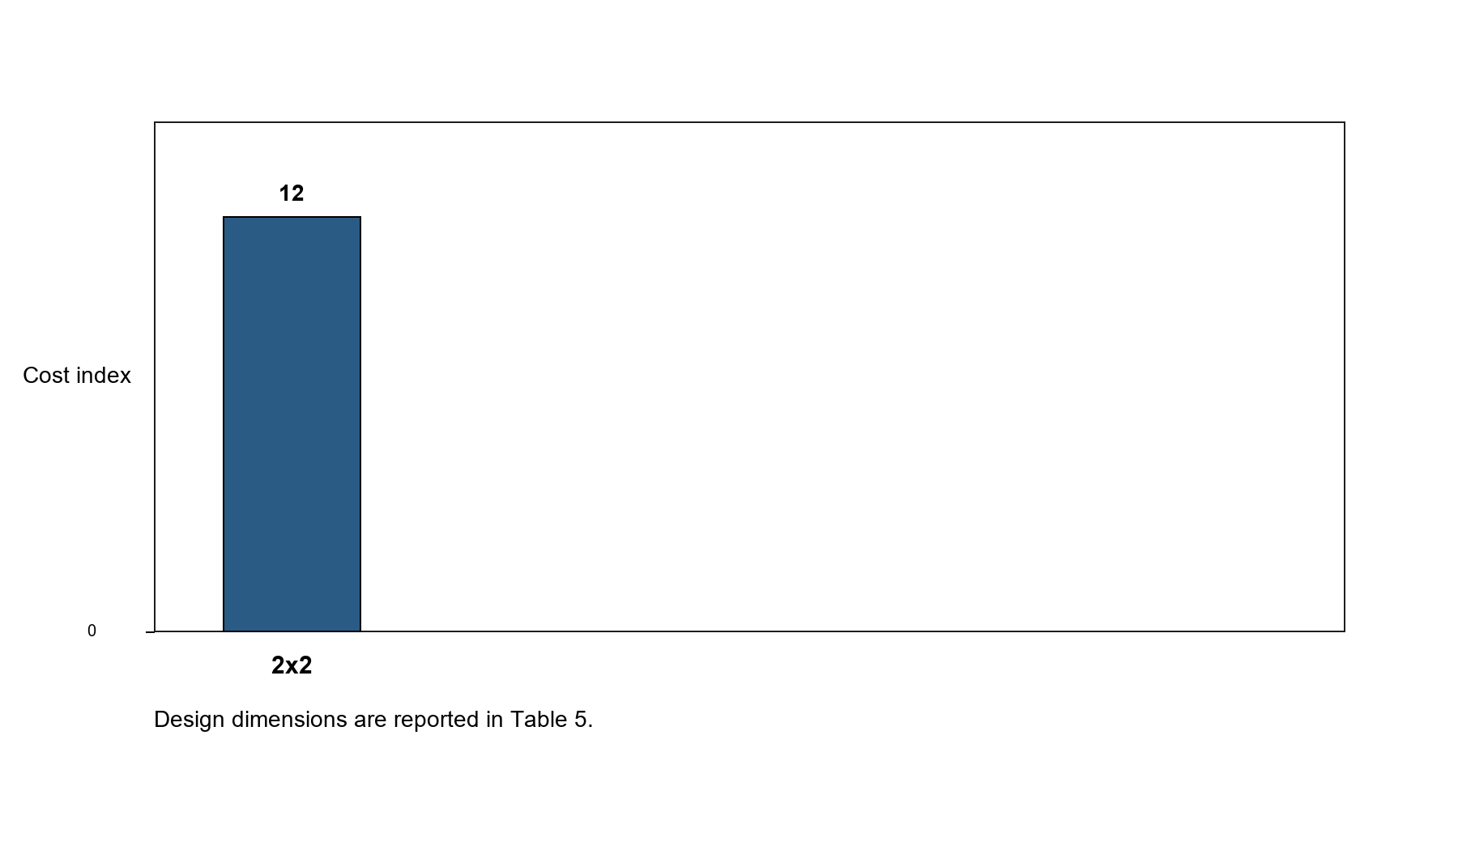
Supplementary Figure S1. Topology/cost ranking retained as supporting evidence for the fixed 2x2 search history.
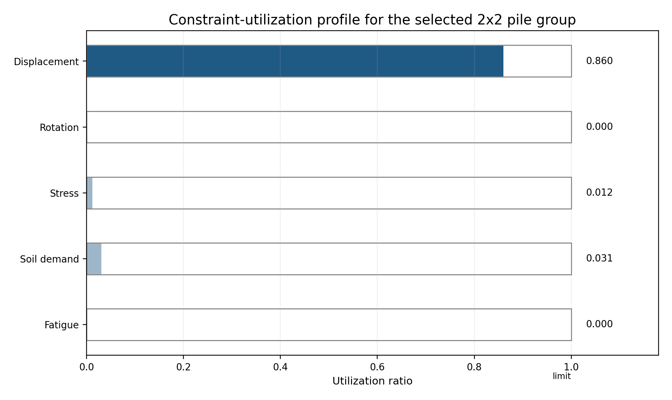
Supplementary Figure S2. Constraint-utilization profile for the selected 2x2 pile group.
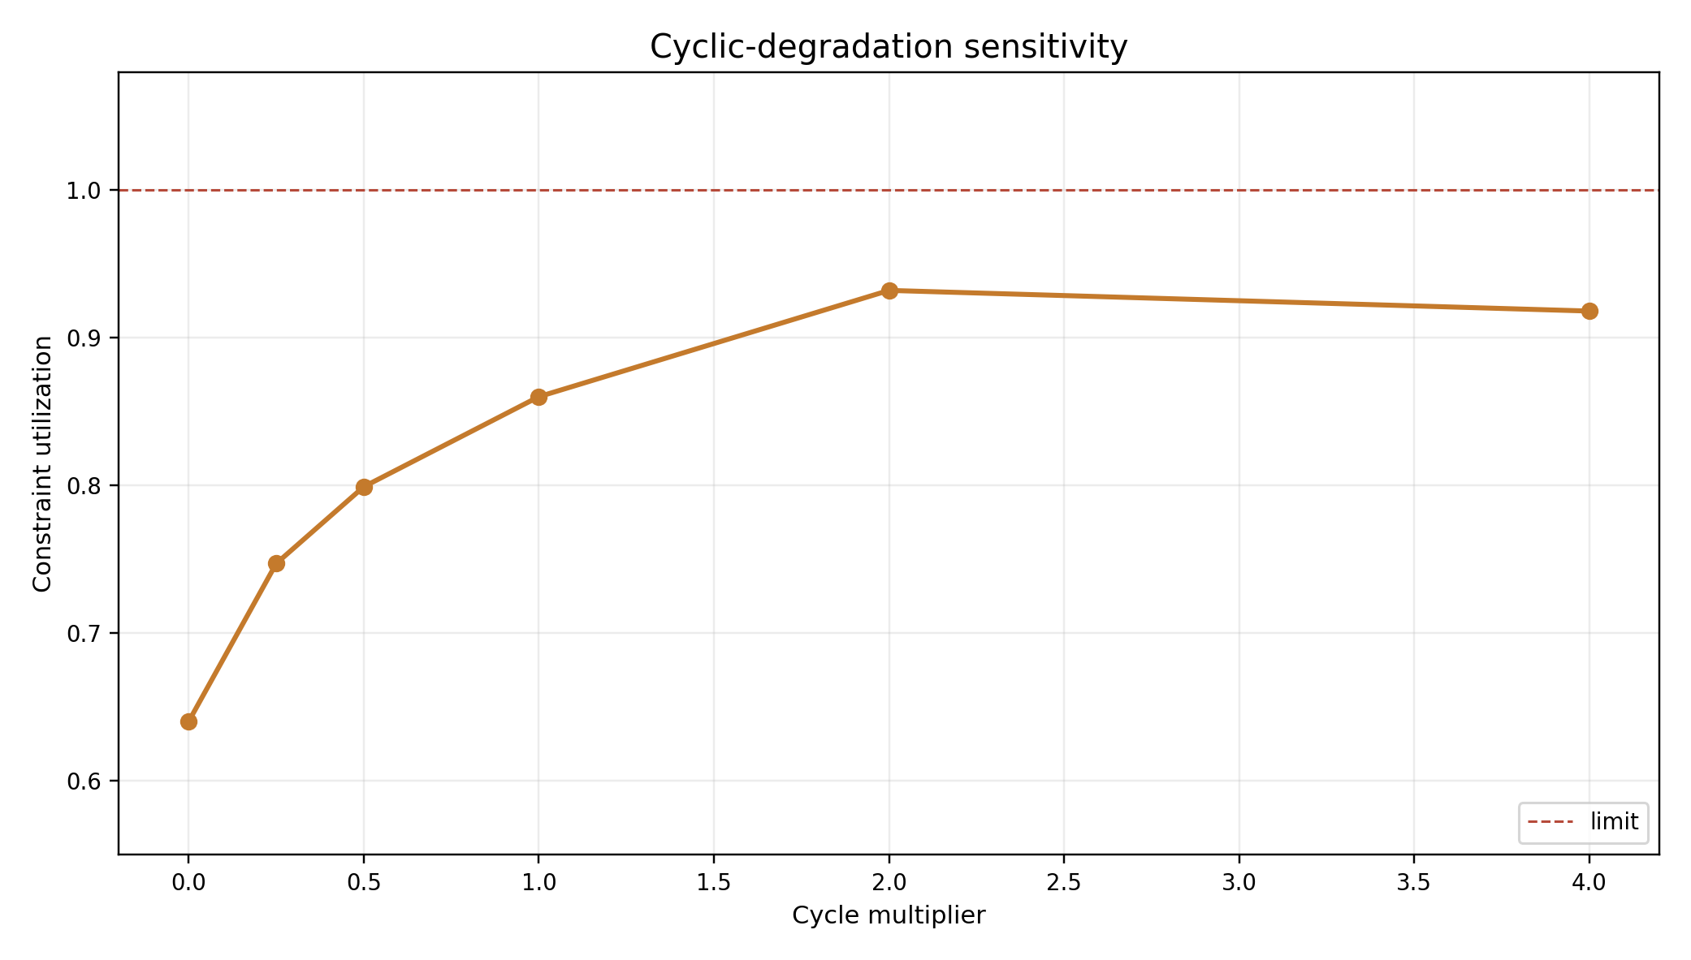
Supplementary Figure S3. Cyclic-degradation sensitivity retained as detailed support for the reserve discussion.
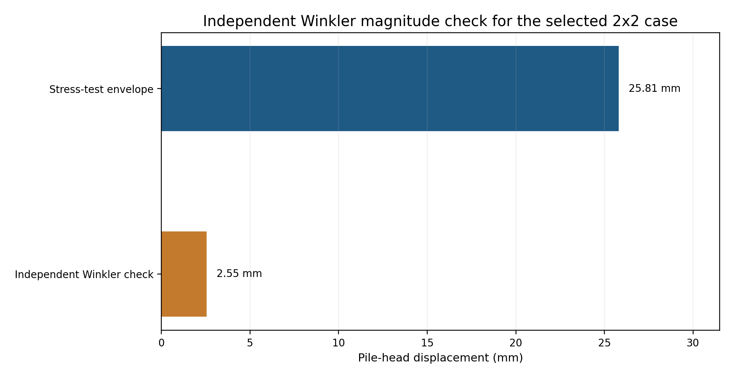
Supplementary Figure S4. Independent Winkler magnitude check for the selected 2x2 case.
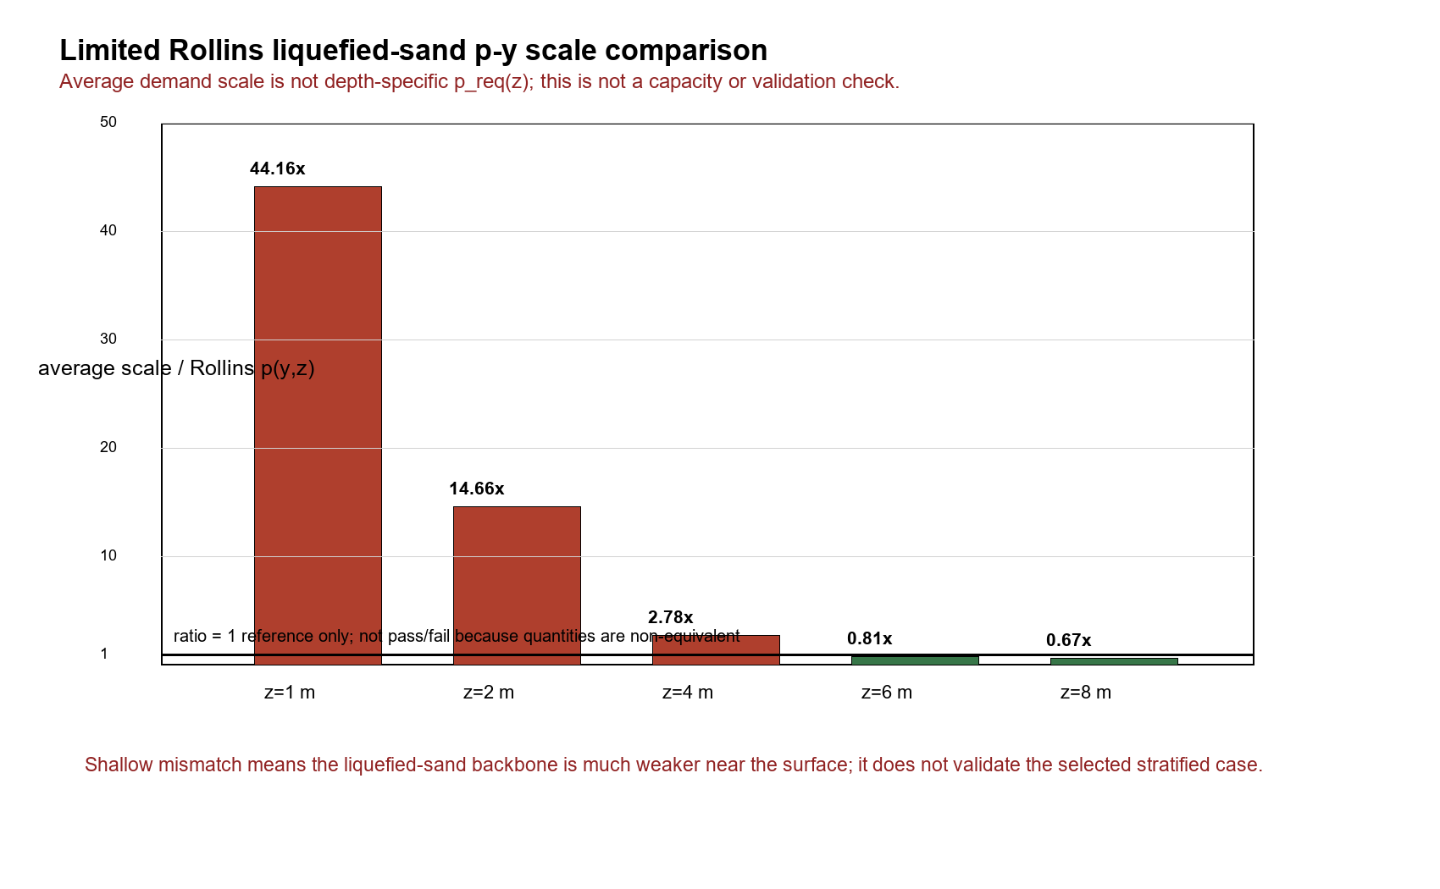
Supplementary Figure S5. Limited Rollins liquefied-sand p-y scale comparison.
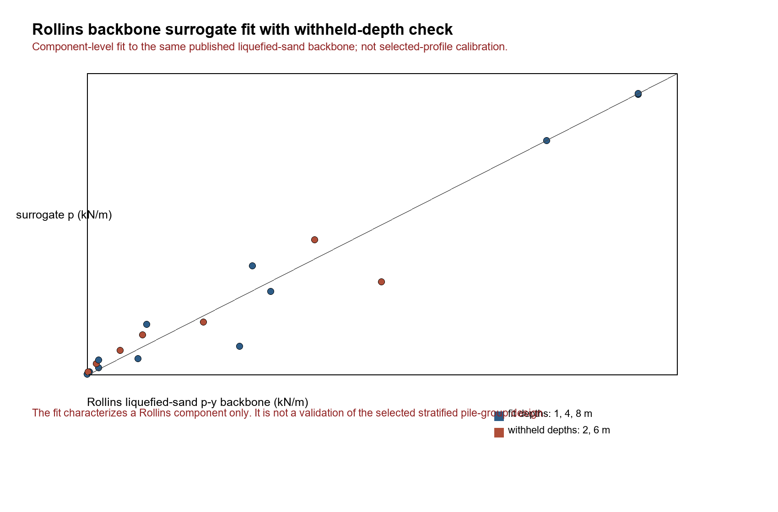
Supplementary Figure S6. Rollins backbone surrogate fit and withheld-depth check.
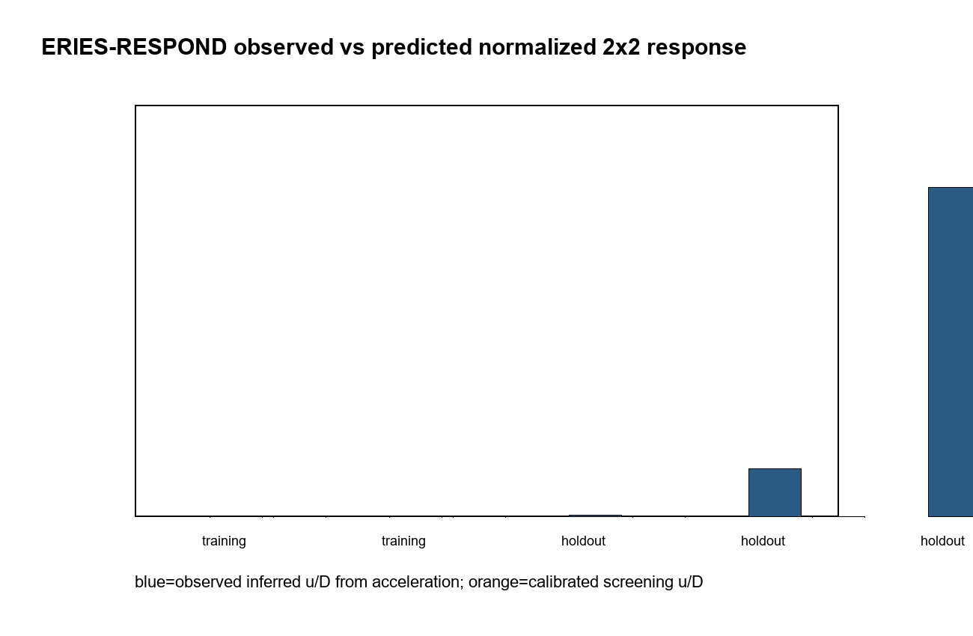
Supplementary Figure S7. ERIES-RESPOND observed versus predicted normalized 2x2 response.
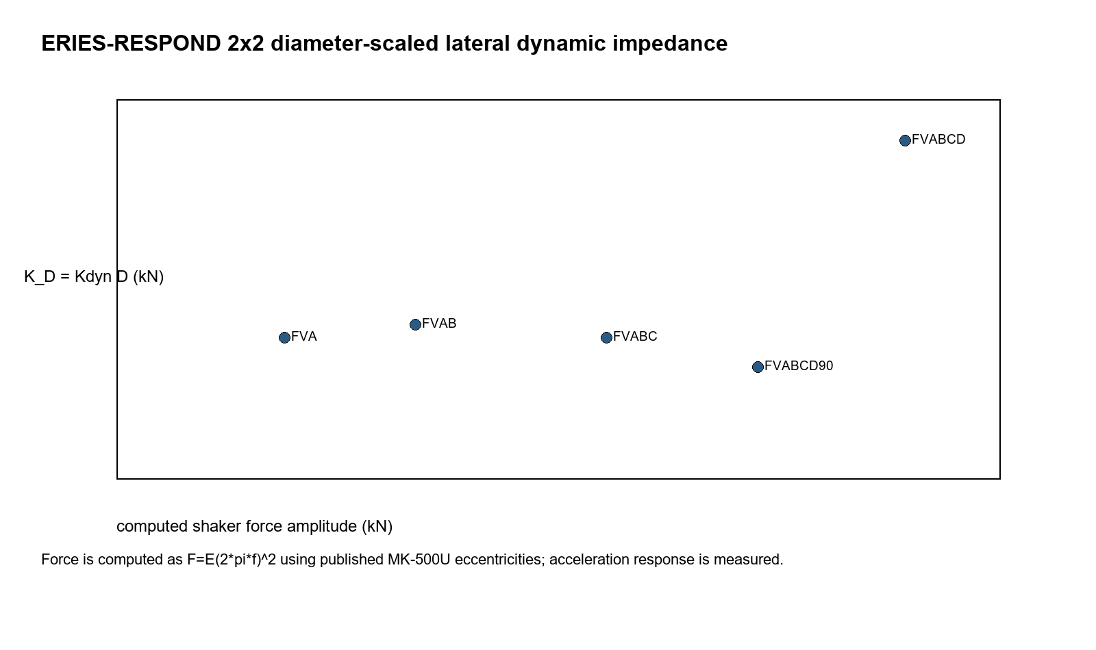
Supplementary Figure S8. ERIES-RESPOND diameter-scaled lateral dynamic impedance.
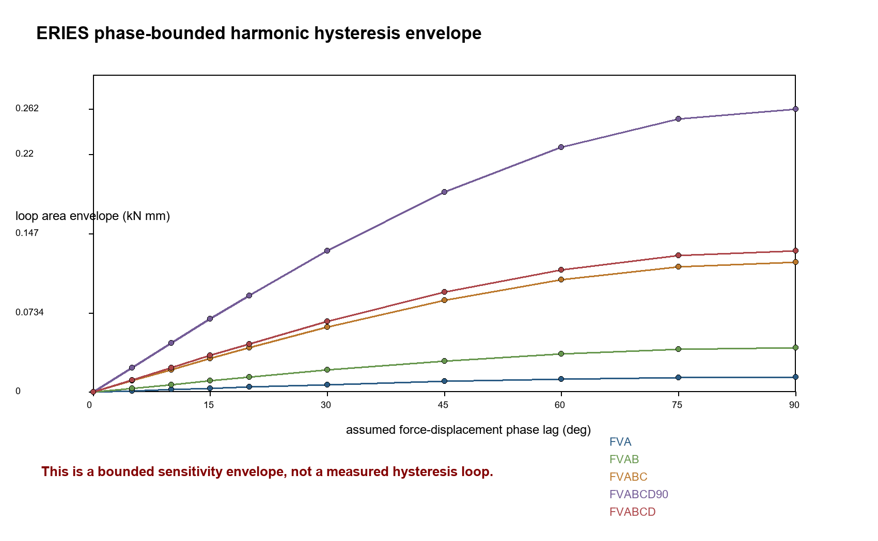
Supplementary Figure S9. ERIES phase-bounded harmonic envelope.
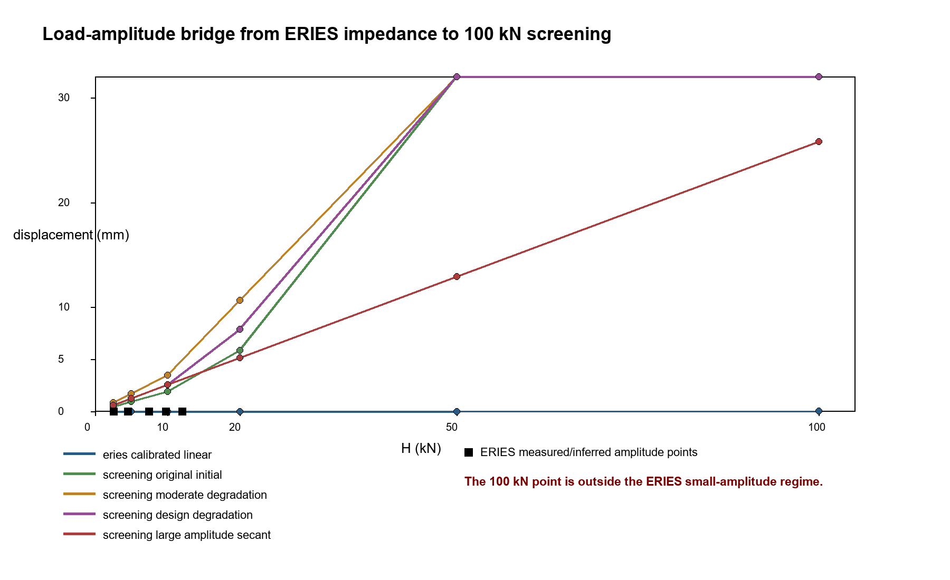
Supplementary Figure S10. Load-amplitude bridge from ERIES impedance to 100 kN screening demand.
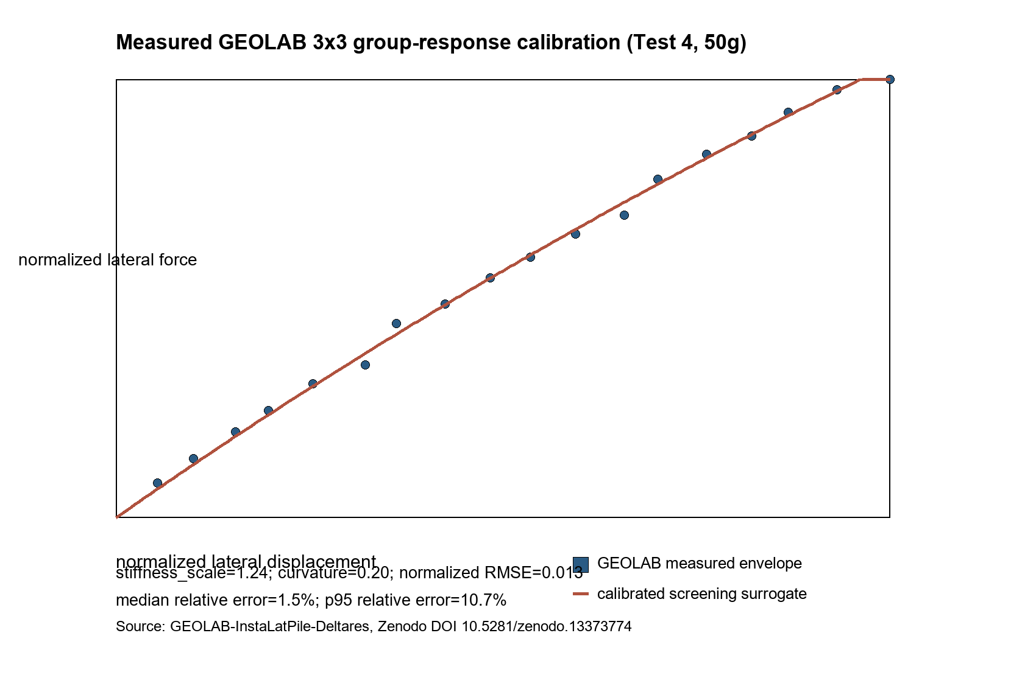
Supplementary Figure S11. GEOLAB/Deltares group-response calibration evidence.
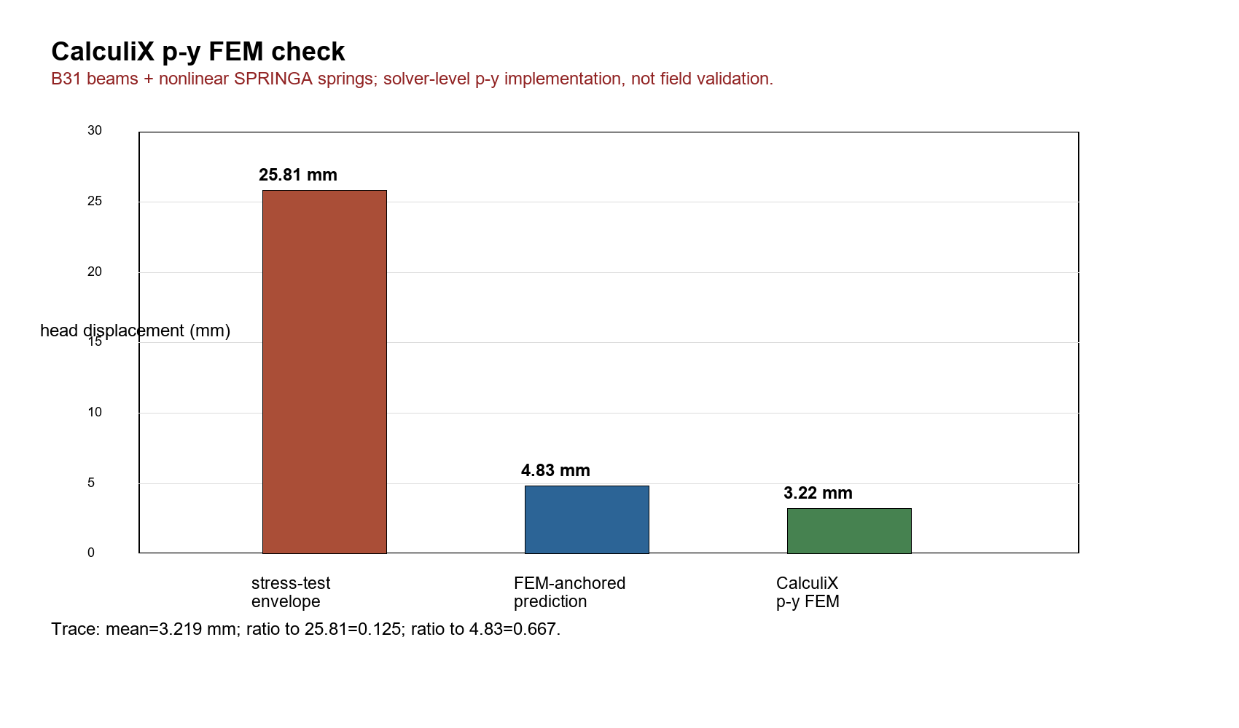
Supplementary Figure S12. CalculiX p-y FEM check.
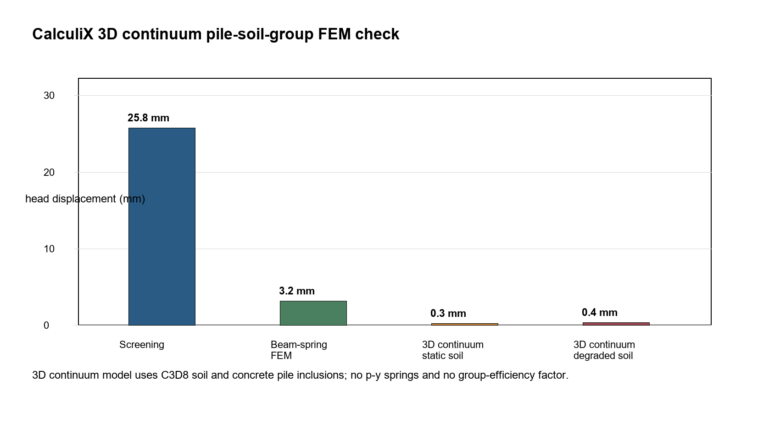
Supplementary Figure S13. CalculiX 3D continuum pile-soil-group FEM check.
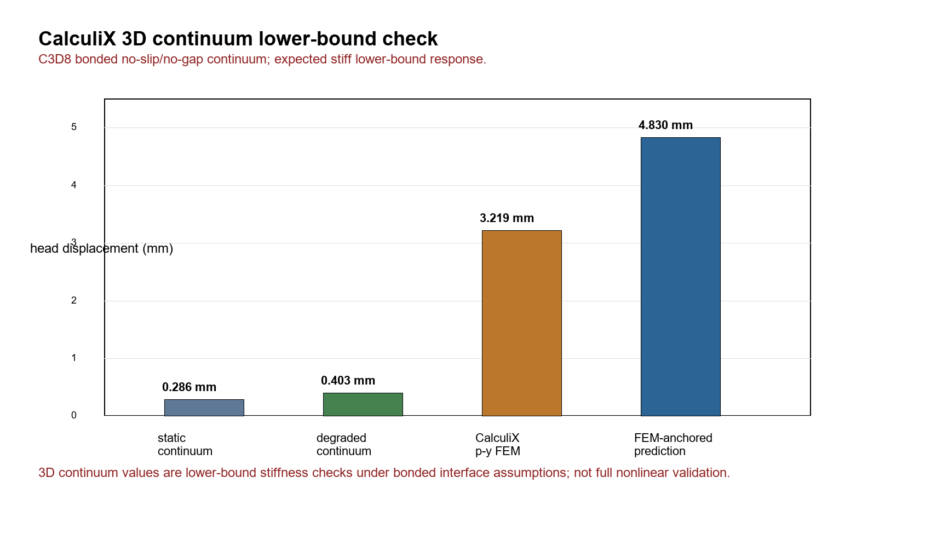
Supplementary Figure S14. CalculiX 3D continuum lower-bound check.
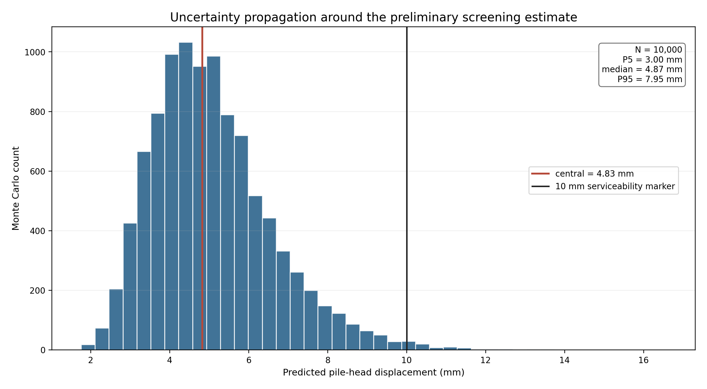
Supplementary Figure S15. Monte Carlo uncertainty propagation around the preliminary screening estimate.
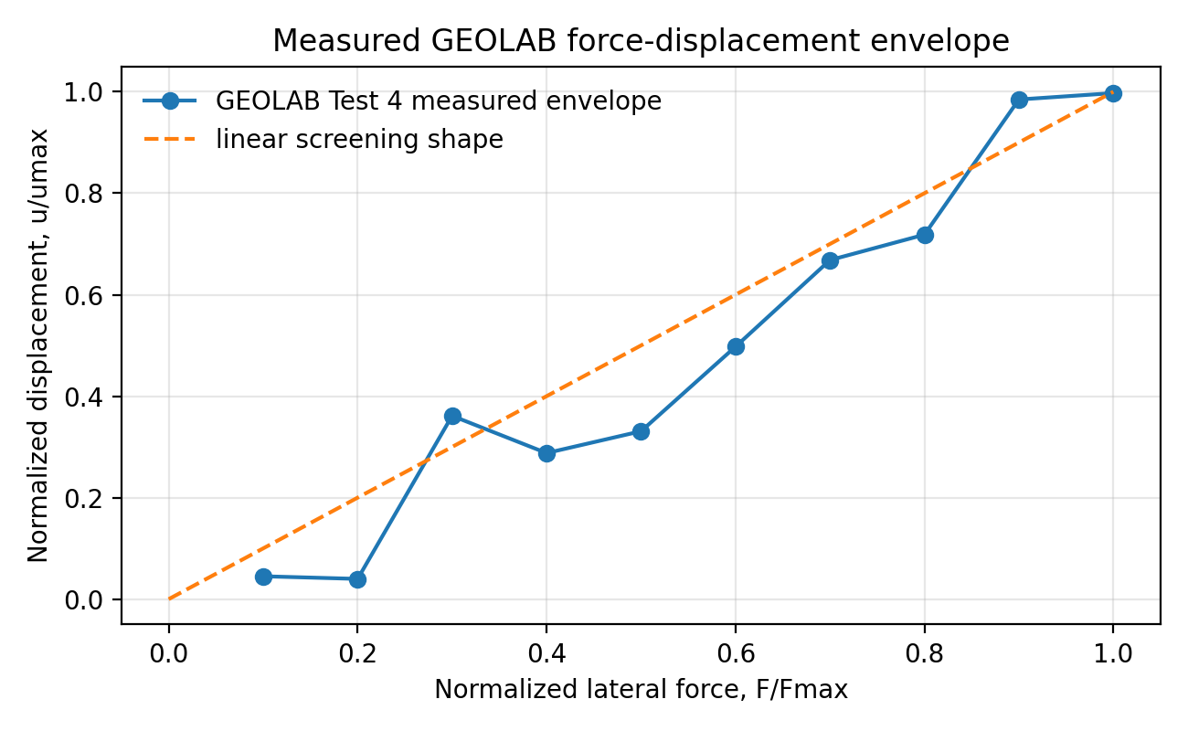
Supplementary Figure S16. GEOLAB measured force-displacement envelope.
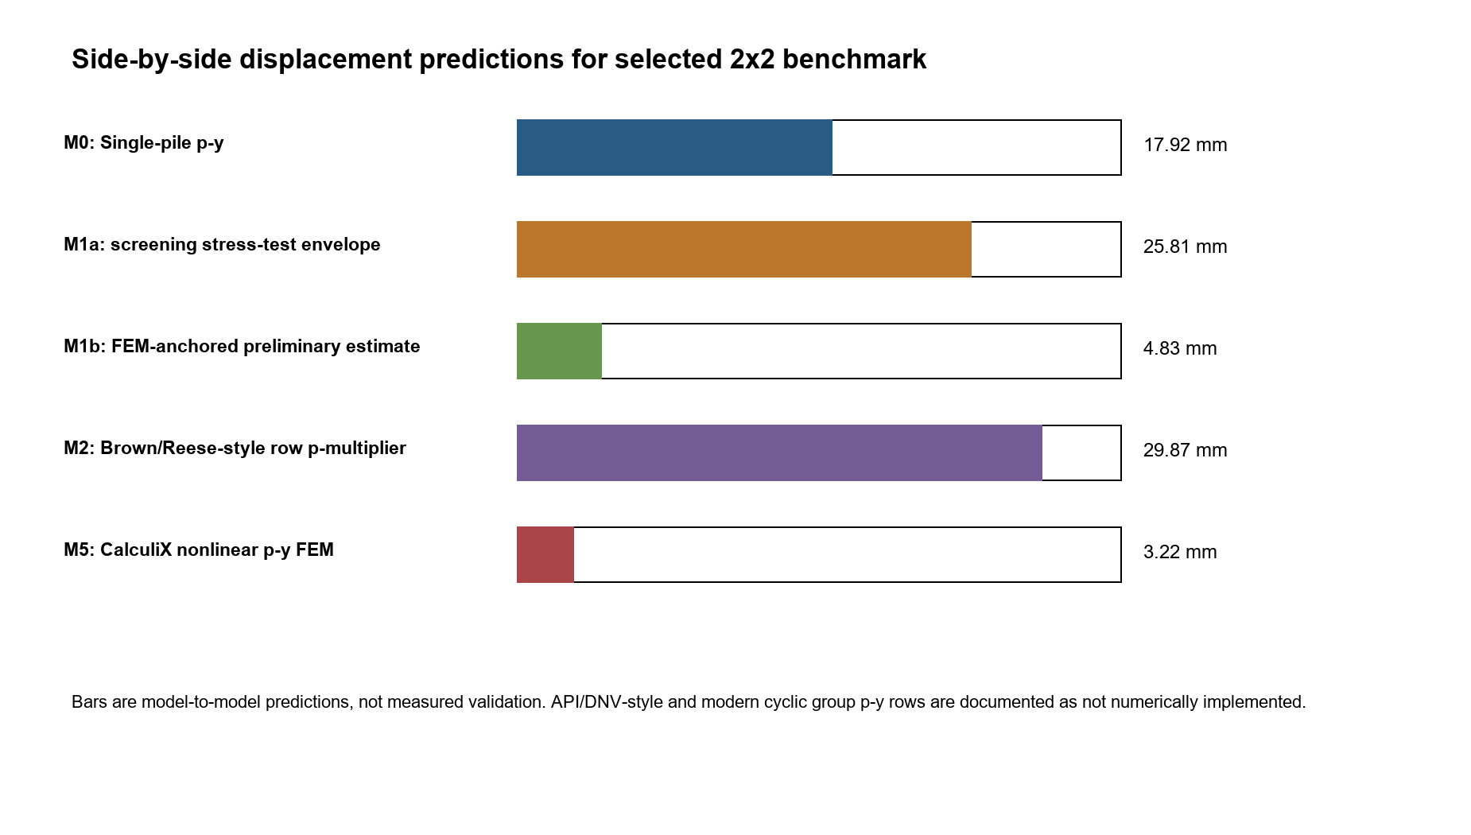
Supplementary Figure S17. Side-by-side p-multiplier displacement comparison.
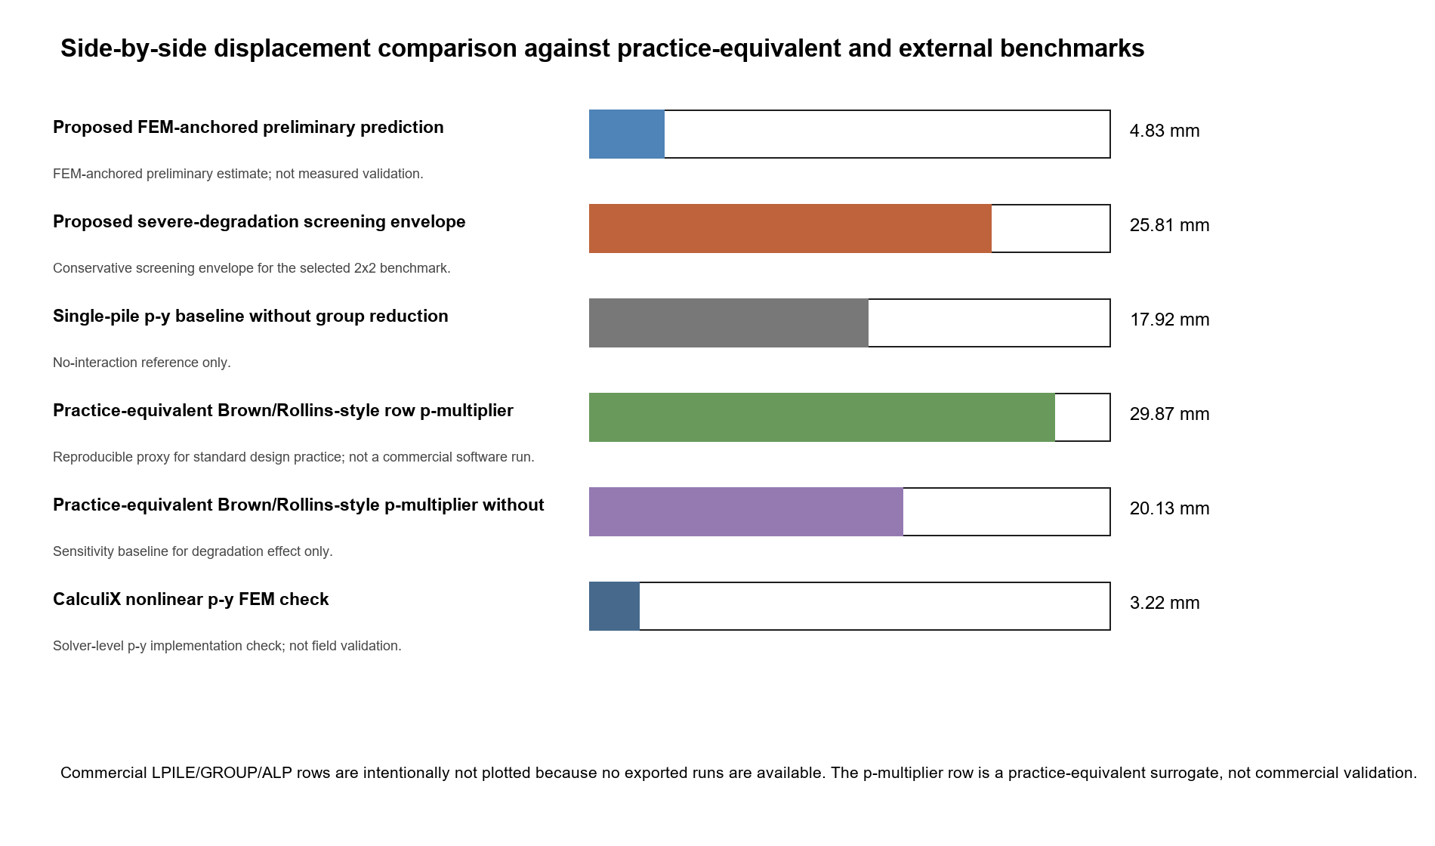
Supplementary Figure S18. Practice-equivalent and commercial/field group comparison.

Supplementary explanatory material moved from the main manuscript
This section preserves explanatory material that is relevant to reproducing and interpreting the article, but was kept outside the main manuscript to comply with the International Journal of Geotechnical Engineering research-article word limit. The main article contains the selected narrative, while this Online Resource retains the fuller audit logic behind the validation and claim boundaries.

S1. Evidence terminology used in the article
The article distinguishes verification, synthetic benchmark evidence, external evidence and direct validation. Verification means that scripts reproduce the reported tables, figures and selected candidate. Synthetic benchmark evidence means that independent implementations of the same idealization give compatible selected-case displacement magnitudes. External evidence means that published or third-party curves support trend or order-of-magnitude behaviour. Direct validation would require measured cyclic force-displacement data for the same selected 2x2 geometry, soil profile and loading history. That strongest level is not claimed in the manuscript.
This separation is necessary because p-y springs, Winkler checks, bonded 3D continuum models and published load-displacement curves may all produce a displacement value while carrying different physical meanings. The supplementary evidence should therefore be read as a hierarchy of support, not as a single interchangeable validation score.

S2. External blind-validation protocol
The non-GEOLAB blind-validation material is included to make the external comparison more rigorous than a retrospective literature overlay. The protocol separates blind_inputs.csv, blind_predictions_frozen.csv, blind_outputs_revealed.csv and error_metrics.csv. Predictions were frozen before measured outputs were revealed, and SHA-256 hashes document the files used in the comparison. The reported normalized RMSE values are 0.115, 0.229 and 0.166 for the three external cases.
The blind protocol is curve-scale external evidence. It supports trend and order-of-magnitude plausibility across published pile-group response curves, but it is not selected-profile calibration for the ERIES-aligned 2x2 design. This limitation is intentional and prevents the supplementary material from overstating what the external data can prove.

S3. Model-component and boundary-condition notes
The fixed 2x2 screening workflow uses a finite diameter-length-spacing enumeration. It calculates an equivalent degraded soil modulus, a spacing-dependent group-efficiency factor, an equivalent pile-head stiffness index, utilization ratios and a normalized cost index. The effective length is bounded through Le = min(L, lambda_T T), where T = (EI/(kD))^0.25. These quantities are reproducible screening components, not calibrated substitutes for nonlinear p-y curves or full contact/interface finite-element modelling.
The CalculiX p-y check is a solver-level implementation of the p-y idealization. The CalculiX 3D continuum check is intentionally treated as a stiff lower-bound or compliance-sensitivity check because bonded interface assumptions can suppress displacement. The open-source evidence band is therefore interpreted through model role and claim level rather than by forcing all models to match one displacement exactly.

S4. Claim governance and prohibited interpretations
The V4-S passport allows the article to claim a reproducible fixed-layout pre-design screening workflow, a selected 2x2 candidate, a displacement-governed reserve interpretation, a preliminary screening band and explicit escalation rules. It does not allow claims of final design safety, global topology optimality, direct field calibration, absolute displacement prediction for arbitrary sites, or replacement of site-specific nonlinear analysis.
If a final design decision is required, the selected candidate must be escalated to project-specific nonlinear p-y analysis, commercial group-analysis software, calibrated three-dimensional contact/interface finite-element modelling or measured load-test data. The screening result is therefore a documented candidate and evidence passport for later analysis, not the final analysis itself.

S5. Rationale for moving material to the supplement
The main manuscript was reduced to the central fixed 2x2 workflow, V4-S passport, multi-model evidence band and claim/escalation rules. Detailed secondary evidence, long model-component tables, additional plots, audit files and reproducibility ledgers are placed here so that the article remains within the IJGE word limit while preserving the evidence needed for review and reproduction.
The supplementary figures that are not embedded in the main manuscript are included below to preserve the full validation and sensitivity record. They should be cited as supporting evidence for interpretation and reproduction, not as independent final-design validation unless the corresponding claim class explicitly allows that interpretation.

