Supplementary material
  - Moved tables and figure for Canadian Geotechnical Journal article-type limits
This supplementary Word file contains tables and one figure moved from the main manuscript to keep the research-article file within the CGJ limit of 12,000 words and a maximum of 20 combined figures/tables. Numbering is supplementary and does not alter the underlying reproducibility package.
Supplementary Table S1 summarizes the corresponding evidence or audit item moved from the main manuscript.
Supplementary Table S1. Contribution matrix relative to established modelling components.
Existing modelling element | Representative basis | Limitation addressed here | Added contribution
Suction-dependent strength | Bishop stress and independent stress variables | Often evaluated without explicit hydraulic path memory | Path-dependent chi and saturation branch selection
Elastoplastic unsaturated soil model | BBM and related suction-hardening models | Usually presented without a compact seismic benchmark | Material-point cyclic benchmark with simplified comparators
Water-retention hysteresis | Drying/wetting retention branches | Often treated hydraulically but not propagated to cyclic damage | Hysteresis affects stiffness, preconsolidation and plastic strain accumulation
Cyclic degradation | Kinematic hardening and seismic demand indices | Often separated from unsaturated hydraulic history | Hydraulic and seismic damage variables interact in one algorithm
Supplementary Table S2 summarizes the corresponding evidence or audit item moved from the main manuscript.
Supplementary Table S2. Theoretical admissibility propositions for the hydraulic-memory benchmark.
Proposition | Statement | Short Proof | Manuscript Use
P1 HMAI bounded | If every component is clipped to [0,1] and non-negative weights sum to one, then 0 <= HMAI <= 1. | HMAI is a convex combination of clipped unit components; a convex combination of unit-interval values remains in the unit interval. | Supports bounded diagnostic phase-map interpretation.
P2 HMN dimensionless and non-negative | HMN is a dimensionless ratio of hydraulic-history intensity to cyclic demand; all factors are non-negative in the declared domain. | Each factor is a ratio of like units or dimensionless saturation/strain quantities; all factors are non-negative by construction. | Prevents treating HMN as an empirical dimensional fit coefficient.
P3 Damage monotonicity | Hydraulic and seismic damage variables are non-negative and non-decreasing within each simulated case. | The update accumulates non-negative reversal or overstress increments and then clips to a non-negative bounded interval. | Supports physical admissibility of internal degradation variables.
P4 Positive stiffness | Secant stiffness remains positive for the declared damage bounds and positive effective stress. | The stiffness update preserves positive G when G0>0, p_eff>0 and the damage variables remain below unity. | Rules out nonphysical negative stiffness in the benchmark envelope.
P5 Reduction without hydraulic memory | If the hydraulic-memory gate is zero, the composite HMAI is zero; full mechanical equivalence with the baseline also requires cyclic damage to be inactive. | The HMAI definition multiplies the component contrast by the hydraulic-history gate; the mechanical model still differs if seismic damage remains active. | Separates a true memory limit from a broader no-damage/no-memory baseline.
P6 Unique phase class | Every computed HMAI value belongs to exactly one of negligible, relevant or dominant. | The intervals [0,0.10), [0.10,0.30] and (0.30,1] are mutually exclusive and cover the bounded HMAI range. | Makes the phase-map classification mathematically unambiguous.
Supplementary Table S3 summarizes the corresponding evidence or audit item moved from the main manuscript.
Supplementary Table S3. Reproducible material-point update used in the controlled study.
Step | Operation | Diagnostic output
1 | Read imposed suction and cyclic strain increments | suction (kPa), shear strain
2 | Select drying or wetting branch | degree of saturation, Bishop chi
3 | Update effective stress and preconsolidation | mean effective stress (kPa), preconsolidation pressure (kPa)
4 | Evaluate demand/yield ratio | overstress diagnostic in script
5 | Update hydraulic and seismic damage | hydraulic damage, seismic damage
6 | Compute stiffness, stress and plastic strain index | secant stiffness (MPa), shear stress (kPa), plastic-strain index
Supplementary Table S4 summarizes the corresponding evidence or audit item moved from the main manuscript.
Supplementary Table S4. Benchmark parameters and units used in the reproducible script.
Parameter | Description | Unit | Value
p₀ | reference mean stress | kPa | 100.0
p_{c0} | initial preconsolidation pressure | kPa | 120.0
e₀ | initial void ratio | - | 0.72
S_{r,res} | residual degree of saturation | - | 0.08
S_{r,sat} | saturated degree of saturation | - | 0.98
alpha_{dry} | drying retention parameter | 1/kPa | 0.03
alpha_{wet} | wetting retention parameter | 1/kPa | 0.018
n_{dry} | drying van Genuchten exponent | - | 1.7
n_{wet} | wetting van Genuchten exponent | - | 1.45
k_{suction} | suction hardening coefficient | - | 0.52
h_{suction} | wetting-collapse coefficient | - | 0.38
beta_{h} | maximum hydraulic damage factor | - | 0.2
beta_{c} | maximum cyclic damage factor | - | 0.26
G₀ | reference shear stiffness | MPa | 42.0
m_{cc} | cyclic threshold multiplier | - | 1.25
gamma_{y0} | reference yield shear strain | - | 0.006
Supplementary Table S5 summarizes the corresponding evidence or audit item moved from the main manuscript.
Supplementary Table S5. Highest plastic-strain cases in the controlled study.
Model | Suction amplitude (kPa) | Cyclic amplitude | Stiffness loss (%) | Final plastic-strain index
full hysteretic damage | 100 | 0.20 | 18.39 | 0.004521
hysteresis only | 100 | 0.20 | 0.00 | 0.004234
full hysteretic damage | 75 | 0.20 | 17.10 | 0.003276
hysteresis only | 75 | 0.20 | 0.00 | 0.003068
full hysteretic damage | 100 | 0.16 | 17.76 | 0.002470
hysteresis only | 100 | 0.16 | 0.00 | 0.002376
Supplementary Table S6 summarizes the corresponding evidence or audit item moved from the main manuscript.
Supplementary Table S6. Ablation logic used to interpret the controlled study.
Simplified model | Mechanism removed | Expected consequence | Observed diagnostic use
constant suction | All hydraulic path variation | Suppresses wetting-drying memory | Baseline for detecting environmental-history effects
no hysteresis | Drying/wetting branch separation | Under-represents path-dependent saturation | Tests whether suction variation alone is enough
hysteresis only | Damage variables | Captures hydraulic path without irreversible stiffness degradation | Separates path dependence from degradation
full hysteretic damage | None | Captures coupled hydraulic and seismic degradation | Reference model for final conclusions
Supplementary Table S7 summarizes the corresponding evidence or audit item moved from the main manuscript.
Supplementary Table S7. Component-level verification against independent closed-form evaluations.
Verification check | Maximum absolute error | Mean absolute error | Status
van Genuchten retention | 0.000e+00 | 0.000e+00 | pass
suction hardening closed form | 2.842e-14 | 6.750e-15 | pass
Supplementary Table S8 summarizes the corresponding evidence or audit item moved from the main manuscript.
Supplementary Table S8. External validation registry and protocol roles for independent unsaturated cyclic or dynamic studies.
Source | External observation | Model expectation | Comparison
Nishimura (2015) | Drying-wetting suction changes produced strong SWCC hysteresis under isotropic compression; apparent saturated soil after suction changes showed liquefaction-like cyclic response. | The model must retain hydraulic path memory and allow cyclic degradation after wetting-drying history. | consistent
Howard (2021) | Unsaturated cyclic triaxial tests on silty sand showed that wetting-path specimens had higher cyclic resistance than drying-path specimens, and higher initial matric suction increased cyclic resistance. | The model must distinguish wetting and drying branches and include suction-dependent resistance. | consistent
Suprunenko (2015) | Suction-controlled cyclic triaxial tests on sand reported dynamic shear modulus dependence on degree of saturation, with higher modulus at mid-range saturation. | The model must allow saturation-dependent stiffness through Bishop chi and effective stress. | consistent with mechanism; not calibrated to the sand data
Dai and Zhou (2025) | Suction-controlled cyclic tests on unsaturated loess showed permanent vertical strain and resilient modulus vary systematically with suction, compaction water content, density and CSR. | The model must couple suction, cyclic demand and plastic-strain accumulation rather than treating suction as a constant parameter. | consistent
Supplementary Table S9 summarizes the corresponding evidence or audit item moved from the main manuscript.
Supplementary Table S9. Time-step convergence for the most demanding full-model case.
Time steps | Normalized dt | Final plastic-strain index | Stiffness loss (%) | Plastic error vs finest (%)
360 | 2.786e-03 | 0.004478 | 18.39 | 1.23
720 | 1.391e-03 | 0.004521 | 18.39 | 0.30
1440 | 6.949e-04 | 0.004531 | 18.39 | 0.06
2880 | 3.473e-04 | 0.004534 | 18.39 | 0.00
Supplementary Table S10 summarizes the corresponding evidence or audit item moved from the main manuscript.
Supplementary Table S10. Compact sensitivity and uncertainty checks used to bound numerical interpretation.
Check | Evidence retained | Interpretation boundary
Time-step convergence | High-step comparison and convergence log retained; detailed values are in Supplementary Note S2. | Supports numerical stability of envelope trends, not exact time-history validation.
Local sensitivity | Local surrogates retain R2 = 0.986-0.989 with cyclic amplitude as dominant driver. | Ranks drivers over the declared perturbation range only.
Uncertainty and claim boundary | Monte Carlo summaries, negative claim tests and Table 14 invariant checks remain in the package. | Bounds interpretation as a plausibility-envelope benchmark, not a calibrated design model.
Supplementary Table S11 summarizes the corresponding evidence or audit item moved from the main manuscript.
Supplementary Table S11. Compact mathematical-invariants and dimensional-consistency audit.
Check | Result | Interpretation
Shear-stress unit consistency | max residual = 5.76e-12 kPa after G(MPa)*1000*gamma conversion | Closes the dimensional ambiguity in plotted shear stress.
State-variable bounds | saturation, Bishop chi, damage and positivity checks passed | Shows bounded benchmark states within declared model limits.
Effective-stress identity and irreversibility | p_eff identity residual <= 5.68e-14 kPa; plastic-strain increments non-negative | Verifies the scalar implementation and monotonic plastic-strain accumulation.
HMAI bounds | HMAI remains within [0, 1] across scripted cases | Keeps the novelty metric dimensionless and bounded, not a design coefficient.
Supplementary Table S12 summarizes the corresponding evidence or audit item moved from the main manuscript.
Supplementary Table S12. External literature anchors used to interpret the benchmark without inventing experimental calibration data.
Literature anchor | Observed or modelled mechanism | Representation in this paper
Barcelona Basic Model and BBM implementations | Suction-dependent yield stress, collapse on wetting and elastoplastic hydro-mechanical coupling | Suction hardening, preconsolidation update and wetting-collapse tendency
Extended BBM under cyclic loading | Need for internal variables to represent cyclic effects under unsaturated conditions | Seismic cyclic damage and plastic-strain accumulation index
Suction-controlled cyclic triaxial/simple-shear testing | Dynamic stiffness and cyclic resistance vary with suction and degree of saturation | Hysteretic retention, Bishop chi and stiffness evolution under cyclic demand
van Genuchten-Mualem hydraulic models | Closed-form retention/conductivity functions govern saturation changes | Component verification of the retention law and path-dependent saturation
Supplementary Table S13 summarizes the corresponding evidence or audit item moved from the main manuscript.
Supplementary Table S13. Claim-evidence passport for reviewer interpretation.
Claim allowed in this paper | Evidence supporting the claim | Prohibited extrapolation
Reproducible material-point benchmark | run_all.py, regenerated CSV histories, summary tables, figures and software-verification files | Do not claim calibrated prediction for a named soil.
Internal component verification | Retention and suction-hardening closed-form checks; preconsolidation-pressure consistency audit | Do not treat verification as experimental validation.
External plausibility envelope | Published cyclic and hydraulic trend sources; partial suction-level direction check | Do not claim blind validation or parameter identification.
Geotechnical relevance | Near-surface unsaturated deposits, slopes, embankments, corridors and shallow foundations identified as target contexts | Do not claim site-response, design approval or seismic safety certification.
Practical next use | Calibrate retention, hardening, collapse and cyclic-damage constants before boundary-value use | Do not use declared benchmark parameters as project-specific design parameters.
Supplementary Table S14 summarizes the corresponding evidence or audit item moved from the main manuscript.
Supplementary Table S14. Recent direct-cyclic evidence gate and state-of-art comparison used to bound novelty and evidence claims.
Comparator | Direct cyclic evidence | Reproducibility status | Implication for this paper
Current package | No blind external cyclic time-history fit | Full local scripts, CSVs, figures and logs bundled | Supports Plausibility-Envelope and reproducibility claims only
Kinikles, Rong and McCartney (2024) | Undrained cyclic simple shear, 200 cycles, saturation range 0.00-0.56 | Open article and downloaded figures; raw time histories are data-on-request | Defines the next evidence target; not passed here as calibrated prediction
Chen et al. (2024) | Repeated-load triaxial and cyclic simple-shear comparisons | Open article/PDF and parsed public supplementary DOCX; raw cyclic time histories are data-on-request | Recent novelty comparator with audited calibration supplement; this paper must not claim to be the first cyclic hardening law
Supplementary Table S15 summarizes the corresponding evidence or audit item moved from the main manuscript.
Supplementary Table S15. Direct Rong/McCartney cyclic experimental program audit added to the reproducibility package.
Source | Exact cyclic evidence added | What it proves | What it does not prove
Rong UCSD dissertation | 12 undrained cyclic simple-shear initial-condition rows; 200 cycles at 1% cyclic shear strain | Direct undrained cyclic state-space coverage from saturation 0.00-0.94 and suction 0.04-100 kPa | No public raw response time histories were extracted from the PDF
Rong and McCartney (2019) E3S | 16 drained constant-suction cyclic simple-shear rows; 200 cycles at 0.3-5% strain | Direct drained cyclic suction and amplitude coverage | Not a calibrated fit of the present benchmark to measured volumetric-strain histories
PEER 2022/05 McCartney report | Open model/data comparison figures and trend statements | Defines the strongest next digitization target for stronger external-evidence support | Figure evidence must be digitized with uncertainty before being called a quantitative envelope check
Supplementary Table S16 summarizes the corresponding evidence or audit item moved from the main manuscript.
Supplementary Table S16. Digitized Kinikles et al. (2024) Figure 12(a) volumetric-strain envelope.
Item | Digitized evidence | Interpretation boundary
Point cloud | 22 manually digitized open-figure points across 6 initial-saturation groups | Direct cyclic figure evidence added; cycle assignment is not reliable from the grayscale marker reproduction
Observed envelope | Maximum digitized volumetric strain is 1.87% at the S0 = 0.40 group; median peak also occurs at S0 = 0.40 | Supports the external nonmonotonic saturation-dependence gate
Uncertainty | Pixel digitization uncertainty is recorded as +/-0.008 S0 and +/-0.076% volumetric strain | Usable for a transparent figure-based comparison, not for design calibration
Claim boundary | Raw time histories remain unavailable in the downloaded sources | The manuscript must not claim blind calibrated prediction of Kinikles et al. response histories
Supplementary Figure S1 reports the corresponding graphical validation evidence for the external-evidence workflow.
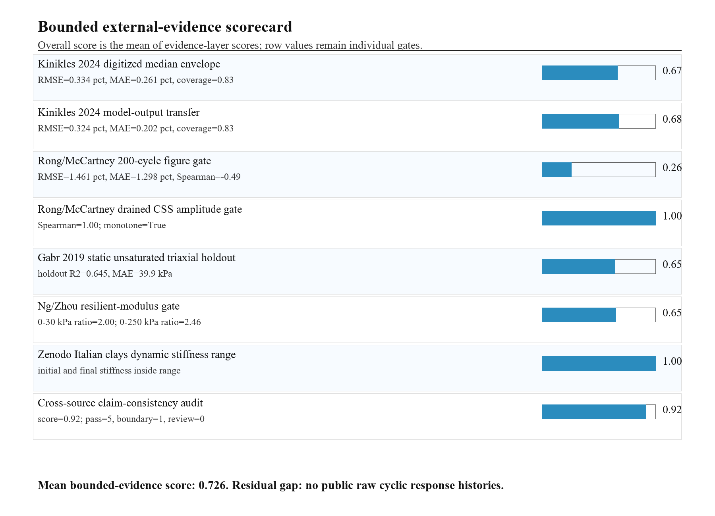
Supplementary Figure S1. Bounded external-evidence scorecard. Row scores are evidence-layer gates and the overall score is the mean of the reported evidence-layer scores; the figure is not a calibrated design-validation grade.

