*-****Seminars 3 & 4: Spectrum Representation***

1. A signal composed of sinusoids is given by the equation
 $x(t)=10cos(800πt+\frac{π}{4})+7cos(1200πt-\frac{π}{3})-3cos(1600πt)$

  1. Sketch the spectrum of this signal, indicating the complex amplitude of each frequency component. Make separate plots for real/imaginary or magnitude/phase of the complex amplitudes at each frequency.
   2. Is x(t) periodic? If so, what is the period?
   3. Now consider the signal y(t)=x(t)+5cos(1000πt+π/2). How has the spectrum changed? Is y(t) periodic? If so, what is the period?
2. A signal x(t) has the following spectral representation:

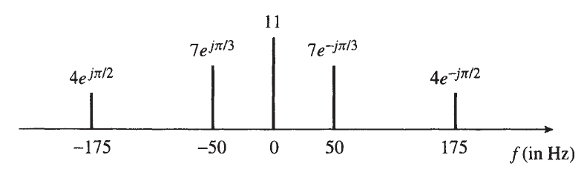

* 1. Write an equation for x(t) as a sum of cosines.
  2. Is x(t) periodic? If so, find its fundamental period and its fundamental frequency?
  3. Explain why the negative frequencies are needed in the spectrum.

1. Let $x(t)={\sin^{3}}^{}(27πt)$
   1. Determine a formula for x(t) as the real part of a sum of complex exponential signals in the form: $x(t)=X_{0}+ℜ\left\{\sum_{k=1}^{N}{}X_{k}e^{j2πkf_{0}t}\right\}$
   2. Plot the spectrum for x(t).
   3. What is the fundamental period of x(t) ?
2. Consider the signal x(t)=10+20cos(2π(100)t+π/4)+10sin(2π(250)t)
   1. Using Euler's relation, the signal x(t) can be expressed as a sum of complex exponential signals using the finite Fourier synthesis summation as follows $x(t)=\sum_{k=-N}^{N}{}a_{k}e^{j2πkf_{0}t}$. Determine values for $f_{0},$ N, and ${{{\left\{a_{k}\right\}}_{k=-N}^{N}}_{}^{}}_{}^{}$ indicating the correct index value k for each $a_{k}$. *It is not necessary to evaluate any integrals to obtain $a_{k}$*  .
   2. Is x(t) periodic? If so, what is the period?
   3. Plot the spectrum of the signal.
3. An amplitude-modulated (AM) cosine wave is represented by the formula x(t)=[12+7sin(πt−π/3)]cos(13πt)
   1. Use Euler's formula to show that x(t) can be expressed in the form $x(t) = A_{1}cos(ω_{1}t+φ_{1})+A_{2}cos(ω_{2}t+φ_{2})+A_{3}cos(ω_{3}t+φ_{3})$
   2. Sketch the two-sided spectrum of this signal on a frequency axis. Be sure to label important features of the plot.
4. A periodic signal $x(t)=x(t+T_{0})$ is described over one period $-T_{0}/2 ≤t≤T_{0}/2$ by the equation: $x(t)=1 for \left|t\right|<t_{c},$ $x(t)=0 for t_{c}<t≤T_{0}/2$, where $t_{c}$ < $T_{0}/2$
   1. Sketch x(t) over the time interval $-2T_{0}<t≤2T_{0}$ for the case $t_{c}=T_{0}/4$.
   2. Determine the DC coefficient $a_{0}$.
   3. Determine a formula for the Fourier series coefficients $a_{k}$. Your final result should depend on $t_{c}$ and $T_{0}$.
   4. Sketch the spectrum of x(t) for the case where $ω_{0}=2π(100)$ and $t_{c}=T_{0}/4$ in the range $-10 ω_{0}$ to $10 ω_{0}$.
5. A signal x(t) is periodic with period $T_{0}$ = 8. Therefore, it can be represented as a Fourier series of the form: $x(t)=\sum_{k=-∞}^{∞}{}a_{k}e^{j(2π/8)kt}$. Assume that the Fourier series coefficients of the signal x(t) are given by the following integral: $a_{k}=\frac{1}{8}\int_{-4}^{0}{}(4+t)e^{j(2π/8)kt}dt$
   1. In the integral expression for $a_{k}$ above, the integrand and the limits define the signal x(t). Determine an equation for x(t) that is valid over one period.
   2. Using the result from part (a), draw a plot of x(t) over the range −8 ≤ t ≤ 8 . Label your plot carefully.
   3. Determine the DC value of x(t).
6. We have seen that a periodic signal x(t) can be represented by its Fourier series as follows: $x(t)=\sum_{k=-∞}^{∞}{}a_{k}e^{jkω_{0}t}$. It turns out that we can transform many operations on the signal into corresponding operations on the Fourier coefficients $a_{k}$. In all the following cases, find a relationship between the Fourier series coefficients of y(t), denoted by $b_{k}$, and the Fourier series coefficients of x(t), $a_{k}$.
 $y(t)=\frac{d}{dt}x(t)$

  1. y(t)=A x(t) , where A is a real-valued constant.
$y(t)=x(t-t_{d})$

7. A chirp signal is one where its instantaneous frequency increases or decreases in time. A chirp is linear if the instantaneous frequency varies linearly in time, i.e., f (t)=αt+β. An example of a linear chirp signal is shown below:

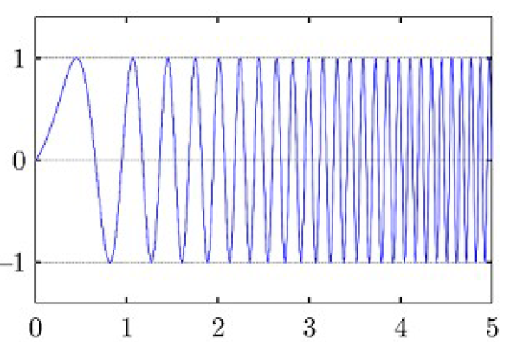

* 1. In the chirp signal shown in the figure above, is the frequency increasing or decreasing with time?
  2. For the chirp signal $x(t)=ℜ\left\{e^{j(40t^{2}+27t+13)}\right\}$ derive a formula for the instantaneous frequency in Hz. Is this chirp linear?
  3. Make a plot of the instantaneous frequency (in Hz) versus time over the range 0 ≤ t ≤1 seconds.

1. To calibrate the note scales, the reference tone commonly used is the A4 which has a frequency of 440Hz. Each octave contains 12 tones and the ratio between frequencies of successive tones is constant. The 12 tones starting at A4 (note A of the 4th octave) is computed with the equation $f_{0}=\left(440\right)2^{\frac{k}{12}}$, where $k =0, 1, ...., 11$. The tone location is k. To compute the frequencies of other octaves, k can take values below 0 and above 12.
   1. Compute the frequencies of the 12 tones of an octave starting with C3.
   2. Compute the frequencies of the C major scale starting with C3. [A major scale has 7 notes in an octave, which correspond to the tones 0 (C), 2 (D), 4 (E), 5 (F), 7 (G), 9 (A), 11 (B)].
2. The plots in the following figure show waveforms on the left and spectra on the right.
   1. Match each waveform letter with its corresponding spectrum number.
   2. In each case, write the formula for the signal as a sum of sinusoids.

