***Seminar 5: Sampling***

1. Consider the system

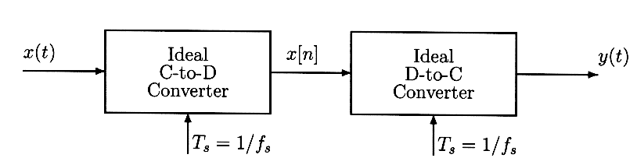

If $x(t)=4+4cos(1000πt)sin(50000πt)$, what condition has to be satisfied for the sampling frequency $f_{s}=1/T_{s}$, so that y(t) = x(t)?

1. Given a signal $x(t)=cos(50πt)sin(700πt)$
   1. Draw a sketch of the spectrum of $x(t)$, labelling the frequencies and complex amplitudes of each component.
   2. Determine the minimum sampling rate that can be used to sample $x(t)$ without any aliasing.
2. Suppose that a discrete signal $x[n]=100 cos(0.4πn+\frac{π}{4})$ was obtained sampling a continuous signals with a sampling frequency $f_{s}=5000$ samples/sec.
   1. Determine two continuous signals $x_{1}(t)$ and $x_{2}(t)$ so that $x[n]=x_{1}(nT)=x_{2}(nT)$ for T =.0002 sec. The two signals have to have a frequency smaller than 5000 Hz. Give an equation for each signal.
   2. Determine the amplitude and phase of the two signals obtained in section (a).
3. A signal *x(t)* has the following spectral representation:

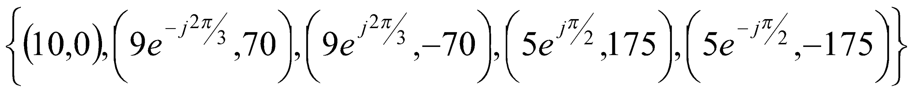

* 1. Write an equation for *x(t)*.
  2. The signal *x(t)* is sampled with a sampling frequency $f_{s}=\frac{1}{T_{s}}=400$ samples/sec to obtain a discrete signal $x[n]=x(nT_{s})$. Write an equation for *x*[*n*] and draw the spectrum of *x*[*n*] for normalized frequencies $-π≤\hat{ω}≤π$.

1. A chirp signal can be synthesized using the following formula:
$x[n]=Re\left\{e^{jθ[n]}\right\}=cos(π{10}^{-4}n^{2}) for n=0,1,2,....,4000$

2. Draw the phasor $e^{jθ[n]}$ for the three cases n = 10, 100, 1000
3. If the signal goes through an D-A converter with a sampling frequency of 4kHz, draw the instantaneous analog frequency (in Hz) with respect to time. Make sure that the coordinates are drawn correctly.
4. Given a signal $x(t)=12sin(22πt)$, the corresponding discrete signal is obtained sampling $x(t)$ with a frequency $f_{s}$; and the resulting x[n] can be written as $x(t)=Acos(ω_{0}t+φ)$. Determine the values of $A, φ,$ and ${\hat{ω}}_{0}$ for each of the following values of $f_{s}$
   1. 10
   2. 25
   3. 15
5. The following complex-valued signal is a phasor: $z[n]=e^{jθ[n]}$, where $θ[n]$ is the phase.
   1. When the phase changes by a constant amount versus n, the phasor rotates at a constant speed. For the following phasor: $z[n]=e^{j\left(0.08πn-0.25π\right)}$, make a plot of the phasor locations for $n=0,1,2,7,10,17,20,22,50 and 99.$
   2. What is the period of $z[n]$?
   3. Repeat for the complex phasor that corresponds to the chirp signal: $c[n]=e^{j0.1π{n^{2}}^{}}$. In this case plot the phasor locations for $n=0,1,2,3,4 and 7.$