***Seminar 6: FIR Filters***

1. If the impulse response $h\left[n\right]$ of an FIR filter is: $h\left[n\right]=δ\left[n-1\right]-2δ\left[n-4\right]$.
   1. Make a plot (versus n) of $h\left[n\right]$
   2. Write the difference equation for the FIR filter
2. An FIR filter is described by the following difference equation: $y[n]=x[n]+2x[n-2]-4.5x[n-3]+5x[n-5]$
   1. Draw the block diagram of the filter
   2. Compute the impulse response $h\left[n\right]$ and draw it over *n*
   3. Compute $y\left[n\right]$ for the complex input signal $x[n]=2{e^{j(.2πn-\frac{π}{4})}}^{}$
3. Assume that we have a linear system for which we do not know the difference equation but we introduce a signal $x[n]=5 cos(0.25πn+\frac{π}{4})$ and the obtained output signal is $y[n]=.2 cos(0.25πn)$. Using the property of linearity and time invariance compute the output of the system when the input is $x[n]=4 cos(0.25π(n-8))$
4. Let x[n] be the complex exponential $x[n]=11{e^{j(.3πn+0.5π)}}^{}$. If we define a new signal $y[n]=2x[n]+4x[n-1]+2x[n-2]$, it is possible to express $y[n]$ in the form $y[n]=A{e^{j(ω_{0}n+ϕ)}}^{}$. Determine the numerical values of $A, ϕ$ and $ω_{0}$.
5. For each of the following systems, determine whether or not the system is (1) linear, (2) time-invariant, and (3) causal.
 $y[n]=x[n] cos(0.2πn)$

 $y[n]=x[n] -x[n-1]$

 $y[n]=\left|x[n]\right|$

$y[n]=x[n^{2}] -{\left(x[n-1]\right)}^{2}$

$y[n]=Ax[n]+B,$ 1. where A and B are constants.
6. If an LTI system is described by the block diagram below, where $b_{0}=1$, $b_{1}=\frac{1}{3}$, $b_{2}=0$, $b_{3}=\frac{2}{3}$, determine its impulse response $h[n]$.

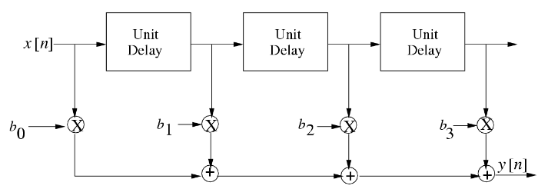

1. Consider the discrete time system described by $y[n]=0.5(x[n+1]+x[n-1])$.
   1. Describe in words how the value $y[5]$ would be computed from the input sequence.
   2. Suppose that the input is the complex exponential signal $x[n]=A{e^{jϕ}e^{j\hat{ω}n}}^{}$ $-∞<n<∞$. Determine an expression for the output $y[n]$.
   3. Use your result from part (b) to find the output of the above system due to the input $x[n]=e^{j\left(0.5π\right)n}$.