# Seminar 8: Z-Transform

1. An LTI system is described by the difference equation
 $y[n]=\frac{1}{3}(x[n]+x[n−1]+x[n−2])$

  1. Determine the system function *H*(*z*) for this system.
   2. Plot the poles and zeros of *H*(*z*) in the *z*-plane.
   3. From *H*(*z*) obtain an expression for $H(e^{j\hat{ω}})$, the frequency response of the system.
   4. What is the output if the input is $x[n]=4+cos[0.25π(n−1)]−3cos[(2π/3)n]$
2. Consider an LTI system whose system function is the product of five terms as follows
 $H(z)=(1−z^{−1})(1−e^{j\frac{π}{2}}z^{−1})(1−e^{−j\frac{π}{2}}z^{−1})(1−0.9e^{j\frac{π}{3}}z^{−1})(1−0.9e^{−j\frac{π}{3}}z^{−1})$

  1. Write the difference equation that relates the output of this system to its input.
   2. Plot the poles and zeros of *H*(*z*) in the complex *z-*plane.
   3. If the input is $x[n]=Ae^{jφ}e^{j\hat{ω}n}$, for what values of $-π<\hat{ω}<π$ will $y[n]=0$.
3. Suppose that an LTI system is defined by the system function
 $H(z)=(1−z^{−1})(1+z^{−2})(1+z^{−1})$

  1. Write the time-domain description of this system in the form of a difference equation.
   2. Write a formula for the frequency response of the system.
   3. Derive simple formulas for the magnitude response and the phase response versus $\hat{ω}$. These formulas must contain no complex terms and no square roots.
   4. This system can “null” certain input signals. For which input frequencies ${\hat{ω}}_{0}$ is the response to $x[n]=cos({\hat{ω}}_{0}n)$ equal to zero?
   5. When the input to the system is $x[n]=cos({\hat{ω}}_{0}n)$, determine the output signal in the form $y[n]=Acos({\hat{ω}}_{0}n+φ)$. Give numerical values for the constants $A$, ${\hat{ω}}_{0}$, and $φ$.
4. An LTI system has the system function

$H(z)=(1+z^{−2})(1−4z^{−2})=1−2z^{−2}−4z^{−4}$

The input to the system is

$x[n]=20−20δ[n]+20 cos(0.5πn+\frac{π}{4})$

for $−∞<n<∞$. Determine the output of the system $y[n]$ corresponding to the above input. Give an equation for $y[n]$ that is valid for all *n*.

***Note:*** This is an easy problem if you approach it correctly.

1. Consider a cascade system as shown below

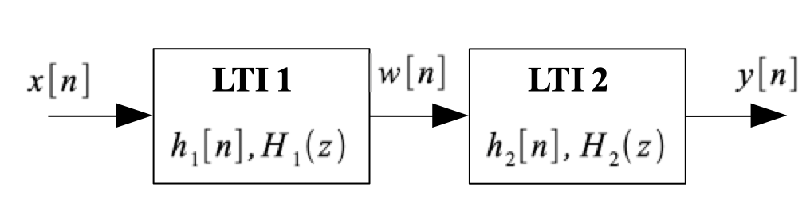

where the system function $H(z)$ of the overall system is given as

* 1. Determine the poles and zeros of $H(z)$ and plot them in the complex *z*-plane.
  2. Find $H_{1}(z)$ and $H_{2}(z)$ such that the overall cascade system has the system function $H(z)$ given above, and the output of the first system is given by $w[n]=x[n]−x[n−4]$.
  3. Determine the difference equation that relates $y[n]$ to $w[n]$ for your answer in part (b).

1. Suppose that a system is defined by $H\left(z\right)=1-z^{-1}$
   1. Write the time-domain description of the system in the form of a difference equation.
   2. Write the formula for the frequency response of the system.
   3. Sketch a plot of the magnitude response versus $\hat{ω}.$
   4. When the input to the system is $x[n]=sin\left(\frac{1}{100}πn\right)$ determine the output signal $y[n].$
2. An LTI system is described by $y[n]=x[n]-x[n-4]$
   1. Find its system function $H\left(z\right)$
   2. Plot the poles and zeros of $H\left(z\right)$ in the z-plane
   3. Find the frequency response $H(e^{j\hat{ω}})$ and express it in polar form (magnitude and phase). Remember the “trick” $\left(1-e^{-jθ}\right)=e^{-j0.5θ}\left(e^{j0.5θ}-e^{-j0.5θ}\right)$
   4. Sketch $\left|H(e^{j\hat{ω}})\right|$ for $-π<$ $\hat{ω}$ < $π$