***Seminar 5: Sampling  
[solutions]***

1. Consider the system

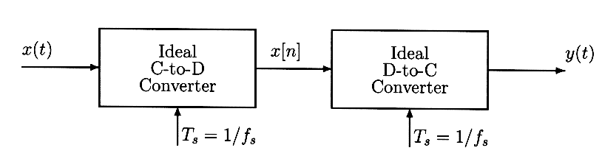

If $x(t)=4+4cos(1000πt)sin(50000πt)$, what condition has to be satisfied for the sampling frequency $f_{s}=1/T_{s}$, so that y(t) = x(t)?  
**ANSWER**: Using $sin(a)cos(b)=\frac{sin(a+b)+sin(a-b)}{2}$, then $x(t)=4+2[sin(51000πt)+sin(49000πt)] ⇒f_{max}=\frac{51000π}{2π}=25500 Hz$

$f_{s}>2f_{max}=51000 Hz$

1. Given a signal $x(t)=cos(50πt)sin(700πt)$
   1. Draw a sketch of the spectrum of $x(t)$, labelling the frequencies and complex amplitudes of each component.
   2. Determine the minimum sampling rate that can be used to sample $x(t)$ without any aliasing.

**ANSWER**: trivial using solution of previous exercise.

1. Suppose that a discrete signal $x[n]=100 cos(0.4πn+\frac{π}{4})$ was obtained sampling a continuous signals with a sampling frequency $f_{s}=5000$ samples/sec.
   1. Determine two continuous signals $x_{1}(t)$ and $x_{2}(t)$ so that $x[n]=x_{1}(nT)=x_{2}(nT)$ for T =.0002 sec. The two signals have to have a frequency smaller than 5000 Hz. Give an equation for each signal.   
      **ANSWER**: The aliases have frequencies of the form $lf_{s}±f_{0}$, and there are only 2 aliases with frequencies smaller than $f_{s}$, $f_{1}=f_{0}(l=0)$ and $f_{2}=f_{s}-f_{0}(l=1)$
   2. Determine the amplitude and phase of the two signals obtained in section (a).  
      **ANSWER**: The aliases have frequencies of the form $lf_{s}±f_{0}$, and there are only 2 aliases with frequencies smaller than $f_{s}$, $f_{1}=f_{0}(l=0)$ and $f_{2}=f_{s}-f_{0}(l=1)$
2. A signal *x(t)* has the following spectral representation:

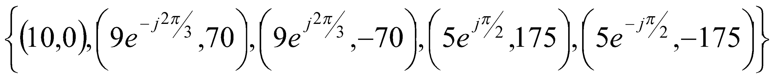

* 1. Write an equation for *x(t)*.  
     **ANSWER**: $x(t)=10+18 cos(140πt-2π/3)+10 cos(350πt+π/2)]$
  2. The signal *x(t)* is sampled with a sampling frequency $f_{s}=\frac{1}{T_{s}}=400$ samples/sec to obtain a discrete signal $x[n]=x(nT_{s})$. Write an equation for *x*[*n*] and draw the spectrum of *x*[*n*] for normalized frequencies $-π≤\hat{ω}≤π$.  
     **ANSWER**: $x[n]=10+18 cos(0.35πn-2π/3)+10 cos(0.875πn+π/2)]$

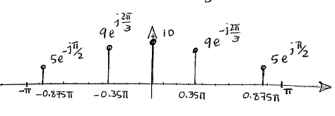

1. A chirp signal can be synthesized using the following formula:
$x[n]=Re\left\{e^{jθ[n]}\right\}=cos(π{10}^{-4}n^{2}) for n=0,1,2,....,4000$

2. Draw the phasor $e^{jθ[n]}$ for the three cases n = 10, 100, 1000  
   **ANSWER**: $e^{jθ[n]}=e^{jπ{10}^{-4}n^{2}}=e^{jπ{10}^{-2}}, n=10; e^{jπ}, n=100; e^{j100π}=1, n=1000;$  
     
   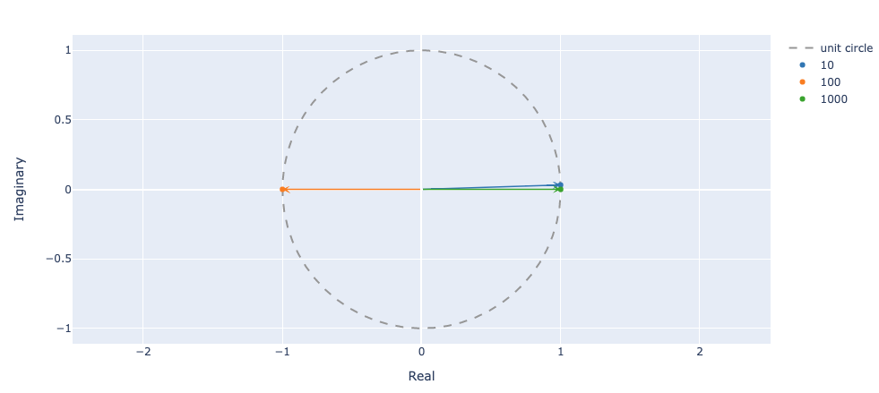
3. If the signal goes through an D-A converter with a sampling frequency of 4kHz, draw the instantaneous analog frequency (in Hz) with respect to time. Make sure that the coordinates are drawn correctly.  
   **ANSWER**: ideally $x(t)={cos(π{10}^{-4}n^{2})}_{n= tf_{s}}=cos(π{10}^{-4}*16*{10}^{6}t^{2})=cos(1600πt^{2})$ $f_{2}(t)=\frac{1}{2π}\frac{d}{dt}\left(1600πt^{2}\right)=1600t$ 
     
   Due to aliasing and folding, the instantaneous frequency cannot exceed $f_{s}/2=2000 Hz$
4. Given a signal $x(t)=12sin(22πt)$, the corresponding discrete signal is obtained sampling $x(t)$ with a frequency $f_{s}$; and the resulting x[n] can be written as $x(t)=Acos(ω_{0}t+φ)$. Determine the values of $A, φ,$ and ${\hat{ω}}_{0}$ for each of the following values of $f_{s}$ 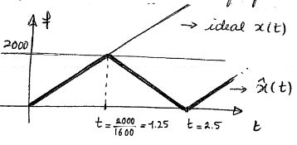
   1. 10

**ANSWER**:

* 1. 25

**ANSWER**:

* 1. 15

**ANSWER**: $x[n]=12 cos(22πn/15-π/2)=12 cos(1.46πn-π/2) =12 cos(0.54πn+π/2)$

1. The following complex-valued signal is a phasor: $z[n]=e^{jθ[n]}$, where $θ[n]$ is the phase.
   1. When the phase changes by a constant amount versus n, the phasor rotates at a constant speed. For the following phasor: $z[n]=e^{j\left(0.08πn-0.25π\right)}$, make a plot of the phasor locations for $n=0,1,2,7,10,17,20,22,50 and 99.$  
      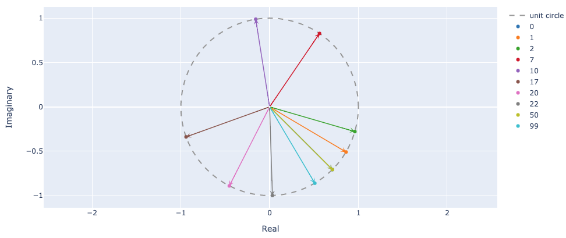

Note: the phasor location for n=0 and n=50 are the same, thus we only see the plast one plotted, n=50.

* 1. What is the period of $z[n]$?  
     **ANSWER**: Period = $2π/0.08π=25$, which means that z[50]=z[0]
  2. Repeat for the complex phasor that corresponds to the chirp signal: $c[n]=e^{j0.1π{n^{2}}^{}}$. In this case plot the phasor locations for $n=0,1,2,3,4 and 7.$  
     **ANSWER:   
     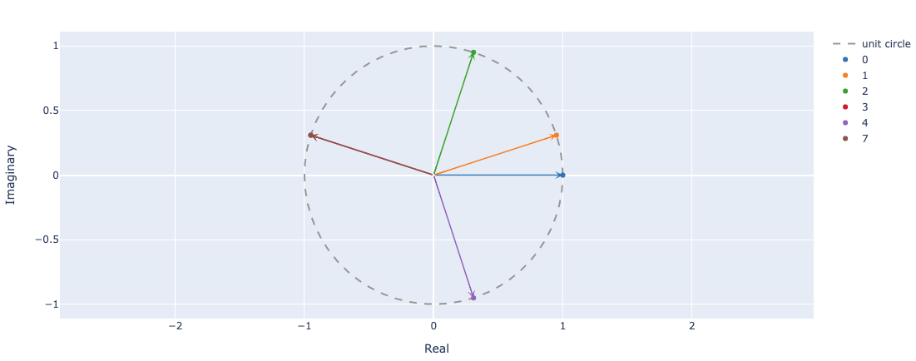**

Note: when $n=7, c[7]=e^{j0.1π(49)}=e^{j4.9π}=e^{j0.9π}$, Not periodic