***Seminar 6: FIR Filters  
[solutions]***

1. If the impulse response $h\left[n\right]$ of an FIR filter is: $h\left[n\right]=δ\left[n-1\right]-2δ\left[n-4\right]$.
   1. Make a plot (versus n) of $h\left[n\right]$

**ANSWER**:  
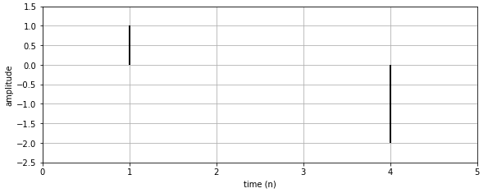

* 1. Write the difference equation for the FIR filter  
     **ANSWER: $y[n]=h[n]*x[n]=x[n-1]-2 x[n-4]$**

1. An FIR filter is described by the following difference equation: $y[n]=x[n]+2x[n-2]-4.5x[n-3]+5x[n-5]$
   1. Draw the block diagram of the filter

**ANSWER:**  
 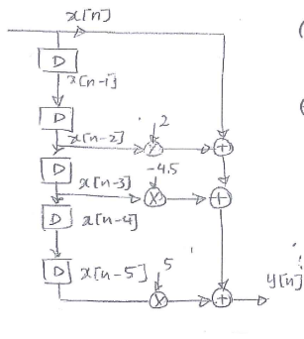

* 1. Compute the impulse response $h\left[n\right]$ and draw it over *n*

**ANSWER**:   
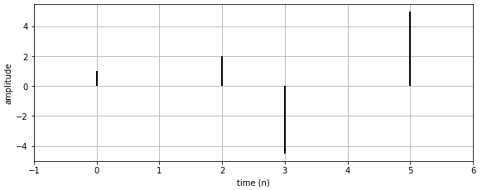

* 1. Compute $y\left[n\right]$ for the complex input signal $x[n]=2{e^{j(.2πn-\frac{π}{4})}}^{}$  
     **ANSWER**: $y[n]=2{e^{j(.2πn-π/4)}}^{}+4{e^{j(.2πn-0.4π-π/4)}}^{}-9{e^{j(.2πn-0.6π-π/4)}}^{}+10{e^{j(.2πn-π-π/4)}}^{}$

$=2{e^{j(.2πn-π/4)}}^{}+4{e^{j(.2πn-0.65π)}}^{}-9{e^{j(.2πn-0.85π)}}^{}+10{e^{j(.2πn-1.25π)}}^{}$

1. Assume that we have a linear system for which we do not know the difference equation but we introduce a signal $x_{1}[n]=5 cos(0.25πn+π/4)$ and the obtained output signal is $y[n]=0.2 cos(0.25πn)$. Using the property of linearity and time invariance compute the output of the system when the input is $x_{2}[n]=4 cos(0.25π(n-8))$  
   **ANSWER**:

$x_{2}[n]=4 cos(0.25π(n-8))=4 cos(0.25πn-2π)=4 cos(0.25πn)$ $=4/5 x_{1}[n-1]$

Note that $x_{1}[n]=5 cos(0.25π(n+1))$

Then using LTI, $y_{2}=4/5 y_{1}[n-1]=0.16 cos($ $0.25π(n+1)$)

1. Let x[n] be the complex exponential $x[n]=11{e^{j(0.3πn+0.5π)}}^{}$. If we define a new signal $y[n]=2x[n]+4x[n-1]+2x[n-2]$, it is possible to express $y[n]$ in the form $y[n]=A{e^{j(ω_{0}n+ϕ)}}^{}$. Determine the numerical values of $A, ϕ$ and $ω_{0}$.  
   **ANSWER: $x[n]=11{e^{j(0.3πn+0.5π)}}^{}=11e^{j0.5π}{e^{j0.3πn}}^{}$** , thus $y[n]=2(11e^{j0.5π}{e^{j0.3πn}}^{})+4(11e^{j0.5π}{e^{j0.3π(n-1)}}^{})+2(11e^{j0.5π}{e^{j0.3π(n-2)}}^{})$

Factor out $11e^{j0.5π}$ and $e^{j0.3πn}$

$y[n]=11e^{j0.5π}{e^{j0.3πn}}^{}(2+4e^{-j0.3π}+2e^{-j0.6π})=1{1e}^{j0.5π}{e^{j0.3πn}}^{}6.35e^{-j0.3π}$ $=69.86e^{j0.2π}{e^{j0.3πn}}^{}⇒ A=69.86, ϕ=0.2π, ω_{0}=0.3π$

Note: The term $6.35e^{-j0.3π}$, obtained by vector addition of $2+4e^{-j0.3π}+2e^{-j0.6π}$ is the frequency response $H\left(\hat{ω}\right)$ evaluated at $\hat{ω}=0.3π$

1. For each of the following systems, determine whether or not the system is (1) linear, (2) time-invariant, and (3) causal.
   1. $y[n]=x[n] cos(0.2πn)$**ANSWER:**Linear. Since scaling x[n] by $α$ will give the same scaling of the output: $y[n]=(αx[n]) cos(0.2πn)=α(x[n] cos(0.2πn))$, and the superposition also holds: $y[n]=(x_{1}[n]+x_{2}[n]) cos(0.2πn)=x_{1}[n] cos(0.2πn)+x_{2}[n] cos(0.2πn)$

Not Time-Invariant. Because we can make the following counter example. Let $x[n]=δ[n]$ so that the output is $y[n]=δ[n] cos(0.2π(0))=δ[n]$, now change the input to $x[n]=δ[n-1]$, so we expect the output to shift by 1 time index. However the output is $y[n]=δ[n-1] cos(0.2πn)=δ[n-1] cos(0.2π(1))=0.809 δ[n-1]$  
  
Causal. Because y[n] only depends on the current value of x[n]

* 1. **ANSWER:** Linear, Time-Invariant, and Causal. Trivial to demonstrate.
  2. $y[n]=\left|x[n]\right|$**ANSWER**:   
     Not linear: because when we multiply the input by -3, the output does not get multiplied by -3. $y[n]=\left|-3 x[n]\right|=3\left| x[n]\right|$

Causal: Because y[n] only depends on the current value of x[n]  
Time-Invariant: if input is $x[n-n_{0}]$, $y[n-n_{0}]=\left|x[n-n_{0}]\right|$

$y[n]=x[n^{2}] -{\left(x[n-1]\right)}^{2}$

**ANSWER:**

Not-linear. Since scaling x[n] by $α$ will not give the same scaling of the output. Easy demonstration.

Not Time-Invariant. Since depending on n, the same input value will give different results. Easy demonstration.  
Not Causal. Since the output of a given n will might depend on a higher valued n (given $n^{2}$). Easy demonstration.

* 1. where A and B are constants.  
     **ANSWER:**

Not-linear. Since scaling x[n] by $α$ will not give the same scaling of the output. Easy demonstration.

Time-Invariant. Easy demonstration.  
Causal. Because y[n] only depends on the current value of x[n].

1. If an LTI system is described by the block diagram below, where $b_{0}=1$, $b_{1}=\frac{1}{3}$, $b_{2}=0$, $b_{3}=\frac{2}{3}$, determine its impulse response $h[n]$.

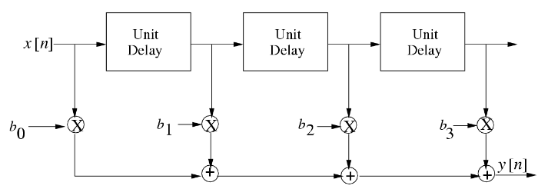

**ANSWER: $h[n]=δ[n]+\frac{1}{3}δ[n-1]+\frac{2}{3}δ[n-3]$**

1. Consider the discrete time system described by $y[n]=0.5(x[n+1]+x[n-1])$.
   1. Describe in words how the value $y[5]$ would be computed from the input sequence.  
      **ANSWER**: $y[5]=\frac{x[6]+x[4]}{2}$, which is the average of its previous input sample, x[4], and its next input sample, x[6].
   2. Suppose that the input is the complex exponential signal $x[n]=A{e^{jϕ}e^{j\hat{ω}n}}^{}$ $-∞<n<∞$. Determine an expression for the output $y[n]$.  
      **ANSWER**: $y[n]=\frac{1}{2}A{e^{jϕ}e^{j\hat{ω(}n+1)}+\frac{1}{2}A{e^{jϕ}e^{j\hat{ω(}n-1)}=\frac{e^{j\hat{ω}}+e^{-j\hat{ω}}}{2}A{e^{jϕ}e^{jn\hat{ω}}}^{}}^{}=cos(\hat{ω})A{e^{jϕ}e^{jn\hat{ω}}}^{}}^{}$
   3. Use your result from part (b) to find the output of the above system due to the input $x[n]=e^{j\left(0.5π\right)n}$.  
      **ANSWER**: $y[n]=cos(π/2){e^{j(π/2)n}=0}^{}e^{j(π/2)n}=0$ 
      , for all n  
      the system removes a component of the input at frequency $π/2$ (and $-π/2$ too).