# Seminar 8: Z-Transform [solutions]

1. An LTI system is described by the difference equation
 $y[n]=\frac{1}{3}(x[n]+x[n−1]+x[n−2])$

  1. Determine the system function *H*(*z*) for this system.  
      **ANSWER: $H(z)=\frac{1}{3}(1+z^{-1}+z^{-2})$**
   2. Plot the poles and zeros of *H*(*z*) in the *z*-plane.  
      **ANSWER: $H(z)=\frac{1}{3}(1+z^{-1}+z^{-2})=\frac{1}{3}\frac{z^{2}+z^{}+1}{z^{2}}$**zeros: poles:

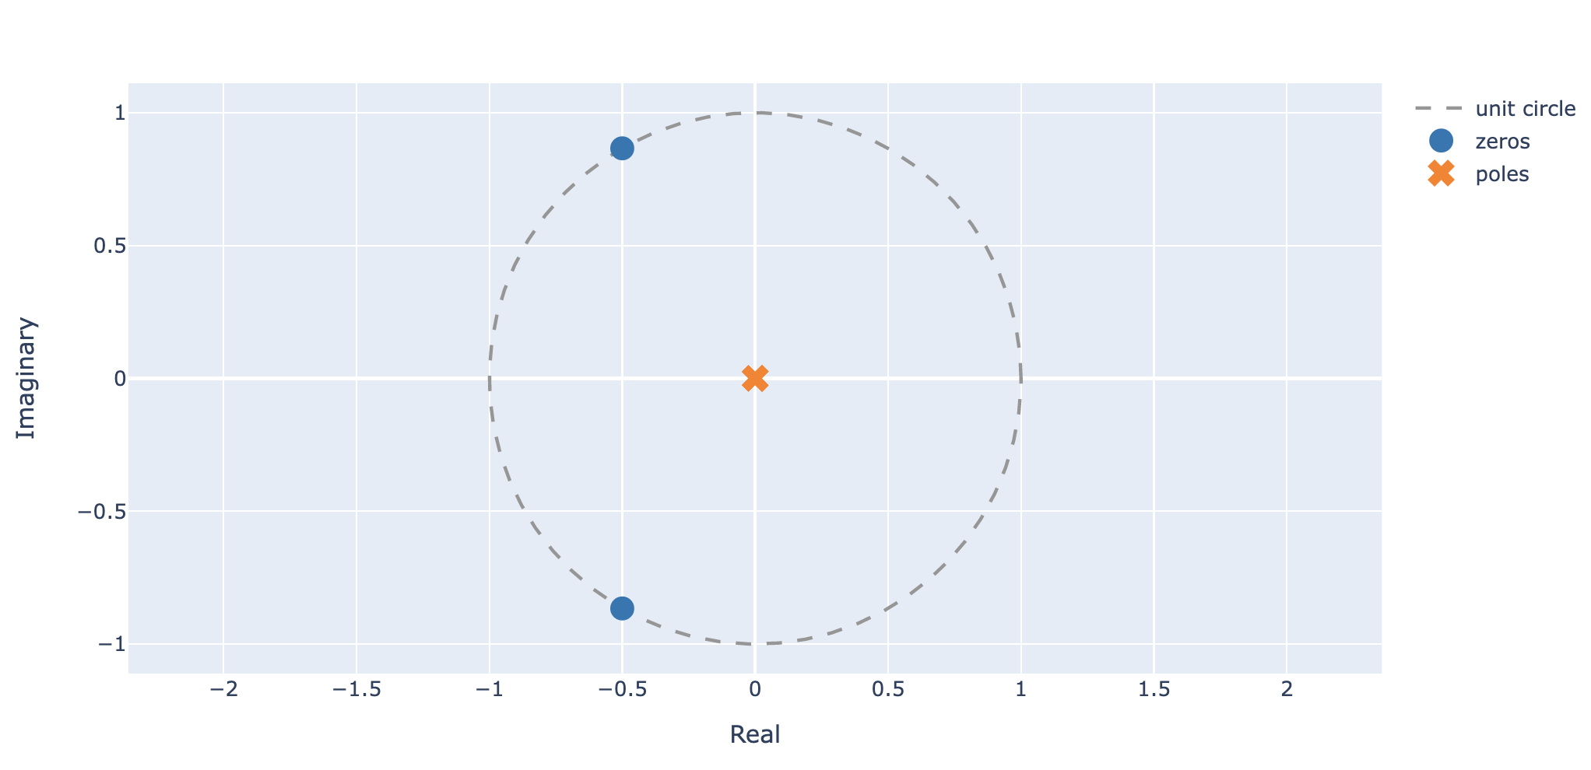

* 1. From *H*(*z*) obtain an expression for $H(e^{j\hat{ω}})$, the frequency response of the system.  
     **ANSWER: $H(e^{j\hat{ω}})=\frac{1}{3}(1+e^{-j\hat{ω}}+e^{-j2\hat{ω}})=\frac{1}{3}e^{-j\hat{ω}}(1+2cos(\hat{ω}))=\frac{1+2cos(\hat{ω})}{3}e^{-j\hat{ω}}$**
  2. What is the output if the input is $x[n]=4+cos[0.25π(n−1)]−3cos[(2π/3)n]$ 
     **ANSWER: $y[n]=4H(e^{j0})+\left|H(e^{jπ/4})\right| cos[0.25π(n−1)+<H(e^{jπ/4})]$ $+3\left|H(e^{j2π/3})\right| cos[2π/3n+<H(e^{j2π/3})]$**

$=4+\frac{1+\sqrt{2}}{3} cos[π/4(n−1)-π/4]+0=4+\frac{1+\sqrt{2}}{3} cos[π/4(n−2)]$

1. Consider an LTI system whose system function is the product of five terms as follows
 $H(z)=(1−z^{−1})(1−e^{j\frac{π}{2}}z^{−1})(1−e^{−j\frac{π}{2}}z^{−1})(1−0.9e^{j\frac{π}{3}}z^{−1})(1−0.9e^{−j\frac{π}{3}}z^{−1})$

  1. Write the difference equation that relates the output of this system to its input.  
      **ANSWER**: $H(z)=(1−z^{−1})(1−2cos(π/2)z^{−1}+z^{−2})(1−1.8cos(π/3)z^{−1}+0.81z^{−2})$ $=(1−z^{−1})(1+z^{−2})(1−0.9z^{−1}+0.81z^{−2})$ $=1−{1.9z}^{−1}+2.71z^{−2}-2.71z^{−3}+1.71z^{−4}-0.81z^{−5}$ $y[n]=x[n]−1.9x[n-1]+2.71x[n-2]-2.71x[n-2]+1.71x[n-3]$ $+1.71x[n-4]-0.81x[n-5]$
   2. Plot the poles and zeros of *H*(*z*) in the complex *z-*plane.  
      **ANSWER**: $H(z)=\frac{(z−1)(z−e^{j\frac{π}{2}})(z−e^{−j\frac{π}{2}})(z−0.9e^{j\frac{π}{3}})(z−0.9e^{−j\frac{π}{3}})}{z^{5}}$ 
        
      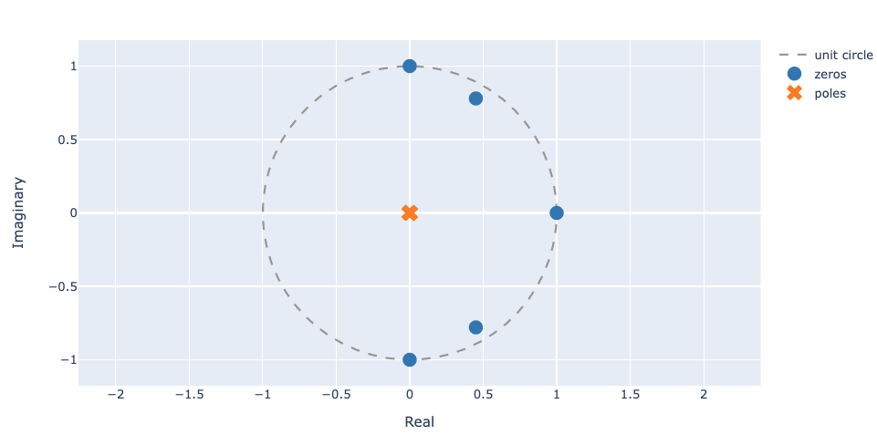
   3. If the input is $x[n]=Ae^{jφ}e^{j\hat{ω}n}$, for what values of $-π<\hat{ω}<π$ will $y[n]=0$.  
      **ANSWER**: If $\hat{ω}=0, π/2, - π/2 ⇒ y[n]=0$  
      note:   
      for $\hat{ω}=±π/3, y[n]≠0$, for $\hat{ω}=±π/3, y[n]=0$ only if x[n] is in the form $x[n]=z_{0}^{n}$ with $z_{0}=0.9e^{±jπ/3}$
2. Suppose that an LTI system is defined by the system function
 $H(z)=(1−z^{−1})(1+z^{−2})(1+z^{−1})$

  1. Write the time-domain description of this system in the form of a difference equation.  
      **ANSWER**:

* 1. Write a formula for the frequency response of the system.  
     **ANSWER**: $H(e^{j\hat{ω}})=1-e^{-4j\hat{ω}}=e^{-2j\hat{ω}}(e^{2j\hat{ω}}-e^{-2j\hat{ω}})=2j sin(2\hat{ω})e^{-2j\hat{ω}}=2 sin(2\hat{ω})e^{-j2\hat{ω}+π/2}$
  2. Derive simple formulas for the magnitude response and the phase response versus $\hat{ω}$. These formulas must contain no complex terms and no square roots.  
     **ANSWER**: $\left|H(e^{j\hat{ω}})\right|=\left|2sin(2\hat{ω})\right|$ 
       
     < $H(e^{j\hat{ω}})= -2\hat{ω} +π/2$
  3. This system can “null” certain input signals. For which input frequencies ${\hat{ω}}_{0}$ is the response to $x[n]=cos({\hat{ω}}_{0}n)$ equal to zero?  
     **ANSWER**: when $\left|H(e^{j\hat{ω}})\right|=0 ⇒ sin(2\hat{ω})=0$ iff $\hat{ω}=k π/2$
  4. When the input to the system is $x[n]=cos({\hat{ω}}_{0}n)$, determine the output signal in the form $y[n]=Acos({\hat{ω}}_{0}n+φ)$. Give numerical values for the constants $A$, ${\hat{ω}}_{0}$, and $φ$.  
     **ANSWER**: $y[n]=\left|H(e^{j{\hat{ω}}_{0}})\right| cos({\hat{ω}}_{0}n+φ+<H(e^{j{\hat{ω}}_{0}}))=\left|2sin(2{\hat{ω}}_{0})\right| sin({\hat{ω}}_{0}n-2{\hat{ω}}_{0})$

1. An LTI system has the system function

$H(z)=(1+z^{−2})(1−4z^{−2})=1−2z^{−2}−4z^{−4}$

The input to the system is

$x[n]=20−20δ[n]+20 cos(0.5πn+\frac{π}{4})$

for $−∞<n<∞$. Determine the output of the system $y[n]$ corresponding to the above input. Give an equation for $y[n]$ that is valid for all *n*.

***Note:*** This is an easy problem if you approach it correctly.  
**ANSWER**:

$H(z)=\frac{(z^{2}+1)(z^{2}−4)}{z^{4}}$, zeros: $z^{2}=-1 ⇒z=±j=e^{±jπ/2}$; and $z^{2}=4 ⇒z=±2$ $x[n]=20(1−δ[n]+ cos(0.5πn+\frac{π}{4}))=20(x_{1}[n]+x_{2}[n]+x_{3}[n])$ $⇒ y[n]=$ $20(y_{1}[n]+y_{2}[n]+y_{3}[n])$ ${x_{1}[n]=1^{n} ⇒y}_{1}[n]=H(1)1^{n} =1-2-4=-7$

${x_{2}[n]=δ[n] ⇒y}_{2}[n]=h[n] =δ[n]-2δ[n-2]-4δ[n-4]$

${x_{3}[n]=cos(0.5πn+\frac{π}{4}) ⇒y}_{3}[n]=\left|H(e^{jπ/2})\right| cos(0.5πn+\frac{π}{4}+H(e^{jπ/2}))=0$ $⇒ y[n]=20(-7+δ[n]-2δ[n-2]-4δ[n-4])$ $=-140+20δ[n]-40δ[n-2]-80δ[n-4])$

1. Consider a cascade system as shown below

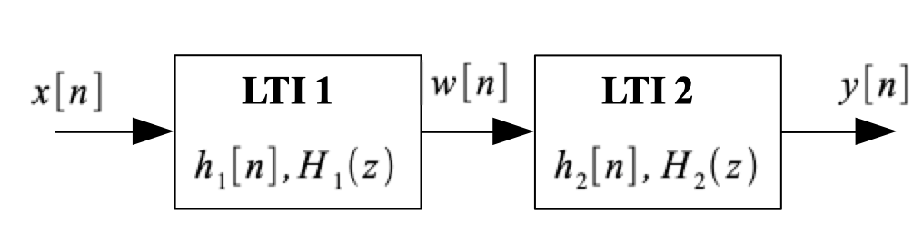

where the system function $H(z)$ of the overall system is given as

* 1. Determine the poles and zeros of $H(z)$ and plot them in the complex *z*-plane.  
     **ANSWER**: $H(z)=\frac{1}{z^{6}}(z^{2}−1)(z−0.8e^{j\frac{π}{4}})(z−0.8e^{−j\frac{π}{4}})(z^{2}+1)$  
     zeros: $z^{2}=1 ⇒ z_{1}=1, z_{2}=e^{jπ} ;z_{3}={0.8e}^{jπ/4}; z_{4}={0.8e}^{-jπ/4};$

$z^{2}=-1 ⇒ z_{5}=e^{jπ/2}, z_{6}=e^{-jπ/2}$ poles: 0 (x6)  
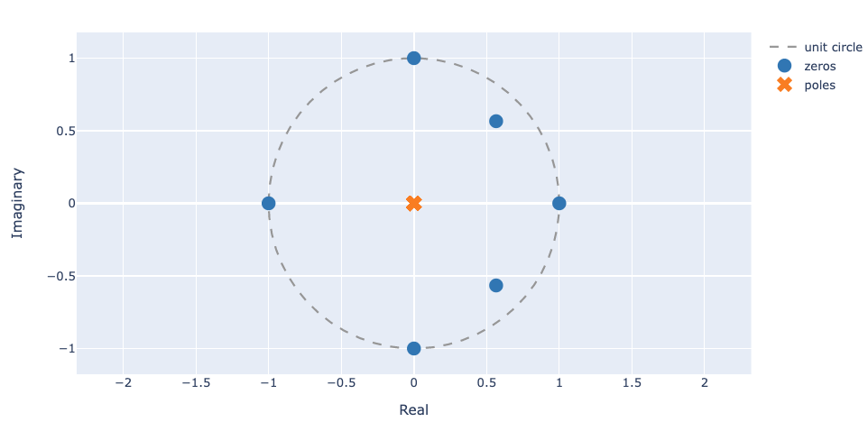

* 1. Find and $H_{2}(z)$ such that the overall cascade system has the system function $H(z)$ given above, and the output of the first system is given by $w[n]=x[n]−x[n−4]$.  
     **ANSWER**: $w[n]=x[n]−x[n−4] ⇒H_{1}(z)=(1−z^{−2})(1+z^{−2})$ ${H(z)=H}_{1}(z)H_{2}(z) ⇒{ H}_{2}(z)=(1−0.8e^{j\frac{π}{4}}z^{−1})(1−0.8e^{−j\frac{π}{4}}z^{−1}))$
  2. Determine the difference equation that relates $y[n]$ to $w[n]$ for your answer in part (b).  
     **ANSWER**: ${ H}_{2}(z)=1−0.8(e^{j\frac{π}{4}}{+e^{−j\frac{π}{4}})z}^{−1}+0.64z^{−2})$

$⇒ y[n]=w[n]-0.8\sqrt{2}w[n-1]+0.64w[n-2]$

1. Suppose that a system is defined by $H\left(z\right)=1-z^{-1}$
   1. Write the time-domain description of the system in the form of a difference equation.  
      **ANSWER**: $y[n]=x[n]-x[n-1]$
   2. Write the formula for the frequency response of the system.

**ANSWER**:

* 1. Sketch a plot of the magnitude response versus $\hat{ω}.$  
     **ANSWER**:  
     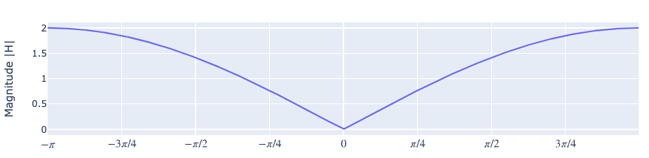
  2. When the input to the system is $x[n]=sin\left(\frac{1}{100}πn\right)$ determine the output signal $y[n].$  
     **ANSWER**: $y[n]=\left|H(e^{jπ/100})\right| sin\left(π/100 n+<H(e^{jπ/100})\right)=$ $\left|2 sin(π/200)\right| sin\left(π/100 n -π/200-π/2\right)=0.0314 cos\left(π/100 n-π/200\right)$

1. An LTI system is described by $y[n]=x[n]-x[n-4]$
   1. Find its system function $H\left(z\right)$  
      **ANSWER**: $H\left(z\right)=1-z^{-4}$
   2. Plot the poles and zeros of $H\left(z\right)$ in the z-plane  
      **ANSWER**: $H\left(z\right)=1-z^{-4}=\left(1-z^{-2}\right)\left(1+z^{-2}\right)=\frac{1}{z^{4}}\left(z^{2}-1\right)\left(z^{2}+1\right)$  
      zeros: $z^{2}=1 ⇒z_{1}=1, z_{2}=e^{jπ};{ z}^{2}=-1 ⇒z_{1}=e^{jπ/2}, z_{2}=e^{-jπ/2}$  
      poles: z = 0 (x4)

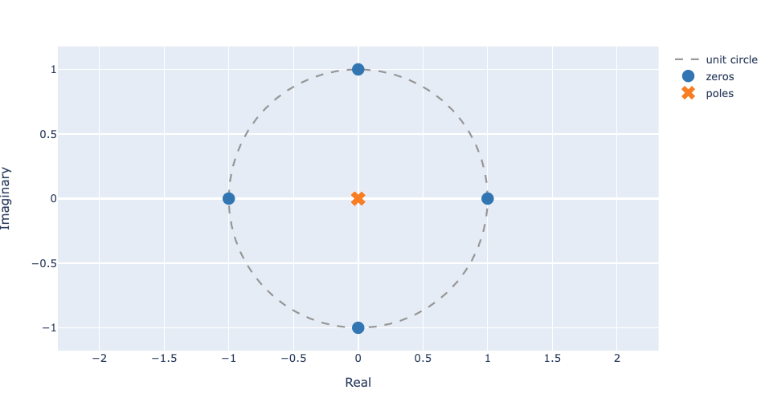

* 1. Find the frequency response $H(e^{j\hat{ω}})$ and express it in polar form (magnitude and phase). Remember the “trik” $\left(1-e^{-jθ}\right)=e^{-j0.5θ}\left(e^{j0.5θ}-e^{-j0.5θ}\right)$  
     **ANSWER**: $H(e^{j\hat{ω}})=\left(1-e^{-j4ω}\right)=e^{-j2\hat{ω}}\left(e^{j2\hat{ω}}-e^{-j2\hat{ω}}\right)=e^{-j2\hat{ω}} 2j sin(2\hat{ω})$ $=e^{-j(2\hat{ω}+π/2)} 2 sin(2\hat{ω})$
  2. Sketch $\left|H(e^{j\hat{ω}})\right|$ for $-π<$ $\hat{ω}$ < $π$ 
     **ANSWER**: $\left|H(e^{j\hat{ω}})\right|=\left|2 sin(2\hat{ω})\right|$  
     