***Seminars 1 and 2: Sinusoids and Exponentials***

***[Solutions]***

1. Given $x(t)=3 cos(ω_{0}t-\frac{π}{3})$. For $ω_{0}$ = $\frac{π}{5}$, make a plot of $x(t)$ over the range $-10≤t≤20$.  
   **ANSWER:**

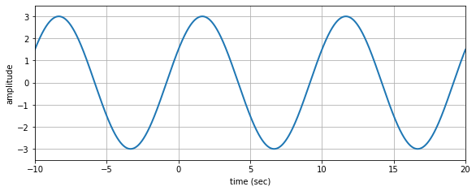

1. Make a carefully labelled sketch for each of the following functions.
   1. Sketch $cos(θ)$ for values of $θ$ in the range $0≤θ≤6π$.  
      ANSWER:  
      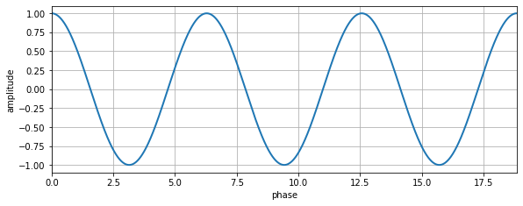
   2. Sketch $cos(0.2πt)$ for values of t such that three periods of the function are shown.  
      **ANSWER:**  
      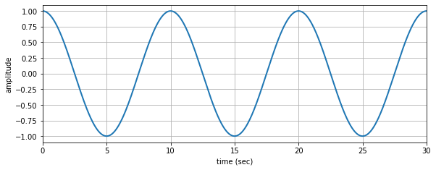
   3. Sketch $cos(0.2πt+\frac{π}{2})$ for values of t such that three periods of the function are shown.   
      **ANSWER:**  
      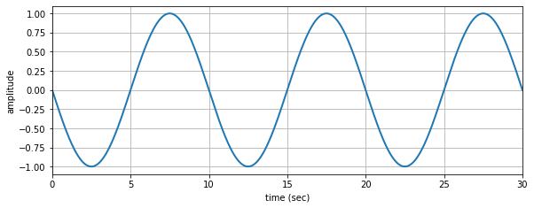
   4. Sketch $cos(0.2πt-\frac{π}{2})$ for values of t such that three periods of the function are shown.   
      ANSWER:  
      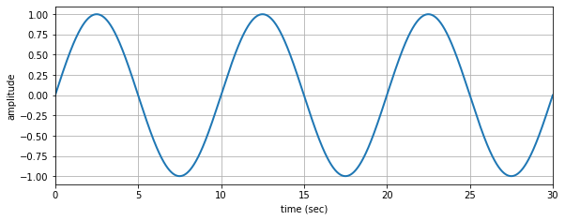
2. The figure below is a plot of a sinusoidal wave. From the plot, determine values for the amplitude (A), phase $(φ)$, and frequency $(ω_{0})$ needed in the formula: $x(t)=Acos(ω_{0}t+φ)$. Give the answer as numerical values including the units where applicable.

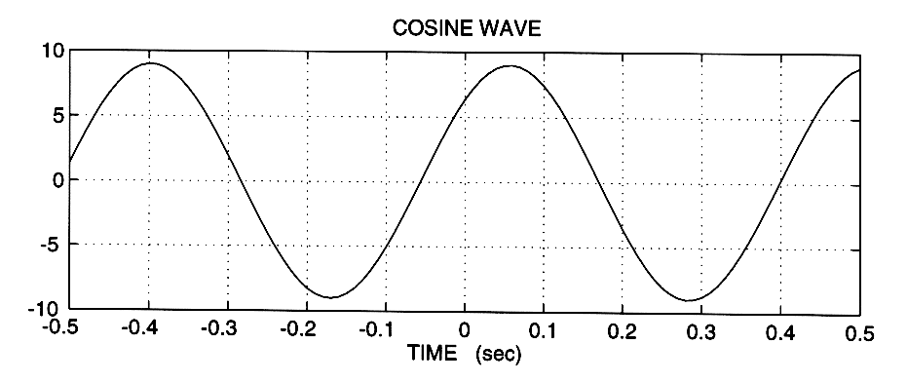  
  
**ANSWER: $A=9; ω_{0}=2π\left(20/9) [rad/s]; φ=-2π(1/9\right)$**

1. Use complex exponentials (i.e., phasors) to show the following trigonometric identities

$cos(θ_{1}+θ_{2})=cos(θ_{1})cos(θ_{2})-sin(θ_{1})sin(θ_{2})$

$cos(θ_{1}-θ_{2})=cos(θ_{1})cos(θ_{2})+sin(θ_{1})sin(θ_{2})$

**ANSWER:** To solve these two apply the inverse Euler’s identities: $cos ϕ=\frac{e^{jϕ}+e^{-jϕ}}{2}$, $sin ϕ=\frac{e^{jϕ}-e^{-jϕ}}{2j}$, on the right side of both equalities, make the products, and simplify to get the left side of the equations.

1. The phase of a sinusoid can be related with the time-shift $x(t)=Acos(2πf_{0}+φ) =Acos(2πf_{0}(t-t_{1}))$.
   1. Determine the formula that relates $φ$ with $t_{1}$.   
      ANSWER: $φ=-2πf_{0}t_{1}$
   2. When $x(t)=Asin(11πt)$ determine the value of $t_{1}$ that would be needed to express *x(t)* as $x(t)=Acos(2πf_{0}(t-t_{1}))$.   
      **ANSWER: $t_{1}=1/22$** [s]
   3. Prove that the maximum of the cosine wave is always at $t_{1}$ = t.  
      **ANSWER:** If $t=t_{1}$, we have $cos(0)$ which is equal to 1 (the maximum value that the cosine function can reach).
2. If $x(t)= 20 cos (2π(40)t-0.4π)$ find *G* and $t_{1}$ so that $y(t)=Gx(t-t_{1})=5cos(2π(40)t)$, i.e., obtain an expression for $y(t)=5cos(2π(40)t)$ in terms of $x(t)$.  
   **ANSWER: $G=1/4$** , $t_{1}= -1/200$
3. Consider the three phasors $X_{1}= e^{jα},X_{2}= e^{jβ}$, and $X_{3}=X_{1}+X_{2}$.
   1. Show that $X_{3}= 2 cos(\frac{α-β}{2})e^{j\frac{α+β}{2}}$.   
      **ANSWER:** Start from this compact representation of $X_{3}$, apply $cos ϕ=\frac{e^{jϕ}+e^{-jϕ}}{2}$ to the first term, multiply by the other complex exponential, and simplify.
   2. Plot the phasors in the complex plane and explain the result in part (a)

**ANSWER:**  
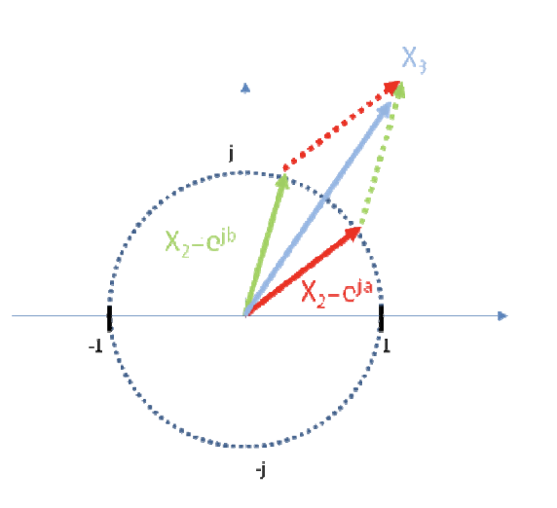

1. Let $x[n] = e^{j\left(0.4πn-0.5π\right)}$. If we define a new signal $y[n]$ to be the first difference: $y[n]=x[n]-x[n-1]$ it is possible to express $y[n]$ in the form $y[n]=Ae^{j({\hat{ω}}_{0}n+ϕ)}$. Determine the numerical values of A, $ϕ$, and ${\hat{ω}}_{0}$. (Should ${\hat{ω}}_{0}$ be equal to $0.4π$?)
2. A signal $x(t)= 2 cos(200πt+\frac{π}{3}) + \sqrt{2} cos(200πt-\frac{3π}{4})$.
   1. Obtain phasor representations for both cosine signals in the above sum, and plot both phasors in the complex plane.
   2. Use the phasors obtained in part (a) to express *x(t)* in the form $x(t)=A cos(ω_{0}t+ϕ)$. Plot any additional phasors needed to solve this part on the plot made in part (a).
   3. Find a complex-valued signal *z(t)* such that $x(t)=ℜ\left\{z(t)\right\}$.
3. A signal $x(t)= 20 cos(300πt+\frac{π}{4})+5\sqrt{2} cos(300πt-π)+5\sqrt{2} cos(300πt-\frac{π}{2})$
   1. Obtain phasor representations for the three cosine signals and draw the phasors in the complex plane.   
      **ANSWER: $X_{1}=20e^{jπ/4}$** , $X_{2}=5\sqrt{2}e^{-jπ}$, $X_{3}=5\sqrt{2}e^{-jπ/2}$
   2. Add the three phasors drawn in part (a).   
      **ANSWER: $X_{1}+X_{2}+X_{3}=10e^{jπ/4}$**
   3. Express $x(t)$ in the form $x(t) = A cos(ω_{0}t+ϕ)$.  
      **ANSWER: $x(t)=10cos(300πt+π/4)$**
4. Given $x(t)= 4\sqrt{2} sin\left(ω_{0}t+{45}^{∘}\right)+3 cos\left(ω_{0}t\right)$.
   1. Express $x(t)$ in the form $x(t)= A cos\left(ω_{0}t+ϕ\right)$, where $ϕ$ is expressed in radians.   
      **ANSWER: $x(t)=\sqrt{65 }cos(ω_{0}t+ϕ)$** , where $ϕ=arctan(-4/7)$
   2. Assume that $ω_{0}= 10π$. Draw $x(t)$ in the range $-1≤t≤1$. How many periods are included in the drawing?

**ANSWER:** 10 periods  
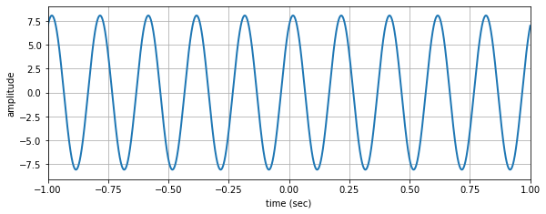

1. We define the general form of a discrete sinusoid as $x[n]=Xz_{0}^{n}, n=0,1,2,...,$ where $X=2e^{j\frac{π}{4}}, z_{0}=0.9e^{j\frac{π}{8}}$.
   1. What is the amplitude of the sinusoid? What is the normalised frequency in radians? What is the phase in radians?   
      **ANSWER:**

A = ;

* 1. Draw and $ℑ\left\{Xz_{0}^{n}\right\}$ with respect to n.   
     **ANSWER:**  
     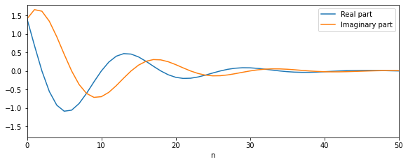
  2. Draw $Xz_{0}^{n}$ as a collection of dots in the complex plane (imaginary part with respect to real part).  
     **ANSWER:**  
     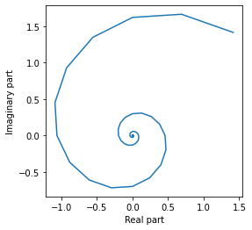

1. Consider two sinusoids, $x_{1}=5 cos\left(2π(110)t+\frac{π}{3}\right),{ x}_{2}=4 cos\left(2π(110)t-\frac{π}{4}\right),$

Obtain the representation with phasors of the two signals, add the phasors, draw the phasors and their sum in the complex plane, and show that the sum of the two signals is $x_{3}=5.536 cos\left(2π(110)t+0.2747\right)$.  
**ANSWER: $X_{1}=5e^{jπ/3}$** , $X_{2}=4e^{-jπ/4}$, $X_{1}+X_{2}=5.536e^{j0.2747}$  
