christineRogers_explore_linelist_20210114.R

gabrielodom

2021-01-14

# Query State Linelist  
# Gabriel Odom  
# 2021-01-14  
  
library(tidyverse)

## ── Attaching packages ─────────────────────────────────────── tidyverse 1.3.0 ──

## ✓ ggplot2 3.3.2 ✓ purrr 0.3.4  
## ✓ tibble 3.0.4 ✓ dplyr 1.0.2  
## ✓ tidyr 1.1.2 ✓ stringr 1.4.0  
## ✓ readr 1.4.0 ✓ forcats 0.5.0

## ── Conflicts ────────────────────────────────────────── tidyverse_conflicts() ──  
## x dplyr::filter() masks stats::filter()  
## x dplyr::lag() masks stats::lag()

library(lubridate)

##   
## Attaching package: 'lubridate'

## The following objects are masked from 'package:base':  
##   
## date, intersect, setdiff, union

library(readxl)  
  
linelist_df <- read_csv(  
 file = "../../data/deaths/Case_Data_arcGIS_20210110.csv"  
)

##   
## ── Column specification ────────────────────────────────────────────────────────  
## cols(  
## County = col_character(),  
## Age = col_double(),  
## Age_group = col_character(),  
## Gender = col_character(),  
## Jurisdiction = col_character(),  
## Travel_related = col_character(),  
## Origin = col_character(),  
## EDvisit = col_character(),  
## Hospitalized = col_character(),  
## Died = col_character(),  
## Case = col_character(),  
## Contact = col_character(),  
## Case_ = col_character(),  
## EventDate = col_datetime(format = ""),  
## ChartDate = col_character()  
## )

### Questions for MDC ###  
mdcLinelist_df <-  
 linelist_df %>%  
 filter(County == "Dade") %>%   
 rename(CaseDate = Case_) %>%   
 # Regular expression to remove " 5:00" from the end of the date  
 mutate(CaseDate = str_remove(CaseDate, pattern = " .*")) %>%  
 mutate(CaseDate = as.Date(CaseDate, format = "%m/%d/%Y")) %>%   
 mutate(CaseDate = as_date(CaseDate))  
  
# Christine Rogers hs asked 3 questions concerning the state linelist:  
# 1. Number of FL resident cases per day (the linelist data will not enable us  
# to indicate if the case was the first, or if the person tested positive  
# multiple days in a row). FLDoH measures this as "percent positivity for  
# new cases in FL residents".  
# 2. Number of non-FL resident cases per day (similar comments to above)  
# 3. Number of FL resident deaths daily (we are aware that this number is   
# delayed, up to weeks or months at a time)  
  
  
  
###### Question 1: FL Resident Cases / Day ##################################  
mdcLinelist_df %>%   
 pull(Jurisdiction) %>%   
 table(useNA = "always")

## .  
## FL resident Non-FL resident   
## 322768 3838   
## Not diagnosed/isolated in FL <NA>   
## 1 0

dailyMDCflResCount_df <-   
 mdcLinelist_df %>%   
 filter(Jurisdiction != "Non-FL resident") %>%   
 group_by(CaseDate) %>%   
 summarise(  
 DailyCount = n()  
 )

## `summarise()` ungrouping output (override with `.groups` argument)

# write_csv(dailyMDCflResCount_df, "mdcDailyResCases_20210114.csv")  
  
ggplot(data = dailyMDCflResCount_df) +  
 aes(x = CaseDate, y = DailyCount) +  
 geom_col()

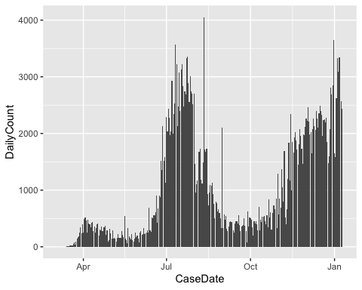

###### Question 2: Non-FL Resident Cases / Day ##############################  
  
dailyMDCflNonResCount_df <-   
 mdcLinelist_df %>%   
 filter(Jurisdiction == "Non-FL resident") %>%   
 group_by(CaseDate) %>%   
 summarise(  
 DailyCount = n()  
 )

## `summarise()` ungrouping output (override with `.groups` argument)

# write_csv(dailyMDCflNonResCount_df, "mdcDailyNonResCases_20210114.csv")  
  
ggplot(data = dailyMDCflNonResCount_df) +  
 aes(x = CaseDate, y = DailyCount) +  
 geom_col()

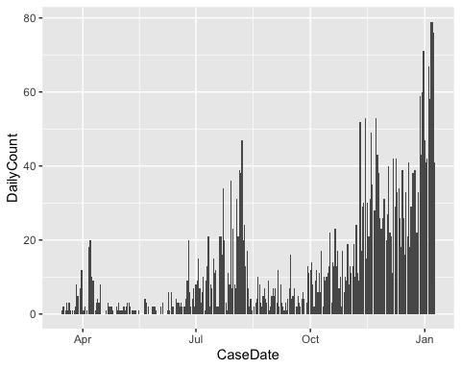

###### Question 3: FL Resident Deaths / Day #################################  
  
dailyMDCflDeathsCount_df <-   
 mdcLinelist_df %>%   
 filter(Died %in% c("Recent", "Yes")) %>%   
 group_by(CaseDate) %>%   
 summarise(  
 DailyCount = n()  
 )

## `summarise()` ungrouping output (override with `.groups` argument)

# write_csv(dailyMDCflDeathsCount_df, "mdcDailyDeaths_20210114.csv")  
  
ggplot(data = dailyMDCflDeathsCount_df) +  
 aes(x = CaseDate, y = DailyCount) +  
 geom_col() +  
 # Add line chart  
 stat_smooth(method = "gam")

## `geom_smooth()` using formula 'y ~ s(x, bs = "cs")'

