S. Florida COVID-19 Trajectory

Gabriel J. Odom, PhD, ThD

5/4/2020

# Overview

Analyse Daily COVID-19 Trajectory  
WRITE MORE HERE

library(tidyverse)

## Testing Data

sflCases_df <- read_csv(  
 file = "../../data/FLDH_COVID19_cases_20200504.csv"  
)  
knitr::kable(sflCases_df)

|  |  |  |
| --- | --- | --- |
| Date | Positive | Negative |
| 2-Apr | 544 | 2413 |
| 3-Apr | 625 | 1878 |
| 4-Apr | 531 | 2521 |
| 5-Apr | 311 | 1260 |
| 6-Apr | 556 | 2309 |
| 7-Apr | 493 | 1990 |
| 8-Apr | 488 | 1113 |
| 9-Apr | 435 | 2636 |
| 10-Apr | 542 | 2505 |
| 11-Apr | 563 | 2732 |
| 12-Apr | 364 | 1614 |
| 13-Apr | 477 | 2267 |
| 14-Apr | 364 | 1663 |
| 15-Apr | 438 | 2392 |
| 16-Apr | 536 | 2767 |
| 17-Apr | 519 | 2901 |
| 18-Apr | 296 | 1509 |
| 19-Apr | 465 | 2690 |
| 20-Apr | 413 | 3232 |
| 21-Apr | 577 | 4230 |
| 22-Apr | 465 | 2701 |
| 23-Apr | 619 | 3647 |
| 24-Apr | 552 | 2852 |
| 25-Apr | 564 | 4136 |
| 26-Apr | 384 | 2576 |
| 27-Apr | 446 | 2789 |
| 28-Apr | 213 | 1333 |
| 29-Apr | 309 | 1704 |
| 30-Apr | 333 | 3724 |
| 1-May | 250 | 3616 |
| 2-May | 152 | 2185 |
| 3-May | 301 | 2924 |

library(lubridate)  
sflCases2_df <-   
 sflCases_df %>%   
 mutate(Date = as.POSIXct(strptime(Date, format = "%d-%b"))) %>%   
 mutate(PropPositive = Positive / (Positive + Negative))

We see the following pattern of positive and negative tests over the past month (shown on a log scale):

ggplot(data = sflCases2_df) +  
 theme_bw() +  
 aes(x = Date) +   
 scale_y_log10() +  
 labs(  
 title = "Proportion of Positive COVID-19 in Miami Dade County",  
 subtitle = "2 April to 3 May, 2020",  
 caption = "Green represents a positive test result while blue is negative.",  
 y = "Counts (Log10 Scale)"  
 ) +  
 geom_point(aes(y = Positive), colour = "green") +  
 stat_smooth(aes(y = Positive), method = "loess", colour = "green") +  
 geom_point(aes(y = Negative), colour = "blue") +  
 stat_smooth(aes(y = Negative), method = "loess", colour = "blue")

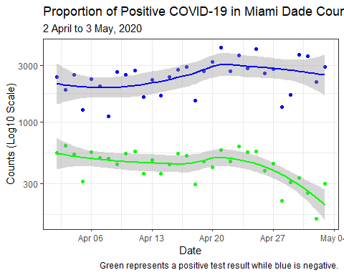

The proportion of positive tests over the past two weeks is

ggplot(  
 data = sflCases2_df %>%   
 filter(Date > "2020-04-19")  
) +  
 theme_bw() +  
 aes(x = Date) +  
 labs(  
 title = "Proportion of Positive COVID-19 in Miami Dade County",  
 subtitle = "20 April to 3 May, 2020",  
 caption = "Solid line represents the LOESS Predictor; Dashed line for Linear.",  
 y = "Proportion of Positive Cases"  
 ) +  
 geom_point(aes(y = PropPositive)) +  
 stat_smooth(aes(y = PropPositive), method = "loess", colour = "black") +  
 stat_smooth(  
 aes(y = PropPositive),  
 method = "lm",  
 colour = "black",  
 se = FALSE,  
 linetype = "dashed"  
 )

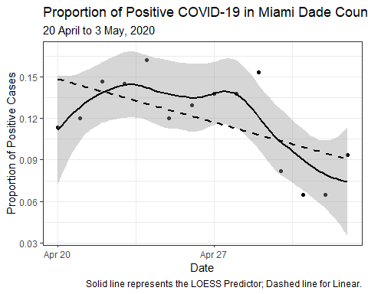

## Hospitalisation Data

data_dir <- "../../data/"  
dataFiles_char <- list.files(path = data_dir, pattern = "ESS_.*hrs")  
  
library(readxl)  
miamidadeHospitalised_df <-   
 map(  
 .x = dataFiles_char,  
 .f = ~{  
   
 read_excel(  
 path = paste0(data_dir, .x),   
 sheet = "County_Bed_Availability_Report_",   
 skip = 1  
 ) %>%   
 filter(County == "MIAMI-DADE") %>%   
 select(contains("COVID")) %>%   
 mutate(  
 Date_char = str_remove(  
 .x,  
 pattern = "ESS_BedAvailabilityWithAddlinfo_Hospitals_"  
 )  
 ) %>%   
 mutate(  
 Date_char = str_sub(Date_char, end = 10)  
 ) %>%   
 mutate(  
 Date_char = str_replace_all(  
 Date_char,  
 pattern = "\\.",  
 replacement = "-"  
 )  
 ) %>%   
 mutate(Date = as.POSIXct(Date_char, format = "%m-%d-%Y")) %>%   
 select(-Date_char) %>%   
 select(Date, everything())  
   
 }  
 ) %>%   
 bind_rows()

knitr::kable(  
 miamidadeHospitalised_df %>%   
 mutate(Hospitalised = `COVID IN ICU` + `COVID NON ICU`) %>%   
 rename(  
 ICU = `COVID IN ICU`,  
 Ventilated = `COVID ON VENT`,  
 AdmitPrevDay = `COVID + Admits Day Before`,  
 DischPrevDay = `COVID + Disch Day Before`  
 ) %>%   
 select(Date, Hospitalised, ICU, Ventilated, AdmitPrevDay, DischPrevDay)  
)

|  |  |  |  |  |  |
| --- | --- | --- | --- | --- | --- |
| Date | Hospitalised | ICU | Ventilated | AdmitPrevDay | DischPrevDay |
| 2020-04-02 | 320 | 130 | 116 | NA | NA |
| 2020-04-03 | 346 | 133 | 116 | 111 | 33 |
| 2020-04-04 | 416 | 133 | 112 | 59 | 37 |
| 2020-04-05 | 533 | 188 | 146 | 108 | 19 |
| 2020-04-06 | 516 | 178 | 151 | 89 | 21 |
| 2020-04-07 | 591 | 199 | 167 | 76 | 28 |
| 2020-04-08 | 636 | 215 | 166 | 107 | 32 |
| 2020-04-10 | 681 | 245 | 172 | 79 | 37 |
| 2020-04-10 | 676 | 251 | 183 | 73 | 36 |
| 2020-04-12 | 672 | 243 | 192 | 80 | 59 |
| 2020-04-13 | 653 | 247 | 184 | 74 | 47 |
| 2020-04-13 | 695 | 251 | 184 | 80 | 48 |
| 2020-04-14 | 653 | 204 | 146 | 69 | 41 |
| 2020-04-15 | 693 | 234 | 169 | 84 | 76 |
| 2020-04-18 | 697 | 221 | 170 | 101 | 137 |
| 2020-04-20 | 727 | 210 | 167 | 58 | 64 |
| 2020-04-21 | 759 | 205 | 155 | 92 | 81 |
| 2020-04-28 | 763 | 204 | 128 | 53 | 43 |
| 2020-04-28 | 776 | 203 | 127 | 71 | 52 |
| 2020-04-29 | 746 | 204 | 119 | 74 | 48 |
| 2020-04-29 | 747 | 196 | 120 | 75 | 44 |

mdCOVID_df <-   
 miamidadeHospitalised_df %>%   
 mutate(Hospitalised = `COVID IN ICU` + `COVID NON ICU`) %>%   
 rename(  
 ICU = `COVID IN ICU`,  
 Ventilated = `COVID ON VENT`,  
 AdmitPrevDay = `COVID + Admits Day Before`,  
 DischPrevDay = `COVID + Disch Day Before`  
 ) %>%   
 select(Date, Hospitalised, ICU, Ventilated, AdmitPrevDay, DischPrevDay) %>%   
 pivot_longer(  
 Hospitalised:DischPrevDay,  
 names_to = "Type",  
 values_to = "Count"  
 )

ggplot(  
 data = mdCOVID_df %>%   
 filter(Type != "DischPrevDay")  
) +  
 theme_bw() +  
 aes(x = Date, y = Count, group = Type, colour = Type) +  
 scale_color_manual(  
 values = c(  
 "Ventilated" = "#ff0000",  
 "ICU" = "#ff7400",  
 "Hospitalised" = "#ffc100",  
 "AdmitPrevDay" = "black"  
 )  
 ) +  
 scale_y_log10() +  
 labs(  
 title = "Counts of Patients Hospitalised with COVID-19 in Miami Dade County",  
 subtitle = "2 April to 29 April, 2020",  
 y = "Counts (Log10 Scale)"  
 ) +  
 geom_point(size = 2) +  
 stat_smooth(se = FALSE)

