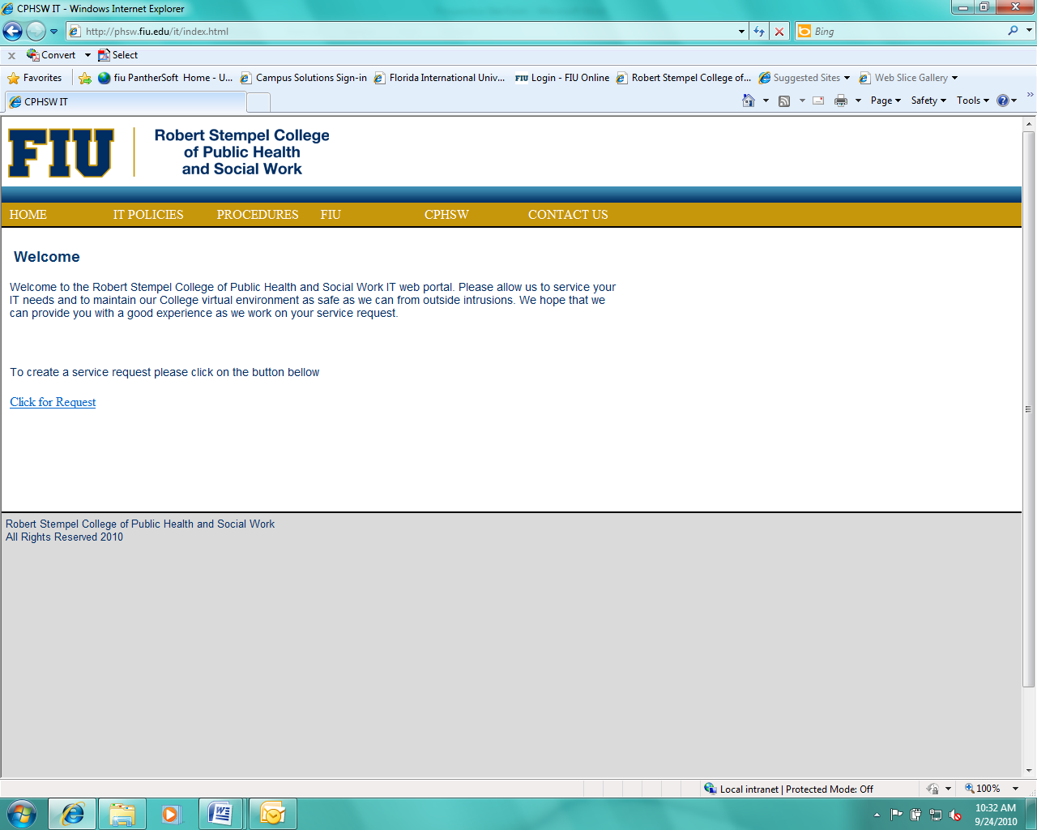

PHC 6XXX – Introduction to Bayesian Inference

3 Credits

**Course Syllabus**

|  |
| --- |
|  |
| GENERAL INFORMATION |

**Instructor**: Gabriel Odom

**Office**: AHC5 470

**Phone**: 305 348 5486

**E-mail**: Gabriel.odom@fiu.edu

**Office Hours**: By appointment

**Class Meets**: Tuesdays and Thursdays, 1:00-2:30PM

|  |
| --- |
|  |
| PREREQUISITE(S) |

Completion of PHC 6052 Biostatistics I and PHC 6091 Biostatistics II or equivalent statistical inference courses (with permission).

|  |
| --- |
|  |
| DESCRIPTION |

This course will introduce students to advanced probabilistic statistical inference through the Bayesian paradigm. Bayesian statistical inference is a powerful and flexible statistical school of thought popular in many areas research, including clinical trial design, clinical trial analysis at all phases, bioengineering and reliability studies, meta-analyses, and many areas of health analytics. Topics will include, but are not limited to, basic mathematical probability theory, likelihood theory and applications to discrete or continuous univariate probability distributions, prior distributions to model expert and published knowledge, and computational languages and software. This course is designed to expand students’ understanding of varied paradigms of statistical decision theory, as well as to equip students to perform basic computing within the Bayesian statistical framework.

|  |
| --- |
|  |
| COURSE OBJECTIVES |

Understand the basics of probability theory and likelihood theory, as well as to demonstrate competency in computing tasks, as necessary for research methods using the Bayesian statistical paradigm or as necessary to be prepared for the course PHC 7XXX – Advanced Bayesian Inference.

Upon completion of this course, the student will be able to:

1. Describe mathematical uncertainty through probability triples and introductory measure theory
2. Construct and manipulate likelihoods from data
3. Construct and evaluate the appropriateness and influence of prior distributions
4. Complete rudimentary Bayesian computational tasks
5. Have a basic understanding of multivariate prior distributions and likelihoods

|  |  |  |  |  |
| --- | --- | --- | --- | --- |
| M | | | | |
| CONCENTRATION-SPECIFIC COMPETENCIES  This course will assist students in developing the following PhD core competencies in biostatistics: | | | | |
| **COMPETENCY** | **COURSE OBJECTIVE** | **Learning opportunity** | **Assessment OPportunity**  **(graded)** |
| 1. Understand statistical and computing theory to develop new analytic methods in medicine and public health | 1, 2, 3, 5 | Lectures 1-18, 27-28 | Assignments |
| 3. Apply contemporary data science skills in the analysis of complex medical and public health data | 2, 3, 4 | Lectures 19-26 | Assignments |

Competencies Rating Scale (See page 5 for details):

0 – Poor (does not meet expectations)

1 – Developing (partially meets expectations)

2 – Adequate (meets expectations)

3 – Excellent (exceed expectations)

|  |
| --- |
|  |
| TEXTBOOK |

Course materials:

1. Christensen et al. Bayesian Ideas and Data Analysis. ISBN-13: 978-1439803547

2. Gelman et al. Bayesian Data Analysis, 3rd Ed. ISBN-13: 978-1439840955

3. Carlin, B., and Louis, T. Bayesian Methods for Data Analysis, 3rd Ed. ISBN-13: 978-1584886976

4. Kruschke, J. Doing Bayesian Data Analysis, 2nd Ed. ISBN-13: 978-0124058880

5. McElreath, R. Statistical Rethinking, 2nd Ed. ISBN 9780367139919

|  |
| --- |
|  |
| TOPICS COVERED |

The course is based on a set of topics listed below. These topics may be modified or expanded to accommodate possible changes in the schedule or to adjust the pace as required.

|  |  |  |
| --- | --- | --- |
| Meetings | Topic | Specifics |
| 1-2 | Theoretical probability | 1. Introductory Measure Theory  2. Probability Triples  3. Conditional Probability  4. Bayes Theorem |
| 3-6 | Discrete likelihoods | 1. Bernoulli  2. Binomial  3. Poisson  4. Negative Binomial  6. Discrete Uniform and Dirac-δ  7. Geometric  8. Empirical |
| 7-10 | Continuous likelihoods | 1. Beta  2. Gamma  3. Normal  4. Uniform  5. Inverse Gamma  6. Additional parameter extensions |
| 11-12 | Loss functions | 1. Hypothesis testing  2. Common loss functions |
| 13-16 | Conjugate priors | 1. Integration review  2. Beta-Binomial  3. Beta-Geometric  4. Poisson-Gamma  5. Normal-Normal  6. Normal-Inverse Gamma  7. Gamma-Gamma  8. Gamma Extensions-Gamma |
| 17-18 | Prior effective sample sizes and power priors | 1. Prior sample size  2. Power priors  3. Sample-size determination (univariate) |
| 19-20 | Computing software | 1. BUGS  2. JAGS  3. STAN  4. R connections |
| 21-22 | MCMC and Gibbs sampling | 1. Monte Carlo procedures  2. Markov-chain Monte Carlo  3. Gibbs sampling |
| 23-26 | Computing theory and limitations | 1. Chains and mixing  2. Autocorrelation and thinning  3. Burn-in  4. Identifiability |
| 27-28 | Introduction to Multivariate likelihoods and priors | 1. Review of matrix algebra  2. Multinomial  3. Multivariate Normal  4. Wishart  5. Inverse Wishart  6. Dirichlet  7. Multinomial-Dirichlet conjugacy  8. Multivariate Normal-Wishart conjugacy |
| 29-30 | Review and final exam |  |

|  |
| --- |
|  |
| CLASS POLICIES AND PROCEDURES |

**Lecture:** The class will meet twice per week (location TBD) for 90 minutes each day. The class sessions will consist of lecture, applied computing, and development work. After class, there will be time for 1-1 Q/A. The instructor will be available by appointment or by email for additional help. As a courtesy to your fellow students and the instructor please put your mobile phones on silent, and if you must answer a phone call as an emergency, please step out of the classroom or a lab. If safety becomes a concern due to severe weather, we will follow FIU policies and procedures and the course schedule will be adjusted by the instructor.

**Materials:** BUGS, JAGS, STAN, and R are free programs. You can download and install them on your personal computer or laptop (highly recommended). The textbooks can be on the expensive side, but used copies are ok.

**Notes:** There will be one report and short presentation per week and a final exam. See evaluation for details. Concerning withdrawal: it is the student’s responsibility to initiate the paperwork required to drop or withdraw from courses. Failure to attend classes does not constitute proper procedure for dropping or withdrawal and may result in an F.

**Disability**

The University provides reasonable accommodations and services to all students on a nondiscriminatory basis consistent with legal requirements as outlined in the Americans with Disabilities Act as Amended (ADAAA) of 2008 and the Rehabilitation Act as Amended. . If you have disability and/or need special assistance during the course or exams, please make arrangements through the Office of Disability Services (305-348-4131). More information about the accommodation process is available at <http://drc.fiu.edu/index.php>

|  |
| --- |
|  |
| EVALUATION AND GRADING |

Methods of evaluation:

1. Weekly reports and presentations for a total of 140 points.
2. Final exam worth 60 points.

Homework will be assigned before the lecture. Students will start working on the homework problems in the classroom following the lecture with time for questions and answers. Students will complete the assignment at their convenience and turn in typed reports and derivations (for theoretical exercises) or “marked up” code and output (via RMarkdown; for computational exercises) at the beginning of the next week. At the end Thursday’s class each week, one student will be chosen at random to present their homework.

For the final exam,students will have an in-class (theoretical) and a take-home (computational) portion.

Grading rubric:

|  |  |  |  |
| --- | --- | --- | --- |
| Homework and Theoretical Exam Questions | Met | Partially met (minor errors) | Not met (or major errors) |
| Report is introduced and motivated | 3 | 2 | 0-1 |
| Mathematical procedures are valid and logical | 4 | 2-3 | 0-1 |
| Results are correct | 3 | 2 | 0-1 |
|  |  |  |  |
| Computational Exam Questions |  |  |  |
| Statement of the problem is clearly communicated | 10 | 5-9 | 0-4 |
| Code is well-documented and accurate | 10 | 5-9 | 0-4 |
| Likelihood and prior are appropriate and justified | 20 | 10-19 | 0-9 |
| Results and conclusions are correct | 20 | 10-19 | 0-9 |

|  |  |
| --- | --- |
| Weekly reports and presentations | 70% |
| Final Exam (two components) | 30% |

|  |  |  |  |
| --- | --- | --- | --- |
| **Grading Scale** | | | |
| A | 92.6 – 100 | C+ | 76.6-79.5% |
| A- | 89.6 – 92.5 | C | 69.6-76.5 |
| B+ | 86.9 – 89.5 | D | 59.6-69.5 |
| B | 82.6 – 86.5 | F | < 59.5 |
| B- | 79.6 – 82.5 |  |  |

|  |
| --- |
|  |
| FIU HONOR CODE |

Florida International University is a community dedicated to generating and imparting knowledge through excellent teaching and research, the rigorous and respectful exchange of ideas and community service. All students should respect the right of others to have an equitable opportunity to learn and honestly to demonstrate the quality of their learning. Therefore, all students are expected to adhere to a standard of academic conduct, which demonstrates respect for themselves, their fellow students, and the educational mission of the University. All students are deemed by the University to understand that if they are found responsible for academic misconduct, they will be subject to the Academic Misconduct procedures and sanctions, as outlined in the Student Handbook.

Misconduct includes: Cheating – The unauthorized use of books, notes, aids, electronic sources; or assistance from another person with respect to examinations, course assignments, field service reports, class recitations; or the unauthorized possession of examination papers or course materials, whether originally authorized or not. Plagiarism – The use and appropriation of another’s work without any indication of the source and the representation of such work as the student’s own. Any student who fails to give credit for ideas, expressions or materials taken from another source, including internet sources, is responsible for plagiarism. All students are expected to abide by the Florida International University Honor Code. Any violation will be reported.

In addition, students are required to sign an honour code at the end of all assignments and exams. The honour code should state “*I have neither given nor received any unauthorized aid on this [assignment, exam]*”. Please sign after the statement.

**Student conduct**

**Students are responsible for knowing and complying with all FIU Policies and Regulations which are listed in the Student Handbook and also at the following link: http://policies.fiu.edu/files/740.pdf. The following are excerpts:**

**Reason for the policy:**

**“**Graduate students at Florida International University are expected to adhere to the highest standards of integrity in every aspect of their lives. Honesty in academic matters is part of this obligation. Academic integrity is the adherence to those special values regarding life and work in an academic community. Any act or omission by a graduate student which violates this concept of academic integrity and undermines the academic mission of the University shall be defined as academic misconduct and shall be subject to the procedures and penalties that follow.”

**Definition of academic misconduct:**

Academic misconduct is defined as the following intentional acts or omissions committed by any FIU graduate student:

***“Cheating***: The unauthorized use of books, notes, aids, electronic sources; or unauthorized use of on-line exams, library materials or assistance from another person with respect to examinations, course assignments, field service reports, class recitations; or the unauthorized possession of examination papers (or on-line examinations) or course materials, whether originally authorized or not. Any student helping another cheat may be found guilty of academic misconduct”

***Plagiarism***: The deliberate use and appropriation of another's work without any indication of the source and the representation of such work as the student's own. Any student, who fails to give credit for ideas, expressions or materials taken from another source, including internet sources, is guilty of plagiarism. Any student helping another to plagiarize may be found guilty of academic misconduct.

***Misrepresentation***: Intentionally lying to a member of the faculty, staff, administration, or an outside agency to gain academic advantage for oneself or another, or to misrepresent or in other ways interfere with the investigation of a charge of academic misconduct.

***Misuse of Computer Services***: The unauthorized use of any computer, computer resource or computer project number, or the alteration or destruction of computerized information or files or unauthorized appropriation of another's program(s).

***Bribery***: The offering of money or any item or service to a member of the faculty, staff, administration or any other person in order to commit academic misconduct.

Conspiracy and Collusion: The planning or acting with one or more fellow students, any member of the faculty, staff or administration, or any other person to commit any form of academic misconduct together.

***Falsification of Records***: The tampering with or altering in any way of any academic record used or maintained by the University.

**Ethical Guidelines for Statistical Practice:** “Statistics play a vital role in many aspects of science, economy, governance, and even entertainment. It is important that all statistical practitioners recognize their potential impact on the broader society and the attendant ethical obligations to perform their work responsibly. Furthermore, practitioners are encouraged to exercise "good professional citizenship" in order to improve the public climate for, understanding of, and respect for the use of statistics throughout its range of applications” (American Statistical Association)

|  |
| --- |
|  |
| COURSE SCHEDULE AND ASSIGNMENTS |

|  |  |  |
| --- | --- | --- |
| MEETING | TOPIC | ASSIGNMENT |
| 1-2 | Theoretical probability | TBD |
| 3-6 | Discrete likelihoods | TBD |
| 7-10 | Continuous likelihoods | TBD |
| 11-12 | Loss functions | TBD |
| 13-16 | Conjugate priors | TBD |
| 17-18 | Prior effective sample sizes and power priors | TBD |
| 19-20 | Computing software | TBD |
| 21-22 | MCMC and Gibbs sampling | TBD |
| 23-26 | Computing theory and limitations | TBD |
| 27-28 | Introduction to Multivariate likelihoods and priors | TBD |